An exploration into the motivation and satisfaction of volunteers at community events- Case study of MUUK Adventures

By Rebecca Reynolds
1701301

BA (Hons) Events management
UWTSD Swansea
2020


DECLARATION
This work has not previously been accepted in substance for any degree and is not being concurrently submitted in candidature for any degree
Signed................................................... Date......................................................
STATEMENT 1
This dissertation is being submitted in partial fulfilment of the requirements for the degree of BA. Signed....................................................
Date......................................................
STATEMENT 2
This dissertation is the result of my own independent work/investigation, except where otherwise stated.
Other sources are acknowledged by footnotes giving explicit references. A bibliography is appended.
Signed...................................................
Date......................................................
STATEMENT 3
I hereby give consent for my dissertation, if accepted, to be available for photocopying and for interlibrary loan, and for the title and summary to be made available to outside organisations.
Signed...................................................... Date.........................................................

STATEMENT 4
I hereby give consent for my dissertation, if accepted, to be available on the university’s IT system to those who have consent to use the system.
Signed...................................................... Date.........................................................

Acknowledgements

Firstly, I would like to show appreciation to the University of Wales Trinity Saint David and the staff that have helped to be able to complete the degree. A big thank you to my dissertation supervisor, Matthew James for all the support and encouragement provided during the dissertation process. Thank you, Caroline Jawad and Graham Orr, for all their help and support to be able to write the dissertation. I would like to show appreciation to Mike Davies, Suzanne Wells, Marie Pitson and Jacqui Jones for the guidance and support throughout the 3 years, thank you.

I would like to thank the staff at MUUK-Adventures for being helpful with the research of the dissertation. In particular, the manager and all the interviewees for giving up their time.

Lastly, a special thank you for everything to my friends that I have made at university for the motivation and support to finish off the dissertation. To my family for all the encouragement throughout to complete the degree.

Abstract

The aim of this dissertation was to explore the motivation and satisfaction of community events. The research will use MUUK-Adventure events to gather primary research. With over eight events each year and with the events expanding, volunteers have played a significant role for the organisation and the community. Therefore, it was significant to find out what the main motivations was to volunteer at the events and how satisfied the volunteer were with their experience. This in turn has provided MUUK-Adventures with recommendations to help retain their volunteers.

An extensive literature review was conducted on different motivation factors and satisfaction. As a result, the research has formulated frameworks to evaluate the motivation and satisfaction of community events. The research showed that volunteers experience a range of different motivations depending on the event if the motives are satisfied, the volunteers are more likely to volunteer again.

To achieve the aim and objectives of this dissertation, the methodology was formed from pre-existing literature. A mixed- method approach was conducted given the study an inductive and deductive approach. An online questionnaire and face-to-face interviews were conducted to achieve the objective. The primary research revealed that the main motivation to volunteer at MUUK-Adventure events was solidary factors followed by purposive. The volunteers were overall satisfied with their experience and highly likely to volunteer again. It was recommended that MUUK-Adventures need to provide more information prior to the events as this was highlighted in the findings that volunteers expressed their concerns.

Table of Contents
Chapter 1: Introduction 7
1.1.Background and rationale 8
1.2 Introduction to MUUK- Adventures 10
1.3 Aims and objectives 10
Chapter 2: Literature review 11
2.1. Introduction 11
2.2. Events typology 11
2.3. Volunteering defined 12
2.4 The role of volunteers 13
2.5. Volunteering satisfaction 14
2.5.1. Satisfaction and well-being 14
2.6. Episodic volunteering and Continuous volunteers 15
2.7. Motivation theories 15
2.7.1. Hierarchy of Needs 16
2.7.2. Two-dimensional model- Altruism and egoistic 17
2.7.3. Three- and four-dimensional motivation theories 18
2.8. Best practice management of volunteers 19
2.9. Conclusion 20
Chapter 3: Methodology 21
3.1. Research methodology 21
3.1.1. Research onion 21
3.1.2. Philosophy 22
3.1.3. Approach 23
3.1.4. Strategy and choice 23
3.1.5. Time horizon 24
3.2. Collection and analysis 24
3.2.1. Questionnaire 24
3.2.2 Pilot study 25
3.2.3. Questionnaire design 25
3.2.4. Interview and design 25
3.3. Sampling 26
3.4 Data analysis 26
3.5. Ethical considerations 27
Chapter 4: Data analysis 27
4.1 Introduction 27
4.1.1. Sample 27
4.2. Qualitative and quantitative data 28
4.2.1. Nodes created through NVivo 28
4.3. Demographics 28
4.3.1 Gender 28
4.3.2 Age 29
4.3.3 Working status 30
4.4. Motivation 32
4.4.1. Difference between genders for purposive motivation. 34
4.4.2. Challenges faced volunteering 38
4.4. Satisfaction 40
4.5. Best practice management 42
Chapter 5: Conclusion and recommendations 44
5.1. Introduction 44
5.2. Summary of findings 44
5.3. Recommendations to MUUK-Adventures 45
5.4. Limitations 46
5.5. Recommendations for future studies 46
5.6. Conclusion 47
6. Bibliography 48
7. Appendices 55
7.1 Appendix 1: Questionnaire questions 55
7.2 Appendix 2- Question responses 62
7.3 Appendix 3. Interviews questions 68
7.3.1 Appendix 4- Manager interview questions 69
7.4 Appendix 5- Interview responses 70
7.4.1 Participant 1 70
7.4.1 Participant 2 72
7.4.3 Participant 3 75
7.4.4 Participant 4 77
7.5 Appendix 6- Questionnaire matrix 80
7.6 Appendix 7- Farrell et al (1998) 28 items table 81
7.6. Appendix 8- Ethics form 82
7.7 Appendix 9- Consent form 92

List of figures

Figure 1: Future Generation Act (2015) 9
Figure 2. Volunteering in the 21st century 13
Figure 3. Maslow’s (1993) Hierarchy of needs 17
Figure 4. Saunders (2016) The research onion 22
Figure 5. Gender 29
Figure 6. Age 30
Figure 7. Cross tab between age and skill for CV. 30
Figure 8. Crosstabulation between age and social interaction 30
Figure 9. Working status 31
Figure 10. Crosstabulation of working status and sport volunteers 32
Figure 11. Averaging mean from Likert scales 33
Figure 12. Crosstabulation of gender and being part of a community 34
Figure 13. Chi- square test 35
Figure 14. Purposive motivations 35
Figure 15. Solidary motivations 36
Figure 16. External motivations 37
Figure 17. Commitment motivations 37
Figure 18. Challenges faced by volunteers 38
Figure 19. Taken part as a competitor 39
Figure 20. Satisfaction 40
Figure 21. Word cloud: Satisfaction 42
Figure 22. Word cloud: Recruitment 43

List of tables
Table 1. Job roles 28

Chapter 1: Introduction

1.1.Background and rationale
The purpose of this dissertation is to explore the motivational factors and satisfaction levels of community event volunteers via the study of MUUK-Adventures. In turn this will give insights to the event manager on how to understand their volunteers and to help retain them.
The events sector alone is currently worth £42.3 billion in the United Kingdom’s economy with sport events contributing £2.3 billion to the economy, with each year rising (BVEP, 2015). The survival of many events across the United Kingdom relies highly on event volunteers (Kerwin et al., 2015). When it comes to events, a number people can help organise and manage events with volunteers providing many capacities for paramount work. The expense of organising events can be perceived as costly. With limited financial costing volunteers are considered a value (Douglas et al., 2000). Therefore, event organisers acquire volunteers to help with the running of the event. Volunteers play an essential role in making communities sustainable through a wide range of activities (Cuskelly et al., 2006). While it is evident that volunteers are essential for the survival and success of events, it can be seen challenging for many organisations to recruit and attain volunteers (Cuskelly et al., 2006). This shows the relevance of this study of knowing the key motivation and satisfaction factors will help event managers know how to retain their volunteers.

In the year 2017/18, over 20.1 million people volunteered through clubs and organisations in the United Kingdom (NCVO, 2020). There are many initiatives in the United Kingdom to encourage people into volunteering. By using slogans such as ‘Get Inspired’ (BBC Sport, 2020) and providing organisations with funding many employers are motivated to get employees involved in volunteering. According to Sport England (2018) at least 6.3 million adults gave their time to volunteer at least twice a week. This shows the significance of volunteers’ contribution to communities. To retain volunteers, Sport Wales (2020) have used slogans ‘Give to Gain’ to show their support and appreciation to volunteers across the country. By encouraging volunteering in the community, this will increase attitudes and engagement towards volunteering (Doherty, 2009).
The volunteering sector with sport events have made a positive impact on communities through the involvement and the opportunities created according to Kerwin et al. (2015). Participation in sporting events helps build skills and confidence in people. This benefits the seven goals set out by the Future generation act (2015) shown in figure one to improve the well-being of Wales. The seven goals contribute to ‘Taking Wales Forward’. The act involves the improvement of social, economic, environmental and cultural interactions in Wales. This will benefit communities by working together by taking a joined-up approach. The Third Sector Support Wales (TSSW) works with the Welsh Government and other public bodies to improve volunteers’ experience and to raise the profile (Volunteering Wales, 2020). Public bodies including Sport Councils in Wales need to work together towards the well-being goals. The volunteering sector in Wales contribute to 221 million hours of activity, which generates a worth of £2.2 billion according to WCVA (2014). This shows the significance of sport volunteers and how volunteers contribute to the goals set out by the Welsh Government.
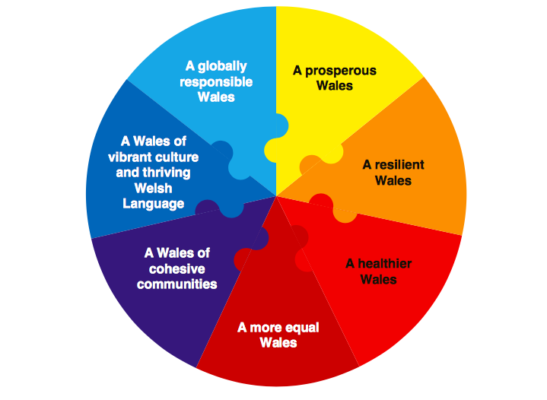

Figure 1: Future Generation Act (2015)

Pembrokeshire Country Council have encouraged community initiatives through the support of formal and informal volunteering (Pembrokeshire gov, 2018). Volunteering provides opportunities for local communities that can impact Pembrokeshire through to 2030 by engaging the community and making communities more resourceful and resilient to challenges. According to Pembrokeshire Gov (2018) all organisations are supported to achieve their goals from the bottom through to grassroots. To help support organisations, the council of Pembrokeshire provide opportunities in collaboration with PAVS a Pembrokeshire voluntary service working with different types of organisations. The Pembrokeshire National Park (2020) actively encourages people to get involved to keep fit and active and to develop skills which can contribute to local communities.

Sport event volunteers are evidently significant to local communities and it is vital to understand the main factors of motivation and satisfaction to help organisation retain their volunteers. Farrell et al. (1998) reported that there is a linkage between volunteer motivation, satisfaction and actual experience.

1.2 Introduction to MUUK- Adventures
MUUK Adventures is the case study organisation for this study. The organisation provides outdoor endurance events in Pembrokeshire and started in 2010 (MUUK-Adventures, 2020). Predominately the events are held in the community of St.Davids. The endurance events include; Coastal path marathons, cycling, open water swimming and Mud Runs. The increased popularity of the events year on year, meant 2019 saw the organisations largest growth in the number of events it held since its start date of 2010. The organisation works closely with its partners and hires people with expertise in their fields. From statistics taken by MUUK-Adventures (2020) over 5,000 people have taken part in their events and over £20,000 has been raised for charities and organisations. The events happen thanks to the support received from the local community and individuals offering their free time to volunteer for the organisation

MUUK-Adventures was chosen due to their experience of hosting a vast array of sporting events, held in small communities. With high levels of support from groups and individuals to make the events happen, this organisation is seen as useful for this study.

1.3 Aims and objectives

The aim of this study is to explore volunteer motivation and satisfaction at a community sports event to help the organisation of MUUK-Adventures retain their volunteer engagement. The following objectives will be achieved through research:

•To examine the volunteer motivation through primary research investigating the main motivational factors behind why individuals volunteer at MUUK Adventure events.
•To critically examine the satisfaction of the volunteers through a mixed method approach from their experience of volunteering at community events conducted by MUUK Adventures.
•To provide MUUK Adventures with recommendations of best practise toward volunteer management through the use of feedback from theory and primary research.

To achieve the aim and the objective set for this study, a mixed method approach was taken to capture primary and secondary data. The key themes that will be explored in this study will involve extensive literature reviews that surrounds motivation, satisfaction through volunteering and key management practices to get an understanding of how volunteers are managed.

Chapter 1 has given an overview of the background of the research and the rationale behind it. Chapter 2 will explore the key themes surrounding the chosen topic.

Chapter 2: Literature review

2.1. Introduction

This chapter will begin with the definition of volunteers and the investigation into the literature surrounding volunteer satisfaction and motivation followed by best practice management.

2.2. Events typology

The events industry is diverse, anyone can plan and organise an event. Events have a range of definitions due to how they have evolved but Bladen (2012) defines events as a temporary occurrence that are a catalyst of bringing people together. Events can be planned and will have a start and a set end. According to Bowdin (2011) events are distinguished by their size and scale. MUUK events are community sporting events which rely on volunteers due to the size of the events. With the size of the events, it can be more financially costing to hold an event which makes volunteers more valued within a community (Douglas et al., 2000). Many communities host events to target local audiences to provide social benefits and encourage participation. Putnam (2000) supports that events can build a community and create trust amongst its members (Misener and Mason, 2006). This can create social capital by offering opportunities to members within the community. Therefore, it can be seen as important to motivate the audience who lives with in the community.

Community events compared to major events are small in size and have lower attendance. Community events are typically short lived and temporary which can bring people together (Douglas et al.,2000). According to Vecina et al. (2012) events that are smaller in size only rely on smaller volunteer numbers as few as 50 to 100 volunteers to make sure the event will be a success. The demographics of St.Davids is only 1,600 according to (Visit Pembrokeshire, 2020). From statistics from MUUK-Adventures (2020) with a small population and around 300 participants per event, MUUK-Adventures events rely on a smaller size volunteer pool and community participation. According to Misener and Mason (2006) sport events can have a positive impact within local communities and is significant in creating civic pride and a sense of community through participation.

2.3. Volunteering defined

With the definition of volunteers having similar definitions there is no universal meaning and can be quite complex rather than simple (Cuskelly et al., 2006). The National centre for volunteering (United Kingdom) defines volunteering as:
‘any activity which involves spending time unpaid doing something which aims to benefit the environment or someone (individual or groups)’. (NCVO,2020).

Similarly, Wilson (2001) states a volunteer is:
‘any action in which time is given freely to benefit another person, group or organisation’ cited in Tomazos and Luke (2015 p.g 215 ).

As there is no standard practise in volunteering (Gaskin, 2003) argues that there is no clear definition of the term. Although Bussell and Forbes (2002) asserts that the different definitions view volunteers as those with an altruistic rationale. Handy et al. (2000) concluded that the perceptions of volunteering consist of the benefits that can occur to the volunteer and how the volunteer will perform with or without financial and social benefits (Cuskelly et al., 2006).

Rochester (2016) researched that volunteering can be split into three overlapping perspectives: Unpaid work, serious leisure and activism. The model shown in figure two shows how volunteers can experience opportunities through activities which can include MUUK Adventures. Section one from the model shows how rewards and merchandise can be given to volunteers from an event. Section two of serious leisure can be seen as hobby or interest for sports events where volunteers can contribute their skills. This can be previous participants from MUUK endurance events wanting to give their expertise into volunteering at their events. Thirdly, activism relates to the power of change and making a difference. According to Rochester (2016), these three pillars are an important aspect to volunteering.
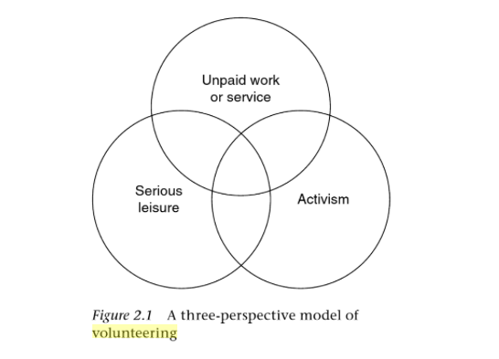

Figure 2. Volunteering in the 21st century (Rochester, 2015)

2.4 The role of volunteers

Volunteers fill a crucial role in the successful management of any event. Sport events rely on a large number of individuals for delivery (Bang and Ross, 2009). Kemp (2002) states that volunteers will give their spare time without the need of tangible rewards and will invest time. According to Ingerson (2001) this can contribute through volunteers and is increasingly important for the economic and cultural benefit components of events. Alternatively, Cuskelly et al. (2006) acknowledges that volunteers at many levels contribute to making communities more sustainable through to the community to international organisations. Cravens (2006) identified that volunteers can often develop skills and expertise through contributing at community events which cannot be found in an organisation. Although with the benefits, there is a high short dropout rate (Hager & Brudney, 2004). With support from theories of why people no longer volunteer at events in the United Kingdom, numbers are increasingly dropping (NCVO, 2019). With community events, it can be seen as more difficult to recruit and sustain volunteers due to motivation and satisfaction factors compared to mega events as smaller scale events are considered to have less of a reputation supported by Fairley et al. (2014). Mega event volunteers are likely to volunteer for that ‘once in a lifetime’ experience according to Homes and Smith (2012). On the other hand, Cary and Snyder (1999) disagree and found that people felt it was more superior to help others within the community.

2.5. Volunteering satisfaction

A key component of the volunteering process is volunteer satisfaction. Bang and Ross (2009) suggest if the motives to volunteer are satisfied it will attract them to continue in future events. The authors state that the most important predictors for satisfaction for volunteers are expressed in the motivations of values, career gain and passion. This evidently shows that there is a clear link between volunteer motivation and satisfaction, and it is important for event managers to identify this. Getz (2007) maintains that through identifying volunteer motivations this will increase volunteering satisfaction which will create a positive experience. This will result in retaining volunteers and shows how significant events can be to encourage people to volunteer. Although Farrell et al. (1998) cited in Johnson et al. (2017) argues that fulfilment of goals is not related to satisfaction but through the event itself and the facilities it provides for sport. It can also be argued that volunteer satisfaction is actual time spent volunteering, the length of time and the motivation to want to continue. (Lee et al., 2014). Volunteer satisfaction plays an important role for sustaining volunteers and for the volunteer process. Similarly, Xiao (2017) suggests that it is vital to know the knowledge of volunteer satisfaction to retain volunteers.

According to Pauline (2011) previous studies have evaluated satisfaction of volunteers and results have shown that satisfaction relates to motivation, commitment, intrinsic and extrinsic benefits (Ramili et al.,2014). Through motivation of intrinsic rewards, positive feelings and attitudes can be adopted along with a sense of doing something valuable. Clary et al. (1998) suggests that satisfaction can indicate the emotional state and achievement felt gained through volunteering activities (Ramili et al., 2014). This reinforces the intrinsic needs of satisfaction. Ramili et al. (2014) discusses that through volunteering, positive experiences can contribute to individuals psychological needs to express their values, career prospects and the social enjoyment being involved in sporting activities. If these needs are fulfilled it is likely individuals are motivated to volunteer in the future supported by Bang and Ross (2009). Strigas and Jackson (2003) argues that it is important for managers to identify individuals needs from measuring satisfaction (Bang and Ross, 2009). Unawareness from event manages could affect the morale and the retention and growth of volunteers at community events (Ramili et al., 2014).

2.5.1. Satisfaction and well-being
Studies on life satisfaction have been important for those who volunteer against non- volunteers. Volunteers have reported an increased sense of life satisfaction and improved quality of life after volunteering. Dunlin et al. (2001) states that only those who volunteer at a community level for altruistic motivators will increase well-being (Kwok et al., 2013). Binder (2015) also recommends that volunteering can positively benefit life satisfaction and well-being of individuals. Sport Wales (2020) are using the slogan ‘Give to Gain’, showing that if people give up their time that they will gain in return. This encourages volunteers and shows how their efforts can create a positive impact and in turn will encourage retainment. Volunteers can be healthier and benefit from improved social economic impacts (Miller et al., 2005) due to a result of volunteering. Through research and results volunteering can support individuals and increase well-being which impacts on individual’s satisfaction with leisure time.

2.6. Episodic volunteering and Continuous volunteers

It is important for event managers to be aware of the motives and satisfaction for episodic and continuous volunteering in order to recruit, sustain and retain volunteers according to Holmes (2014). With events being temporal, many authors have discussed volunteering as a form of episodic volunteering. With community events including MUUK Adventure events, these are short term and temporary, which can rely on episodic rather than continuous volunteers. For volunteers of MUUK events, this gives flexibility and shows the relationship between the organisation and the volunteers. It is seen as a current and future trend for events to recruit episodic volunteers and it has been recognised that may return to volunteer again for the organisation (Wilson 2012). He continues to state how those who episodically volunteer have more loyalty with the organisation. Criticism of episodic and continuous volunteers from Cnaan and Amrofell (1994) who have suggested that it is the length of volunteering as a continuum instead of separating them into two separate categories cited in Fairley et al. (2014). The continuum from one end being individuals who volunteer for one-time events and those individuals who continually give their all to serve events. This suggests that depending on how many events a person volunteers this classes them on the continuum rather that two distinctive categories.

2.7. Motivation theories
There has been significant research into volunteer engagement at mega- events. Although a lack of discussion into community events according to Jepson and Clarke (2016) despite evidently a significant contributor to the development of a community. According to Clary (1998) Volunteer motivation can be seen as a person who wants to seek opportunities, show commitment by helping and to sustain their involvement (Johnson et al., 2017). He goes onto to suggest that activities can include social interaction, contributing to development and enhancing well-being. Sport volunteer motivation can highlight satisfaction through beneficial experiences and the increased volunteer return prospect. Much research has been conducted by Clary (1998) using the Volunteer function inventory (VFI), although these factors have been used by other authors and adapted to fit shorter sport event motivation scales highlighted by Johnson et al., 2017).

2.7.1. Hierarchy of Needs
One of the most known motivation theories is Maslow (1943) theory of ‘a hierarchy of needs’ which is based on individuals’ requirements that are essential. The model of hierarchy of needs pyramid consists of an order of the most basic to the highest level of need starting with physiological, safety, love and belonging, esteem and self-actualisation (Han,2007). The top level relates to event volunteers, through to working environment to recognition and the volunteers worth. The lower levels are not relevant to event volunteers. Event managers will need to identify the levels in order to develop the individual’s potential. Van Liere and Dunlap (1980) cited in Han (2007) argued that motivation can be changeable depending on the need. Lower levels need to be achieved before considering the higher level of the pyramid and therefore progressing up through the pyramid.
From Maslow’s theory, Knowles (1972) ended with volunteering is a way of looking after an individual’s self-actualisation as well as a way of living which is supported by (Han,2007). Therefore, Maslow’s theory suggests that it emphasises one’s own desire aspect from the variety of motivations on volunteering. Although this theory of motivation is often discussed by researchers, it is seen as outdated but is relevant for this study due the principles of the theory are still used in modern society. Tum et al (2006, p.g 117) states

‘it has yet to be fully researched whether people from different cultures have the same need categories and hierarchies.’
Criticism of this model have led to the modification and development of other theories which consist of a variety of motivations.
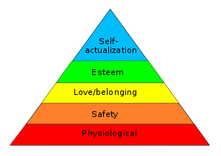

Figure 3. Maslow’s (1993) Hierarchy of needs

McClelland (1973) stated that motivation can be split into three categories: Achievement, affiliation and power. These traits are developed through time and experience rather than being born with them according to McCellend (2009). This can suggest that the reason why groups or families tend to volunteer is due to the experience whilst growing up and has become a normal expectation. This can be beneficial for communities due to families volunteering through time. The three factors can be a motivation why people volunteer at events. For the research of this study, the 1973 theory will be relevant to discover if individuals past experience from competing in any events will affect any volunteers’ decisions.

2.7.2. Two-dimensional model- Altruism and egoistic

The two-dimensional model is between altruism and egoistic motivations which has been enhanced by Horton Smith (1981) links into volunteerism in sport events (Monga,2006). An egoistic motive refers to tangible and directs towards a volunteer’s goal to increase personal gains for example ‘I wanted to improve my skills and abilities through volunteering’. (Strigas and Jackson,2003). It drives intrinsic and intangible needs which results in improved self-esteem (Monga, 2006). This contributes as a great motivator for volunteering. Monga (2006) suggests that both motivations correlate with one another as individuals want to help others for their ego selves.

On the other hand, altruism is the aim to increase other people’s welfare stated by Monga (2006). This reflects a person’s intrinsic motivation in helpings others. According to Kim (2018) pure altruism motives is important to the delivery of the events. Leventhal (2009) argues and agrees that altruistic outcomes could be egocentric and self- serving (Kim,2018). Although research has shown that motivation is not just through altruism but a range of motivations which can include personal and local community benefits. Wilson (2005) discusses that the reasons for the decline in volunteer’s was specific to organisation and through altruism and self-interest (Kim, 2018).
A study conducted for Sport England by Nichols et al. (2016) implies that volunteering has changed to become more of a self-interest. Altruism is on the decline due to the changes of young people’s opinions. From the Cabinet office of (2015) statistics show that the most likely age range to volunteer is young people (Nichols et al., 2016). According to NVCO (2020) more females are volunteering over males. This is highlighted due to the promotion of enhancing employment prospects and having transferable skills in the workplace from research conducted by Sport England. From this research, through questionnaires conducted by the researcher for volunteers at MUUK, linking demographics with motivation of altruism will learn if this is true.

2.7.3. Three- and four-dimensional motivation theories

Volunteers can be motivated through both intrinsic and extrinsic motivations and is outlined in motivation theories. Caldwell and Andereck (1994) have researched and conducted a three-dimensional motivation model categorised; purposive, solidary and material incentives (Kim, 2010). Purposive refers to doing something useful and giving back to society. Solidary incentives for volunteering are generated through social engagement, being identified, group affiliation and creating networks. Monga (2006) suggests that without intrinsic motivation, volunteer numbers would be low and small reward such as a free lunch can encourage individuals motive and show they are recognised. Although Farrell et al. (1998) gave it more of an egoistic approach by referring to instrumental values (Monga, 2006). Lastly, material incentives are on tangible rewards and benefits volunteering. Overall, Caldwell and Andereck (1994) identified that that the strongest motive is purposive incentives from their study on a mega event in skiing (Kim,2010).

Based on a women’s curling event in Canada (1996), a motivation theory was adapted into four categories by Farrell et al. (1998) based on research and data collected. The four categories measured for motivation is called the Special Event Volunteer Motivation Scale (SEVMS) which consists of; purposive, solidary, external traditions and commitments (Kim, 2010). The first two categories are the same motives as Caldwell and Andereck (1994) and received the same results as to which was the most important motivations. This can be seen as a reliable model to collect data for research into volunteer motivations. According to Kim (2010) the motivation through external traditions is based on family traditions and an external influence to motivate a person to volunteer. Commitment concept refers to the need to increase person skills and satisfaction through volunteering.
By using the SEVMS model, Kim (2018) believes that sport event volunteers can experience multiple motivations at one time wanting to volunteer and developing satisfaction with their experiences. This will be useful in the research methodology as this model can be used to find out what has which is the most important motivation factor for MUUK Adventure volunteers by comparing it to the curling event. The model has been completed in other special events and further found that volunteers will experience various motivations. From support of Slaughter (2002) of these findings agreed but argued that motivations will change over time due to the changes in volunteering (Cuskelly et al., 2006).

2.8. Best practice management of volunteers

Identifying ways to encourage, gain volunteer interest and to retain volunteers has been of interest and very well researched (Mutawa,2015). Event managers will need to focus on the human resource approach which will involve preparation before, during and post event in order to keep volunteers interested and to continue to volunteer. The assumption of satisfaction, commitment and performance need to be adopted (Cuskelly et al., 2006). For sporting events, human resource processes such as recruitment and selection, training and development through to recognition and reward is supported by Cuskelly et al. (2006) due to the different motives of volunteering. Farrell et al (1998) argued that sport event managers need knowledge of the volunteer’s level of satisfaction (Mutawa, 2015). Positive experiences from events is key from the operation side and facilities provided can be a factor in ensuring volunteers will give their services again. The researcher will be able to provide MUUK-Adventures with feedback from primary research conducted to determine the levels of satisfaction that is required.

It is important for organisers to carefully select the event timing in the pre event build up emphasised by Cuskelly et al. (2006). This ensures the right suitability of the timings for volunteers and gets them involved in the planning and implementation. During the event, time is needed for debriefs in order to explain roles and effectively place and support volunteers. Post event, immediately thanking and the recognition of the volunteers is recommended. A good example of an organisation appreciating their volunteers is Park run. Park run rewards volunteers who show commitment by acknowledgement and recognition through small incentives (Park run, 2020). Showing recognition helps retain volunteers and increase motivation and overall satisfaction. With the volunteer numbers dropping, support and retention is important to keep skilled volunteers which is key to management (Warner,2011). Hager (2004) states that many organisations face challenges which include availability of volunteers, finance, problems in recruiting the right people with skills, unreliability of people and volunteers not turning up (Mutawa, 2015). Therefore, it is important for managers to identify the motivations of their volunteers and satisfaction to mitigate these issues.

There is importance in the recognition of the emotional profile and personalities of volunteers in order for the organisers to place the volunteer in the logical role implemented Smith et al. (2014). Placing volunteers in the wrong role can cause combustion which leads to dissatisfaction and a negative impact on the individual volunteer which results in an impact on the success of the event. Smith (2014) goes on to discuss the importance of event managers knowing the motivational components in fitting the right person for the role. Well written job descriptions will keep the volunteers informed and engaged which can increase satisfaction (Einolf, 2018). According to Einolf (2018) volunteers who have highlighted that their roles were clear are more intended to continue volunteering. Organisers need to maintain volunteer’s morale pre and post event and diminish negative emotional outcomes to increase and maintain motivation and get the possible best work ethic from the event volunteers. It is recommended that positive experience from communication and support which volunteers receive is another factor for longer hours and continuing for individuals to volunteer (Einolf, 2018).
2.9. Conclusion
This chapter has found underpinning theories which can be investigated and analysed in chapter three, four and five. Volunteering is extremely important for community events and the future of the events industry. In order to keep volunteers motivated and get them to continue it is important to be able to identify what motivates people to volunteer and to give support and recognise their efforts.

Chapter 3: Methodology

Chapter 3 outlines the data collection and analysis procedures that have been used for this research.

3.1. Research methodology

The method of primary research chosen for this study has been justified by using Saunders et al (2016) ‘Research Onion’ identifying the philosophy, data collection methods through to the analysis techniques.
Saunders et al (2009, pg.5) defines research as ‘something that people undertake to find out things in a systematic way, thereby increasing knowledge’, it can be therefore understood that through research knowledge can be gained using a strategic approach.

3.1.1. Research onion

The research onion uses multiple layers which has be pivotal for choosing the most suitable collection method as well as identifying good practice for deciding the selected methods effectively.
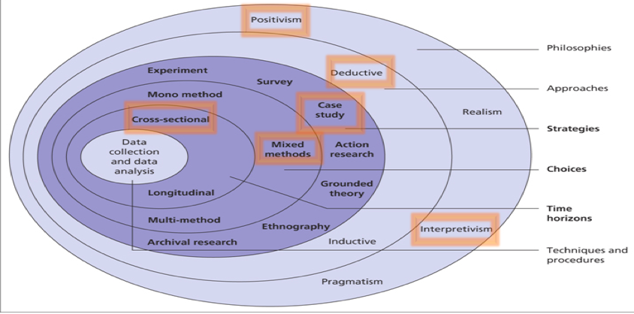

Figure 4. Saunders et al (2016) The research onion

The figure above illustrates the selected pathway chosen by the researcher on Saunders’ et al. (2016) ‘Research Onion’ going from the outside of the layer through to the centre. Following the pathway, a primary focus on quantitative data has been used and qualitative research will be used for the purpose of meeting the objectives of this study.

3.1.2. Philosophy

A positivism approach has been chosen for this research with elements of interpretivism. The positivism approach refers to an ‘observable social reality’ (Saunders et al., 2016, p.g.135). As this study uses positivism, quantitative data will ensure the results can have high reliability (Bryman, 2016). According to Veal (2011) reliability is the extent to which data collected provides consistent findings by replication of the study. This focuses on scientific research gathered by high volume date and facts which leads to credible data. A quantitative method is being used to meet the objective set out for this study the positivism approach is the most relevant paradigm.
With aspects of qualitative data being collected areas of interpretivism paradigm have been used. According to Veal (2011) interpretivist paradigm is reality that can be known through individual interpretations which involves humans’ opinions and thoughts with numerical findings. This will allow for a richer understanding of interpretations. Both approaches are seen as important for this research as they are the best fit method for using a questionnaire and interview to gather extensive quantitative being the primary focus with qualitative data additionally being used to gather reliable data.

3.1.3. Approach

With the study investigating the motivation and satisfaction factors associated with volunteering while there is extensive literature on motivational factors a deductive approach was seen as most appropriate for this study. Bryman and Bell (2007) states a deductive research approach is more appropriate for quantitative research by evidence and experience. Inductive and deductive approaches are often used to support each other to look at the research objective from different angles in order to get a conclusion (Veal, 2011). A deductive approach is seen as most appropriate with the aims and objectives of this dissertation.

3.1.4. Strategy and choice
The purpose of the survey was to collect primary data that has been relevant to the topic and objectives. Questionnaire surveys can cover a wide selection of attitudes and perceptions of a topic (O’ Gorman and Maclntosh, 2014). This is seen as important because it allows the researcher to gather data which covers a range of topics. Bryman and Bell (2007) outline that surveys have smaller numbers of questions with an uncomplicated approach to design. Some errors and bias answers can occur from participants or the researcher. To minimise the impacts, all participants for the questionnaire were anonymous and the interviews were conducted by one researcher to make it consistent and reliable. Errors can occur from the input of data and this can be mitigated by the use of online software ‘google docs’.

A mixed- method technique was used for this research. According to Saunders et al. (2016), by using one or more approach this enables triangulation to take place. This is important for the research as by pursuing the triangulation method it has given a broader insight into the explorations of the issues that have been discussed (Veal, 2011). Denscombe (2014) agrees and states that using more than one method to collect data means a greater confidence being placed and higher validity of results. Validity will be needed to justify the motives, as the mix method approach might show different outcomes. Validity concerns the integrity of the findings produced from a section of research (Bryman 2016). To ensure high validity for the research conducted this will be through a none bias way enabling it to be equal to all participants. It is important that the population selected is targeted correctly.

3.1.5. Time horizon

The time horizon refers to how long the research project takes to conduct and complete by either using a cross- sectional or longitudinal approach. Cross- sectional was used to collect data from volunteers at a single time (Saunders et al., 2016). Cross- sectional occurs at one-point in time due to time constrains according to Saunders et al. (2016). For the research, cross sectional was seen as the most appropriate as it can be applied to the mixed method approach by achieving the aims of this research.

3.2. Collection and analysis

The collection method is made up of quantitative research which is an online questionnaire and qualitative in the form of interview. Analysis was conducted from online software by using google docs and SPSS. The interviews will be recorded on a device and interpreted and analysed by using the software NVivo.

3.2.1. Questionnaire

A form of quantitative data is a questionnaire which is designed to gather data suitable for the completion of the research objectives (Wilson, 2010). Questionnaires use a positivist approach which can ensure a high reliability (Collins and Hussey, 2009). This is important to achieve the research objectives by gathering the same questions by different respondents in order to create a database of answers for the analysis (O’ Gorman and Maclntosh, 2014).

The use of an online questionnaire was seen as appropriate due to its purpose of collecting large amount of data in the cross-sectional time. The online questionnaire will be shared to the manager of MUUK-Adventures and online through the organisation’s social media pages. This will allow the volunteers to be aware of the study and to respond. In appendix 6, a questionnaire matrix was created to help the researcher create the questions using authors from the literature review.

3.2.2 Pilot study

A small pilot study was conducted before using the questionnaire. The importance of a pilot study is to make sure that the respondents will be able to answer the questions without problems and to a make sure it is done with ease. This will help retain the questions’ validity and reliability of the data that has been collected (Saunders et al., 2016)

3.2.3. Questionnaire design

One questionnaire was administrated consisting of eighteen questions. These questions vary from demographics such as gender and age (to be able to investigate the demographics effecting volunteering) to finding out the motivational reasons for volunteering comparing the results to Farrell et al. (1998) results in appendix 7. The questionnaire consisted of closed questions (tick boxes). The benefits of closed questions are that it can be used to collect figures which are useful for the analysis of data (Veal, 2011). Multiple choice questions with a range of open- ended answers were used due to the advantages of the respondents not being influenced by the options of wording (Veal, 2011). Likert scales questions were used to give a more detailed attitude and feeling toward motivation and satisfaction. It can be argued that data collected by a Likert scale can give more complexity in the answer as respondents can rate their levels rather than give an answer (O’ Gorman and Maclntosh, 2014). This has helped in order to conduct more in-depth research to get an understanding into key motives and satisfaction of volunteers. The questions were written clearly in a concise manner to ensure the respondents understand the questions.

3.2.4. Interview and design

Interviews allow an understanding of themes and questions with the use of words rather than numbers (O’ Gorman and Maclntosh, 2014). The use of words has allowed the researcher to further gather valid and reliable data that is useful for this study (Saunders, 2016).

For the purpose of this study, four interviews have been conducted with a given time of 10 minutes to 20 minutes to be audio taped. One in depth interview with the organisation’s manager and a set of questions for the volunteers. The questions were open ended while providing prompts for guidance. The aim of this interview was to build on from the questionnaire regarding knowledge and motives and satisfaction factors. This in turn will allow for a greater understanding of volunteering at community events. Saunders et al (2007) outlines that one limitation in using interviews is transcribing the audio interview, it is seen as time consuming. To minimize this impact the questions presented with the same questions regarding the same subject in the same order. The questions were structured using a standard set questions for each volunteer and a different set of questions for the manager.

3.3. Sampling

Non-probability sampling was used as the most appropriate method as it represents the group that has been chosen. In order to meet the research objectives, the researcher’s judgement has been used to select the right group of people (Saunders et al., 2016). As selected volunteers were used for interviews and questionnaires’, a purposive sampling technique was adopted. With the participants being easily accessible convenience sampling has been chosen.

From data collected from the event manager, over 150 people have volunteered for MUUK Adventures in the past year for the community events. Resulting from this data, a sample being 66% has been used of the population of volunteers (Saunders et al., 2016) due to the convenience. Therefore, by having a sample of 100 volunteers, this is seen as acceptable due to the timeframe of this research. According to Jones (2014) a small sample will result in more depth data and quality. The questionnaire was sent out to the event manager who decided who were the most suitable individuals to complete the questionnaire this has involved a hint of snowballing sampling.

3.4 Data analysis

Data collected through the online questionnaire was analysed through numerical form. Before beginning the analysis, the researcher coded answers into a numerical form to be able to carry out statistical tests to discover the most important factors. The software SPSS was used to carry out a chi-square test and excel was used for calculating the averages of the Likert scale. Cross tabulations were created to present a relationship between two or more variables (Veal, 2011). The researcher used graphs, pie charts and tables to enable comparison. This is important because it will allow the findings to presented effectively according to O’ Gorman and Maclntosh (2014). The open-ended questions were analysed by creating themes to identify any common themes or trends.

In regard to analysing interviews, the researcher recorded the audio with consent from the participants and transcribed ready to analyse (Saunders et al., 2016) the interviews were transcribed into the software NVivo. Common themes were able to be identified and creations of word clouds to identify key words used. The full transcripts can be seen in appendix 5.

3.5. Ethical considerations

The chosen topic was guided by ethical considerations, see appendix (8). The data collected was thoughtfully considered and ethical decisions were applied for the study. There were no vulnerable individuals completing the questionnaire or being interviewed and all participants were over the age of eighteen. All participants were involved with the interview and questionnaire remained anonymous and each answer was kept confidential. The data was collected was not viewed or shared with any other person that other than the researcher and the faculty helping with the research at University of Wales Trinity St. David’s.

Chapter 4: Data analysis

4.1 Introduction

In chapter three, the methodology for the primary research was defined. This chapter has been undertaken to analyse the data towards investigating what are the key motivation and satisfaction factors of community volunteers. This chapter intends to achieve the objectives set out for this dissertation stated in chapter one.

4.1.1. Sample

The data analysis collected came from recent volunteers at MUUK. The data included volunteers from five different events in 2019 and in total 102 responded to the questionnaire. The researcher sent out the questionnaire to a list of volunteers from the 2019 events on social media, from a list of volunteers created by the organisation’s manager which included a total of 150 individuals, 65 males and 85 females. With 102 responses from a possible 150, this indicates a high response rate which represents the volunteers at MUUK-Adventures well. The primary focus of this research is to look at the main motivation factors for individuals to volunteer at community events and their overall satisfaction from the event experience.

4.2. Qualitative and quantitative data

The structure this chapter will use the interview findings will complement the questionnaire findings in this chapter through a triangulation method discussed in chapter 3.

The qualitative data was gathered through interviews and the findings were analysed using NVivo and by identifying themes outlined in the nodes below.

Interviewee | Job roles
MUUK.1 | Admin and a volunteer
MUUK.2 | Event manager
MUUK.3 | Volunteer
MUUK.4 | Volunteer

Table 1. Job roles

4.2.1. Nodes created through NVivo
•Volunteering
•Satisfaction
•Experience
•Recognition
•Recommendations
•Recruitment

4.3. Demographics

4.3.1 Gender

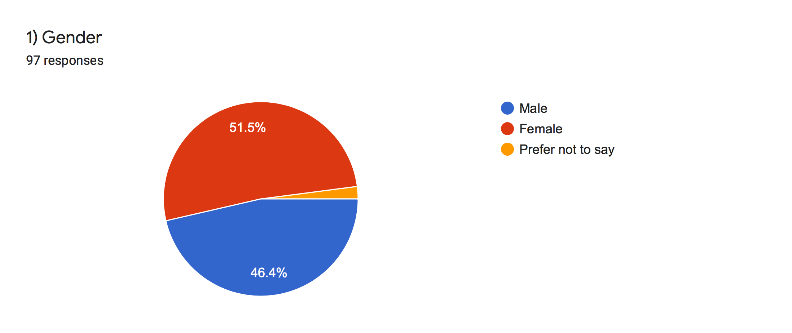

Figure 5. Gender

Demographics were posed to see if age, gender and employment status had an impact on motivation and satisfaction on volunteering for MUUK-Adventures. The first question (Q1) found that 51.5 % of those completing the questionnaire identified themselves as females and 46.4% identified themselves as male. As discussed in Chapter 2, NVCO (2020) support the findings that more females are volunteering over men since date from 2007. The gap between the difference in genders is closing and with the trend of data, by 2025 there will be equal numbers for both male and female volunteers. With the close percentage of gender participation in this survey, the data set by NVCO (2020) is supported.

4.3.2 Age

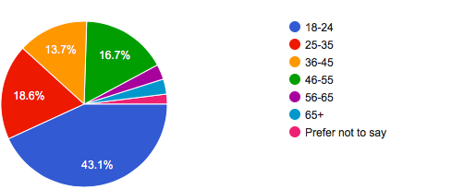

Figure 6. Age

The biggest age category that responded to the questionnaire was the 18-24 category of 43.1% shown in figure 6. The lowest age category was both 56-65 and 65+ with just three responses. Sport England statistics gave evidence that younger people are most likely to volunteer (Nichols et al., 2016) due to altruism motivation. This is evident from the online questionnaire and the below crosstabulation that young people do think it is important to volunteer for skills to enhance career prospects. The questionnaire also shows that young people think socialising and interacting with others is very important. This is extremely important for future generations and local communities to engage involvement for getting young people to volunteer. According to Case (2011), young people have more free time and are not limited to family commitments.
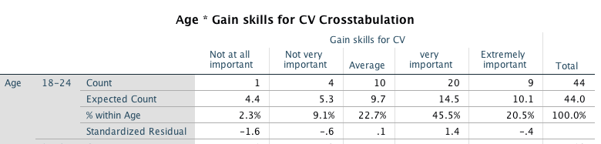

Figure 7. Cross tab between age and skill for CV.
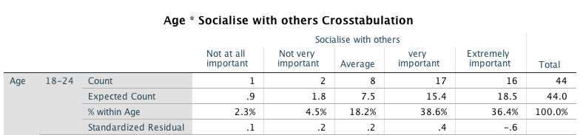

Figure 8. Crosstabulation between age and social interaction

4.3.3 Working status

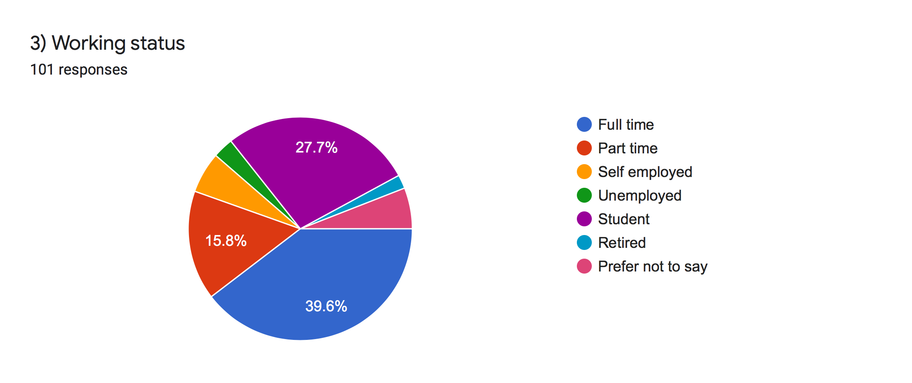

Figure 9. Working status

Employment status can be considered an important determinant of volunteering due to hours spent at work. Question three asked for an indication of current working status to allow an understanding of which groups are more likely to volunteer. QA3 found that 39.6% of people working full time have volunteered for MUUK-Adventures and 15.8% of part time people have volunteered. Secondly, 27.7% of students have volunteered. Overall, 89% of people who are in employment have volunteered.

Employees average full time work hours per week is 45 which leaves minimal time for volunteering activities (Gov,2020) rather than time at leisure. According to Taniguchi (2006), full and part time workers are likely to volunteer for the chance to socialise and be part of the community (Bang and Ross,2009). NCVO (2020) statistics show that people in employment are more likely than people who are unemployed to volunteer on a regular basis. This is significant for community events as it shows people in employment are willing to volunteer despite lack of time. Students are more likely to volunteer due to having more free time according the Guardian (2016). It can also be the second highest because of the presence of students being on the researcher’s social media.

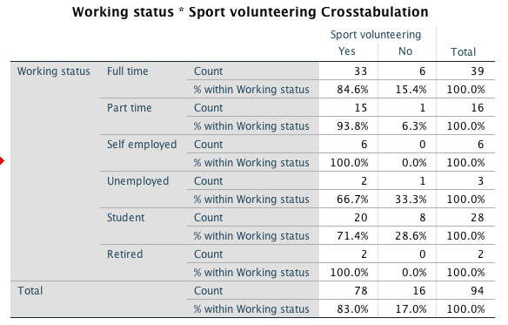

Figure 10. Crosstabulation of working status and sport volunteers

4.4. Motivation

Questions 6,7,8 and 9 from the questionnaire asked the respondents to indicate the importance of each of the five factors through a Likert scale developed using Farrell et al (1998). Number 1 of the Likert scale being Not at all important and 5 being extremely important. The factors; Purposive, solidary, external and commitments.

Purposive
Solidary
Commitments
External

Figure 11. Averaging mean from Likert scales

From analysing the Likert scales and adding all factors together. Figure 11 identifies the highest reason to volunteer to the lowest reason from left to right. The highest important influence on volunteering, with a mean of 4.2 on a five-point Likert scale was ‘’To be part of the community’’. The least important with a mean of 2.5, was ‘’Having nothing else to do’’. The highest scored factors were a combination of purposive and solidary.

When respondents were asked which event, they have volunteered at (question 12) the top two responses were Ras Dewi Sant at 58.2% which is an endurance marathon event and 50.6% responded to Mud Runs. Both events involve many volunteers throughout and is very popular with the community and charity events. This can impact motivation factors due to the type of event being more social with more volunteers and spectators. We can compare this data with the special event elite competition from 1996 with a significant 900 event volunteers (Farrell et al., 1998). The findings from their research show the most important volunteer factor was ‘’Making the event a success’’ with a mean of 4.0 and the least important factor with 1.16 was the same finding as this data with ‘Having nothing else to do’’. Farrell et al (1998) states ‘Motivation for special event volunteers is different from that for other volunteers (Giannoulakis 2007, P.g.194)’. The differences from the community volunteers compared to the major event shows that social incentives and being part of the community is more important to volunteer rather than for the event itself. Comparing the MUUK-Adventure volunteers with other type of events shows that volunteers experience different volunteering motivations which supports Cuskelly et al. (2006).

4.4.1. Difference between genders for purposive motivation.

Hypothesis
H_{o}⁻ - There is no difference in between genders who want to volunteer to be part of the community

H_{oa}⁻ - There is a difference in between genders who want to volunteer to be part of the community
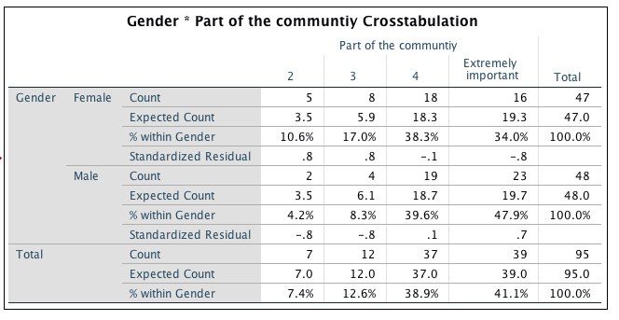

Figure 12. Crosstabulation of gender and being part of a community

Figure 12 shows 35% females think that volunteering to be part of the community is an extremely important factor to volunteer whereas 47.9% of males have stated this.

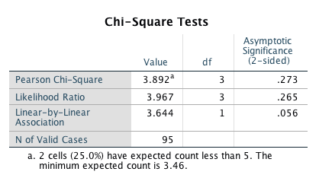

Figure 13. Chi- square test

As the cells have an expected count of less than 5 the chi- square test is not valid. With the sig (2-sided) being .273 which is greater than 0.05 the original hypothesis lies and there is no significant difference. A fisher’s Exact test was performed as the Chi- square test did not work and to do this the data in SPSS was collapsed to find the P value of 0.943. With the value of P being more than 0.05 there is no significant difference between genders volunteering to be part of the community.

Figure 14. Purposive motivations

Figure 15. Solidary motivations

From averaging the Mean, Median and Mode of each of the purposive, solidary, external tradition’s and commitments. The data shows the most important motivation factor for people to volunteer is solidary motivations shown if figure 15. This was supported during the interview of participant 4 who stated: ‘Well for me it is the social side to it, meeting people and the people do the events are all really nice and they appreciate what we do, and you make friends’. It is apparent that the theme emerging from the interviews is the social factors which have been identified as solidary motivations by Kim (2010). Therefore, combining the questionnaire and interviews supports the main motivation identified.

The two highest factors of reasons to volunteer are purposive and solidary motivations. The interview with participant 3 supported purposive motivations by mentioning; ‘it felt like you were taking part in something by being part of the community’. With episodic volunteering, as discussed in chapter 2 by Fairley et al. (2014), this has showed the relationship and loyalty between the volunteers and the organisation. With feeling appreciated and being part of the community events is a theme from the motivating factors. The findings have shown that by helping others and being part of a successful event demonstrates altruism as a key factor over egoistic motivations as defined by Monga (2006). Social aspects gained through volunteering links satisfaction of volunteering through to key motives to volunteer.

The results of solidary being the main motivation differ from the findings from the elite curling event in 1998. The highest grouped category for the curling event was purposive motivations. This shows that there is a difference with the most important motivation to volunteer between special events and community events.

Figure 16. External motivations

Figure 17. Commitment motivations

Two other factors by Caldwell and Andereck (1994) to consider, were external and commitment factors, which scored the lowest by the MUUK-Adventure volunteers. The evidence here shows that external motivation is a motivating factor to get family members involved in volunteering. This is apparent both from a mean of 3.1 relating to my friends and family who were volunteering and through participant 4 who stated; ‘I was volunteering then my son was and then his friends was as well. It was an opportunity to volunteer but also to encourage young people to volunteer as well’.

4.4.2. Challenges faced volunteering

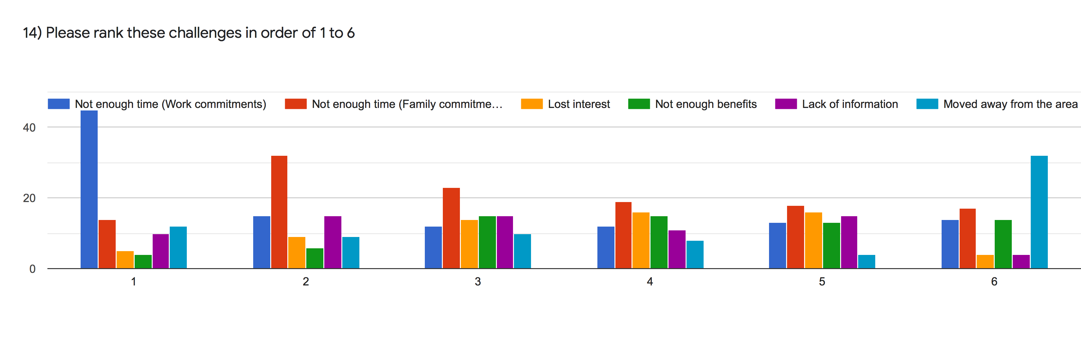

Figure 18. Challenges faced by volunteers

A reoccurring theme for people not volunteering at events was not having enough time due to work or family commitments. According to Dunn (2016), increased pressures on individuals and increased time constraint have changed individual’s participation in volunteering. This mirrors the results from question 13 and 14 indicating that the top two challenges were related to not having enough time. Lost interest and not enough benefits were a case for challenge faced by volunteers. The interviews support the questionnaire findings. The theme emerging from the interviews is work commitments. The volunteers have other commitments that the prioritise over volunteering. Time is an important factor for many people for choosing whether to volunteer or not and participant 4 gives evidence for this stating ‘time for me is a critical thing because I have quite a busy job during the days’.

To gain an understanding of what benefits would encourage volunteers to engage, question 15 used an open-ended question to find out. The main theme identified ‘recognition’ as being an extra benefit for encouragement. Examples of recognition from the open-ended question is through a social event. Moving away from the area which can mean travel restrictions and not being close enough to the event. MUUK-Adventures will need to identify the reasons why people are not volunteering and can help work out a strategy with key stakeholders to overcome issues faced by volunteers.

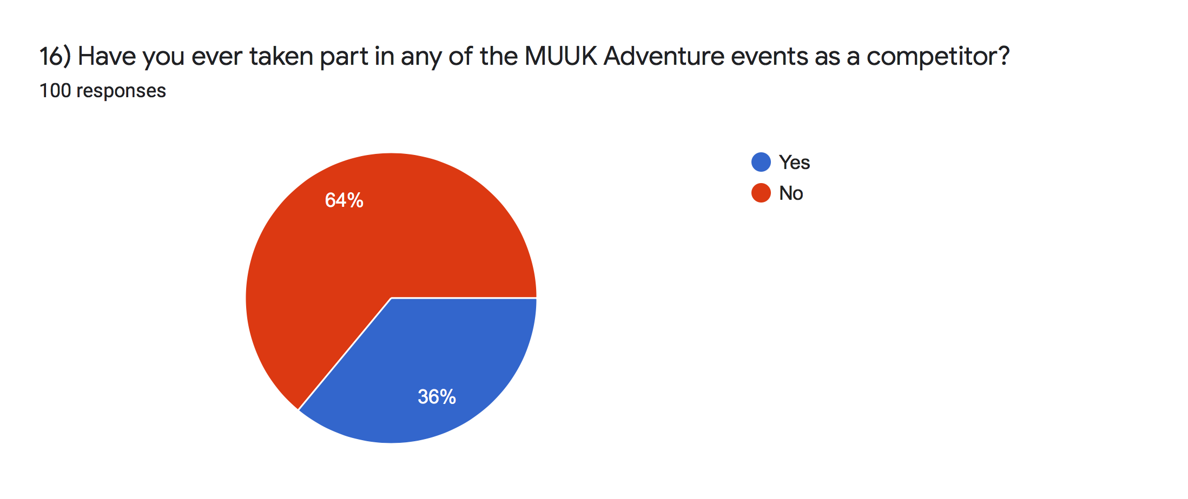

Figure 19. Taken part as a competitor

Question 16 asked MUUK-Adventures if they have taken part in one of the events as a competitor. From the responses, 36% ticked yes. This demonstrates that a percentage of the volunteer’s volunteer as a direct result of their experience at an event and for their passion for endurance events. McCellend (1973) categorised motivation into experiences over time rather than traits, with a small percentage taking part as a competitor shows that this can be a reason to volunteer. A study conducted by Coyne and Coyne (2009) of volunteers from a golf tournament found that the volunteers were likely to volunteer for ‘’Love of the game’’ and because they felt it was doing something for the sport (Bang, 2009). This can have implications on the recruitment strategies by managers recruiting ex participants. An open-ended question from question 16 asked the volunteers why they took part. The responses resulted in comments such as ‘It’s a great local company and I’ve competed at some of their events’. This is encouraging for MUUK-Adventures as it shows the participants have experienced satisfaction from the event and in turn have encouraged them to volunteer to support the organisation and the community.

4.4. Satisfaction

Figure 20. Satisfaction

To find out MUUK-Adventures volunteers’ level of satisfaction, question ten asked respondents to choose their level of satisfaction experienced from volunteering. A Likert scale was conducted with six items identified for satisfaction levels. The satisfaction was quite high throughout with the whole volunteer experience. The results indicate that the lowest satisfaction came from two areas one was through the information received with a mean of 3.869 and the second was due to a dissatisfaction with the access of facilities which showed a mean of 3.867.

To fulfil volunteer motivations, satisfaction through positive experience need to be attained. The volunteers for MUUK-Adventures were highly satisfied with their overall experience from findings from Q10. Through receiving a positive experience question ten asked the respondents would they volunteer for MUUK-Adventures again. An impressive 92% responded saying yes which indicates the management of MUUK have provided a positive experience for the volunteers and have been able to retain them. MUUK- Adventures (2020) state that the organisation works closely and develops relationships with those who are part of the community. MUUK Adventures links with the community and episodic nature of the volunteering opportunities available to individuals allow flexibility for volunteers to give their time and commitment to MUUK Adventures events as they are short term (Fairley et al., 2014). This shows with respondents are likely to volunteer again, demonstrating their commitment and dedication.
Using an open-ended question with a Likert scale showed that the volunteers were satisfied by using words ‘good experience’ and ‘enjoyed supporting the local community’. The themes that are apparent to satisfaction in the interview is being able socialise and meet new people. Participant 3 supports this by stating; ‘you do get satisfaction with people being happy and they are on a high that they have finished the events that’s a good side to’. It is evident that positive experiences and the emotional achievement from volunteering can contribute to physiological needs such as social enjoyment through research by Ramili (2014). This is represented in question ten in the way the volunteers are indicating they are satisfied and therefore wanting to volunteer again. By being satisfied volunteers will be motivated and will volunteer for future events if they have experienced their physiological needs within the event (Bang and Ross, 2009). Therefore, as the motivational needs are satisfied, the volunteers will continue giving their time in helping at community events (Bang and Ross 2009).
The theme of well- being through volunteering has shown that the events by MUUK-Adventures can contribute to a volunteer’s well-being through building confidence. Participant 1 mentions that ‘It builds your confidence meeting people and socialising, so it gives you a boost, so it thinks it improves well-being’. Previous research has shown evidence through Kwok et al. (2014) study on volunteers discussed in chapter two. The study reported an increase in sense of life satisfaction and improved quality has been identified after volunteering. The word cloud below identifies the key words used by the node from NVivo satisfaction. The words support that the events increase well-being by the words ‘boost, confidence, people, socialising’. These words contribute to show that the volunteers are satisfied.

Figure 21. Word cloud: Satisfaction

4.5. Best practice management

In addition to satisfaction and motivation of volunteers the qualitative data also revealed how the organiser recruited and provided recognition to the volunteers which can impact motivation and satisfaction.

Figure 22. Word cloud: Recruitment

The word cloud identifies key words from the interview on recruitment and recognition. The top words used ‘people’ and ‘events’ show that the volunteers are important to the organisation, although other words that are identified as being used frequently are ‘difficult’ and ‘expect’ which indicates the difficulty perceived and may provide insight into difficulties recruiting volunteers. One theme that emerged regarding the difficulty recruiting numbers is touched on by participant four who mentions that ‘it’s hard to get people to commit and it gets busier more people on the events it means more work and there’s more people. As well so more companies running events and they are all looking for volunteers. Therefore, it is important for the organiser to identify key motivating factors and how to keep the volunteers enthused in order to combat issues relating why volunteers face challenges.

The event manager (participant two) has identified what makes a good volunteer and is shown to be a key factor in identifying motivation factors which is key for recruitment. By identifying key skills of communication, initiative and reliability discussed in the interview. These factors identified can create an overall positive atmosphere amongst participants and volunteers which influence the volunteer’s decision to volunteer (Cuskelly et al., 2006).

It is apparent through the findings from the interview that MUUK-Adventures need to do a bit more to retain their volunteers. It is understood that MUUK Adventures currently use word of mouth and social media to recruit their volunteers. Participant two states that ‘its though people you know and people who offer their services’. A way to retain volunteers is through a social event as suggested by participant one; ‘if there is an event on after like a social event after the event t just to make them feel part of it’. It can also be seen that by giving young volunteers rewards like a t-shirt or contribution to a donation to their club can be helpful. Participant four discusses to get young people involved then there needs to be some sort of incentives. Although incentives are not important to people and as Monga (2006) argues that altruism rewards are enough for some people. Participant one from the interview supports Monga (2006) by stating that incentives are not important to them.

Chapter five will conclude on these findings and will discuss the implications that the findings can have on volunteering at community events. Recommendations will be made from the findings and from what the volunteers have suggested.

Chapter 5: Conclusion and recommendations

5.1. Introduction

This chapter will discuss the aims and objectives that have been achieved and conclude the findings of chapter 4, and in addition will provide strategic recommendations. This chapter will resolve the third objective of this study:
• To provide MUUK Adventures with recommendations with best practise volunteer management through the use of feedback from theory and primary research.
Further recommendations for future areas of analysis will be conducted into this field and lastly the chapter will discuss the limitations of this dissertation.

5.2. Summary of findings

The first objective set in chapter one was to investigate the main motivations for why individuals volunteer at MUUK-Adventures. The aim was met though conducting primary research that surrounds the motivation models used by previous researchers. It can be concluded from the interview and questionnaire conducted that the main motivation to volunteer at MUUK-Adventure events is solidary motivations. Farrell et al. (1998) recognised that social interaction is one of the most important motivational factors for event volunteers. Asserted by Kodama et al. (2013), event managers need to recognise solidary motivations when managing volunteers as it affects volunteers’ decisions for future events (Lee et al., 2016). Purposive motivations followed solidary by a minimal margin and MUUK-Adventure volunteers enjoy being part of a community. This differs to the curling event in 1996 as study conducted by Farrell et al. (1998) as purposive factors were the main reasons individuals to volunteer at a major event. This shows that volunteers’ main motivation to volunteer differs by the type of event. By conducting a chi- square test, there was no difference between male and females in being part of a community. With a positive experience of feeling part of a community, evidence by Costa et al. (2006) that positive community experience will determine levels of satisfaction (Lee et al., 2016).

The findings from chapter four uncovered that one of the barriers to volunteering faced by volunteers is work commitments. Comparing the findings with the literature review, Dunn (2016) outlines that time constraint is a pressure faced by volunteers. The literature review supports that it is important for event managers to carefully select the timing of the event to ensure right suitability (Cuskelly et al., 2006).

The second objective focused on satisfaction levels of volunteering. As stated in the literature review if the motivational factors are met this will increase satisfaction levels (Bang and Ross, 2009). Arguably, Lee et al. (2016) suggests that satisfaction is from the overall experience and from volunteering in past events. The results from chapter four show that the volunteers had a positive experience and were highly satisfied with their volunteering experience. With the majority stating they would volunteer again; this supports Lee et al. (2016) by having a positive experience will provide high satisfaction amongst the volunteers. The volunteers were able to socialise and interact with their friends and their motivation factor was met. The issue identified was that there needs to be more communication prior to the events. This has implications for MUUK as the volunteers will volunteer again if their needs are satisfied (Bang and Ross,2009).

Individuals who have volunteered for MUUK-Adventures have reported that they experienced an increase in their well-being. By fulfilling their solidary motivation, meeting new people has resulted in increased confidence. This supports Binder (2015) as he recommended that volunteering can positively benefit life satisfaction and well-being of individuals. Therefore, it is evident that volunteering supports individual’s well-being.

5.3. Recommendations to MUUK-Adventures

The last objective of this study is to provide MUUK-Adventures with feedback. Based off the literature review and data analysis it is apparent that the themes that have emerged from the respondents is to:

- To help manage the volunteers more effectively, it is recommended that more information is needed prior to events. This will give awareness to the volunteers of an expectation of the day and where they will be located. This in turn will organise the volunteers more efficiently and provide a positive atmosphere.
- To disperse volunteers more effectively in designated areas as volunteers felt there was a shortage of marshals in at certain sites. As solidary was the main motivation to volunteer it can be promoted that the volunteers will be placed amongst different people or their friends to allow them to socialise.
- To satisfy solidary motivations, through advertising a social event post event will attract volunteers. This allows volunteers to socialise with other volunteers and provides recognition from the organisation to thank their volunteers.
- To advertise merchandise such as uniform with branding from MUUK-Adventures to help recruit volunteers. This will help volunteers feel part of the community and can be a way of motivating them to feel appreciated and part of the organisation.
- Promotion techniques such as a discounted entry fee for MUUK-Adventure events. This needs to be more advertised to recruit more people
- To provide training to improve skills and information so that volunteers can answer competitors queries.

The third objective of this study has been met by providing strategic recommendations to the management of MUUK-adventures.

5.4. Limitations

Despite the research fulfilling the aims of objectives set out for this dissertation, limitations were still present. The sample size was relatively low due to the events being small which meant lower numbers of event volunteers. A total of 102 volunteers responded to the online survey which satisfied the intended target. Due to time limitation, the participation from the interview and questionnaire were done in a way of convenience. By limiting the scale, it restricted the amount of the volunteers that were able to be approached for the interviews. With the sample size, the online questionnaire could only be accessible online through the organisations Facebook page and the researchers.

5.5. Recommendations for future studies

With using a small sample size from small scale events. If a replication of this study was conducted, an added case study of a major event could be used as a comparison. This would allow more insight into the different motivational experience at different type of events. By comparing different sporting events with a greater sample, the reliability and validity of the data collected will be ensured. This would give the researcher a better understanding of the research topic and additional contribution to the findings.

With the results showing that the main type of people volunteering was in active employment, it would useful to add questions to investigate if MUUK-Adventures provide social capital through helping volunteers to networking. This could provide insight as to whether networking is a reason why full-time workers volunteer. In addition, to investigate if either employed or unemployed feel socially excluded by the events. This will give more in-depth reasoning and will provide the researcher with reasons why different demographics are most likely to give up their time at community events.
The researcher could add a question to discover if volunteers would choose other events like festivals, corporate and charity events over sport events. This can give an element of what other type of events people would choose over the option of volunteering at a sporting event. This insight would help event managers identify what people’s preference is to what events they like to volunteer at and what they can do differently.

5.6. Conclusion

Given the research, it can be concluded that the main motivations for why people chose to volunteer at MUUK-Adventures community events is through solidary motivations. The volunteers experience high levels of satisfaction through their motivation factors being fulfilled. This study has provided the management of MUUK-Adventures a more of an understanding of their volunteer’s motivation factors and their satisfaction of events and will be useful for future events to help manage and retain their volunteers.

6. Bibliography

Bang, H. and Ross, S.D. (2009) ‘Volunteer motivation and satisfaction’. Journal of venue and Event Management, 1(1), pp.61-77.

BBC Sport., (2020) Get Inspired: How to get into volunteering. [online]. Available at: https://www.bbc.co.uk/sport/get-inspired/28427094
Binder,M. (2015) ‘Volunteering and life satisfaction: a closer look at the hypothesis that volunteering more strongly benefits the unhappy’, Applied Economics Letters, 22:11, 874-885
Bowdin, G., Allen,j., O’toole, W., Harris,R and Mcdonell,I. (2011) Events management. (3rd ed). Oxford: Elsevier Butterworth-Heinemann.

Bladen, C., Kennell,J., Abson,E. and Wilde,N. (2012) Events management: An introduction. Oxon: routledge Ltd.
Bryman, A. (2016). Social research methods. (4th ed). Oxford University Press. P3
Bryman, A. & Bell, E. (2007) Business Research Methods (2nd ed). Oxford: Oxford University Press.
Bussell, H., & Forbes, D., (2001). ‘Understanding the volunteer market: The what, where, who and why of volunteering’. International Journal of Nonprofit and Voluntary Sector Marketing. 7 (3). pp.244-257.
BVEP., (2015) Value of events industry rises 8 percent to £42.3 billion [online]. Available at: https://www.businessvisitsandeventspartnership.com/news/bvep-press-releases/393-value-of-events-industry-rises-8-per-cent-to-42-3-billion (Accessed: 19.5.2020).
Caldwell, L.L and Andereck, K.L. (1994) ‘Motives for initiating and continuing membership in a recreation- related voluntary association’, Leisure studies, 16, pg. 33-44
Cary, E-G and Snyder, M., (1999) ‘The motivations to volunteer: theoretical and practical considerations’, Current directions in psychological science, 8 (5): 156-159.
Collis, J and Hussey, R. (2009). Business research methods. (3rd ed). New York: Palgrave Macmillan.
Cravens, J. (2006). ‘Involving international online volunteers: Factors for success, organisational benefits, and new views of community’. The International Journal of Volunteer Administration. 24 (1). pp, 15-23.
Cuskelly, G., Hoye, R., and Auld C-J. (2006) ‘working with volunteers in sport’: Theory and practice, London: Routledge

Denscombe, M. (2014) Grounds rules for good research. Philadelphia: Oxford university press. Pg. 177

Doherty, A., (2009) The volunteer legacy of a major sport event. Journal of policy research in tourism, leisure and events, 1(3), pp.185-207.

Douglas, N., (2001). ‘Special interest tourism: context and cases’, Special interest tourism. Australia: Milton., p.g 67.
Dunn, J. Chambers, S.K. and Hyde, M.K., (2016). ‘Systematic review of motives for episodic volunteering’,VOLUNTAS: International Journal of Voluntary and Nonprofit Organizations, 27(1), pp.425-464.

Einolf, C. (2018). ‘Evidence-based volunteer management: a review of the literature’, Voluntary Sector Review, 9(2), pp.153-176.

Fairley, S. Green, B.C., O'Brien, D. and Chalip, L., (2014). ‘Pioneer volunteers: The role identity of continuous volunteers at sport events’, Journal of Sport & Tourism, 19(3-4), pp.233-255.
Farrell, J-M. Johnston, M-E and Twynam, G-D., (1998) ‘Volunteer motivation, satisfaction, and management at an elite sporting competition’. Journal of sport management, 12(4): 288-300
Future Generation Act., (2015). Well-Being of Future Generations (Wales) Act 2015 [online]. Available at: https://futuregenerations.wales/about-us/future-generations-act/ (Accessed: 22.5.2020).
Gaskin, K. (2003). A Choice Blend: What Volunteers Want from Organisation and Management. London: Institute for Volunteering Research.
Giannoulakis, C. Wang, C.H. and Gray, D. (2007) ‘Measuring volunteer motivation in mega-sporting events’, Event Management, 11(4), pp.191-200.

Getz, D., (2007). Event studies: Theory, research and policy for planned events (1st ed)., Amsterdam ; London: Elsevier Butterworth-Heinemann.
Gov (2020) ‘Gov’ [online]. Available at: www.gov.uk (Accessed: 13.4.2020)
Griffith, A., (2010). SPSS for Dummies. 2nd ed. Indianapolis : Wiley Publishing, Inc.
Han, K. (2007). Motivation and commitment of volunteers in a marathon running event. Florida state university libraries
Holmes, K. (2014). ‘It fitted in with our lifestyle’: an investigation into episodic volunteering in the tourism sector. Annals of Leisure Research, 17(4), pp.443-459.
Holmes, K., and Smith, K. (2012) Managing volunteers in tourism. Routledge. P.88

Jepson, A and Clarke, A., (2016) Managing and developing communities and festivals and events. London; Palgrave Macmillan
Johnson, J.E., Giannoulakis, C., Felver, N., Judge, L.W., David, P.A. and Scott, B.F. (2017). Motivation, satisfaction, and retention of sport management student volunteers.
Jones, I. (2014). Research methods for sport studies. Routledge
Kemp, S. (2002). ‘The Hidden workforce: Volunteers’ learning in the Olympics’, Journal of European Industrial Training. 26 (2/3/4). pp.109-116.
Kerwin, S. Warner, S., Walker, M. and Stevens, J., (2015) ‘Exploring sense of community among small-scale sport event volunteers’, European Sport Management Quarterly, 15(1), pp.77-92.

Kim, E. (2018) ‘A systematic review of motivation of sport event volunteers’, World Leisure Journal, 60(4), pp.306-329.

Kim, May & Zhang, James & Connaughton, Daniel. (2010). ‘Modification of the Volunteer Functions Inventory for application in youth sports’, Sport Management Review. 13. 25-38.
Kwok, Y.Y., Chui, W.H. and Wong, L.P. (2013) ‘Need satisfaction mechanism linking volunteer motivation and life satisfaction: A mediation study of volunteers subjective well-being’, Social indicators research, 114(3), pp.1315-1329.

Lee, C.K., Reisinger, Y., Kim, M.J. and Yoon, S.M. (2014) ‘The influence of volunteer motivation on satisfaction, attitudes, and support for a mega-event’, International Journal of Hospitality Management, 40, pp.37-48.

Lee, Y., Kim, M. and Koo, J. (2016). The impact of social interaction and team member exchange on sport event volunteer management. Sport Management Review, 19(5), pp.550-562.

Maslow, A (1954), motivation and Personality. London: Harper 28.

Maslow, A., Stephens, D., and Hell, G., (1998). Maslow on management. New York: Wiley
McClelland, D., (2009). Human motivation. Cambridge. Cambridge University Press. P1
Miller, K.D., Schleien, S.J., Brooke, P., Frisoli, A.M. and Brooks III, W.T. (2005) ‘Community for all: The therapeutic recreation practitioner's role in inclusive volunteering’, Therapeutic Recreation Journal, 39(1), p.18.

Misener, L. and Mason, D.S. (2006) ‘Creating community networks: Can sporting events offer meaningful sources of social capital?’, Managing Leisure, 11(1), pp.39-56.

Monga, M. (2006) ‘Measuring motivation to volunteer for special events’, Event Management, 10(1), pp.47-61.

Mutawa, O. (2015). Impact of volunteer management practice on volunteer motivation and satisfaction to enhance volunteer retention (Doctoral dissertation, Brunel University London.).
MUUK-Adventures., (2020)., ‘MUUK-Adventures [online]. Available at: www.muuk-adventures.com (Accessed: 1, November, 2019).
Nichols, G., Knight, C., Mirfin-Boukouris, H., Uri, C., Hogg, E. and Storr, R. (2016). Motivations of sport volunteers in England: A review for Sport England.
NVCO (2020). Volunteering. Available: https://www.ncvo.org.uk/ncvo-volunteering. (Accessed: 30.1.2020).
O'Gorman, K.D. and MacIntosh, R. (2014) Research methods for business and management. (2nd ed) Goodfellow Publishers Limited.
Park run (2020) Volunteer awards and nominations [online]. Available at: www.parkrun.org (Accessed: 20.5.2020).

Pembrokeshire coast (2020) Volunteering [online]. Available at: www.pembrokeshirecoast.wales/getinvolved/volunteering/ (Accessed: 19.5.2020).

Pembrokeshire.gov (2018) Well-being plan for Pembrokeshire [online]. Available at: www.Pembrokeshire.go.uk (Accessed: 19.5.2020).

Ramli, N., Ghani, W.S.W.A., Bahry, N.S. and Rohaidah, A. (2014) ‘Evaluating volunteer motivation and satisfaction at special event’, Tourismos: An International Multidisciplinary Journal of Tourism.

Rochester, C., Paine, A.E., Howlett, S., Zimmeck, M. and Paine, A.E. (2016) Volunteering and Society in the 21st Century. Springer.

Saunders, M., Lewis, P. & Thornhill, A., (2016)., Research methods for business students 6th ed., Harlow: Pearson.

Saunders, M., Lewis, P. & Thornhill, A. (2009) Research methods for business students. 5th ed. Essex: Pearson Education

Saunders, M. Lewis, P, & Thornhill, A., (2007). Understanding Your Research. (4th ed), Research Methods of Business Students. Harlow: Person Education Limited.
Sheppard, E., (2016) What makes some people more likely to volunteer than others?. The Gaurdian [online]. Available at: https://www.theguardian.com/voluntary-sector-network/2016/jun/01/science-behind-volunteering-psychology (Accessed: 15.4.2020).

Sport England (2018) ‘Work force’ [online]. Available at: www.sportengland.org (Accessed: 13.4.2020).

Sport Wales (2020) Give to Gain [online]. Available at: www.sportwales.org.uk (Accessed: 20.5.2020).
Smith, K-A., Lockstone-Binney, L., Holmes, K and Baum, T. (2014) Event volunteering International perspectives on the event volunteering experience. Routledge.

Strigas, A., & Jackson, N., (2003) ‘Motivation volunteers to serve and succeed; design and results of a pilot study that explores demographics and motivational factors in sport volunteerism’ International sports journal, 7(1), 111-123.
Taniguchi, H., (2006)’ Men’s and Women’s volunteering: Gender differences in the effects of employment and family characteristics’ Nonprofit and voluntary sector quarterly 35(1) p.g. 83-101.

Tomazos, K. and Luke, S. (2015) ‘Mega-sports events volunteering: Journeys with a past, a present and a future’, VOLUNTAS: International Journal of Voluntary and Nonprofit Organizations, 26(4), pp.1337-1359.

Tum, J., and Norton ,P. (2006). Management of event operations. Routledge.

Veal, A.J. (2011) Research methods for leisure and tourism : a practical guide (4th ed)., Harlow: Financial Times Prentice Hall.
Vecina, M.L., Chacón, F., Sueiro, M. and Barrón, A. (2012) ‘Volunteer engagement: Does engagement predict the degree of satisfaction among new volunteers and the commitment of those who have been active longer?’, Applied Psychology, 61(1), pp.130-148.

Visit Pembrokeshire (2020) ‘Visit Pembrokeshire’ [online]. Available at: www.visitpembrokeshire.com (Accessed: 15.5.2020).
Warner, S., Newland, B.L. and Green, B.C. (2011) ‘More than motivation: Reconsidering volunteer management tools’. Journal of Sport Management, 25(5), pp.391-407.

WCVA (2019) ‘The Well-being of Future Generations Act’ [online]. Available at: https://wcva.cymru/influencing/legislation/the-wellbeing-of-future-generations-act/ (Accessed: 19. 5. 2020)
Wilson, J. (2012). Volunteerism research: A review essay. Nonprofit and Voluntary Sector Quarterly, 41(2), 176-212.
Xiao, M. (2017) ‘Motivation and satisfaction of marathon volunteers: How important is volunteers' level of running experience?’, Journal of Convention & Event Tourism, 18(1), pp.41–60.

7. Appendices

7.1 Appendix 1: Questionnaire questions

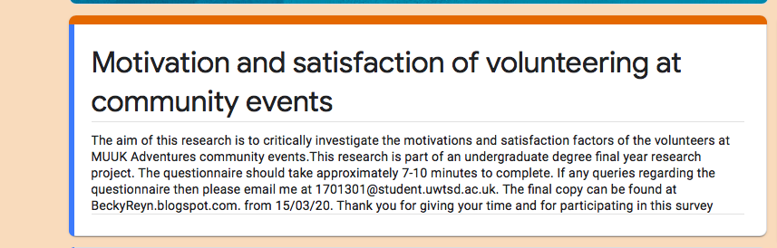
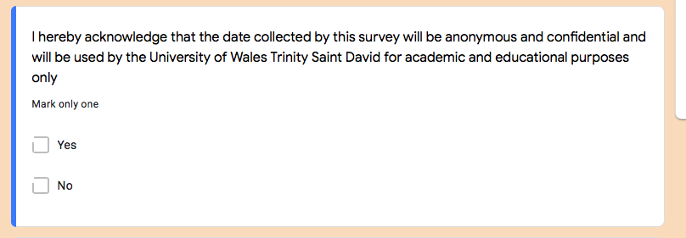



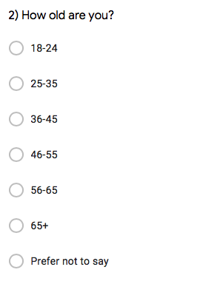




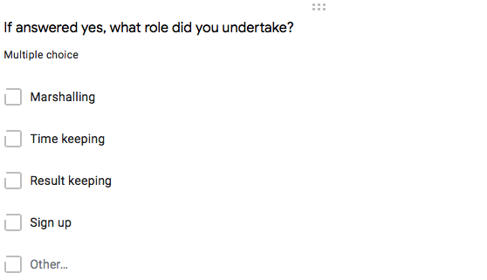
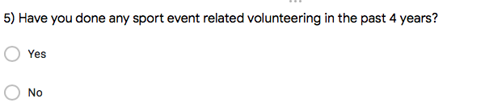
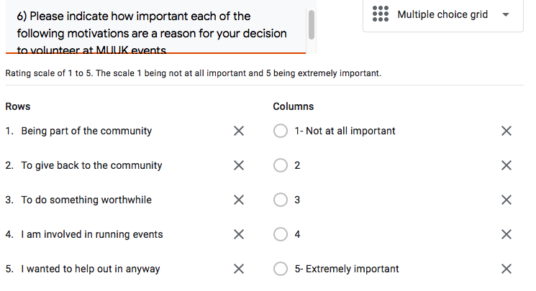
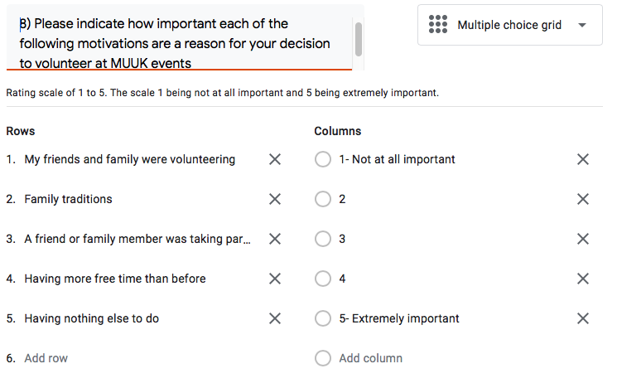
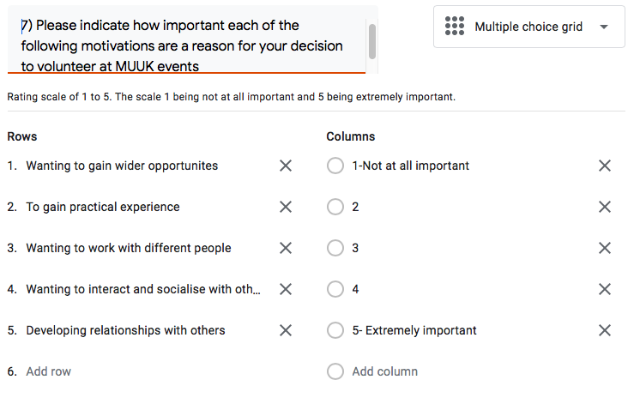
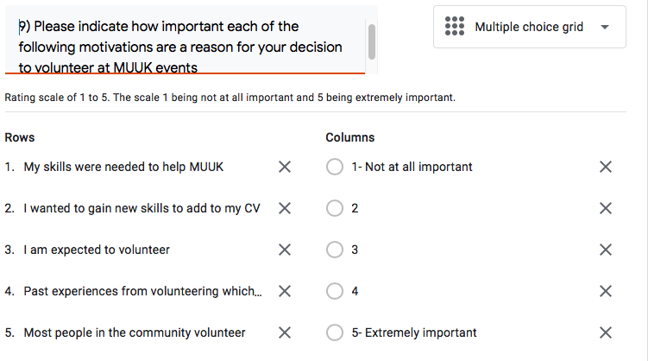

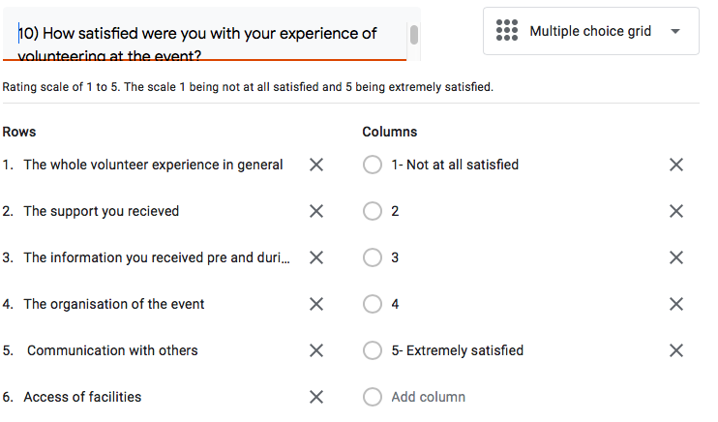


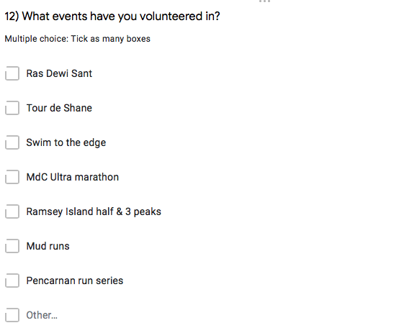
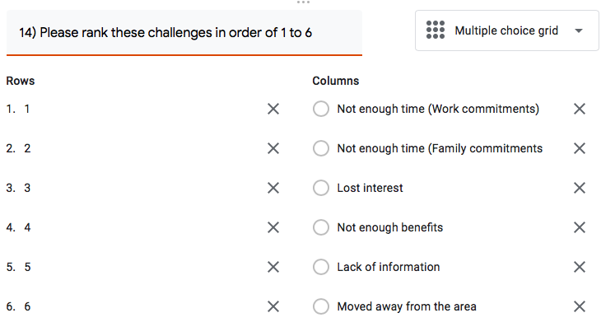
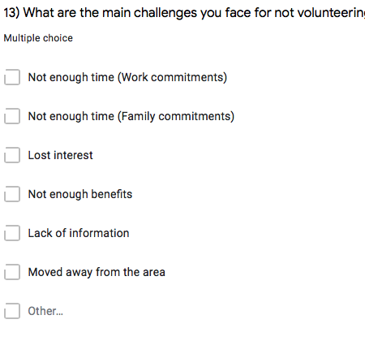
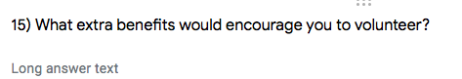

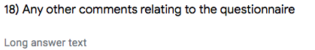

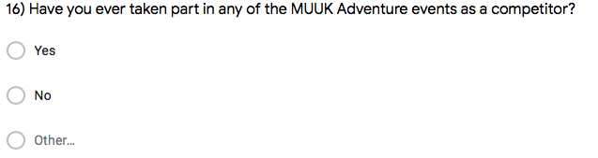

7.2 Appendix 2- Question responses

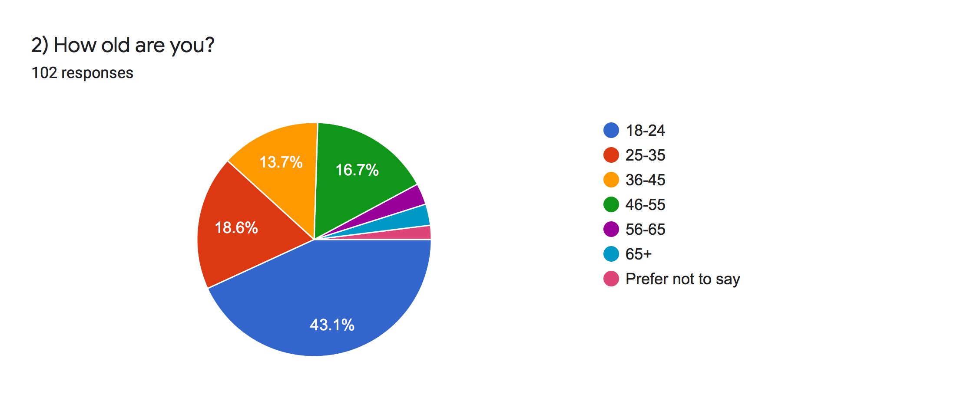

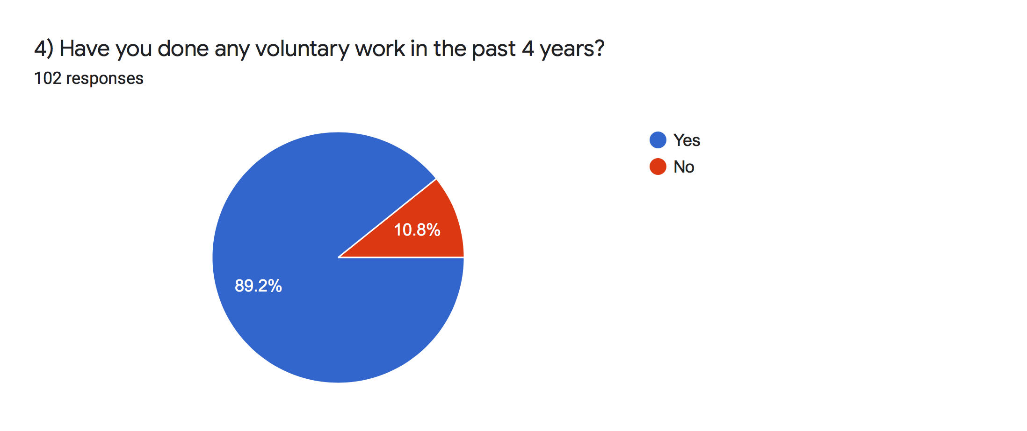

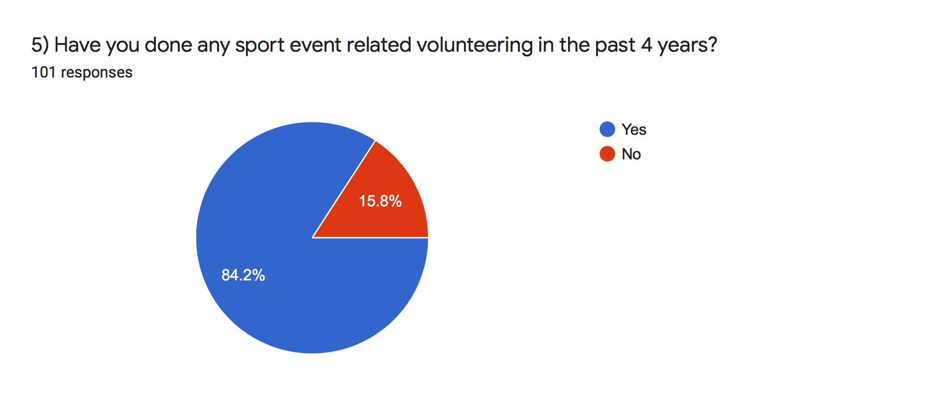
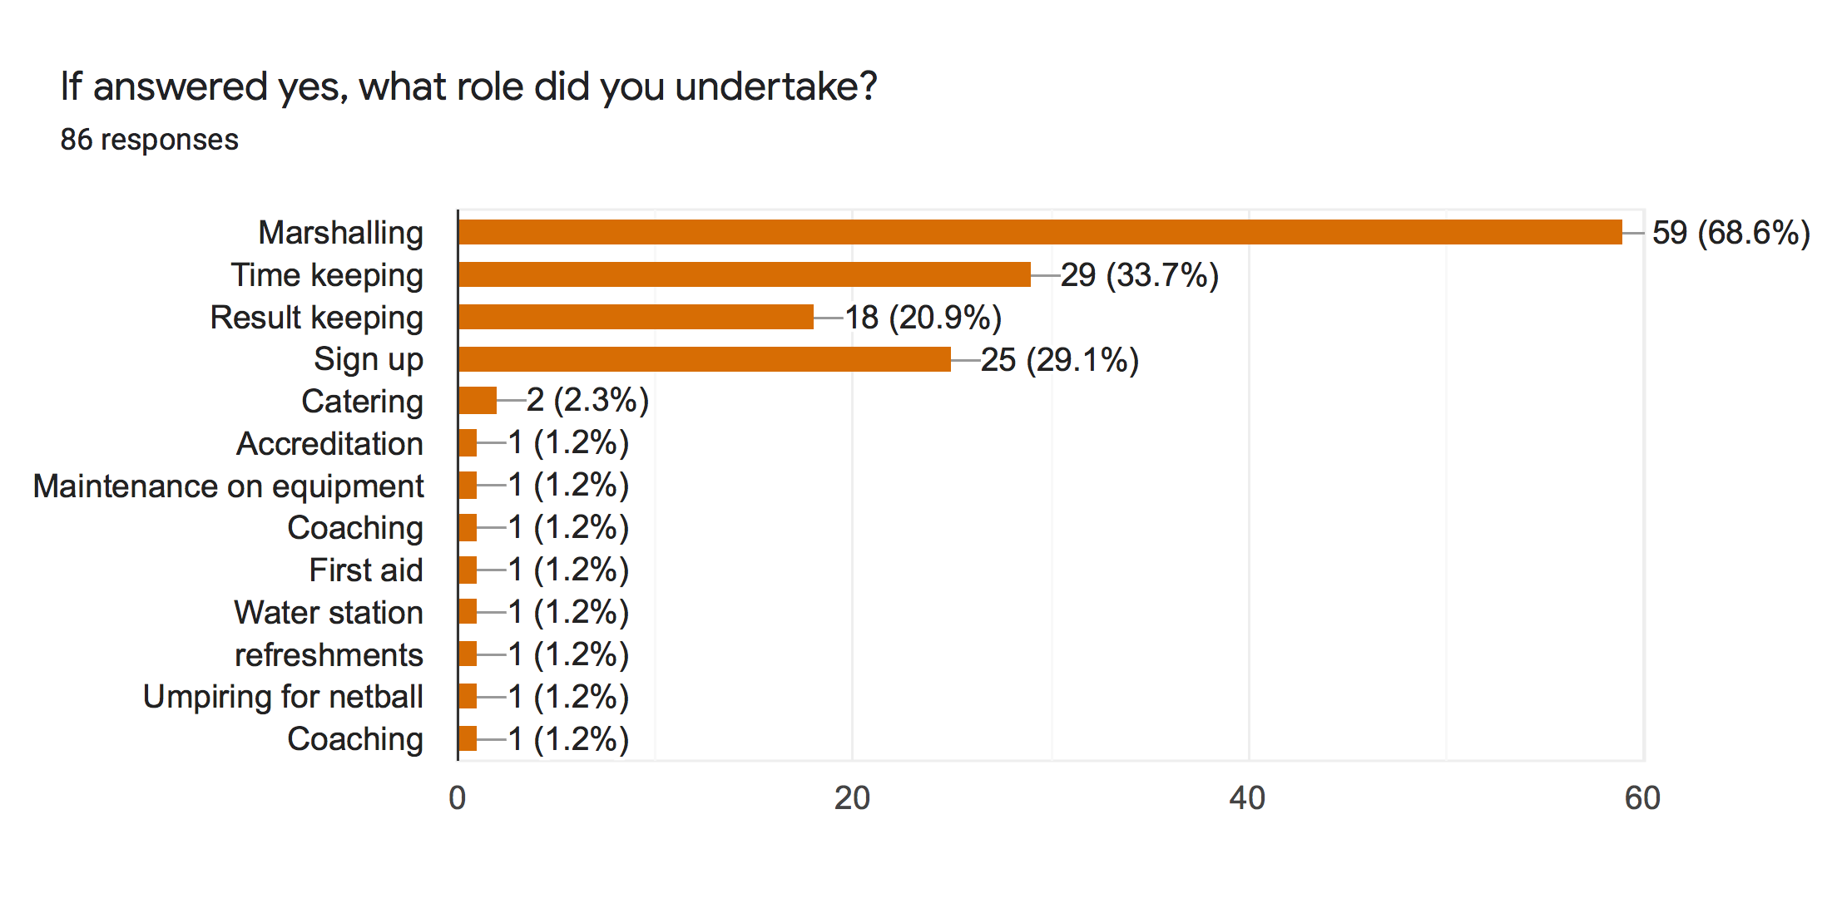

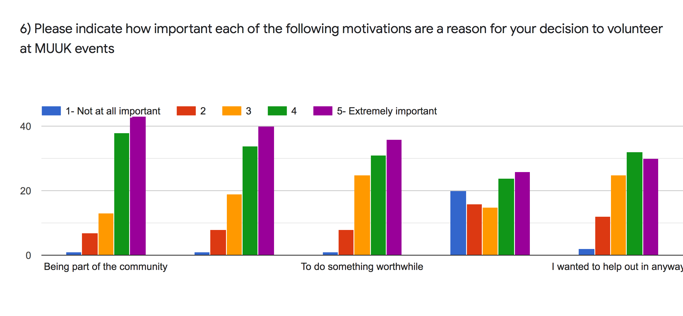

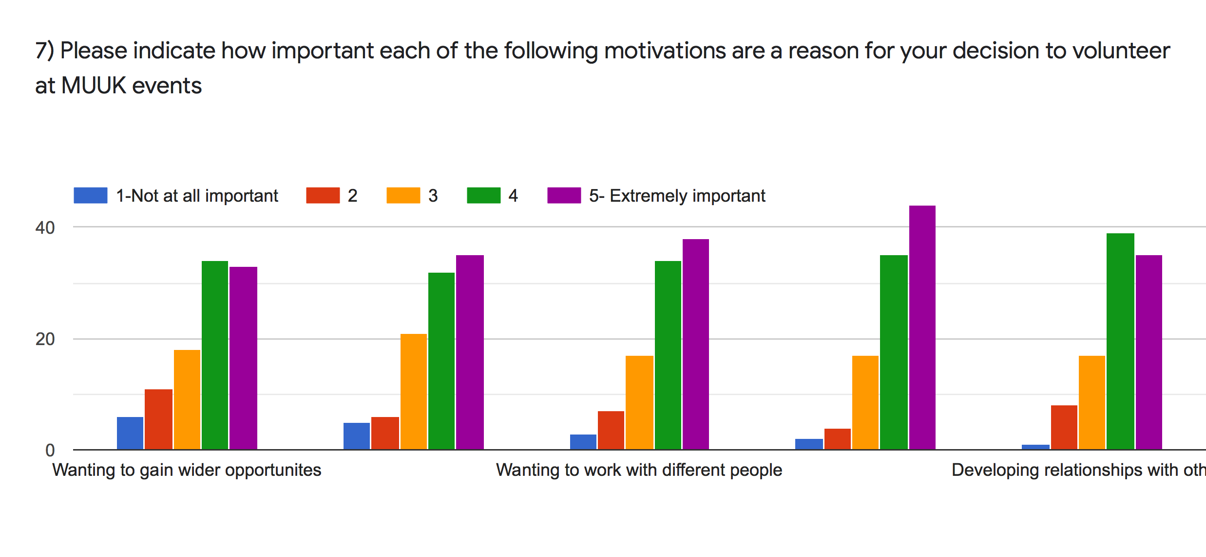

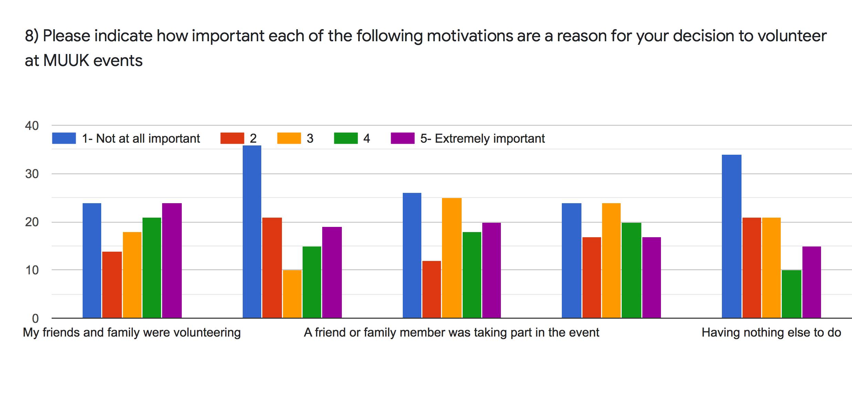

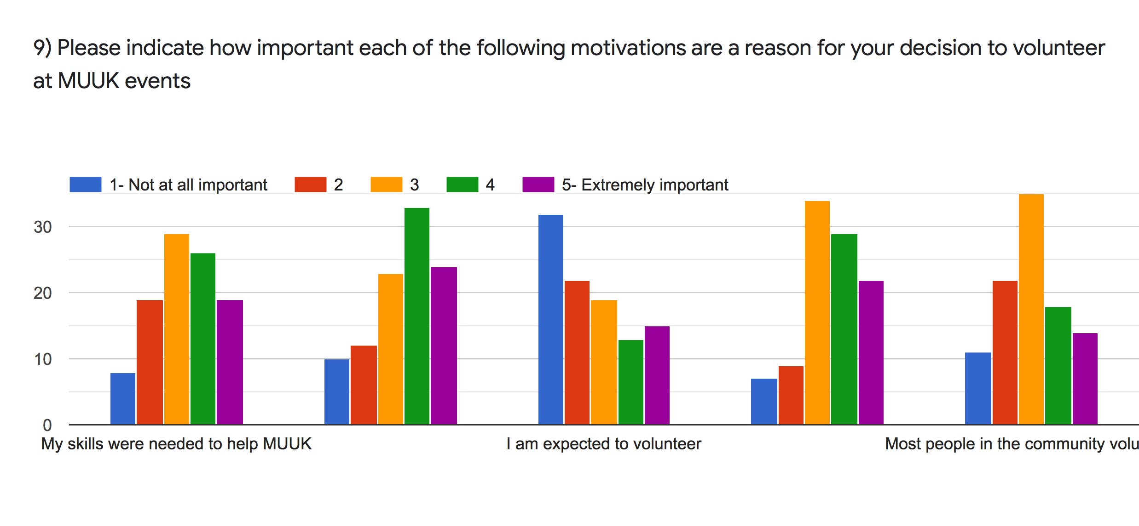

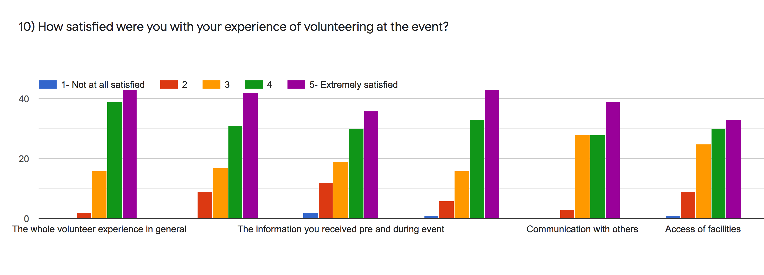

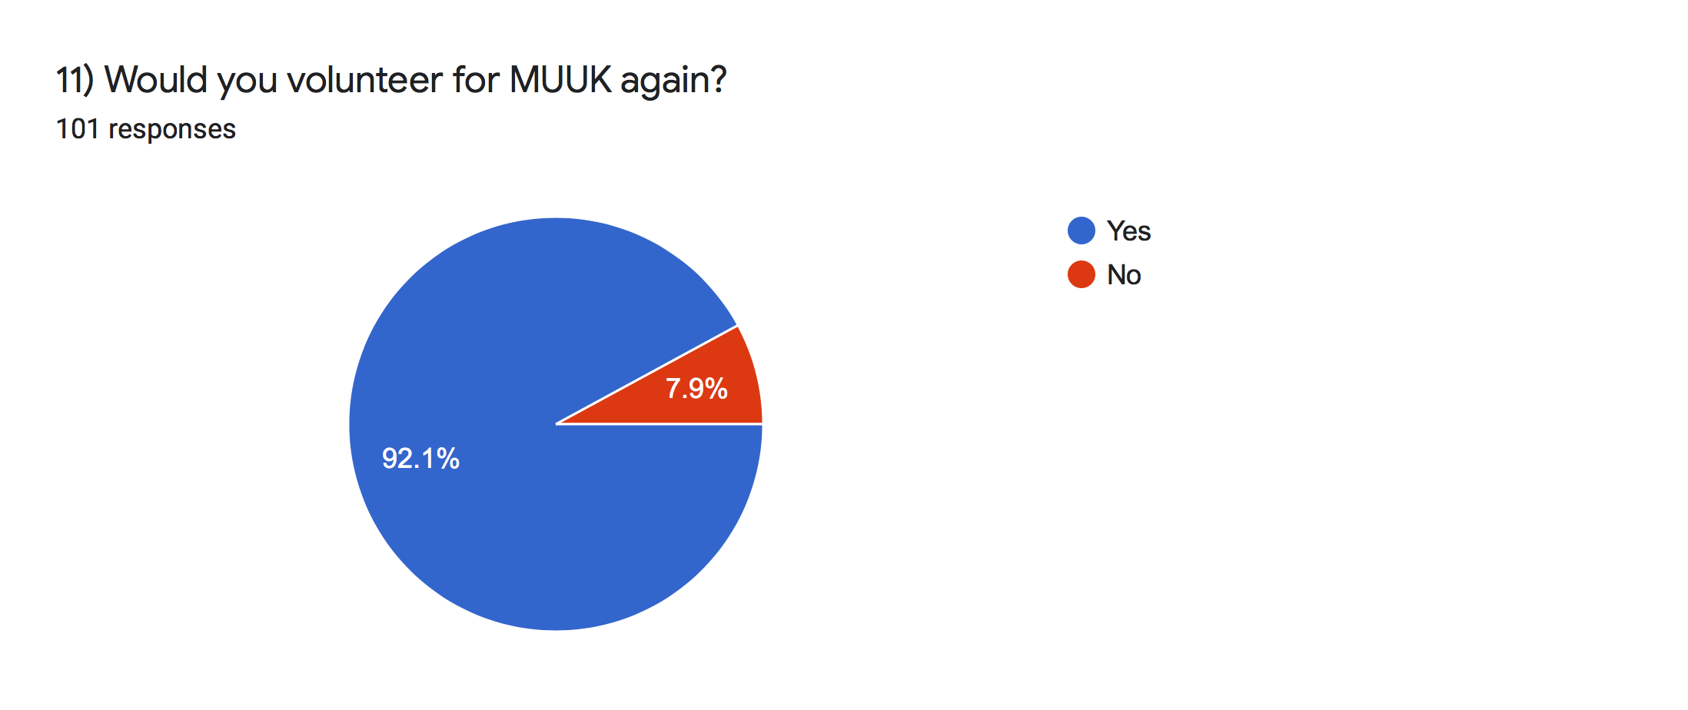

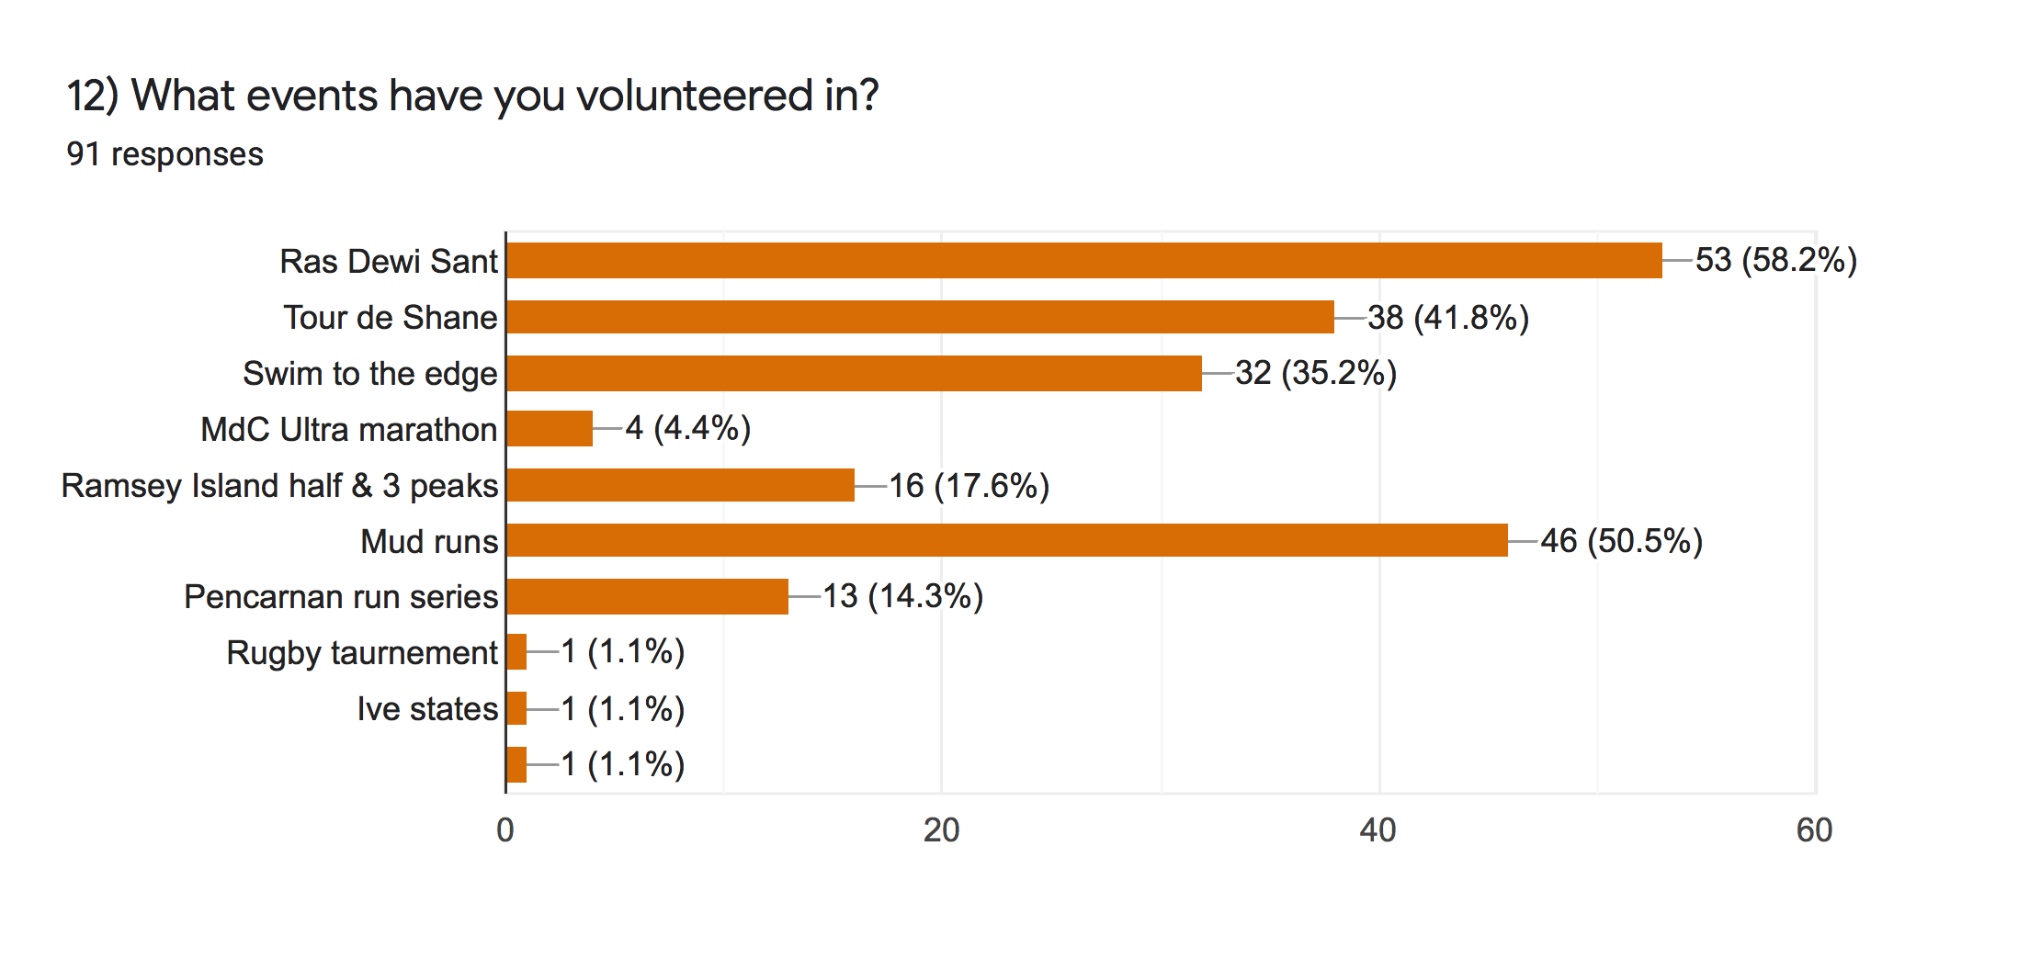

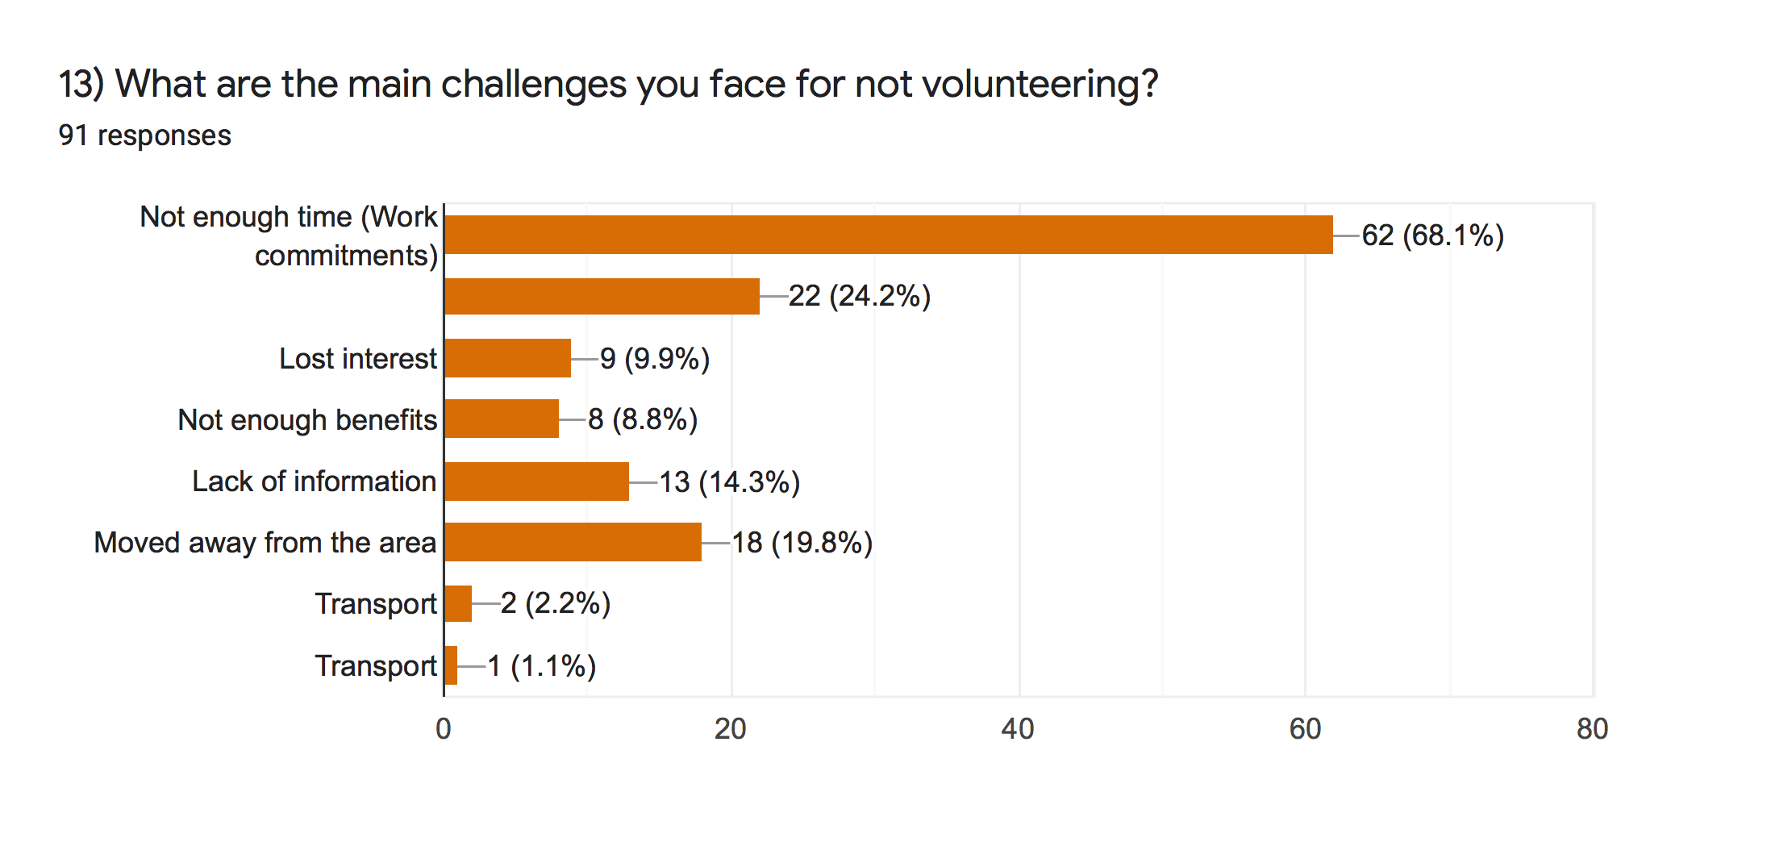

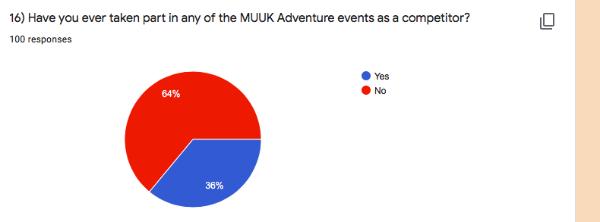

7.3 Appendix 3. Interviews questions

Motivations to volunteer
1) What was the main reason why you volunteered for MUUK Adventures?
2) What makes you continue to volunteer?
Prompt: Do you think that the others that volunteer are the reason or you want to continue for yourself?
3) What are the most important benefits you get from volunteering?
Prompt: The factors; Physiological needs, working conditions, feeling belonged to the community, improving self-esteem.
4)What are the biggest challenges faced when volunteering at events?
Experience
5) What roles have you undertaken through volunteering?
6) In your opinion, would you suggest that the type of the event is a factor of volunteering over the job role itself?
Prompt: the size and scale of the event, do you think that is a bigger influence over why you volunteer compared to the role you are given on the day?
7) Based on your experiences of volunteering at the events, would you consider volunteering again?
Satisfaction of volunteering
8) With the overall experience from volunteering, were you satisfied on your experience?
9) Do you think volunteering can improve personal well-being?
Prompt: Explain why you think volunteering can contribute to a person’s well-being? Self-esteem, confidence?
10) How important do you consider incentives are to volunteers?
Recommendations
11) Can you provide any recommendations for the management of MUUK Adventures on your overall experience and what can be done in the future?

7.3.1 Appendix 4- Manager interview questions
Motivations
1) What do you think motivates people to volunteer at MUUK Adventure events?
2) What do you think makes a good volunteer?
Prompt: Do you think commitment, being reliable is a useful factor?
Working with volunteers
3) How do you recruit volunteers at MUUK Adventures?
4) Do you provide any training for new and continuing volunteers?
5) Do you give feedback and recognition to volunteers after the event?
Promt: For example, explain how you would reward you volunteers?
6) Do you think it is harder to recruit volunteers in modern day society compared to the past? If so, why do you think this?
Communication and recognition
7) In what ways do you communicate with you volunteers?
Prompt: What methods would you use? Word of mouth, social media, through friends and family?
8) On the day of the event, how do you distribute the roles between your volunteers?
9) Do you think volunteers make a contribution to your work with MUUK Adventures?
Prompt: Why do you think this? Do you think they are key to making the events successful?
Recommendations
10) For future events, what have you learned to do differently from experience from other events?
Prompt: Different recruitment methods? The way in which information is communicated?
7.4 Appendix 5- Interview responses

7.4.1 Participant 1

Hi, thank you for coming to meet me to be interviewed.

Absolutely, no problem
Q1. What was the main reason why you volunteered for MUUK Adventures?

Well originally it was because we were fundraising for the mini rugby and when the first white sands challenge started. So we were all in it together at that point and so I just did it then at a one off event but after that event, the manager decided to set up the business and got into volunteering because of that really and the manager kept asking me after that so I just got into It that way
Q2. What makes you continue to volunteer?
Because Fintan asks me every time, but no actually I really enjoy it and look forward to it, it’s nice seeing everyone in it and, so I enjoy it really and I’m quite glad he asks me really.
Q3. What are the most important benefits you get from volunteering?
Well for me it is the social side to it, meeting people and the people do the events are all really nice and they appreciate what we do and you make friends don’t you from the people that I volunteer with the other marshals I’ve made friends from all of them. I enjoyed that really and the people I meet actually doing the events they are all really nice so yeah that is the main thing for me.
Q4. What are the biggest challenges faced when volunteering at events?

Work sometimes I can’t make the Saturdays I can’t because I have to work, things like that but that does not happen very often to be honest the only challenge we had once one event volunteering was a mud run obviously when it was so cold people started to get hyperthermia but nothing has really happened like that before or maybe if a runner falls things like that where you got to do some first aid sort things out but generally it’s all okay.
Q5. What roles have you undertaken through volunteering?
Marshalling and registration. I think that’s all I have done. I haven’t done any of the catering side or anything time keeping so marshalling, time keeping, registration that’s the main things I do
Q6. In your opinion, would you suggest that the type of the event is a factor of volunteering over the job role itself?
It is to do with the event and what I’m told I don’t care what I do it’s just the event and yeah it’s not what I do I don’t mind what I do it’s just the event.
Q7. Based on your experiences of volunteering at the events, would you consider volunteering again?

Yes definitely, I enjoy it.
Q8. With the overall experience from volunteering, were you satisfied on your experience?

Yes, I have always come away from it feeling like I have enjoyed it and I have met people and you’re on a bit of a high maybe sometimes probably from it definitely I will keep doing it.
Q9. Do you think volunteering can improve personal well-being?
I think so. It builds your confidence meeting people and socialising so yeah it gives you a boost, so it thinks it improves well-being.
Q10. How important do you consider incentives are to volunteers?

No that doesn’t bother me at all even though we do get them.
Q11. Can you provide any recommendations for the management of MUUK Adventures on your overall experience and what can be done in the future?
No, overall it is good because he does like you said he will give us a t-shirt or a something from the event but maybe if there is an event on after like a social event after the event then maybe ask all the volunteers to come to it. Things like that just to make them feel part of it but no everything he does really is good I think we get a lot out of it .

Thank you

7.4.1 Participant 2
Thank you for taking the time to be interviewed.

No problem.

Q1. What do you think motivates people to volunteer at MUUK Adventure events?

Their community spirit, their willingness to support me and the vision that we have and hold and that’s what I believe in.
Q2. What do you think makes a good volunteer?
What makes a good volunteer is it is commitment definitely someone who if they are going to turn up they are going to turn up and not someone who will give you the answer yeah maybe or that should be alright and then the day before they can’t make it. But that is the danger of volunteers is that they are volunteers and they have other things that can pop up. Someone who has a good personality be able to think for themselves and communication skills. Ideally people who have a good work background or a good sort of life skills like people who work in customer services
Q3. How do you recruit volunteers at MUUK Adventures?

The mainly come to me. No it started off through people you knew like friends people you know and then we do try and hand pick people like you know of or see and you think they would be good at it or that they have showed interest in it. Then some people do offer their services they will contact you and say if you ever want anyone to help gives us a shout.
what about charity groups.

We have had charity groups do it, we have had sports clubs things like that not so many but you have that avenue of getting big groups of people together
Q4. Do you provide any training for new and continuing volunteers?

For key personal we do. When we started it was very much just stand here and do this but as events have grown and numbers have expectations of people have grown. You try and do thinks like have a briefing for key people whether you can get together and meet and do that we have done that over the years. You know sometimes we have given cue cards out to people of where they are sort of with information on it for them so that sort of thing because it may change at that location. We have done that a few times at events and we have had key people have had training of where they need to be and what they need to do. It is very difficult when you have organisations turn up with volunteers like your charity groups as you don’t know who is going to turn up so you try and give them a role that is suitable for them and brief and tell them what to do. Also getting feedback off them and a debrief after and speaking to people with people like our regulars its quite informal like one on one or over message and say this is what you need to do and then some briefings are on site you know.
Q5. Do you give feedback and recognition to volunteers after the event?
Like a social event?

You do speak to them and get feedback and some you have to manage expectation and our expectations of what to expect of people if they are just turning up on the day and what you can expect them to do and the role you can expect them to perform. But you know they need expectations of what their role is too and that comes out in the feedback. So you know we do get feedback off them and feedback to them and that’s where the debriefs come in as well. You can look at certain locations, do we need more people there? Do we need quality of people there? Do we actually need someone there at all or at locations where we should have people there and even times when they have turned up and it’s difficult to get the food there or the water because the location has got poor access and simple things like that can be ironed out.
Q6. Do you think it is harder to recruit volunteers in modern day society compared to the past? If so, why do you think this?
Yes, in fact to recruit volunteers, the word volunteering to me is people volunteering and they are not getting money for it or any payment for it and that is really hard for a big event such as Ras Dewi Sant or something like Tour De Shane. You will never get enough people to volunteer you know you are going to have to go down the route of paying some people and when you start paying some people you got to sort of offer to others. It is really difficult to get loads even with charity groups you could say I’ll give you 200 pound if you provide 10 people with certain events. Maybe like a bike ride where you just need certain junctions covered that could work but then if you were looking for another event like Ras Dewi Sant then you’re better off paying people a wage that you know who have skills and qualifications or have done it before. Having 3 people paid 200 pound between the 3 of them rather than paying for 10 people 200 pound and they are limited in what they can do you have to look at those issues behind it. But getting volunteers, the thing is when you are first doing the events we had almost every junction covered with marshals such as the first white sands challenge we had more people around the mountains doing that than you have on Ras Dewi Sant nowadays because if you are doing in hundred percent for a charity you can ask people to do it for free and don’t feel bad for asking people to spend an hour or 2 but if you are doing a commercially you know it is very difficult to ask people to spend 5 hours on the coast path for nothing. They think you are making loads of money out of it which is not the case so yeah it is and now there is so many events on. When we first started 10 years ago, we were only doing 1 or 2 events a year for 3 or 4 years but when you are doing 6-7 events a year maybe 8 it’s hard to get people to commit and it gets busier more people on the events it means more work and there’s more people doing the events. As well so more companies running events and they are all looking for volunteers. So one of the things is with the volunteers is we offer places so if they volunteer then they can get a free entry into one of our events.
Q7. In what ways do you communicate with you volunteers?
All of them. Messenger, text. We try and have a meeting with key ones and see them in person but it is mainly all of those and we have had people who asked friends so they will ask one person and then they will get 3 or 4 and they will deal with them.
Q9. On the day of the event, how do you distribute the roles between your volunteers?

Its normally done before that and you do it on experience who’s best on what role, so you try and hand pick people to do specific jobs. Then things change people don’t turn up and then you have to utilise and think on your feet then you know some people don’t like some jobs then when you get to a certain experience level
Q10. Do you think volunteers make a contribution to your work with MUUK Adventures?
Yeah they do. You can’t do it without people helping out and fair play we have had really good support over the years you can do it without them.
Q11. For future events, what have you learned to do differently from experience from other events?
It’s been pretty good really, been spot on. Some people say do this, but I would argue with them and say no I think you are wrong, and I think we have nailed it. But no really you learn from everyone and a lot of the restrictions is financial, and people won’t say you should do that. When you build a bigger financial profile and you get more people come into events you can give volunteers more. It is very tight like and it might seem like it’s been tight and some of the volunteers at the earlier events might feel like they did not get anything out of it but we didn’t have anything to give them and now as it is growing you can do it. You learn from everything on how better to do an event, how to change things you know or you have done a change and you think that that did not work very well and you were trying to improve the standards for the volunteers. Where if that’s communication whatever sort of rewards they get , some of them just want to be told how valuable they are and want recognition on social media , some people are just happy with that and some people just disappear and they don’t come back until the day before the event and will just message do you want a hand tomorrow and sometimes this is the sort of people you want sometimes.

Me: Thank you for giving your time to meet up and take part.

7.4.3 Participant 3

Q1. What was the main reason why you volunteered for MUUK Adventures?

Well we first started with when it was for charity events, so the manager asked so we were happy to do it after that.
Q2. What makes you continue to volunteer?
Do you think that the others that volunteer are the reason, or you want to continue for yourself?

It is a laugh and when you are with other people and also really talking to the competitors that’s really good as well
Q3. What are the most important benefits you get from volunteering?
You do feel quite satisfied if people are happy and it is nice being outside if the sun is shining
Q4. What are the biggest challenges faced when volunteering at events?

I suppose I think one of the biggest challenges I have faced was on the second event the first wave came through and they had ate all the food and ran out and then we had about and extra two lots to come in so we were running low and had to run to the shop to get food but that’s about it really. Whether sometimes it’s not very nice when it is pouring with rain and windy
Q5. What roles have you undertaken through volunteering?

Well registration making food timing and first aid, counting people, on the food aid stations, putting/ collecting signs about everything
Q6. In your opinion, would you suggest that the type of the event is a factor of volunteering over the job role itself?
The size and scale of the event, do you think that is a bigger influence over why you volunteer compared to the role you are given on the day?
Yeah I don’t really like doing the bigger events I like doing the smaller ones where it’s so you get to know people so I don’t really like doing the big events.
Q7. Based on your experiences of volunteering at the events, would you consider volunteering again?

Yeah I like to pick and choose what I like to do so like I said I don’t like doing the bigger events I prefer the smaller ones or the cycle events.
Q8. With the overall experience from volunteering, were you satisfied on your experience?
I really enjoy doing some of them it is a good laugh and you do get satisfaction with people being happy and they are on a high that they have finished the events that’s a good side to it
Q9. Do you think volunteering can improve personal well-being?
I think so, you do have to talk to people you do have to make it up sometimes so explaining lots of lots of questions so yeah you do feel good about volunteering, yes definitely
Q10. How important do you consider incentives are to volunteers?

Well it is quite nice to have little freebies like drinks, food and that’s about it really. Oh, and t-shirts
Q11. Can you provide any recommendations for the management of MUUK Adventures on your overall experience and what can be done in the future?
Well I think it will be better if we knew what was going on before the events so you can answer the questions that people ask you

Thank you

7.4.4 Participant 4

Hello, thank you for taking the time to be interviewed.

Q1. What was the main reason why you volunteered for MUUK Adventures?

Because I was helping a friend out initially but then it was good because it got a lot of young people involved as well. So, as a positive role model I was volunteering then my son was and then his friends was as well. It was an opportunity to volunteer but also to encourage young people to volunteer as well.
Q2. What makes you continue to volunteer?
I really enjoyed it. I enjoyed the experience I’m not sporty myself, but it felt like you were taking part in something and it was a really good atmosphere and you get to meet lots and lots of new people. It is a good way to get out and about and see Pembrokeshire as well.
Q3. What are the most important benefits you get from volunteering?
I suppose it is meeting lots of people being part of a really good event as well and you get a really good buzz from it as well. When you see as I always do registration and I do the start and volunteering halfway through and I am always at the finish. You kind of get to see every stage of it and you get the thrill from it without competing and without getting muddy and out of breath

Q4. What are the biggest challenges faced when volunteering at events?

Time for me is a critical thing because I have quite a busy job during the days and to get back and always be volunteering is one. I think it’s sometimes not always being necessary being able to, so when you dealing with lots of sports people I have always had a lot of questions with sports related injuries so all I can do I is certain things and nothing else. Sometimes the biggest challenge is being inadequate because I’m not a sports person and I can’t answer a lot of sport related questions and queries, but I can I can tell them what direction to go and how many miles they have got left.
Q5. What roles have you undertaken through volunteering?

Just with MUUK
Registration, Time keeping ,start finish and marshalling and food station as well
Q6. In your opinion, would you suggest that the type of the event is a factor of volunteering over the job role itself?

I never know what I am going to be doing when I turn up even though I can ask the manager a thousand times what I am doing at next week’s events he won’t tell me until the day. I never know what job role I am going to have. So it is the type of event because we are really lucky to live where we are and its really great to see so many people from all over Wales and to get a bit of pride as well I suppose.
Q7.Based on your experiences of volunteering at the events, would you consider volunteering again?
I would do them all except I can’t do the next two because of work commitments. But I do I like it. When you’re in it just seems like a massive thing and in actual fact the time commitment isn’t actually that big.
Q8. With the overall experience from volunteering, were you satisfied on your experience?

Yeah I was, absolutely. You feel as though you have spent time with friends, you get to meet people and it’s a good buzz
Q9. Do you think volunteering can improve personal well-being?
Absolutely, like the response you get from doing the events, the majority of the people are really grateful, and they are really good for thanking you. When you see the comments coming from Facebook like a special thanks to the marshals and you think that’s really good, so It gives you a bit of a buzz. You don’t compete so it gives you a kick

Q10. How important do you consider incentives are to volunteers?

They are not that important to me, but I think but I think if you want to get young people involved then there needs to be some sort of incentives. With my son and his friends they were volunteering and the manager was giving donations to their rugby club tour to Ireland or tour to South Africa and also I help the manager out with if I want to bring a group of kids from school down to do some of the mud runs he gives me a bit of money off. It does make you feel like you belong as well with the events I suppose.
Q11. Can you provide any recommendations for the management of MUUK Adventures on your overall experience and what can be done in the future?
Well, he has got a lot better. The big events are difficult to organise but it think before for the manager its always been a bit hard because he wants to keep a tight hard on everything but he’s so busy that I think he maybe perhaps he needs to put more people in charge for different things. If someone is needed for marshalling or if someone is needed on the publicity. That sort of thing because I think is expertise is actually going out there and planning it all and organising it. I think he needs to encourage others. But he is much better, he asked me at least a month ago to help out with Ras Dewi Sant. As the events have grown and grown, he needs to make sure he is not to over stretched as you know yourself as when you’re standing at the bishop’s palace with these cyclists turning up and you don’t know

Thank you

That’s ok.

7.5 Appendix 6- Questionnaire matrix

Questions In survey | Relation to chapter two
Q1) Gender  Q2) How old are you?  Q3) Employment status | Questions 1-3 were all demographic which will help gather relevant data on participants.
Q4) 4) Have you done any voluntary work in the past 4 years?  Q5) 5) Have you done any sport event related volunteering in the past 4 years? | Prior volunteering experiences Lee et al (2014).
Q6) Please indicate how important each of the following motivations are a reason for your decision to volunteer at MUUK events (Purposive)  Q7) (Solidary)  Q8) External traditions  Q9) Commitments | Different types of motivations of volunteering (Farrell et al 1998), Caldwell and Andereck (1994), Kim (2010), Mongo (2006) and Cuskelly (2006)
Q10) How satisfied were you with your experience of volunteering at the event? | Satisfaction experienced from events (Bang and Ross (2006, Farrell et al (1998), Ramili et al (2014) and Kwok et al (2013).
11) Would you volunteer for MUUK again? | Questioned developed from Ramili et al (2014) and Bang and Ross (2009) motivation model.
12) What events have you volunteered in? | Key events in 2019. Questioned relevant to help the researcher find out what events used the most volunteers.
13) What are the main challenges you face for not volunteering? | Barriers faced by volunteering NCVO (2020) and Cuskelly (2006), Hager (2004).
14) Please rank these challenges in order of 1 to 6 | Barriers faced by volunteering NCVO (2020) and Cuskelly (2006), Hager (2004).
15) What extra benefits would encourage you to volunteer? | Motivation drive for incentives Cuskelly (2006) and Mongo (2006)
16) Have you ever taken part in any of the MUUK Adventure events as a competitor? | Competitor motivations to volunteer Coyne and Coyne (2009) and Bang (2009)

7.6 Appendix 7- Farrell et al (1998) 28 items table

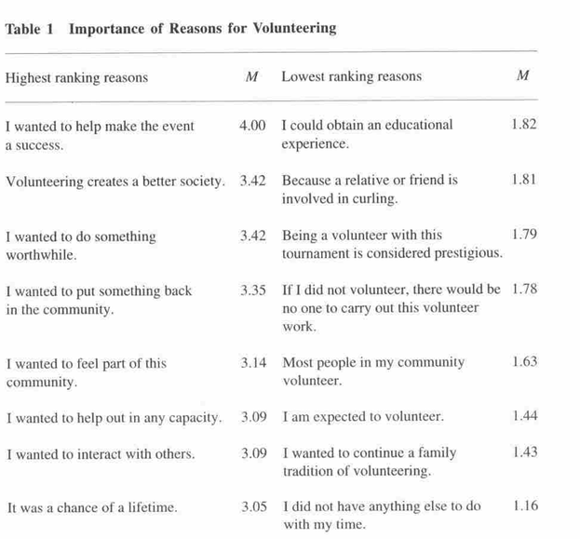

7.6. Appendix 8- Ethics form

APPLICATION FOR ETHICAL APPROVAL

SECTION A: About You (Principal Researcher)

Full Name: |  |  | Rebecca Reynolds
Tick all boxes which apply:
Member of staff: | ☐ | Student: |  | ☒ | Honorary research fellow: | ☐

Faculty/School/Centre: | Business school
Campus: | Swansea
E-mail address: | 1701301@student.uwtsd.ac.uk
Contact Telephone Number: | 07527373754
For students:
Student Number: | 1701301 | Undergraduate | ☒
Programme of Study: | BA Events management | Taught Postgraduate | ☐
Director of Studies/Supervisor: | Caroline Jawad | Research | ☐

SECTION B: Approval for Research Activity

Has the research activity received approval in principle?  (please check the Guidance Notes as to the appropriate approval process for different levels of research by different categories of individual) |  | YES | ☒ | NO | ☐
 |  |  |  | Date
If Yes, please indicate source of approval (and date where known): | Research Degrees Committee |  | ☐
 | Faculty Research Committee |  | ☐
 | Other (write in) |  | ☒ | supervisor
Approval in principle must be obtained from the relevant source prior to seeking ethical approval.

SECTION C: External Ethical Guidance Materials

Please list the core ethical guidance documents that have been referred to during the completion of this form (including any discipline-specific codes of research ethics, and also any specific ethical guidance relating to the proposed methodology). Please tick to confirm that your research proposal adheres to these codes and guidelines.
Dissertation handbook | ☒
Advise from supervisor | ☒
 | ☐

SECTION D: External Collaborative Research Activity

Does the research activity involve collaborators outside of the University? |  | YES | ☐ | NO | ☒
If Yes, please provide the name of the external organisation and name and contact details for the main contact person:
Institution
Contact person name
Contact person e-mail address

Where research activity is carried out in collaboration with an external organisation
Does this organisation have its own ethics approval system? | YES | ☐ | NO | ☐
If Yes, please attach a copy of any final approval (or interim approval) from the organisation

SECTION E: Details of Research Activity

Indicative title: | An exploration into the motivation and satisfaction of volunteers at community events- MUUK Adventures
Proposed start date: | October 1st 2019 | Proposed end date: | 11 May 2020
Purpose of research activity (including aims and objectives)
Outline the purpose, aims and objectives of the research activity, including key research questions. Show briefly how existing research has informed the proposed activity and explain what the research activity will add and how it addresses an area of importance. (Maximum 300 words)
The overall aim of this dissertation is to explore the motivation and satisfaction of volunteering at community events by using the case study of MUUK Adventures. With levels of volunteer numbers dropping, this research will investigate how are people motivated to volunteer at community events and giving recommendations on how the management of the organisation can retain volunteers.
•To examine the volunteer motivation through primary research investigating the main motivations for why individuals volunteer at MUUK Adventure events.
•To critically examine the relationship between motivations to volunteer and the satisfaction of volunteering at community events.
•To provide MUUK Adventures with recommendations with best practise volunteer management.

(this box should expand as you type)
Proposed methods
Provide a brief summary of all the methods that may be used in the research activity, making it clear what specific techniques may be used. If methods other than those listed in this section are deemed appropriate later, additional ethical approval for those methods will be needed. (Maximum 600 words)
Interview

Online questionnaire

(this box should expand as you type)

Location of research activity
Identify all locations where research activity will take place.
Swansea business school
(this box should expand as you type)
Research activity outside of the UK
If research activity will take place overseas, you are responsible for ensuring that local ethical considerations are complied with and that the relevant permissions are sought. Specify any local guidelines (e.g. from local professional associations/learned societies/universities) that exist and whether these involve any ethical stipulations beyond those usual in the UK (provide details of any licenses or permissions required). Also specify whether there are any specific ethical issues raised by the local context in which the research activity is taking place, for example, particular cultural sensitivities or vulnerabilities of participants.
(this box should expand as you type)

SECTION F: Scope of Research Activity

Will the research activity include: | YES | NO
Use of a questionnaire or similar research instrument? | ☒ | ☐
Use of interviews? | ☒ | ☐
Use of diaries? | ☒ | ☐
Participant observation with their knowledge? | ☒ | ☐
Participant observation without their knowledge? | ☐ | ☒
Use of video or audio recording? | ☒ | ☐
Access to personal or confidential information without the participants’ specific consent? | ☐ | ☒
Administration of any questions, test stimuli, presentation that may be experienced as physically, mentally or emotionally harmful / offensive? | ☐ | ☒
Performance of any acts which may cause embarrassment or affect self-esteem? | ☐ | ☒
Investigation of participants involved in illegal activities? | ☐ | ☒
Use of procedures that involve deception? | ☐ | ☒
Administration of any substance, agent or placebo? | ☐ | ☒
Working with live vertebrate animals? | ☐ | ☒
Other primary data collection methods, please explain in this box | ☐ | ☐

If NO to every question, then the research activity is (ethically) low risk and may be exempt from some of the following sections (please refer to Guidance Notes).

If YES to any question, then no research activity should be undertaken until full ethical approval has been obtained.
SECTION G: Intended Participants

Who are the intended participants: | YES | NO
Students or staff at the University? | ☒ | ☐
Adults (over the age of 18 and competent to give consent)? | ☒ | ☐
Vulnerable adults? | ☐ | ☒
Children under 18? | ☐ | ☒
Prisoners? | ☐ | ☒
Young offenders? | ☐ | ☒
Those who could be considered to have a particularly dependent relationship with the investigator or a gatekeeper? | ☐ | ☒
People engaged in illegal activities? | ☐ | ☒
Others (please identify): | ☐ | ☐

Participant numbers and source
Provide an estimate of the expected number of participants. How will you identify participants and how will they be recruited?
Minimum of 60 people - questionnaire
Minimum of 4 interview participants
this box should expand as you type)

Information for participants: | YES | NO | N/A
Will you describe the main research procedures to participants in advance, so that they are informed about what to expect? | ☒ | ☐ | ☐
Will you tell participants that their participation is voluntary? | ☒ | ☐ | ☐
Will you obtain written consent for participation? | ☒ | ☐ | ☐
Will you explain to participants that refusal to participate in the research will not affect their treatment or education (if relevant)? | ☒ | ☐ | ☐
If the research is observational, will you ask participants for their consent to being observed? | ☒ | ☐ | ☐
Will you tell participants that they may withdraw from the research at any time and for any reason? | ☒ | ☐ | ☐
With questionnaires, will you give participants the option of omitting questions they do not want to answer? | ☒ | ☐ | ☐
Will you tell participants that their data will be treated with full confidentiality and that, if published, it will not be identifiable as theirs? | ☒ | ☐ | ☐
Will you debrief participants at the end of their participation, in a way appropriate to the type of research undertaken? | ☒ | ☐ | ☐
If NO to any of above questions, please give an explanation
(this box should expand as you type)

Information for participants: | YES | NO | N/A
Will participants be paid? | ☐ | ☒ | ☐
Is specialist electrical or other equipment to be used with participants? | ☐ | ☒ | ☐
Are there any financial or other interests to the investigator or University arising from this study? | ☐ | ☒ | ☐
Will the research activity involve deliberately misleading participants in any way, or the partial or full concealment of the specific study aims? | ☐ | ☒ | ☐
If YES to any question, please provide full details
(this box should expand as you type)

SECTION H: Anticipated Risks

Outline any anticipated risks that may adversely affect any of the participants, the researchers and/or the University, and the steps that will be taken to address them.

If you have completed a full risk assessment (for example as required by a laboratory, or external research collaborator) you may append that to this form.
Full risk assessment completed and appended?

Yes ☐
No ☐

Risks to participants
For example: emotional distress, financial disclosure, physical harm, transfer of personal data, sensitive organisational information
(this box should expand as you type)
If research activity may include sensitive, embarrassing or upsetting topics (e.g. sexual activity, drug use) or issues likely to disclose information requiring further action (e.g. criminal activity), give details of the procedures to deal with these issues, including any support/advice (e.g. helpline numbers) to be offered to participants. Note that where applicable, consent procedures should make it clear that if something potentially or actually illegal is discovered in the course of a project, it may need to be disclosed to the proper authorities
Non-disclosure agreement

(this box should expand as you type)
Risks to investigator
For example: personal safety, physical harm, emotional distress, risk of accusation of harm/impropriety, conflict of interest
Will be treated with respect
(this box should expand as you type)
University/institutional risks
For example: adverse publicity, financial loss, data protection
(this box should expand as you type)
Adverse outcomes
List measures put in place to limit any adverse effects or outcomes of research activity where appropriate. Include any emergency protocols.
Information will be stored securely and confidentiality at all times
(this box should expand as you type)

Disclosure and Barring Service
If the research activity involves children or vulnerable adults, a Disclosure and Barring Service (DBS) certificate must be obtained before any contact with such participants. | YES | NO | N/A
Has a DBS certificate been obtained? | ☐ | ☐ | ☒
SECTION I: Feedback, Consent and Confidentiality

Feedback
What feedback will be provided to participants, how will this be done and when?
Dissertation will be available to all participants and organisation by email request and blog post of questionnaire results.

(this box should expand as you type)
Informed consent
Describe the arrangements to inform potential participants, before providing consent, of what is involved in participating. Describe the arrangements for participants to provide full consent before data collection begins. If gaining consent in this way is inappropriate, explain how consent will be obtained and recorded.
Interviewees will sign a form and tick boxes for their agreement

(this box should expand as you type)
Confidentiality / Anonymity
Set out how anonymity of participants and confidentiality will be ensured in any outputs. If anonymity is not being offered, explain why this is the case.
All participants will be anonymous

(this box should expand as you type)

SECTION J: Data Protection and Storage

In completing this section refer to the University’s Research Data Management Policy and the extensive resources on the University’s Research Data Management web pages (http://uwtsd.ac.uk/library/research-data-management/).
 | YES | NO
Does the research activity involve personal data (as defined by the Data Protection Act)?  “personal data” means data which relate to a living individual who can be identified—  (a) from those data, or  (b) from those data and other information which is in the possession of, or is likely to come into the possession of, the data controller, and includes any expression of opinion about the individual and any indication of the intentions of the data controller or any other person in respect of the individual. | ☐ | ☒
If YES, provide a description of the data and explain why this data needs to be collected:
(this box should expand as you type)
Does it involve sensitive personal data (as defined by the Data Protection Act)?  “Sensitive personal data” means personal data consisting of information as to –  (a) the racial or ethnic origin of the data subject,  (b) his political opinions,  (c ) his religious beliefs or other beliefs of a similar nature,  (d) whether he is a member of a trade union (within the meaning of the Trade Union and Labour Relations (Consolidation) Act 1992),  (e) his physical or mental health or condition,  (f) his sexual life,  (g) the commission or alleged commission by him of any offence, or  (h) any proceedings for any offence committed or alleged to have been committed by him, the disposal of such proceedings or the sentence of any court in such proceedings. | ☐ | ☒
If YES, provide a description of the data and explain why this data needs to be collected:
(this box should expand as you type)

Will the research activity involve storing personal data on one of the following: | YES | NO
Manual files (i.e. in paper form)? | ☐ | ☒
University computers? | ☒ | ☐
Private company computers? | ☐ | ☒
Home or other personal computers? | ☒ | ☐
Laptop computers/ CDs/ Portable disk-drives/ memory sticks? | ☒ | ☐
“Cloud” storage or websites? | ☐ | ☒
Other – specify: | ☐ | ☐
For all stored data, explain the measures in place to ensure data confidentiality, including details of password protection, encryption and anonymisation:
All data will be collected anonymous. Passwords will be used and memory stick will be kept away in a locked draw

(this box should expand as you type)

Will the research activity involve any of the following activities: | YES | NO
Electronic transfer of data in any form? | ☐ | ☒
Sharing of data with others at the University? | ☐ | ☒
Sharing of data with other organisations? | ☐ | ☒
Export of data outside the European Union or importing of data from outside the UK? | ☐ | ☒
Use of personal addresses, postcodes, faxes, emails or telephone numbers? | ☐ | ☒
Publication of data that might allow identification of individuals? | ☐ | ☒
Use of data management system? | ☐ | ☒
Data archiving? | ☐ | ☒
If YES to any question, please provide full details, explaining how this will be conducted in accordance with the Data Protection Act (and/or any international equivalent):
(this box should expand as you type)

List all who will have access to the data generated by the research activity:
Student
(this box should expand as you type)
List who will have control of, and act as custodian(s) for, data generated by the research activity:
Student
(this box should expand as you type)
Give details of data storage arrangements, including where data will be stored, how long for, and in what form. Will data be archived – if so how and if not why not.
Storage will be secured by student and there will not be paper storage

(this box should expand as you type)

SECTION K: Declaration

The information which I have provided is correct and complete to the best of my knowledge. I have attempted to identify any risks and issues related to the research activity and acknowledge my obligations and the rights of the participants.

In submitting this application I hereby confirm that I undertake to ensure that the above named research activity will meet the University’s Research Ethics and Integrity Code of Practice
Signature of applicant: | Rebecca Reynolds | Date: | 17.11.2019

For students:
Director of Studies/Supervisor:
Signature:
Date:

For staff:
Head of School/Assistant Dean:
Signature:
Date:

Checklist: Please complete the checklist below to ensure that you have completed the form according to the guidelines and attached any required documentation:
☒ | I have read the guidance notes supplied before completing the form.
☒ | I have completed ALL RELEVANT sections of the form in full.
☒ | I confirm that the research activity has received approval in principle
☒ | I have attached a copy of final/interim approval from external organisation (where appropriate)
☒ | I have attached a full risk assessment (and have NOT completed Section H of this form) (where appropriate)
☒ | I understand that it is my responsibility to ensure that the above named research activity will meet the University’s Research Ethics and Integrity Code of Practice.
☒ | I understand that before commencing data collection all documents aimed at respondents (including information sheets, consent forms, questionnaires, interview schedules etc.) must be confirmed by the DoS/Supervisor, module tutor or Head of School.

7.7 Appendix 9- Consent form

CONSENT FORM

Title of Project: An exploration into the motivation and satisfaction of volunteers at community events- Case study of MUUK- Adventures

This research seeks to explore volunteer motivation and satisfaction at a community sports event to help the organisation of MUUK-Adventures retain their volunteer’s involvement.

Name and contact details of researcher: Rebecca Reynolds 1701301@student.uwtsd.ac.uk
Please tick box if you
agree with the statement

1 |  | I confirm that I have read and understand the information sheet for the above study and have had the opportunity to ask questions. |  |  |  | □
2 |  | I understand that my participation is voluntary and that I am free to withdraw at any time. |  |  |  | □
3 |  | I agree to take part in this study. |  |  |  | □
4 |  | I understand that data collected about me during this study will/will not* be anonymised before it is submitted for publication. |  |  |  | □
5 |  | I agree to the interview/focus* group being audio/video recorded* |  |  |  | □
6 |  | I agree to allow the dataset collected to be used for future research projects |  |  |  | □
7 |  | I agree to be contacted about possible participation in future research projects. |  |  |  | □
 | ________________________  Researcher |  | ___________________  Date | _____________________  Signature

Information
Study Title: An exploration into the motivation and satisfaction of volunteers at community events- Case study of MUUK- Adventures

Aims of the Research
The aim of this study is to explore volunteer motivation and satisfaction at a community sports event to help the organisation of MUUK-Adventures retain their volunteer’s involvement.

Invitation
You are being invited to consider taking part in the research study ‘An exploration into the motivation and satisfaction of volunteers at community events- Case study of MUUK- Adventures’.

Before you decide whether or not you wish to take part, it is important for you to understand why this research is being done and what it will involve. Please take time to read this information carefully and discuss it with friends and relatives if you wish. Ask us if there is anything that is unclear or if you would like more information.

Why have I been chosen?
You have been chosen as you are a key member of the volunteer team at MUUK. There will be a total of 4 people being interviewed

Do I have to take part?
You are free to decide whether you wish to take part or not. If you do decide to take part you will be asked to sign two consent forms, one is for you to keep and the other is for our records. You are free to withdraw from this study at any time and without giving reasons.

What will happen if I take part?
You will be given a set of questions to complete and answer

If I take part, what do I have to do?
To answer the questions as best as you can from you experience as a volunteer.

What are the benefits (if any) of taking part?
Provide recommendations to the organisation which in turn can be beneficial to the volunteers

What are the risks (if any) of taking part?

How will information about me be used?

That data will be stored securely and where the data will be stored (e.g. in a locked filing cabinet, on a password protected computer)
The level of identifiably (e.g. coded, unlinked-anonymous, fully identifiable)
That the data will be stored in line with the sponsor’s guidelines (where there is a sponsor) and that the data will be retained by the principal investigator for at least five years.
What the longer-term arrangements are for disposing of or keeping the data (e.g. that they will be securely disposed of, or placed in a repository)

Who will have access to information about me?
your confidentiality will be safeguarded during and after the study.

What if there is a problem?

If you have a concern about any aspect of this study, you may wish to speak to the researcher(s) who will do their best to answer your questions. You should contact Rebecca Reynolds on. 1701301@student.uwtsd.ac.uk. Alternatively, if you do not wish to contact the researcher(s) you may contact Dr Caroline Jawad <caroline.jawad@uwtsd.ac.uk>

If you remain unhappy about the research and/or wish to raise a complaint about any aspect of the way that you have been approached or treated during the course of the study please write to Dr Caroline Jawad who is the University’s contact for complaints regarding research at the following address:-

Name
E-mail:

Contact for further information

