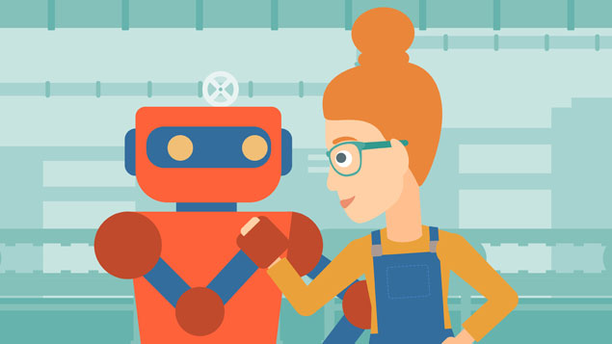
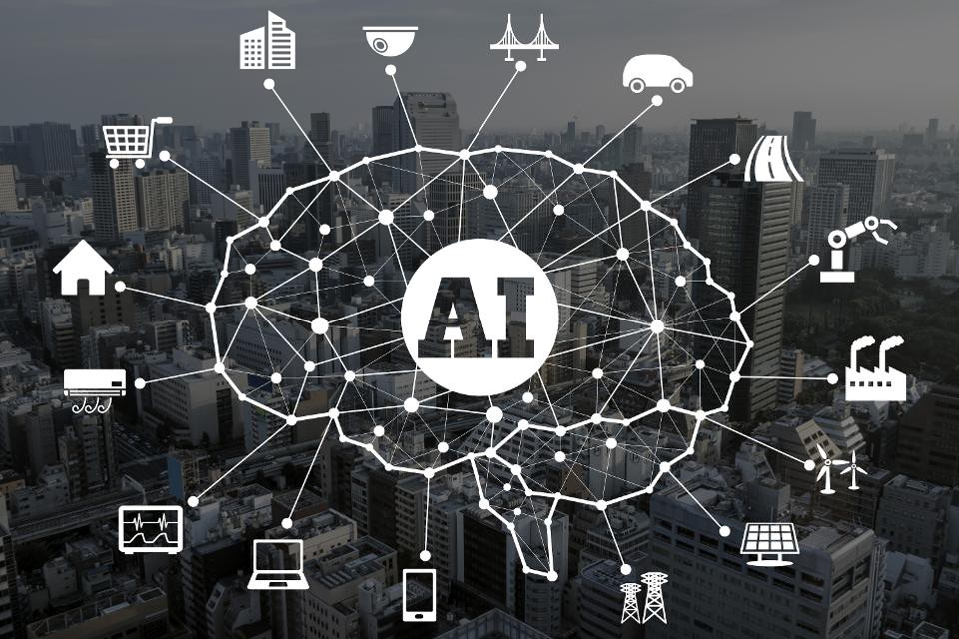

- Car manufacturer sector: case of RENAULT -
A business case for artificial intelligence application to managing people

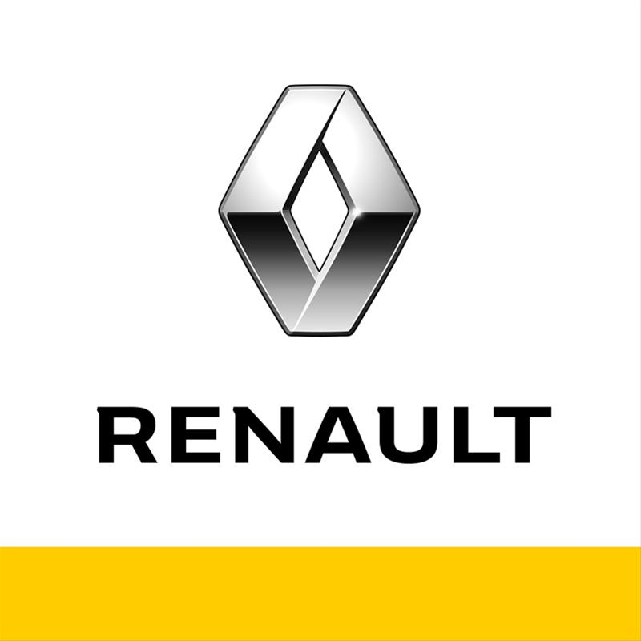

Executive summary

This report will cover the application of artificial intelligence in managing people. It will explain what are the different advantages of new technologies in the management, especially in the four areas of human resources management and how they operate. For lean the facts, the report will take the example of the car industry sector, in particular, Renault. This sector is constantly innovated in terms of production and management. Thus, it is a good way to analyse how the establishment of AI is impacting the work of the human resources team and employees generally. Moreover, some recommendation will be made to improve the company’s management and cope with disadvantages and ethical issues.

Contents Page

Introduction 1

1. What is AI technology? How AI is impacting people management? 1

2. The benefits of adopting AI technology. 2

3. Implementation of AI in the Renault’s group, and its competitors. 3

4. Recommendations and how the company can support the changes. 4

5. The disadvantages, risks and costs. 6

CONCLUSION 7

REFERENCES 8

Introduction

The report considers the case of Renault’s group. This organisation is a French multinational car manufacturer. It was created in 1898 and never stop innovating since this year. The Renault family has founded a public limited company, which today be part of the biggest international automaker. The headquarter is based in Paris, in France. Every year the group sell more than 3 700 000 vehicles thanks to 181 344 employees in 2017 (Renault, 2017). A big industry as Renault has a strong management strategy and use technology to improve its structure and improve the employees’ conditions. Nowadays, in the automobile manufacturer as in every sector, new technologies could be a real benefit for companies. Market issues and global environmental problems, in the VUCA world (volatility, uncertainty, complexity and ambiguity environment) make companies do organizational changes. The technology development generates adaptation challenges for organizations for in the end achieve competitive advantages.

What is AI technology? How AI is impacting people management?

First, “human resources management is making sure the business objectives are met through people whilst also making sure workers are ethically treated, looked after and engaged” (Healey-Benson, 2018a). It’s really important to manage correctly employees in a company because, as Richard Branson said, “success in a company is all about people”. Hence the arrival of AI in this department to allow the improvement of the employee’s work, because “people management activities can and lead to improved organizational performance” (Hutchinson, 2013). People management cover 4 key areas:
- Recruitment, to attract and bring talent to fill the business need
- Learning and development, to help employees to learn and develop to reach their potential, like so improve their skills
- Employee engagement, to improve employ feel and relationship in-house.
- Performance management, to reward employees in terms of performance

Since “the first experiments in AI were conducted in the 1950s” (Scheweyer, 2018), technologies have grown a lot and quickly. AI is “the theory and development of computer systems able to perform tasks that normally require human intelligence” (Oxford, 2018). People say that AI is “the future of work”. Unlike “traditional performance management approaches which are focused primarily on business efficiency and process” (Vasudeva et. al, 2017), AI’s purpose is to increase human engagement, endeavour and performance (Healey-Benson, 2018b) through the understanding of employees’ behaviour, the prediction of their performance, and the improvement of the wellbeing in work. In this way, employees can do properly their job and produce better results. Advances in terms of technology for people management are driven by “big data, productive analytics, a rise in computing power, increased connectivity, new methods of human-machine interaction and advances in transmitting digital directives to the physical world” (Healey-Benson, 2018c). AI has a real impact on people management, especially through software which has simplified the analysis of data. Thus, employees’ issues and organizations’ problems can be solved, like discrimination, the weak of training, and the lack of rewards, thanks to digital learning solutions. The aim is to ensure the effectiveness of HR functions. “A recent survey found that 38% of enterprises are already using AI in their workplace with 62% expecting to use it by 2018” (In, 2017). People must acquire new skills and qualifications and become adaptive thinking because their work environment is modified. Even so, it is important to take on board that “ethical issues have to be considered before decisions are made” (Rees et. Al, 2015, p98) and before AI are implanted in companies.

2. The benefits of adopting AI technology.

Companies have to adopt these approaches in terms of AI for having the most innovated management strategy, help ensure competitive advantage and improve overall business performance. Organisations must motivate employees to perform at their best, that include autonomy, purpose, learning, inclusion, and appreciation (Scheweyer, 2018). Thus, many benefits have emerged through the application of AI in the 4 areas of human resources management.

In a general point of view, AI eliminates some repetitive tasks and make cost and time savings. Through recruiting automation with recruiting software, sourcing tools, and social media recruiting, AI improves the process of hiring. In 2018, thanks to Chatbot AI (computer program or a dialogue system), “Unilever has reduced time to hire from more than four months to about four weeks while reducing recruiter screening time by 75 per cent” (Scheweyer, 2018). The purpose is to have better Job-Candidate matching because “it may be necessary to examine the match between people’s abilities and needs with job requirements” (Rees and Porter, 2015), and also have a proactive communication and better sourcing information. By means of algorithms people can be identified faster, more precisely, fairer (Taska, 2018), and it allows to reduce discrimination.

Concerning learning and development, “organisations spend more than $350 billion on workplace training each year” (Scheweyer, 2018), and it is a long time process. AI offers predictive analysis to know when people require learning and increase retention, and new methods of training like e-learning (Rees, 2015), with micro-Learning, videos, mobile learning, game-based learning. Thereby, employees can improve their skills in time and have good training corresponding to their needs to drive business performance.

About the collection of data, information must properly analyse to understand employee’s behaviour and develop a retention strategy. AI act through automates feedback, learning algorithms, mobile apps for staff, and application to awards employees about their performance in work. Technology has revolutionising employee wellbeing and engagement, it helps increase levels of engagement, promote co-operation, network and reduce conflicts (Healey-Benson, 2018d).

Thanks to AI work become easier, people low stressful, more motivated, and dare to talk about problems. Through AI, managers are helped in terms of decision making and companies could use new strategies and process. There are many benefits, especially because “technology can predict problems and prescribes solutions” (Barnett, 2016). The aim is to link together performance, motivation, individual goals, departmental purpose and organisational objectives” (Boxall and Purcell, 2016).

Implementation of AI in the Renault’s group, and its competitors.

Car manufactory must be continuously creative and innovative. They need to satisfy the constant need from customers and make a profit, so employees must feel good in work to accomplish correctly their job.

In the case of the Renault group, the company use AI for years. First, it uses it inside the production and innovation services with especially automatic, connected and electric vehicles. The company has to align itself with the trends sectors and the competitors, because “an organisation is influenced by internal and external factors, which can cause changes in the company’s management. These factors can be digital data, the redefinition of work, and the on-demand economy” (Healey-Benson, 2018e). Renault use also AI in the human resources management. The organisation’s objectives are to “provide varied human resources, adapted continually the employees’ skills to the company’s need, and contribute to the quality of the management” (Renault, 2018). It wants to resolve some ethical issues, especially discrimination, every employee must have the same opportunities in terms of recruitment and career advancement at the company. Renault’s managers want to help all employees to find their place and blossom within the company. With the arrival of AI and new methods of work, the company must adapt its management.

“The learning & development department supports management committees in their digital transformation through learning expeditions objectives.” Thus, Renault’s group promote diversity, support the education and training by way of the Renault foundation (an organization which promote inclusion and sustainable mobility), and especially develop itself in terms of methods of management through AI (Renault, 2018). The Renault’s HR policy is centred on the engagement and skills improvement of employees. To increase these, the company use a legible recognition system which rewards individuals and group performance. Through software, in-house communication is improved and employees can assert their project ideas (Francois, 2012).

Regarding competitors in the car industry sector, companies do not have strategic plans in terms of managing people. Car manufacturer “regularly lack the time to institute management and leadership development programs” (Morley, 2018). Thus, thanks to AI, companies like Renault can stand out from the crowd and have competitive advantages. The most important points are to facilitate the employee work, analyse the market and examine their own statistics. “Human resources management is one of the key factors for the success of the auto manufacturing companies in Japan”. Toyota Motor Corporation is a rival. The group improve the training scale through a new technologic process, “worker productivity gains have been enhanced through the application of suggestion programs” (Wan, 2001).

Recommendations and how the company can support the changes.

The Renault’s group try to be an innovator in terms of AI and improve its people management, but it can make enhancement. To adopt new methods of management, it is important to first make a SWOT analysis. Thus, the company could know more about the internal factors like staff flexibility, attitudes to change, equipment, opportunities, through strengths and weaknesses, and also about external factors (political, economic, socio-cultural, technological, legal, environmental), through opportunities and threats. An environmental analysis is important to HR planning, because” trends influencing the world of work, the structure of work and the way people work”. Moreover, operating in the digital world demands new skills, strategic focus, and organisation models (Healey-Benson, 2018f). Thus, Renault has to establish a new business model, it is certainly the best solution to be compatible with these new approaches to work. The company must improve its communication in-house because employees need more information to work in team. There is a system, whose name is Slack, which allows people to exchange with each other inside a company to talk about a project, a collaborative work or trade information. The purpose is to centralise all the communication flow to maximise the employee’s productivity. Companies can also transform the call centre and increase productivity through Chatbot, a program which adapts responses to fit a situation (Sprout social, 2018). It also may be interesting for the company to use more data and improve their analysis. HR team have to support digital transformation through employee’s training. People in the company must be adaptive thinking to be able to make new tasks and work daily with technologies. However, Renault must control the using of AI because “ethics are at the heart of professionalism” (CIPD, 2018). The organization has to regulate its activities especially the quantitative and qualitative data collection, and respect privacy and diversity.

PESTLE (external factors): Car industry
Political | - Regulations  - Low emission vehicles  - Environment friendly vehicles  - Different to each country  - Taxes
Economic | - Economic crisis  - Taxes on the high priced vehicles
Socio-cultural | - Trends  - Use of social media
Technological | - Innovations  - Investment in research and development  - Low emission  - Fuel efficient  - High mileage vehicles  - Automatic and electric vehicles
Legal | - Laws related to product quality and safety  - Environmental laws: strict emission control  - Tax laws
Environmental | - Carbon emission  - Environment friendliness and pollution control  - Hybrid and electric vehicles

The disadvantages, risks and costs.

In this new age of new technologies and never stop innovating in terms of AI, companies are confronted with ethical issues. Despite all the benefits that occurred from AI, some disadvantages and ethical issues exist. It could have failures because of the complexity of digital programs. There is also a possibility of cyber-attacks, so a control department must be creating. Regarding ethical issues, discrimination in recruitment is reduced and human bias is eliminating, but unfortunately, “AI may displace huge sectors of the workforce”. People are the ones most affected by the changes in the digital workplace. Thus, concerning people in work, “73% think technology can never replace the human mind” (PWC, 2018), but the autonomy removes some human jobs and generates the loss of competent employees. The working environment is altered and people’s habit is impacted. Employees requiring to acquire new skills and qualifications, they must know how to use these new tools of work, so it can take time. Companies have to establish training support to make employees comfortable with AI. Moreover, AI has a high cost, especially about the arranging and the maintenance of the program and software. Decisions can be made from incomplete data (e.g. exclude certain groups of employees, part-time employees or contractors), the analysis must be done properly. Thus, technology has to be regulated.

CONCLUSION

To conclude, the company have to continue using AI in its managed to improve its work and it must take the recommendations into consideration. Given the disadvantages and ethical issues identified in the report have the potential to undermine the benefits of the AI implementation is it very key for the organisation to have plans in place to mitigate or reduce their impact. Thus, here are the different solutions to resolve these problems:

Human resources areas | Ethical issues and recommendations
Recruitment | - Reduce the discrimination  - Extend the retention  - Use software
Employee engagement | - More feedback  - Improve the rewards
Learning and development | - Increase the data quantity and quality  - Use predictive analysis to properly train employees
Performance management | - Observation and analysis of work

Finally, AI as a good impact on people management. It became an essential factor and a competitive advantage in the management of big companies. It allows to make cost and time saving. Moreover, AI is in a constant evolution, but the human has some aspect that AI could not replace and ethical issues have to take on board. Now, HR team research “people who have a variety of skills, can step into multiple roles and quickly react and pivot their capabilities in response to disruption” (Vasudeva et. al, 2017). To help mitigate any disadvantages, the company must make more predictive analysis to anticipate any possible problem and increase the communication between human resources managers and employees, and of course train employees to these new changes.

REFERENCES

Bailey, 1993, Managing people and technological change, accessed on November 2018.

Barnett, 2016, The business journals, The role of artificial intelligence in people management, available at: https://www.bizjournals.com/bizjournals/how-to/human-resources/2016/06/the-role-of-artificial-intelligence-in-people.html, accessed on December 2018.

Renault, 2018, Commercial Renault website, available at: https://www.renault.co.uk / https://rapport-annuel.groupe.renault.com/#/fr/les-chiffres-cle / https://group.renault.com/en/talent/our-career-areas/engineering/, accessed on December 2018.

Curtin, 2017, Inc, available at: https://www.inc.com/melanie-curtin/the-10-top-skills-that-will-land-you-high-paying-jobs-by-2020-according-to-world-economic-forum.html, accessed on December 2018.

Deloitte, 2017 Global Human Capital Trends, available at: https://www2.deloitte.com/insights/us/en/multimedia/videos/human-capital-trends.html, accessed on December 2018.

Francois, 2012, Slide share, available at: https://www.slideshare.net/ladykichigai/stratgie-dentreprise-renault, accessed on December 2018.
Healey-Benson, F. 2018a/b/c/e/f, Lesson 1: Introduction to AI and Managing People, 3RD October, 2018 Managing People, Swansea Business School, UWTSD.
Healey-Benson, F. 2018d, Lesson 5: Retention and employee engagement, 31th October, 2018 Managing People, Swansea Business School, UWTSD.
Hutchinson, 2013, Performance management (theory and practise), page 1, accessed on November 2018.

In, 2017, Personal today, Ten ways HR tech leaders can make the most of artificial intelligence, available at: https://www.personneltoday.com/hr/ten-ways-hr-tech-leaders-can-make-artificial-intelligence/, accessed on December 2018.

Kolbjornsrud, Amico, Thomas, 2016, HBR, How Artificial Intelligence Will Redefine Management, available at: https://hbr.org/2016/11/how-artificial-intelligence-will-redefine-management, accessed on December 2018.

McCalman, Robert A. Paton, Sabrina Siebert, 2016, Change management / A guide to effective implementation, accessed on November 2018.

Mondal, 2017, Talent culture, Five Facts About Using A Recruitment Chatbot, available at: https://talentculture.com/five-facts-about-using-a-recruitment-chatbot/, accessed on December 2018.

Morley, 2018, Chron, Human Resources Challenges in the Auto Industry, available at: https://smallbusiness.chron.com/human-resources-challenges-auto-industry-76339.html, accessed on December 2018.

Nunn, 2018, Forbes, How AI Is Transforming HR Departments, available at: https://www.forbes.com/sites/forbestechcouncil/2018/05/09/how-ai-is-transforming-hr-departments/#187551cf1c0f, accessed on December 2018.

Polli, 2018, Forbes, How AI Will Make Our Workplace Fair With Diversity Tech Stack, available at: https://www.forbes.com/sites/fridapolli/2018/05/10/diversity-tech-stack-how-ai-will-make-our-workplace-fair/#114f036c1bc2, accessed on December 2018.

Pratap, 2016, Cheshnotes, A PESTEL Analysis of the automotive/automobile industry Available at: https://www.cheshnotes.com/2016/09/automotive-industry-pestel/, accessed on December 2018.

Rees, Porter, 2015, Skills of management and leadership / Managing people in organizations, page 2/16/42/98/125/240/337, accessed on December 2018.

Renault, available at: https://group.renault.com/en/our-commitments/our-corporate-and-social-responsibility/, accessed on December 2018.

Rogers, 2018, Ultimate software, How AI is transforming people management and HCM, available at: https://blog.ultimatesoftware.com/ai-people-management-hcm/, accessed on December 2018.

Riley, 2018, CNBC, Get ready, this year your next job interview may be with an A.I. robot, available at: https://www.cnbc.com/2018/03/13/ai-job-recruiting-tools-offered-by-hirevue-mya-other-start-ups.html, accessed on December 2018.

Scheweyer, 2018, IRF, Predictive Analytics and Artificial Intelligence in People Management, available at: http://theirf.org/research/predictive-analytics-and-artificial-intelligence-in-people-management/2527/, accessed on December 2018.

Stewart, 2018, The drum, Renault is using artificial intelligence to run its influencer marketing campaigns, available at: https://www.thedrum.com/news/2018/05/24/renault-using-artificial-intelligence-run-its-influencer-marketing-campaigns, accessed on December 2018.

Vasudeva, Good, Eerenstein, 2017, Technology reinvents performance management, Accenture strategy, page 4, accessed on November 2018.
Wan, 2001, Education and Training in the Auto Manufacturing Industry, available at : http://www.who.int/hrh/en/HRDJ_5_05.pdf, accessed on December 2018.
Wong, 2016, Berkeley Haas, How AI is reshaping management, available at: https://cmr.berkeley.edu/blog/2016/6/ai/, accessed on December 2018.

2017, EYUK Careers, The Future of Work - adapting your skills and 'selves' to succeed, available at: https://www.youtube.com/watch?v=5BKEtruJAEw, accessed on December 2018.

2018, All business, available at: https://aibusiness.com/the-role-of-artificial-intelligence-in-people-management/, accessed on December 2018.

2018, CIPD, available at: https://www.cipd.co.uk/knowledge/culture/ethics/role-hr-factsheet, accessed on December 2018.

2018, PWC, Available at: https://www.pwc.co.uk/services/economics-policy/insights/the-impact-of-automation-on-jobs.html, accessed on December 2018.

2018, Sprout social, The complete guide to Chatbot in 2018, available at: https://sproutsocial.com/insights/topics/chatbots/

