Analysing, Ethically Hacking and
Securing an Enterprise Network
  - Advanced Cybersecurity (ACCB6000)
  - BSc Applied Computing

Student Name: Uri Neto
Student Number: 2327255

Table of Contents
Introduction 1
Assessment Scope 1
TASK 1: 1
TASK 2: 1
2.1) Setup Security-focused Operating System of your choice 1
2.2 Vulnerability Assessment: 1
Introduction 1
TASK 3: 1
3.1 Ethically Hacking SWANSEA.ACCA Network 1
Introduction 1
3.1 Exploitation 1
3.2 Post-Exploitation 1
4.1 Preventive Security Measures 1
References 1

Introduction
This report presents the security assessment of the SWANSEA.ACCA network in an authorised lab environment. It covers network verification, vulnerability assessment, controlled exploitation of an identified weakness, and preventive security measures. The aim of the assessment was to identify security weaknesses and evaluate how the network could be better protected [1].

Assessment Scope
The scope of this assessment included the main hosts within the SWANSEA.ACCA environment, including the S-DC server, L-CD, and the client systems located in both Swansea and London. The assessment focused on internal network connectivity, exposed services, vulnerability identification, controlled exploitation of a selected weakness, and the implementation or recommendation of security controls to reduce the identified risks.

TASK 1:

S-DC:
IPCONFIG /ALL
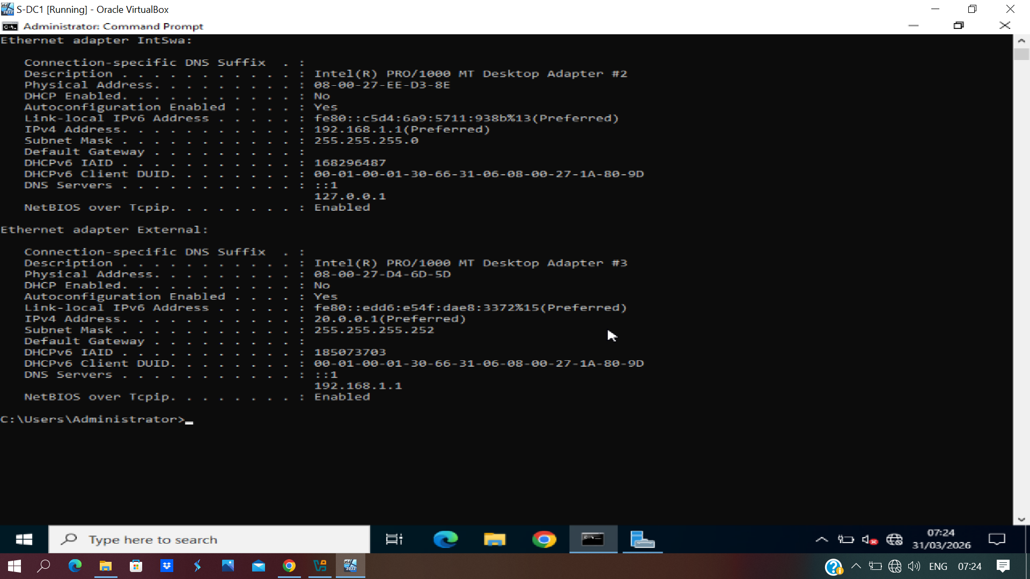

ping 192.168.1.10
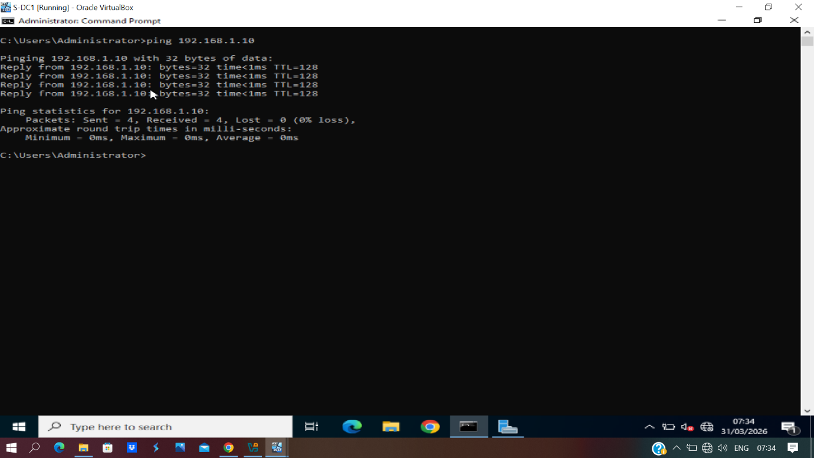
ping 192.168.2.1
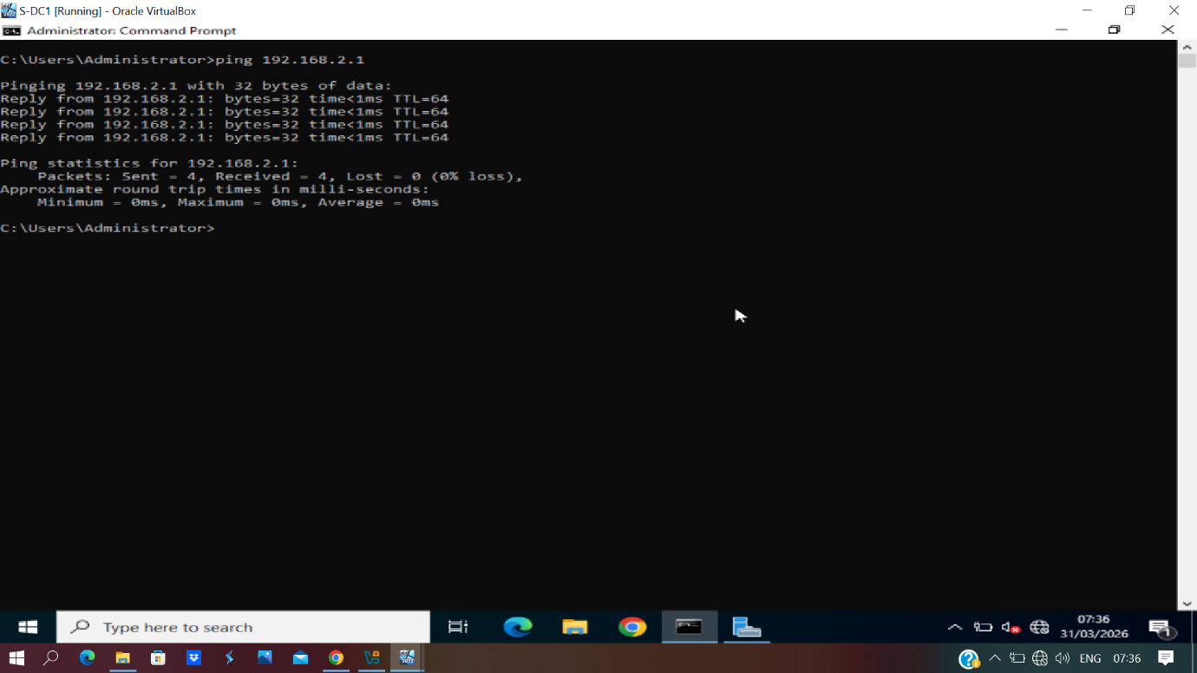

ping 192.168.2.10
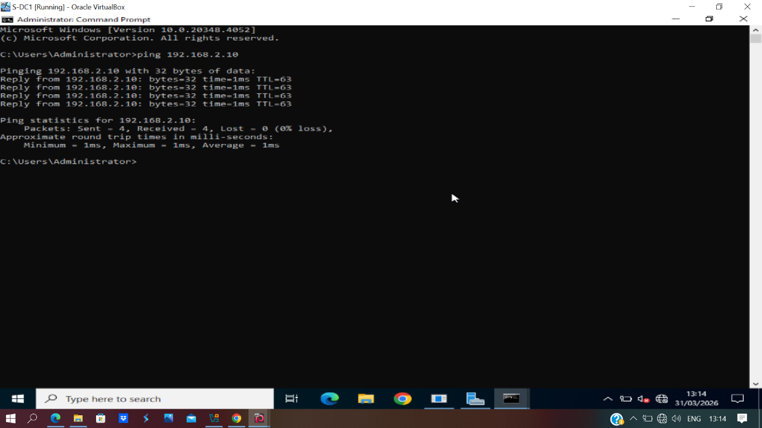

L-CD:
ip address
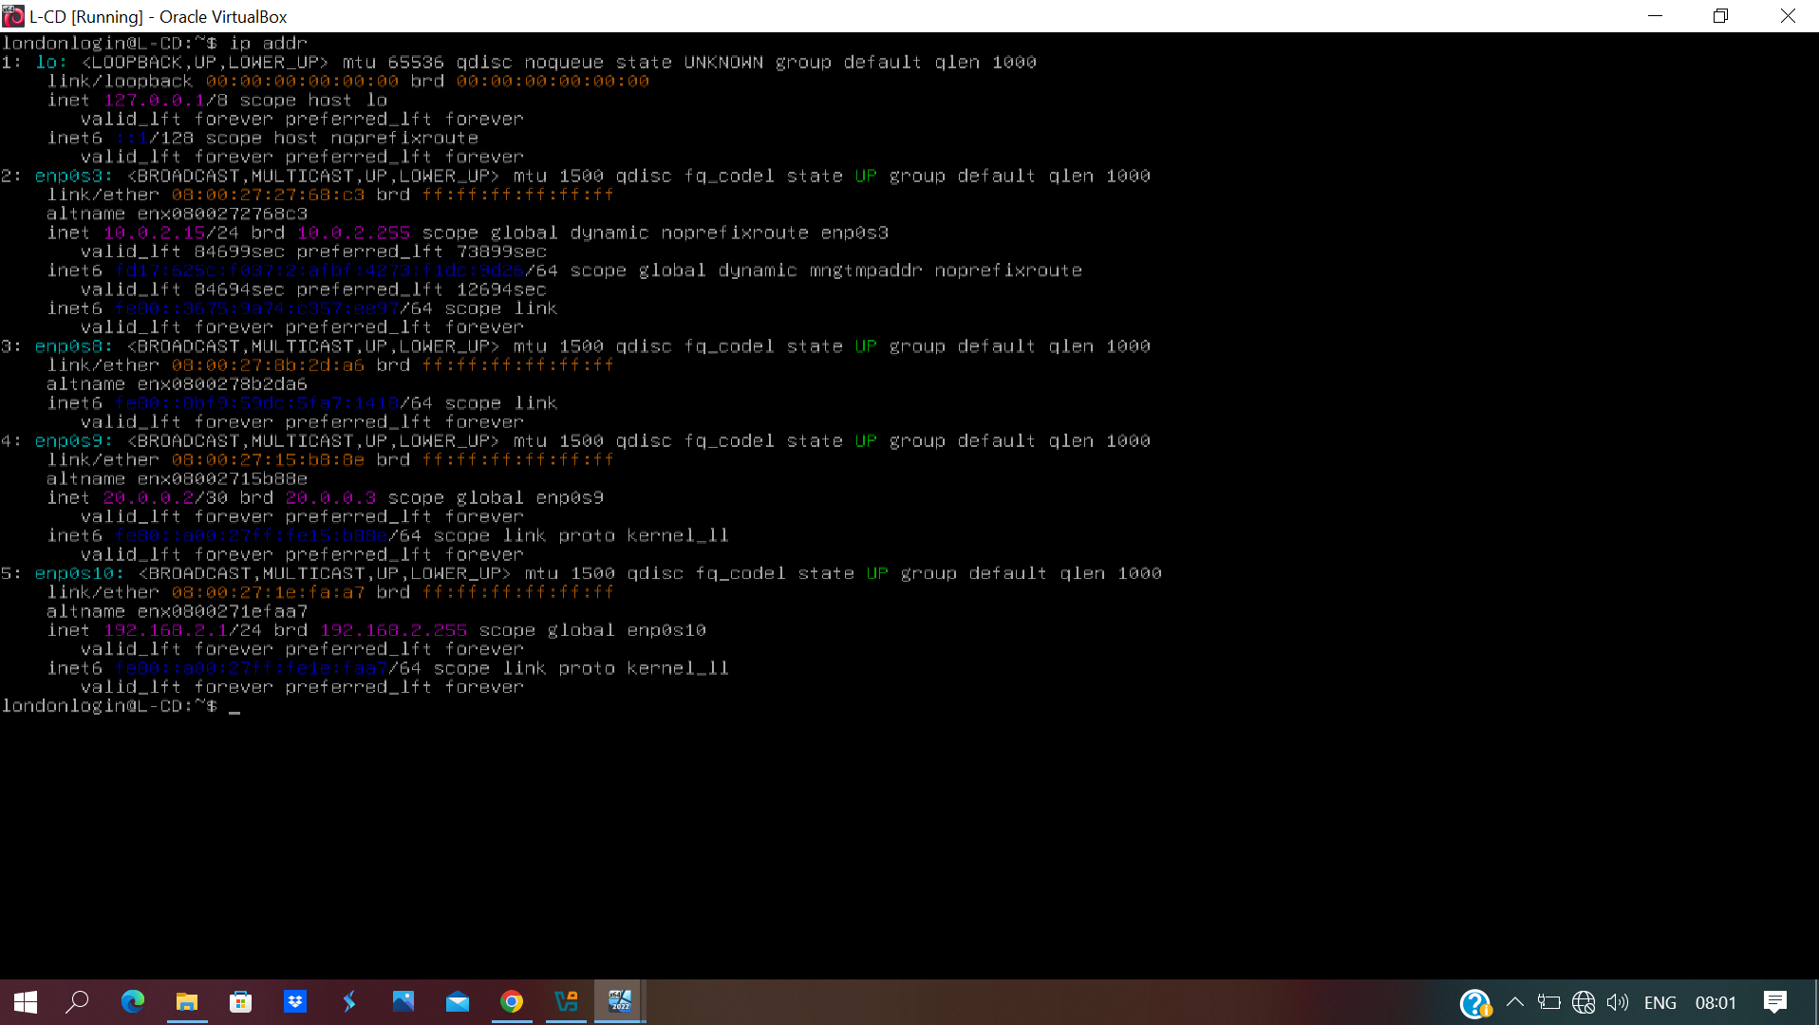

ping 192.168.1.10
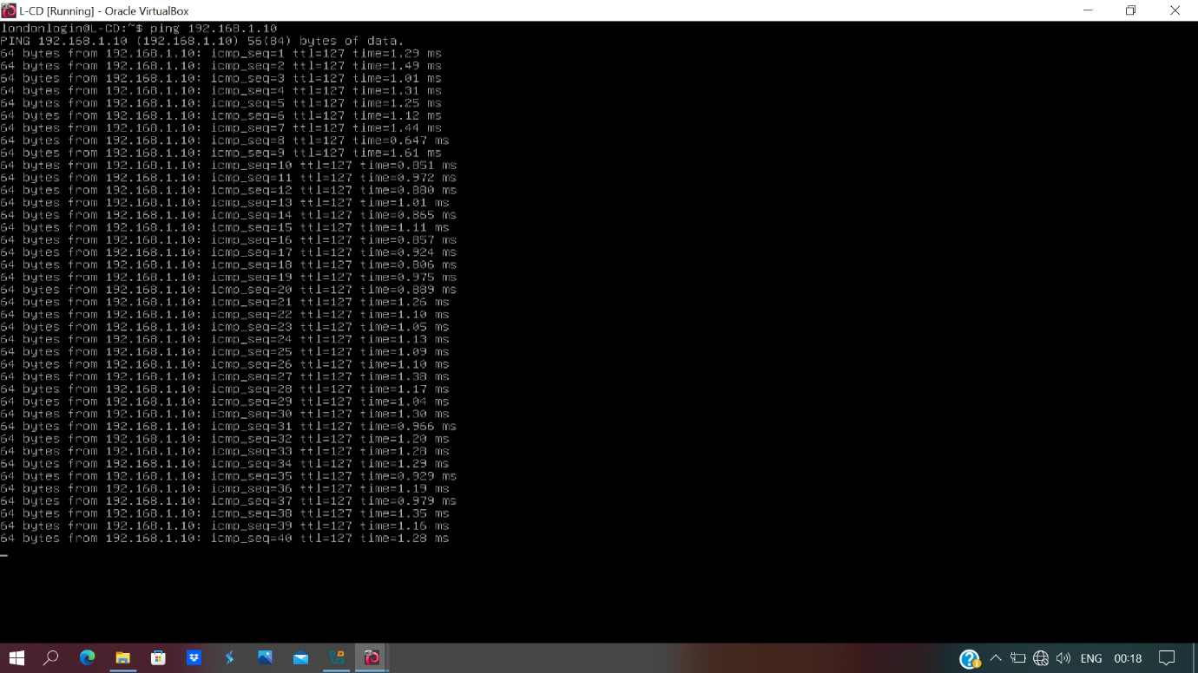

ping 192.168.1.1
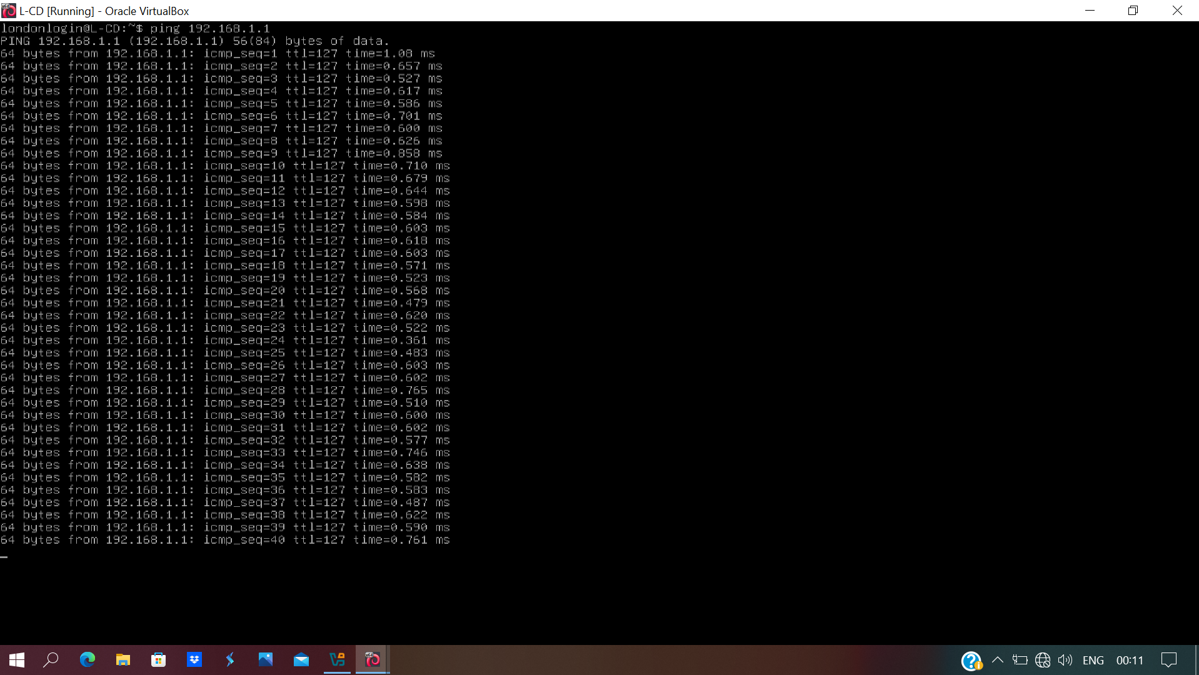

ping 192.168.2.10
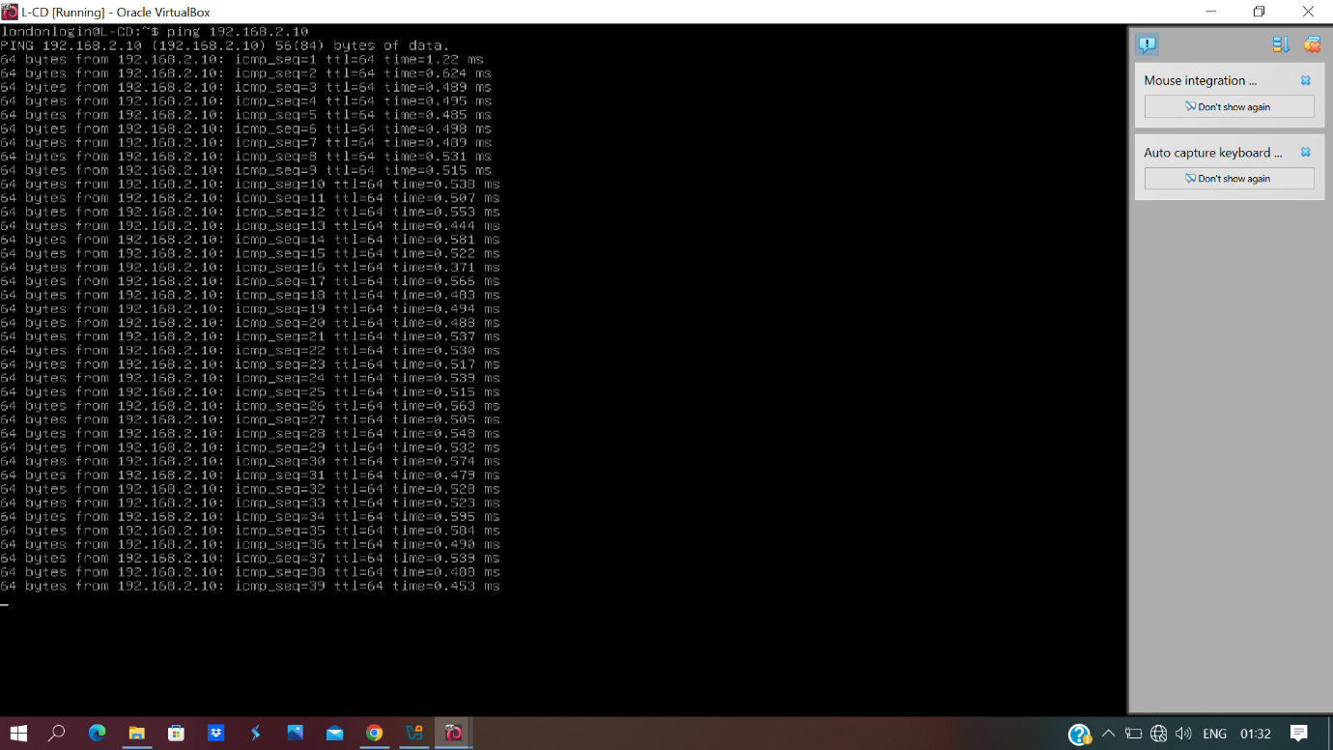

--------------------------------------------------------------------------------------------------------------------------------------------------------------------------------------------------------------------------------------------------------------------------------------------------------------------------------------------------------------------------------------------------------------------------------------------------------------------------------------------------------------------------------------------------------

TASK 2:

2.1) Setup Security-focused Operating System of your choice
A security-focused operating system was deployed to support the security assessment of the SWANSEA.ACCA network. In this assessment, Kali Linux was used as the testing platform because it provides suitable tools for network discovery, vulnerability assessment and ethical hacking activities. The virtual machine was connected to the Swansea network segment and configured with an internal IP address so that it could communicate with hosts in both the Swansea and London locations.
Note: Due to a technical issue with the original Kali 2019 virtual machine, it was replaced with a Kali 2026 virtual machine during the assessment process. As a result, the ip addr screenshot was captured from the replacement system, while the connectivity test screenshots were taken from the original system. The differing terminal hostnames reflect this change only and do not affect the validity of the demonstrated network connectivity.

IP Address Configuration
Figure 1 shows the IP address configuration of the security-focused operating system. The ip address command was executed in the terminal to verify that the machine had been assigned a valid network configuration within the Swansea network.
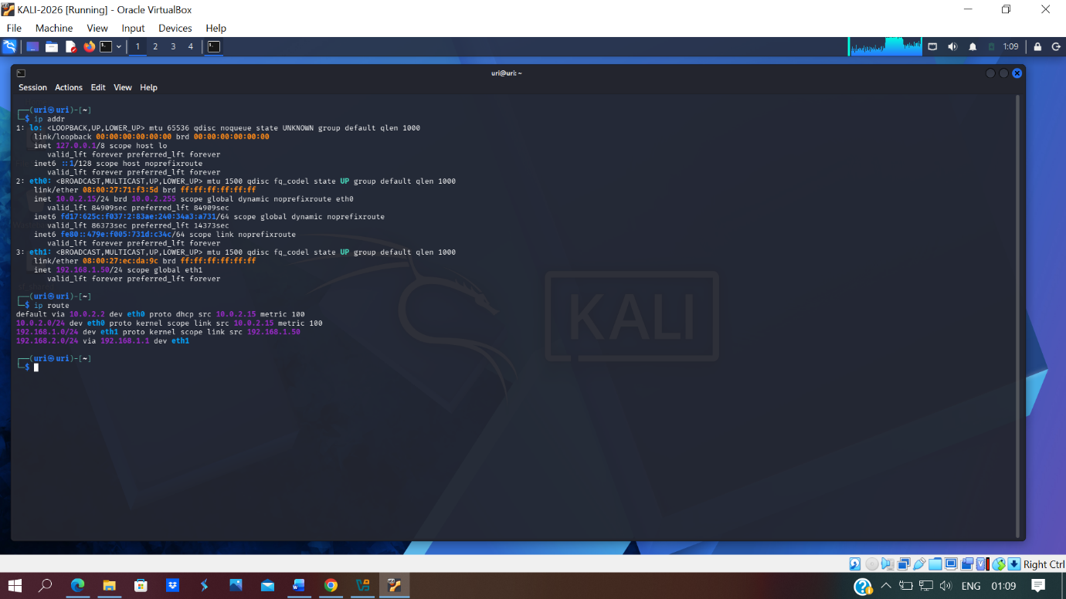
Figure 1: IP address configuration of Kali Linux
The output confirms that the Kali Linux machine was successfully configured with the IP address 192.168.1.50 on the eth1 interface. This verified that the system was active on the internal Swansea network and ready to communicate with other devices in the environment. This step was important because the security-focused operating system needed internal access in order to perform further assessment activities across both network locations.

Ping Test to Swansea Server
Figure 2 shows the connectivity test from the security-focused operating system to the Swansea server. A ping command was used to verify that the testing machine could reach the host successfully across the internal network.
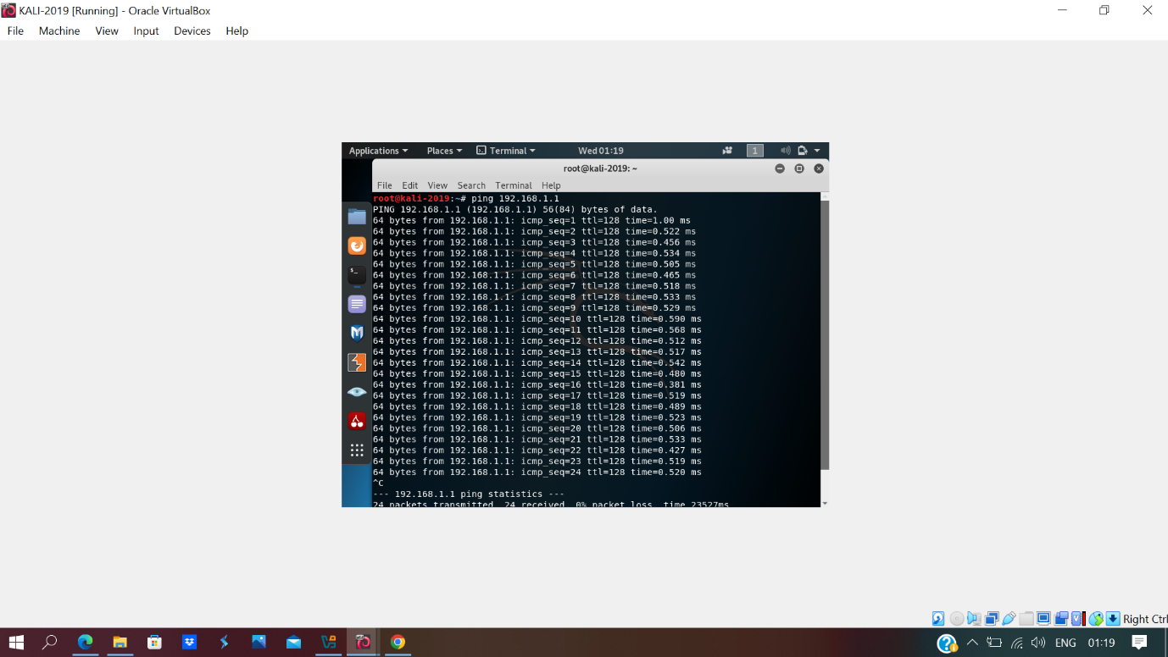
Figure 2: Ping test from Kali Linux to Swansea server

The result shows that communication with the Swansea server at 192.168.1.1 was successful. The successful replies confirmed that the security-focused operating system had network access to critical systems within the Swansea site. This demonstrated that the machine had been connected correctly and could interact with local hosts for assessment purposes.

Ping Test to Swansea Client
Figure 3 shows the connectivity test from the security-focused operating system to the Swansea client device. This test was carried out to confirm that communication was available not only to servers but also to endpoint devices within the same site.
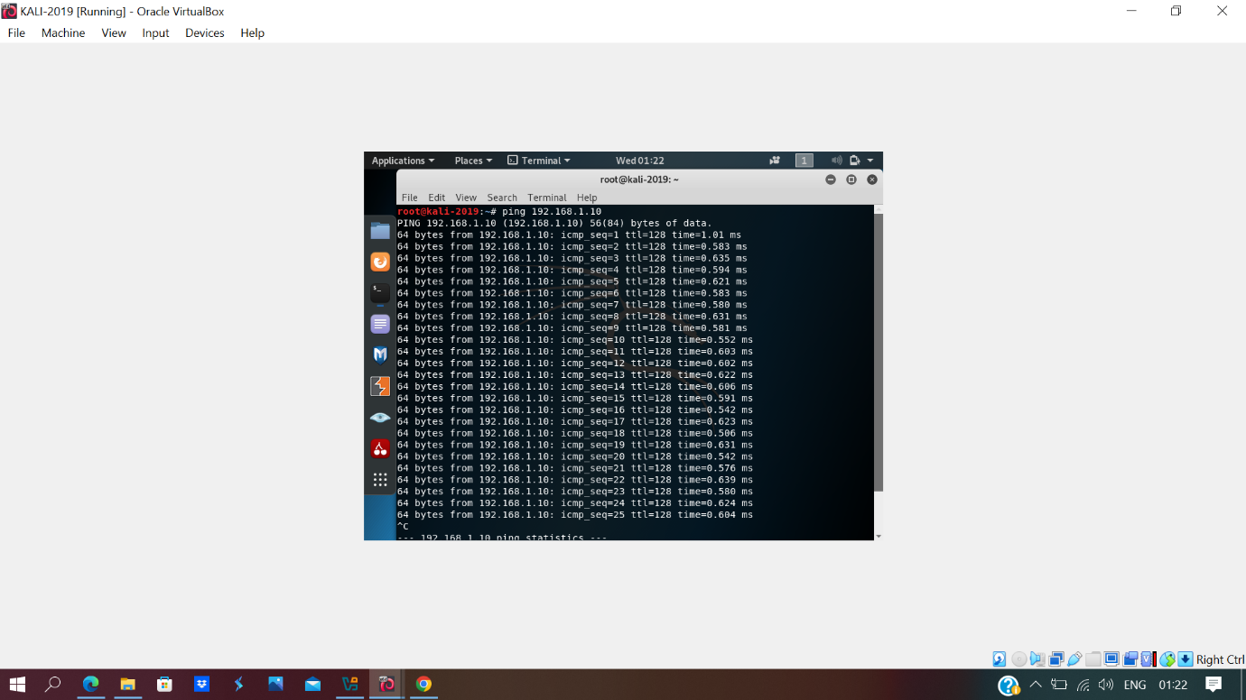
Figure 3: Ping test from Kali Linux to Swansea client

The successful ping responses confirm that the testing machine was able to communicate with the Swansea client at 192.168.1.10. This indicates that the local internal network configuration was functioning correctly and that the security-focused operating system could reach user devices within the domain environment.

Ping Test to London Server
Figure 4 shows the connectivity test from the security-focused operating system to the London server. This was performed to verify that the Swansea-connected testing machine could also communicate with devices located across the site-to-site VPN connection.

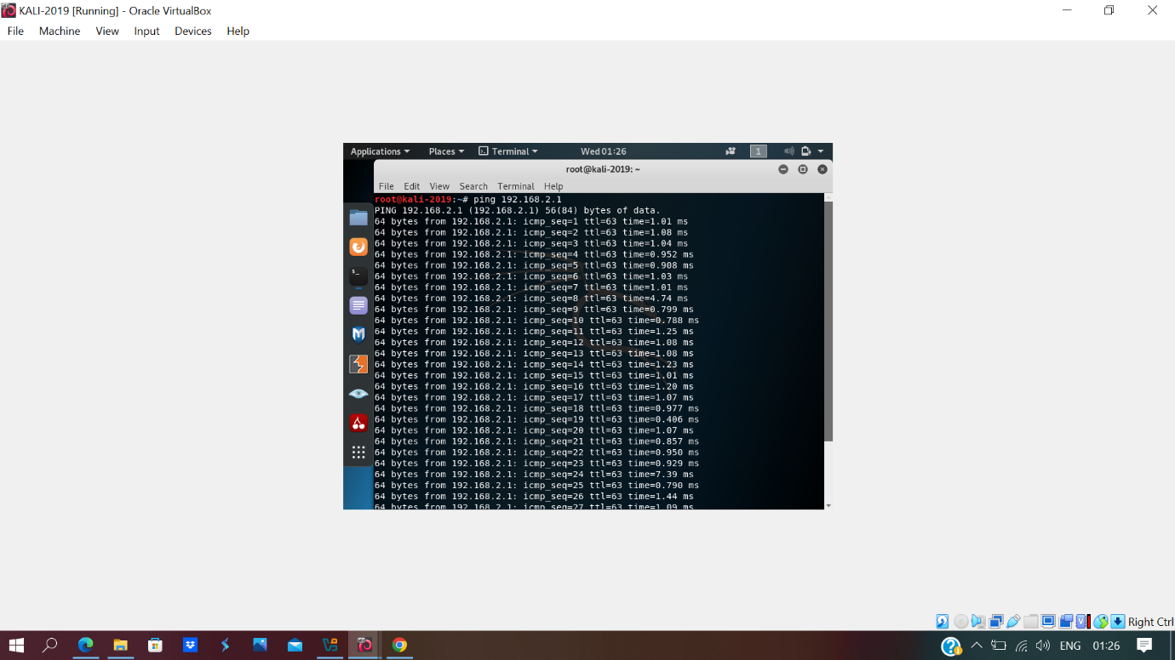
Figure 4: Ping test from Kali Linux to London server

The successful response confirms that the London server at 192.168.2.1 was reachable from the security-focused operating system. This demonstrates that the VPN connection between Swansea and London was operational and that the testing machine had visibility across both sites. This was necessary because the vulnerability assessment was required to cover the whole SWANSEA.ACCA network.

Ping Test to London Client
Figure 5 shows the connectivity test from the security-focused operating system to the London client device. This final test was completed to ensure full reachability between the testing system and endpoint devices in the remote site.

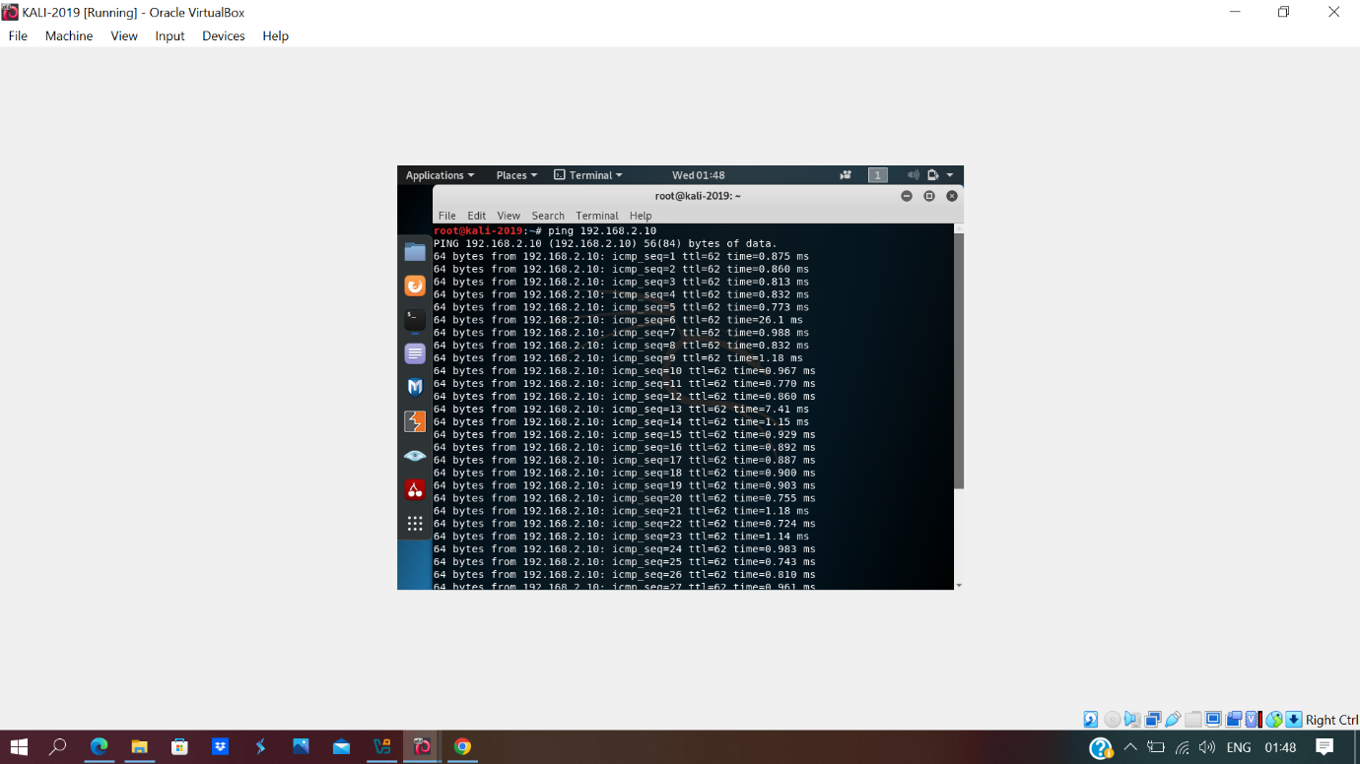
Figure 5: Ping test from Kali Linux to London client

The successful ping output confirms that the London client at 192.168.2.10 was reachable from the Kali Linux machine. This verified full communication between the testing platform and hosts in both Swansea and London. As a result, the security-focused operating system was fully prepared for the next stage of the assessment, including information gathering and vulnerability identification.

Conclusion
In conclusion, the security-focused operating system was successfully deployed and configured within the Swansea network. The IP configuration was verified using the ip address command, and connectivity tests confirmed successful communication with servers and clients in both Swansea and London. This demonstrated that the testing machine was correctly positioned within the enterprise environment and ready to support the vulnerability assessment activities in the following task.

2.2 Vulnerability Assessment:

Introduction
This task focused on assessing the vulnerabilities present within the SWANSEA.ACCA network across both the Swansea and London locations. The purpose of the assessment was to gather technical information about the network, identify active hosts, detect open ports and running services, and determine potential security weaknesses affecting the environment. Manual and automated vulnerability assessment techniques were used in order to evaluate the security posture of the network and to classify the identified vulnerabilities according to their severity. In line with the assessment requirements, the vulnerabilities were grouped into High, Medium and Low severity categories to support later exploitation and mitigation activities.

Information gathering was carried out from the Kali host using Nmap. Host discovery identified live systems on both the Swansea and London networks, and service/version scans were then performed against the discovered hosts to identify exposed ports, services, and protocols.
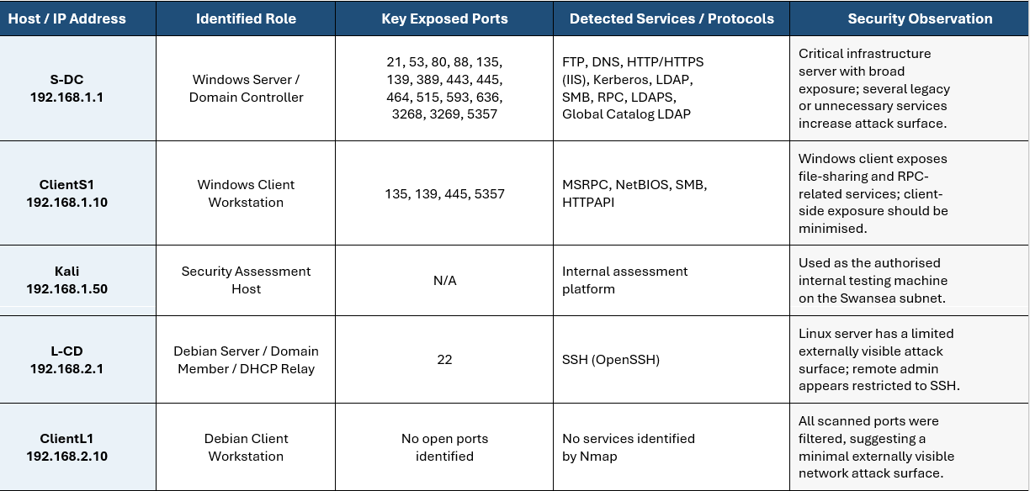

Categorised Vulnerability Assessment Findings
Automated vulnerability assessment was performed using Nessus Essential following manual network enumeration with Nmap. The Nessus results provided more specific evidence of insecure configurations and service-related weaknesses across the SWANSEA.ACCA environment. On the S-DC host (192.168.1.1), Nessus identified medium-severity findings including IP Forwarding Enabled, Echo Service Detection, Quote of the Day (QOTD) Service Detection, and Chargen-related exposure, together with additional grouped Windows, SMB, SSL and TLS issues. On ClientS1 (192.168.1.10), Nessus identified SMB Signing not required as a medium-severity finding and ICMP Timestamp Request Remote Date Disclosure as a low-severity finding. These automated results were correlated with the Nmap enumeration results and then prioritised into High, Medium and Low categories for remediation and demonstration.

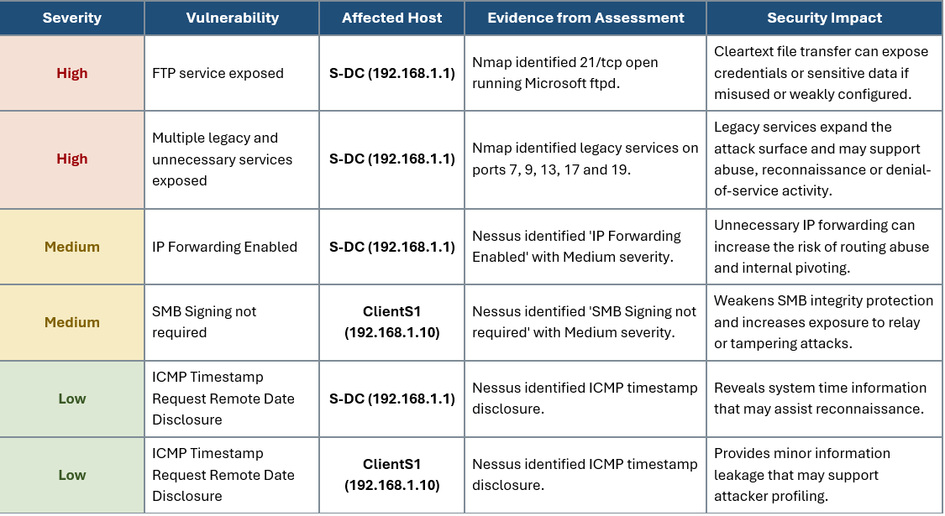

Evidence:

Nmap evidence: Live Hosts
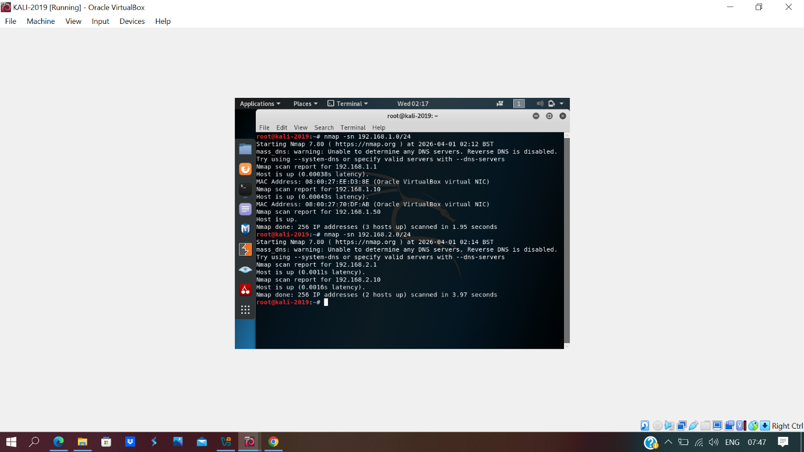

Nmap evidence: S-DC
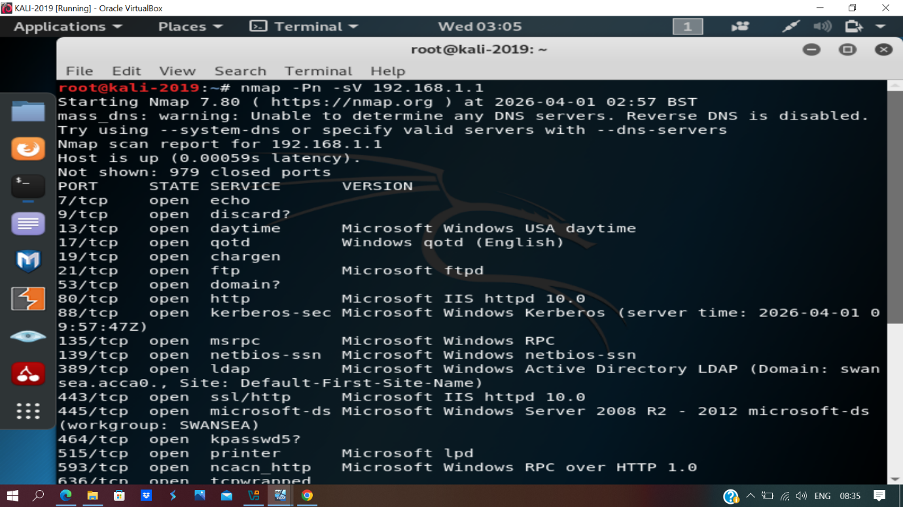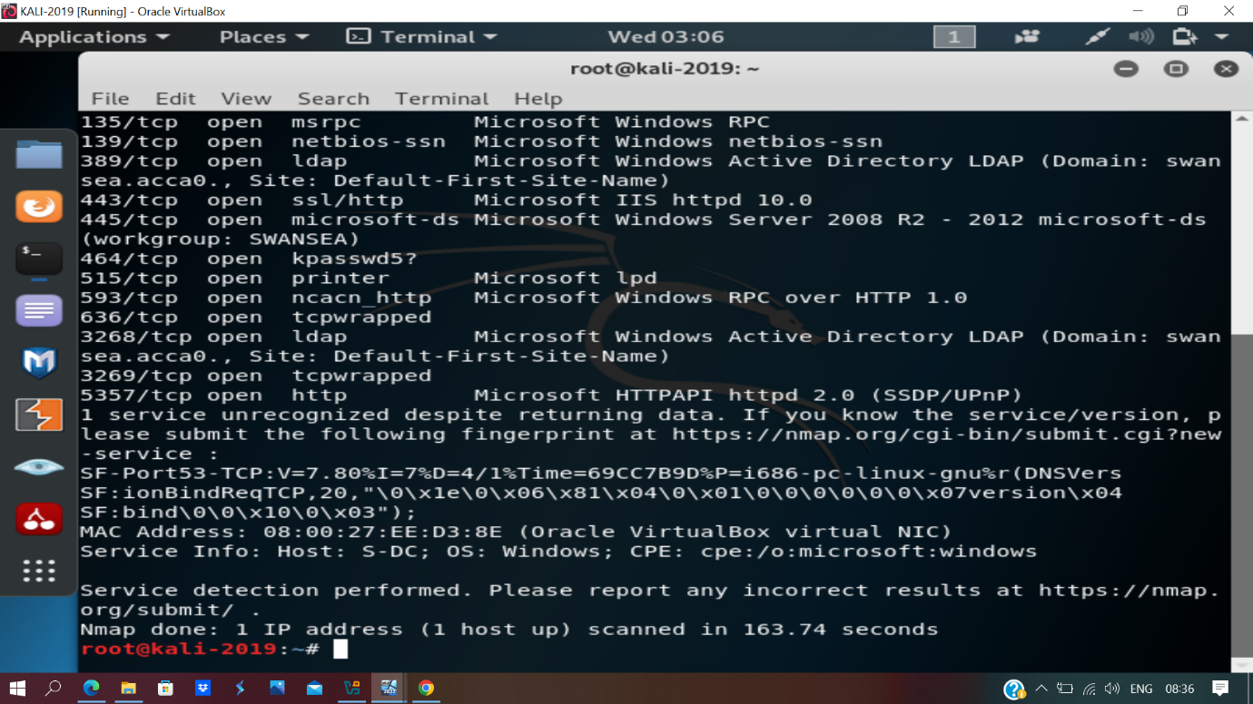

Nmap evidence: L-CD
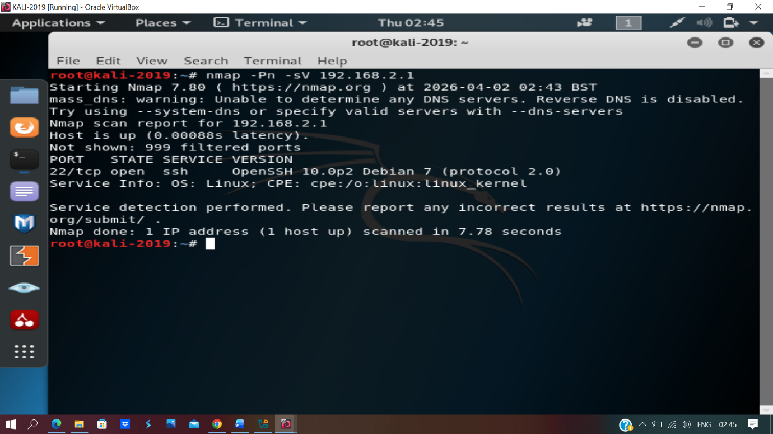

Nmap evidence: ClientS1
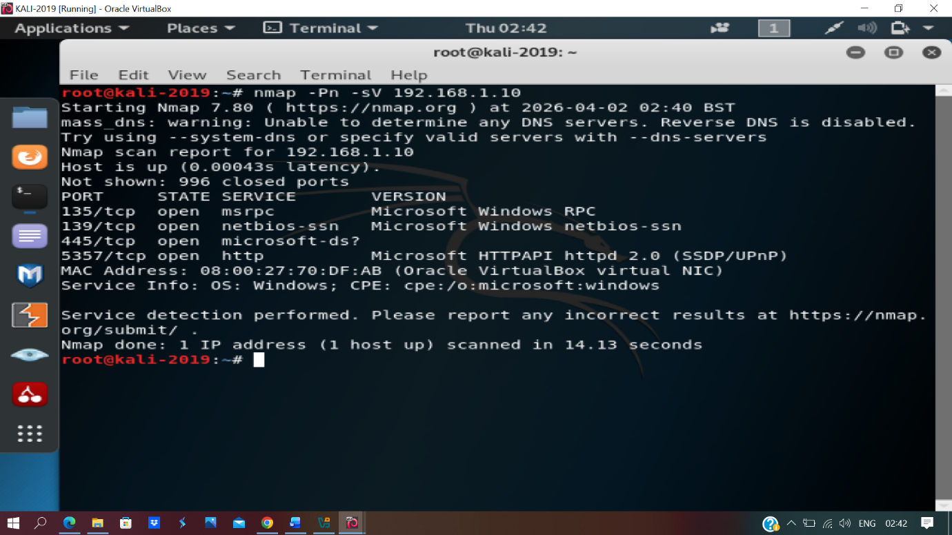

Nmap evidence: ClientL1
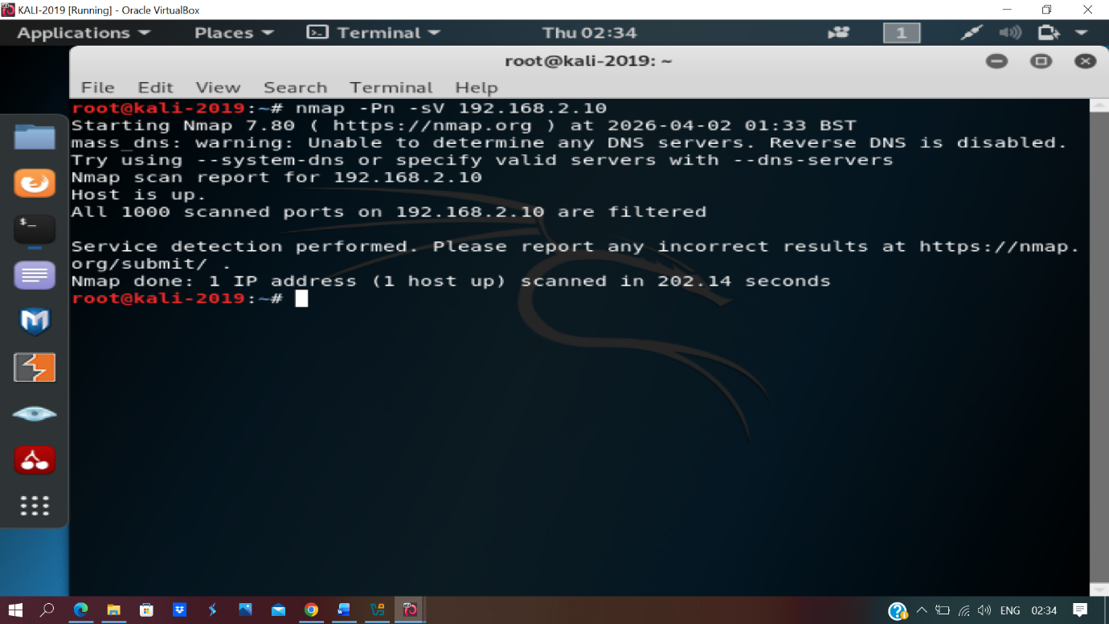

Nessus evidence: S-DC
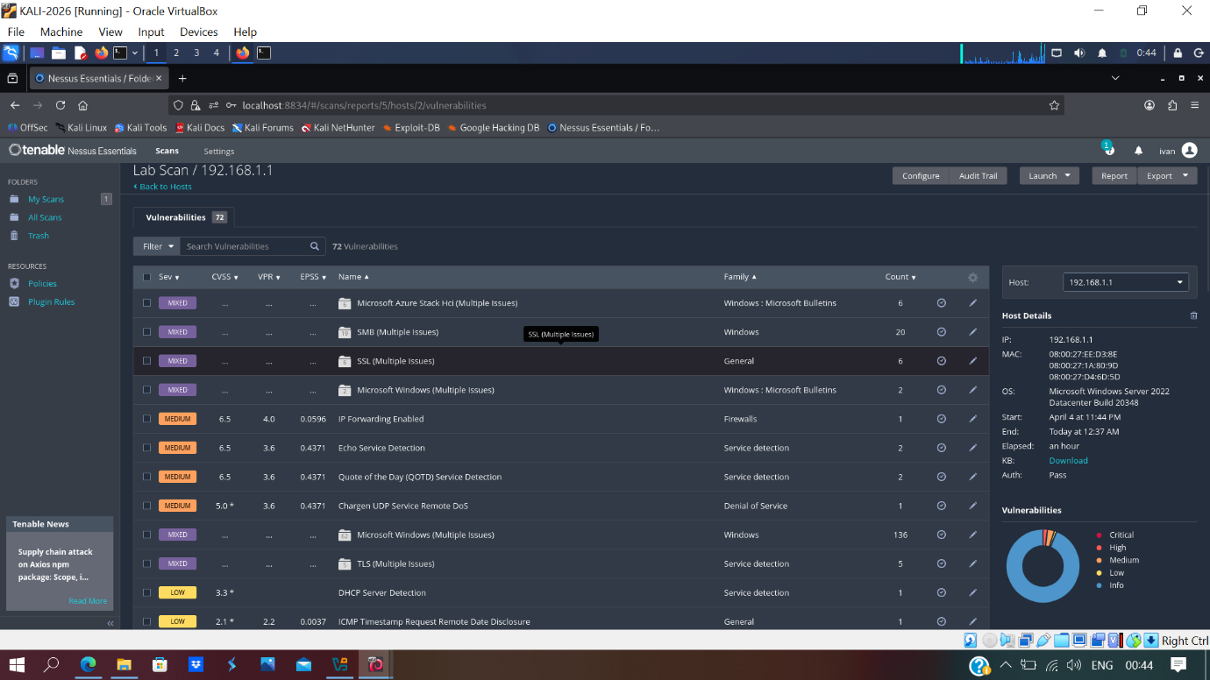

Nessus evidence: L-CD
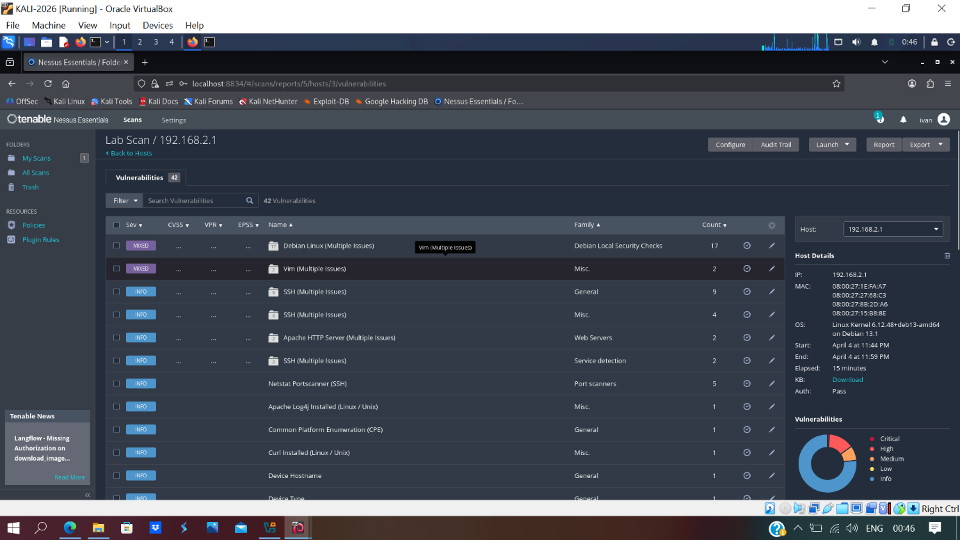

Nessus evidence: ClientS1
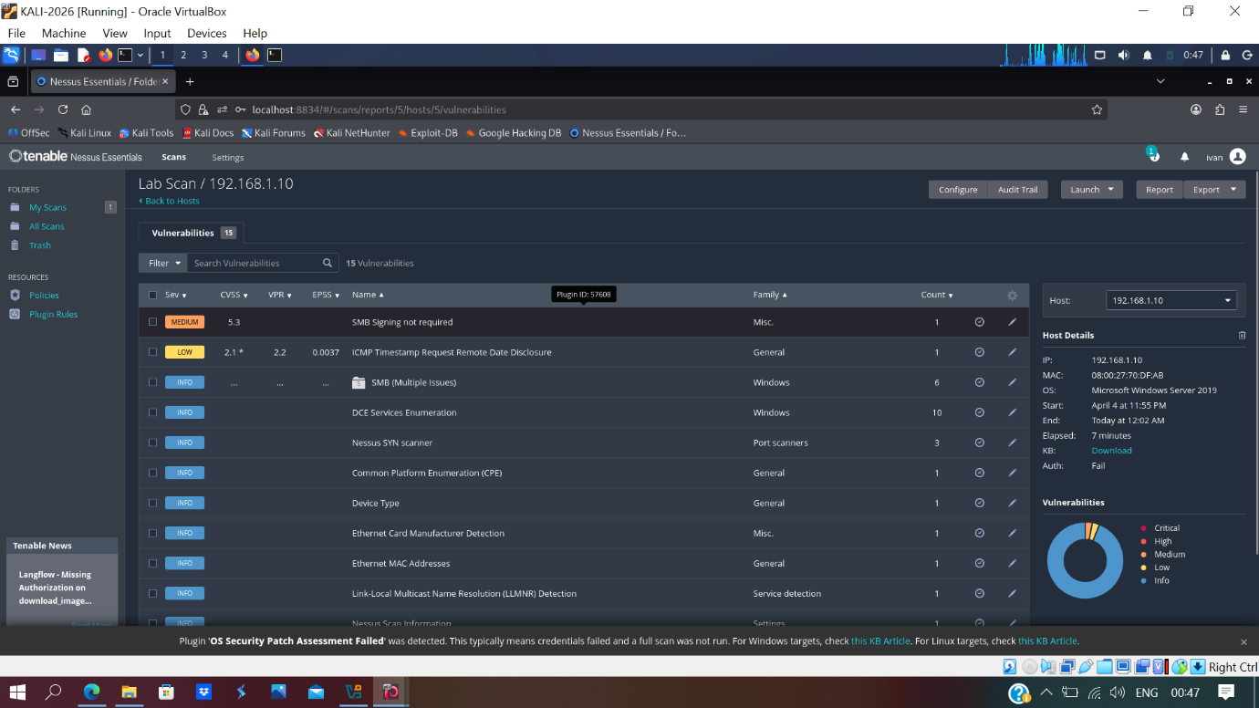

Nessus evidence: ClientL1
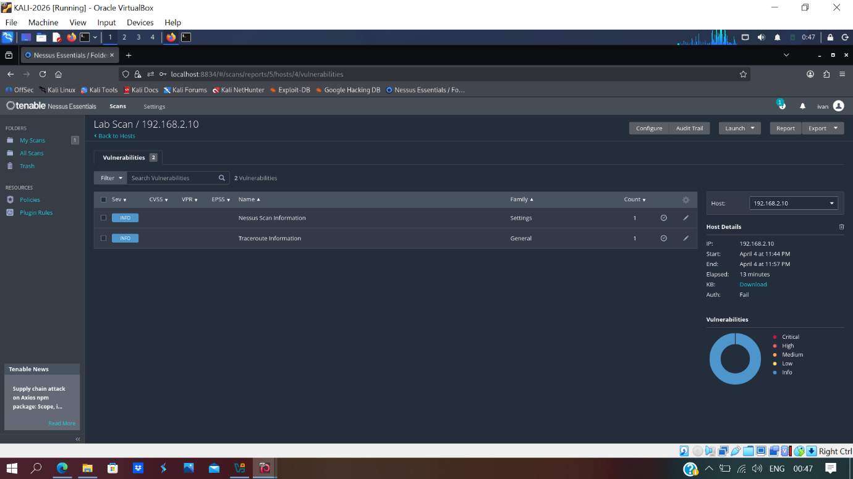

TASK 3:

3.1 Ethically Hacking SWANSEA.ACCA Network

Introduction
Following the vulnerability assessment stage, a controlled ethical hacking was conducted within the SWANSEA.ACCA environment in order to validate the practical impact of the identified weaknesses. The purpose of this task was to determine whether a selected vulnerability could be exploited from the internal assessment machine and to assess the extent of unauthorised access that could be achieved. In this case, the selected target was the S-DC server (192.168.1.1), and the chosen weakness was the exposed FTP service identified during the earlier Nmap assessment. This task focused on demonstrating the exploitation of that service and evaluating the post-exploitation impact in a controlled and authorised manner.

3.1 Exploitation
The exploitation stage focused on the FTP service running on the S-DC host (192.168.1.1). During the earlier information-gathering and manual scanning stage, it was identified that port 21/TCP was open and running Microsoft FTP Service. Because FTP is an insecure legacy protocol and should not normally be exposed on a critical domain-related server, this finding was selected for further testing in order to confirm whether it created a real security risk.

Evidence of Vulnerability Identification
Figure 1 shows the Nmap scan results of the target server. The scan confirmed that port 21/TCP was open and that the host was running Microsoft ftpd.
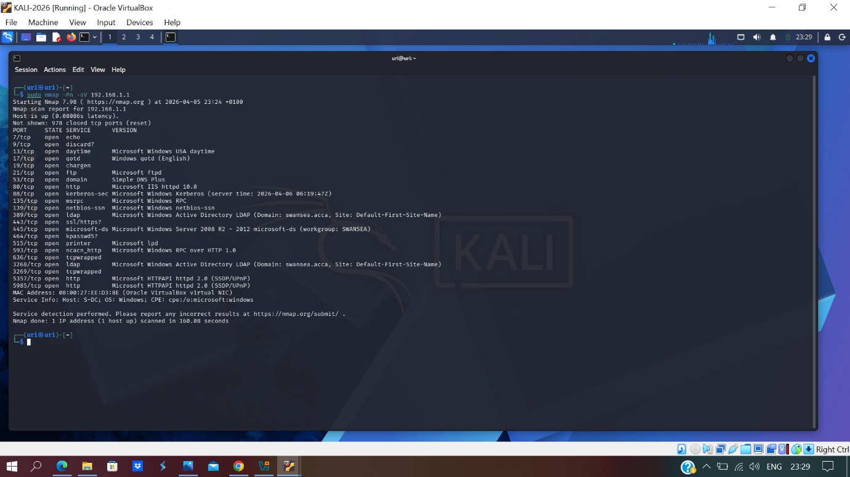

The scan results confirmed that the target exposed an active FTP service. This was significant because FTP transmits data insecurely and, if misconfigured, may permit unauthorised access to server resources. The presence of the FTP service on a critical internal server increased the attack surface of the SWANSEA.ACCA environment and justified further exploitation testing [6].

Preparation of the Assessment Machine
Figure 2 shows the preparation of the Kali Linux assessment machine for the exploitation exercise. In this stage, the FTP client package was verified and made available on the attacker system.
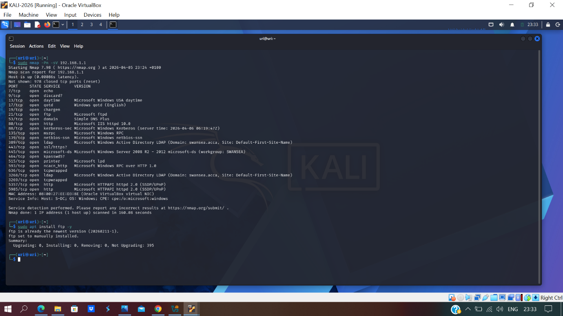

This step confirmed that the Kali Linux machine had the required FTP client tools available in order to interact with the service running on the target server. Preparing the assessment machine ensured that the exploitation exercise could be conducted in a controlled and authorised manner from within the internal network.

Establishing the FTP Connection
Figure 3 shows the successful establishment of a connection from the Kali Linux assessment machine to the FTP service on 192.168.1.1.
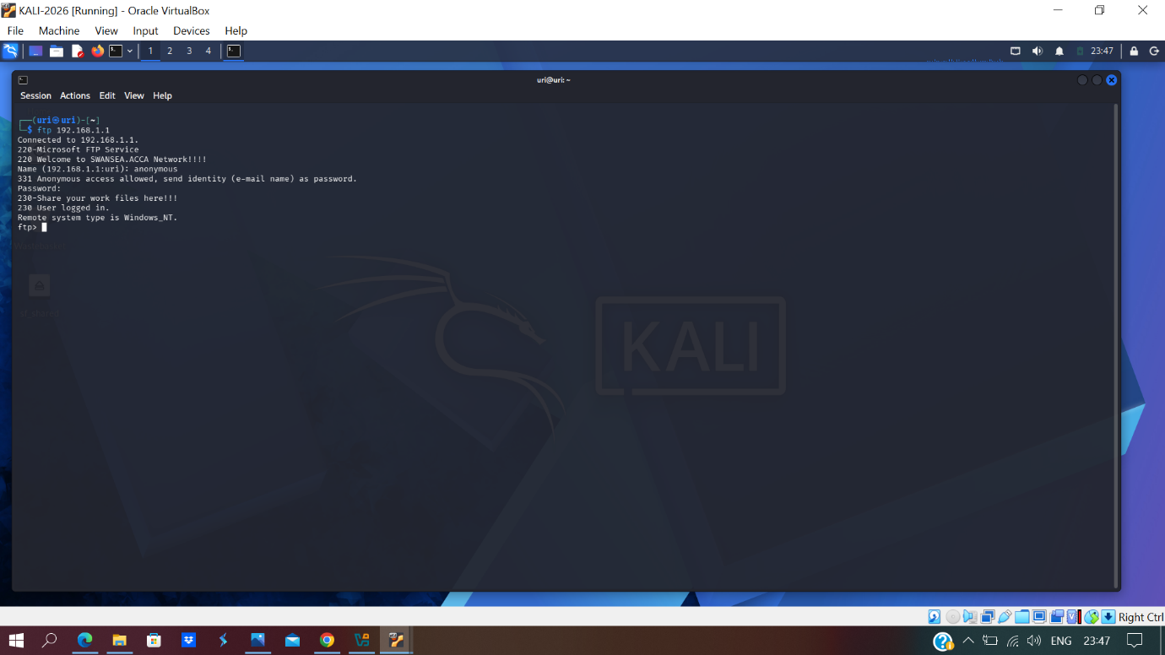

The screenshot confirms that the FTP service on the target host accepted the connection and permitted anonymous login. This was a serious security weakness because it showed that an unauthorised user could access the server without valid credentials. The successful login demonstrated that the vulnerability was not theoretical and could be exploited in practice from within the internal network.

Listing Files on the Target System
Figure 4 shows the remote file listing obtained after access to the FTP service had been established.
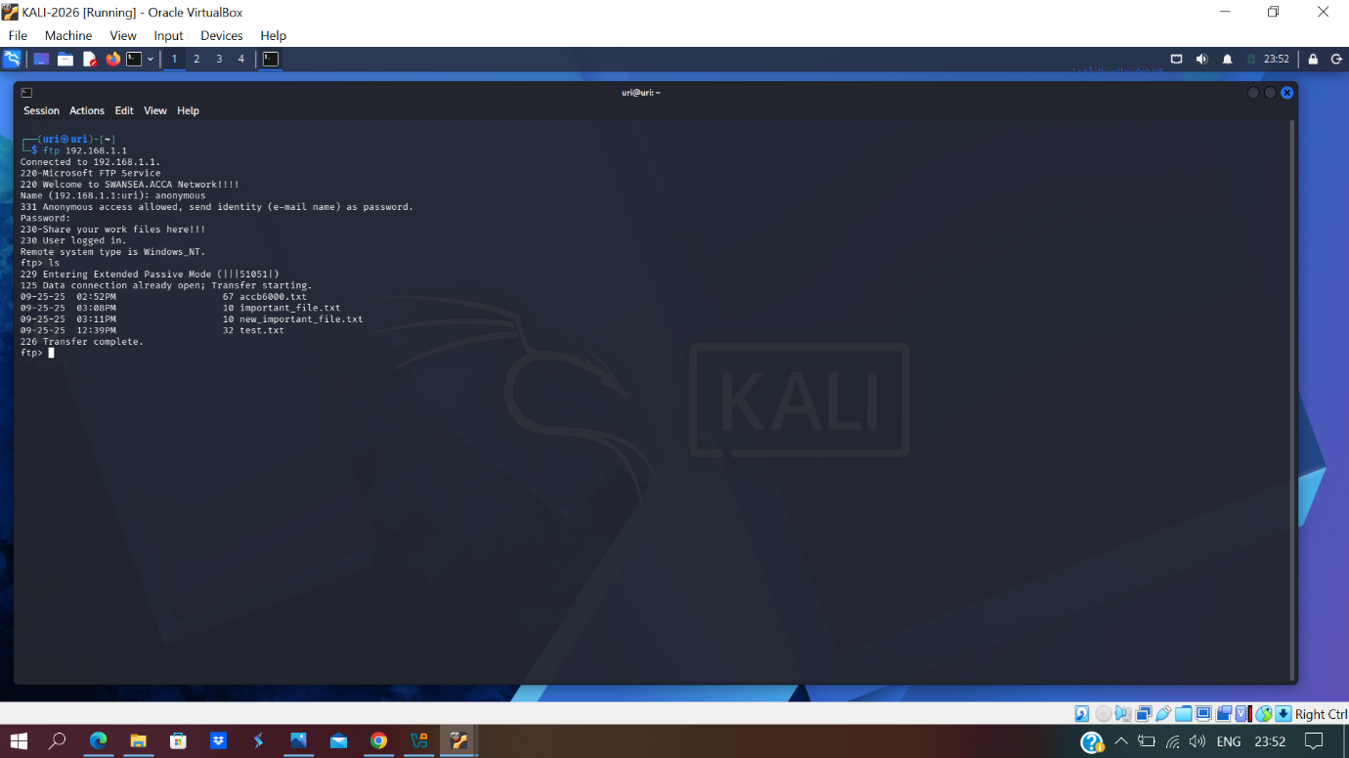

The directory listing confirmed that files stored on the target server were visible to the unauthorised user. This demonstrated that the exposed FTP service did not only allow connection but also allowed an attacker to enumerate available files on the system. From a security perspective, this increased the risk of information disclosure and exposed the contents of the server to unauthorised inspection.

Downloading Files from the Target
Figure 5 shows the successful retrieval of files from the target server to the Kali Linux assessment machine.
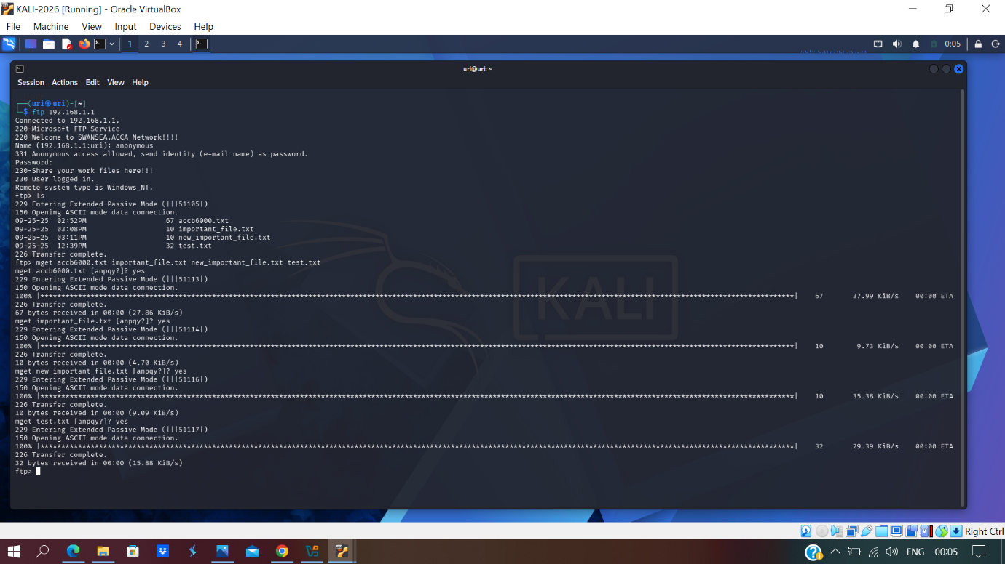

This screenshot provides the strongest evidence that the exploitation was successful. The unauthorised user was able to download multiple files from the S-DC server without the use of legitimate credentials. This confirmed a clear failure of access control and demonstrated that the exposed FTP service allowed sensitive information to be extracted from the server environment.

Verification of Downloaded Files
Figure 6 shows the downloaded files now present on the Kali Linux assessment machine after the transfer was completed.
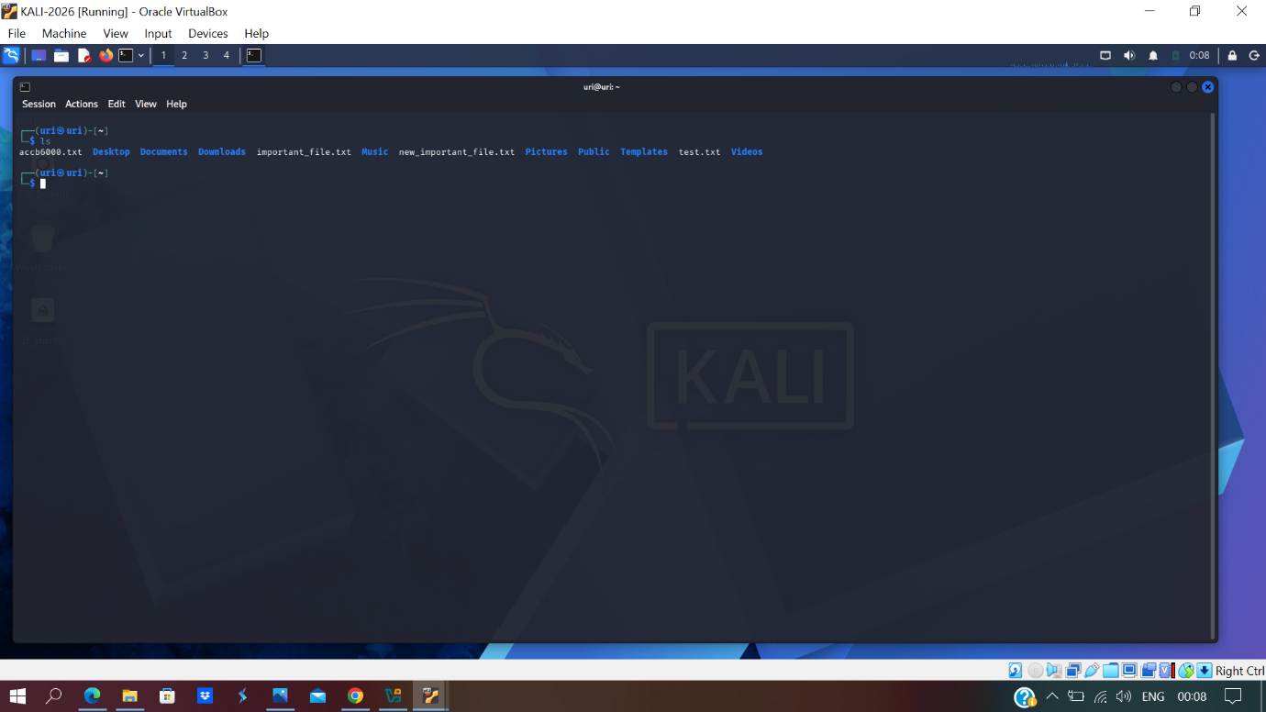

The successful presence of the transferred files on the attacker machine confirmed that the exploitation had practical impact. This demonstrated that the attacker was not limited to viewing file names only but was able to retrieve data from the target system for further inspection. Such access could be highly dangerous in a real enterprise environment, particularly when the affected host provides critical infrastructure services.

Exploitation Summary
Overall, the exploitation attempt was successful. The FTP service on the S-DC host was found to permit anonymous access, allowing the attacker to establish a session, list the remote directory contents and download files from the server without authorisation. This confirmed that the vulnerability posed a real and immediate risk to the confidentiality of data hosted on the target machine. Because the affected server formed part of the core SWANSEA.ACCA infrastructure, the successful exploitation demonstrated a significant security weakness requiring urgent remediation.

3.2 Post-exploitation
Following successful exploitation of the FTP service, the post-exploitation stage focused on assessing the value and sensitivity of the information that had been obtained. The objective at this stage was not to damage or alter the server, but to evaluate the extent of unauthorised access and determine whether the retrieved files contained information that could support further compromise of the network.

Review of Extracted Data
Figure 7 shows the contents of the files after they had been downloaded from the target server and opened on the Kali Linux machine.
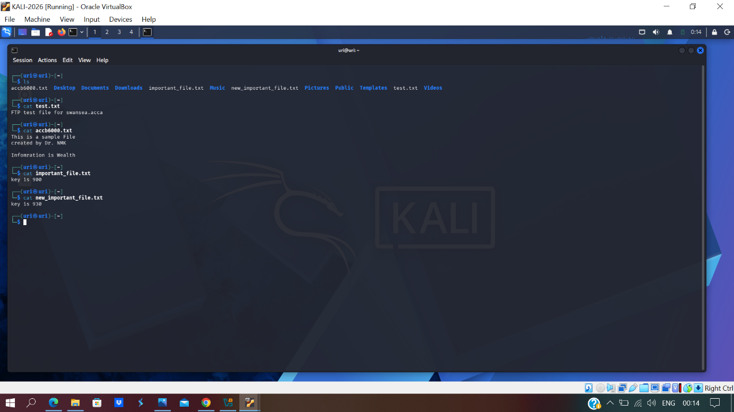

The screenshot confirms that the downloaded files contained readable information, including internal text content and key-related values. This demonstrated that the attack resulted in meaningful information disclosure rather than simple access to empty or irrelevant files. Even though full administrative control of the target host was not obtained, the unauthorised disclosure of internal files still represented a serious security issue.

Post-Exploitation Analysis
The post-exploitation findings showed that the impact of the vulnerability extended beyond simple service exposure. By accessing and retrieving files from the server, an attacker could potentially obtain internal organisational data, configuration information, usernames, notes, or other material useful for further attacks. In a real-world enterprise environment, such information could support reconnaissance, lateral movement, privilege escalation, or the planning of additional attacks against connected systems in the domain.
The exploitation did not lead to full system takeover; however, the ability to read and extract files from a critical server without authentication was sufficient to demonstrate a substantial breach of confidentiality. This justified the classification of the FTP exposure as a high-severity vulnerability, because it allowed unauthorised access to server resources and exposed potentially sensitive information to an internal attacker.

Task 3 Conclusion
In conclusion, the ethical hacking exercise successfully demonstrated the exploitation of the exposed FTP service on the S-DC server (192.168.1.1). The assessment showed that an unauthorised user could connect through anonymous FTP access, view the contents of the remote directory, and download files from the server without valid credentials. The post-exploitation review confirmed that the retrieved files contained readable internal information, proving that the vulnerability had real security impact. This exercise demonstrated that the FTP configuration on the target server was insecure and required immediate remediation in order to protect the confidentiality of data within the SWANSEA.ACCA network.

4.1 Preventive Security Measures
Based on the results of the manual and automated vulnerability assessment, several preventive security measures were identified in order to reduce the attack surface of the SWANSEA.ACCA network and mitigate the vulnerabilities discovered during the earlier stages of the assessment. These measures focused on hardening exposed systems, restricting unauthorised access, improving secure communication, and increasing monitoring capability across the environment. Particular attention was given to the S-DC server, as it presented the largest attack surface and was shown during exploitation testing to expose sensitive information through insecure service configuration [2], [3].

Implemented and Recommended Security Measures

Server Hardening:
- Disable the exposed FTP service on the S-DC server if it is not required for operational purposes.
- If file transfer is required, replace insecure FTP with a more secure protocol such as SFTP.
- Remove anonymous FTP access to prevent unauthorised users from connecting without valid credentials.
- Review and restrict file permissions so that only authorised users can access sensitive server data.
- Disable unnecessary legacy services such as echo, discard, daytime, QOTD and chargen-related services to reduce the attack surface.

Patch Management and Secure Configuration
- Apply operating system and application updates regularly to reduce exposure to known vulnerabilities.
- Address the Windows-, SMB-, SSL-, and TLS-related weaknesses identified during the Nessus scan.
- Enable SMB signing where applicable to improve the integrity of SMB communications.
- Disable unnecessary IP forwarding unless it is specifically required for routing purposes.
- Review host configuration settings regularly to ensure that insecure defaults are removed.

Firewall and Access Control
- Configure host-based and network-based firewall rules to allow access only to trusted systems and required ports.
- Restrict access to administrative and sensitive services according to the principle of least privilege.
- Use access control lists (ACLs) to ensure that only approved hosts or administrators can communicate with critical services.
- Limit unnecessary communication between Swansea and London hosts where business access is not required.

Encryption and Secure Communication
- Avoid the use of insecure legacy protocols such as FTP for transferring data.
- Use encrypted communication methods to protect sensitive data in transit [7]
- Maintain secure communication across the site-to-site VPN between Swansea and London.
- Configure web services to use secure TLS settings and disable weak or outdated protocols.

Monitoring and Traffic Analysis
- Use Wireshark or similar monitoring tools to capture and analyse suspicious traffic [8]
- Monitor for unusual FTP activity, failed connections, and unexpected communication between hosts.
- Use packet capture and traffic analysis to support earlier detection of attacks and incident investigation.
- Review logs and monitoring output regularly to identify abnormal behaviour on critical systems.

Summary
Overall, the preventive security measures identified in this assessment were designed to address the vulnerabilities prioritised earlier in the report. By disabling insecure services, strengthening authentication and access control, applying secure configuration changes, improving encryption, and increasing monitoring, the overall security posture of the SWANSEA.ACCA network can be significantly improved. These measures reduce the likelihood of unauthorised access, limit opportunities for lateral movement, and provide stronger protection for critical systems and organisational data across both network locations.

Conclusion
In conclusion, the preventive security measures for the SWANSEA.ACCA network were aimed at reducing the risks identified during vulnerability assessment and exploitation testing. The most important actions included restricting insecure services such as FTP, strengthening system and network configuration, improving secure communications, and introducing monitoring to detect suspicious activity. Together, these measures provide a stronger defensive posture and help protect the enterprise network against future compromise.

References

[1] | K. Scarfone, M. Souppaya, A. Cody and A. Orebaugh, "Technical Guide to Information Security Testing and Assessment," National Institute of Standards and Technology, Gaithersburg, MD, USA, 2008.
[2] | K. Scarfone and W. Jansen, "Guidelines on Firewalls and Firewall Policy," National Institute of Standards and Technology, Gaithersburg, MD, USA, 2009.
[3] | K. Scarfone, W. Jansen and M. Tracy, "Guide to General Server Security," National Institute of Standards and Technology, Gaithersburg, MD, USA, 2008.
[4] | G. F. Lyon, Nmap Network Scanning: The Official Nmap Project Guide to Network Discovery and Security Scanning, Sunnyvale, CA, USA: Insecure.Com LLC, 2009.
[5] | Tenable, "Welcome to Tenable Nessus 10.11.x," 2026. [Online]. Available: https://docs.tenable.com/nessus/10_11/.
[6] | M. Allman and S. Ostermann, "FTP Security Considerations," Internet Engineering Task Force, Fremont, CA, USA, 1999.
[7] | K. A. McKay and D. F. Cooper, "Guidelines for the Selection, Configuration, and Use of Transport Layer Security (TLS) Implementations," National Institute of Standards and Technology, Gaithersburg, MD, USA, 2019.
[8] | Wireshark Foundation, "Wireshark User's Guide," 2026. [Online]. Available: https://www.wireshark.org/docs/wsug_html_chunked/.

