


Quality Management Failures
in Healthcare – Lessons from the Lucy Letby Case
Service improvement report

Module: Quality Assurance and Service Improvements
Module Code: LCHS7006_LON
Lecturer: Dr. Oluwadamilola Tayo
Student: Nevyana Nikolova | ID: 2111481

Table of Contents

Background and Justification of the Problem: The Lucy Letby Case 3
Integrated Application of Analytical Frameworks to Identify Root Causes 4
Fishbone (Ishikawa) Diagram Analysis 4
The Donabedian Model 7
SWOT Analysis 8
Service Improvement Recommendations Using Quality Frameworks 11
Redesigning Incident Reporting Pathways Using Lean Management 11
Reducing Variation in Neonatal Mortality Review Using Six Sigma 12
Strengthening Independent Whistleblowing Systems Using PDSA (Plan-Do-Study-Act) 13
Embedding Leadership Safety Culture Training Using PDCA (Plan-Do-Check-Act) 14
Conclusion 16
References 17

- Background and Justification of the Problem - The Lucy Letby Case

The case of Lucy Letby represents one of the most serious failures in quality management, clinical governance, and organisational oversight within the National Health Service (NHS) in recent history. Between June 2015 and June 2016, Letby deliberately harmed infants in the neonatal intensive care unit (NICU) at the Countess of Chester Hospital. Her conviction in August 2023 for the murder of seven infants and the attempted murder of six others highlights not only extreme individual criminality but also significant systemic failures that enabled such actions to persist over an extended period.
Central to this case is the concept of quality assurance, defined as the systematic processes and frameworks used to ensure that healthcare services consistently meet established standards of safety, effectiveness, and patient care. It involves continuous monitoring, evaluation, and improvement of clinical practices to minimise risk and safeguard patients. In the Letby case, these processes failed to function effectively, as early warning signs were neither adequately recognised nor acted upon, resulting in sustained harm within a highly vulnerable patient population.
Although Letby’s actions were the direct cause of harm, however, an exclusively individualised explanation is insufficient to explain the scale and duration of the failures observed. Multiple organisational systems broke down simultaneously, with weaknesses evident in clinical monitoring, incident reporting mechanisms, managerial oversight, and external regulatory processes (NHS England, 2015). Of particular concern was the failure to respond appropriately to concerns raised by consultants regarding an unusual increase in neonatal deaths. These concerns were not effectively escalated or investigated, reflecting not only procedural shortcomings but also deeper cultural issues within the organisation.
Evidence suggests that organisational priorities, including the protection of institutional reputation and the management of internal conflict, took precedence over patient safety (Department of Health and Social Care, 2023). This reflects a culture in which staff concerns are undervalued, and escalation mechanisms fail to operate as intended hence it raise questions about psychological safety within healthcare teams and whether staff feel empowered to challenge unsafe practices. Although governance framework are present however, the failure to act on early indicators of risk suggests they were not effectively implemented in practice. From a public health perspective, this case highlights broader patient safety challenges within complex healthcare systems. The World Health Organisation (2018) identifies patient safety as a global priority, noting that preventable harm remains a leading cause of death worldwide reinforcing the Letby case which demonstrates how failures in communication, accountability, and organisational learning can persist despite formal regulatory structures.
This report adopts a service improvement approach, focusing on the systemic failure to identify, investigate, and respond to patterns of harm within a neonatal care setting. It will utilise key analytical frameworks, including the Fishbone (Ishikawa) Diagram, the Donabedian Model, and SWOT analysis, to critically examine the root causes of failure. These frameworks will support a structured evaluation of how organisational, cultural, and systemic factors interact to produce adverse outcomes. The report will develop recommendations guided by the Plan–Do–Study–Act (PDSA) cycle, Lean Management, and Six Sigma to strengthen clinical governance, enhance patient safety, and reduce the likelihood of similar failures occurring in the future.

- Integrated Application of Analytical Frameworks to Identify Root Causes

2.2 Fishbone (Ishikawa) Diagram Analysis

The Fishbone (Ishikawa) Diagram is a quality improvement tool used to identify root causes of a problem by categorising contributing factors into key themes (Gabbay and Le May, 2020). In the Lucy Letby case, the central issue, the failure to detect and prevent infant harm, can be examined across six categories: people, process, policy, environment, technology, and management.

Figure 1: Fishbone diagram applied to the Lucy Letby Case
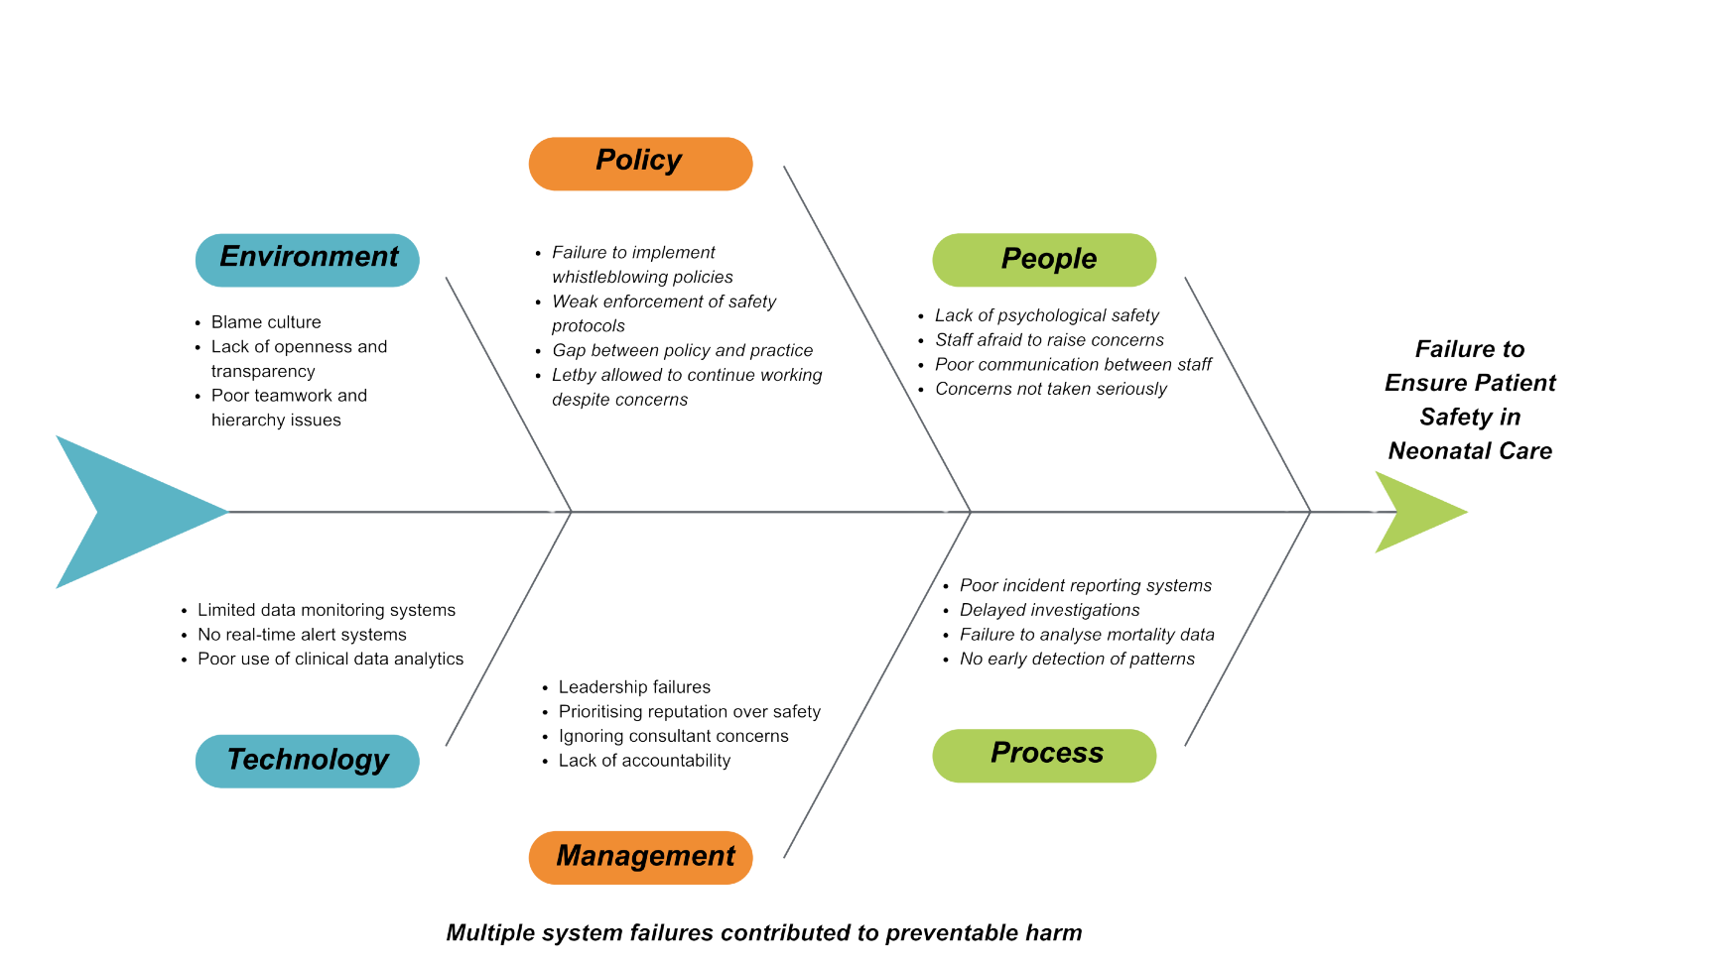

The diagram demonstrates that the failure was multi-factorial, involving organisational, cultural, and technological weaknesses rather than a single cause.

People
A major contributing factor was the lack of a psychologically safe culture. Senior consultants raised concerns about unusual neonatal deaths; which were not effectively addressed and were reportedly met with resistance (DHSC, 2023). Psychological safety is essential for staff to speak up without fear as its absence likely suppressed critical safety concerns, reflecting wider issues within healthcare hierarchies where staff may feel unable to challenge decisions ((Edmondson, 2004; Dixon-Woods et al., 2014).

Process
There were significant failures in incident reporting and investigation processes. The NHS Serious Incident Framework requires a timely review of unexpected deaths (NHS England, 2015), yet in this case, mortality data were not analysed effectively to identify patterns. Delays in investigation prevented early intervention (Royal College of Nursing, 2020). This demonstrates a breakdown in the quality assurance process, where systems existed but were not used effectively.

Management
Leadership failures were a critical factor. Evidence suggests that hospital management prioritised organisational reputation over patient safety (DHSC, 2023). Leadership helps in shaping safety culture; where defensive behaviours are present, staff may feel discouraged from raising concerns (Mannion and Davies, 2018). The absence of supportive and transparent leadership significantly contributed to the failure to act on early warning signs (West et al., 2017).

Policy
Although policies such as Freedom to Speak Up exist to protect whistleblowers (NHS England, 2016), their implementation was ineffective. The continuation of Letby in clinical duties despite repeated concerns highlights a gap between policy and practice. Professional standards, such as the Nursing and Midwifery Council Code (2018), require staff to raise concerns, but without organisational support, these policies cannot function effectively (Buchan et al., 2019).

Environment and Technology
There was limited use of data monitoring systems to detect abnormal mortality trends. A more robust use of technology and data analytics could have identified patterns earlier. Additionally, the organisational environment did not support open communication or learning from incidents, further compounding risk.

Summary
The Fishbone analysis demonstrates that the failure was not the result of a single breakdown, but a complex and systemic collapse across multiple organisational levels. In line with the Swiss Cheese Model (Reason, 1990), interconnected weaknesses in culture, leadership, processes, and oversight aligned to create conditions in which harm could occur and persist undetected. Critically, this case illustrates that existing safety systems were not absent, but ineffectively implemented and poorly embedded within organisational practice.
This reinforces the need for a fundamental shift from individual blame to system-level accountability, where patient safety is actively prioritised through strong leadership, a psychologically safe culture, and robust governance mechanisms. Without addressing these underlying structural and cultural deficiencies, similar failures are likely to recur (Leape, 1994).
While helpful for categorising causes, the Fishbone Diagram can oversimplify complex healthcare systems by presenting factors as separate rather than interconnected. It lacks prioritisation, making it hard to identify which causes had the greatest impact. Therefore, it should be used alongside more systemic models.

  - The Donabedian Model

The Donabedian Model (Donabedian, 1988) provides a tripartite framework for evaluating quality in healthcare, comprising three interconnected dimensions: structure, process, and outcome. This model is widely regarded as one of the most influential theoretical contributions to healthcare quality assessment (Scally and Donaldson, 1998) and is particularly well-suited to analysing the systemic failures evident in the Letby case.

Structure refers to the organisational resources, governance arrangements, and physical or human infrastructure within which care is delivered. At Countess of Chester Hospital, significant structural deficiencies are apparent. These include an absence of robust board-level clinical governance mechanisms, a neonatal unit operating without sufficient independent oversight, and an organisational culture that was demonstrably not conducive to safety reporting (Thirlwall, 2024). The Care Quality Commission (CQC, 2018) has identified a persistent gap across NHS organisations between formal governance structures on paper and their operational effectiveness in practice. Structurally, the hospital lacked the foundational conditions necessary to prevent or detect harm. Aiken et al. (2012), in a major cross-national study of nurse staffing and patient outcomes across twelve countries, demonstrated that inadequate structural investment in nursing workforce and governance directly correlates with increased patient mortality, a finding with clear relevance to the staffing and oversight failures at Countess of Chester Hospital.

Process refers to the activities and interactions that comprise the delivery of care, including clinical decision-making, communication, and safety monitoring. In this case, process failures were extensive. The formal escalation pathway for raising patient safety concerns was not functioning effectively; despite repeated attempts by consultants to alert management, no formal Root Cause Analysis (RCA) was initiated until external pressure mounted (NHS England, 2015). The process of documenting and reviewing adverse events was inadequate, and the whistle-blowing procedure, a critical safety process, was not operationally effective in protecting those who raised concerns (Royal College of Nursing, 2020). Wachter and Pronovost (2009) argue that effective patient safety processes require a carefully calibrated balance between individual accountability and systemic no-blame frameworks; evidence from the Letby case suggests that neither accountability nor learning culture was effectively operationalised.

Outcomes in the Donabedian framework refer to the measurable effects of healthcare provision on patient health status. In the Letby case, outcomes were catastrophic: seven infants died, and six others sustained serious harm. Beyond these immediate clinical outcomes, broader organisational outcomes include the erosion of public trust in neonatal services, significant financial costs associated with investigation and litigation (DHSC, 2023), and lasting psychological harm to the families affected and healthcare staff who had raised unheeded concerns (Thirlwall, 2024). Patient Safety Learning (2020) notes that organisational failure to act on safety signals invariably generates cascading secondary harms, emotional, financial, and reputational, that compound the original patient harm many times over.
Although widely applied, the Donabedian Model is relatively linear and does not fully capture the complexity and feedback loops within healthcare systems as it underemphasises organisational culture, which was a key factor in this case.

  - SWOT Analysis

A SWOT (Strengths, Weaknesses, Opportunities, Threats) analysis provides a strategic overview of the internal and external factors that shaped the quality failure at Countess of Chester Hospital and that will influence the success of future improvement efforts.
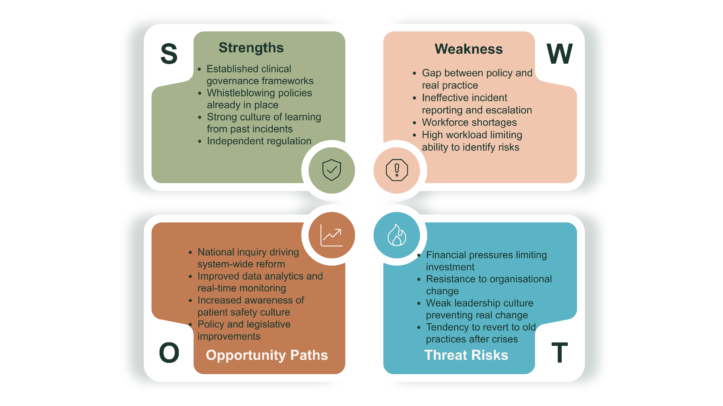
Figure 2: SWOT diagram applied to the Lucy Letby Case

Strengths
For this case study, the NHS possesses well-established frameworks for clinical governance, including the Serious Incident Framework (NHS England, 2015), the Freedom to Speak Up policy (NHS England, 2016), and the National Patient Safety Strategy. These represent credible foundations upon which improvement can be built. Furthermore, the NHS has a strong tradition of learning from serious incidents, as evidenced by post-inquiry reforms following the Francis Report (2013) and the subsequent publication of the Berwick Review (Berwick, 2013). The existence of the CQC as an independent regulatory body constitutes a structural strength, even if its performance in this case was inadequate (CQC, 2018).

Weaknesses
The Letby case reveals a fundamental gap between policy intent and operational reality. Existing mechanisms for incident reporting, escalation, and external oversight were demonstrably not functioning as designed at the institutional level. Additionally, an entrenched culture of defensiveness and hierarchy within certain NHS trusts represents a significant internal weakness that policy alone cannot resolve (Mannion and Davies, 2018). Staffing pressures, particularly within specialist neonatal units, further compromise the capacity of frontline staff to identify and report safety concerns as documented by Health Education England (HEE) which recorded persistent shortfalls in neonatal nursing workforce capacity, creating structural conditions that heighten risk across the sector (Buchan et al., 2019; HEE, 2021).

Opportunities
The Thirlwall Inquiry (2024) has created a historic opportunity for systemic reform because its findings and recommendations carry significant political and institutional weight, providing the impetus for meaningful legislative and regulatory change. Advances in data analytics and real-time mortality monitoring also present technological opportunities to strengthen pattern-detection capabilities. Moreover, growing professional and public awareness of patient safety culture creates a more receptive environment for culture-change interventions (Jones, 2019). Kostal et al. (2021) argue that digital quality improvement tools, when properly implemented, can substantially enhance the speed and accuracy of adverse event detection.

Threats
Ongoing financial pressures within the NHS risk limiting investment in governance infrastructure and training. Organisational inertia, the tendency of institutions to resist change and revert to pre-existing behaviours after a crisis has passed, represents a persistent threat to sustained improvement (Gabbay and Le May, 2020). There is a risk that improvements remain superficial and performative rather than deeply embedded, particularly if leadership culture does not fundamentally change. Hollnagel et al. (2013) warn that healthcare systems frequently oscillate between reactive responses to crises and a gradual regression towards pre-existing vulnerabilities once immediate scrutiny diminishes.
SWOT is inherently subjective and may oversimplify complex issues such as organisational culture and leadership failure. It lacks guidance on prioritisation, limiting its usefulness as a standalone analytical tool.

- Service Improvement Recommendations Using Quality Frameworks

3.1 Redesigning Incident Reporting Pathways Using Lean Management

Lean management, developed by Womack and Jones (2003) and widely adapted for healthcare settings, is the most appropriate methodology for this recommendation because its core purpose is the systematic identification and elimination of waste in processes, any step that consumes resources without adding value to the patient or the safety system.

Lean Implementation Steps

Step 1 – Identify the Problem
Map the current-state incident reporting pathway using a Lean Value Stream Map, conducted with frontline neonatal staff, ward managers, and governance leads. Document every step from the moment a concern is identified to the moment a formal investigation is initiated.

Step 2 – Identify Waste
Evaluate each step against the seven categories of Lean waste (overproduction, waiting, unnecessary motion, over-processing, defects, inventory, and unused talent). In the Countess of Chester context, key waste sources include: unnecessary sign-off chains, delayed escalation thresholds, and duplicated documentation between ward and governance teams.

Step 3 – Design the Future State
Redesign the pathway to remove non-value-adding steps. The future-state pathway should ensure that a concern raised by any clinician reaches the appropriate governance authority within a defined, audited timeframe, with no unnecessary intermediary stages.

Step 4 – Implement and Train
Pilot the redesigned pathway in three neonatal units over a six-month period. Provide staff training on the new process and embed clear escalation accountability at each stage.

Step 5 – Sustain
Conduct quarterly process audits to ensure the streamlined pathway is maintained and does not revert to previous patterns. Radnor et al. (2012) emphasise that Lean gains in NHS settings are only sustained when accompanied by ongoing measurement and leadership commitment.
Lean may be difficult to implement in healthcare due to variability in patient care. Over-simplifying processes could risk removing important safeguards, particularly in sensitive areas such as incident reporting.

  - Reducing Variation in Neonatal Mortality Review Using Six Sigma

Six Sigma DMAIC Implementation Steps

D – Define the problem clearly
The absence of standardised, statistically grounded neonatal mortality review within NHS trusts. Identify the key stakeholders, the scope of the surveillance system, and the patient safety outcomes to be measured.

M – Measure
Collect historical neonatal mortality and serious incident data across comparable NHS trusts. Establish baseline rates using national benchmarking data provided by NHS England (2015) and the National Neonatal Audit Programme. Identify current measurement gaps and inconsistencies.

A – Analyse
Apply statistical process control tools, including control charts and run charts, to distinguish between normal variation and statistically significant anomalies. Determine the specific threshold levels at which a deviation constitutes a mandatory safety alert requiring immediate formal review.

I – Improve
Implement real-time mortality surveillance dashboards with pre-defined alert thresholds in neonatal units across participating NHS trusts. Ensure alerts are automatically escalated to governance leads and, where thresholds are exceeded, to the CQC, without requiring individual clinical judgement to initiate the process.

C – Control
Embed ongoing statistical process monitoring with mandatory six-monthly audits of alert accuracy, response timeliness, and investigation outcomes. The control phase ensures that improvements are not a one-off intervention but become embedded as standard operating practice, consistent with the principles of sustained quality management (Donabedian, 1988).
Six Sigma’s focus on quantitative data may overlook early warning signs based on clinical judgement. In this case, concerns were raised qualitatively, suggesting data alone is insufficient.

3.3 Strengthening Independent Whistleblowing Systems Using PDSA (Plan-Do-Study-Act)

PDSA Cycle Implementation Steps
P – Plan
Co-design an independent, externally managed neonatal safety reporting portal in partnership with the CQC, NHS England, the Royal College of Nursing, and Freedom to Speak Up Guardians. Develop legally protected protocols for report handling, aligned to the Freedom to Speak Up policy (NHS England, 2016). Define the specific outcomes to be measured in the pilot: portal usage rates, staff confidence levels, and regulatory response timeliness.

D – Do
Pilot the portal in five neonatal units over a six-month period. Train Freedom to Speak Up Guardians in its operation. Ensure all participating clinical staff are aware of the portal, its legal protections, and how to use it. During this phase, collect data on all defined outcome measures.

S – Study
Analyse the pilot data systematically. Evaluate whether usage rates indicate that staff feel safe to report, whether regulatory responses are timely and proportionate, and whether the portal has led to formal investigations where warranted. Conduct anonymous staff surveys to assess whether confidence to raise concerns has improved. Dixon-Woods et al. (2014) recommend longitudinal cultural assessment as the most reliable measure of genuine behavioural change in NHS settings.

A – Act
Use the findings from the Study phase to refine the portal before national roll-out. Address any identified barriers – technical, cultural, or legal. Integrate findings into a revised NHS Freedom to Speak Up policy with strengthened statutory protections for reporters and explicit consequences for organisations found to have retaliated against whistleblowers (Edmondson, 2004).
PDSA depends heavily on organisational culture. If psychological safety is lacking, staff may still hesitate to report concerns, limiting the effectiveness of the intervention.

3.4 Embedding Leadership Safety Culture Training Using PDCA (Plan-Do-Check-Act)

PDCA Cycle Implementation Steps
P – Plan
NHS England and the NHS Leadership Academy co-develop a mandatory accredited programme in patient safety leadership and just culture principles. The curriculum incorporates evidence-based case studies from the Letby case, the Francis Inquiry (2013), and the Kennedy (2001) Bristol Inquiry. Specific modules are designed to address: recognising defensive organisational cultures, prioritising patient safety over institutional reputation, and creating psychologically safe environments for staff.
Define the measurable outcomes to be tracked: pre- and post-training knowledge scores, NHS staff survey results, incident reporting rates, and CQC inspection outcomes.

D – Do
Mandate completion of the programme for all serving and newly appointed NHS Trust Board members and senior clinical managers within a two-year implementation window. Embed completion as a prerequisite for executive reappointment. Deliver refresher modules every three years to ensure ongoing engagement and to incorporate new evidence as it emerges.

C – Check
Systematically evaluate programme effectiveness over a rolling three-year period. Triangulate pre- and post-training assessments of safety culture knowledge with NHS staff survey data, incident reporting rates, and CQC inspection scores. Identify gaps between intended programme outcomes and actual organisational behaviour. West et al. (2017) demonstrate that sustained measurement is essential to distinguish genuine cultural change from superficial compliance with training requirements.

A – Act
Use the findings from the Check phase to update and strengthen the curriculum in each successive programme cycle. Address identified gaps, incorporate emerging serious incident learning, and refine delivery methods based on participant feedback. This creates a self-improving training system that evolves in response to evidence – directly addressing the static, policy-on-paper failure that contributed to the governance collapse at Countess of Chester Hospital.
Leadership training alone may not achieve sustained cultural change and risks becoming a compliance exercise without wider organisational support.

- Conclusion

The analysis clearly shows that the failures were not due to a single person or isolated mistake, but rather the result of systemic issues in clinical governance, process failures in incident reporting and escalation, deep-rooted cultural barriers to transparency, and insufficient external regulatory oversight. The Fishbone Diagram revealed the wide range and interconnected nature of causal factors involving people, processes, management, and policies; the Donabedian Model confirmed that catastrophic outcomes were foreseeable consequences of specific structural and process deficiencies; and the SWOT analysis identified both institutional vulnerabilities and strategic opportunities for meaningful reform. These findings align with a substantial international body of evidence, from Leape (1994) and Kohn, Corrigan and Donaldson (2000) to Hollnagel et al. (2013), affirming that major healthcare safety failures share common systemic causes.
Four distinct, evidence-based recommendations have been proposed, each supported by carefully selected and systematically applied quality improvement methods: Lean for redesigning inefficient incident reporting pathways; Six Sigma DMAIC for reducing variation in neonatal mortality surveillance; PDSA for iteratively developing and testing independent whistleblowing systems; and PDCA for embedding continuous quality assurance into leadership safety culture training. Each method was chosen for its specific suitability in addressing the root cause it targets. Together, these recommendations offer a coherent, practical, and multi-layered strategy. As Berwick (2013) states, patient safety must be the primary, inviolable aim of every healthcare organisation, and the reforms outlined in this report are the means through which that goal can be credibly and sustainably maintained.

- References

Aiken, Linda H., Sermeus, Walter, Van den Heede, Koen, Sloane, Douglas M., Busse, Reinhard, McKee, Martin, Bruyneel, 2012) ‘Patient safety, satisfaction, and quality of hospital care: cross-sectional surveys of nurses and patients in 12 countries in Europe and the United States’, BMJ, 344, p. e1717. Available at: https://doi.org/10.1136/bmj.e1717
Berwick, Don (2013) A promise to learn – a commitment to act: Improving the safety of patients in England. London: Department of Health. Available at: https://www.gov.uk
Braithwaite, Jeffrey, Westbrook, Johanna I., Travaglia, John F. and Hughes, Claire (2010) ‘Cultural and associated enablers of, and barriers to, adverse incident reporting’, Quality and Safety in Health Care, 19(3), pp. 229–233. Available at: https://doi.org/10.1136/qshc.2008.030700
Bristol Royal Infirmary Inquiry (2001) Learning from Bristol: The report of the public inquiry into children’s heart surgery at the Bristol Royal Infirmary 1984–1995. London: The Stationery Office.
Care Quality Commission (2018) Opening the door to change: NHS safety culture and the need for transformation. London: CQC. Available at: https://www.cqc.org.uk
Deming, William Edwards (1986) Out of the crisis. Cambridge, MA: MIT Press.
Department of Health and Social Care (2023) Government agrees scope of inquiry into Lucy Letby’s crimes. Available at: https://www.gov.uk (Accessed: 14 March 2026).
Dixon-Woods, Mary et al. (2014) ‘Culture and behaviour in the English National Health Service: overview of lessons from a large multimethod study’, BMJ Quality & Safety, 23(2), pp. 106–115. Available at: https://doi.org/10.1136/bmjqs-2013-001947
Donabedian, Avedis (1988) ‘The quality of care: How can it be assessed?’, JAMA, 260(12), pp. 1743–1748. Available at: https://doi.org/10.1001/jama.1988.03410120089033
Edmondson, Amy C. (2004) ‘Learning from mistakes is easier said than done’, Journal of Applied Behavioral Science, 40(1), pp. 66–90. Available at: https://doi.org/10.1177/0021886304263679
Francis, Robert (2013) Report of the Mid Staffordshire NHS Foundation Trust Public Inquiry. London: The Stationery Office.
Gabbay, John and Le May, Andrée (2020) Able to improve: The skills and knowledge NHS front-line staff use to deliver quality improvement. London: The Health Foundation. Available at: https://www.health.org.uk
George, Michael L. (2003) Lean Six Sigma for service. New York: McGraw-Hill.
Harry, Mikel J. and Schroeder, Richard (2000) Six Sigma: The breakthrough management strategy revolutionising the world’s top corporations. New York: Currency.
Hollnagel, Erik, Braithwaite, Jeffrey and Wears, Robert L. (eds.) (2013) Resilient health care. Farnham: Ashgate.
Jones, Ben H. (2019) The improvement journey. London: The Health Foundation. Available at: https://www.health.org.uk
Kennedy, Ian (2001) Learning from Bristol. London: The Stationery Office.
Kohn, Linda T., Corrigan, Janet M. and Donaldson, Molla S. (eds.) (2000) To err is human: Building a safer health system. Washington DC: National Academies Press. Available at: https://doi.org/10.17226/9728
Kostal, Greg et al. (2021) ‘Putting improvement in everyone’s hands’, British Journal of Healthcare Management, pp. 1–6. Available at: https://doi.org/10.12968/bjhc.2021.0028
Langley, Gerald J. et al. (2009) The improvement guide: A practical approach to enhancing organizational performance. 2nd edn. San Francisco: Jossey-Bass.
Leape, Lucian L. (1994) ‘Error in medicine’, JAMA, 272(23), pp. 1851–1857. Available at: https://doi.org/10.1001/jama.1994.03520230061039
Mannion, Russell and Davies, Huw (2018) ‘Understanding organisational culture for healthcare quality improvement’, BMJ, 363. Available at: https://doi.org/10.1136/bmj.k4907
Mid Staffordshire NHS Foundation Trust Public Inquiry (2013) Francis Report. London: The Stationery Office.
NHS England (2015) Serious Incident Framework: Supporting learning to prevent recurrence. London: NHS England. Available at: https://www.england.nhs.uk
NHS England (2016) Freedom to Speak Up: Raising concerns policy. London: NHS England. Available at: https://www.england.nhs.uk
Nursing and Midwifery Council (2018) The Code. London: NMC. Available at: https://www.nmc.org.uk
Patient Safety Learning (2020) A blueprint for action. London: Patient Safety Learning. Available at: https://www.patientsafetylearning.org
Radnor, Zoe, Holweg, Matthias and Waring, Justin (2012) ‘Lean in healthcare: The unfilled promise?’, Social Science & Medicine, 74(3), pp. 364–371. Available at: https://doi.org/10.1016/j.socscimed.2011.02.011
Reason, James (1990) Human error. Cambridge: Cambridge University Press.
Reason, James (2000) ‘Human error: Models and management’, BMJ, 320(7237), pp. 768–770. Available at: https://doi.org/10.1136/bmj.320.7237.768
Royal College of Nursing (2020) Nursing workforce shortages in the UK. London: RCN. Available at: https://www.rcn.org.uk
Scally, Gabriel and Donaldson, Liam (1998) ‘Clinical governance and the drive for quality improvement in the NHS’, BMJ, 317(7150), pp. 61–65. Available at: https://doi.org/10.1136/bmj.317.7150.61
Thirlwall, Kate (2024) The Thirlwall Inquiry. London: UK Government. Available at: https://www.gov.uk
Vincent, Charles (2010) Patient safety. 2nd edn. Oxford: Wiley-Blackwell.
Wachter, Robert M. and Pronovost, Peter J. (2009) ‘Balancing “no blame” with accountability in patient safety’, New England Journal of Medicine, 361(14), pp. 1401–1406. Available at: https://doi.org/10.1056/NEJMp0903885
West, Michael, Eckert, Regina, Collins, Bill and Chowla, Jabeer (2017) Caring to change: How compassionate leadership can stimulate innovation in health care. London: The King’s Fund. Available at: https://www.kingsfund.org.uk
Womack, James P. and Jones, Daniel T. (2003) Lean thinking: Banish waste and create wealth in your corporation. 2nd edn. New York: Free Press.
World Health Organization (2018) Delivering quality health services: A global imperative for universal health coverage. Geneva: WHO. Available at: https://www.who.int

