Module: - Leadership Innovation and Product Development - M7X01372
Assignment title: - Innovative Approaches
Author: - Adrian Devonald
Student Number: - 0450573

Introduction
The aim of this paper is to identify and analyse the effects different types of innovation can have on a given organisation, Altrad Services. I aim to review the advantages and disadvantages on how they have been applied within the organisation as a whole, and look at the impact these innovations have had, and will have long term on the organisation. Businesses within the oil and gas industry are increasingly confronted with high degrees of technological dynamics. Innovation involves three key elements — search, selection and implementation. The key challenge in managing innovation is to find ways of carrying out these activities within the context of a particular organisation — and over time these learned patterns of behaviour become ‘routinised’ (embedded in structures and processes) so that the firm is able to repeat the trick (Nelson and Winter, 1982, Tidd and Bessant, 2009). Successful innovating organisations also require the ability to review these routines and extend or change them — this is dynamic capability (Teece, Pisano, & Shuen, 1997). 1.- (Bessant, Öberg and Trifilova, 2014)
Innovations are considered to be the key to productivity growth and better life conditions. They create jobs, generate incomes and improve people's lives by creating useful products and services. 2.(Skibiński and Sipa, 2015)-2
Altrad, are a global leader in the provision of industrial services, generating high added value solutions principally for the Oil & Gas, Energy, Power Generation, Process, Environment and Construction sectors. The group is also a recognised leader in the manufacturing of equipment dedicated to the Construction and Building market. 3- (Altrad.com, 2018)-3

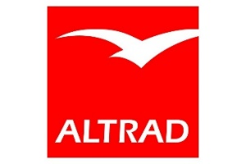
3-(Altrad.com, 2018)
Altrad’s multidisciplinary services range from engineering and technical services to maintenance, access solutions and specialised services for industry leaders. The Group, headquartered in France, employs around 42,000 people and owns established international brands including Cape, Hertel and Prezioso Linjebygg. Our ambition is to become an undisputed leader in multi-services, ensuring that our customers remain essential partners providing them with a complete and integrated offer guaranteeing ever greater safety, simplicity and reliability thus enabling them to successfully meet their own challenges. (Altrad.com, 2018)-3

Sources of innovation
Innovation should not be analysed as a single event, but rather as a process occurring in time, a continuous interaction of science, technique and production. Innovative activity in the company is an interactive process, characterized by reciprocal technological relationships between different subsystems (Teece, 1996). The innovation process can also be analysed as a process of learning. (Cohen, Levinthal 1989; Dodgson 1993; Hitt et al., 2000).2-(Skibiński and Sipa, 2015)

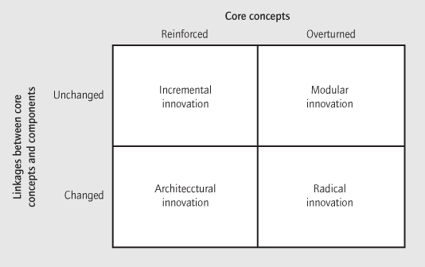
4- (Henderson and Clark, n.d.)
There are many models in which can describe the different sources of innovation and how they can be implemented into a business from the above, four sources- incremental, modular, architectural and radical right through to 7 seven sources as noted below by Peter Drucker.

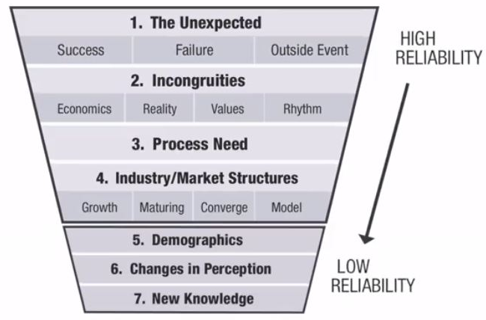
5-(VICHE MEAN-SOFTSKILLS, 2019)

I aim to analyse three sources of innovation, incremental, modular and radical and how these can be applied into a business and the benefits and limitations they may bring. I feel each of these can play a massive part into how a business can implement changes within their organisation, be it developing existing right through to introducing a completely new process. I aim to talk about each concept and give an example on how this can be related to Altrad, past, current and future developments going forward within the business.
Incremental
Technical progress consists of improvements made upon the existing technology (incremental innovation) and innovative activities aiming at entirely new technology (discrete innovation). 6-(Ghosh, Kato and Morita, 2017)-5. The computer has been an incremental system within the business to help processes become more efficient and effective to keep up with industry demand. The computer has affected the world as a whole on how organisations conduct their business worldwide.
Within the mechanical sector within the industry, there has been a number of changes through the years for when it comes to producing detailed construction isometric and alike. When Altrad took over Cape engineering, they were still producing a number of isometrics by hand. Using hand held techniques, numerous drawing tools in which could take from a few hours to weeks to produce a full package to submit to clients and customers.

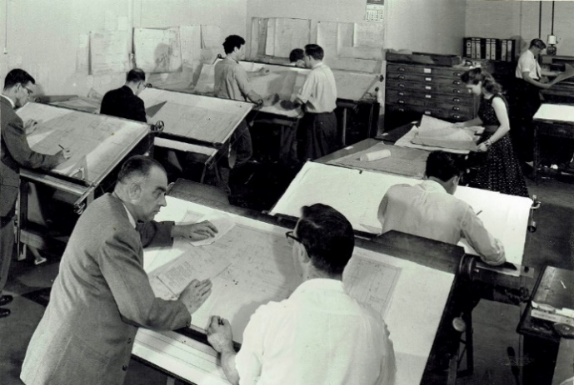
7-(Our Warwickshire, 2019)

When the above tasks are undertaken using traditional drafting methods, or even with specialised, but separate, unintegrated software packages, this results in poor re-use of information between the design stages. This leads to the duplication of design data input at each stage, and therefore many opportunities for human error to creep in. This in turn leads to lengthy design times, poor overall design quality and inevitably, downstream construction problems and delays 8-(Directionsmag.com, 2019).
The computer was an innovation that has changed the way the world operates. It changes the way in which organisations conduct their day to day business. Computers have been in use within Altrad from many years, but it’s the software packages and systems that are continuously improving. The use of computer aid design was rolled out to a number of draughts men, in which would take over the way on which the drawing office operated as shown in the image above. Computer aid is one of the tools which enable to visualize workshop environment, the motion of all its objects and so to predict the behaviour of individual technical or technological equipment’s in the real production process. The collisions and other problems can be eliminated, so consequently the quality and production efficiency of existing manufacturing process can be improved. 9-(Monka and Hloch, 2013)
The time in which sketches and concepts could be drawing up into ready for construction drawings was compressed massively, making this a key factor when dealing with customers. Revolutionising the way in which organisations produce pipework drawings.

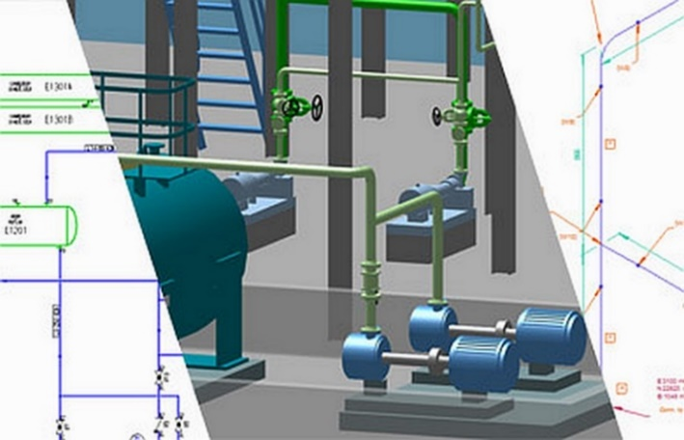
8-(Directionsmag.com, 2019)

The use of a modern, computerised pipework design systems offers huge potential for savings. Design work can be performed faster and more effectively than ever before, and expensive tasks, such as the manual drafting of piping isometrics, are completely eliminated. Thanks to the interference and consistency checking systems that are included in CAD programs, design errors can also be easily detected and resolved, thereby avoiding costly on-site construction issues and project delays. It soon becomes clear that such programs will pay for itself after just a few projects, enabling even the most investment-cautious companies to get into the fast lane. (Directionsmag.com, 2019)
Altrad are striving to be go to business within the industry and having the best technological software is paramount to achieving best in their sector. Having the latest software packages available for employers to use is paramount. Once obtained, training is provided to make sure the user is familiar with the program making sure the best of its ability is achieved.
Although CAD is widely used within industry, there are many other options for designers to use and as time goes on, they will become more readily available as now Altrad are using a system that allows sites to be 3D scanned in which will produce 3D models in which details drawings can be extracted from.

Modular
Modular innovation refers to the innovation that changes only one or more core design concepts of a technology, but the other components and the link between these components remain intact. By contrast, modular innovation, such as the replacement of analogue telephones with digital telephones, leads to few changes for the organization [1]. To some extent, firms can simply replace an analogue dialling device with a digital device and maintain the same operation of the product of telephone services (i.e., architecture knowledge is still applicable). 10-(Chou, Chuang and Shao, 2016)
Within the mechanical engineering sector, welding has been around for many years with little growth with regards to the processes used. Tig, MIG, SMAW and GTAW are the most common process used within Altrads fabrication workshops and site installations.
Due to the demand by senior management and clients worldwide, every day organisations are striving to provide a more efficient, cost effective process to carry out existing processes. Altrad are in the process of trailing orbital welding into the way on which they manufacture process piping. Orbital Welding is a specialised welding process in which the arc is rotated mechanically through 360° around the static workpiece, in a continuous process. Orbital Welding was developed as a solution for a higher quality, repeatable welding process. (Ltd, 2019). Implementing orbital welding into the organisation can and will cause uncertainty within the organisation as is new territory in which Altrad are not be familiar with. If this process is not implemented accordingly, it can be disruptive within the organisation and work force unless the approach is managed in the correct manner. Altrad are involving the welders to be trained up in the process and taking the valuable knowledge and experience into account at every stage.
Orbital Welding
Although orbital welding is a process in which is used in industry already, Altrad have yet to introduce it into the organisation. Welding is considered one of the most complex manufacturing processes and is frequently the least understood. Orbital Welding was first used in the 1960s when the aerospace industry recognised the need for a superior joining technique for aerospace hydraulic lines. A mechanism was developed from which the arc from a Tungsten electrode was rotated around the tubing welding joint. The arc welding current was regulated with a control system, in turn automating the entire process. The result of this was a more precise and reliable method in comparison to manual welding. 16- (World Class Engineering & Manufacturing Solutions, n.d.)

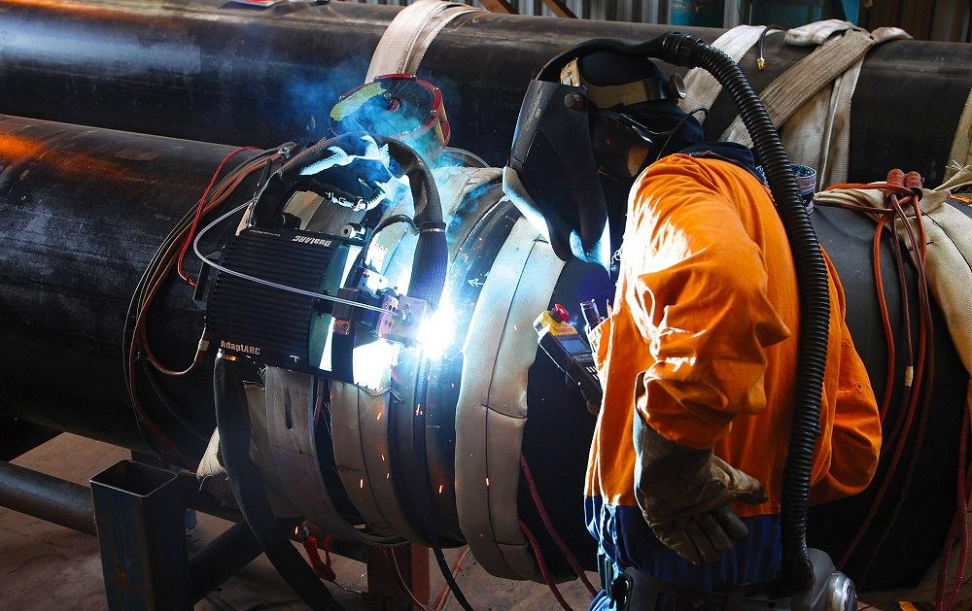
11-(Thefabricator.com, 2019)
In order to remaining able to fulfil the ever-increasing demands of their customers, it is essential for every supplier to have the ability to supply solutions based on current technologies as well as developing and co-ordinating new technological knowledge in very short periods of time. The underlying reason why technological change represents a challenge for every industrial firm can be seen in its tendency to render obsolete technological knowledge that has been accumulated for years. 12- (Luthardt and Mörchel, n.d.)

Radical
Certain kinds of radical innovation continue to pose a challenge, even for ‘smart’ organisations with experience and well-established innovation management routines. Radical innovation involves higher levels of uncertainty, moving towards exploration activity in which risks are greater and the links to an established knowledge base more tenuous. They often require the input of specialists and, whilst it is possible to establish repeatable patterns of behaviour and supporting structures, the routines involved here are different. 12- (Luthardt and Mörchel, n.d.)
The industry in which Altrad operate in are undergoing a shift as the energy and industry demands change. By being agile, Altrad will adapt the business to make sure what they provide is sustainable.
One of the implementations Altrad have introduce currently is the roll out of Virtual Simulation Training to organisations across the business.
Virtual Training Simulation
The technology used is not new to marked, but the way in which Altrad are using it to provide training is new to the organisation. Virtual reality is the computer-generated simulation of a real-world environment or situation. It provides an artificial experience that makes the user feel as if he or she is actually in the simulated environment. Advancements in virtual reality technology are providing new opportunities for improved simulator-based operator training. 13-(For Construction Pros, 2019)


14-(Florentine, 2019)

As the costs of virtual reality (VR) hardware and software have decreased in recent years, the technology’s use within various industries has grown. The oil and gas industry, for instance, sees the benefits it can provide, particularly to help provide training and improve safety on jobsites. 14-(For Construction Pros, 2019)
This will be a radical implementation within Altrad and the way in which they provide training to all employees all over the world. Altrad have planned and trial this on a number of sites across the UK in which feedback had been positive. Virtual simulation connects classroom knowledge with operational knowledge.
Impact of Innovations within the organisation
We live in a world that is changing faster than ever and meet the challenges that are unpredictable. Changing the role and functioning of today's business systems, as well as basic subjects of economic activity is caused by the radical change of the role and importance of their employees. In this sense, new, modern managers are required who, in conditions of great economic uncertainty, rapid technological changes, dynamic transformation and changes in property relations, can provide an effective achievement of the goals of business and development policy. The organization cannot be innovative without leadership ready to change. Management needs to be emotionally intelligent in order to be able to identify, correctly communicate, motivate, reward and encourage the creative employees to realize their ideas, resulting in an innovative organization. 15-(Zivkovic, and Veljkovic, 2016)
When Altrad implement new process within the working environment it take a number of aspects into account. From management level right through to the shop floor. Taking input from all levels is key to allow the organisation to obtain the best from the process introduced.
As mentioned, above, there are a number of sources of innovation that can be implemented, each of their own having an impact on the organisation.
Being ahead of potential market competitors is key within industry. Having the latest technologies, processes and methods of work is an ongoing cycle within Altrad. There are specific departments within the organisation who are constantly researching the market making sure Altrad are positioned best in their sector.
With regards to Altrad introducing orbital welding within their fabrication workshops, this leads to a number of challenges on the way. As with everything there are pros and cons when introducing new process and the transition period can be difficult for some parties. For example, the technology of orbital welding is connected to a computerized system which allows the user to control the weld settings electronically.
There are many welders within the organisation in to which benefit from various levels of experience. With technology constantly changing the way we work and computer systems becoming more advance, there will be different levels of knowledge when it comes to system in which will be introduced when orbital welding implemented. The younger generation may benefit from the technologies they have lived with throughout their life and be intrigued with the new process, whereas the more experience may not want the process introduced due to the minimal experience and knowledge held. It would require further training of which my not be of interest to someone who has been in industry for many years.
Orbital Welding can be favourable over Manual Welding for many reasons:
In Orbital Welding, the weld quality is always regulated and relied upon at 100%, producing consistent welds. This is in comparison to manual TIG welding, which relies on the welder’s experience and the precision of their work.
Orbital Welding is safer, providing less potential leak paths with safer connections throughout the system.
Low Maintenance: Orbital Welding eliminates threaded and mechanical joints that can cause costly maintenance and replacement costs.
Orbital Welding creates automatic reports, whereas in manual welding relying on the welder’s accuracy in reports is generally less reliable.
16- (World Class Engineering & Manufacturing Solutions, n.d.)
Although the orbital welding process is not a new process in industry, it will be a new method of welding used within the Altrad organisations. It will be incremental on how Altrad as a business implement this process to make sure everyone inhouse and external are aware of the potential benefits and the short comings it could potentially bring.
Further on in this paper, I will be discussing change of management and how this can be disruptive within the business and how a change within the organisation can be disruptive and the applications that can be in place to reduce this and make any change within the business a successful one in which will benefit the efficiency, costs, productivity all of which will affect the market position of the organisation.

Change in Management
Company’s senior executive and top management plays a vital role in executing changes successfully. Regular change in senior managements helps to overcome technological, social and political resistance (Ocasio, 1993) studied this relationship and explained how senior management organizational performance can be inter linked in order to bring a strategic change. Katz (1982) and Hambrick (1995) explained that longer tenure of top management in organization is likely to have negative relation with strategic change in organization 17-(Wadood, Gharleghi and Samadi, 2016)
Altrad purchased Cape Engineering in 2016 I which a transition period of twelve to sixteen months was rolled out and a team was put together to work with both organisation on who would merge the two together becoming one identity.
The rapid changes are very well witnessed in many industries recently. But there have been event when an organization faced failure due to misjudgement and miscalculation about how innovations and technologies should be presented and used. Mercedes Benz and Sony has born losses and because of new complex systems and failure to predict the technological demand from customer market. These situations were termed as disruptive technology and innovation by many authors. Samsung in its line of mobile phones and LED televisions has outclassed many others in innovations and customer-oriented technology. 17- (Wadood, Gharleghi and Samadi, 2016)
A change in management can be very disruptive to an organisation. As mentioned, Altrad took over Cape engineering in 2016, where a number of roles and processes clashed once the takeover had been confirmed.
Even to this day, Altrad gave a transition period of 12-16 months for the merge to be complete. This meant all documentation, processes, method statements, risks assessments and alike all had to be reviewed and aspects extracted from one and merged to another. Due to the multiple disciplines under the Altrad umbrella, this has caused a lot of issues on the way.
Resistance to Change
Change within an organisation is difficult, time consuming and often fails because there is a failure to work through the change process with the individuals involved in the change and progress their personal thinking to evolve and improve the changes desired. 18-(Thenewindustrialist.com.au, 2019)
When organisations plan to implement new process or make a change to an existing process within the business, there will all ways be questions from all levels of employers. For example, in Altrad, the welding process mentioned earlier in this paper (orbital welding) will be presented, welders on the work face will be asking many questions. And that will be filtered down to supervisors, facility managers, area managers all the way down to the managing director. The way in which the changers are handled is key to make the change a successful one.
If employees of an organisation do not fully back the change, it will fail. Working together, interacting and communicating through the whole process are key factors.
On each of these stages noted on the below figure, there would need to be a plan on place to making sure all parties involved are aware of the changes. Right from the start to the end.

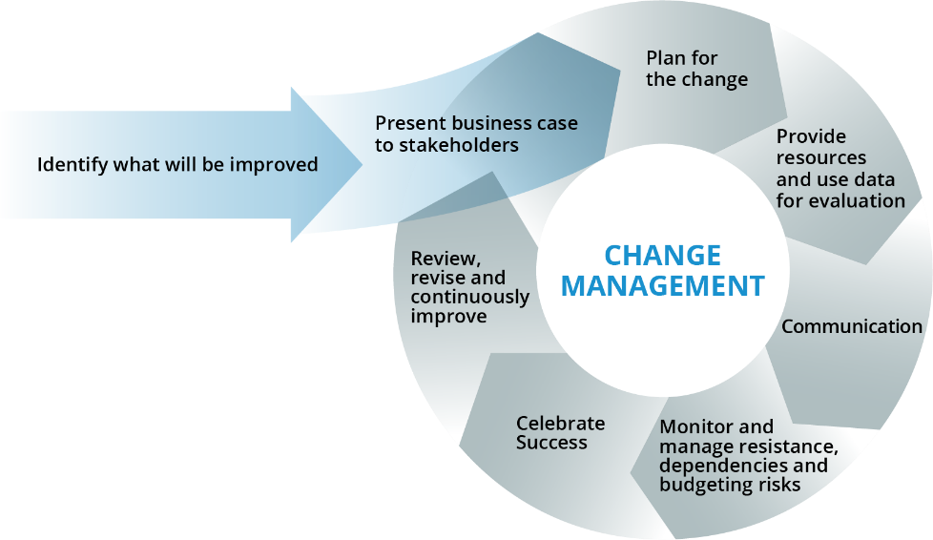
19-(Meet Me In The Cloud, 2019)

-Identify what will be improved- It is critical to identify what is going to be changed. Is it a process, product, new equipment or alike that’s is going to be implemented?
-Business Case- There will be many levels of within a business whom will have input when implementing change. From shareholders to the work force on the shop floor. Each and every level should be aware of the plan and the way in which the changes are going to be implemented.
-Plan for Change- Prepare and plan sufficiently for the implementation to go as smoot as possible. Plan the resources required, scope of works required and cost.
-Provide resources and Data for evaluation- Each party involved should be presented with the relevant information regarding the change and kept up to date of any change of information along the way.
-Communication- One of the most important aspects when change is occurring. Constant communication throughout the who organisation into the changes. A successful change within an organisation can be down to simply good communication throughout the process.
-Monitor and manage resistance-There will be resistance thought stages of change. How management deal with this is key. Get all parties involved, with the development, implementation and close out of the change so they feel a part of the change.
-Celebrate Success-Once the changes have been implemented, recognise and reward those involved to achieving the end goal. Be it a promotion, pay rise or simply a well done can go a long way in the way people act to change.
-Review and constantly improve- Continuous monitoring of the change is key. Reviewing all the feedback is critical to making sure the change is a successful one inwhcih will foresee any issues that may arise in the future.
All the above need to be reviewed at each stage, taking all the feedback firm the employees into account. Clear, transparent information shared with all parties is key throughout the change.

Conclusion
Organisation strive and work hard to be the leading organisation within their given sector. They need to be willing to be innovative to keep on top of the ever so often change in market and the level of service consumers want to experience. Altrad are a new organisation within the mechanical engineering sector and have already made a massive impact to the way they are projecting themselves within industry.
There are many ways into which process, new technologies, equipment, personnel and alike are implemented into new and existing business. How these are managed and communicated through the process is key. Altrad strive to be the best in their sector and are continuously looking for new innovations to implement into the business. It is key to keep ahead of competitors within industry.
The necessity of introducing innovation is beyond argument and promoting a knowledge-based economy constitutes the best example. The rapidness of transformations taking place in the business environment, market pressure and complexity of the created innovations contribute to the entrepreneurs being focused on searching for new opportunities of increasing the level of innovativeness at their organizations. Skibiński and Sipa, 2015)- 2

“In defining and choosing the values that it proposes to embody and defend, a group puts forward the responsibility to which each of its members engages, both for them self and above all in relation to others”
Mohed Altrad. (Altrad.com, 2018)

Reference
1-A-Bessant, J., Öberg, C. and Trifilova, A. (2014). Framing problems in radical innovation. Industrial Marketing Management, 43(8), pp.1284-1292.
2-Skibiński, A. and Sipa, M. (2015). Sources of Innovation of Small Businesses: Polish Perspective. Procedia Economics and Finance, 27, pp.429-437.
3-Altrad.com. (2018). Altrad, learning more about the industrial services company - Altrad Group. [online] Available at: https://www.altrad.com/en/altrad-at-a-glance.html [Accessed 1 Nov. 2018].
4- Image-Henderson and Clark (n.d.). The Innovation Book. [online] O’Reilly | Safari. Available at: https://www.oreilly.com/library/view/the-innovation-book/9781292011905/html/chapter-041.html [Accessed 9 Oct. 2019].
5- VICHE MEAN-SOFTSKILLS. (2019). Peter Drucker's Seven Source of Innovation. [online] Available at: http://vichemean-softskills.weebly.com/skills/peter-druckers-seven-source-of-innovation [Accessed 4 Nov. 2019].
6-h, A., Kato, T. and Morita, H. (2017). Incremental innovation and competitive pressure in the presence of discrete innovation. Journal of Economic Behavior & Organization, 135, pp.1-14.
7-Our Warwickshire. (2019). F.H. Biddle of Nuneaton Drawing Office Recollections. [online] Available at: https://www.ourwarwickshire.org.uk/content/article/biddle [Accessed 30 Oct. 2019].
8-Image-Directionsmag.com. (2019). P&IDs, 3D Pipework and Piping Isometrics in One Integrated System. [online] Available at: https://www.directionsmag.com/pressrelease/8752 [Accessed 30 Oct. 2019].
9- Monka, P. and Hloch, S. (2013). Technological Process Design and Simulation. Applied Mechanics and Materials, 440, pp.188-193.
10- Chou, Y., Chuang, H. and Shao, B. (2016). The impact of e-retail characteristics on initiating mobile retail services: A modular innovation perspective. Information & Management, 53(4), pp.481-492.
11- Image-Thefabricator.com. (2019). AdaptARC programmable orbital welding system from Tri Tool handles variety of jobs. [online] Available at: https://www.thefabricator.com/tubepipejournal/product/automationrobotics/adaptarc-programmable-orbital-welding-system-from-tri-tool-handles-variety-of-jobs [Accessed 2 Nov. 2019].
12-Luthardt, S. and Mörchel,, J. (n.d.). Institute of Industrial Marketing Management. [online] Impgroup.org. Available at: https://www.impgroup.org/uploads/papers/87.pdf [Accessed 9 Oct. 2019].
13- For Construction Pros. (2019). Virtual Reality Simulators Enhance Equipment Operator Training. [online] Available at: https://www.forconstructionpros.com/business/business-services/training-education/article/12318254/virtual-reality-simulators-enhance-construction-equipment-operator-training [Accessed 3 Nov. 2019].
14- Florentine, S. (2019). How VR can improve anti-harassment training. [online] CIO. Available at: https://www.cio.com/article/3254188/how-vr-can-improve-anti-harassment-training.html [Accessed 3 Nov. 2019].
15- Zivkovic,, S. and Veljkovic, M. (2016). Economic and Social Development: Book of Proceedings; Economic and Social Development: Book of Proceedings, [online] pp.433-440. Available at: https://search-proquest-com.ezproxy.uwtsd.ac.uk/docview/1858230715/fulltext/590BDED83C8D40ADPQ/1?accountid=130472 [Accessed 2 Nov. 2019].
16- World Class Engineering & Manufacturing Solutions. (n.d.). World Class Engineering & Manufacturing Solutions. [online] Available at: https://www.orbitalfabrications.co.uk/tig-welding-orbital-welding-manual/ [Accessed 2 Nov. 2019].
17- Wadood, S., Gharleghi, B. and Samadi, B. (2016). Influence of Change in Management in Technological Enterprises. Procedia Economics and Finance, 37, pp.129-136.
18- Thenewindustrialist.com.au. (2019). » 6 Layers of Resistance. [online] Available at: http://thenewindustrialist.com.au/6-layers-of-resistance/ [Accessed 3 Nov. 2019].
19- Meet Me In The Cloud. (2019). Change Management | Meet Me In The Cloud. [online] Available at: https://meetmeinthecloud.com/collaboration-services/change-management/ [Accessed 3 Nov. 2019].

