Module Code - BMIH6005
Module Name - Organisational Consultancy
Assignment Title- Event Strategic Planning and Delivery Considerations for an International Meeting
Word Count: 2500
Student ID - 2126415
Student Name - Gianina Aghinitei

Table of contents
Introduction 3
The Event Cycle 3
Event Concept 5
Experience of delegates: The community attending this event will experience an interactive day wherein: 5
Aims and objectives 7
Aims: 7
Objectives: 7
Event operations 9
Event budget 9
Industry Trends 11
Market trends 11
Issues and impact 11
Influence on TechFusion Summit 14
Cultural and Situational Considerations 14
Cultural considerations: 14
Situational considerations: 15
Why may these considerations be important: 16
Conclusion 16
References 16

Introduction
Strategic planning plays a crucial role in conducting an event or meeting to avoid any disruption particularly after the Pandemic hit (Ranasinghe et al., 2020). To discuss various key elements aligned with Artificial Intelligence and Machine Learning in the hospitality sector a technology and innovation event called “TechFusion Summit” at The Savoy Hotel, London happens. This event has chosen to speculate on the validation of innovation and technology in the hospitality industry and how these can be utilised to further demonstrate better facilities to guests. This event’s focus area will be AI and ML applications to build a Smart Hotel, a better customer experience framework, and personalisation of service to guests. The location is selected based on its fervid support of tech-gavelled events where amenities like well-developed transportation and state-of-the-art equipment facilities are featured. The event will be conducted with a keen eye for tech-savvy people and professionals where technological strategy and innovation will be discussed to seek business opportunities as a futuristic strategy in the hospitality sector.
This report aims to recognise strategic planning and delivery considerations of the event where its cycle and concept will be verified. Through illustration of SMART objectives and operations value, this event's budget-conscious impact on the current market environment will be demonstrated using relevant theories and practical views.

The Event Cycle
By selecting a prestigious venue for the tech event where technological professionals and business leaders are the target audience, “TechFusion Summit” is going to feature numerous expert solutions. Through its past SWOT and PESTLE analysis its present validation whether it is going to be a potential solution is identified. Defining definite planning, plotting, and executing of a meeting where its focused objectives can be achieved or not are discussed that can be considered as an Event Cycle. Based on the analysis its Event Cycle is provided below:
Concept Promotion: The event’s objectives are to analyse opportunities of AI and ML integration in the hospitality sector where hospitality business leaders and tech innovators are targeted as the audience.
Explicit planning:
- Venue: The Savoy Hotel, London
- Date: Not disclosed
- Budget: €150000
Marketing: Workshops on digital marketing through social media platforms like Facebook and Instagram, PPC ads like Google Ads, email personalised marketing will be conducted to invite people for massive attendance (Goyal et al., 2021). Concept marketing like blogs, podcasts, and partnerships with tech-organisations will be done for cross-promotion about the event.
Execution: An efficient check-in process and equipped venue set up where on-site employees and essential technologies like AV for live streaming will be present (Stringam, and Gerdes, 2021). Well-maintained keynote speakers and interactive sessions are included for better program delivery.
Post-event evaluation: Collect reviews of attendances and analysis of data like event attendance number and their reviews will be done in post-event evaluation. Generated report where professionals' feedback and suggestions will be considered for further adjustment and assessment of its success.
Follow-up: Sharing content over professionals’ feedback highlighting the event’s main part and future planning as a forward-thinking will be conducted. Thank you posts and emails will be sent where an interactive relationship with the community will proceed for improvement in the future (Shupjatskij, and Laurikainen, 2023).
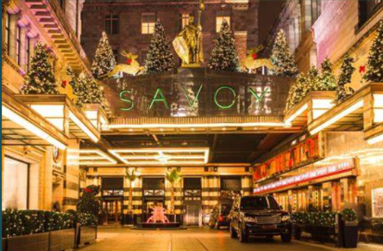
Figure 1 of Event Operations
Sources: (Hubilo, 2021)

Event Concept
Name: TechFusion Summit
Event theme: Advancement in the hospitality sector through utilising AI and ML
Highlighted areas:
- Application of AI and ML to build Smart Hotel.
- Increasing sales revenue through high operational performance with technology.
- Personalised targeting facilities to guests utilizing data analytics.

Experience of delegates: The community attending this event will experience an interactive day wherein:
Registration and breakfast from 8.00 AM to 10.00 AM: Easy check-in process where attendees will obtain event materials and a whole-day schedule where they will be served the rich hospitality of the hotel staff establishing an informal network.
Opening Ceremony at 10.00 AM to 10.30 AM: With a welcome address by a keynote speaker the event will advocate for the introduction of the events where attendees will be informed about the purpose and objectives of the events. This shall enlighten the researchers to nurture their knowledge on AI and ML (Bladen et al., 2022).
Keynote session from 10.30 AM to 11.30 AM: The current market trends and economic growth aligning with the integration of AI and ML will be discussed by industry leaders.
Network building from 11.30 AM to 12.00 PM: Event visitors will build a network formally or informally taking a small refreshment break. They may discuss earlier sessions creating a culture of innovation.
Panel discussion at 12.00 PM to 1.00 PM: Panel discussion will be conducted where hospitality industry leaders and tech-innovators, AI or ML experts will be allowed to talk about current technologies’ advancement. This is important in providing better value to customer experience in hospitality settings (Walker, 2021).
Lunch Break at 1.00 PM to 2.00 PM: Speakers and Specialists will build connection with each other through taking lunch break where a variety of food and beverage options will be offered.
Breakout Session at 2.00 PM to 3.00 PM: Following through 4 breakout sessions where AI and ML’s application process, opportunities in operational efficiency, personalised hospitality industry hotel, and data analytics will be discussed in the presence of tech specialists. Topics over the threats and opportunities due to AI and ML in hospitality business will be discussed.
Workshop at 3.00 PM to 4.30 PM: Workshops will be the concluded portion of the sessions where presentations over a successful hotel utilising AI and ML will be presented. A workshop on how to build a SMART hotel with proceeding steps will be observed by attendees through group discussions and activities presenting case studies discussion and practical demo sessions.
Closing remarks at 5.00 PM to 5.30 PM: Closing remarks highlighting the main concept of the prior sessions will be provided followed by a closing speech to thank you. The future of the hospitality sector through utilizing advanced technologies will be discussed by providing a closing speech.

Aims and objectives

Aims:
“TechFusion Summit” aims to illustrate the opportunities of technology like AI and ML applications in the hospitality sector while offering business leaders and tech innovators a platform to allow them intriguing insights and values to determine technology validation in the hospitality sector.

Objectives:
- Knowledge sharing
Specific | Measurable | Achievable | Relevant | Time
Sharing knowledge about the implementation of AI and ML in Hotels for the improvement of guest experience (Bharwani, and Mathews, 2021). | Ensure 85% of attendees give positive feedback upon understanding the implementation according to the post-event evaluation | Embark tech experts and keynote speakers to engage in discussions. | Promote the essentiality of technological integration in the development of hospitality setting | Attain this within the end of the day.
Table 1: of SMART objectives of “TechFusion Summit”
Sources: (Self-created)
- Network building
Specific | Measurable | Achievable | Relevant | Time
Providing opportunities for business leaders and attendees to build a network for further innovation. | Ensure at least three interactive sessions for network building whether it is informal or formal so that 75% of attendees can make new connections. | Offering breaks like lunch or refreshment breaks to allow attendees to make connections through network-building activities (Williamson et al ., 2021). | Advocate for alliances and value of knowledge sharing | Attain this by the perfecting of the event.
Table 2: of SMART objectives of “TechFusion Summit”
Sources: (Self-created)
- Practical integration information
Specific | Measurable | Achievable | Relevant | Time
Offer participators practical demo sessions and integration information on AI and ML. | Offer at least two case study presentations with practical demos. | Partnerships with technology experts and hospitality builders for more interactive collaborative works. | Furnish leaders and attendees with knowledge of the integration of AI and ML encouraging them to initiate their business (Goh, and Sigala, 2020). | Achieve this by the conclusion of the day.
Table 3: of SMART objectives of “TechFusion Summit”
Sources: (Self-created)

Event operations
Required skills and resources are dependent on the steps of the event concept. In event planning and management, project management skills are required to ensure attendees are valued and not facing trouble to delve into the knowledge (Ekemezie, and Digitemie, 2024). Potential organisation management abilities are essential to ensure attendees feel comfortable where advanced teamwork is required. Event management programs like Eventbrite or EventZilla, Cevent can be utilised to operate the check-in process of attendees whereas an efficient event planner organisation is necessary (Richards, 2020). Better logistics coordination for checking organised areas like seating capacity, equipment like AV availability, food supply whereas critical problem-solving skills are essential to ensure improvised management for the event. Enough staff and IT support, troubleshooting skills, and IoT infrastructure like laptops and presentation software are required. Staff must be skilled with communication where they may have multilingual volume for mitigating any inquiries of attendees (Jayes, 2023). To market the events specialists in content creation and personalization of email invitations are some required resources as they may increase the number of attendees to the meeting whereas programs committee and a coordinator to address keynote verbal discussions for attendees is essential. The event must acknowledge at least 15 customer service hotlines for resolving any queries of attendees of an easily accessible mobile application should be provided.
For financial management budgeting and reporting are required abilities where two financial teams will be responsible for delivering estimated value to conduct the meeting and its promotion whereas financial reporting should mention all accounts of expenditures from pre-event to post-event evaluation. An accountable finance team who can count the expenditure and income values is required (Tzenios, Frsph and FWAMS, 2022). Accounting tools like Quickbook or SAP can be utilized to determine the budget value compared to its scope.

Event budget
Income | Amount (€) | Expenditure | Amount (€)
Ticket Sales | 20,000 | Venue Booking | 50,000
Sponsorships | 60,000 | Event Management Team | 25,000
Exhibition Booth Rentals | 30,000 | Marketing and Promotion | 20,000
Workshop Fees | 10,000 | AV Equipment and Technology | 15,000
Food and Beverage Sales | 15,000 | Catering Services | 20,000
Merchandise Sales | 5,000 | Printing and Stationery | 5,000
Total Income | 140,000 | Speaker Fees and Accommodation | 15,000
Total Income | 140,000 | Security and Insurance | 10,000
Total Income | 140,000 | Miscellaneous (Contingency Fund) | 10,000
Total Expenditure |  | Total Expenditure | 170,000
Table 4: Budget
Funding to put on the 'TechFusion Summit' primarily comes from ticket sales, sponsorship from some of the top technology companies in North America and around exhibition and workshop fees. Revenue will further be generated from selling food & beverages during the event as also by offering event branded merchandise. Focusing his fundraising efforts on ticket sales and sponsorships, both driven by the calibre of keynote speakers and industry thought leaders scheduled to attend. If you are developing groundbreaking AI and ML solutions within the hospitality space, show off your work to leading executives in this field with our sponsorship packages. This benefit means that the event has a strong financial backing considering how diverse it is.

Industry Trends

Market trends
As the event’s theme is based on advancement in the hospitality sector through utilising AI and ML current market trends and patterns are initially taken as note to determine its aims and objectives. Some current market trends are:
Technology implementation: Currently industries and customers are inclined towards technology implementation for convenience and better accessibility of opportunities (Paul et al., 2024). An increment can be captured by utilising AI and AR in event management.
Personalised targeting and digital marketing: Digital marketing is in high demand as digital marketing triggered the creation of more interactive marketing techniques and connected groups of customers in both the real and virtual worlds. Ad spending in the digital advertising market is projected to be 740 billion euros in 2024 (Statista, 2023) where personalised targeting marketing is also preferred.
Sustainability: The next-generation population is fond of environmentally friendly operations and sustainable development.
Mixed meetings: To increase reach and accessibility to attendees summarising physical and virtual elements mixed meetings are in high demand (Cheng et al., 2021).

Issues and impact
Several issues and its impact have also influenced the event’s motive and objectives:
Cybersecurity: Cybersecurity is a known crisis in events as use of virtual elements has increased. In 2023 cybercrime happening in the UK is estimated to be around 320 billion euros (Statista, 2023). Hospitality sector wants to enhance the cybersecurity interface utilising advanced technologies like AI.
Broader reach: Mixed model in events can grab the attention of attendees better than traditional interactive channels as virtual elements can capture attendees' eye using interactive icons and explanations.
Sustainability goals: Ensuring green initiatives through setting sustainability goals in the operation can provide a positive brand reputation to hospitality settings where advanced technologies can meet the demand of guests.
Economic uncertainty: As a global recession is going on after the pandemic economic downturn is prominent in the global market (United Nations, 2023). The fidelity in currency rate may impact the event's estimated budget, ticket purchasing power, and ticket rate.
SWOT Analysis
Strengths | Weaknesses
- Equipped and prestigious venue  - Innovative themes  - Network building advantages | - Increased cost due to economic downturn.  - Complications in event operating as many resources as possible and skills are needed (Vielberth et al., 2020).
Opportunities | Threats
- High market trends for technology and its integration.  - Technological organizations guarantee capital resources for tech events where their innovations are featured (Battisti, Agarwal, and Brem, 2022).  - Mixed events are in preference of attendees. | - Economic downturn and global recession.  - Cyberattack and unprotected information.  - Technological failures.
Table 5: of SWOT Analysis
PESTLE Analysis:
Elements | Justification
Political | - Taxation rules and regulations may influence the event objectives.  - Data protection rules like (GDPR) also can be influential.
Economical | - The global recession  - Economic uncertainty like fluctuations in rate as the United Kingdom's GDP fluctuated between -5% to 3% over twenty years increased in quarters by 0.6% in 2024 (Gov.UK, Census 2021).
Social | - Cultural trends such as norms  - Sustainability in health-conscious awareness
Technological | - Advanced technology adaptation in event management  - Increased rate of cybercrimes
Legal | - Intellectual property obligation due to laws like Copyright, Designs, and Patent Act, 1988 (Legislation UK, 1988)
Environmental | - Climate-changing disruption like natural disasters  - Sustainability development rules and regulations in international matters
Table 6: of PESTLE Analysis
Analysis: Political factors like taxation rules and regulations may influence the event objectives. Data protection rules like (GDPR) may affect global attendees. The global recession and economic uncertainty may affect the ticket purchasing power of attendees whereas budget constraints can be seen. Swift technology adaptation in events may replace traditional resources and skills in the event (Hradecky et al., 2022). Cybersecurity is a major concern for “TechFusion Summit” as preventing cyberattacks on information about the sessions of the event is required. Climate change may hinder the event at the Savoy Hotel as the determined date and venue may be cancelled due to sudden natural disasters. Sustainability goals are in high demand which may influence TechFusion Summit’s waste management logistics.

Influence on TechFusion Summit
The detailed market trends and issues can be heavily impactful on the event. As the event’s theme is associated with the advancement of technology integration in the hospitality sector the rise of digital marketing and use of virtual elements in events may implicate opportunities for “TechFusion Summit”. The rising affluence of mixed meetings where both physical elements and virtual elements are used may increase the scope of the event as international attendees may find it engaging (Uccello, Pawlicki, and D'Antonio¹iD, 2024). Current trend of sustainability may influence the waste management process of the event as “TechFusion Summit” may demonstrate efforts to reduce carbon footprint. However, the challenge of cyberattack may increase costs of the event to protect data whereas an economic downturn may pose budget constraints for the event that can redesign its budget planning and strategic execution. Event management make sure to handle these threats to achieve the Smart objectives where a rigorous cybersecurity interface like encryption and contingency planning may navigate the planning issues (Gunduz, and Das, 2020).

Cultural and Situational Considerations

Cultural considerations:
Diversity and inclusion are important aspects to consider in the event as international attendees will be invited (Mair, and Smith, 2022). To welcome the variegated audience an inclusive speaker, note and equal accessibilities must be provided to maintain cultural sensitivity.
As distinct cultures are going to be infused under the same roof, networking style, and interactive sessions must be considered. With structured networking, maintenance of cultural elements is required to facilitate support for attendees.
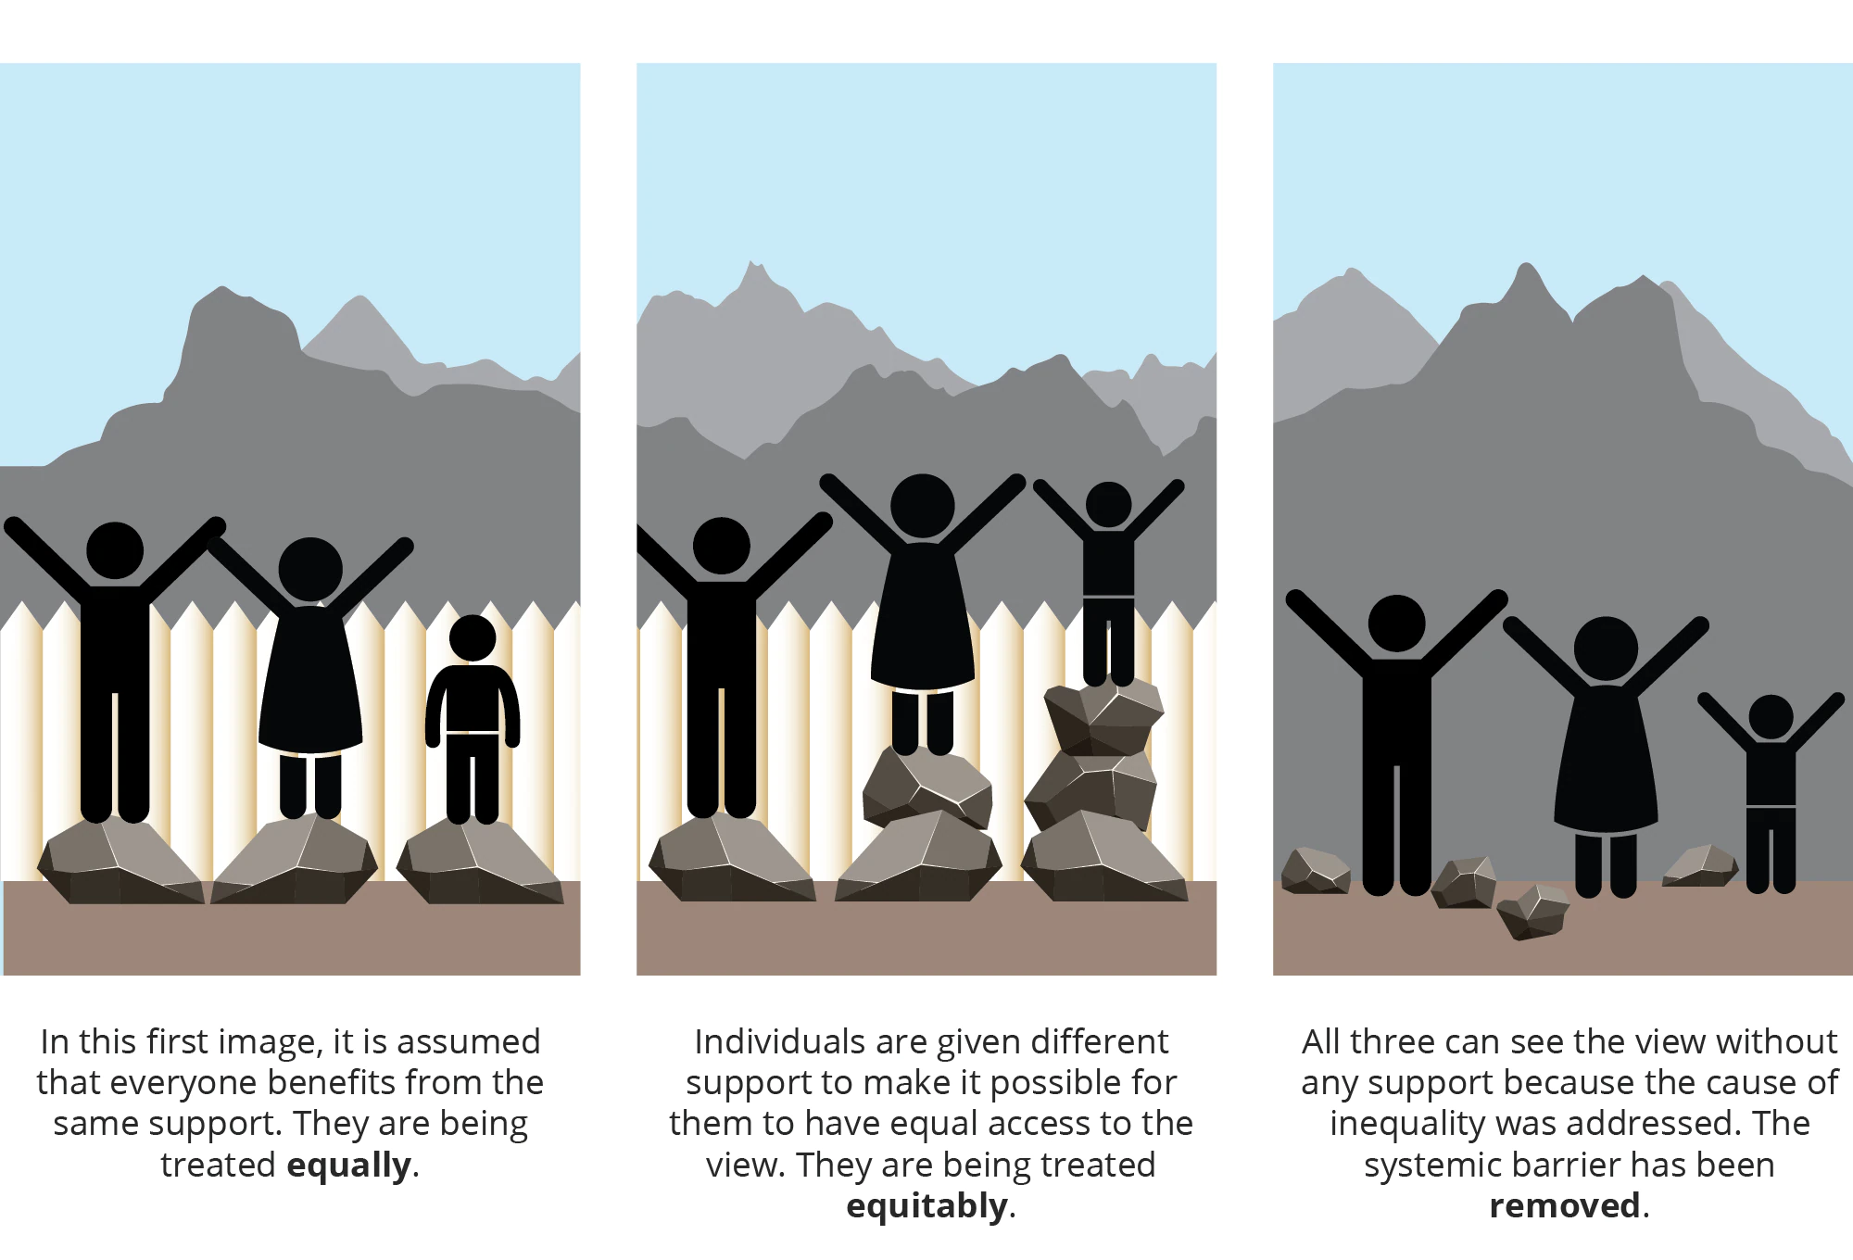
Figure 2: Diversity, Equity, and Inclusion
Sources: Bourke, (2018)

Situational considerations:
Economic environment: The current economic environment can impact the behaviour of attendees as well as their participation in the “TechFusion Summit”. Tiered pricing strategy based on geographical conditions for tickets must be considered whereas grabbing the attention of tech companies for sponsorship is required (Davis, 2022).
Technological arrangements: The technological arrangements must adhere to high performance as the event’s theme refers to the utilization of AI and ML in the hospitality sector. To meet the expectations of attendees high-quality AV implements and relevance is needed. To conquer the possibility of technical failures, alternative plans and technical support are necessary (van Antwerpen, 2023).

Why may these considerations be important:
Cultural and Situational Considerations are important for the “TechFusion Summit” as they can impact the achievement of the event. Cultural and inclusivity are considered over to enhance better attendee experience as the interactive sessions can build an engaged network (Gourlay et al., 2020). By maintaining cultural sensitivity by including inclusive speech in the sessions positive reputation and awareness can be created. The economic situation may influence purchasing behaviour of international attendees whereas the technological arrangements are required to achieve the primary objectives of the “TechFusion Summit”. Implementation of strategies based on these considerations may improve quality of experience for attendees as inclusive and diverse perspectives in keynote speech presenting multilingual volume can achieve feasible outcomes of the event.

Conclusion
Overall, “TechFusion Summit’s strategic planning requires resources and developed skills to meet the expectations of international attendees like tech-savvy professionals and enthusiastic business leaders. By considering the challenges and opportunities from SWOT and PESTLE analysis the event can achieve its aim and SMART objectives which it needs to take note of situational and cultural considerations as they may impact its prime purpose.

References
Battisti, S., Agarwal, N. and Brem, A., 2022. Creating new tech entrepreneurs with digital platforms: Meta-organizations for shared value in data-driven retail ecosystems. Technological Forecasting and Social Change, 175, p.121392.
Bourke, J. (2018, January 22). The diversity and inclusion revolution: Eight powerful truths. Deloitte Insights. https://www2.deloitte.com/us/en/insights/deloitte-review/issue-22/diversity-and-inclusion-at-work-eight-powerful-truths.html (Accessed on 28.05.2024)
Bharwani, S. and Mathews, D., 2021. Techno-business strategies for enhancing guest experience in luxury hotels: a managerial perspective. Worldwide Hospitality and Tourism Themes, 13(2), pp.168-185.
Bladen, C., Kennell, J., Abson, E. and Wilde, N., 2022. Events management: An introduction. Routledge.
Cheng, Y., Yan, Y., Yi, X., Shi, Y. and Lindlbauer, D., 2021, October. Semanticadapt: Optimization-based adaptation of mixed reality layouts leveraging virtual-physical semantic connections. In The 34th Annual ACM Symposium on User Interface Software and Technology (pp. 282-297).
Davis, R.N., 2022. Sponsorship of international events. In Handbook on International Sports Law (pp. 571-606). Edward Elgar Publishing.
Ekemezie, I.O. and Digitemie, W.N., 2024. Best practices in strategic project management across multinational corporations: a global perspective on success factors and challenges. International Journal of Management & Entrepreneurship Research, 6(3), pp.795-805.
Goh, E. and Sigala, M., 2020. Integrating Information & Communication Technologies (ICT) into classroom instruction: teaching tips for hospitality educators from a diffusion of innovation approach. Journal of teaching in travel & tourism, 20(2), pp.156-165.
Gourlay, L., Campbell, K., Clark, L., Crisan, C., Katsapi, E., Riding, K. and Warwick, I., 2021. Engagement discourses, relationality and the student voice: connectedness, questioning and inclusion in post-Covid digital practices. Journal of Interactive Media in Education, 1.
Gov.UK, Census 2021, Gross Domestic Product, Available At: https://www.ons.gov.uk/economy/grossdomesticproductgdp (Accessed on 28.05.2024)
Goyal, A., Bhong, S., Kumbhare, P. and Bharadkar, R., 2021. The new era of digital marketing: a literature review. PalArch's Journal of Archaeology of Egypt/Egyptology, 18(10), pp.728-741.
Gunduz, M.Z. and Das, R., 2020. Cyber-security on smart grid: Threats and potential solutions. Computer networks, 169, p.107094.
Hradecky, D., Kennell, J., Cai, W. and Davidson, R., 2022. Organizational readiness to adopt artificial intelligence in the exhibition sector in Western Europe. International journal of information management, 65, p.102497.
Jayes, T., 2023. Conference interpreting and technology. Interpreting Technologies–Current and Future Trends, 37, p.217.
Legislation UK, 1988, Copyright, Designs, and Patent Act, 1988, Available At:https://www.legislation.gov.uk/ukpga/1988/48/contents (Accessed on 28.05.2024)

Mair, J. and Smith, A., 2022. Events and sustainability: why making events more sustainable is not enough. In Events and sustainability (pp. 1-17). Routledge.
Paul, J., Ueno, A., Dennis, C., Alamanos, E., Curtis, L., Foroudi, P., Kacprzak, A., Kunz, W.H., Liu, J., Marvi, R. and Nair, S.L.S., 2024. Digital transformation: A multidisciplinary perspective and future research agenda. International Journal of Consumer Studies, 48(2), p.e13015.
Ranasinghe, R., Damunupola, A., Wijesundara, S., Karunarathna, C., Nawarathna, D., Gamage, S., Ranaweera, A. and Idroos, A.A., 2020. Tourism after corona: Impacts of COVID 19 pandemic and way forward for tourism, hotel and mice industry in Sri Lanka. Hotel and mice industry in Sri Lanka (April 22, 2020).
Richards, P., 2020. The virtual ticket: The event manager’s guide to live streaming engaging virtual events. StreamGeeks.
Shupjatskij, M. and Laurikainen, H., 2023. How to create an exclusive event by defining hospitality standards and training your staff.
Statista, 2023, Impact of cyber crimes on companies, Available At: https://www.statista.com/topics/8131/cyber-crime-and-companies-in-the-uk/#topicOverview (Accessed on 28.05.2024)
Statista, 2023 Available At: https://www.statista.com/outlook/dmo/digital-advertising/worldwide (Accessed on 28.05.2024)
Stringam, B.B. and Gerdes, J.H., 2021. Hotel and guest room technology. University of South Florida (USF) M3 Publishing, 17(9781732127593), p.6.
Tzenios, N., Frsph, F. and FWAMS, F., 2022. Budget management for the non-profit organization. International Journal of Global Economic Light, 8(6), pp.9-13.
Uccello, F., Pawlicki, I.M. and D'Antonio¹iD, S., 2024. Check for updates Towards Hybrid NIDS: Combining Rule-Based SIEM with AI-Based Intrusion Detectors. In Proceedings of the Second International Conference on Advances in Computing Research (ACR'24) (Vol. 956, p. 244). Springer Nature.
United Nations, 2023, Post-Pandemic World Economic still feeling Covid-19’s sting Available At:https://news.un.org/en/story/2023/05/1136727 (Accessed on 28.05.2024)
van Antwerpen, S., 2023. A proposed integration of the event and project management body of knowledge. International Journal of Applied Sciences in Tourism and Events, 7(2), pp.108-119.
Vielberth, M., Böhm, F., Fichtinger, I. and Pernul, G., 2020. Security operations center: A systematic study and open challenges. IEEE Access, 8, pp.227756-227779.
Walker, J.R., 2021. Introduction to hospitality. Pearson.
Williamson, J., Li, J., Vinayagamoorthy, V., Shamma, D.A. and Cesar, P., 2021, May. Proxemics and social interactions in an instrumented virtual reality workshop. In Proceedings of the 2021 CHI conference on human factors in computing systems (pp. 1-13).

