University of Wales Trinity Saint David - Cardiff
2022
Claudia Baragau
Student number:1905817

Honeybee Business Plan

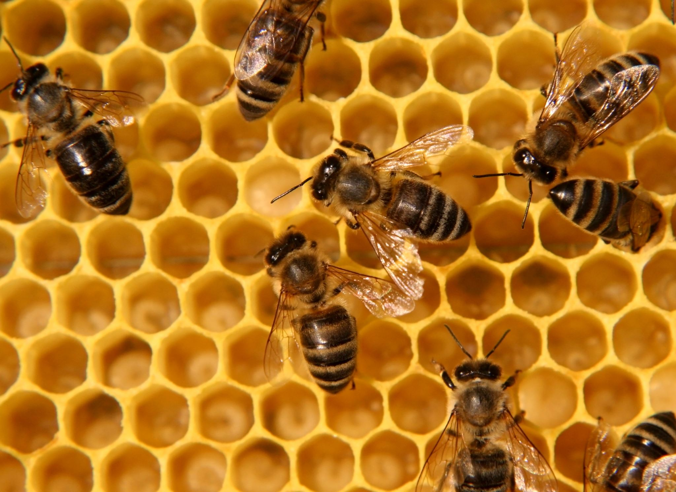
Beekeeping Business Plan
Table of Contents
Introduction 3
Name of business/owner(s) and type of business ownership 4
Mission statement/aim , objectives of business and USP 4
Describe the product or service offered by your business 5
Physical -location of business, equipment required 5
Human resources 6
Marketing activities, market research and marketing and promotional activities 6
Financial resources 8
SWOT Analysis 9
12 month cash flow forecast 10
Conclusion 11
Reference list 12

Introduction
Managing an enterprise requires the specific ways of controlling and conducting the business, information, process, IT capabilities, resources, service offering along with the activities of the enterprise. The major objectives of the enterprise management and planning is to make sure that the enterprise is going in the right direction and allows its resources to have the maximum impact on achieving its goals (Kurpayanidi, 2020).
This report will provide the essential details on the part-time business named “I Bee” which has recently entered into the market and offers the best quality honey to the customers. It will discuss the aims and objectives along with its ideal location in operating its business. Further it will provide the details regarding the human resource and will identify the potential employees working under this new bussiness. The report will discuss the marketing activities of ,,I bee’’ and how it will promote its products to reach out to wider populations. Moreover it will demonstrate its financial resources and analyse the company's weakness, strength, opportunities and threat through the SWOT analysis. Lastly the report will forecast the 12 month cash flow of the ,,I bee’’ company.

Name of business/owner(s) and type of business ownership
I Bee is a new company which will offer high quality Organic honey products. It is a sole trader which is often referred to as sole proprietorship. The company has a simple business structure in which the owner runs the entire business. The owner of the company is entitled to keep all of its profits after the deduction of tax; however the owner is liable towards all the losses that might occur during operating its business. Many people use the term sole trader as the business where there are no employees except the owner; however, it refers to a legal structure of the business, instead of employees numbers (Bruwer, 2019). I bee is considered to be the sole trader business where its owner manages and runs the whole business. The sole trader has the simple registration, as it is registered as the self -employed for tax purposes. Another reason why the company has decided to be a sole trader is that it requires minimal costs to startup the business (Marsden, 2020). In addition the owner of the business can have complete control towards its business and are free to make the decisions and direction regarding its business activities. The profit earned by the business will completely belong to the owner.

Mission statement/aim and objectives of business
The mission of I Bee is to provide customers with the best quality honey on the existing market. The major aim of the company is to become the best honey selling company in the UK without compromising the health of the consumers. At the same time I Bee is helping the environment with its little pollinators by improving the quality of crops and promoting a whole variety of colors to our world thru flowers. The objective of the company is to make a healthy start of the company and within 10 years the company aims to become the best seller of honey in the UK. For the first financial year the companys objective is to manage and cover the initial investment and at the same time the company will focus on establishing the brand image. For the first year the company will also be doing aggressive promotion of the product so that the product awareness will be created.
The USP of I Bee is: We produce quality honey that fits your pocket and boosts your health.

Describe the product or service offered by your business
The core products of I Bee are the high quality honey products manufactured by bee keeping. The company will focus on producing different types of honey (Wildflower, Hawthorn,Clover Honey, soft set honey), honey that could often be used as a substitute for sugar or as a health supplement. Other products that I bee will be selling are honey combs. The next products will be the medical grade honey, as it is effective in healing burns and wounds. It has antibacterial and anti-inflammatory properties which is usually used for the skin care and wound care and it is often effective for digestion and health. Thus the company has a focus to offer these products of honey, soon it will expand its products and add some more products made of honey such as Candles and Mead (Honey wine).
Another key product that I Bee will provide is ,, Adopt a hive”, where customers could adopt a hive and receive a set amount of honey and photographs with updates from their hive. For a period of 12 months customers adopting a hive will be welcome to arrange a day to visit and experience a day out in the nature with their adopted bees and test it’s golden liquid. The company is planning to open up its official websites and offer the service of online delivery of its products. The USP of the company is that it will offer the best organic quality honey products at an affordable price, and will encourage everyone to protect the environment by making their green area bee friendly as well as reusing honey containers whenever possible. The huge demand for honey in the market will enable the company to have a higher profit margin.

Physical -location of business, equipment required
The company has decided to locate at an Local Farm in Bettws, Newport – South Wales, farm that is willing to rent some land for free, as benefitting from bees pollinating their fields and crops. The company will require beekeeping equipment in order to produce the honey. The basic equipment required are the hives and nucs, protective gears, hive tools, smokers , one honey extractor, one automatic honey filler and jars/bottles. Moreover for the workplace, the company will invest in trying to automatize the way honey is being sold, fact that will allow the customers to reduce and reuse the honey products and therefore to participate in improving the environment.

Human resources
Human resources refers to the people who work within an organisation along with the department who are responsible in managing the matters regarding the employees, all together forming the most valuable resources of the organisation (Boon et al., 2019). For a business it is essential to have enough employees as they are the true asset of almost every firm. They are the true contributors who work effectively toward implementing the organization functions successfully. I bee, being a sole trader currently have just the one employee(owner), however planning to recruit more in the future as the business develops further. All the beehives work and paperwork is currently handled by the owner . In the future the company will recruit more employees in order to run its business smoothly. While manufacturing more products, the company needs more workers to increase its efficiency (Macke and Genari, 2019). I bee will provide job advertisements in its website and in some social networking sites with the job details and salary structure in attracting the new employees. The hiring process is to identify the right candidate and it will be done through interviewing and identifying their potentials and nature along with their experiences.

Marketing activities, market research and promotional activities
Marketing activities refers to the significant factors which help in determining the success of the business (Bilgin, 2018). It is implemented by the organisation in boosting sales and to improve its brand value. It is also considered to be the process of exchanging, delivering services which add value towards customers and creating effective communication. As a market activity I Bee requires to implement market researches as conducting research is the best way in achieving the customer satisfaction, elevating business and reducing customer churn. It will help the company in forecasting the needs and preferences of the customer and provide the valuable information regarding opportunities available for the new products along with the competitive advantages. I Bee will conduct the market research on the following:
Market segmentation: the company has already conducted market segmentation through asking the survey questions which will aim at capturing the values, behaviours, attitudes, demographics and needs of the customers. As the company does not have enough resources to target the mass market, it is essential for the company to target the particular market segment which needs their product. By conducting the research in market segmentation will allow it to understand the needs and preferences of the targeted market.
Brand awareness: I bee will also conduct the brand awareness survey in the future in order to identify the effectiveness of its marketing campaigns of promoting its products. It will help the company in measuring brand recall, brand identity, recognition, image, trust and loyalty. It is important to create the brand awareness into the customers and they should recall our brands rather than its competitors (Qualtrics, n.d.)
For the promotional activity, I Bee will promote its products through digital marketing, in which it will post on social media such as instagram and facebook. The company will provide the necessary details regarding its products and its uniqueness in its post to attract as many people as possible. Social media has been the ideal platform in promoting products and brands, as it is an easy way to reach out the audience and the followers can easily share the post into their own profile (Chen and Lin, 2019). The customers can directly ask questions regarding the products in social media, which will help the company in obtaining loyal customers. The company has also planned to provide its official websites, where it can showcase its products and can offer their products through online services by delivering them at customers door step. Therefore all these promotional activities will help the company in creating brand awareness and will likely get the customer's attention towards its products.
Another way of promoting I Bee , is through it’s location. Benefiting from being located on an already know Organic farm, I Bee will be able to sell it’s products straight from the Farm ,as well as making use of one automatic Honey filler, helping the customers to re-use their own containers.
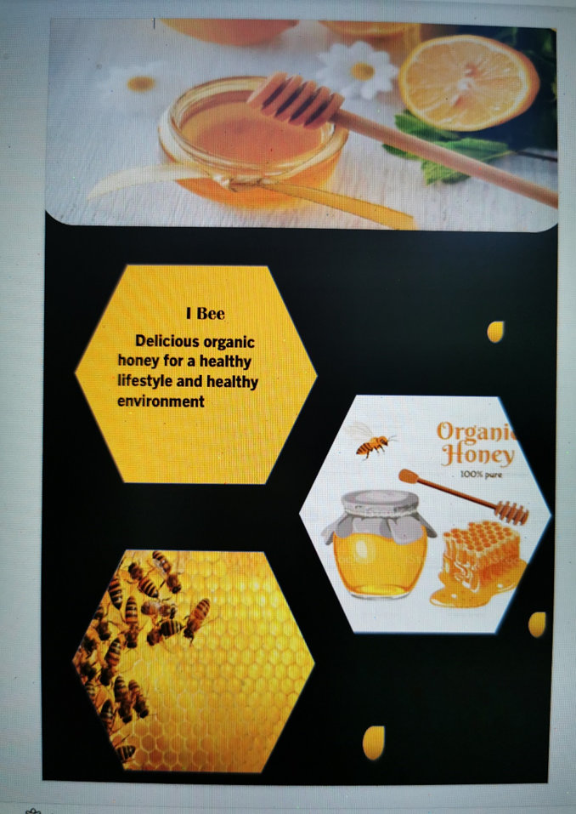
Another way of reaching our customers is through Leaflet distribution and here is an example:
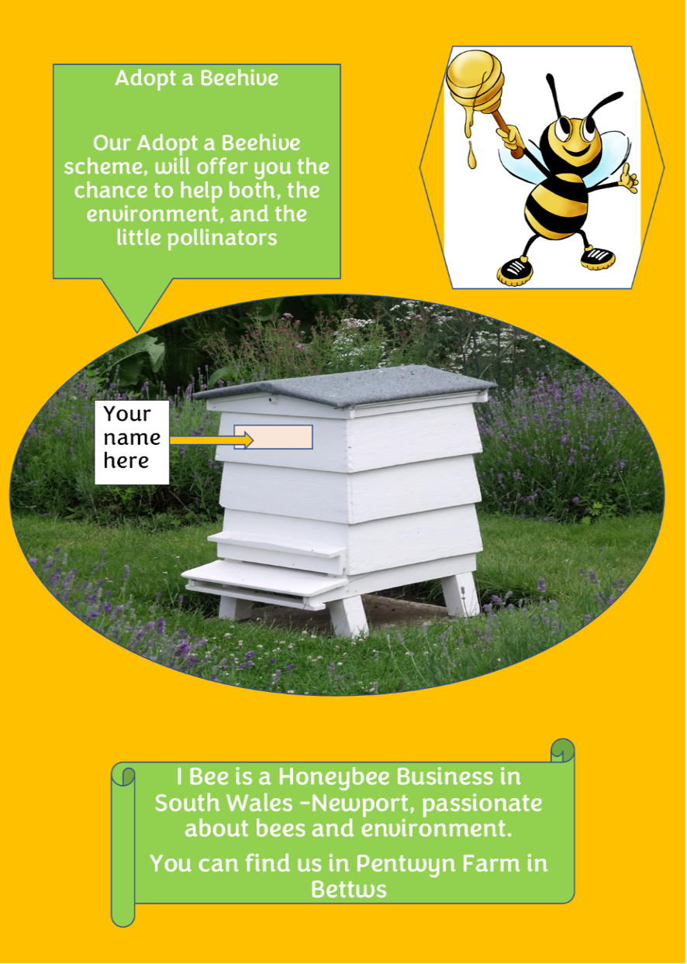

(Baragau,2022)

Financial resources
Financial resources are the key aspect in running the business effectively (Dvouletý et al., 2021). The sufficient funds are required to meet the daily expenses in order to purchase the long term asset of the company. The financial resources of I Bee come from three segments as follows:
Personal investment: The owner of the company will invest the fund and manage the financial instrument. It will be difficult to attract the investor or to borrow money from the bank unless the owner himself has invested his savings into the company. Self financing the business will allow the owner of the company to have more control than the other financial options and will retain full ownership in the business.
Start-up government grant: being a small and new business will look into applying for a start-up government grant to help cover some of the the investment for equipment and to help reaching the desired markets (Business Wales , n.d.).
Bank loans: It is the commonly used financial resource for almost all small businesses (Bakhtiari et al., 2020). I Bee will look after the potential banks which will offer advantages whether in a customised repayment or the personalised service while taking loan for the business. As the personal investment and the government grant might not be sufficient for the company, the bank loan will be the third option in getting the financial resources. The company will look for the bank which meets its specific needs and requirements.

SWOT Analysis
Strength | Weakness
I Bee will have a variety of honey products. Good pricing strategy as compared to other competitors.  Eco-friendly: possibility to bring your own jar, if purchasing honey from the Farm, resulting in less expensive honey and reduced waste for environment  Locally produced honey | Weak financial resources that could lead to debt.  As being a new business to the market, low brand awareness will be another weakness of the company  Not enough experience
Opportunities | Threats
Possibility of more sales through online services.  Possibility to produce more products in winter time, such as: candles, Mead (honey wine)  Possibilities to develop a Commercial Automatic Honey filler machine for placements on High Street/Markets | Being a new company, already established competitors are a major threat to the company.  The bad weather conditions of the UK, can cause a week honey production.  Honey Bee Diseases can affect the business and it’s honey production
(Baragau,2022)

12 month cash flow forecast

Conclusion
From the report it is concluded that managing enterprise requires specific ways in conducting the business activities. The report has provided the information regarding the new company I Bee, which aims at providing the best quality honey for customers and to increase its revenue in the coming years. The report has identified the location in which the company will operate its business. The report has been entirely based on this company and has provided its human resource such as number of employees and their roles in the company. Through the report it has been identified the importance of marketing research, promotional activities and financial resources in order to run the business effectively.

Reference list
Bakhtiari, S., Breunig, R., Magnani, L. and Zhang, J., 2020. Financial constraints and small and medium enterprises: A review. Economic Record, 96(315), pp.506-523.
Bilgin, Y., 2018. The effect of social media marketing activities on brand awareness, brand image and brand loyalty. Business & management studies: an international journal, 6(1), pp.128-148.
Boon, C., Den Hartog, D.N. and Lepak, D.P., 2019. A systematic review of human resource management systems and their measurement. Journal of management, 45(6), pp.2498-2537.
Bruwer, J.P., 2019. Critical innovation skills required of sole trader Small, Medium and Micro Enterprise (SMME) management and its influence on perceived business profitability.
Business Wales. (n.d.). Grants. [online] Available at: https://businesswales.gov.wales/businessfinance/types-finance-and-how-apply/grants#guides-tabs--4.
Chen, S.C. and Lin, C.P., 2019. Understanding the effect of social media marketing activities: The mediation of social identification, perceived value, and satisfaction. Technological Forecasting and Social Change, 140, pp.22-32.
Cleverley, J. and Heeson, S.J.A., 2019. Usage, engagement and impact: evaluating the usage of and measuring impact and engagement with library resources at Leeds Beckett University Library. Insights, 32(1).
Cunningham, M.M., Tran, L., McKee, C.G., Ortega Polo, R., Newman, T., Lansing, L., Griffiths, J.S., Bilodeau, G.J., Rott, M. and Marta Guarna, M. (2022). Honey bees as biomonitors of environmental contaminants, pathogens, and climate change. Ecological Indicators, 134, p.108457. doi:10.1016/j.ecolind.2021.108457.
Dvouletý, O., Srhoj, S. and Pantea, S., 2021. Public SME grants and firm performance in European Union: A systematic review of empirical evidence. Small Business Economics, 57(1), pp.243-263.
Kurpayanidi, K., 2020. Analysis of industrial enterprise management systems: essence, methodology and problems. Journal of Critical Reviews.
Macke, J. and Genari, D., 2019. Systematic literature review on sustainable human resource management. Journal of cleaner production, 208, pp.806-815.
Marsden, E., 2020. “Music for your breakfast” relational work in a sole trader’s intercultural business emails. Politeness in Professional Contexts, 311, p.225.
Putri, D.R. (2021). Digital Marketing Strategy to Increase Brand Awareness and Customer Purchase Intention (Case Study: Ailesh Green Consulting). European Journal of Business and Management Research, 6(5), pp.87–93. doi:10.24018/ejbmr.2021.6.5.1063.
Qualtrics. (n.d.). Brand Awareness: What Is It and How to Increase It in 2021. [online] Available at: https://www.qualtrics.com/uk/experience-management/brand/brand-awareness/.

