

A Correlation Report exploring the relationship between sensation seeking and the likelihood of engaging in risky driving behaviours
Louisa Smith
University of Wales Trinity Saint David
0173005

Abstract

Risky driving behaviour has the potential to lead to serious road traffic accidents through distracted and aggressive driving. With previous studies indicting a strong correlation between sensation seeking behaviour and risky driving behaviour (Dahlen, Martin, Ragan & Kuhlman 2005) a correlation study was conducted with 26 first year students at the University of Wales Trinity Saint David. Results showed only a weak correlation between sensation seeking and risky driving behaviour, however, there are issues with the small sample size and the lack of detail and possible subjectivity within the questionnaires that may have affected the results and thus limited the study. Suggestions have been made for improvement in future studies such as using a larger sample size and including a more detailed questionnaire. Implementing these suggestions in future research may lead to a result that is more consistent with other research into the topic.

Introduction

In 2016, police reports indicated that 537 out of 1445 fatal crashes in Britain that year had contributing factors of “failure to look” or distracted driving such as phone use. A further 100 fatal crashes were recorded as being due to aggressive driving (Department of Transport, 2017). Risky driving behaviour for the purpose of this report, is defined as any behaviour knowingly carried out by a person driving a vehicle that has the potential to cause harm or death to the driver or another person. Examples of risky driving behaviour include travelling too closely to the vehicle in front, driving over the speed limit and using a phone while driving. If there was a possibility of these behaviours being reduced, it could mean that hundreds of road traffic accident (RTA) deaths are avoided every year. Sensation seeking is defined as “A personality trait associated with a preference for intense sensory stimulation, strong, novel, and varied experiences, and in many cases risk taking.” (Oxford, 2015). Sensation seeking tendencies in individuals are typically measured through self-reported questionnaires. Dahlen, Martin, Ragan and Kuhlman (2005) used the Arnett Inventory of Sensation Seeking (AISS) which uses a 4-point Likert scale to assess participants. A study on this topic carried out by Dahlen et al. did find that sensation seeking predicted risky driving behaviour, and also found links to other dangerous driving behaviours such as aggressive driving. These findings are consistent with other studies such as Ulleberg and Rundmo (2003), who investigated risky driving behaviour in young drivers.
Based on this information, the expectation and hypothesis for this study is that the results will show a strong, positive correlation between sensation seeking and risky driving behaviour, with high scores on a sensation seeking questionnaire associated with high scores on a risky driving behaviour questionnaire.

Method
Participants:
Participants were 26 first year psychology students from the University of Wales Trinity St. David (M=4, F=22). They were recruited for the study through email and invited to complete the questionnaires. The participants ages ranged between 18 and 60 (M= 27.58, SD= 11.13).

Design:
The study used between subjects to investigate the hypothesis. The two variables in the study were scores on a sensation seeking questionnaire known as Brief Sensation Seeking Scale (BSSS) (Stephenson, Hoyle, Slater & Palmgreen, 2003) (Appendix A) and scores on a risky driving behaviour questionnaire created by Ivers et al. (2009) (Appendix B). Results were calculated using the SPSS software package (Appendix C).

Materials:
Data for the study was collected via two online questionnaires. These were available to participants through the university’s online Moodle portal. Before completing the questionnaires, participants were asked to complete a demographic page (Appendix D). Participants were asked to give their age, gender, the type of driving license they held (if any) and if they were regular drivers (specified as at least two to three times a week). The first questionnaire presented to participants was the Brief Sensation Seeking Scale (BSSS). The online questionnaire consisted of eight questions asking the participant to record their feelings towards various scenarios using a five-point Likert scale. Answers on the scale ranged from strongly disagree (1) to strongly agree (5), none of the answers were reverse scored. Total scores for the questionnaire could range between a minimum of eight and a maximum of forty, with a higher score indicating greater sensation seeking tendencies.
The second questionnaire was created by Ivers et al. and asked participants to answer fourteen questions regarding risky driving behaviour (e.g. How often do you… Drive about 50mph in a 40mph zone). The questionnaire again used a five-point Likert scale, however the responses ranged from very often (4) to never (0), giving participants an option to score zero on the questionnaire. No questions were reverse scored, and scores could range between zero and fifty-six, higher scores indicated a high likelihood of engaging in risky driving behaviour.
Procedure:
Participants were contacted via email and asked to complete the online questionnaires at their convenience. Before giving any responses, participants were presented with a consent form with a description of the study (Appendix E) and asked to read this fully before consenting to take part in the study via clicking yes or no under the statement “I have read and understood the information provided above”. After proceeding to the next page participants were asked to fill in a demographic data form. On the next page was the BSSS questionnaire. After filling in this questionnaire using check boxes to record their responses and clicking “next page”, participants were presented with the second questionnaire. The second questionnaire was presented in the same way as the first, with checkboxes below each question to record responses. After completing the second questionnaire and clicking next page, participants were thanked for completing the study and shown a debrief page (Appendix F). The debrief page contained the aims of the study, as well as informing participants of their right to withdraw their information and how to do so. Participants were informed that after clicking “submit” at the bottom of the page their information would no longer be retrievable. The page also provided the name and email address of the researcher to contact if participants had any questions. If participants were happy to continue, they were asked to finish the study by clicking “submit” at the bottom of the page.

Results
The relationship between sensation seeking and risky driving behaviour was investigated using Pearson product-moment correlation coefficient. The results showed r= 0.08, N= 26, p= 0.71 which indicates that there is only a weak negative correlation between sensation seeking (M= 25.88, SD= 4.49) and risky driving behaviour (M= 14.58, SD= 7.88) within this sample. This means that the original hypothesis has been found to be null, and is therefore rejected.

Figure 1. Scatter graph to show correlation between total BSSS scores and total risky driving behaviour questionnaire scores
Discussion
The scatter graph results show only a weak negative correlation between sensation seeking and risky driving behaviour, leading to a null hypothesis. However, these results are only representative of a small sample and should not be used to make generalisations about the wider population. The study consisted of only 26 participants, which when compared to the number of people in the UK who hold a valid driving licence (45.5 million in 2014, DVLA, 2015) does not provide a representative sample. As an improvement on this, future studies could seek out a larger sample size to recreate the study. For example, a study conducted to investigate poor driving, driver fatigue and risk taking and their association with RTAs (Smith, 2016) Surveyed 2856 people. This study produced findings consistent with those of Dahlen et al. who studied 224 participants. The questionnaires themselves could also provide more questions in order to give participants an opportunity to give more information on their driving habits. For example, the 14 questions provided on the risky driving behaviour questionnaire may not have been sufficient to gain an accurate account of the participant’s driving behaviours. To compare, the Driver Behaviour Questionnaire (DBQ) (Reason, Manstead, Stradling, Baxter & Campbell, 1990, cited in Cordazzo, Scialfa, Bubric & Jones-Ross, 2014) has 50 questions that it askes participants regarding risky driving behaviours. Another factor that may have affected results is that all of the answers on the risky driving behaviour questionnaire were self-reported, meaning that the participants themselves may not realise when they may be following too closely to a car, for example. This leaves many of the questions open to perceived risk as opposed to actual risk. To counter this, a suggestion would be to show a driving safety video to participants before completing the questionnaire.
In conclusion, though the results would reject the original hypothesis, there were factors within the study that prevent a generalisation being made. A sample of 26 participants is too small to be representative of the general driving population. A suggestion for future studies could be to conduct the study with a more detailed questionnaire, with participants perhaps also viewing driving safety material before the questionnaire in order to establish a “benchmark” to compare their driving behaviour with.

References

Cordazzo, S., Scialfa, C., Bubric, K. and Ross, R. (2014). The driver behaviour questionnaire: A north american analysis. journal of safety research, 50, pp.99-107.

Dahlen, E., Martin, R., Ragan, K. and Kuhlman, M. (2005). Driving anger, sensation seeking, impulsiveness, and boredom proneness in the prediction of unsafe driving. Accident Analysis & Prevention, 37(2), pp.341-348.

Department for Transport (2017). Contributory factors for reported road accidents (RAS50), London: Department for Transport, RAS50001.

GOV.UK. (2018). How many people hold driving licences in the UK. [online] Available at: https://www.gov.uk/government/publications/how-many-people-hold-driving-licences-in-the-uk

Ivers, R., Senserrick, T., Boufous, S., Stevenson, M., Chen, H., Woodward, M. and Norton, R. (2009) novice drivers' risky driving behavior, Risk Perception, and crash risk: Findings from the DRIVE study. American Journal of Public Health, 99(9), pp.1638-1644.

Oxfordreference.com (2018) Sensation seeking - Oxford Reference. [online] Available at: http://www.oxfordreference.com/view/10.1093/acref/9780199657681.001.0001/acref-9780199657681-e-9579?rskey=O9d3jD&result=2

Smith, A. (2016). A UK survey of driving behaviour, fatigue, risk taking and road traffic accidents. BMJ Open, 6(8), p.e011461.

Stephenson, M., Hoyle, R., Palmgreen, P. and Slater, M. (2003) Brief measures of sensation seeking for screening and large-scale surveys, Drug and Alcohol Dependence, 72(3), pp.279-286.

Ulleberg, P. and Rundmo, T. (2003) Personality, attitudes and risk perception as predictors of risky driving behaviour among young drivers, Safety science, 41(5), pp.427-443.

Appendices
Appendix A)
Brief Sensation Seeking Scale (BSSS)
Stephenson,M. T., Hoyle, R. H., Slater, M. D., & Palmgreen, P. (2003). Brief measures of sensation seeking for screening and large scale surveys. Drug and Alcohol Dependency, 72, 279-286.

Please respond to the statements below about how you generally feel about yourself, using the rating scale as follows:
Strongly disagree Disagree Neither disagree nor agree Agree Strongly agree

- I would like to explore strange places
- I would like to take off on a trip with no pre-planned routes or timetables
- I like to do frightening things
- I would like to try parachute-jumping
- I like wild parties
- I like new and exciting experiences, even if I have to break the rules
- I get restless when I spend too much time at home
- I prefer friends who are excitingly unpredictable

Scoring key:
Strongly disagree = 1
Disagree = 2
Neither disagree nor agree = 3
Agree = 4
Strongly agree = 5

Range of scores between 8 and 40. Higher scores indicated greater sensation seeking tendencies.

Appendix B)
Risky Driving Behaviour
Ivers, R., Senserrick, T., Boufous, S., Stevenson, M., Chen, H-Y., Woodward, M., … & Norton, R. (2009). Novice drivers’ risky driving behaviour, risk perception, and crash risk: Findings from the DRIVE study. American Journal of Public Health, 99(9), 1638-1644.

Please respond to the statements below as honestly as possible, using the rating scales as follows:
Very Often Often Sometimes Hardly Ever Never

1. Drive with 2 or more passengers
2. Drive while listening to loud music
3. Drive about 50mph in a 40mph zone
4. Drive fast just for the thrill of it
5. Follow very closely behind slow drivers
6. Speed up if someone is trying to pass
7. Take some risks when driving because it makes driving more fun
8. Make rude gestures at other drivers
9. Honk your horn or flash your lights in anger at other drivers
10. Do burnouts, donuts, or skids just for the fun of it
11. Race or drag race for the fun of it
12. Drive while using SMS on a mobile phone
13. Drive while talking on a mobile phone
14. Drive without wearing a seatbelt

Scoring key:
Very often = 4 Often = 3 Sometimes = 2 Hardly ever = 1 Never = 0

Range 0-56 with higher scores indicating greater likelihood of engaging in risky driving behaviours.
Appendix C)
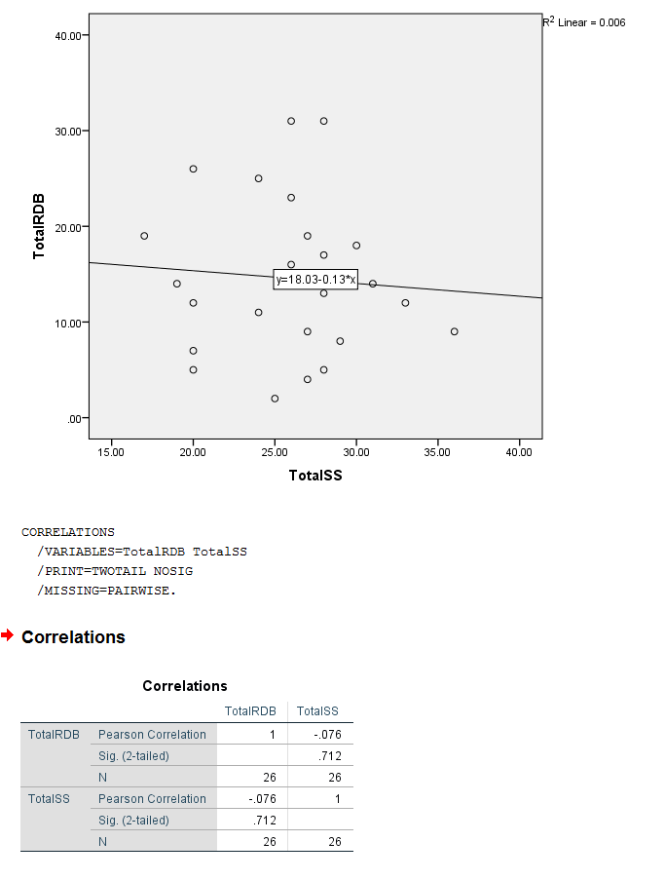

Appendix D)
Demographic information

- Please state your gender:
- Male
- Female
- Other
- Prefer not to say

- Please state your age:
______________

- What type of driving license do you have?
- Provisional driving license
- Full driving license
- No license

Q4 dependent on response to Q3 – if ‘no licence’ this question is not displayed

4. Do you drive regularly? (i.e., at least 2 to 3 times a week)
- Yes
- No

Appendix E)
Study information and consent

I understand that taking part in this research survey will involve me answering two short questionnaires regarding my driving behaviour.
I understand that participating in this study is entirely voluntary and I am free to withdraw my participation at any time by closing the browser screen. I am aware that if I have concerns about the study that I can contact the principal researcher via the details below following completion of the study.
I understand that the information provided by my will be used for the purpose of providing data for analysis, but that this data will be held confidentially and anonymously, with a code assigned in place of my name. These data will be stored in accordance with the Data Protection Act.
I also understand that at the end of the study I will be provided with debrief information outlining the full nature of the study. I will also have the opportunity to contact the researcher with any questions I may have.

Researcher details:
Miss Stacey Coleman
stacey.coleman@uwtsd.ac.uk

I have read and understood the information provided above
- Yes
- No

I consent to taking part in this study
- Yes
- No

Appendix F)
Debrief information

Thank you for taking part in this study.
The main aim of this study was to explore whether there is a relationship between levels of sensation seeking and the likelihood of engaging in risky driving behaviours. It was specifically hypothesised that higher levels of sensation seeking would be related to a greater likelihood of engagement in risky driving behaviours.
If you wish to withdraw your data from the study you must email the researcher now. Once you submit this form, all of your data will remain confidential and it will not be able to be traced back to you.
Researcher details:
Miss Stacey Coleman
stacey.coleman@uwtsd.ac.uk

Please click the button below to submit your answers

- SUBMIT

