Module. Digital technologies
Lecturer. Munyaradzi N Murira
Student. Taiba Rashid 2229734
Task 3.
Evidence for completing course communicating using email.

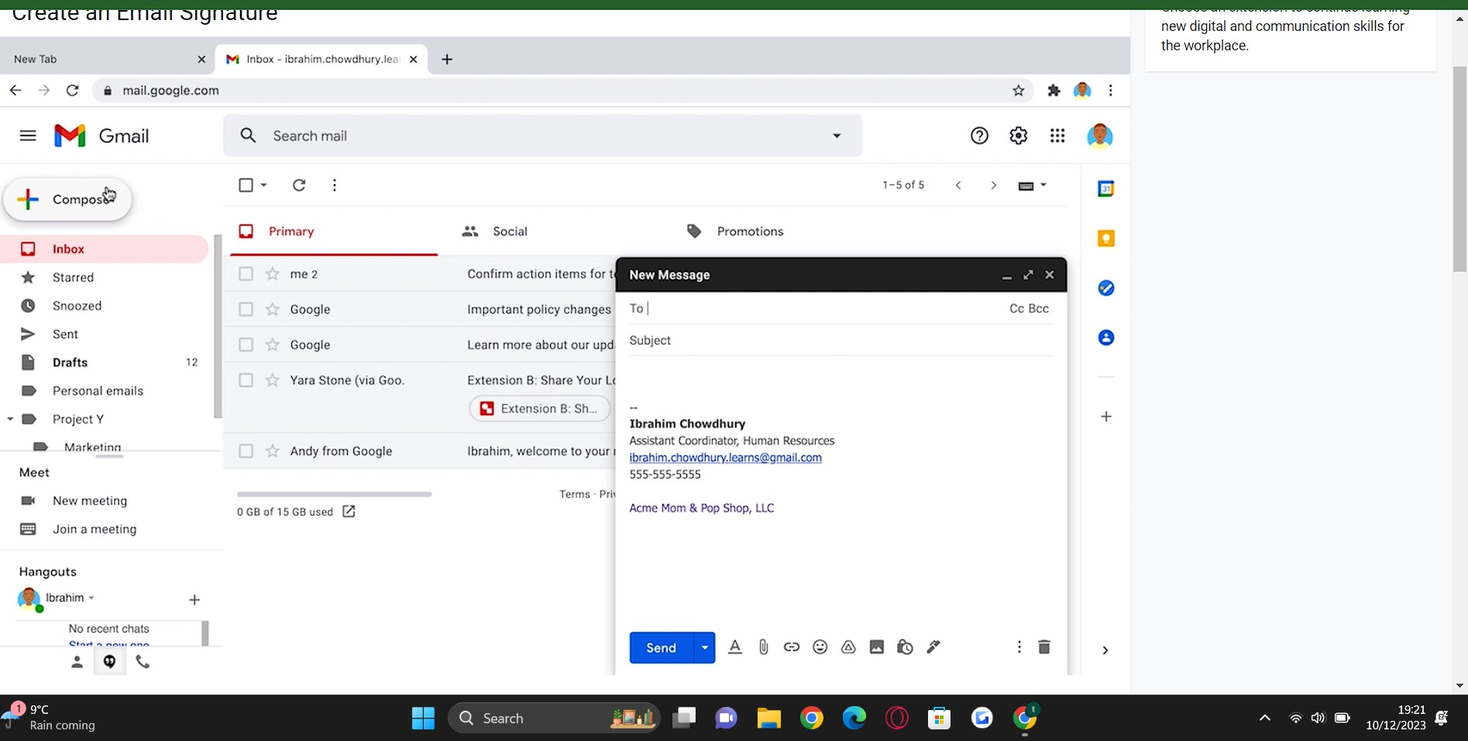
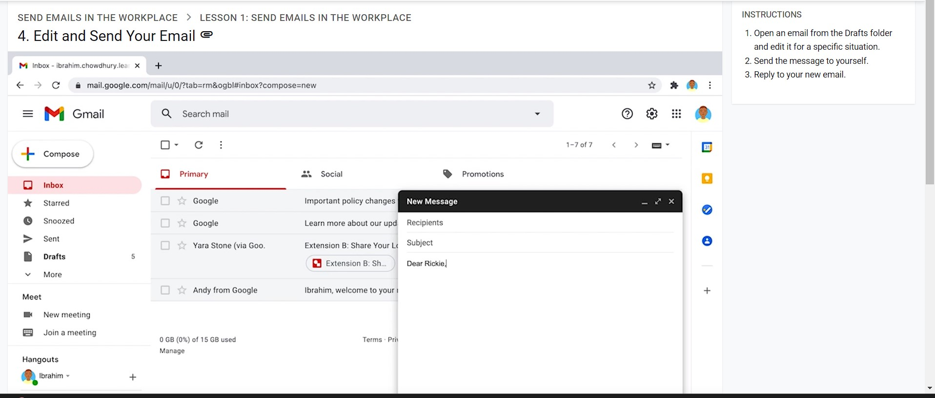
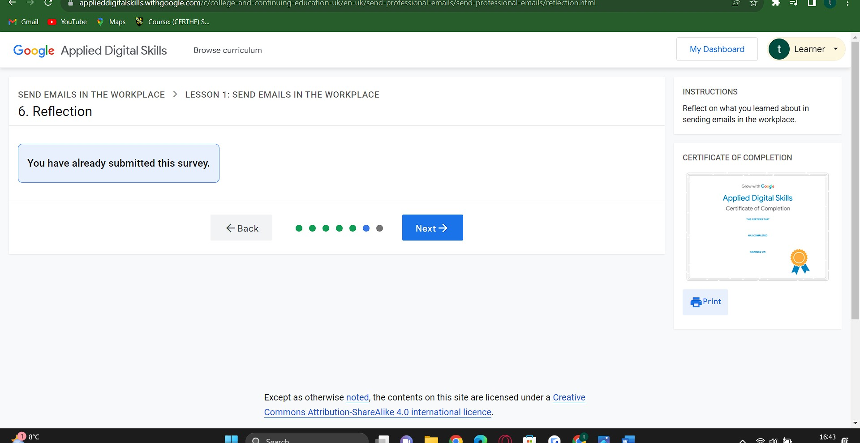

What have I learnt from this course?
From this course I learnt how to communicate using emails how to edit and send emails.
I chose an extension to learn how to write an email to work to inform I will be late.

