Winter Heritage & Arts Festival
Student name: Alina Elena Craciun
Student ID: 2212851
The assignment title: Planning and Delivering an International Meeting/Event.
Lecturer : Kathryn Flynn
Module: International Meetings Management BMIH6007

TABLE OF CONTENTS
1.Executive summary ………………….……4
2.Introduction ………………………….……..4
3.The Event Cycle …………………….……..5
4.Event Concept……………………………..10
5.Aim and Objective ………………..……….11
6.Event Management………………...………12
7.Event Budget ……………………………….14
8. Industry Trends …………………………….15
9. Situational and Cultural Considerations …16
10. Conclusion…………………………………18
11. References List……………………………18
12. Appendix……………………………………23

I acknowledge the use of Grammarly (https://www.grammarly.com/) on 07/11/2024 to check my work using the prompt(s):
1. Please check the following text for readability, grammar and syntax. I confirm that I have not presented any AI generated text as my own work. I confirm I have copies of my drafts, notes, and other resources I used before, and after the use of AI tools which I may be asked to provide in evidence.

Executive summary
The Winter Heritage & Arts Festival is an immersive cultural event that celebrates international winter traditions through a unique combination of performances ,workshops and exhibitions . Held at the Rathausplatz in Vienna , a renowned and iconic location , the festival aims to foster cultural exchange while offering an engaging experience for diverse audiences .
The central theme of the festival is the exploration and celebration of winter traditions from around the world , bringing together an diversity of performances from music and dance to storytelling and visual art. Interactive workshops will invite participants to experience traditional winter crafts,cuisines,and custom firsthand , further promoting cultural understanding and exchange.
Rathausplatz, located in the heart of Vienna , is recognised as an ideal venue for large-scale winter events due to its accessibility , spaciousness , and the rich cultural ambiance it offers . With its stunning surroundings , including the City Hall (Rathaus) and the famous Christmas markets, the venue provides a perfect backdrop for this winter festival , enhancing the overall atmosphere and appeal.
This executive summary outlines the key components of the festival , including its strategic vision, the importance of the venue and the festival potential to engange both local and international audience . It emphasizes the festival capacity to generate cultural dialogue and understanding through its diverse programming , making it an exciting addition to Vienna cultural calendar.

Introduction
The Winter Heritage & Arts Festival provides a captivating exploration of international winter traditions, combining performances, workshops, and exhibitions to promote cultural exchange. Participants will have the distinct opportunity to interact with winter traditions from various cultures, making the festival a complete cultural experience.
Rathausplatz in Vienna, a central and emblematic site, functions as the optimal venue. This venue, recognised for accommodating large winter events, offers accessibility and a dynamic cultural ambiance that complements the festival's global charm (Ardani, 2017).
This event was selected to address the increasing demand for cultural tourism, which prioritises genuine experiences. The festival's capacity to draw international tourists while strengthening local economies positions it as a significant feature of Vienna's winter season, providing both economic and cultural advantages (Borowiecki and Castiglione, 2014).

The Event Cycle
The Event Cycle, a key structure in event management, offers a systematic method for the planning and implementation of events. It defines five separate phases: Initiation, Planning, Implementation, Event, and Closure. The EMBOK (Event Management Body of Knowledge) outlines phases that facilitate the systematic progression of an event by prioritising both strategic and operational dimensions (Silvers et al., 2005). The EMBOK model is exceptionally versatile and prioritises ongoing improvement, innovation, ethics, and connection throughout each phase.

1. Initiation:
This phase includes the identification of the event's purpose, vision, and primary objectives. The initiation phase of the Winter Heritage & Arts Festival is focused on showcasing international winter traditions through performances, workshops, and cultural exhibitions. Initial discussions involve stakeholders and establish collaborations with sponsors such as Emirates Airlines, increasing global visibility. This phase integrates cultural activities, such as Norwegian wool weaving, activities like mărțișor crafting and Andean solstice rituals into the festival's vision, linking objectives with winter heritage.

2. Planning:
The planning phase include logistics, budgeting, marketing, and operations. Effective budget management is essential for this festival, as expenses for venue setup, marketing, and rentals are fundamental (Kelly et al., 2019). Scheduling and resource allocation necessitate collaboration with local artisans and performers. Craft workshops, such as Finnish paper snowflake crafting and Norwegian wool weaving or Polish pierogi making, are strategically scheduled in the mornings to boost participant engagement prior to afternoon performances. Marketing strategies facilitate broad exposure and promote workshops (Campillo-Alhama and Martínez-Sala, 2019).
3. Implementation:
The logistical arrangement of the event starts, covering crowd control, heating systems, and safety measures. Infrastructure such as lighting and sound, along with venues for performances and exhibitions, are developed (Mallen and Adams, 2024). Real-time coordination facilitates easy transitions, such as shifting from Norwegian wool weaving workshops and Mongolian throat singing to performance venues, guaranteeing attendee continuity.

4. Event:
Management monitors workshops, performances, and exhibitions during the event. Events such as the grand winter parade, which includes lanterns and folkloric figures, and ice sculpting exhibition necessitate meticulous oversight to ensure safety and improve the experience for attendees. Volunteers guide attendees along pathways, and heated tents are utilised near popular workshops, such as Norwegian wool weaving, to ensure comfort (Deng et al., 2019).

5. Closure:
Post-event evaluations collect feedback, analyse financials, and draw conclusions for future events. Surveys assess satisfaction with workshops and performances, targeting 85% positive feedback. Feedback brings out the achievements, such as the Norwegian wool weaving workshop, influencing improvements in the future. A financial report evaluates revenue in relation to the budget, while meetings with partners, including workshop leaders, address successful strategies and opportunities for improvement (Wood, 2009).
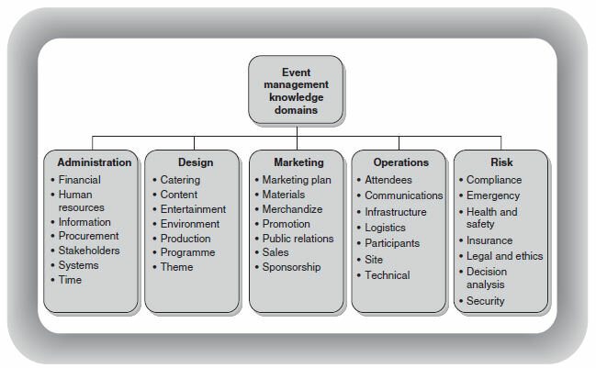
1. Event Design
1.a Event Theme & Concept : The festival is designed to explore international winter traditions through performances, workshops and exhibitions . The overall concept combines cultural exchanges , artistic expression and hand-on learning.
1.b Program Structure : The festival will include music,dance performances , art exhibitions and craft workshops.
1.c Guest Experience : Focuses on immersive experiences from storytelling about global winter traditions to hands-on craft like decorations or creating winter-themed art.
2. Event Planning
2.a Timeline : Planning must begin months in advance , securing sponsors , performers , vendors and the venue (Rathausplatz) . Specific milestones include finalizing the program, promoting the event and ensuring logistical arrangements such as stage setup, catering and transportation.
2.b Vendor Management : Selection and coordination of vendors , including artisans , caterers and performers are critical to delivering a seamless event. These vendors will provide the winter themed decorations, food and interactive experiences.
2.c Legal and Saftey Requirements :Ensure compliance with all regulations including insurance , permits, health and safety protocols.
3. Event Marketing
3.a Target Audience : The festival aims to attract both local and international attendees with an emphasis on families, tourists and individuals interested in cultural exchange.
3.b Promotional Channels : Use of digital marketing ( social media , email campaings, event websites ) traditional media ( flyers , posters ) and partnerships with cultural organizations .
3.c Branding : The events branding will emphasize themes of global cultural exchange , winter heritage and artistic expression , utilizing vibrant visuals and culturally relevant messaging to resonate with the target audience.
4. Event Operations
4.a Logistics : Managing the physical setup of the venue , including staging , lighting , sound systems and exhibition spaces . Coordination with local authorities for road closures, safety and security will be necessary .
4.b Staffing : A large team of staff and volunteers will be required for various roles : registration, ticketing , crowd control , vendor support and customer service .
4.c Attendee Experience : Ensuring attendees can easily access the event with clear signage , sufficient amenities and smooth registration/check-in processes.
5. Event Risk Management
5.a Health and Safety : With the festival taking place during the winter season risk as cold weather , slippery surfaces and potential overcrowding need to be considered .
5.b Emergency Planning : Include medical staff on-site , first-aids stations and clear evacuation plan in case of an emergency , health protocols related to the food and sanitations .
5.c Insurance : Ensure event insurance covers liability for accidents , property damage and cancellations due to unforeseen circumstances.
So, each phase of the EMBOK framework provides an elaborate and systematic methodology for event management, facilitating the successful implementation of the Winter Heritage & Arts Festival .

Event Concept
What makes a festival memorable? It’s the complete experience that engages all senses and links participants to an undiscovered world. The Winter Heritage & Arts Festival highlights profound involvement, merging cultural exploration with interactive engagement.
Every morning includes practical workshops in which attendees learn skills in traditional winter crafts. Imagine creating elaborate Finnish paper snowflakes or weaving Norwegian wool motifs with regional artisans. These workshops promote engagement, providing an actual understanding of global winter heritage (Cetin and Bilgihan, 2016). Notable activities include the creation of Romanian mărțișor, a red-and-white charm symbolising the end of winter (Kravcenko, 2022), and the preparation of Polish pierogi, exemplifying Eastern European culinary heritage (Kulinski, 2022).
Afternoons transition to showcases of rhythmic drumming by Siberian tribes and captivating Japanese winter dances. These exhibitions illustrate the diverse artistic expressions of various cultures in relation to winter, involving attendees in international traditions (Brown, 2019). The program features a recreation of the Andean Inti Raymi winter solstice ceremony (Carvache-Franco et al., 2018) and a Mongolian throat singing performance that emphasises winter resilience and narrative (Lkhaasuren, 2022).
As night descends, the atmosphere becomes reflective, hosting art exhibitions and a spectacular winter parade. The exhibitions commemorate winter through contemporary and traditional folklore presentations from various global regions, including a Canadian ice sculpting demonstration where artists create elaborate, winter-themed sculptures displayed at Canadian festivals (Travel Banff Canada, 2024).
The parade, the day's highlight, travels the streets decorated with luminous lanterns, folkloric figures, and colourful floats symbolising winter myths (Borowiecki and Castiglione, 2014). Throughout the day, food stalls and merchandise booths provide sustenance and souvenirs, including Swiss hot cocoa, German gingerbread, and hand-knit scarves from Nepal. These crafts support cultural understanding and community through artisan engagement (Nyfeler and Aspers, 2023). The marketplaces offer a sensory experience and a concrete link to the represented cultures, as food significantly contributes to community revitalisation and heritage preservation (Timothy and Ron, 2013). Culinary selections consist of traditional dishes such as Polish pierogi and Andean quinoa soup, Romanian sarmale with mamaliga and palinca, and other traditional dishes from around the world, representing warming cuisines from Eastern Europe and South America.
This curated experience guarantees that attendees depart with not only memories but also a greater understanding for the diversity and richness of global winter traditions.

Aim and Objectives
Creating a distinctive cultural experience that profoundly connects with its audience is a challenging pursuit. The Winter Heritage & Arts Festival seeks to provide a fascinating celebration of international winter traditions, encouraging attendees to both observe and engage in a diversified cultural environment. The festival aims to deepen the understanding and appreciation of winter celebrations across diverse cultures, bringing these traditions to life through workshops, performances, and exhibitions.
To guarantee the success of this mission, the event has set precise SMART objectives. The festival seeks to attract 10,000 attendees throughout its duration, appealing to both cultural tourists and local participants (Kelly et al., 2019). Secondly, it aims to generate £170,000 in revenue through a combination of ticket sales, sponsorships, and vendor participation (Rivera et al., 2008). The objective is to achieve 85% positive feedback, ensuring that attendees leave with a significant memorable experience that underscores the importance of cultural exchange (Li et al., 2022).

Event Management
Successful event management requires an optimal integration of logistical precision and strategic planning. The Winter Heritage & Arts Festival will accomplish this through carefully coordinated operational activities, strategic planning, and marketing initiatives (Getz, 2018).
1. Operational Activities
Choosing the appropriate venue and monitoring crowds are essential for the festival's success (Bowdin et al., 2011). Rathausplatz in Vienna, known for its spaciousness and winter event hosting, serves as an optimal venue for large gatherings while preserving a cultural ambiance (Ardani, 2017). Crowd flow will be carefully observed through designated entry and exit points, facilitating seamless movement among workshops, performances, and food stalls.
Infrastructure is another critical component. Temporary heating tents, illumination, and sanitation facilities are essential to create a comfortable environment in potentially severe winter conditions (Mallen and Adams, 2024). Acquiring these materials necessitates cooperation with local suppliers, guaranteeing both efficiency and compliance to the event's sustainability objectives. The stage configuration must be properly built to protect equipment from weather effects while providing optimal sound and lighting conditions.

2. Activity Planning
Strategic alliances are essential for the financial viability of the event (Getz, 2018). Coca-Cola, as a co-sponsor, will implement branded beverage stations to increase visitor engagement while capitalising on its global presence (Joines, 2018). Marriott Hotels will provide hospitality services, including a branded VIP lounge, to support the festival's operational requirements (Dolores et al., 2021). Emirates Airlines increases international visibility and strengthens the event's global appeal through extensive branding opportunities (Al Saed et al., 2020).
Moreover, the implementation of marketing strategies during the planning phase is very important. The combination of digital initiatives and offline marketing ensures the effective targeting of both local and international audiences. Partnerships with tourism boards and cultural institutions will draw visitors from nearby regions, whereas digital strategies will captivate a worldwide audience.
3. Marketing Initiatives
In the contemporary event context, influencers significantly impact public perception and boost participation (Bowdin et al., 2011). For example, influencers utilise Instagram and YouTube to provide behind-the-scenes content and event highlights to generate global interest, imitating successful models such as Coachella (Bashar et al., 2024).
Promotional material will highlight global artisans and performers, such as Romanian mărțișor crafting, Andean solstice rituals, and Canadian ice sculpting. These elements are going to highlight the festival's international scope, drawing participants seeking distinctive, interactive experiences (Ayesu et al., 2020).
Collaborations with cultural organisations will make sure that the event is culturally orientated and widely advertised. Collaborating with tourism boards will boost participation from other countries and local residents (Truong and Hall, 2013). Partnering with influencers from regions covered in the festival, such as Eastern Europe, Northern Europe and South America, will improve international visibility and attract niche audiences interested in cultural and craft-oriented events (Hudson et al., 2015).
By means of precise operational planning, strategic alliances, and a thoughtfully designed marketing initiative, the Winter Heritage & Arts Festival will harmonise logistical efficiency with cultural involvement, guaranteeing a successful and unforgettable event.

Event Budget
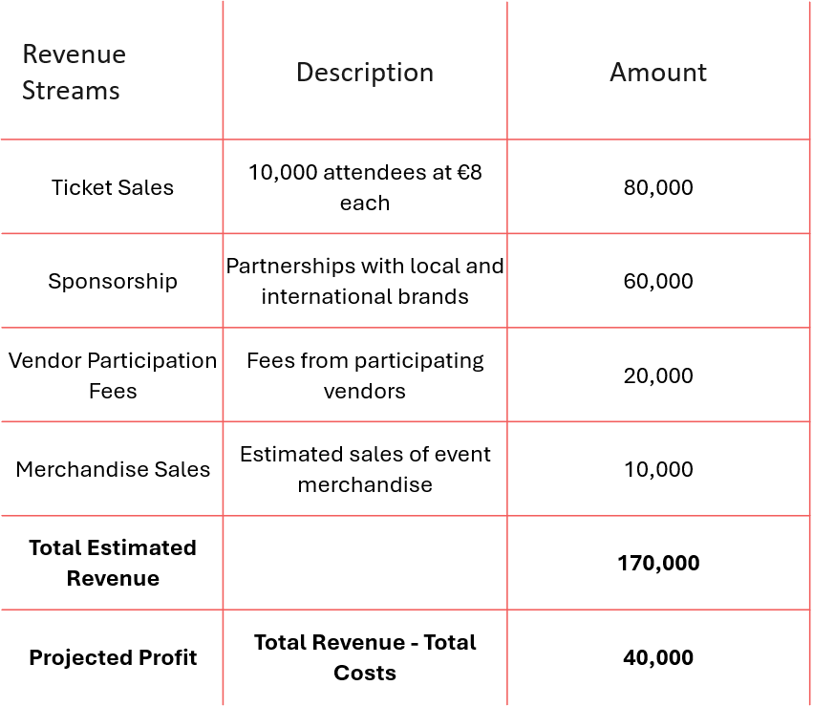
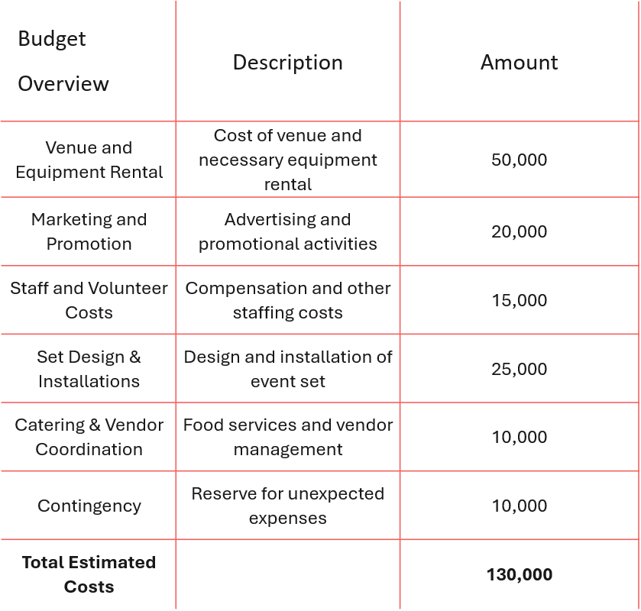

Event budgeting surpasses simple numerical balance; it involves aligning each expenditure with strategic objectives to guarantee the event's success. The Winter Heritage & Arts Festival depends on a well organised budget that covers both the logistical and artistic aspects of the event.
This budget demonstrates a balanced strategy, prioritising the logistical requirements of the event along its primary goals of revenue generation, audience attraction, and the delivery of a superior experience.

Industry Trends / Issues / Impacts

The event industry is constantly transforming, influenced by technological innovations and shifting societal priorities. A prominent trend is the rise of digital marketing and the increasing influence of celebrities in event promotion. Platforms such as Instagram and YouTube are essential for captivating younger demographics and achieving worldwide exposure. The Winter Heritage & Arts Festival can utilise influencers, similar to the effective strategies employed by brands such as Coachella, which utilised influencers to generate excitement and increase attendance (Campillo-Alhama and Martínez-Sala, 2019).
Sustainability is an ever-growing issue in event planning. Due to a growing realisation of environmental impacts, events are increasingly required to reduce their ecological footprint. Locally sourcing food, minimising plastic consumption, and implementing energy-efficient infrastructure have become accepted as standard practices. Festivals like Glastonbury have implemented substantial measures by banning single-use plastics and utilising renewable energy sources, a framework that the Winter Heritage & Arts Festival might replicate to achieve comparable sustainability objectives (Negrușa et al., 2016).
Ultimately, global economic changes have transformed sponsorship dynamics, forcing companies to reevaluate their marketing expenses and prioritise value-oriented collaborations. The tourism sector, influenced by variable economies and political instability, faces challenges, necessitating events to provide evident returns on investment. Consequently, enduring partnerships—such as Emirates Airlines' continuous participation in significant global festivals—are increasingly appealing in order to guarantee sustained support (Dolores et al., 2021).
These trends reinforce the necessity for events to continue to change and innovate, balancing contemporary demands with effective, impactful strategies.

Situational and Cultural Considerations
Each event must be evaluated within its wider situational and cultural context to guarantee that it will be successful and resonate with its target audience. A SWOT analysis provides insight into the strategic position of the Winter Heritage & Arts Festival.
The strengths are rooted in its strong cultural positioning. The festival's focus on global winter traditions amplifies its international attraction, drawing participants interested in cultural tourism, a sector that has experienced growth in recent years (Borowiecki and Castiglione, 2014). The festival receives community support in Vienna, a city renowned for its dynamic cultural landscape and extensive history of hosting successful winter markets and events, including the renowned Christmas markets (Kelly et al., 2019).
On the other hand, a weakness is the event's dependence on weather conditions. Winter festivals are particularly vulnerable to unforeseen weather conditions, potentially resulting in cancellations or reduced attendance. Moreover, the substantial initial expenses for the venue, infrastructure such as heating, and contingency measures for bad weather impose considerable financial strains (Deng et al., 2019).
The increasing interest in cultural tourism presents many possibilities for media collaborations and sponsorships with global brands like Emirates Airlines and Coca-Cola, which have historically sponsored similar events (Joines, 2018). These collaborations strengthen the event's financial foundation and broaden its reach through international marketing initiatives.
However, threats persist, particularly from rival winter festivals, notably in European nations with long-standing Christmas markets. Vienna, despite its popularity, faces with competition from cities such as Munich and Prague, where traditional markets have become rooted in the local culture and may draw similar tourist demographics.

A PESTEL analysis provides further context:
• Political: The festival expects support from cultural ministries and tourism boards due to its capacity to help improve tourism and facilitate cultural exchange. Historically, similar events have received governmental support to promote heritage tourism (Zhang, 2023).
• Economic: The festival, fuelled by tourism, has the potential to strengthen the Viennese economy through hotel accommodations and dining expenses, while simultaneously drawing sponsorships from international brands. Previous festivals in Vienna have shown considerable economic benefits (Negrușa et al., 2016).
• Social: The festival have to maintain cultural sensitivity in its presentation of traditions, to make sure no culture is misrepresented or transformed, a challenge common in numerous large cultural events (Disegna et al., 2011).
• Technological: The success of the festival will depend on making efficient use of social media and digital marketing. Platforms such as Instagram and YouTube will not only engage younger demographics but also increase global visibility through influencer collaborations, exemplified by events like Coachella (Bashar et al., 2024).
• Environmental: Ultimately, climate risks and the necessity for sustainable practices present obstacles. To address these issues, the festival will implement sustainable practices, including the procurement of local materials and the setting up of an environmentally responsible waste management, mimicking eco-centric events such as Glastonbury (Negrușa et al., 2016).
SWOT analysis
Using a SWOT analysis we discovered:
Strengths : Vienna reputation as cultural hub
Weaknesses : Logistical challenges , weather conditions
Opportunities : International partnerships
Threats : Competition from other events , financial risk

Conclusion
The success of the Winter Heritage & Arts Festival depends on strategic planning and precise execution. From site selection to sponsorship agreements, every aspect is coordinated to provide an unforgettable cultural experience. The festival builds cultural preservation by promoting global winter traditions and catering to the demand for cultural tourism.
The next steps involve finalising sponsorship contracts, initiating marketing campaigns, and organising logistical operations. With these essential components set up, the festival has the potential to become an iconic event in Vienna's cultural atmosphere and the international festival arena.

References List
1. Al Saed, R., Upadhya, A. and Saleh, M.A., 2020. Role of airline promotion activities in destination branding: Case of Dubai vis-à-vis Emirates Airline. European Research on Management and Business Economics, 26(3), pp.121-126. https://doi.org/10.1016/j.iedeen.2020.07.001
2. Antonio Rivera, M., Hara, T. and Kock, G., 2008. Economic impact of cultural events: The case of the Zora! Festival. Journal of Heritage Tourism, 3(2), pp.121-137. https://doi.org/10.1080/17438730802138139
3. Ardani, E., 2017. The importance of the venue selection in an event organization: Case study - Special Event Organization Rencontre Alumni Entreprise 1 & 2. E-Journal of Tourism, 4. Available at: https://doi.org/10.24922/EOT.V4I1.30168
4. Ayesu, S., Osei, M., Chichi, C., and Acquaye, R., 2020. Festival Elements: A Source of Inspiration for Contemporary Fashionable Products. Journal of Textile Science and Technology. https://doi.org/10.4236/jtst.2020.64017.
5. Bashar, A., Wasiq, M., Nyagadza, B. and Maziriri, E.T., 2024. Emerging trends in social media marketing: a retrospective review using data mining and bibliometric analysis. Future Business Journal, 10(1), p.23. https://link.springer.com/content/pdf/10.1186/s43093-024-00308-6.pdf
6. Borowiecki, K.J. and Castiglione, C., 2014. Cultural participation and tourism flows: An empirical investigation of Italian provinces. Tourism Economics, 20(2), pp.241-262. https://doi.org/10.5367/te.2013.0278
7. Bowdin, G. A. J. (2011). Events management (3rd ed.). Elsevier Butterworth-Heinemann. https://librarysearch.uwtsd.ac.uk/permalink/44WHELF_UWTSD/tj3s4p/alma99100158759802421
8. Brown, G., 2019. Eventscapes. Transforming Place, Space and Experiences. https://doi.org/10.4324/9781315105000
9. Carvache-Franco, M., Carvache-Franco, W., Borja Morán, J.L. and Contreras Moscol, D., 2018, May. Tourist demand characterization. Andean cultural festival Inti Raymi (Ecuador). In Journal of Convention & Event Tourism (Vol. 19, No. 3, pp. 248-267). Routledge. https://doi.org/10.1080/15470148.2018.1459213
10. Cetin, G. and Bilgihan, A., 2016. Components of cultural tourists’ experiences in destinations. Current issues in tourism, 19(2), pp.137-154. https://doi.org/10.1080/13683500.2014.994595
11. Deng, Y., Cao, B., Yang, H. and Liu, B., 2019. Effects of local body heating on thermal comfort for audiences in open-air venues in 2022 Winter Olympics. Building and Environment, 165, p.106363. https://doi.org/10.1016/j.buildenv.2019.106363
12. Disegna, M., Brida, J.G. and Osti, L., 2011. Authenticity perception of cultural events: A host-tourist analysis. Available at SSRN 1825369. https://dx.doi.org/10.2139/ssrn.1825369
13. Dolores, L., Macchiaroli, M. and De Mare, G., 2021. Sponsorship’s financial sustainability for cultural conservation and enhancement strategies: an innovative model for sponsees and sponsors. Sustainability, 13(16), p.9070. https://doi.org/10.3390/su13169070
14. Getz, D 2018. Event Evaluation: Theory and Methods for Event Management and Tourism, Goodfellow Publishers, Limited, Oxford. Available from: ProQuest Ebook Central. https://ebookcentral.proquest.com/lib/trinity/detail.action?docID=29281298
15. Hudson, S., Roth, M., Madden, T., and Hudson, R., 2015. The effects of social media on emotions, brand relationship quality, and word of mouth: An empirical study of music festival attendees. Tourism Management, 47, pp. 68-76. https://doi.org/10.1016/J.TOURMAN.2014.09.001.
16. Joines, M.J., 2018. Corporate sponsorship and university campuses: Determining the effectiveness of university sponsorship efforts at Pittsburg State University. Pittsburg State University Electronic Theses and Dissertations. Available at: https://digitalcommons.pittstate.edu/cgi/viewcontent.cgi?article=1312&context=etd
17. Kelly, P., Newbold, C., Jordan, J. and Diaz, K., 2019. Creating your festival budget. Principles of Festival Management, 4(1). Available at: https://doi.org/10.23912/978-1-911396-82-6-4067
18. Kravcenko, V., 2022. Illustrated books from the second half of the XXth century – beginning of the XXIst century and the visualization of national traditions included in the UNESCO Representative list of Intangible Cultural Heritage of Humanity. Studii culturale, Volumul II. Available at https://doi.org/10.52603/9789975352147.02.
19. Kulinski, W., 2022. “It Comes with Practice”: Pierogi-Making as Preserving and Imagining Polonia. Canadian Theatre Review, 189, pp. 13. Available at https://muse.jhu.edu/article/852483/figure/img01 , https://blog.utpjournals.com/2022/04/04/imagination-and-everyday-performance/
20. Lkhaasuren, K., 2022. THE CONCEPT ON THE TERM OF MONGOLIAN THROAT SINGING. Mongolian Diaspora. Journal of Mongolian History and Culture, 2, pp. 31 - 54. https://doi.org/10.1515/modi-2022-020105.
21. Li, Y., Liu, Y., & Tong, S., 2022. Observer-Based Neuro-Adaptive Optimized Control of Strict-Feedback Nonlinear Systems With State Constraints. IEEE Transaction on Neural Networks and Learning Systems, PP(7), 1–15. https://doi.org/10.1109/TNNLS.2021.3051030
22. Mallen, C., and Adams, L. J., 2024. Event management in sport, recreation, and tourism : theoretical and practical dimensions (Fourth edition.). Routledge. https://doi.org/10.4324/9781003391098
23. Negruşa, A.L., Toader, V., Rus, R.V. and Cosma, S.A., 2016. Study of perceptions on cultural events’ sustainability. Sustainability, 8(12), p.1269. https://doi.org/10.3390/su8121269
24. Nyfeler, J. and Aspers, P., 2023. Social interaction on craft fairs: Instances of communality, visibility, and trade. FormAkademisk, 16(4). https://doi.org/10.7577/formakademisk.5404
25. SILVERS, J.R., BOWDIN, G.A.J., O'TOOLE, W.,J. and NELSON, K.B., 2005. Towards an International Event Management Body of Knowledge (EMBOK). Event Management, 9(4), pp. 185-198. https://www.proquest.com/scholarly-journals/towards-international-event-management-body/docview/2779475569/se-2?accountid=130472
26. Timothy, D.J. and Ron, A.S., 2013. Understanding heritage cuisines and tourism: Identity, image, authenticity, and change. Journal of Heritage Tourism, 8(2-3), pp.99-104. https://doi.org/10.1080/1743873X.2013.767818
27. Travel Banff Canada, 2024. 'Lake Louise Ice Sculptures and the Ice Magic Festival in 2025', available at: https://www.travelbanffcanada.com/lake-louise-ice-sculptures/
28. Truong, V.D. and Hall, C.M., 2013. Social marketing and tourism: what is the evidence?. Social Marketing Quarterly, 19(2), pp.110-135. https://doi.org/10.1177/1524500413484452
29. Wood, E.H., 2009. Evaluating Event Marketing: Experience or Outcome?. https://doi-org.ezproxy.uwtsd.ac.uk/10.1080/10496490902892580
30. Zadel, Z. and Bogdan, S., 2013. Economic impact of cultural tourism. UTMS Journal of Economics, 4(3), pp.355-366. https://www.econstor.eu/bitstream/10419/105319/1/775077062.pdf
31. Zhang, H., 2023. The Innovation of the PEST Analysis Model in Public Sector Strategy Formulation. Academic Journal of Management and Social Sciences, 2(1), pp.85-88. https://doi.org/10.54097/ajmss.v2i1.6376

Appendix 

