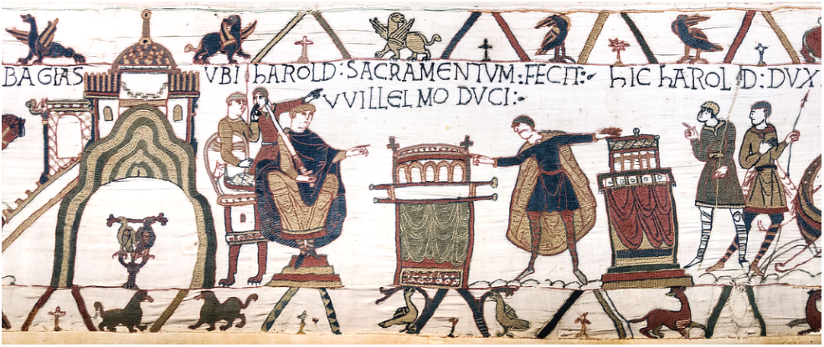

This image from the Bayeux Tapestry depicts an oath being sworn by Harold Godwinson to William Duke of Normandy in the cathedral of Bayeux. Like all the episodes in the entire embroidery the narrative in this scene is divided into one central broad panel, with a narrow border, or margin, above and below the main narrative. These margins are decorated with small depictions of plants, animals, and birds.

In the central scene of this panel Duke William is seated on the left, holding his sword, and is pointing towards Harold. Harold’s arms are outstretched touching two richly decorated reliquaries. Harold is clearly swearing an oath upon these relics. The embroidered text, tituli, above the scene informs us of this: hARoLD SACRAMENTVM FECIT VVILLELMO DVCI. Two men stand behind William, one of them holding William’s shield, suggesting that they are Norman and are loyal to William. These men appear to be discussing the main action in the central panel. One of the men is pointing to the word SACRAMENTVM and the other to the word hARoLD as if to underline the crucial importance of this event. At the same time the nature of their gestures could suggest commandment and authority (upright pointing) and accusation (directional pointing). This scene is crucial because the breaking of Harold’s oath provides the Norman justification for the invasion and conquest of England in 1066. This underlines the importance of this episode to the narrative and also underlines the importance of carefully reading the details and any symbolic resonances that it may contain.

William is depicted wearing longer robes and a longer cloak than all the other men in this scene. This is probably to highlight his authority. William, the only character sitting, is seated here in a position and style typical of the depiction of kings. This can be seen as a statement of his legitimacy as heir to the throne of England. In contrast with William, Harold is depicted in a style of dress only worn by Saxons throughout the tapestry. William is pointing in the direction of Harold and the relics which Harold is touching. There is a hint of an order of execution here. William’s position and the position of his sword and how he is pointing at Harold indicate that William is Harold’s lord. This means that he has the power to execute him in the event of betrayal and treason. This foreshadows the events of the Battle of Hastings. According to Guy of Amiens in the Carmen de Hastingae Proelio William himself slays Harold in the battle. Although this is unlikely it gives a sense of this being a dispensing of justice to a traitor.

It is interesting to note that in the preceding scene, which appears to depict Harold being knighted by William, hIC VVILLEM: DEDIT: hAROLDO: ARMA, implying that Harold will support William’s legitimate claim to the English throne, Harold has an open palm and a hand turned downwards. This gesture suggests another foreshadowing of Harold’s treason. Harold’s horizontal and outstretched arms could be indicative of prayer and sanctity but can also mean separation and rejection. There are scenes of marriage annulments where the bishop is depicted with outstretched arms pushing away each partner in a very visual depiction of separation. A marriage is another type of sacred oath. Harold’s position in this scene foreshadows his breaking of his own sacred oath and his act of separating himself from William. Arguably this makes clear that Harold deliberately perjured himself and had no intention of upholding his oath to William.

This message is further highlighted by the presence of certain animals in the borders. The griffins directly above the words hARoLD SACRAMENTVM suggest that Harold does not respect and love his new lord as he should. Griffins are described as being violent towards both men and horses, a griffin “hates the horse bitterly”. The horse is crucial to the Normans. Normans fought on horseback, unlike the Saxons, and at this point there is already the beginning of a notion of chivalry and a knightly order. Horses are a constant image throughout the Bayeux Tapestry. The griffin imagery is even more damning as this panel comes immediately after Harold is knighted by William. Harold in the previous panel has in effect become a horseman and is now ‘Normanised’. Dogs are also depicted below Harold in the panel. The dog is a symbol of loyalty and here implies the loyalty that Harold should have shown to William. Lions are embroidered beneath William suggesting kingship and nobility. Lions also represent Christ, as do the phoenixes and pelicans which appear in the border at this point. These creatures serve to underline the sacred nature of this event and the holy authority of William’s claim to the throne of England. In addition, when William later invades England in 1066 he has the backing of the pope, Christ’s representative on earth.

Harold’s oath to William is believed to have taken place in 1064 or 1065. At this date Harold was in the strong position of being the most powerful man in England, “…he was beyond all rivalry at court.” Although the Bayeux Tapestry offers no clear explanation for Harold’s journey to Normandy in 1064, it is possible that he was sent as an ambassador by Edward the Confessor to confirm that William was Edward’s chosen heir. This would be an astute move by Edward. By having the most powerful man in England swear fealty to the legal heir, Edward is doing everything he can to ensure a smooth and peaceable succession. At this point William does not consider Harold to be a rival. There is no evidence that William is preparing for, or planning, an invasion of England. The Bayeux Tapestry only has scenes of boat building and military preparation after depicting Harold’s coronation. The obvious imagery of this scene shows a straightforward swearing of fealty. It is the smaller details in the images that imply that, unbeknownst to William, Harold has no intention of keeping his promise.

The oath scene is pivotal to the Norman betrayal story as depicted in the Bayeux Tapestry. Not only has Harold betrayed his liege lord but he has broken his oath to God.

Bibliography

Barber, Richard, Bestiary: MS Bodley 764 (Woodbridge: The Boydell Press, 1993).
Bates, David, Normandy Before 1066, (New York: Longman, 1982).
Brown, R. Allen, The Normans (Woodbridge: The Boydell Press, 1984).
Chibnall, Marjorie, The Debate on the Normand Conquest (Manchester: Manchester University Press, 1999).
Douglas, David C., The Normans Achievement 1050-1100 (London: Eyre & Spottiswoode, 1969).
Garnier, François, Le Langage de l’Image au Moyen Âges: signification et symbolique (Paris: Le Léopard d’Or, 1982).
Lindsay, Jack, The Normans and their World (London: Purnell Book Services Limited, 1974).
McIlwain Nishimura, Margot, Images in the Margins, (London: The British Library, 2009).
Stenton, Frank M., Anglo-Saxon England, (Oxford: Oxford University Press 1971).
van Houts, Elisabeth, The Normans in Europe, (Manchester: Manchester University Press, 2000).

F. Garnier, Le Langage de l’Image au Moyen Âges: signification et symbolique (1982) pp. 165-166
F. Garnier, Le Langage de l’Image au Moyen Âges: signification et symbolique (1982) pp. 165-166
F. Garnier, Le Langage de l’Image au Moyen Âges: signification et symbolique (1982) pp. 166-167
F. Garnier, Le Langage de l’Image au Moyen Âges: signification et symbolique (1982) p. 166
F. Stenton, Anglo-Saxon England (1971) p. 577
F. Garnier, Le Langage de l’Image au Moyen Âges: signification et symbolique (1982) p. 226
Ibid.
M. McIlwain Nishimura, Images in the margins (2009) p. 44
R. Barber Bestiary: MS Bodley 764 (1993) p. 39
R. Barber Bestiary: MS Bodley 764 (1993)pp. 72-77
R. Barber Bestiary: MS Bodley 764 (1993)p. 147
F. Stenton, Anglo-Saxon England (1971) p. 577
F. Stenton, Anglo-Saxon England (1971) pp. 576-578
F. Stenton, Anglo-Saxon England (1971) p. 577
D. Bates Normandy Before 1066 (1982) p. 84
Ibid.

