Reflective Report
(Based on Gibb's "Reflective Cycle Model")

MODULE: Professional Career Development
(BMSW4001)
Module lecturer: Rita Ukachi-Lois

Student: Ermelindo Pereira
Number: 2124215

Table of Content

- Introduction………………………………………………………… 3

- Career Path ….………………………………………… 3

- Current Skills …………………… ……………………………. 4

- Gap in Skills …………………………. ……………………… 5

- Systematic Approach to Skills Acquisition…………………... … 6

- Recruitment and recommendations ………………………...7

- Conclusion…………………………………………………………….8

- References…………………………………………………………….9

- Appendix……………………………………………………………… 10

- Introduction
In October I started a new challenge in the Professional career development module, a module that came to bring a lot of knowledge, which came to help me develop my skills, the ability to resolve conflicts, increased my level of communication and greatly increased my level of confidence, all this to say that today I feel more confident and I am already sure that I want to be a Future Chef and that I already have the skills and knowledge to apply for the position.
In this report I will use Gibb's cycle to better demonstrate my career development plan, a cycle that was created by Graham Gibb's in 1988 with the objective of organizing learning through experiences, making use of a structure of event analysis, something that will not only help to draw lessons but also help in the creation of plans for situations that may not go as well as intended.
- Career Path

- Description
I decided to pursue my career as a Chef, as I already have a lot of experience acquired over the 3 years that I worked as a Chef in a restaurant in Portugal, but it was from the age of ten that I aroused my interest in cooking when I was still living under my parents' roof.
- Feelings
A mixture of feelings, an enormous satisfaction when I cooked something and everyone liked it and an enormous peace when I found myself in the kitchen, feelings that made me believe that I was in the ideal place and that I should do everything to live that dream.
- Evaluation
Over the years, I gained a lot of experience, learned a lot, developed my skills in the kitchen, I believe I developed my leadership as well and managed my time better.
- Analysis
I had some difficulties initially, as everything was very new to me, despite having knowledge in the field of cooking, I still had no experience in a professional kitchen and serving more than three hundred people a day, so it was something that I had to work on a lot.
- Conclusion (General)
I can conclude that despite the difficulties encountered during my journey, I have always remained focused on improving my skills and conquering my space.
With the experience gained from working time, he has made a huge progression to the point of being the head of the kitchen, making several dishes at the same time and dealing with customers daily.
- Personal Actions Plan
Now I intend to continue with my evolution day after day, giving my best in each dish I make, creating my range of customers and opening a restaurant in the future.
- Current Skills
- Description
Now I have skills such as time management, good communication, leadership, creativity, and flexibility.
- Feelings
It's a feeling of accomplishment, because I feel that I'm on the right path to achieve my goals and that I've been able to improve and gain more skills every year.
- Evaluation
I gained many skills that helped me a lot to stand out and gain my space, but I also had some bad moments in the initial phase, the fact of having to deal with different types of colleagues from different cultures and even the concept of the restaurant itself, weighed in a lot in the first few months.
- Analysis
I believe that the fact that the first months did not go so well had to do with my lack of experience in a restaurant with a lot of movement, different cultures within the kitchen, which made me withdraw my skills a little and had difficulties in that touches on communication and being at ease to demonstrate everything that could be added to that kitchen.
- Conclusion (General)
I learned that no matter how many skills we may have, we must always be open to learning more and improving as much as possible both our strengths and our weaknesses.
- Personal Action Plan
The next time I must go through the same situation, I will be better prepared, because my level of communication is much better, and I will do more extensive research on the culture of my workmates so that there is a greater connection.
- Gap in Skills
- Description
To better achieve my goal, I must develop my communication skills further, as it is one of the skills I already have, but if I want to enter the English market, I will have to improve my English, as it is not my native language, work better in my leadership skills.
- Feelings
A little frustrating for me sometimes, when I feel that I have the ability and talent, but I have the English language as a barrier that prevents me from exhaling all my talent.
- Evaluation
I have in mind that I am missing two skills as I said earlier, but that will not influence the main objective, it is just a barrier that I will have to break to move forward and take it as a learning experience.
- Analysis
Weaknesses have been identified, I already know where I need to improve and what processes to follow for better efficiency, now it only remains to focus on those same processes to overcome all barriers and overcome this great challenge.
- Conclusion (General)
I conclude that we must always see the positive side even in our weaknesses, so that we can clearly see where the error is and what can be done to eliminate it.

- Personal action Plan
Knowing in advance the difficulties I had and what led me to have difficulties when it comes to communication and leadership, now my thinking goes through the search for improvement in these fields, going after more knowledge and focusing on the negative points to be able to overcome the problem.
- Systematic Approach to Skills Acquisition
- Description
Once the points I need to improve have been detected, I will have to follow step by step the process of improving my communication and leadership skills.
- Feeling
It is a feeling of hope and positive thinking because I believe that if I follow the process in detail, I will be able to reach the desired position, but at the same time a little afraid of failing and continuing without any progress.
- Evaluation
As far as communication is concerned, I will take notes during conversations with a colleague, invest even more in my English, even though it has improved a lot during my time at university, listen more, improve my body language, always check any message before send and think very carefully before saying anything.
As far as leadership is concerned, the path would be to continue to learn, delegate more tasks, put myself in charge of any event or task of extreme importance, always try to solve problems and learn to listen to suggestions and ideas from everyone around me.
- Analysis
Many of the communication problems I had throughout my workday were because I didn't follow the process for good communication, when I had to listen, I didn't do it, I wasn't specific in my actions, my body language was weak, that is , a set of things that made me have problems in this field, the same happened with leadership, I lacked a firm hand, firmness and consistency in task delegations, I did not pay much attention to the ideas and opinions of employees , which I did me a bad listener and a poor leader.
- Conclusion (General)
In short, if you manage to follow the steps for good communication to the letter, such as, listen more, take notes, treat everyone equally, always think before you speak, always check all messages before sending, maintain a positive attitude and a smile, improve body language and always be specific in my actions, I will overcome this weakness.
The same will serve for the leadership, which I will certainly be a leader, because the plan will be to be a good listener, resolve conflicts whenever necessary, delegate tasks, present suggestions, and solutions without always expecting others, continue to learn, take the lead in projects or events that arise and serve as inspiration for colleagues. Following this philosophy, I will have all the conditions to occupy the position.
- Personal action Plan
The plan will be to overcome my weaknesses following the process mentioned above, something that was not done in the past, I learned from the mistakes and now I will do it differently and with a focus on success.
- Recruitment and recommendations
Role Plays allow students to participate in activities that simulate career-related circumstances. Role-plays should be content-focused, meet learning objectives, and be relevant to real-world circumstances to help students understand how to apply them. Role-playing exercises allow students to think critically about complicated and contentious issues and see events in a new light. Role plays, when used correctly, can encourage students in a fun and engaging way. The role play was very interesting and important not only for us as students, but also for us as workers and the future manager of their dreams, it served to demonstrate what we learned during the classes, testing our abilities in a simulation close to reality. Role play has a very important role in the recruitment and selection process, because through it, we can prepare ourselves for a real situation, as it will help us to identify our strengths and weaknesses, help to observe the critical points, motivate, and involve the students, which will help them know how to improve to be ready for any situation that arises. It was an interview with an exchange of questions and answers that led us to reflect on the position we wanted to occupy, I confess that I was very nervous and tense during the interview, which at times seemed to be in a real job interview situation, it was an excellent learning experience, because it got the best out of me and prepared me even more for a real situation.
I felt that I could have done much more in relation to the questions I asked, but I believe that I will do better after the experience.
- Conclusion
This module taught me a lot and certainly prepared me to go in search of what I want as a career, as I found most of the topics covered and learning in general to be extremely important, topics that will be part of my journey from now on. The role play was of great importance, as it served as preparation for a real situation and helped us to be better prepared, I believe I have acquired more skills and improved some that I already had and of course, I feel much more confident and motivated to reach the goal, since I so desire.

- References

References
author, G., May 12, 2022. Wrike. [Online]
Available at: https://www.wrike.com/blog/9-ways-develop-leadership-skills/
[Accessed 1 January 2023].
EDINBURGH, T. U. O., 11 Nov, 2020. THE UNIVERSITY OF EDINBURGH. [Online]
Available at: https://www.ed.ac.uk/reflection/reflectors-toolkit/reflecting-on-experience/gibbs-reflective-cycle
[Accessed 1 January 2023].
group, M., 2023. Manpower group. [Online]
Available at: https://manpowergroup.com/wcm/connect/right-it-it/legacy-home/thoughtwire/categories/career-work/10-Ways-to-Improve-Your-Communication-Skills
[Accessed 1 January 2023].
He, G., August 27, 2022. Teambuilding.com. [Online]
Available at: https://teambuilding.com/blog/professional-development-ideas
[Accessed 1 January 2023].
Jefferson, C., August 6, 2021. Better up. [Online]
Available at: https://www.betterup.com/blog/career-path
[Accessed 1 January 2023].
learn, F., September 26th, 2022. Future learn. [Online]
Available at: https://www.futurelearn.com/info/blog/what-is-the-skills-gap
[Accessed 1 January 2023].
Quescrem, n.d. Quescrem. [Online]
Available at: https://quescrem.es/en/six-skills-of-the-perfect-chef/
[Accessed 1 January 2023].
University, N. I., 2012. Northern Illinois University. [Online]
Available at: https://www.niu.edu/citl/resources/guides/instructional-guide/role-playing.shtml
[Accessed 1 January 2023].

- Appendix
Fig.1. Job Description
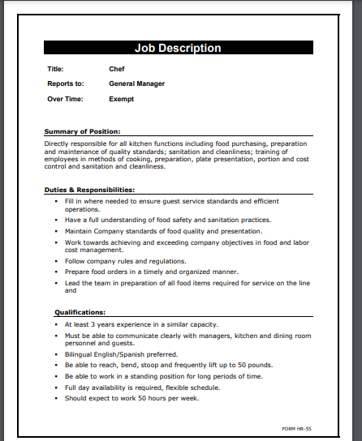

Fig.2. Job description
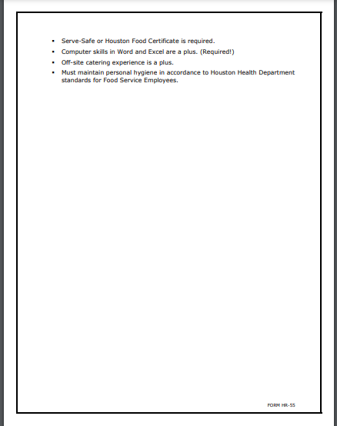

Fig.3. Questions


