

Student name: Jamila Zakari
Student ID: 2322381
Module name: Physiology
Module code: BMHP5023_LON
Lecturer name: Shaila Hussain
Assessment: Diabetes

Table of Contents
3. Introduction
3,4 Types of Diabetes and Associated Risk Factors
5. Blood Sugar Regulation
6. Cellular Metabolism
7. Recording and Tracking Blood Sugar Levels in Type 2 Diabetes
8. Recommendations
8,9 Recommendations
10. Conclusion
11. References
11,12 References

Introduction
This case study report will provide an understanding of diabetes for patients attending a local GP clinic. As a diabetic nurse, there are several care plans that need to be accounted for in managing diabetic patients with their conditions. This report will highlight the following, what diabetes means, the types of diabetes and the risks associated with it, blood sugar regulations, cellular metabolism, recording and tracking blood sugar levels for type two diabetes and finally, recommendations, a conclusion, and references.
Diabetes mellitus, popularly known as diabetes, is a chronic condition that occurs when there are elevated levels of blood glucose. This happens either because the body cannot produce enough insulin, a hormone that helps regulate blood sugar levels, or because it cannot effectively utilise the insulin it produces.
Insulin is an essential hormone produced in the pancreas. It allows glucose from the bloodstream to enter the body’s cells, where it is converted into energy or stored. Insulin is also essential for the metabolism of protein and fat. A lack of insulin, or the inability of cells to respond to it, leads to high levels of blood glucose (hyperglycaemia), which is the clinical indicator of diabetes. (International Diabetes Federation 2021).
Diabetes is an endocrine disorder that directly affects the body’s hormonal regulation of blood glucose, which is primarily controlled by insulin and glucagon produced by the pancreas, an essential endocrine gland. Type 1 diabetes occurs when the immune system destroys the pancreatic beta cells responsible for insulin secretion, leading to a failure of a key endocrine function (American Diabetes Association, 2022). Type 2 diabetes also involves the endocrine system, as chronic insulin resistance forces the pancreas to over produce insulin until beta-cell exhaustion occurs, causing impaired hormonal regulation of glucose (World Health Organisation, 2023). Gestational diabetes similarly reflects an endocrine imbalance; during pregnancy, placental hormones create insulin resistance, and if the endocrine response is insufficient, blood glucose levels rise (NICE, 2020). Overall, all forms of diabetes represent disruptions within the endocrine system that alter hormonal control of metabolism and energy balance. The diagram below shows the scientific aspect of diabetes and how it works.
.

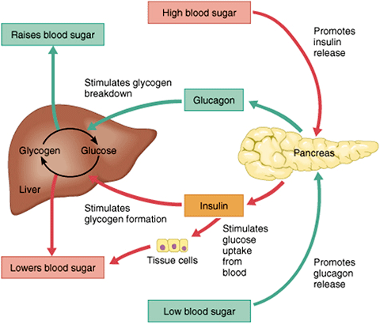

Types of Diabetes and Associated Risk Factors
Type of Diabetes | Description | Main Risk Factors
Type 1 Diabetes | Autoimmune destruction of pancreatic beta cells | Family history, genetics, autoimmune disorders
Type 2 Diabetes | Insulin resistance and reduced insulin production | Obesity, inactivity, poor diet, family history, age, ethnicity
Gestational Diabetes | Diabetes occurring during pregnancy | Previous GDM, overweight, family history, maternal age, ethnicity

Blood Sugar Regulation
Blood sugar regulation is a crucial process that maintains balanced blood sugar levels, which is crucial for overall health and energy. Blood sugar regulation is a vital process that keeps blood sugar levels balanced, which is essential for overall health and energy. This process involves multiple hormones, primarily insulin and glucagon, which help prevent the risks associated with both high blood sugar (hyperglycaemia) and low blood sugar (hypoglycaemia).
Insulin is released by the pancreas in response to high blood sugar levels. Its primary function is to help transport glucose from the bloodstream into the cells, where it is either used for energy or stored for future use. On the contrary, glucagon is also produced by the pancreas and is released when blood sugar levels drop. It signals the liver to release stored glucose back into the bloodstream, thereby raising blood sugar levels. This involves multiple hormones, with insulin and glucagon playing primary roles in preventing the dangers of both high (hyperglycaemia) and low (hypoglycaemia) blood sugar. Insulin, released by the pancreas in response to high blood sugar levels, helps transport glucose from the bloodstream into cells, where it is used for energy or stored for later use. Glucagon, also produced by the pancreas, is released when blood sugar levels are low. It signals the liver to release stored glucose into the bloodstream, raising blood sugar levels.
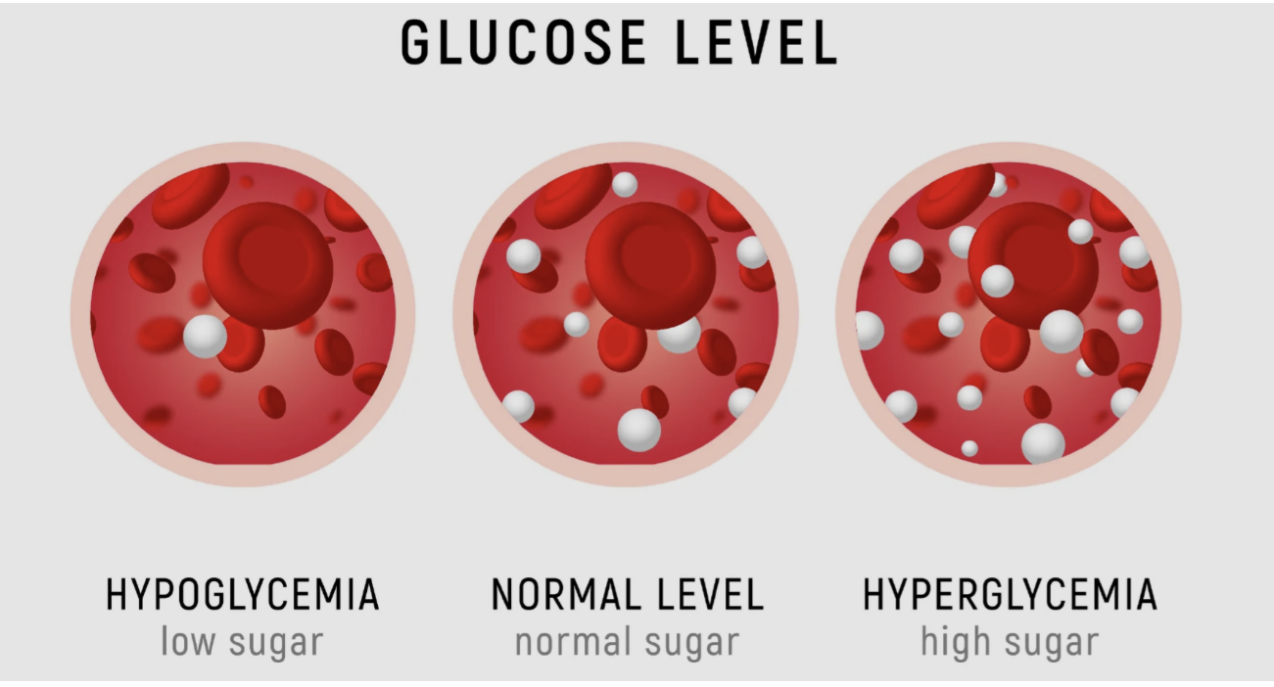

Various factors influence blood sugar levels, such as diet, physical activity, medications, and health conditions. Maintaining a balanced diet that includes complex carbohydrates, fiber, lean proteins, and healthy fats can aid in blood sugar regulation. Regular exercise enhances insulin sensitivity and helps cells absorb glucose. Effective blood sugar management also involves planning balanced meals, controlling portions, staying active regularly, and managing stress. Monitoring blood sugar with a glucose meter or continuous glucose monitor (CGM) is essential, with common check times being in the morning, before meals, two hours after eating, and at bedtime.

Cellular Metabolism
Cellular metabolism plays a key role in how diabetes develops. Diabetes occurs when the body does not make enough insulin or when cells do not respond well to insulin. Insulin helps cells take in glucose, which they use to make ATP through glycolysis and other metabolic pathways. When insulin does not work properly, cells take up less glucose and glycolysis slows down. The body starts using fats and proteins for energy (Nelson and Cox, 2021). This shift leads to more fatty acid breakdown and more ketone body production, which can cause diabetic ketoacidosis in serious cases (Berg et al., 2025). High blood glucose over time also leads to advanced glycation end products, more oxidative stress, and cell damage, which contribute to long-term problems with blood vessels and nerves (Campbell et al., 2021). In this way, diabetes significantly disrupts normal cellular metabolism.

Recording and tracking blood sugar levels for type 2 diabetes
Regularly checking blood glucose is important for people with type 2 diabetes. Frequent checks give quick feedback, helping patients and healthcare professionals spot unusual readings and act fast (Diabetes UK, 2023). Making timely changes to medication, diet, or exercise can help prevent serious problems like low or high blood sugar (American Diabetes Association, 2022). Tracking blood glucose over time helps healthcare providers see patterns, adjust treatments, and give advice that fits each person (NCBI, 2022). Monitoring also shows how food, exercise, stress, and illness affect blood sugar, which helps people stick to their treatment plans (JMIR Diabetes, 2021). Keeping blood glucose steady from the start lowers the risk of complications with the eyes, kidneys, nerves, and heart (Diabetes UK, 2023). Not checking often enough takes away these benefits. Missing changes in blood sugar can delay care and raise the risk of long-term problems (American Diabetes Association, 2022). Not noticing high or low blood sugar can be dangerous. Without enough information, healthcare providers may find it harder to adjust treatments, which makes blood sugar harder to control and increases long-term risks (NCBI, 2022). Without regular feedback, it is harder to see how daily habits affect blood sugar, making it more difficult to manage food and exercise (JMIR Diabetes, 2021). Over time, not monitoring enough can lead to problems with the eyes, kidneys, nerves, and heart sooner (Diabetes UK, 2023). Understand how meals, exercise, stress, and illness affect their glucose, encouraging better self- management and adherence (JMIR Diabetes, 2021). Moreover, consistent blood sugar monitoring is vital for long- term health, as maintaining early and stable glycaemic control can lower the risk of microvascular issues like retinopathy and nephropathy, and macrovascular problems like heart disease (Diabetes UK, 2023). Without regular checks, these benefits diminish, increasing the chance of unnoticed glucose fluctuations, delayed treatment modifications, and higher long- term complication risks. According to (American Diabetes Association, 2022). Conversely, neglecting to monitor blood glucose can lead to serious risks. Hidden episodes of high or low blood sugar may worsen, leading to severe or life- threatening complications. Healthcare providers may lack essential data to optimise treatment, resulting in poor control and increased long- term risks (NCBI, 2022). Patients also lose vital feedback that links lifestyle choices to glucose levels, reducing the effectiveness of diet or exercise strategies (JMIR Diabetes, 2021). Over time, inadequate monitoring may speed up the development of complications like retinopathy, nephropathy, neuropathy, and cardiovascular diseases (Diabetes UK, 2023).

Recommendations
Effective management of type 2 diabetes requires a combination of lifestyle modification, structured education, psychosocial support, and coordinated health and social care interventions.
Lifestyle Modifications
Dietary management is central to glycaemic control. Individuals are encouraged to consume a balanced diet rich in whole grains, vegetables, fruits, lean proteins, and healthy fats, while limiting refined sugars and saturated fats (Evert et al., 2019). Portion control, meal planning, and consistent carbohydrate intake can stabilise blood glucose levels. Regular physical activity, including at least 150 minutes of aerobic exercise per week combined with resistance training, enhances insulin sensitivity, reduces cardiovascular risk, and promotes weight management. According to research (Riddell et al 2017). Weight loss of even 5–10% in overweight patients can significantly improve glycaemic control and reduce reliance on medications (Look AHEAD Research Group, 2013). Reducing sedentary behaviour by incorporating short bouts of movement throughout the day further supports glucose regulation.
Structured Self-Monitoring and Education
SMBG should be accompanied by structured diabetes self-management education (DSME). Education empowers patients to interpret glucose readings, adjust diet and activity, and adhere to prescribed medications (NCBI, 2022). Studies have shown that DSME programs improve glycaemic control, enhance patient self-efficacy, and reduce long-term complications.
Health Promotion and Psychosocial Support
Health promotion strategies should also address stress management, smoking cessation, and alcohol moderation, which influence glycaemic control and cardiovascular health, according to (American Diabetes Association, 2022). Psychological support is critical, as type 2 diabetes is associated with increased risk of depression and anxiety, which can negatively affect adherence to self-care behaviours (Gonzalez et al., 2008). Multidisciplinary care teams, including dietitians, diabetes educators, and mental health professionals, provide coordinated support tailored to individual needs.
Integration of Health and Social Care
Social care interventions, such as access to community exercise programs, nutritional counselling, and peer support groups, can facilitate adherence to lifestyle changes and promote overall well-being (Renders et al., 2001). Personalised care plans that address social determinants of health, such as socioeconomic status, access to healthy foods, and living environment, are crucial for sustainable lifestyle changes.
interventions, can significantly improve glycaemic control and reduce the risk of complications. Coordinated health and social care strategies further enhance adherence to lifestyle changes and promote the overall health and well-being of individuals living with diabetes. Together, these approaches support sustainable self-management and improve long-term outcomes for people with type 2 diabetes. This report has explored the key aspects of diabetes, focusing on its types, associated risk factors, and its relationship with the endocrine system. It has examined the mechanisms of blood sugar regulation and how the body maintains glucose levels within a safe and effective range. The role of cellular metabolism in producing energy from glucose and oxygen has been highlighted, demonstrating the biochemical processes essential for maintaining overall health. Additionally, the importance of recording and tracking blood sugar levels in individuals with type 2 diabetes has been emphasised, showing how monitoring can prevent complications and support effective disease management. Finally, evidence-based recommendations, including lifestyle interventions, dietary adjustments, and health promotion strategies, have been presented to improve the well-being of individuals with diabetes. Overall, this report underscores the critical interplay between physiological processes, self-management practices, and lifestyle choices in controlling diabetes and enhancing quality of life.

Conclusion
Diabetes is a chronic disorder deeply connected with the endocrine system, particularly the pancreas and its regulation of blood glucose via insulin and glucagon. Proper blood sugar regulation, effective cellular metabolism, and ongoing glucose monitoring are vital for maintaining health, especially in type 2 diabetes, where lifestyle factors play a major role. Evidence-based recommendations such as dietary changes, exercise, medication adherence, and continuous education significantly improve long-term health outcomes. Understanding the mechanisms behind diabetes empowers individuals to manage their condition safely and effectively.

References
International Diabetes Federation (2021). What is diabetes? [online] www.ncbi.nlm.nih.gov. International Diabetes Federation. Available at: https://www.ncbi.nlm.nih.gov/books/NBK581938/.
American Diabetes Association (2022) Standards of Medical Care in Diabetes. Arlington, VA: ADA.
National Institute for Health and Care Excellence (NICE) (2020). Diabetes in pregnancy: management from preconception to the postnatal period. Available at: https://www.nice.org.uk/guidance/ng3 (Accessed: 21 November 2025).
World Health Organization (2023). Diabetes. Available at: https://www.who.int/news-room/fact-sheets/detail/diabetes (Accessed: 21 November 2025).
Diabetes UK, 2023. Self-monitoring of blood glucose levels for adults with type 2 diabetes. [online] Available at: https://www.diabetes.org.uk/self-monitoring-of-blood-glucose [Accessed 30 November 2025].
JMIR Diabetes, 2021. Impact of Blood Glucose Monitoring on Self-Management in Type 2 Diabetes. [online] Available at: https://diabetes.jmir.org/2021/4/e29178 [Accessed 30 November 2025].
NCBI, 2022. Diabetes Self-Management Education and Support in Type 2 Diabetes. [online] Available at: https://www.ncbi.nlm.nih.gov/books/NBK56887/ [Accessed 30 November 2025].
Renders, C.M., Valk, G.D., Griffin, S.J., Wagner, E.H., Eijk van, J.ThM. and Assendelft, W.J.J. (2001). Interventions to Improve the Management of Diabetes in Primary Care, Outpatient, and Community Settings: A systematic review. Diabetes Care, 24(10), pp.1821–1833. doi:https://doi.org/10.2337/diacare.24.10.1821.
American Diabetes Association (2022). Introduction: Standards of medical care in diabetes—2022. Diabetes Care, [online] 45(Supplement_1), pp. S1–S2. doi:https://doi.org/10.2337/dc22-sint.
Riddell, M.C., Gallen, I.W., Smart, C.E., Taplin, C.E., Adolfsson, P., Lumb, A.N., Kowalski, A., Rabasa-Lhoret, R., McCrimmon, R.J., Hume, C., Annan, F., Fournier, P.A., Graham, C., Bode, B., Galassetti, P., Jones, T.W., Millán, I.S., Heise, T., Peters, A.L. and Petz, A. (2017). Exercise management in type 1 diabetes: a consensus statement. The Lancet Diabetes & Endocrinology, [online] 5(5), pp.377–390. doi:https://doi.org/10.1016/s2213-8587(17)30014-1.
Evert, A.B., Dennison, M., Gardner, C.D., Garvey, W.T., Lau, K.H., MacLeod, J., Mitri, J., Pereira, R.F., Rawlings, K., Robinson, S., Saslow, L., Uelmen, J., Urbanski, P., Yancy, W.S., Jr.,and American Diabetes Association, 2019. Nutrition Therapy for Adults with Diabetes or Prediabetes: A Consensus Report. Diabetes Care, 42(5), pp.731–754.
Gonzalez, J.S., Peyrot, M., McCarl, L.A., Collins, E.M., Serpa, L., Mimiaga, M.J. and Safren, S.A. (2008). Depression and Diabetes Treatment Nonadherence: A Meta-Analysis. Diabetes Care, [online] 31(12), pp.2398–2403. doi:https://doi.org/10.2337/dc08-1341.
Look AHEAD Research Group, 2013. Cardiovascular effects of intensive lifestyle intervention in type 2 diabetes. New England Journal of Medicine, 369, pp.145–154.
NCBI, 2022. Diabetes Self-Management Education and Support in Type 2 Diabetes. [online] Available at: https://www.ncbi.nlm.nih.gov/books/NBK56887/ [Accessed 30 November 2025].

