Fancy a Malaysian? Or maybe a Bara Brith?

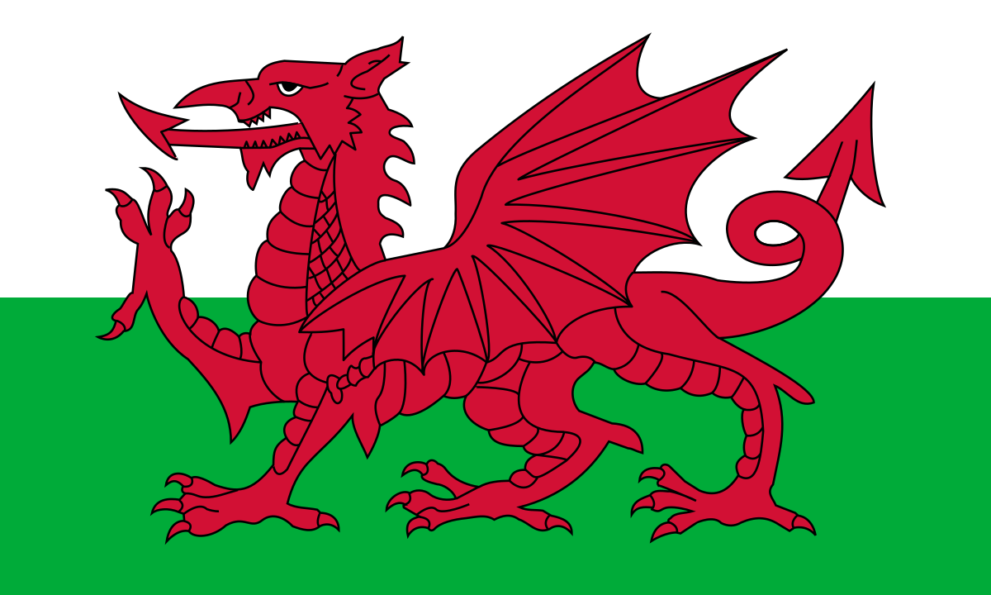Is Food Tourism a motivator for travellers? Or simply a necessity of life?

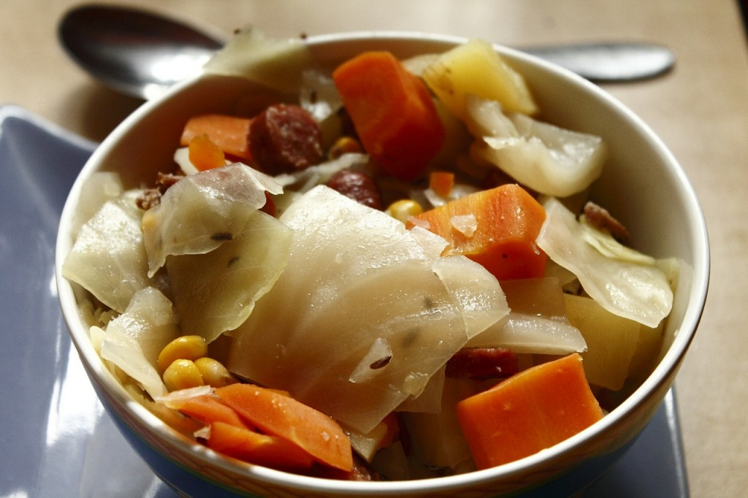



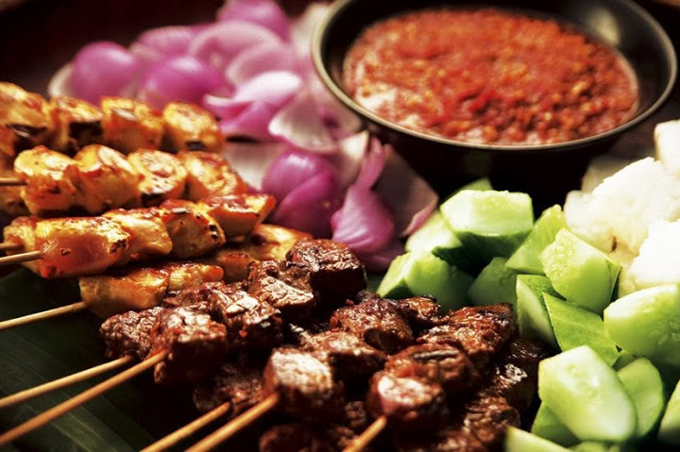

Author: Bethan Jemma Watkins (P140639)

Contents
Is Food Tourism a motivator for travellers? Or simply a necessity of life? 1
Author: Bethan Jemma Watkins (P140639) 1
Do you know what Tourism is? 3
What is Food Tourism? 3
Background History 4
Gastronomy Tourists Motivations 9
The ladder of motivation 11
Food Festivals 13
Conclusion 15
References 16

Figure 1 - London to Malaysia (DistanceFromTo, 2018) 4
Figure 2 - Performance by sector (Welsh Government, 2018) 6
Figure 3 - Origin of visitors (Welsh Government, 2018) 7
Figure 4 - Culinary experiences in KL (Tourism Unit, 2015) 8
Figure 5 - Key initiatives of cuisine heaven (Tourism Unit, 2015) 8
Figure 6 - Breakdown of average total household expenditure (Office for National Statistics, 2018) 11
Figure 7 - UWTSD Mtour Students eating local cuisine (Authors own credit) 13
Figure 8 - Abergavenny Food Festival (Visit Wales, 2018) 14

Table 1 - Malaysians' traditional food (Serious Eats, 2018)Table 2 - Welsh Food Traditions (Visit Wales, 2018) 12
TABLE 2 - WELSH FOOD TRADITIONS (VISIT WALES, 2018) 13

Do you know what Tourism is?
Firstly, before entering the world of food tourism there must be a definition of what tourism can be defined as. Tourism Society (2018) defines tourism as the activities of persons identified as visitors where the visitor chose to visit a main destination outside his/her environment for any main purpose such as holidays, leisure, business, health or other purposes.

Niche Tourism
Niche Markets today is becoming more known within the world of tourism today. Niche Tourism, for some readers who may not know, is how a tourism product can be altered and tailored to meet the needs of a particular audience or a target market (Ali-Knight, 2011).
Wine and food are seen to be a significant niche tourism product which acts as a pull factor as it is inseparably linked to any destination around the world (Kivela and Crotts, 2006; Novelli, 2005). Which leads to what actually is food tourism?

What is Food Tourism?
To understand the motivations behind travellers travelling to Malaysia and Wales, an overview of what food tourism identifies as.
“Food tourism may be defined as visitation to primary and secondary food producers, food festivals, restaurants, and specific locations for which food tasting and/or experiencing the attributes of specialist food production region is the primary motivation factor for travel”
(Hall & Mitchell, 2001)

Taar (2014) can also identify food tourism as gastronomic tourism to define three gastronomy definitions. Gastronomy is a fine cuisine; it is a patrimony established by generations of cooks and is the result of a delicate process. Gastronomy is where the study is focusing on the physical characteristics of foods (such as quality) and seeks to understand the processes that occur when food is consumed. Food is the source of inspiration and pleasure.
As a reader, has the thought of being a ‘food traveller’ crossed your mind? A study shows that in 2016, Food Travel Monitor (2018) proves that 93% of travellers considered food travellers.

Background History
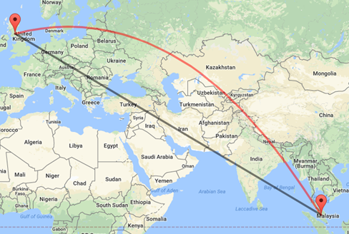
Mentioned previously, this article will be focusing on the motivators of why travellers travel to Malaysia and the United Kingdom. Below are some statistics of the countries.
Figure 1 - London to Malaysia (DistanceFromTo, 2018)

Malaysia!
Malaysia consists of two regions, divided by 640 miles of the South China Sea. Peninsular Malaysia or commonly known as the West Malaysia and Malaysian Borneo is the two regions that can be found. (One World Nations, 2018 & BBC News, 2018). Statistics show that Malaysia’s population, currently to date is 31,876,253.

The United Kingdom!
The United Kingdom with statistics showing 66,573,504, and making up 3,113,200 is Wales! (Office for National Statistics, 2017 & Worldometers, 2018). Now, to reach Malaysia from the United Kingdom will approximately take 11.75 hours which estimates to 6,579 air miles (DistanceFromTo, 2018).
According to Hall and Sharples (2003) states, that food tourism is a tool for agricultural and therefore economic development and a local aspect influenced by the eating behaviours of the tourists. Long (2004) argues that every country has their own means of customs when it comes to different cuisines and how the country prepares, eat and to serve the food.

Gwlad…Gwlad…I am true to my land!
The Welsh Government (2018) set a strategy for Partnership for Growth 2013-2020 which “sets the vision for us and the industry to work in partnership to increase visitor spend to Wales” (Welsh Government, 2016). The five key areas of focuses were set in 2013 and revisited in 2016 in the Strategy Progress Review (Welsh Government, 2016). To apply this strategy to the food motivation, this is what the Welsh Government has applied.
- Promoting the brand
  - Currently, in the review, there have been no changes in food tourism regarding promoting the brand.
  - Although, the Welsh Government (2015) states that the product led approach is evolving with iconic products and experiences, however, there is no mention of how the promotion of food tourism brands.
- Product development and major events
  - The Welsh Government (2016) states that the priority for food and drink is to strengthen Wales’ growing reputation as a food destination.
- People development
  - Currently, in the review, there have been no changes in food tourism regarding promoting the brand.
- Profitable performance
  - Currently, in the review, there have been no changes in food tourism regarding promoting the brand.
- Place building
  - Currently, in the review, there have been no changes in food tourism regarding promoting the brand.


Sosban fach yn berwi ar y tân!

(A little saucepan is boiling on the fire!)
Mentioned previously, The Welsh Government created The Food Tourism Action Plan for Wales 2015-2020 where they define Food Tourism as “any activity that promotes a high quality, distinctive, local and sustainable food experience linked to a particular place” (The Welsh Government, 2015).
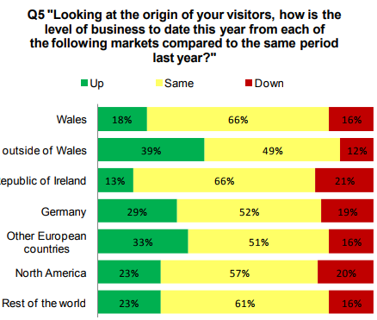
Statistics released by the Welsh Government (2018) provides an insight of what the tourism figures were in 2015. Wales welcomed international travellers in 2015 with figures soaring at 970,000 spending £410 million. Sadly, Malaysian travellers did not make it to the top 4 generating countries, however, the countries that did make it to the top 4 are Republic of Ireland, France, Germany and USA.
Figure 2 - Performance by sector (Welsh Government, 2018)
The Wales Tourism Business Barometer gives an insight of how Wales is performing in the tourism industry as this survey has been running since 2005. 2017, overall, was a successful year for tourism in Wales as 42% of operators such as restaurants, pubs and cafes (Welsh Government, 2017).
Throughout the survey, each organisation was given questions to answer, where all the percentages were finally added up.

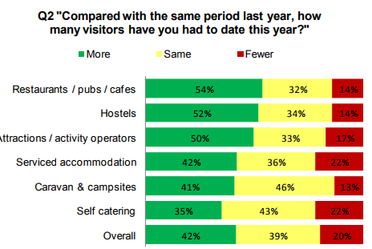
Figure 2 shows question 2 and that 54% of restaurants, pubs and cafes express that the organisation has received more visitors than last year, 32% who believe that they had the same and then only 14% of had fewer.
Figure 3 - Origin of visitors (Welsh Government, 2018)

Figure 3 then shows the origin of visitors than travel to Wales and the market trends of the visitors. The selection of ‘rest of the world’ is at a higher percentage than Wales, Republic of Ireland and is equal to North America. The Welsh Government (2017) comments that some operators have noticed more British people enjoying their holidays and short breaks in Wales, as shown in the above chart this has reflected on the results as operators have seen two in five more non-Welsh UK visitors this year.

Malaysia
Malaysia can see a massive rise in tourism statistics from 2015 to 2017 as recent statistics show. The year 2015 showed that over 25,72 million travellers arrived in Malaysia spending over 69.1RM billion which can be seen as an impressive number compared to Wales. However, arrivals by country, 1,078,953 of Europe visited Malaysia in 2015 (Tourism Malaysia, 2018).
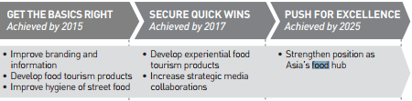
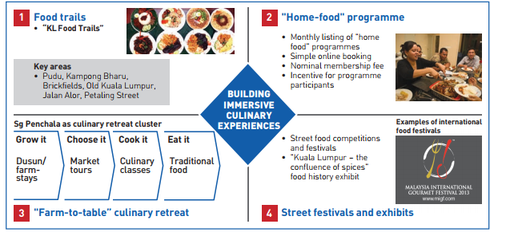
Just as Wales, Malaysia has a Tourism Strategy Plan called ‘Kuala Lumpur Tourism Master Plan 2015-2025’, which reviews their 9 key tourism segments – culture, shopping, nature & adventure, sports, heritage & places of interest, businesses & MICE, entertainment, luxury travel, education and medical & wellness. In this ‘master plan’, Tourism Unit identifies that culture, heritage & places of interest will be the main focus where the Tourism Unit looks to attract tourism to the different cuisines and wish to become a world-class cultural and heritage city by 2025 where the aim is to establish food tourism products as the Unit believes that KL has achieved the development of food tourism products and the hygiene of street food back in 2005 (Tourism Unit, 2015).
Figure 4 - Culinary experiences in KL (Tourism Unit, 2015)
Figure 5 - Key initiatives of cuisine heaven (Tourism Unit, 2015)
Figure 4 validates the key initiatives of the overview and position of KL as a Malaysian cuisine heaven.
Tourism Unit (2015) has selected three recommendations which are believed to improve and develop the Malaysian cuisine heaven.
- The overall awareness of KL’s vibrant street food scene should be improved and enhanced.
- To develop the greater variety of ways and a more immersive manner in which Malaysian food can be explored.
- Enforcement of acceptable hygiene and safety standards.

Unlike like Wales, the Tourism Unit has created a strategy of building new and immersive culinary experiences as shown in Figure 5.
To understand the motivations of why people travel to Wales and Malaysia is to understand Gastronomy tourists motivations.

Gastronomy Tourists Motivations
Motivations of the tourists begin revolving around food and experiencing new tastes, Hall and Sharples (2003) explain that this does in-fact become gastronomic tourism as the tourists will be exploring the history or culture of food tourism. Gastronomic Tourism (2004) explains that gastronomic tourism is a new form of tourism, and gastronomic travellers are essentially the same market as cultural holidays: above average income, professional couples in their thirty and fifties. A study Smith & Costello (2009) food-focused travellers travel as a couple, they have a higher education, they are able to spend more than other cultural tourists, are able to stay longer and accommodate in hotels and their main motivation is that they want to rest, relax and personal indulgence.
To understand the amount of money that these stereotypical food-travellers need to spend within Malaysia, Budget Your Trip (2018) can estimate that meals for one day in Malaysia is 66RM which is equivalent to £12 a day or a more in-depth approach is roughly how much a dish cost and what to expect while the traveller eats in Malaysia. It is found that a Noodle soup or a Fish curry is roughly 6RM (£1) a casual lunch for 2 is 19RM (£3.50) a sit-down dinner is for 2 is 32RM (£6) or finally, an Italian lunch based on 2 people sharing is 48RM (£9). As mentioned previously, relates back to Gastronomic Tourism (2004) comment that above average income and professional couples in their thirty and fifties.
Food tourism has benefits such as economic impact. Research conducted throughout the years on Food Travel Monitor (2018) can indicate that visitors roughly spend approximately 25% of their travel budget on food and drinks. This figure can reach up to 35% for expensive destinations. Although the economic impacts are positive, the tangible benefits for the destinations, which can help visitors, with sustainable food and drink tourism, engage more.
For British travellers travelling to Malaysia, this is a positive as the overall spend on food is much cheaper than if the traveller went for food in a local pub in Britain. Office for National Statistics (2018) can determine the amount of expenditure in a total household. This statistic shows that household expenditure is averaging over £40.00 per week as shown in Figure 6 unlike Malaysia dishes of £12.00 in the result of this if Malaysia travellers come to the United Kingdom they will find that spending money on food will be much pricier.
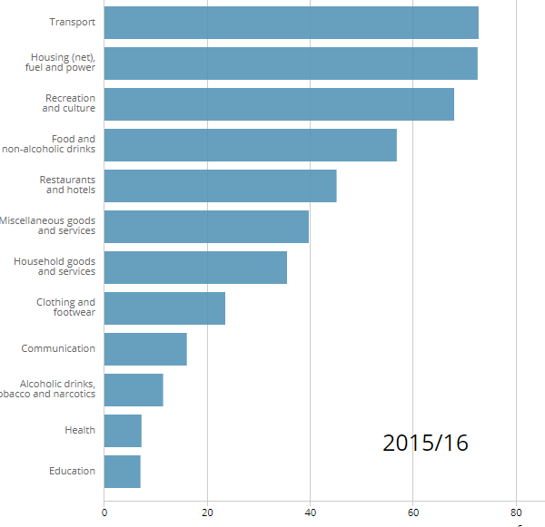
Figure 6 - Breakdown of average total household expenditure (Office for National Statistics, 2018)

Tourism products can also play a major part in why travellers choose to visit a country, such as the 6 categories that Smith (1997) address: ethnic, cultural, historical, environmental, recreational and business tourism. Cultural, historical and recreational tourism may be identified with the reasons to taste the local cuisine.

The ladder of motivation
There are many theories that authors have put in place to why travellers travel to different countries other than their own. Maslow’s Hierarchy of Needs can provide an insight of the reasons why travellers are motivated to travel to certain locations with specific foods in Malaysia and the United Kingdom (Maslow, 1954). Maslow (1954) has been applied to the travellers and the needs they require when they travel.

Physiological needs
- Eating, regardless where you are in the world is one of the main stages in the hierarchical need pyramid (Tikkanen, 2007). Found in the physiological need. Lowenberg (1970) relates Maslow’s motivation agrees that the physiological needs, food consumption classified them as a basic food element to survive.

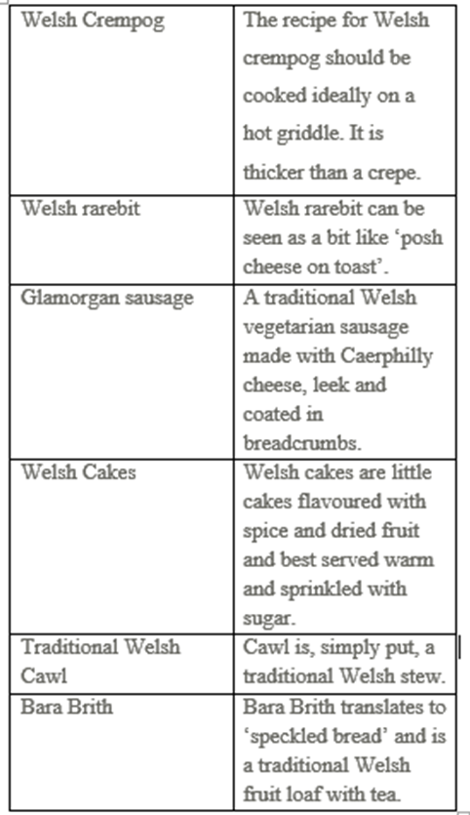
Belonging needs
- The belongingness stage can see the food being used as an interaction and cultural identify medium (Karim, 2006). Food is more than nourishment; it is part of the local culture.
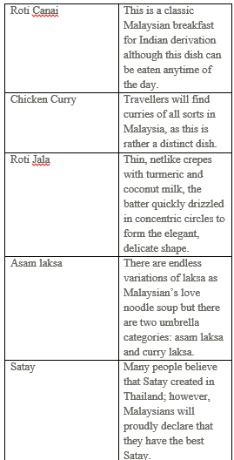
- Local culture plays a major part within Wales and Kuala Lumpur as each country has their own original dishes (these dishes can be can be found in table 1 & 2).
Table 2 - Welsh Food Traditions (Visit Wales, 2018)

Table 1 - Malaysians' traditional food (Serious Eats, 2018)Table 2 - Welsh Food Traditions (Visit Wales, 2018)
Table 1 - Malaysians' traditional food (Serious Eats, 2018)

Table 1 - Malaysians' traditional food (Serious Eats, 2018)

Esteem needs
- The traveller identifies the class of people and place, people who eat with them and with what the traveller eats, describes the social status.
- This can also be related to the amount of *stars or even Michelin Stars are rewarded to a restaurant but also money motivation as some restaurants can be more expensive than others and it is what the traveller can afford.
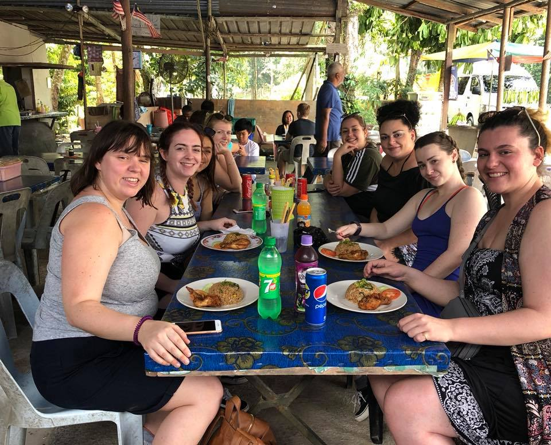
- The Debrief (2018) article shows a few Michelin starred restaurants customers can afford;
  - The Clove Club
  - Thackeray’s
  - Barrafina
  - Arbutus
  - Social Eating House

Self-actualisation
Figure 7 - UWTSD Mtour Students eating local cuisine (Authors own credit)
- The fifth stage in the Maslow’s hierarchy is the self-realisation where the traveller is motivated to experience cultural and local foods (Karim, 2006).
- When a traveller is motivated by Kuala Lumpur and Wales due to the food festivals that they offer to travellers.

Self-actualisation continued…
- Figure 7 shows UWTSD Mtour Students experiencing the local cuisine before adventuring further on their education field-trip. This consisted of plain rice with chicken. A comment made by one of the students is that “the field trip was a positive cultural experience the food however was not an acquired taste”.
- This shows an example of how UWTSD students are willing to experience the local cuisine as it differs from what Wales has to offer.

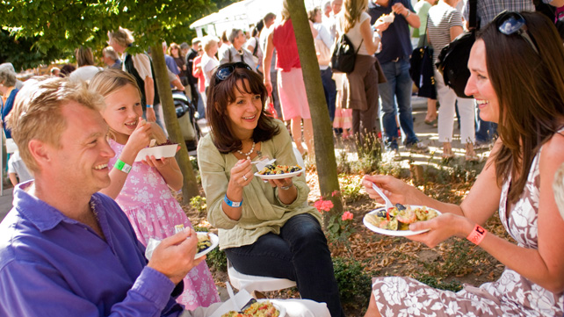
Food Festivals
Figure 8 - Abergavenny Food Festival (Visit Wales, 2018)
Food festivals are a wonderful way for countries to promote their local cuisines they have to offer. Welsh and Malaysia are among the countries that celebrate food festivals each year. Wales’ mission statement for the food festival is that;
“The experience of a Welsh food festival is one not to be missed – our food festivals are outpourings of flavours, colours, and smells. You will find a myriad of different stalls and activities, but the star attraction is the produce brought to you by people with a real passion and talent”.
(Visit Wales, 2018)

These food festivals are continuous throughout Wales in the year accommodating in Abergavenny Food Festival (as seen in Figure 8), Cowbridge food and drink festival, Narberth Food Festival, Cardiff Bay Beaches largest outdoor festival, Neath food and drink festival and Mold food and drink festivals.
In contrast to this, Malaysia holds a Food Festival similar to Wales that has been occurring since 1972. Malaysia Food Festival (2018) mission statement is;
“A journey of where our food comes from and who is bringing it to our tables”.
(Malaysia Food Festival, 2018)
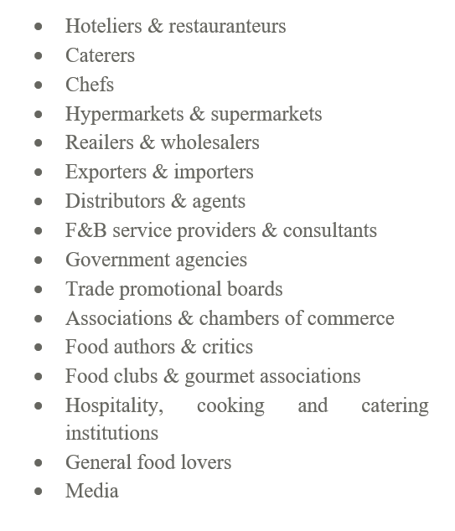
The inspirations behind Malaysia food festivals is that the food is safe, healthy, secure, sustainable, the cooking is done by chefs and live demos, the technology is done by processing and packaging, the dining experience is done by cuisines and menus (Malaysia Food Festival, 2018). They claim to target specific types of travellers.

Although these are created by Malaysia Food Festival (2018) Wales’ likelihood of using a similar targeting visitor strategy is more than likely. There are advantages and disadvantages of food festivals that take place either in Wales or in Malaysia. The advantages are;
- Boosting the economy
- Fostering community pride
- Teaching new things
- Strengthening relationships
- Value of training
(University of Minnesota, 2018)
As the celebrations make travellers feel extrodinary about the time to socialise with their families and friends there are regional standards there are weaknesses of celebrations.
- The location may be incorrect for the right target of audience
- Finding a repeat audience may be difficult.
- Ensuring the right sort of marketing for the targeted audience.
(Sumelius, 2016)

Conclusion
In conclusion, 2018 for both Wales and Malaysia seem a promising year in the food tourism industry. Throughout the year visitor numbers are increasing and the Food Tourism population is becoming more popular, Wales increasing to 18% of new visitors and Malaysia understanding the need of improvement within the sector as three new strategies have been put in place in their tourism masterplan for food tourism. Stated that the expenditure in Wales is more than £410 million visitors spend whereas Malaysia’s expenditure is 69.1RM billion. As discovered in Maslow’s Hierarchy, food is one of the priority needs as it falls in the physiological needs. Although Malaysia has many more (25) traditional cuisines than Wales (5) this still gives visitors the inspiration to try new food. This helps all food organisations as humans do in-fact need to eat to survive which gives the motivation of visitors to experience new and local cuisines in the country.

References
Ali-Knight, J. M., 2011. The Role of Niche Tourism Products in Destination Development, s.l.: Published Works.
BBC News, 2018. Malaysia Country Profile. [Online]
Available at: http://www.bbc.co.uk/news/world-asia-pacific-15356257
Budget Your Trip, 2018. Malaysia. [Online]
Available at: http://www.budgetyourtrip.com/malaysia
DistanceFromTo, 2018. Distance from United Kingdom to Malaysia. [Online]
Available at: https://www.distancefromto.net/distance-from-united-kingdom-to-malaysia
Hall, C. & Mitchell, R., 2001. Wine and food tourism. Special Interest Tourism: Context and Cases, pp. 307-329.
Hall, C. M. & Sharples, L., 2003. The consumption of experiences or the experiences of consumption?. Food Tourism: Around the World: Development, Management and Markets. , pp. Chapter 1, p. 1-24.
Karim, S. A., 2006. Culinary Tourism As A Destination Attraction: An Empirical Examination Of The Destination's Food Image And Information Sources, s.l.: University of Technology.
Kivela, J. & Crotts, J. C., 2006. Tourism and Gastronomy's influence on how tourists expeirience a destination. Journal of Hospitality & Tourism Research, 30(3), pp. 354-377.
Malaysia Food Festival, 2018. Home. [Online]
Available at: http://malaysiafoodfestival.com/#
Maslow, A., 1954. Motivation and Personality. New York: Harper and Row.
Novelli, M., 2005. Niche Tourism: Contemporary issues, trends and cases. Oxford: Butterworth-Heinemann.
Office for National Statistics, 2017. Wales Population mid-year estimate. [Online]
Available at: https://www.ons.gov.uk/peoplepopulationandcommunity/populationandmigration/populationestimates/timeseries/wapop/pop
Office for National Statistics, 2018. People Population and Community. [Online]
Available at: https://www.ons.gov.uk/peoplepopulationandcommunity/personalandhouseholdfinances/expenditure/bulletins/familyspendingintheuk/financialyearendingmarch2016
One World Nations, 2018. Malaysia. [Online]
Available at: http://www.nationsonline.org/oneworld/malaysia.htm
Serious Eats, 2018. 25 Malaysian Dishes You Should Know. [Online]
Available at: http://www.seriouseats.com/2011/08/25-malaysian-dishes-you-should-know-what-is-malaysian-cuisine-slideshow.html#show-176965
Smith, S. & Costello, C., 2009. Segmenting Visitors to a Culinary Event: Motivations, Travel Behaviour, and Expenditures. Journal of Hospitality Marketing & Management, pp. 15-19.
Sumelius, A., 2016. What would be the disadvantages of holding a film & food festival on a monthly basi. [Online]
Available at: https://www.quora.com/What-would-be-the-disadvantages-of-holding-a-film-food-festival-on-a-monthly-basis-for-2-days-instead-of-annually-for-10-days
Taar, J., 2014. The Best Culinary experience. Factors that create extraordinary eating episodes. s.l.:World Conference on Design, Arts and Eduction .
The Welsh Government, 2015. The Food Tourism Action Plan for Wales 2015-2020, Cardiff: The Welsh Government .
Tikkanen, I., 2007. Maslow's Hierarchy and Food Tourism in Finland: Five Cases 109: (9). British Food Journal, pp. 721-734.
Tourism Malaysia, 2018. Malaysia Tourism Statistics in Brief. [Online]
Available at: https://www.tourism.gov.my/statistics
Tourism Society, 2018. Tourism Definitions. [Online]
Available at: http://www.tourismsociety.org/page/88/tourism-definitions.htm
Tourism Unit, 2015. Kuala Lumpur Tourism Master Plan 2015-2025, Kuala Lumpur: Kuala Lumpur City Hall.
University of Minnesota, 2018. Community Festivals. [Online]
Available at: http://www.extension.umn.edu/community/news/community-festivals/
Visit Wales, 2018. Food Festivals in the UK. [Online]
Available at: http://www.visitwales.com/things-to-do/attractions/food-and-drink/food-festivals
Visit Wales, 2018. Traditional Welshg Food Recipes. [Online]
Available at: http://www.visitwales.com/explore/traditions-history/recipes
Welsh Government , 2018. Latest Statistics. [Online]
Available at: http://gov.wales/topics/culture-tourism-sport/tourism/researchmain/latest-stats/?lang=en
Welsh Government, 2016. Partnership for Growth: strategy for tourism 2013-2020. [Online]
Available at: http://gov.wales/topics/culture-tourism-sport/tourism/partnership-for-growth-strategy/?lang=en
Welsh Government, 2016. Strategy Progress Review, Cardiff: Welsh Government.
Welsh Government, 2017. Wales Tourism Business Barometer: Wave 4, Cardiff: Government Social Research.
Wonderful Malaysia, 2018. Kuala Lumpur History. [Online]
Available at: http://www.wonderfulmalaysia.com/kuala-lumpur-history.htm
World Food Travel Association, 2018. Our Industry at a Glance, s.l.: World Food Travel Association.
Worldometers, 2018. Malaysia Population. [Online]
Available at: http://www.worldometers.info/world-population/malaysia-population/

