Cloud Computing Administration

Introduction 3
Cloud Solution for Immediate Computing Services 3
Analysis of Cloud Providers 4
Cost Management in Azure 4
Overview of Managing Costs in Azure 4
Potential Cost Savings of Migrating to Azure 5
Cost Estimation for Computing Configurations 5
Conclusion 5
Azure Active Directory Configuration 9
Understanding Azure Active Directory for User and Group Account Management 9
Features of Azure Active Directory (AAD): 9
Step-by-Step Guide on Configuring Azure AD, Including BYOD Support 10
Explanation of Using Azure Active Directory for User and Group Account Management 10
Cloud Governance and Security in Azure 11
Understanding Cloud Governance for User and Group Account Management: 11
Securing Access to Cloud Resources with Microsoft Azure: 11
Disaster Recovery Plan 12
Conclusion 12
References 14

Abstract— This report outlines Aspire Retailers' strategic move to transition from an on-premises datacentre to Microsoft Azure, aiming to enhance operational efficiency and facilitate global expansion. Focused on key objectives, including immediate computing services, analysis of cloud providers, cost estimation for Azure migration, Azure Active Directory configuration, cloud governance, and disaster recovery planning, the report provides practical insights. By leveraging Azure's capabilities, Aspire Retailers aims to overcome current IT challenges, reduce costs, and position itself for future growth in the competitive retail landscape.

Introduction
Aspire Retailers, a prominent home improvement retailer, currently operates with an on-premises datacentre to host its retail website and manage data and streaming videos for various applications. The management of computing hardware and software, procurement processes, and network monitoring by the internal IT department has presented challenges in delivering applications promptly to end-users. Recognizing the need for a more agile and scalable solution, the Aspire Retailers' management committee has made a strategic decision to transition to the cloud, foreseeing opportunities for business improvement and expansion into new markets.
As an IT administrator within Aspire Retailers, the realisation of the advantages of having readily available servers, storage, databases, and other services for efficient application development and deployment prompted the exploration of cloud solutions. This report outlines a comprehensive plan for Aspire Retailers' cloud journey, focusing on Microsoft Azure as the chosen cloud provider.
The key objectives of this report include guiding Aspire Retailers in leveraging cloud solutions to meet immediate computing service needs, analysing the services offered by three prominent cloud providers, estimating the costs associated with moving to Azure, configuring Azure Active Directory for user management, discussing cloud governance strategies, and proposing a disaster recovery plan.
The transition to Microsoft Azure is not merely a technological shift; it is a strategic move aimed at enhancing operational efficiency, reducing costs, and facilitating global expansion. By examining various aspects of cloud computing, this report aims to provide a roadmap for Aspire Retailers, enabling a seamless transition to Azure and unlocking the full potential of cloud technology.

Cloud Solution for Immediate Computing Services
Cloud solutions are pivotal in delivering immediate computing services, offering efficiency, scalability, and flexibility. In today's fast-evolving technological landscape, businesses and individuals demand instant access to computing resources. Cloud computing meets this need by providing on-demand services through the internet. This chapter of the report explores the advantages of cloud solutions, emphasising efficiency, scalability, and flexibility. Additionally, it delves into the importance of load balancing in optimising performance and resource utilisation.

Cloud computing, defined by Rountree and Castrillo [1] as a paradigm utilizing remote servers for data storage and processing, enables efficient and cost-effective resource access over the internet. Virtualization, a key principle, creates virtual instances of hardware and software, allowing concurrent access by multiple users. Scalability, a significant benefit, enables organizations to adjust resources based on demand, promoting flexibility and cost savings. Enhanced security measures, including encryption and access control, ensure data privacy and integrity [1].

With technology advancing rapidly, cloud solutions have become indispensable across industries. According to Islam et al. [2], they offer efficiency, scalability, and flexibility, enabling organizations to optimise resources and reduce costs. Efficiency arises from avoiding bulky hardware, letting companies focus on core competencies. Scalability allows businesses to adjust computing power without significant investments. Remote access enhances flexibility, fostering collaboration and productivity. In conclusion, the efficiency, scalability, and flexibility of cloud solutions make them valuable for immediate computing needs [2].

Load balancing is crucial in cloud solutions, distributing incoming traffic to prevent server overload. Priya, Kumar, and Kannan [3] describe load balancing's role in achieving higher availability, scalability, and reliability. Techniques like Round Robin and Weighted Round Robin evenly distribute workloads, preventing server overwhelm. Advanced techniques like dynamic and predictive load balancing continuously monitor and optimise performance, ensuring efficient resource utilisation.

In conclusion, cloud solutions revolutionise immediate computing services, offering on-demand resource access and load balancing features. This not only enhances user experience but also reduces downtime and improves productivity. The pay-as-you-go pricing model makes cloud solutions cost-effective, providing organizations with a competitive edge. As technology evolves, cloud solutions will play a crucial role in shaping the future of computing services [2].

Analysis of Cloud Providers
Cloud computing has revolutionised business operations and data management, making it imperative for organizations to grasp the nuances of leading cloud providers. This analysis compares Amazon Web Services (AWS), Google Cloud Platform (GCP), and Microsoft Azure, with Aspire Retailers opting for the latter. Our focus is on an in-depth examination of Microsoft Azure, exploring its features, pricing, and performance to assess its alignment with Aspire Retailers' specific needs.
Cloud computing, as defined by Rountree and Castrillo [1], involves delivering computing resources over the internet. AWS, GCP, and Azure facilitate on-demand access, scalability, and cost optimization. The adaptability of cloud computing to changing demands, without extensive hardware investments, contributes to its popularity. Robust security measures ensure data protection against unauthorised access or loss [1].
Comparing AWS, GCP, and Azure entails considering various factors. AWS offers a comprehensive suite, GCP excels in machine learning and data analytics, while Azure seamlessly integrates with the Microsoft ecosystem. Each provider has distinct pricing models and performance strengths [4].
Microsoft Azure's services cater to diverse business needs. Virtual machines enable flexible application deployment, while a range of storage solutions ensures secure data handling. Data analytics and machine learning services, such as Azure Machine Learning, empower businesses like Aspire Retailers to gain valuable insights. Robust security features, including Azure Active Directory, enhance data protection [5].
In conclusion, cloud providers offer diverse options, but a detailed analysis of Microsoft Azure highlights its suitability for retail businesses. With scalability, comprehensive services, and robust security, Azure stands out as a compelling choice. As businesses navigate the evolving technological landscape, careful evaluation of cloud providers is essential for informed decisions aligned with long-term goals.

Cost Management in Azure
Cost management is an indispensable aspect of any cloud platform, and Azure is no exception. We will delve into effective strategies and tools for managing costs in Azure, with a particular emphasis on optimising expenses without compromising performance.

Overview of Managing Costs in Azure
Managing costs in Azure involves implementing strategies and utilizing tools that enable organizations to monitor, analyse, and optimise their resource usage efficiently. One approach, as suggested by Kline, McDowell, Dorsey, and Gordon [6], is to proactively identify inefficiencies or underutilised resources. For instance, organizations can use Azure's monitoring features to track resource usage patterns and identify areas where adjustments can be made for better efficiency.
A notable tool for achieving transparency and accountability is the use of cost allocation tags. By assigning tags to resources, organizations can track and allocate costs to specific departments or projects, providing insights into how resources are being utilised across different parts of the organization.
Additionally, Azure provides built-in tools such as Azure Cost Management and Azure Advisor. Azure Cost Management offers granular visibility into spending patterns, allowing organizations to understand where their resources are allocated and identify potential areas for cost optimization. Azure Advisor, on the other hand, provides proactive recommendations for optimising resource usage based on best practices.
Let's consider an example to illustrate the practical application of these strategies. Suppose an organization identifies a virtual machine that consistently operates below its capacity. By leveraging monitoring tools, they can analyse historical usage data, identify the underutilization, and either resize the virtual machine or consider decommissioning it to avoid unnecessary costs.

Potential Cost Savings of Migrating to Azure
When evaluating the potential cost savings of migrating a datacentre to Azure, a comprehensive analysis is crucial. As highlighted by Mansouri, Toosi, and Buyya [7], this involves assessing costs related to infrastructure, maintenance, and energy consumption. For example, an organization can use Azure's Total Cost of Ownership (TCO) calculator to estimate the potential savings by migrating specific workloads.
Azure's scalability and pay-as-you-go model offer flexibility in adjusting resources based on demand, contributing to potential cost optimization. Leveraging Azure's energy-efficient infrastructure can further reduce operational costs related to energy consumption. For a practical illustration, organizations can use the TCO calculator to input data centre specifics and compare the costs with Azure-based solutions.

Cost Estimation for Computing Configurations
In the realm of cloud computing, precise cost estimation is pivotal for informed decision-making. Brebner and Liu's [8] study underscores the importance of accurate cost calculations for various computing configurations in Azure.
Consider an example where an organization needs to decide between different virtual machine configurations for running a specific workload. Using the Azure Pricing Calculator, they can input the parameters such as the number of virtual machines, storage requirements, and network bandwidth to obtain a detailed cost estimation. This empowers organizations to make cost-effective choices based on their specific needs.

Conclusion
Effective cost management in Azure involves a strategic combination of monitoring, optimising, and leveraging available tools. The article has provided insights into the importance of managing costs in Azure, practical strategies for optimization, and the potential savings associated with migrating to Azure. By employing these practices, organizations can not only reduce expenses but also enhance operational efficiency and scalability in the ever-evolving landscape of cloud computing.
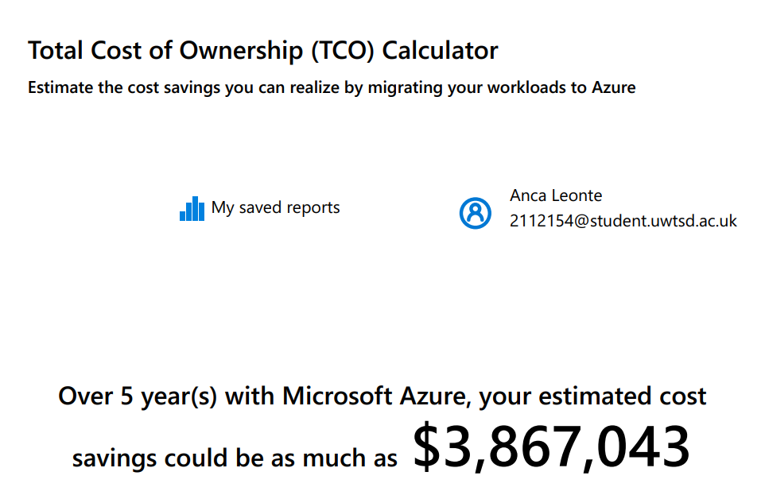
Figure 1. TCO Calculator
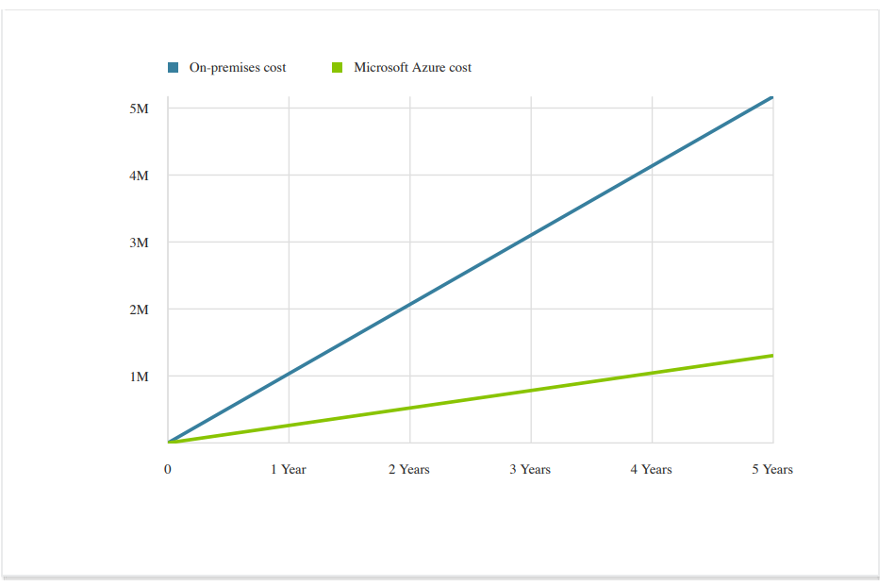
Figure 2. On-premise cost vs Azure Cost
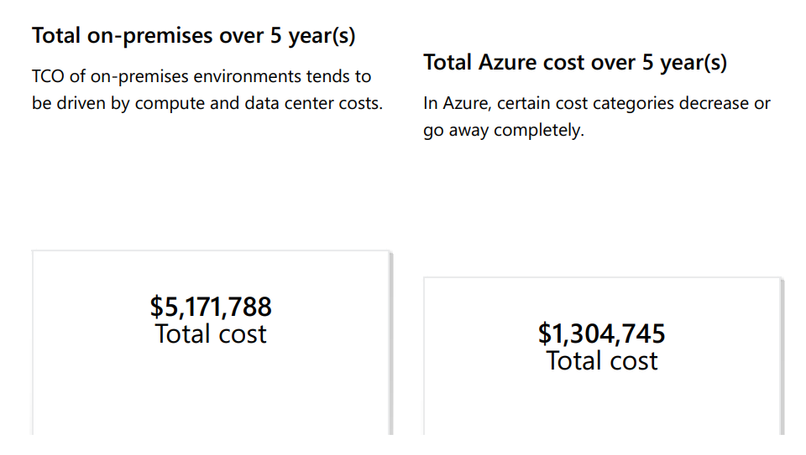
Figure 3. TCO over 5 years
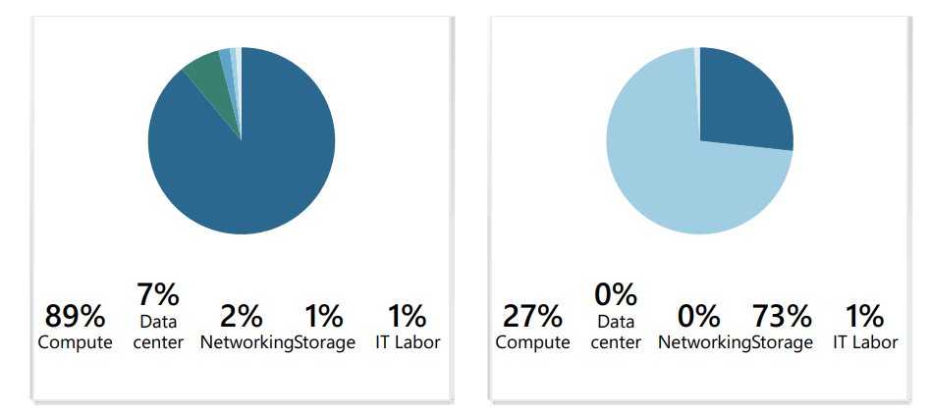
Figure 4. Cost breakdown
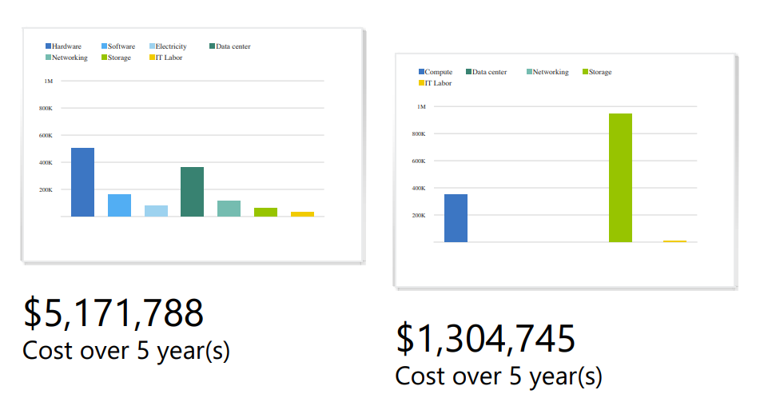
Figure 5. Cost breakdown in dollars
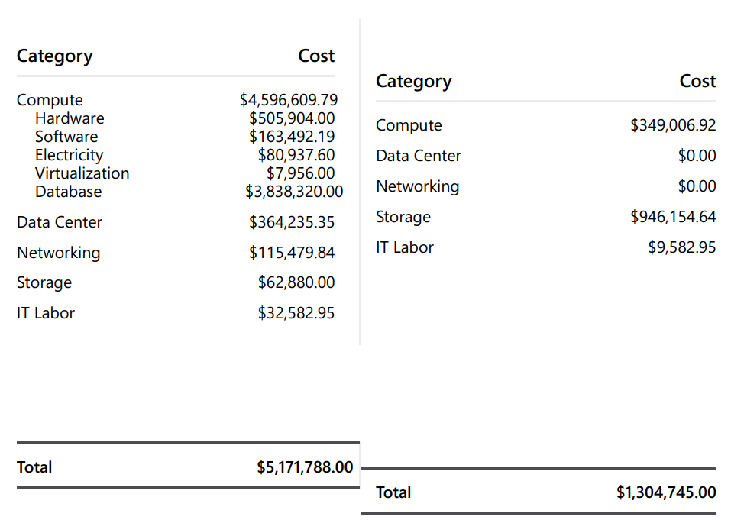
Figure 6. Total cost of On-premises vs Azure

Azure Active Directory Configuration
Azure Active Directory (AAD) stands as a cornerstone in the realm of cloud-based identity and access management, offering a robust solution for user and group account administration. The meticulous handling of user accounts and groups is imperative for organizations of all scales. We will aim to elucidate the nuances of Azure Active Directory, delving into its functionalities, practical applications, and the step-by-step process of configuring Azure AD. Additionally, we'll explore the benefits and features associated with enabling Bring Your Own Device (BYOD) support in Azure AD, emphasising how this capability enhances productivity and flexibility for users.

Understanding Azure Active Directory for User and Group Account Management
Azure Active Directory (AAD) is more than just a tool; it is a comprehensive cloud-based solution provided by Microsoft to manage identities and control access to various cloud-based services. In the context of user and group account management, AAD serves as the linchpin, facilitating centralized control over user identities and access across a multitude of applications and services within the Azure ecosystem.

Features of Azure Active Directory (AAD):
Chilberto et al. [9] emphasise key features contributing to robust user and group account management within AAD:
- User Provisioning and Deprovisioning: AAD streamlines the onboarding and offboarding processes by facilitating efficient user provisioning and deprovisioning.
- Self-Service Password Reset: Users can autonomously reset their passwords, reducing the administrative burden on IT teams, and enhancing user experience.
- Multi-Factor Authentication (MFA): A crucial security layer, MFA adds an extra level of protection by requiring users to provide multiple forms of verification before accessing resources.

Step-by-Step Guide on Configuring Azure AD, Including BYOD Support
To unleash the potential of Azure AD for seamless account management, organizations can follow a structured step-by-step guide, as outlined in the book "Configuring Azure AD: A step-by-step guide to setting up and customising Azure Active Directory" by M. Mayank and M. Garg [10].
- User Management:
- Begin by understanding the user management capabilities in Azure AD. This involves configuring user accounts, assigning roles, and implementing self-service options.
- Authentication Methods:
- Explore the various authentication methods offered by Azure AD, including password-based authentication, multi-factor authentication, and integration with on-premises Active Directory.
- Customization of Azure AD:
- Customise Azure AD to align with organisational needs. This includes branding, custom domains, and the implementation of conditional access policies for heightened security.
- Bring Your Own Device (BYOD) Support:
- Enable BYOD in Azure AD to harness the advantages of employees using their personal devices for work. This involves configuring conditional access policies, app protection policies, and leveraging multi-factor authentication for enhanced security.

Explanation of Using Azure Active Directory for User and Group Account Management
Azure Active Directory proves invaluable in the management of user and group accounts across diverse scenarios. Let's elucidate the significance through examples:
- Hybrid or Cloud-Centric Approach:
- For organizations adopting a hybrid or cloud-centric approach, Azure AD provides a unified point of control. It seamlessly integrates with on-premises Active Directory, allowing businesses to manage user accounts cohesively in both environments.
- Efficiency and Security:
- AAD ensures administrative efficiency by offering features like self-service password reset and user provisioning. Simultaneously, multi-factor authentication bolsters security, safeguarding against unauthorised access.
- Customization for Organisational Needs:
- Organizations can tailor Azure AD to meet specific requirements. This includes configuring conditional access policies, custom domains, and branding to align with the organisational identity.
In conclusion, Azure Active Directory is not merely a tool but a comprehensive solution that empowers organizations to efficiently manage user and group accounts. By following a meticulous step-by-step guide and leveraging BYOD support, businesses can streamline account management processes, enhance security, and foster productivity in today's dynamic digital landscape.

Active Directory Demonstration

The main step is to go into the portal and select the Active Directory from the resources list:

Figure 1 Resources List on Portal

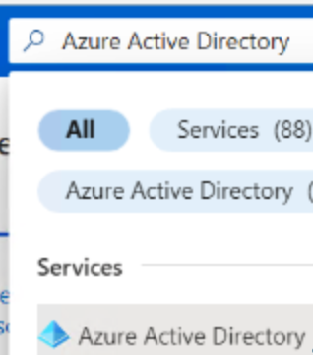
Figure 2 Selecting the Active Directory

The second step is to select from the left panel, Users and go to settings 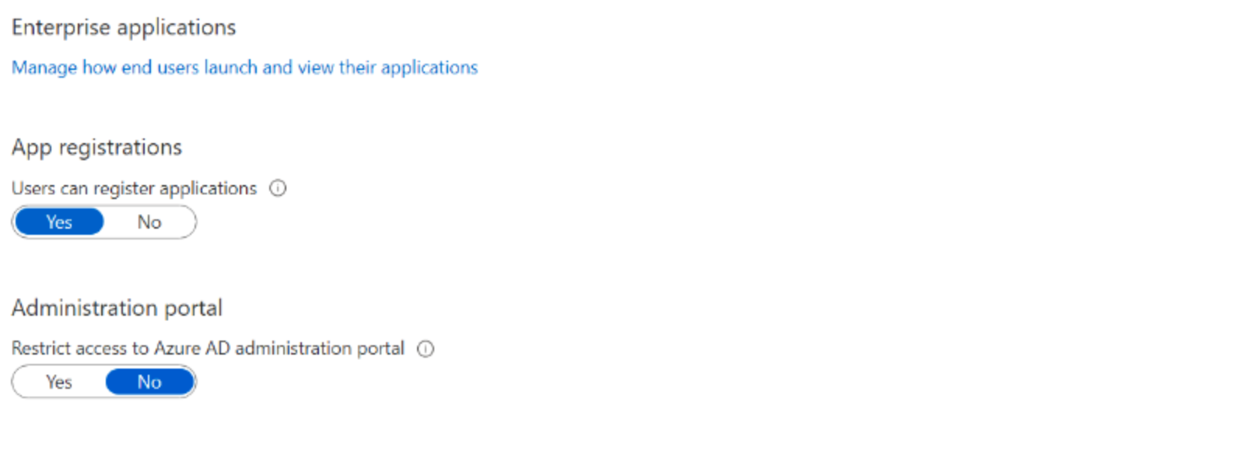
Figure 3 Users

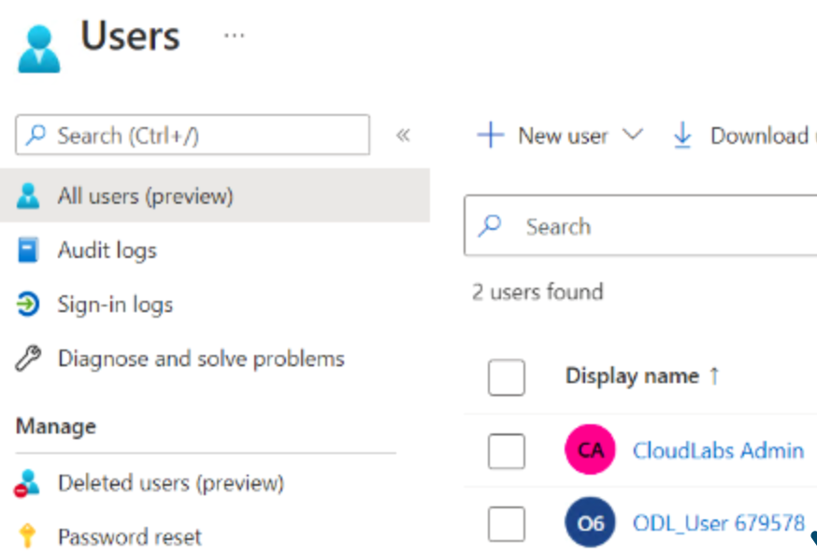
Figure 4 List with the Users

The third step will be to open the properties and select settings:

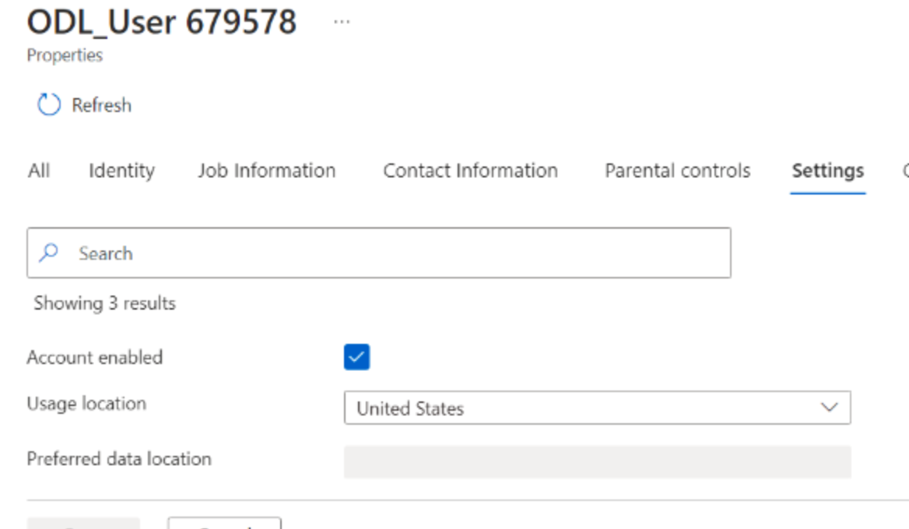
Figure 5 Enabling the Account

Adding or removing Users
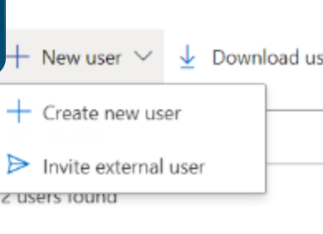
Figure 6 Creating new Users.

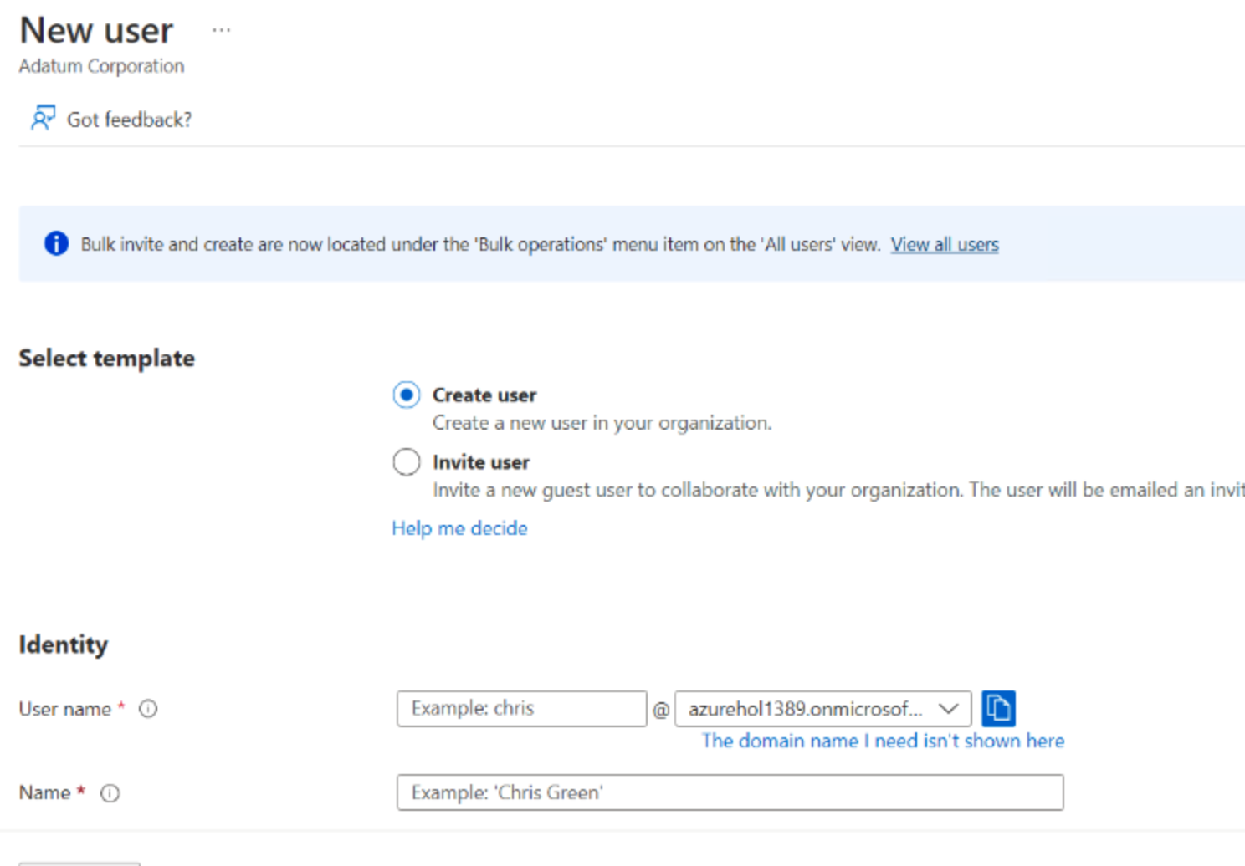
Figure 7 Creating or Inviting the user

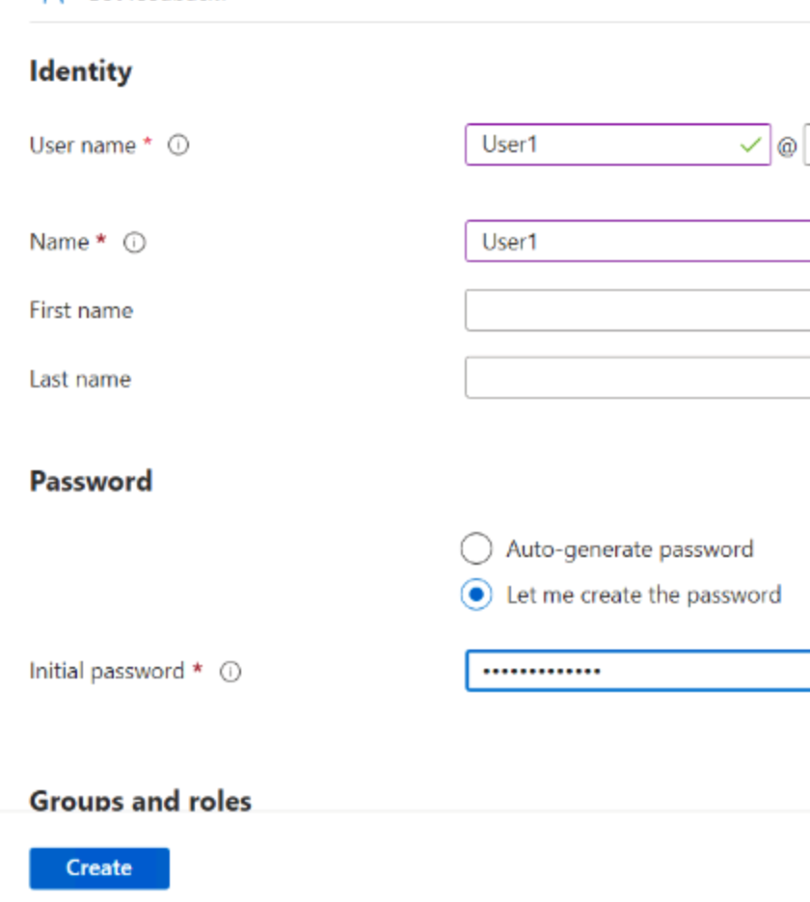
Figure 8 Generating a temporarily password.

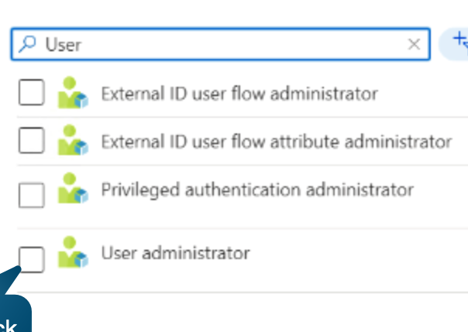
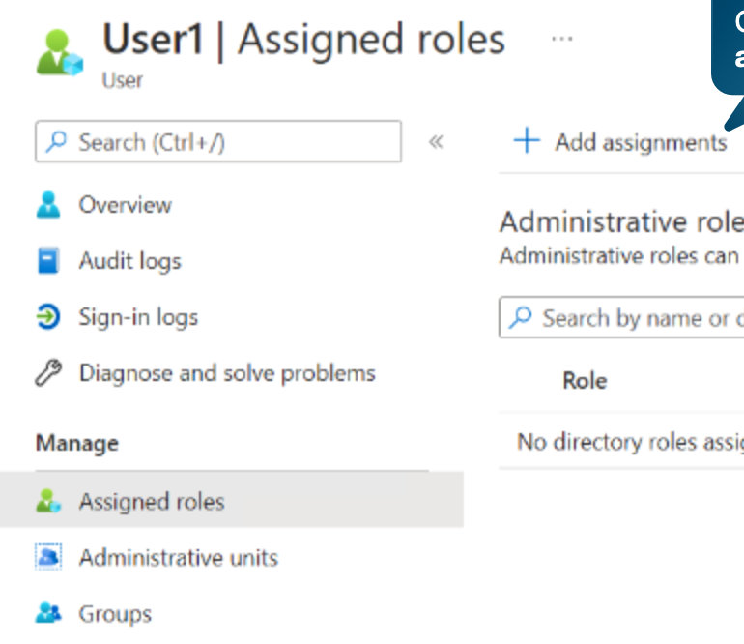
Figure 9 Assign Roles

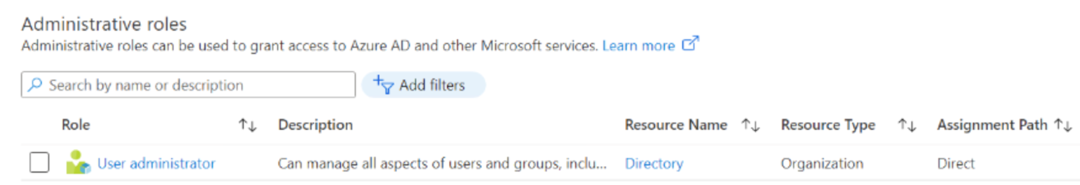
Figure 10 Refreshing the list with the Users.

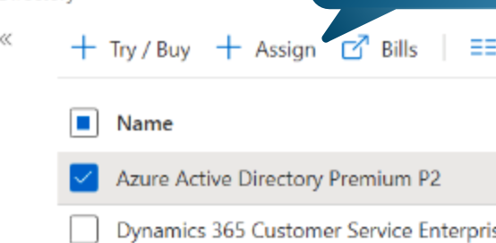

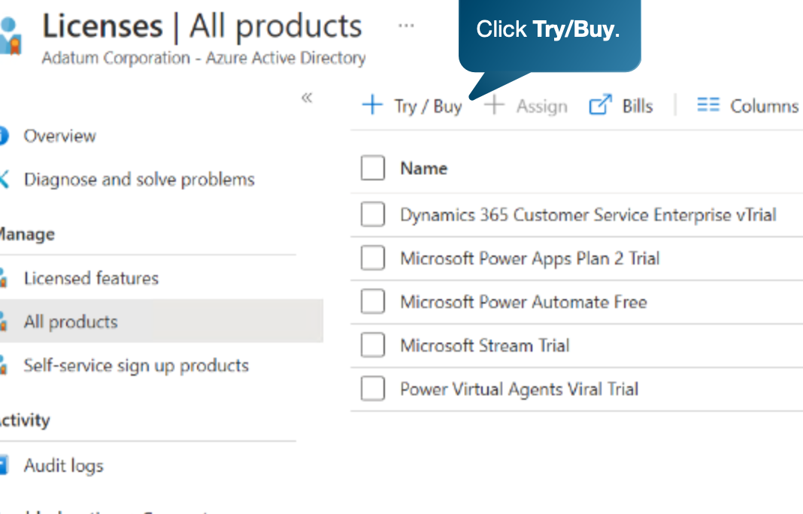
Figure 11 Try for free the license.

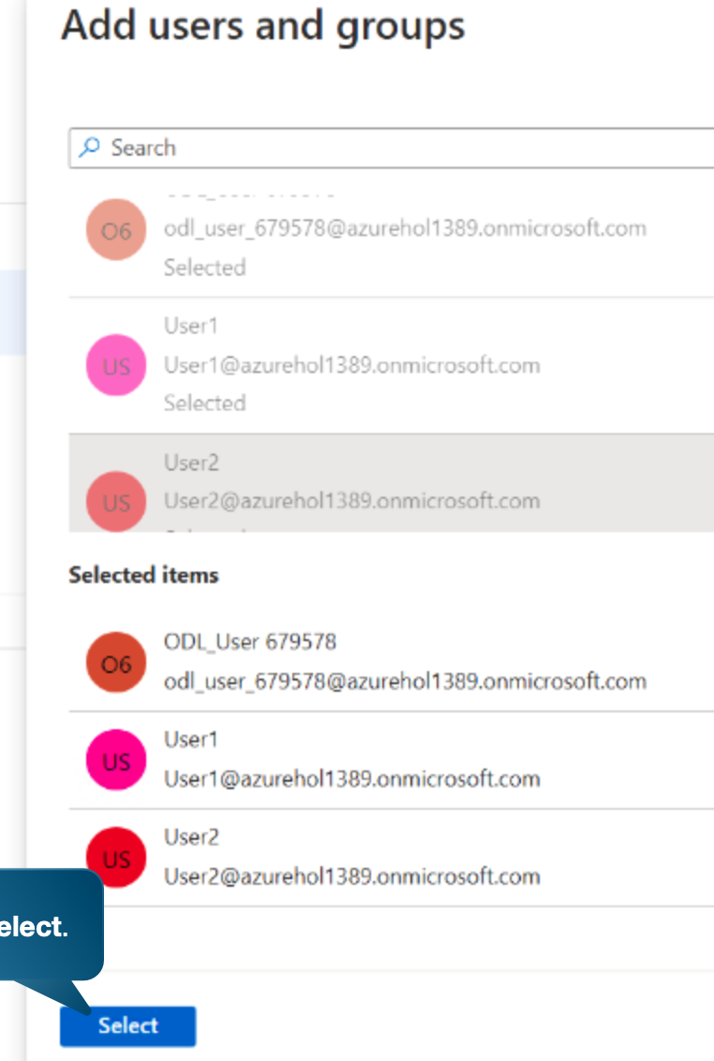
Figure 12 Select the Users for the Group

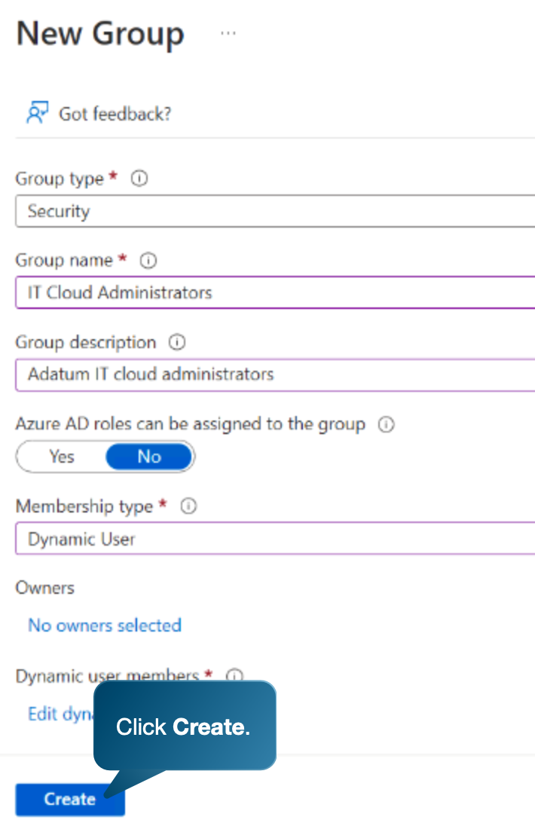
Figure 13 Creating the group with Dynamic Job title = IT Cloud Administrators

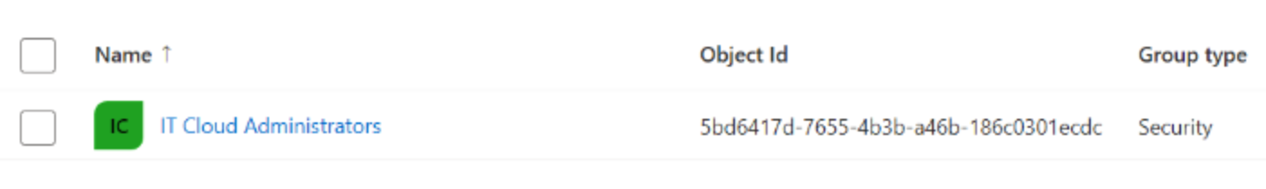

Cloud Governance and Security in Azure
Effectively managing cloud resources and safeguarding sensitive data are paramount in today's digital landscape. This paper delves into the intricacies of cloud governance (Topic 1), examines Microsoft Azure's role in securing cloud resource access (Topic 2), and proposes a comprehensive policy to fortify cloud governance and security for Aspire Retailers (Topic 3). By grasping the fundamentals of cloud governance, utilizing Azure's security features, and implementing a precise policy, Aspire Retailers can ensure the integrity and confidentiality of their cloud infrastructure, fortifying business operations and customer data.

Understanding Cloud Governance for User and Group Account Management:
Cloud governance involves implementing policies, procedures, and practices to ensure effective and secure utilisation of cloud resources. Its significance lies in managing risks and maximising cloud computing benefits. As highlighted by Al-Ruithe, Benkhelifa, and Hameed [11], cloud governance is pivotal for sustaining cloud-based services.
Cloud governance aids in establishing accountability, transparency, and compliance with regulatory requirements, mitigating data breach and unauthorised access risks. It encompasses aspects like data privacy, security, access management, and resource allocation. By implementing robust governance frameworks, organizations can manage and protect their cloud data assets efficiently, ensuring confidentiality, integrity, and availability [11]. Additionally, it aligns cloud strategies with overall business objectives, ensuring efficient and cost-effective resource utilisation.
Furthermore, cloud governance plays a vital role in promoting sustainability in cloud computing. Following Al-Ruithe et al.'s [12] insights, sustainability involves providing environmentally friendly and resource-efficient services. By optimising resource utilisation, promoting resource sharing, and adopting efficient workload management, organizations contribute to the overall sustainability of cloud computing.
In conclusion, a profound understanding of cloud governance is essential for organizations to manage risks, ensure compliance, and maximise cloud computing benefits. It establishes accountability, transparency, and compliance, mitigating risks associated with data breaches and unauthorised access. Cloud governance also contributes to the sustainability of cloud-based services by promoting resource efficiency and environmental friendliness.

Securing Access to Cloud Resources with Microsoft Azure:
Cloud security is a critical concern, and securing access to cloud resources is vital for overall data protection and confidentiality. Microsoft Azure provides an array of features and tools to enhance cloud security and mitigate potential risks. According to Marin [13], a key strategy is implementing strong authentication mechanisms. Azure offers multi factor authentication (MFA) options, such as phone-based verification or token-based authentication, adding an extra layer of security. Azure Active Directory (AD) facilitates effective management of user identities and access controls, supporting role-based access control (RBAC) for granular permission assignment based on job roles. This prevents unauthorised access, reducing the risk of data breaches.
Azure also offers features like conditional access policies, allowing organizations to define specific conditions for user access to cloud resources. For instance, administrators can set policies requiring users to access resources from specific devices or locations, enhancing security and preventing unauthorised access. Implementing these security measures allows organizations to better protect their cloud resources and ensure data integrity and confidentiality [12], [13].
In the rapidly evolving digital landscape, cloud computing has become integral to business operations, offering scalability, cost-efficiency, and flexibility. However, this adoption presents challenges in governance and security. To address these concerns, Aspire Retailers must propose a comprehensive policy strengthening cloud governance and security. This policy should establish clear guidelines for data governance, ensuring sensitive information is protected and accessed only by authorised personnel. Additionally, it should emphasise robust security measures, such as encryption, multi-factor authentication, and regular security audits, to safeguard against potential breaches and unauthorised access [13].
In conclusion, cloud governance and security play a vital role in ensuring the smooth and secure operation of organizations' cloud resources. As discussed, cloud governance encompasses policies, processes, and procedures governing the usage and management of cloud services. Microsoft Azure provides robust features to help organizations secure access to their cloud resources effectively. Implementing policies like multi-factor authentication, role-based access control, and network security groups enhances security and mitigates potential risks. With the right policies and tools, organizations can confidently embrace the benefits of cloud computing while ensuring the confidentiality, integrity, and availability of their cloud resources in Microsoft Azure.

Disaster Recovery Plan
Developing a robust disaster recovery plan is crucial for businesses in today's digital landscape, especially those relying on cloud services like Aspire Retailers. In this part, we will explore the essential components necessary for crafting an effective disaster recovery plan tailored to Aspire Retailers' cloud infrastructure, providing actionable steps for implementation. By understanding the significance of disaster recovery planning and adhering to specific guidelines, Aspire Retailers can ensure operational continuity and mitigate the impact of unforeseen events.
Businesses like Aspire Retailers, dependent on cloud computing services, face critical concerns, including potential unforeseen disasters such as natural calamities or cyberattacks. To address this, Aspire Retailers must establish a disaster recovery plan specifically designed for their cloud-based infrastructure. This planning entails a systematic approach to identify potential risks, assess their impact, and formulate strategies to minimise downtime and data loss during and after a disaster event [14].
Developing an effective disaster recovery plan involves careful consideration of key components. Firstly, a thorough risk assessment is essential to pinpoint hazards and vulnerabilities unique to the organization, covering physical infrastructure, data systems, and critical business processes. Clear communication channels, both internal and external, are crucial during a crisis, ensuring timely and accurate information dissemination. An effective backup and recovery strategy encompasses regular data backups, rigorous testing of restoration processes, and minimising data loss. Regular training and drills familiarise employees with the disaster recovery plan, enhancing response times during a crisis [15].
Implementing a successful disaster recovery plan on the cloud necessitates meticulous planning and execution. This includes a thorough risk assessment, prioritisation of risks, comprehensive plan development, regular testing, and continuous monitoring to ensure a robust strategy [14].
In conclusion, a tailored disaster recovery plan for the cloud is paramount for Aspire Retailers to ensure business continuity, especially in today's technology-driven landscape. Leveraging the cloud's scalability, flexibility, and cost-effectiveness facilitates efficient backup and restoration of critical data. Regular testing and updates to the disaster recovery plan are imperative to address emerging threats and technological advancements, ultimately securing the long-term success and growth of Aspire Retailers [14], [15].

Conclusion
In culmination, the strategic decision of Aspire Retailers to transition from traditional on-premises infrastructure to the dynamic realm of cloud computing, specifically with Microsoft Azure, marks a paradigm shift in the company's technological landscape. This endeavour is not merely a response to immediate IT challenges but a forward-thinking approach to reposition the organization for sustained growth, enhanced operational efficiency, and global market expansion.
The thorough exploration of Aspire Retailers' cloud journey within this report has illuminated various facets critical to the success of such a transformative initiative. The initial discussion centred around the impediments posed by the existing on-premises datacentre and the compelling reasons steering the organization towards the cloud. The insights gained underscore the potential for increased agility and scalability, prompting the need for a more responsive IT infrastructure.
The detailed examination of cloud features, particularly load balancing, revealed how cloud solutions offer immediate computing services, addressing the specific requirements of Aspire Retailers. Load balancing emerged as a pivotal feature, ensuring optimal resource utilisation and high availability of applications, thereby enhancing the end-user experience. This insight serves as a foundation for Aspire Retailers to leverage the full potential of cloud technologies in their operations.
A critical aspect of the report involved evaluating services offered by three major cloud providers, leading to the strategic selection of Microsoft Azure. The rationale behind this choice is rooted in Azure's comprehensive service portfolio, robust security measures, and alignment with the specific needs of Aspire Retailers. The subsequent estimation of migration costs provided valuable financial foresight, enabling the organization to plan effectively for the transition.
Delving into the practical implementation of Azure services, the report addressed the configuration of Azure Active Directory to manage user accounts. This is particularly pertinent as Aspire Retailers expands globally and embraces the 'Bring Your Own Device' (BYOD) model. The step-by-step guidance, supported by relevant screenshots, ensures a clear understanding of the configuration process, empowering the IT team to facilitate a seamless user experience.
Furthermore, the exploration of cloud governance strategies emphasised the significance of a well-defined governance framework to ensure security, compliance, and efficient resource utilisation. The suggestion of a disaster recovery plan adds an additional layer of resilience, safeguarding Aspire Retailers' data and applications from potential disruptions.
In essence, the extended conclusion underscores the holistic nature of Aspire Retailers' cloud journey, emphasising that the migration to Microsoft Azure is not just a technological upgrade but a strategic investment in the future. The amalgamation of technological advancements, financial prudence, and proactive governance positions Aspire Retailers on a trajectory of sustained success in the rapidly evolving landscape of cloud computing. As the organization embarks on this transformative path, it stands poised to reap the benefits of improved efficiency, reduced costs, and unparalleled opportunities for expansion and innovation.

References
[1] | D. Rountree and I. Castrillo, The Basics of Cloud Computing: Understanding the fundamentals of Cloud Computing in theory and practice. Newnes, 2013.
[2] | R. Islam et al., “The future of cloud computing: Benefits and challenges,” Int. J. Commun. Netw. Syst. Sci., vol. 16, no. 04, pp. 53–65, 2023.
[3] | V. Priya, C. Sathiya Kumar, and R. Kannan, “Resource scheduling algorithm with load balancing for cloud service provisioning,” Appl. Soft Comput., vol. 76, pp. 416–424, 2019.
[4] | B. Gupta, P. Mittal, and T. Mufti, “A review on Amazon web service (AWS), Microsoft azure & Google cloud platform (GCP) services,” in Proceedings of the 2nd International Conference on ICT for Digital, Smart, and Sustainable Development, ICIDSSD 2020, 27-28 February 2020, Jamia Hamdard, New Delhi, India, 2021.
[5] | C. Morfopoulou, “The strategies of major Cloud Service providers in the Cloud Computing market,” 2021.
[6] | K. Kline, D. McDowell, D. Dorsey, and M. Gordon, “Azure Cost Management,” in Pro Database Migration to Azure, Berkeley, CA: Apress, 2022, pp. 103–132.
[7] | Ieee.org. [Online]. Available: https://ieeexplore.ieee.org/abstract/document/7835175/. [Accessed: 12-Jan-2024].
[8] | P. Brebner and A. Liu, “Performance and cost assessment of cloud services,” in Service-Oriented Computing, Berlin, Heidelberg: Springer Berlin Heidelberg, 2011, pp. 39–50.
[9] | J. Chilberto, S. Zaal, G. Aroraa, and E. Price, “Identity security with azure active directory,” in Cloud Debugging and Profiling in Microsoft Azure, Berkeley, CA: Apress, 2020, pp. 215–234.
[10] | M. Mayank and M. Garg, Developing applications with azure active directory: Principles of authentication and authorization for architects and developers. Berkeley, CA: Apress, 2019.
[11] | M. Al-Ruithe, E. Benkhelifa, and K. Hameed, “Data governance taxonomy: Cloud versus non-cloud,” Sustainability, vol. 10, no. 1, p. 95, 2018.
[12] | M. M. Bühler et al., “Unlocking the power of digital commons: Data cooperatives as a pathway for data sovereign, innovative and equitable digital communities,” Digital, vol. 3, no. 3, pp. 146–171, 2023.
[13] | C. Marin, “Microsoft Windows Azure cloud application development and security concepts,” Kemi-Tornion ammattikorkeakoulu, 2012.
[14] | Ieee.org. [Online]. Available: https://ieeexplore.ieee.org/abstract/document/5742778/. [Accessed: 12-Jan-2024].
[15] | J. Dibsi and J. Cho, “Data management for environmentally sustainable and profitable business: Evidence from the food retail industry,” Sustainability, vol. 15, no. 23, p. 16298, 2023.

