Part 1

Cultural Influences on Change Management

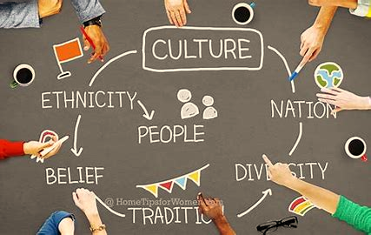
By
Nargas Ahmadzai (2106756)
Module: Leading and Implementing Workplace Change
Module Code: BMSW6103
Lecture by: Masoud Keimasi

Table of contents

Introduction 3
The Al Hilal UAE Energy Power Company 4
The Angel Universal Elect Plc 5
The Cultural Impacts on Communication and Negotiation Process 5
Cultural Backgrounds of The UK and UAE 7
The UK and UAE Communication Style 10
Implementation of Change Management Models 11
Ethnocentric and Polycentric Models in People Management 15
The Interview Analysis on The Validity of The Lewis Model 19
Recommendations and Conclusion 22
References 23
Appendix 25

Table of Figures

Figure 1 Construction Online Week 4
Figure 2 Understanding Different Cultures When Traveling 6
Figure 3 The Lewis Model: How to Understand Every Culture In The World 7
Figure 4 The Lewis Model: How to Understand Every Culture In The World 8
Figure 5 Traditional Dress of UAE For Female & Male, Funding 9
Figure 6 VersaCold: analysis of change management in mergers & acquisitions 13
Figure 7 EPRG Framework- International Business and Market Development, Super Heuristics 18

Introduction
This portfolio outlines the reflection and counselling of a recent graduate student in leadership and management regarding the case study of business acquisition from different cultures and countries. The first part of the portfolio indicates a report regarding the imaginary case study of the UAE Energy Power Company that recently acquired Universal Elect Plc company in the UK and the management asked different departments from the organisation in the UAE to work together and smoothly take over in the UK.
The UAE Energy company aims to expand its business and invest in the UK. During merger and acquisition, several cultural challenges occurred, for instance, communication challenges, conflict management, safety concerns, differences in values and beliefs, and rights of employees, HRM and CRM etc. This report addresses the issue of conflict management, which is a significant challenge for both countries involved in this business agreement. The report uses The Lewis Model to analyse both cultures and examine how cultural differences could affect communication, operations, negotiation, and feedback between the two countries. The analysis aims to identify an effective strategy to overcome the challenge of conflict management.
The report portrays the change management process and the implementation of various strategies to make this change successful. The Ethnocentric Model and The Polycentric Model identify individuals capable of crucial roles during the acquisition procedures. The report includes other important tools to analyse companies' cultural challenges while implementing this new change.
The acquisition is a business agreement when one company takes control over the other for various purposes such as growth, economy, knowledge transfer, tax benefits, etc (Bruner and Perella, 2004). It is a precarious decision for organisations to start a business with different cultures and expectations. The company must consider the culture of the acquiring company because most failed acquisitions were based on cultural issues and challenges, therefore, the change management model is a key element to get successful results. Collecting qualitative data and turning it into practical information for, managers to understand the important aspects of diverse cultures can improve their approach and negotiation (Terranova, 2007).
The portfolio's second part is a reflection that involves validating the Lewis Model through an interview with someone from a different culture. The evaluation includes exploring key differences such as cultural backgrounds, beliefs, customs, and other crucial topics.

The Al Hilal UAE Energy Power Company

Figure 1 Construction Online Week
Source: (Warrier, 2021, Page 1)

Al Hilal Energy Power Company is one of the first established oil and gas suppliers and contractors in the UAE founded in 1961.
With 70 years of expertise in upstream and downstream operations and a workforce of over 1000 headcounts, Al Hilal Energy provides advanced energy services throughout the UAE, the Middle East, North Africa, the Eastern Mediterranean and South Asia.
Headquartered in Abu Dhabi, the company has subsidiaries in Saudi Arabia, Kuwait, Oman, Algeria, and Pakistan, in addition to a sales network in Egypt, Greece and Montenegro, through its foreign affiliate ventures (Al Masood Energy | Who We Are, no date).
Besides its core line of petroleum services, Al Hilal Energy is commonly known as one of the key local sponsors, agents and strategic partners of multinational contractors and manufacturers operating within the energy industry in the UAE (Warrier, 2021).

The Angel Universal Elect Plc
The Angels Universal Elect is a home services provider in the United Kingdom., it has subsidiaries of Centrica. Serving around twelve million homes in the United Kingdom, Angel Gas is one of the energy suppliers in the country and is considered one of the eight dominating the gas and electricity market in the United Kingdom. It was founded in 1982 by Robert William, with headquarters in London.

The Cultural Impacts on Communication and Negotiation Process
What is culture? Why do people have different identities, languages, customs, values, and lifestyles?
Countries have different cultures which differentiate their identities from others in different ways. It portrays their traditions, values, opinions, dress-ups, language, religions, and lifestyles. A recent survey claims that there are about 3,800 unique cultures exist around the world however, culture can simply portray ways of people living in different and unique ways in the world. Exploring and knowing the existence of different cultures broadens individuals’ perspectives about diversity and contrasts around the world, and it enables people to engage and approach in different ways (Understanding Culture and Diversity Building Community, 2017).

Figure 2 Understanding Culture and Diversity Building Community
Source: (Community Toolbox, 2017, Page1)

This report focuses on the acquisition of a UK company by the UAE company for economic growth and identifies factors of cultural differences that affect the operational process. Countries have their styles of communication, negotiation, business settings, management rules, decision-making process, and conflict management therefore, joining or taking over a business requires a thorough understanding of the culture of both parties for a successful outcome.
One of the best models that describe cultural differences is The Lewis Model: Culture Types. This framework was developed by Richard Lewis in 1990 after he visited 135 countries around the world, and he concluded that there are three cultural groups based on their communication and behaviour patterns (Gollin, 2014).

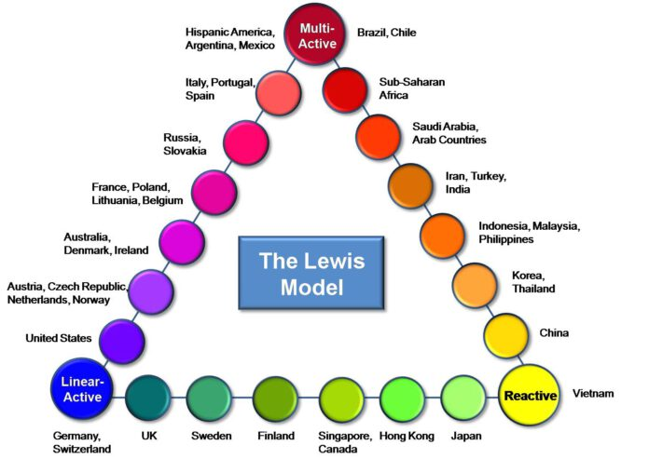
Figure 3 The Lewis Model: How to Understand Every Culture In The World
Source: (Gerlach, 2015, Page1)
1. The first group is called Linear actives, which includes countries such as Germany, Switzerland, and the U.S. These people focus on planning, organising, and pursuing one task at a time. They are a natural planner who prioritises structure, and efficiency and value established regulations for guidance and goal achievement.
2. The second group is multi-actives, consisting of lively and talkative cultures such as Italy, Latin America, and Arab countries. They prefer doing multiple things at once and prioritise their tasks based on their relative importance or thrill. This group classifies environments that encourage connections, relationships, conversations, and expression of emotions.
3. The third group is Reactive, which comprises cultures that value respect and courtesy. They listen carefully and calmly and respond thoughtfully. They respond to situations rather than taking the lead, especially conflict management, they carefully consider different perspectives before forming their decisions. This group includes countries such as Vietnam, Japan, China, and Korea. (Gerlach, 2015).
Each category outlines different behaviours according to the situation. This model helps to make strong connections with people from diverse cultural backgrounds, acknowledge cross-culture competence and identify business opportunities. In the workplace or business agreements, it is important to consider individuals' cultural differences in thinking and behaviour to set appropriate expectations. As globalization continues to grow, more and more people around the world are experiencing immersion in other cultures. This trend is expected to continue in the coming decades. However, those who relocate to a new country as expatriates face the challenge of adapting to a new culture, lifestyle, and standards.

Cultural Backgrounds of The UK and UAE
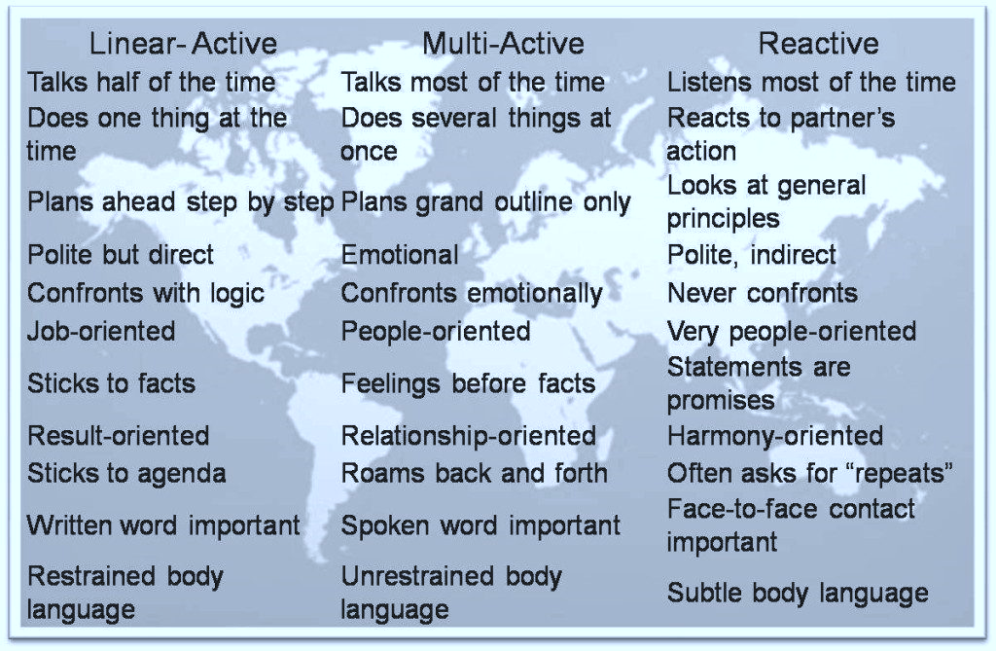
Figure 4 The Lewis Model: How to Understand Every Culture in The World
source: (Gerlach, 2015, Page 1)
To analyse how cultural differences impact communication and conflict management between the UAE and the UK, this report examines their acquisition and considers actions that can be taken to ensure success by utilising The Lewis Model.
According to the Lewis Pyramid, the UAE is categorised as a multi-active culture where people-oriented individuals with strong relationships talk more and do more jobs at a time, give importance to feelings and emotions, and understand body language.
In recent years, the UAE has become a popular destination for expatriates from around the globe, with the expat population dominating the country. The UAE's diverse nationalities and many expatriates make it an interesting cultural experience to study. The United Arab Emirates is a rich multi-culture that interacts with each other to promote mutual understanding. Due to its openness to the world and the diverse nationalities residing within its borders, the culture of the UAE is continuously evolving and changing (Gaweesh, and Al Haid, 2018). The UAE people are Muslims, and they have very unique and traditional dress styles. Men wear long white shirts with headdresses called ghutra and Women should dress smartly and modestly ensuring that their arms are covered regardless of temperature.

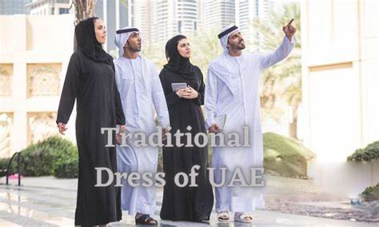
Figure 5 Traditional Dress of UAE For Female & Male, Funding
Source: (Erlandson, 2022)

Cultural changes can be challenging for people in the UAE because of the diversity of people from different ethnicities and cultures, many people in the country have multiple identities. Multiculturalism is a shared and lived experience in the UAE, where being different is considered normal rather than a political ideology. The UAE is rapidly advancing with inputs from all over the world, which could put pressure on local customs and traditions. However, the local people seem to be able to maintain their traditions despite the changes and pressures they face.
Regarding the Power Distance Index in UAE, their culture has a high degree of hierarchy. This is reflected in inherent inequalities, centralisation, an autocratic leadership style, and subordinates' expectation to be told and ordered (Gaweesh, and Al Haid, 2018).
On the other hand, the UK is considered a linear-active culture where people talk less and focus on one task at a time. This group is job-oriented individuals who are polite but strict with routine and schedule. Stick to facts, restrained body language, and prefer written word documents.
A brief overview cannot fully describe England's profound influence on British and global culture. Historically, England was a relatively homogenous country with coherent traditions. However, as the British Empire expanded and people from diverse backgrounds and cultures began to settle in England, the country's culture was enriched with contributions from Afro-Caribbeans, Asians, Muslims, and other immigrant groups. While other parts of the United Kingdom have also undergone similar social and cultural diversification, England remains a powerful cultural force, impacting the world in many ways. English music, film, and literature are widely appreciated globally, and the English language has become the preferred medium for cultural and economic exchange (England - Culture, Traditions, Heritage | Britannica, no date).
When a company merges or acquires another company, it can have a significant impact on the organisation's departments, management, and employees, especially if it occurs in a different country. As previously mentioned in the report, culture can greatly influence a company's operations. Upon comparing the cultural backgrounds of the UK and the UAE, significant differences were discovered between their cultures which impacts the acquisition process and adopting this change. Communication and negotiation are highly impacted sections of the operation because countries have their communication and response styles, leading to conflict between employees.
For instance, in a famous talk show regarding business advice one of the business speakers, Erin Meyer describes how cultural differences can affect business communication and approaches. She added that during her visit to Japan, she presented a business project and then she asked, “Any question?” but no one responded, and she thought there were no questions. In Japan, the way of asking questions is different from that of Western countries. Unlike in the West, people in Japan do not make direct eye contact when they have a question. Instead, their eyes look bright, and they give a direct look to the person they are addressing, which indicates that they have a question to ask (YouTube, 2014). This is an example of non-verbal communication in which individuals express their feelings through their body language as the people in Japan express their feelings through direct eye contact.
Therefore, it is very important to gather cultural knowledge of countries that the company want to do business agreement because their communication and negotiation styles are different in managing conflict issues as The Lewis Model explains.

The UK and UAE Communication Style

The UAE Communication Style   | The UK Communication Style  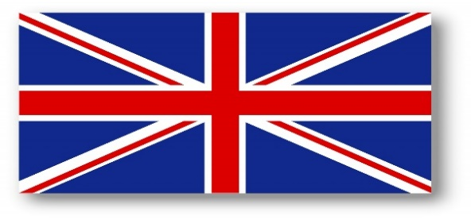
- Indirect and small talk  - Business is conducted on a trust basis  - Interest in knowing personality and family  - Respect for the staff in higher positions  - A good few restaurants meeting before confident in a business transaction  - Personal space mainly eye contact with same sex  - Gift-giving is very common and acceptable  - Religious restrictions, for example, avoiding alcohol, inappropriate dressing, discussing religion and cuddling in public are prohibited.  (Commisceo Global, 2015) | - British people value clarity and politeness in communication.  - Keep a balance between straightforward and politeness  - Professional relationship is highly recommended  - It values a hierarchical decision-making process  - Work-life balance  - Eye contact during conversation  - Formality and diplomacy are in demand  - Punctuality and good negotiation are best  - Too loud can be impolite  - Value and respect diversity  (A Guide to UK Business Culture: What You Need to Know, 2023)

The table above shows the different approaches to communication between the UAE and the UK which may lead to challenges and conflicts for both companies to face. Referring to The Lewis Model multi-active communicators value flexibility, connection, and context, while linear active communicators prioritise clarity, efficiency, and planning with facts. This can lead to challenges due to their different preferences and values. The UK's linear active communicators may find UAE communicators impulsive and rude, while UAE communicators may enjoy more creativity, emotions, and spontaneity. However, this could be due to UK communicators' preference for planning, manners, and concentration on specific activities.
British culture is renowned for being methodical, driven, and task-focused, with a strong emphasis on organisation. Individuals in this culture typically prefer to tackle tasks and action items one at a time systematically and rationally, often communicating directly and straightforwardly with limited body language.
In terms of managing conflicts, the UK organisational approach tends to take a logical and step-by-step process, prioritising facts, and adherence to rules. Their ultimate goal is to find efficient and effective solutions.
On the other hand, UAE is multi-active, they are emotional and expressive, and place great importance on family, relationships, and people. They often use gestures and body language in communication and prioritise relationships over tasks. They seek emotional connections and may address conflict with personal interaction because flexibility and adaptability are their key qualities.
Understanding the behavioural differences between linear and multi-active cultures is essential to effectively manage conflicts. Successful conflict resolution can be achieved through effective communication, flexibility, and cultural sensitivity.

Implementation of Change Management Models
The preceding section of the report highlights the significant impact of cultural differences on business processes, which poses a challenge to achieving success. The Lewis Model provides insight into the three types of cultures and their unique approaches to overcoming obstacles and adapting to change. Throughout the merger and acquisition process, both companies encountered difficult phases and had to devise effective strategies to resolve the outcomes.

One of the most effective strategies in the context of acquisitions is change management. It plays a critical role in ensuring a smooth transition and maximising the benefits of the merger. The start of change is building a strong foundation with a small team. Then, it enables the change to spread throughout the broader organisation. Involve the top leadership team in shaping the change and co-create the foundation by aligning leaders behind the vision and strategies.
Managing change is crucial for an organisation to survive and succeed in a highly competitive and continuously evolving business environment. There are several primary theories exist to provide strategies for effective change management. This report aims to conduct and evaluate cultural solutions for conflict management using Lewin's change management model.

1. Lewins Change Management Model
Successful implementation of change requires a combination of decisions that focus on both the hard and soft aspects. The hard areas comprise project planning, software implementation, and installation of new computer networks. On the other hand, the soft side involves decisions and actions aimed at helping employees embrace new methodologies, technologies, and ways of working. Kurt Lewin proposed a 3 step-change management model in the 1940s, he linked these stages to a melting cube of ice and refreezing into a new shape. The three stages are Unfreeze, Change and Refreeze (Cummings et al.,2016).
To achieve the desired synergies UK and UAE companies that have merged need to undergo some changes. Since employees are the backbone of any organisation and enable them to achieve their objectives, it is crucial to manage them effectively during times of change. Mergers and acquisitions can be intimidating for some employees and can cause significant anxiety and stress, and this can lead to conflicts between employees and management. These changes include environmental and organisational changes.
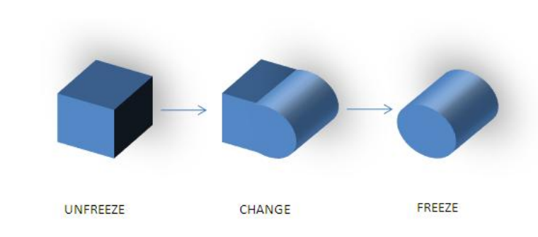
Figure 6 VersaCold: analysis of change management in mergers & acquisitions
Source: (Eslami, 2011, Page 24)

This report outlines a recent business agreement between a UK-based company and a company in the United Arab Emirates (UAE). Specifically, UAE's Al Hilal Energy Power has acquired UK-based Universal Elect Plc, leading to some changes within the organisation. However, conflicts have arisen between employees due to differences in the ways that operations are traditionally conducted in the UK and UAE. This means the UK company will hold their British policies in their workplace. To minimise these conflicts and facilitate a smooth transition, the three stages of the Lewin Model will be used to help employees adapt to the changes.
1.1 The initial phase of the transformation, known as "unfreeze," aims to alter the existing circumstances. The reasons for change must be explained to all affected employees in order to accomplish this. A valid and understandable reason will strengthen the driving force and minimize resistance to maintaining existing circumstances. To increase the driving force, it is important to create a desirable vision and goal. Effective management is essential for enacting new regulations and minimizing stress and ambiguity.
1.2 Lewin's second stage of his model deals with the process of change, instead of viewing it as a one-time event. This modification entails altering the thoughts, emotions, and conduct of employees as they transition from conventional methods to novel ones. It is essential to support employees during this stage in order to reduce their resistance. Support can be provided in numerous forms, including the provision of training and coaching to equip employees for novel procedures. As both sides become trained and comfortable with the new methods, restraining forces will be diminished. It is imperative to comprehend that a significant portion of the impediments stem from the employees' apprehension regarding the possibility of making errors during the process of acquiring new skills. The cultivation of a tolerance for errors and the provision of assistance to employees during the learning curve can aid in reducing this constraining factor. Another factor contributing to this stage is the use of role models, who can provide aspiration for change and demonstrate the benefits of the change to another employee (Eslami, 2011).

1.3 The third stage in Lewin's change model is called "freezing". It aims to stabilise the post-change processes and solidify new attitudes and behaviours. These new processes, attitudes, and behaviours become the new norms that employees accept. This creates a new balancing state where the driving forces and restraining forces are balanced. This stage of Lewin's model is criticised for its applicability to the modern environment, where companies need to undergo more frequent changes compared to the 1940s. Recent change management programs have modified this step to address this concern. They recognise the need to strengthen the newly developed processes while also allowing for flexibility to respond to future changes (Eslami,2011).
The freeze stage requires monitoring and tracking the new management to evaluate the effectiveness and achievement of new changes and prevent further conflicts.
The other important thing is that companies have different organisational cultures that suit their business.

The other important section in a business agreement to be considered is the organisational culture because companies have different organisational cultures to operate their business by having sets of values, rules, beliefs, systems, and behaviours.
Organisations utilise four types of cultures Clan, Market, Adhocracy and Hierarchy to fit their business. Although these types are different one is not better than the other, it has cons and pros, so most organisations change it to any depending on their project requirements.

The UAE and UK companies have a hierarchical organisational culture and during the acquisition and business agreement, the leaders and HRM do not face more challenges to overcome the differences.

Source:(Boogaard, 2020, Page 2)

The UAE and UK companies have a hierarchical organisational culture and during the acquisition and business agreement, the leaders and HRM do not face more challenges to overcome the differences. However, some policies might be different according to their country's cultures.

Ethnocentric and Polycentric Models in People Management

The report highlights the importance of employees in a company's performance and productivity. Therefore, recruitment procedures are crucial in selecting capable individuals to achieve successful goals. As the acquisition is an international business agreement between companies from the UK and UAE, it involves International Human Resource Management (IHRM) to manage people by implementing Ethnocentric and Polycentric models to overcome challenges.
Cultural backgrounds can significantly impact businesses, especially in the case of acquisitions between different countries. International Human Resource Management (IHRM) faces various challenges while trying to make the acquisition process successful. HRM becomes even more complex in international business, for example, an agreement between a UAE company and a UK company could face cultural differences, language barriers, time zone differences, employee retention and morale, reward and recognition differences, work-life balance, change management, employee engagement, and other factors.
The report focuses on two models from EPRG approaches, the Ethnocentric and Polycentric, that offer solutions for staffing, expatriate procurement, compensation, training, and development challenges in International Human Resource Management (IHRM) to ensure the right individuals are in the right roles.
A polycentric staffing policy involves the selection of host-country nationals to manage subsidiaries while the parent company focuses on key positions at the corporate headquarters.
One advantage of this policy is that it helps to minimise cultural differences. Additionally, it is less expensive in terms of the cost of value creation. However, host-country managers may have limited opportunities to gain experience in foreign countries and may not be eligible for senior positions in their subsidiaries. Language barriers and national loyalties can also isolate corporate headquarters staff from foreign subsidiaries. The other disadvantage is the lack of connection between the parent and subsidiary, and it minimises the cultural knowledge of employees from both host and parent countries (Chitakornkijsil, 2010).
The ethnocentric staffing policy imposes filling all crucial management roles with individuals from the parent country. There are several reasons why companies implement this policy. Firstly, many enterprises feel that less developed countries lack qualified candidates for senior management positions. Secondly, companies view an ethnocentric staffing policy as the optimal approach to preserving their corporate culture. Thirdly, to create value by transferring core competencies to a foreign operation, it is believed that the best way to achieve this is by transferring parent-country nationals who possess knowledge of that competency to the foreign operation.
However, an ethnocentric staffing policy may limit advancement opportunities for host-nation nationals. Furthermore, expatriate managers are paid more than home country nationals. An ethnocentric policy can lead to the company’s failure to understand host-country cultural differences, which could result in negative outcomes (Chitakornkijsil, 2010).
Companies can choose from different approaches depending on their business requirements. The two main focused approaches in this section are polycentric and ethnocentric. In the case of the UAE acquisition of the UK company, the preferred approach is polycentric. This approach focuses on local talent, allowing subsidiaries to better understand the local needs and operate effectively within the specific community. The UAE has a policy of hiring a majority of its staff from the host country (Alrawi,2008).
This approach offers several advantages, such as a reduced adjustment period. By hiring local team members, the need for adjusting to a new culture and language is minimised, and local hires are often able to contribute immediately. Additionally, recruiting locally can save costs associated with international hiring and relocation, as it avoids expenses related to moving team members from the parent company's location.
United Arab Emirates acquires a business in the United Kingdom, by implementing a polycentric approach can lead to better integration with the local workforce and a better understanding of UK market dynamics. The UAE's dynamic business environment presents an excellent opportunity for tech-enabled solutions and compliance support in the acquired UK company. To sum up, the polycentric approach promotes localisation and cooperation with local talent, which contributes to the success of cross-border acquisitions (Alrawi, 2008).
Both the ethnocentric and polycentric approaches to human resource management have their advantages and disadvantages. Companies choose which approach to use in their host countries based on the cultural norms and values of those countries, to achieve greater success and sustainability for their business.
Ethnocentric Orientation sees the home market as superior and Polycentric Orientation views each country as unique with differences associated with each new country. As the report highlights, ethnocentric and polycentric approaches help companies hire capable employees for their emerging business.
Another framework that enables organisations to adapt strategies for employee support is the Star model. The Galbraith Star Model, developed by Jay Galbraith in the 1960s, serves as a foundational framework for analysing organisations and making design decisions. This model helps companies shape their organisational structure and policies to influence employee behaviour effectively (Galbraith,2011).
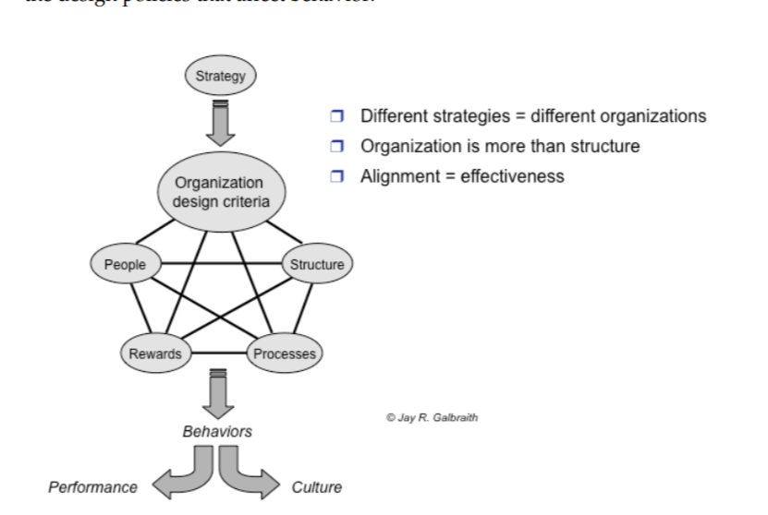
Figure 7 The Star Model
Source: (Galbraith, 2011, Page 5)
This model is used in organisations to provide valuable insights during merger and acquisition transactions. It has five steps strategy, structure, process, reward, and people. The report employs this model to oversee employees, with a particular emphasis on promoting rewards and fostering people-oriented initiatives. As previously mentioned, the M&A change has a significant impact on employees, resulting in the requirement for additional assistance and additional time to successfully navigate the change. The Star model provides a framework for effectively managing employees and providing emotional support to them.
The rewards component focuses on motivating employees during and after the merger and acquisition. Considering important aspects, for instance, retention and bonuses are designed to encourage key employees to stay. Equity-based compensation aligns employee interests with shareholder value. During the recruitment procedure recognition programs acknowledge contributions made during the integration and it provides motivation and incentives for desired behaviours.
In the people step the framework provides strategies for the selection and development of the right individuals, aligned with other policies, to maximise organisational efficiency. This area governs human resource policies for recruiting, selection, and retention. It combines the appropriate combinations to produce the talent required by the strategy and more flexible organisations require flexible employees (Galbraith,2011).
The cross-functional teams require people who are generalists and who can work with cross-functional teams. They must cooperate. Conflict and influence without authority can result in conflict and influence without authority. This step develops people and organisational capabilities while also developing people and organisational capabilities.

The Interview Analysis on The Validity of The Lewis Model

The Lewis model categorises cultures worldwide into three sections, linear active, muti active and reactive cultures as presented in the first part of this portfolio. To validate this model, I interviewed someone in my class from different cultures to compare the significant similarities and differences and align the findings of this interview with the Lewis model analysis.
I am from Afghanistan and according to the Lewis model framework it fits into the multi-active culture. The person I interviewed is from Canada and according to the Lewis model, it comes under linear active culture.
In this section, I compare Canada and Afghanistan using the Lewis Model, to categorise behaviours based on cultural traits.

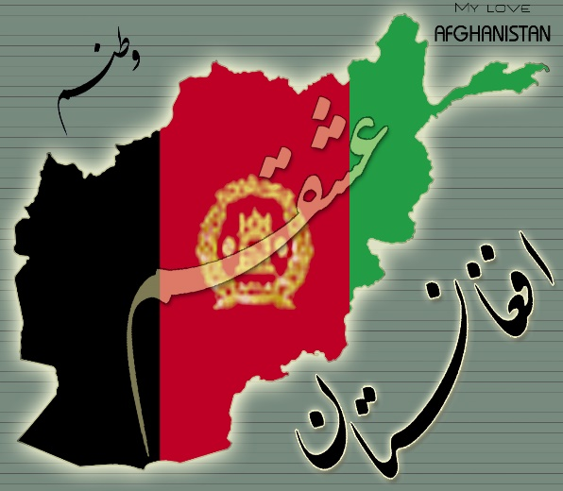 VS 

Canada is a very diverse country, and it welcomes people from around the world however, Afghanistan is a multiethnic and tribal society, and the population consists of different ethnic groups mainly Pashtun, Tajik, Hazara and Uzbek.
To compare the work settings and life balance between Canada and Afghanistan in the current world and situations, referring to the person I interviewed it explains that Canada has a diverse work environment, ranging from corporate offices and work-from-home availability. Workplaces emphasise e professionalism, punctuality, and collaboration. The rights of labourers are protected including their wages, health, and safety and their working hours and vacation time to balance work with life. They have the flexibility to choose options for work which increases employment opportunities.
While my country faces unique challenges due to ongoing conflict and instability. There is a wide range of work environments, from formal offices to family businesses and unofficial marketplaces. Traditional values, which emphasise deference to superiors and hierarchy, have an impact on workplace behaviours. This means that people in high positions have more power and take advantage of it, while those in lower positions must develop additional connections rather than relying solely on their skills to progress in their fields.
Financial difficulties and worries about safety frequently cause the work-life balance to be disturbed. Work that prioritises survival and long work hours takes precedence over leisure time.
Other distinctions that distinguish both countries are the economic conditions and lifestyles that influence their employment and business agreements. Canada has a strong economy, and the unemployment rate is very low compared to Afghanistan, which is struggling to provide basic needs and live a comfortable life.
Norms, values, and historical context significantly impact how authority is perceived in these two countries. Understanding cultural cues is crucial for successful cross-cultural interactions. The emphasis on equal rights and personal freedom allows Canadians to question authority but Afghans must respect authority figures as their representative, and they prefer collectivism. Canadians respect their elders based on their wisdom, but Afghanistan has a strong hierarchal structure that indicates that the tribal leaders and family elders have authority.
In summary of key points, it is stated that Canadians tend to be punctual and organised, and value efficiency. They follow schedules, prioritise tasks, and focus on achieving goals. Afghan culture emphasises relationships, flexibility, and adaptability. Time is often more fluid, and personal connections take precedence over strict adherence to schedules.
Canadians value interpersonal relationships and are comfortable with multitasking. They engage in lively conversations and express emotions openly. Afghans are highly social, and expressive, and prioritise face-to-face interactions. They often engage in animated discussions and build strong personal connections.
Canadians tend to be reserved, and polite and avoid confrontation. They listen carefully and respond thoughtfully. Afghans are sensitive to social cues, respect authority, and maintain harmony within their communities. They value tradition and hierarchy.

After comparing the cultural backgrounds of Canada and Afghanistan, I analysed them to determine that the norms, values, customs, religion, and beliefs of both countries differ in terms of their origins and lifestyles. Their thinking and behaviour depend on the country's conditions. Ways of treating their family, their colleagues, and their government show their values and norms. The comparison outlines that people around the world live and express themselves differently which portrays their cultures.
Referring back to Lewis's model, Richard Lewis travelled to over 130 countries and explored the diversity of people and cultures across the globe. He classified them into three distinct categories, namely linear active, multi-active, and reactive, to identify their differences and similarities. This helps countries and people understand other cultures, enabling them to adapt to changes and find opportunities.
To achieve successful outcomes for international business agreements, organisations must refer to the Lewis model because cross-cultural knowledge and interactions help to develop relationships, communication, empathy, and understanding of different opinions. It aids individuals in negotiating and regulating tolerance and cooperation in business interactions.
Lewis model is the best structure and analysis to consider during negotiation for successful outcomes and prevent failure.

Recommendations and conclusion

The process of starting a business is always an exciting and risky journey, and expanding it internationally adds to the challenges. The application of intelligent strategies by effective leadership and management can enable them to overcome these obstacles. Leadership is very important because their decisions can announce success or failure. this report concluded that countries have different cultures, and this has a huge impact on international businesses. The process of communication, negotiation, feedback, and conflict management are different in each country which creates challenges for business agreements. During the cross-culture merger and acquisitions transactions international human resources management faces cultural challenges. The Lewis model categorises people worldwide into three sections according to their cultural background linear active, multi-active and reactive cultures. This model helps to identify specific approaches to people of each category according to their cultural backgrounds.
The report analyses that to achieve success, international businesses must adopt change management theories such as Lewin's model for successful outcomes and avoid failure. Employees are the backbone of an organisation and mergers and acquisitions agreements have an impact on their emotions and performances. Therefore, it is essential to offer effective support through this transition. The ethnocentric and polycentric approaches explain recruitment and staffing procedures considering their advantages and disadvantages and how each approach has different perspectives.
In addition to cultural differences between countries, organisational cultures also create issues and challenges that businesses must consider before any agreement. It is important to understand that in businesses customers and team members differ across different parts of the world and it is imperative to acknowledge and uphold cultural differences, customs, and regional modes of operation. It is recommended to build a team with diverse members to bring different perspectives and foster collaboration across borders.
In summary, successful M&A integration requires proactive change management, cultural sensitivity, and strategic alignment. By recognising the value of change management, organisations can navigate M&A challenges effectively and emerge stronger on the other side flexibility, adaptability, and a willingness to learn from diverse experiences are required for successful international business.

References
‌
- A Guide to UK Business Culture: What You Need to Know (2023) www.linkedin.com. Available at: https://www.linkedin.com/pulse/guide-uk-business-culture-what-you-need-know-yash-dubal.
- Alrawi, K., (2008). International dimensions of Human Resource Management: gaining a competitive advantage: a review. International Journal of Trade and Global Markets, 1(3), pp.306-318.
- Boogaard, K. (2020) The 4 types of corporate culture, explained, Work Life by Atlassian. Available at: https://www.atlassian.com/blog/teamwork/types-of-corporate-culture.
- Bruner, R.F. and Perella, J.R (2004). Applied mergers and acquisitions (Vol. 173). John Wiley & Sons.
- Chitakornkijsil, P., (2010). The Internationalization of Human Resource Management in The Host Nation Context & Strategic Approach of IHRM. International Journal of Organizational Innovation, 3(2).
- Commisceo Global (2015) UAE - Language, Culture, Customs & Etiquette, Commisceo-global.com. Available at: https://www.commisceo-global.com/resources/country-guides/uae-guide.
- Community Toolbox (2017) Chapter 27. Cultural Competence in a Multicultural World | Section 1. Understanding Culture and Diversity in Building Communities | Main Section | Community Toolbox, Ku.edu. Available at: https://ctb.ku.edu/en/table-of-contents/culture/cultural-competence/culture-and-diversity/main.
- ‌Cross Culture (2015) The Lewis Model – Dimensions of Behaviour | Cross Culture, Crossculture.com. Available at: https://www.crossculture.com/the-lewis-model-dimensions-of-behaviour/.
- Cummings, S., Bridgman, T. and Brown, K.G., (2016). Unfreezing change as three steps: Rethinking Kurt Lewin’s legacy for change management. Human relations, 69(1), pp.33-60.
- England - Culture, Traditions, Heritage | Britannica (no date) www.britannica.com. Available at: https://www.britannica.com/place/England/Cultural-life#Cultural%20life (Accessed: 28 February 2024).
- Erlandson, P.R. (2022) Traditional Dress of UAE For Female & Male, Funding. Available at: https://fundining.ae/traditional-dress-of-uae/ (Accessed: 28 February 2024).
- Eslami, S. (2002) VersaCold: Analysis of Change Management in Mergers & Acquisitions PROJECT SUBMITTED IN PARTIAL FULFILLMENT OF THE REQUIREMENTS FOR THE DEGREE OF, Bachelor of Science (B.Sc.). Available at: https://core.ac.uk/download/pdf/56377159.pdf (Accessed: 19 March 2024).
- Gaweesh, K. and Al Haid, A., (2018). The image of United Arab Emirates culture among the non-Arab expatriates in the UAE. pp.1-41.
- ‌Gerlach, M. (2015) The Lewis Model: How to Understand Every Culture in The World | Society 3.0. Available at: https://society30.com/lewis-model-understand-every-culture-world/.
- Gollin, D., (2014). The Lewis model: A 60-year retrospective. Journal of Economic Perspectives, 28(3), pp.71-88.
- Hofstede (2023) Country Comparison Tool, Hofstede Insights. Available at: https://www.hofstede-insights.com/country-comparison-tool.
- Terranova, C., (2007). Assessing culture during an acquisition. Organization Development Journal, 25(2), p.43.
- Warrier, R., (2021) ‘EWEC calls EOIs for M2 reverse osmosis IWP in Abu Dhabi - Construction Week Online’, 15 February. Available at: https://www.constructionweekonline.com/projects-tenders/270676-ewec-calls-eois-for-m2-reverse-osmosis-iwp-in-abu-dhabi (Accessed: 6 March 2024).
- -YouTube (2014) www.youtube.com. Available at: https://youtu.be/zQvqDvbEg?si=fGZsRMTQVy99zUCo (Accessed: 29 February 2024).
- Galbraith, J.R., (2011). The star model. The STAR Model.
- Al Masaood Energy | Who We Are (no date) www.almasaoodenergy.me. Available at: https://www.almasaoodenergy.me/who-we-are/ (Accessed: 20 March 2024).
- ‌

Appendix

Interview from Different Cultures to Validate
The Lewis Model

- Can you describe your cultural background?
Canada is the second largest country in the world. We speak primarily English, but French is also considered an official language. We are a very diverse nation because we welcome people from different countries and cultures. My country is beautiful, we have beautiful lakes and nature. However, the weather is a bit boring in winter because of heavy snow and degree falls below -15 but summer is my favourite for exploring nature parks and enjoying swimming.
- Can you describe how your cultural background shapes your perspective on work and business settings

Canada is often perceived as being a welcoming and diverse country for entrepreneurs. However, in reality, the Canadian work culture is very practical and time-oriented, which means that people have short meetings and expect prompt responses. Regardless of your role, whether a manager or supervisor, you are expected to take care of things yourself, making it challenging to balance work and personal life. Interestingly, in Canada, we don't typically ask for personal information on business or work documents because we are a trustworthy society. Instead, we sign on behalf of the company, which works well, with some exceptions
3. In your experience, what factors do you believe contribute to successful cross-culture communication in a business environment?
I think maintaining the etiquette of communication is important to successfully engage with cross-culture. Because it shows you respect their values. Patiently listen first and respond in a simple but professional way.

- In your work experience can you explain how cultural differences impact negotiation style and outcomes in business settings?
"My experience of working with colleagues from various cultural backgrounds has taught me that it can have a significant impact on business outcomes. Differences in communication styles, decision-making processes, and business interactions can often lead to conflicts and stress. One of the most challenging differences that can impact negotiations is the language barrier. With over 200 languages spoken across the world, it is impossible to learn and communicate in every language."
5. Can you share an example of cultural misunderstanding or Miscommunication that you have experienced?
" During a work visit to Japan, I had an amusing experience at a sushi restaurant. Being used to the practice of tipping in Canada, I left a tip for the waiter after finishing my meal. However, I was unaware that tipping is considered impolite in Japan, as it is interpreted as an insult to their service. In Japanese culture, tipping is seen as a way of rating their service instead of simply acknowledging and thanking them for it.
6. Have you had a colleague from [ China, Thailand, or Korea] if yes from your perspective, what are the key similarities and differences between you and your colleague in the workplace?
“Yes, in my workplace, I got to know a Korean colleague and realized that they also place a high value on building close relationships, sharing common values, and offering mutual support. They try to avoid conflict as much as possible, but surprisingly, they encourage different ideas. However, in Canada, saying "No" had to be explained. Another difference I noticed was that in Canada, we show equal respect to everyone, whereas in Korea, respecting elders is important and shown through body language such as bowing.”
7. How do you navigate or behave when working with colleagues from diverse cultural backgrounds in situations like problem-solving, taking a risk or teamwork task?
It's a good question,
"I strongly believe in the value of inclusiveness, which requires us to understand the diverse backgrounds, norms, customs, and beliefs of others. This knowledge helps us to respect personal space and choose appropriate verbal or nonverbal communication when interacting with people from different cultures. It is important to create an environment that fosters innovation and encourages taking risks, while also recognising the unique opportunities that different perspectives can bring. Inclusiveness also means involving everyone in the decision-making process, so that decisions are made with consideration of diverse cultural perspectives."

8. In your opinion, how significant are cultural differences in determining the success or failure of international business ventures?
In my opinion, the outcome of business agreements is greatly influenced by several factors that must align with the expectations of both parties. Diverse reasons such as differences in norms, beliefs, communication styles, organisational culture, and environmental cultures can create misunderstandings that affect the results of the agreement. Therefore, it is important to consider these key elements to obtain favourable outcomes in any business agreement.

9. How do you think cultural values and norms impact perceptions of authority in different cultures?
Well, the way people perceive authority figures can vary depending on the cultural values of an organisation or country. In Canada, for instance, police officers are generally given polite deference, but Canadian law also gives people the right to question or disobey authorities with valid reasons. Some cultures favour direct communication with authority figures, while others prefer indirect approaches due to respect or high-power distance.

Thank you very much for your precious time

