Daniel Grasu (1805703)
UWTSD
3/6/2020

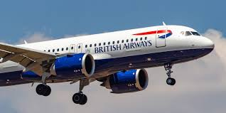
Managing Culture at British Airways

Executive Summary

This assessment will high light the British Airways culture and its evolution in time. In the same time the author will analyze what culture model British Airways had used so far and how and why they have changed their culture.
In the second part, author will analyze British Airways employee skills, knowledge and behavior from begging of the company to present and what changes have been done regarding this do the internal and external factors.

Contents Page

Executive Summary 1
Contents Page 2
1. Introduction 3
2. Findings 4
2.1. British Airways Culture 4
2.2. Employee Skills, Knowledge and Behavior 6
3. Conclusion 10
4. Recommendations 11
5. Appendices 12
6. Reference List 15

1. Introduction

On 6th of March 2020, Module Tutor of Workplace Culture and its Impact on Organisational Efficiency from University of Welsh Trinity Saint David, Mrs. Julie Thomas, had asked Mr. Daniel Grasu to do a report regarding workplace culture and context of one organisation.
The author, Mr. Daniel Grasu, on this report, will conduct a research regarding British Airways Culture to see if employee or management behaviour matches with their rhetoric. In the same time, the author will conduct an analyse regarding employees’ skills, knowledge and behaviour with reference to the organisation’s values.
The author will consult a no. of textbooks, journals, websites, books to support his report.
The report will be finished and uploaded on University Turnitin Assignment Submission Links by 3th April 2020.

2. Findings

British Airways PLC was formed in April 1974 by fusion of British Overseas Airways Corporation (BOAC) with British European Airways (BEA) and their associated companies. (British Airways PLC | History & Facts, 2019)
British Airways has made big investments in Australian airline Qantas and national French carrier TAT during the past few years and purchased DanAir after it fell into financial troubles. (Stanley-Price, 2019)
In 2006, British Airways had implemented online-learning programs, who's teaching cabin crew how to use a new in-flight sales system. According to Wendy Stubbs, British Airways e-learning manager from that time, to insure that British Airways cabin crews were qualified to use this programme as soon as it was rolled out, they needed to create specific learning materials in tandem with the implementation of the Barplus framework. Barplus project it was an on-board point-of-sale system operated via personal digital assistants. (Little, 2006)
In the present, British Airways had fusion with Iberia, bringing to live a new International Airlines Group (IAG). In 2019, British Airways had celebrated 100 years of flying. British Airways carry the Olympic flame on board an Airbus A319 specially named Firefly and sponsor the Olympics and Paralympics. (Explore our past | History & Heritage, 2020)
British Airways seems to be the biggest airline in the United Kingdom operating internal and external air services for passengers and cargo having the headquarter in Waterside, and their major hubs are in London Heathrow and Gatwick International Airports.

2.1. British Airways Culture

According to Hofstede Culture is the collective programming of the mind that distinguishes the members of one group or category of people from another. Culture include invisible and visible components (see appendices 1). Cultural adaptation is the systemic adjustment of the evidence-based therapy (EBT) or therapeutic procedure to understand language, history and context in such a way as to be consistent with the cultural norms, concepts and values of the individual. (Smith, Rodríguez and Bernal, 2011)
According to the author, in the present are known a few models of culture as:
- Charles Handy culture model - The way culture is perceived prompted researchers to use it to connect organisational structure to culture. Handy described four specific forms of cultures as Power Culture, Role Culture, Task Culture and Person Culture (see appendices 2). (Handy, 1990)
- Edgar Schein culture model - Schein’s model looks at culture from the standpoint of the observer and describes culture at 3 levels: Artefacts, Espoused values, Basic underlying assumptions (see appendices 3). (Edgar, 2010)
- Deal and Kennedy culture model - Deal and Kennedy's cultural concept is focused around characterising various four organisational styles, depending on how easily they obtain input and compensation for achieving things and the amount of danger they face (see appendices 4). (Zabel and Avery, 1992)

Cultural experience in British Airways includes how specifically they organise themselves, their values, laws and procedures. Cultural procedure in British Airways are based around a ladder structure, while knowledge is passed down from the council of directors to the exec managers rather than to the different departments to bring into action any boss supervising all operations. They would choose to use both position and mission culture at Uk Airways, two cultures from four of the Charles Handy culture model. (Grugulis and Wilkinson, 2002)
British airways best philosophy is to collaborate with people from all cultures, race, sex, age group, religion and faith to handle them equally without prejudice and they do try to give full service to their customers at all times.
They create a friendly atmosphere for almost all of their customers and have full protection while customers plane their flights. With all clients, health care and protection at British Airways is really critical that they find it their duty to provide everyone or all of their clients a friendly atmosphere and therefore to ensure that they are healthy at all times. (Grugulis and Wilkinson, 2001)
British Airways 'cultural tradition is to carter a wonderful atmosphere in terms of aircraft safety and excellent customer support, thanks to its staff and clients. They guarantee that they have a secure airplane by testing the system frequently before passengers start boarding the plane because they don't want to risk their passenger’s safety. They always guarantee that they provide the top of the line plane and the right equipment to satisfy the customers’ needs during the flight and offer them the greatest servic. (Colling, 1995)
Organizational culture is important to Uk Airways as it allows them to determine their interest, their viewpoint, how workers will behave, their course for the organization and help create tranquilly within the organization. When there is a rise in economic pressure, the corporate structure must improve the company, in order to compete in the market, will amend or create an attempt to modify its community. (Doyle and Stern, 2009)
The Schein model reflects on how to solve challenges, whether internal or external, through exchanging learning. British Airways makes use of cultural norms expectations to build a healthy working atmosphere and set up the path for Uk Airways to operate through territories. Schein's framework focuses on an active corporate atmosphere in which an executive may create a cultural transition, preferably safer inside the business than taking ethnic reform to national level by learning chat. British Airways has a specific learning system which helps professionals pay attention to providing a better work experience for their employees. This will help their interpersonal practices become simpler by utilizing Schein's model on British Airways cultural experience. On second stage, for example, they will claim social values and strong cosmetics.

British Airways Artifacts:
Some of the most visible artefacts of British Airways is their emblem, which has been inspired by the union jack, and is a vague imitation of the pigeon speed symbol. Another artefact for British Airways is their name, English Airways appreciates their logo because they are a sign of this. Her brand's essence is "To Fly. To Help." it is their long-standing slogan which reflects their Coat of Arms and what their customers are assured of. (Coller, Helms Mills and Mills, 2015)

British Airways Value:
British Airways values are they employees because they play a major part in defining the nature of the company. The actions of the employees have a significant influence on British Airways culture. Employee mental state influences the culture at British Airways. British Airways depth perception and vision objective are being the most unique and first preference airline for all air passengers and one direction aims to ensure that their passengers fly with trust that they are always responsible for caring about the environment in which they work. For those British Airways ensures its workforce and passengers that they are safe in the air. They just want British Airways workers and passengers to feel comfortable and secure while they are boarding. (Nigel, Annette and Roger, 2007)

British Airways Assumption
At the highest and most critical point, implicit expectation is where aspects of the British Airways culture are unnoticed and cognitively established by workers in daily practice. Such elements are a part of British Airways culture that always allows the business to be tabulated. British Airways have certain unspoken laws which have acclimatized with time with their attributes. They also use analysis and perform informal interviews with staff, but such characteristics cannot be identified. British Airways ought to realize that society at this stage may be an implicit belief, guiding a part of a vehicle that corporate behavior it’s sometimes overlook. (Bain, 2019)

2.2. Employee Skills, Knowledge and Behavior

British Airways was doing disastrously against almost any measure in the late 1970s and the beginning of the 1980s. An old fleet made unpleasant journeys and provided a major difference to the untimely track record of the airline. (Corke, 1986)
Staff frustration was more than mirrored by consumer disappointment and in 1980 the International Airline Passengers 'Association report placed British Airways at the top of the list of airlines to avoid at all costs. (Blyton and Turnbull, 1998)
By 1996 this image was changed, and British Airways became the most successful company in the world, being voted the company for which most graduates people wish to work. Most of the management literature credits this transformation to British Airways own behavioral shift, which has reshaped workplace perceptions and put customer service at the center of its operations. According to the author, a lot of work and money went into forming the society of British Airways. At the root of this was the management initiative 'Putting People First' introduced by the chief executive of the organization, Colin Marshall, in December 1983. Originally designed for workers direct with the client touch, it was finally followed by all 40,000 workers and aimed at revolutionizing their attitudes. In the context of a direct challenge to the hierarchical and militaristic culture that existed at this time in British Airways, staff have been advised not to attend in uniform and, once during the course, to be part of cross-functional and cross-class groups. The training program it was designed to change employee’s behavior. The participants were encouraged to take a more positive attitude towards themselves, to teach them how to set their objectives and to manage stress, and to instruct them to build trust and to reach their goal on the end.
The way the cabin crew was routed was also changed. Families of staff have been created to work on the same work schedules. They were intended to provide mutual support, make the cabin crew feel happier about their workplace environment and, therefore, encourage the output of emotional work. (Barsoux and Manzoni, 1997).
A new role of 'Passenger Group Coordinator' has been implemented and staff has been trained entirely based on personal qualities. The importance of mental health was also reflected in the new assessment and reward systems in such a way that work was judged on the way in which it was performed and on tougher targets. According to Georgiades and Macdonnell, British Airways had used four main factors of practices between 1984 and1985 (see appendices 5). (Georgiades and Macdonnell, 1998)
After twenty years since PPF was launched, British Airways managers completing a training program remained them to understand themselves and take responsibility.
British Airways has a professional culture where staff must dress up properly and follow strict procedures in any way at all time. In this sense, the employees need to respect some rules as:
- Hair no longer than collar size, clean and clipped back;
- Hairstyles worn must be neat and tidy;
- One pair of earrings in gold;
- No chipped nail polish and need to be either red or very natural pale tones, no blacks, blues, etc.;
- Lipstick must fit with uniform color;
- No exterior badges on clothing or bags (only name badges or suitcases labels);
- Tights only in dark (free from snags) always take spares;
- Shoes polished and simple black for man & girl. Women shoes no higher than several inches wide for the heel;
- Uniform totes and suitcases plain black or navy blue and no stickers;
- Jackets to be worn fastened all the time;
- Gillets to be worn always during the service on board;
- Hats to be worn when walking through the airport and in the public eye;
- Uniform jackets to be worn at the same time (as a staff) i. e. all on or all off, if it is hot weather outside;
- Ties and cravats to be worn always;
- Shirts clean and well ironed, clean white;
- Sleeves never to be rolled up;
- Skirts to sit on the knee no higher;
- Trousers not to be changed e. g. narrowed;
- Name badges to be worn all the time with your wings on your jacket lapel;
- No chewing gum, ever;
- No eating in front of public unless an awful delay or discreetly on board;
- Do not use cell phones whilst walking through the terminal or on board the airplanes;
- No rucksacks or shopping carriers;
- Never use bad dialect or critic the air travel;

According to Barrett, work in an organization whose culture aligns with their personal values, employees can feel liberated. They will be able to bring their full selves to work. They not bring only they energy, creativity, and enthusiasm, they will also bring their commitment to the well‐being of the associates and the success of the organization. Unleashing this energy is tantamount to liberating the corporate soul. (Barrett, 2006)
Recruitment of cabin crews is also heavy, with several applicants attending screening. It ensures additional money for recruiting and on-board operations. This action puts a burden on the current workforce, as they sometimes operate more hours in a month until the new crew is built. But if an airline fails to find enough cabin crew applicants to fill up its pool, when it comes to the onboarding phase it must cut it down perfectly. Failure to keep the paperwork in order ensures that a streamlined onboarding phase will impact the organizational capability of the new team. This sends a negative message to the employees, working to the max. and as other airlines would be hiring, overworked employees may be tempted to go elsewhere. It is a true image of what British Airways saw often when recruiting cabin crew has been left late. The good news is there is time until peak season to get this in order, if airlines act now. (Sprules, 2017)
In 2011, according to Kaveri Niththyananthan, British Airways cabin crew was given a vote on five issues including restoring workplace travel agreements, collective resolution in all cabin crew disciplinary proceedings related to the initial dispute, and hiring and deploying cabin crew at reduced pay rates without the union's consent. The initial conflict, which in 2010 caused 22 days of strikes costing the British Airways more than GBP150 million, was over improvements to cabin crew's working practices on long-haul flights from London's Heathrow Airport. On the strike, British Airways was forced to hire aircraft that came staffed with cabin crew and pilots to help alleviate some of the effects. (Kaveri, 2011)
Indeed, the conventional explanation of British Airways success, following privatization in 1987, was its innovative cultural change programme, Putting People First (PPF), which ostensibly transformed service quality. Cabin crew were intensively trained to manage appearance, attitude and emotions, the aesthetic and emotional dimensions of their work. British Airways HR Director stressed that productivity relied on crew using their hearts participate in what they call emotional labor. (Blyton and Turnbull, 2004)
The impact of reconfigured customer service over time has been to weaken crew loyalties to British Airways. Those who put income above service had hi-jacked British Airways and devalued the integrity of those who delivered it. British Airways no longer offered work tools, resulting in cleanliness, food quality and video equipment reliability worsening. Under straight conditions outstanding customer service was impossible. (Taylor and Moore, 2015)
According to the author, to become a cabin crew for British Airways, 4 steps need to be fallow:
Step 1 - Application Form
The application needs to be done online on British Airways Careers Website. The airline only takes applications submitted through their site. Job description tells exactly what the airline is looking for in applicants. Airline are posting regular open positions for both newbies and seasoned cabin crew.
Step 2 - Email Invitation
All the successfully candidates will receive an email inviting them to the next stage, Assessment Day. Even if a candidate hasn’t made it through, British Airways will still email them to let them know, providing a feedback on where they need to improve for next attempt.
Step 3 – The Assessment Day
The assessment day will include a presentation about the airline and the job, and group exercises, including a discussion and a customer-service based role-play exercise.
After that, will be a functional height and reach test and a form detailing any tattoos or piercings, any upcoming holidays or commitments will be fill out. In this stage, British Airways will check the candidates right to work in the UK to. British Airways selection process is very tough, and only around a quarter of the candidates on the assessment day will be called back for a final interview.
Step 4 –The Interview
This final interview for those on the shortlist will take place on the same day as the assessment day, lasting around 30-40 minutes and containing in-depth questions to find out how suitable they are for the role. Following the interview, whole application and performance will be considered. Candidates won’t be left in suspense too long, they’ll aim to get back in a week with a decision.
Before to start the job, British Airways HR team will do two main checks regarding the background of the successful candidate and a medical check. If the checks are successful, the candidate will be booked on a weeklong safety course. The candidates will get confirmation of the date on they pre-employment training course (this normally lasts around six weeks) and a start date will be given. The successful candidates will be asked to book a uniform fitting, and a security interview. Depend of the situation, a candidate may be asked to complete a functional Math’s and English Assessment. (British Airways Cabin Crew Recruitment Process, 2020)
According to the author, British Airways culture was marked by their employees on indeed with 3.7 stars from 5. They have described British Airways as being a very progressive company and supportive to everyone. Diverse place to work, with lots of opportunities to build on skills and qualities. Transparent company, with clear processes to follow. Great management structure and open-door policy. Employee are encouraged to approach the managers and to provide feedback to improve the business.
Day to day, the cabin-crow role involves the safety and care of their customers to the highest possible standards. Co-workers are always different from week to week as they change crews constantly and so adaptability is important. They meet many different people throughout the year and also, they make many new friends. (Airways, 2020)

As pro, the employees had said:
- Travel and cultural experiences
- Friendly coworkers
- Clean workplace

As Con, the employees had said:
- Daily challenges.
- Unsociable hours
- Away from home too much
- Long hours comprising of shift work with not much sleep in between shifts.

3. Conclusion

Culture is the way to do stuff. In this context culture is the right way to determine people's beliefs and attitudes, and culture who often affects human actions, and human activity, and human perform at work
According to the author, British Airway has a clear structure regarding all responsibilities and cultural work processes of the business. British Airway must create a community that illustrates how each segment functions and how the structure is used to transfer information. It is also really critical that British Airway tells its consumers that they respect them by achieving full consumer loyalty at every period.
The turnaround of the business in a different way with international conventions, interaction with other airlines, condition of the fleet and the network of links between flights lead to enhanced results, which is as critical as the cultural change programmer.
These days, employers may take the line that they want employees to express themselves and grow their potential, but in fact they are only interested in this capacity only to extent the business interest.
British Airways cultural change plan was not an act of mutual trust and shared moral responsibilities between the company's staff and its management, it was and should being interpreted as an additional method of control.
Effective mobilization of staff in key conflicts, such as cabin crew strike from 2009–2011, depends more on the problems existence, no matter how strong, or formal collective agreements are. Minor actions of confrontation, in which control boundaries are protected and staff represented, should be regarded as countless micro-mobilizations that cumulatively constitute a significant tool for more demonstrable collective action when management initiates major change and causes major disputes.

4. Recommendations

Changes in new legislation, competition or the business environment may require a new culture for that author is recommending keeping their culture update.
They might need to adjust the whole set of corporate values and expectations if they want the company to evolve and survive.

5. Appendices

1. Culture
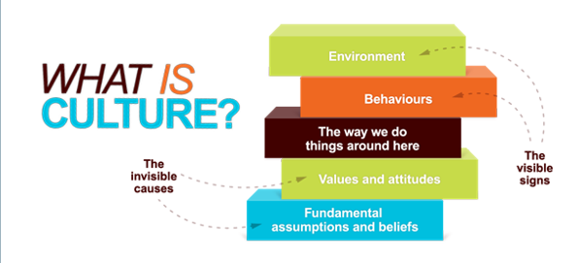

2. Handy’s 4 Classes of Culture
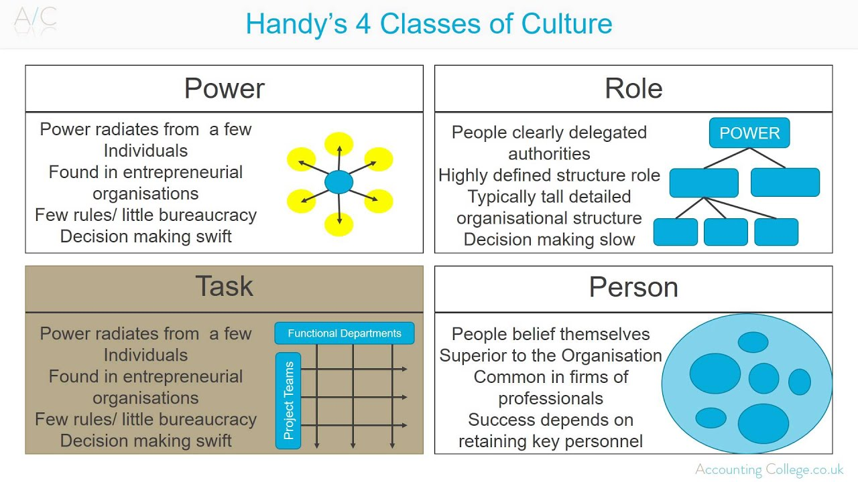

3. Edgar Schein’s Culture Framework

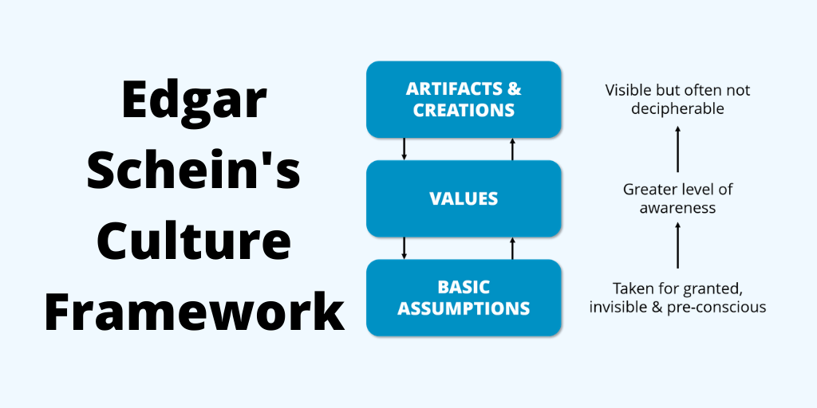

4. Deal and Kennedy's cultural model

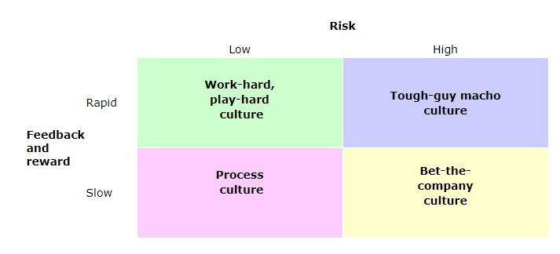
5. The four-factor menu of practices used in British Airways in 1984 – 1985
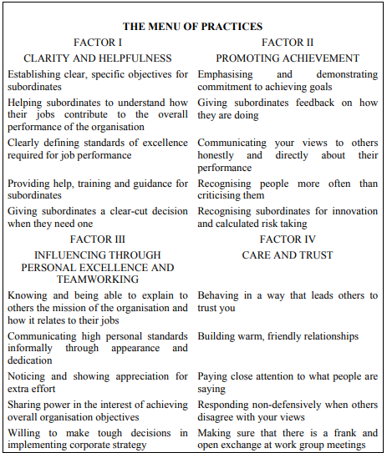

6. Reference List

- Encyclopedia Britannica. 2019. British Airways PLC | History & Facts. [online] Available at: https://www.britannica.com/topic/British-Airways-PLC [Accessed 31 March 2020].

- Stanley-Price, N., 2019. Flying to the Emirates: The end of British Overseas Airways Corporation’s service to Dubai and Sharjah in 1947. The Journal of Transport History, 39(3), pp.333-354.

- Little, B., 2006. British Airways flies high with online learning system. Human Resource Management International Digest, 14(4), pp.20-22.

- Britishairways.com. 2020. Explore Our Past | History & Heritage. [online] Available at: https://www.britishairways.com/en-gb/information/about-ba/history-and-heritage/explore-our-past [Accessed 31 March 2020].

- Smith, T., Rodríguez, M. and Bernal, G., 2011. Culture. Journal of Clinical Psychology, 67(2), p.166.

- Handy, C., 1990. Inside Organizations : 21 Ideas For Managers.. London: Penguin.

- Edgar, H., 2010. Organizational Culture And Leadership. 4th ed. San Francisco: Jossey-Bass.

- Zabel, D. and Avery, C., 1992. Corporate Cultures: The Rites and Rituals of Corporate Life by Terrence E. Deal and Allen E. Kennedy. American Library Association, 32(2), p.212.

- Grugulis, I. and Wilkinson, A., 2002. Managing culture at British Airways: hype, hope and reality. Long Range Planning, 35(2), pp.179-194.

- Grugulis, I. and Wilkinson, A., 2001. British Airways. 10th ed. Manchester: Business School Research Series.

- Colling, T., 1995. Experiencing Turbulence: Competition, Strategic Choice and the Management of Human Resources In British Airways. Human Resource Management Journal, 5(5), pp.18-32.

- Doyle, P. and Stern, P., 2009. Marketing Management And Strategy. Harlow: FT Prentice Hall.

- Coller, K., Helms Mills, J. and Mills, A., 2015. The British Airways Heritage Collection: an ethnographic ‘history’. Business History, 58(4), pp.547-570.

- Nigel, M., Annette, P. and Roger, P., 2007. Destination Branding. 2nd ed. London: Elsevier.

- Bain, A., 2019. The fifth basic assumption. Tongued with Fire, pp.92-119.

- Corke, A. (1986) British Airways: The Path to Profitability, London: Frances Pinter

- Blyton, P and Turnbull, P (1998) The Dynamics of Employee Relations (2nd Edition) Macmillan.

- Barsoux, J-L and Manzoni, J-F (1997a) Becoming the World’s Favourite Airline: British Airways 1980 - 1993 Bedford: European Case Clearing House

- Georgiades, N., and Macdonell, R., (1998), Leadership for Competitive Advantage, London: John Wiley.

- Barrett, R., 2006. Building A Values-Driven Organization. Amsterdam: Butterworth-Heinemann.

- Sprules, S., 2017. Don't forget the cabin crew. Airline Business, 33(3), p.57.

- Kaveri, N., 2011. British Airways Cabin Crew Vote To Strike. Dow Jones Institutional News,.

- Blyton, P, Turnbull, P (2004) The Dynamics of Employee Relations, 3rd Edition. Basingstoke: Palgrave Macmillan.

- Taylor, P. and Moore, S., 2015. Cabin crew collectivism: labour process and the roots of mobilization. Work, Employment and Society, 29(1), pp.79-98.

- Cabin Crew Wings. 2020. British Airways Cabin Crew Recruitment Process 2020. [online] Available at: https://www.cabincrewwings.com/blog/british-airways-cabin-crew-recruitment-process/ [Accessed 2 April 2020].

- Airways, B., 2020. Working As A Flight Attendant At British Airways: Employee Reviews About Culture | Indeed.Co.Uk. [online] Indeed.co.uk. Available at: https://www.indeed.co.uk/cmp/British-Airways/reviews?fjobtitle=Flight+Attendant&fcountry=GB&ftopic=culture&sort=rating_desc [Accessed 2 April 2020].

