

NAME: Carmen De Luca
STUDENT NUMBER: 2207751
MODULE: LCMB7001
LECTURER: Tushara Balendran
COURSE: Marketing Management
SUBMISSION DATE: 09/09/2022

- INTRODUCTION
  - History
  - Mission
- COMMUNICATION
  - Communication model
- INTEGRATED MARKETING COMMUNICATION
  - New strategies
- BRANDING
  - Branding and brand equity
  - Keller’s Brand Equity
    - Advantages and disadvantages
- COSTUMERS JOURNEY
  - Stages in a costumer journey
  - Touchpoint for EasyJet: Pre, During and post purchase
  - Diagram of costumer journey map
  - Strengths and weakness of EasyJet
- TOTAL ENGAGEMENT MODEL EASYJET
- CONCLUSION AND RECCOMENDATIONS
  - New touchpoint for EasyJet

- INTRODUCTION
  - History
On this elaborate I would really like explain exclusive scenario concerning advertising and marketing techniques, communication and branding for EasyJet.
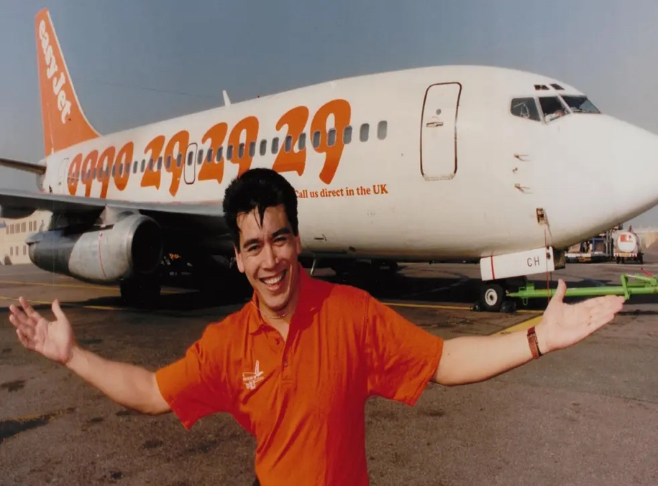
EasyJet is a low-price EU airline that capitalize on their price advantages, operational performance and its leading region at major airports to provide less costly fares that seamlessly join Europe with the warmest reception. easyJet is one in every of the most important airways inside the world, with 308 aircraft, 927 locations in 34 international locations and 153 airports.
Released in 2019, easyJet vacations gives holiday programs that permit 84% of our leisure guests to spend greater time with us in place of reserving lodging some other place.
EasyJet commenced while the influential Greek Cypriot Stelios Hadji-Ioannou determined to go into the airline business.
Rumours unfold that Virgin Atlantic had approached him and asked him to emerge as a major investor in the employer's Greek franchise. that is what opened the entrepreneur's eyes to the aviation industry, gold mining. because of this, he started out to assume significantly approximately starting his personal airline. Before that, he took out a $7.7m (£5m) loan from his father.
At once, he began gaining knowledge of the marketplace, taking notes on commercial enterprise models and distinguishing between people who labored and people that failed. Southwest airlines, an American airline that extensively modified price flexibility and created robust competition inside the airline enterprise, stuck his eye.
The difficulty of price flexibility will quickly become a guiding principle for EasyJet.
In 1995, the enterprise turned into finally based through Stelios and changed into the primary corporation in EasyGroup. before everything it had 70 personnel and changed into based at London Luton Airport, which turned into used as a charter flight.
As a form of help for brand new businesses inside the world of big aviation, Luton Airport donated a 15,000 square meter building to the employer.
It changed into the headquarters of EasyJet and become referred to as EasyLand.
This humble initiative turned into characterised through a minimalist fashion, the most well-known of which was the paperless workplace.

While work continued, the company began the use of "a couple of Boeing 737-2 hundred aircraft for rent". These aircraft should seat 148 passengers each and have been used for return flights from Luton (the location of the base) to Edinburgh and Glasgow.

Its most valuable capability was its ability to provide a lower fee than other AMIRRALAL airlines.

The company has registered at least 40,000 passengers within the organization's first year. The following year, in April 1996, it took over its very own aircraft and took its first step as a global airline serving Amsterdam.

This brought about direct opposition from major airlines including BritisAirwaysys and Dutch-based KLMThe British airlines ignored this competition right away, while the Dutch airlines refused to give up without a fight.t.

This led the employer to adopt a pricing method that prompted the European Union to launch an investigation. The research is designed to determine whether or not KLM's pricing method violates the rules of competitive practice.

Until October 1997, EasyJet was operated via GB airlines, Monarch airways and Air Foyle. This is because EasyJet has not yet acquired a certificate from the airline.

Nowadays, the airline has received shares in several competing airways, including Bland institution and Cross Fly.
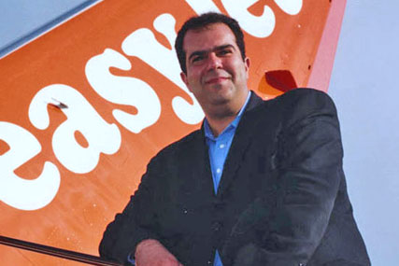
In March 2020, because of the COVID-19 pandemic, the corporation determined to cancel all flights, together with all flights.
However, earlier than that, the agency had provided 650 rescue flights, offering tremendous assistance to mankind. As a result, at least 45k people had been able to return home.
The company was able to secure a £600 million loan from the United Kingdom financial sector with no environmental requirements.
The company plans to resume operations in July, but will most likely operate 50% of its routes.
Unfortunately, in May also 2020, the enterprise was subjected to a huge cyber-attack that uncovered the information and private records of nine million clients. These days, EasyJet flies to 156 airports and 979 locations in 33 nations. It's miles one in all the largest low-fee airways in Europe and offers low fares to clients international with its fee advantage and pricing approach.

The organization also prides itself on customer support. The enterprise model used by EasyJet is designed to satisfy stakeholders and clients and drive growth within the airline.

In 2016, it was named the quality airline for business travel in the EMEA region via the undertaking Awards event in Italy.

In 2017, it was named "great short-haul" in the "Buying Enterprise Journey" Awards". It won the award for the most pleasant low-cost airline at the 2018 Business Travel Awards.

EasyJet also operates the latest version of Airbus aircraft in its A320 family of aircraft. There are also plans to upgrade the cabin to 186 seats and upgrade the A320neo aircraft. All this is to help our customers travel safely and comfortably. According to the official website, EasyJet is built around security. They get rid of the unimportant and believe in the power of cooperation.
- How they do it
Their efficiency is obtained through long -term partnerships with land airports and construction and the company aims to provide services for customer assessment.
- Their funds
Financial capital
Easyjet has a significant capital, 5 billion pounds, a market ceiling of 913 ml and their credit review is one of the best in the world.
Aircraft
EasyJet operates a fleet of modern Airbus A320 aircraft, of which approximately 59% are owned. They invest in state-of-the-art aircraft that are more fuel efficient2,3, which will reduce operating costs and CO2 emissions over time.
Employees
EasyJet has a highly skilled workforce of over 13,000 people, including over 4,000 pilots and 7,000 cabin crew members.
Slots and brand
The company has a valuable portfolio of slot pairs at slot-constrained primary airports, as well as flying rights across Europe and AOCs5 in the UK, Switzerland and Austria.

- COMMUNICATION
Marketing communication (MarCom) is a fundamental and complex part of a company’s marketing efforts and includes advertising, direct marketing, branding, packaging, your online presence, printed materials, PR activities, sales presentations, sponsorships, trade show appearances and more.
  - Communication Model
MESSAGE
Feedback
Response
Noise

The communication model is a process that involves the following components:
- Sender: meaning the marketing firm which is transmitting the message. It is also called source of communication such as a person or organization that share the information with others.
- Encoding: the process begins only when the sender selects word, symbols or pictures to represent the message that will be delivered to the receiver(s). The main goal is to encode the message in easily way for the receiver.
- Message: it may be verbal or nonverbal, oral or written, or symbolic however must be write into a transmittable form that is appropriate for the cannel of communication being used.
- Decoding: is the process by which the receiver attempts to covert symbol transmitted by the sender into a message. It happens that the receivers may be interpret the message in a different way due to individual characteristics or experiences.
- Receiver: Generally, are costumers in the target market or who read, hear or see the marketer’s message and interpret it.
- Response: is the reaction of the receiver(s) such to purchase the product in store or to visit the physical shop.
- Feedback: is a communication between the receiver and the sender about is understood the message and reacted to it. The sender must then decode the feedback message and the longer it takes the sender to receive and interpret the feedback, the less valuable it become.
- Noise: during the process, the message could be subject of external factors that can interfere with its reception. For example, if there are many adverting for different brands in one page of magazines can be a distraction.

- INTEGRATED MARKETING COMMUNICATION
Integrated marketing communication (IMC) is the process of unifying brand messages for consistency across all the mediums brands use to reach their target audiences.
It is a strategic approach that guides the communications and tactics used in all marketing channels.
  - New strategies
Being a multinational company with high income, EasyJet could improve some of the following communications:

- TV advertising: EasyJet communicates that you are a friend to your customers and increases your brand awareness.
It is not goal-oriented (this is a change from the marketing model traditionally used by low-cost airlines.
When you tell people where to fly and at what price, they go because they want to go, not because they want to go to their destination).
The website processes 200,000 orders per day, so it puts a lot of effort into improving the user experience and adapting to different geographical markets.
This is achieved through a streamlined design and the use of personalization based on previous searches.

- CRM: EasyJet does not segment its audience too harshly.
The main segmentation criteria are very broad. For example, a customer who took a flight last year but has not yet boarded this year.
In this case, content marketing is often used to convince customers to fly again. This is presented in a very simple format, such as path icons such as sunlight, couples and points of interest.
- Mobile: easyJet fully embraces mobile marketing through its mobile apps and technology. For example, make sure your mobile email campaigns have the fastest processes and leads. They have also redesigned key mobile processes and require users to download the easyJet app when requesting information or making a booking. This includes weather, flights and more. it includes.
They could adopt weather updates directly from their operations team to manage potential delays.

- Sustainability: as Ryanair adopted, the company may be used a reminder when you purchase a flight for the C02 emission in the sky. This is strategy that is able to attract more people because it presents the idea of a Green Company.

- Email: when you buy a flight on EasyJet.com they send to you immediately your ticket.
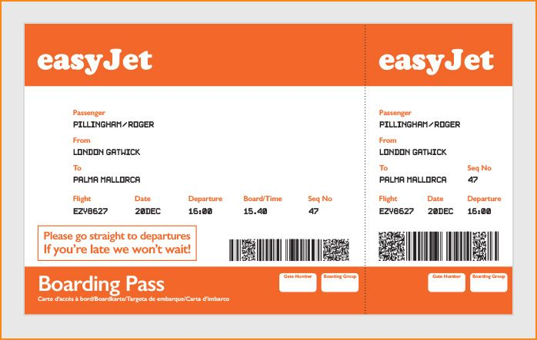
However, there are a lot of people that prefer the physical ticket and via app is impossible to have a pdf.

To have a ticket on a paper you have to do an external access via computer and the you can save and print the ticket. As other companies do for each service, EasyJet should be improving the service on the App for every range of ages and needs.
- BRANDING
  - Definition of Branding and Brand Equity
The term branding refers to business and marketing concepts that help people identify a particular company, product or individual.
Branding is intangible, which means it cannot be touched or seen. As such, it helps shape people's perceptions of a company, product or individual.
Brands often use identifiers to help create a brand identity in the marketplace. It provides significant value to a company or individual, giving them a competitive edge over others in the same industry.
Brand equity is a lever which impacts a brand has on the consumer's mind, the value of owning a recognizable and well-thought-out brand.
Organizations create brand equity by creating positive experiences that entice consumers to continue buying more than their competitors who make similar products. Through campaigns that communicate the values of target consumers, the fulfilment of promises, and the qualification of products when consumers use them, brands build equity.

  - Keller’s Brand Equity
The Keller’s Brand equity model was developed by Kevin Lane
Keller, a marketing professor author of many marketing books.
This model has a concept behind simply used to build a strong brand such as the company must perceive how customers think and feel about the product. In order to this, the company has to build the right type of experience around the brand helpful to receive specific, positive thoughts, feelings, beliefs, opinions and perceptions about it.
One of the most important things that you can achieve with a strong brand equity is that the customers not only will buy more from you nevertheless also, they will recommend the company to a friend or other people.
The model is represented by a pyramid with different steps useful to build a strong brand equity. The four steps are:
- Brand Identity/Salience: Who are you?
- Brand Meaning/ Performance and Imagery: What are you?
- Brand Response/ Quality, Credibility, superiority and consideration: What do I think or feel about you?
- Brand Resonance- relationship / Sense of community, active engagement, attitudinal attachment and behavioural loyalty: What about you and me?
To explain each level, I will approach with this model for EasyJet.
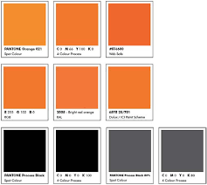
- Brand Identity:
Is the first step to build a strong brand name creating something that people recognize it and are aware of it.
EasyJet has a strong brand identity supported by a specific colour: Orange. In order to this, the majority of the people know that an orange airline is for sure EasyJet. In fact, today the company has an
own colour called EasyOrange.
- Brand meaning:
This step includes to identify and communicate what the brand means for the customer in terms of performance and imagery.
- Performance: how well the product meets the customers’ needs and in this case for EasyJet it is for customer that likes travel with a reasonable price and comfortable.
- Imagery: how well the brand meets the customers’ needs on a social level and EasyJet is direct to niche of people that know to pay a good price due to pasts experience or reviews.
- Brand response:
With the brand response, the model is divided in two categories:
- Judgments: the costumers will judge the product by the quality, credibility, consideration and superiority. EasyJet to achieve this level show to the external people its durability, safety and how they take care of their client with a numerousness offers to make loyalty.
- Feelings: how the costumers feel when using the service or after and EasyJet is always on different strategies to make the customer safe, especially when there is the payment online.
- Brand Resonance:
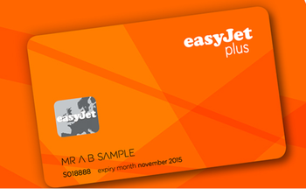
It is the last level of the pyramid and that means that is the harder goal to reach for a company. It is regarding the loyalty, attitudinal attachment, sense of community and active engagement. EasyJet to achieve this level created Flight Club (“the Scheme”) is a loyalty programme for our most frequent flyers and its b
enefits are personal to its members and their immediate friends and family.
That club includes a lot of benefits and one of this is if you find another flight cheaper than the one bought on EasyJet.com they will be refund 10% of the ticket with a voucher.

    - Advantages and disadvantages of Keller’s Brand Equity model
- Advantages:
- Strong brand name: the company it able to create it via experience, emotions and thoughts from customers.
- Consistency in the marketplace: the customer will buy more often the product if the brand is in the marketplace, especially if the product has consistent quality that reflect the image as well.
- Customer loyalty: a well-developed branding helps to create customer loyalty by reinforcing the purchase of merchandise in the consumer’s mind.
- Disadvantages:
- Might become commonplace: for example, when you ask for an aspirin to a doctor, he will give you a generic medicine and not the original one. As we know, one of the goals of branding is to become a standard not a generic term of line of products.
- Negatives attributes: if a product or service receive a complaint or negative feedback, that will be attach to the bran immediately. (Ex. Offensive advertising campaign)

- COSTUMER JOURNEY MAP
A costumer journey map is a diagram that allows to understand the steps for the costumers go through in engaging with the company.
  - This “itinerary” helps the company to create a story of customer’s experience across all touchpoints and it is focused on different steps:
- Awareness:
Is the first step for a costumer to become familiar with the brand. They start to know about the company, the brand and what is the main production.
- Consideration:
After deep research, the costumer begins to consider the company as an option. They are now curious about the offer and want to learn more about benefits and incentive with the product.
- Decision (purchase):
With this step the costumer will look at reviews and offers and will decide the best fit for what they want.
- Retention:
This is an important stage as the company has to provide to the consumer a great experience. This means offering an excellent support, rewards, discount and everything can avoid negative feedbacks.
- Advocacy:
The last step is advocacy where the consumer is happy about the brand and will offer you a positive word of mouth.

We define Customer touchpoint as any direct or indirect contact a costumer has with a brand. They may happen before, during or after the purchase.
This paragraph will explain the touchpoint from EasyJet brand with a costumer pre, during and post purchase a service.
- Pre purchase:
The first thing that a potential EasyJet costumer will do is to search on google cheap flight for a specific period. One of first website that you can see when you are looking for a flight is EasyJet.com and immediately a costumer is able to see a lowest minimum price for a flight that capture the attention.
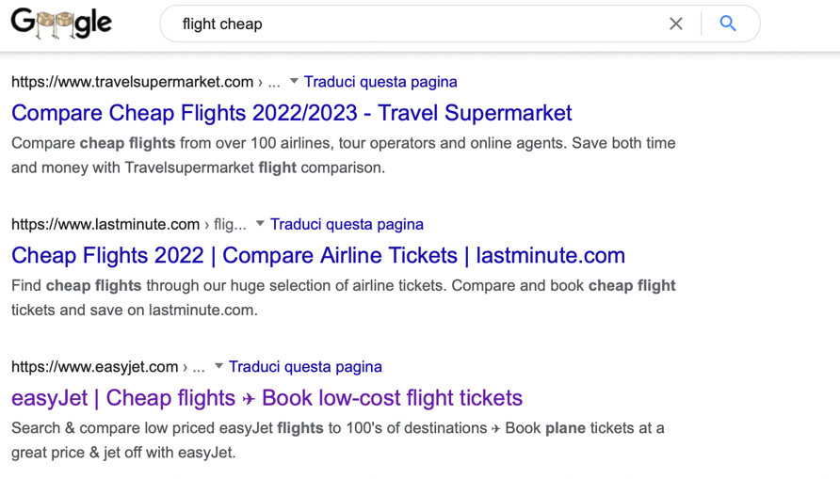
If the costumer is not sure about the company, the website through the cookies will show on every social media the offers for that specific destination managing to convince the costumer to purchase often the service.
- During the purchase:
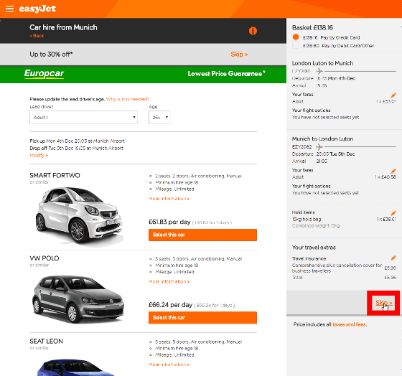
After a costumer bought a flight, the company will send immediately the QR ticket with a customer service team list to contact in case of some issues.
The company will offer additional service as for example to rent a car or to book a room with discounts.
In addition, they will contact you regarding to download their online menu in case to order something on board and an advice regard to complete the check in online instead to pay a supplement to the airport.

- After the purchase:
When the costumer has received the service, EasyJet will send immediately email feedback regarding the quality or if there are delays and lost luggage’s.
Another thing that the company does is to send an email with the next destination similar the last one (city breaks, beach or mountains) with great offers.
At the end, EasyJet offer a loyalty program with an annual fee to have for example speedy boarding, fast track security or bag drop.

  - Costumer journey map of EasyJet
Costumer journey Map | Awareness | Discover | Purchase | Use | Bond
Website |  |  | 2) Buying tickets via website
Store
Call Center | 5) before, during as well as after the flight for changes and cancellation policies.
Social Media | - Attract customers flights |  |  |  | 6)feedback regarding the service: delays or on time.
Web form
Word of mouth
Email |  | 3)Discover other destination after purchase |  | 4)Qr code via email for the check in and departure | 7) Email with offers and coupons after the service.
Post

  - Strengths and Weaknesses of EasyJet
- Strengths:
- The brand reputation of EasyJet has been developed for the cheapest airline in UK and Europe, in particular for teenagers and business people.
- They have created a website and phone App easy to use and simple to purchase a ticket.
- One of the new entries are the modern planes to ensure safety and even emission reduction.
- Customer loyalty is offered by email, text and special sales alerts.
- The company is constantly to update and create new routes throughout Europe.

- Weaknesses:
- There are many competitors with numerous brands fighting for the same niche of customer. This create a price war into the market and it is difficult keep the same strategies.
- The company not offers a free food service on flights longer of more than two hours.
- The niche of customer of EasyJet could be a problem in order to find new consumer as the atmosphere on the please is not always relaxing and quietly.

- TOTAL ENGAGEMENT MODEL
The customer engagement model is how businesses connect and build long-term relationships with customers. This allows the company to have specific marketing strategies tailored to the customers to develop a sustainable brand and is often part of a wider strategy to help you understand how people use your products. The customer engagement process starts before the sale, helps find consumers and continues to build customer loyalty after the sale.
During the last two years, despite flight restrictions, easyJet has recorded a global customer satisfaction rating (CSAT) of 80% since relaunch, up 13 percentage points year-on-year, thanks to operational performance and handling of the Covid-19 policy.
Last year, customer satisfaction increased by double digits in each of our key markets, with very strong improvements in customer satisfaction in Portugal, the Netherlands, the United Kingdom and Switzerland.
Customers who have been with us since the re-launch were very satisfied with the cleanliness and neatness of the aircraft and the boarding experience.
This is a testament to the amazing work our nation as a whole is doing in these difficult times.
It also highlights the enhanced biosecurity measures introduced in June.
- Aircraft Cleaning: All aircraft have a daily disinfection process that protects surfaces from viruses for at least 24 hours.
- Onboard Measures: All passengers and crew must wear a face mask at all times while on board. EasyJet aircraft are already equipped with cutting-edge filtration technology. The high-efficiency particulate filter removes 99.97% of indoor air pollutants, including viruses and bacteria. This filter is the same one used in hospitals and ensures that the air in the room is refreshed every 3-4 minutes.
- Airport measures: To protect customers and ground staff at the airport, customers can use an automated baggage drop-off service where they can check in their baggage, and screens are installed at airports and check-in counters where there is automated baggage drop-off; It is not possible, the company already recommends that all customers check in online before arriving at the airport and either download the boarding pass to their smartphone or print the boarding pass.
These biosecurity measures will be maintained for as long as necessary to ensure safe flights for our customers and crew as the world continues to battle the impact of the Covid-19 pandemic.

- CONCLUSION
In the final part of this elaborate, it is important to make some recommendation for EasyJet.
Due to the current situation with global warming and an increased air pollution, the company should be able to reduce the emission and to improve the situation.
As we know, an aircraft is the most dangerous item on our world and is important that they will adopt green initiatives such as: Reduce, Reuse and Recycle.
One of these is the plastic free on board of the airline.
Advantages of this could be to improve branding of EasyJet with making a positive impact on the environment and the customer will associate easyJet with being green.
The company already has adopted few measures to eliminate this problem, however is not enough and in the next 5 years they have promised to the customers to decrease the emission.
One of the solutions could be the new strategy from Formula 1 that they are focused to do on 2026 a championship using less fuel and carbon net zero. They will create a special fuel that will pollute poorly the environment.

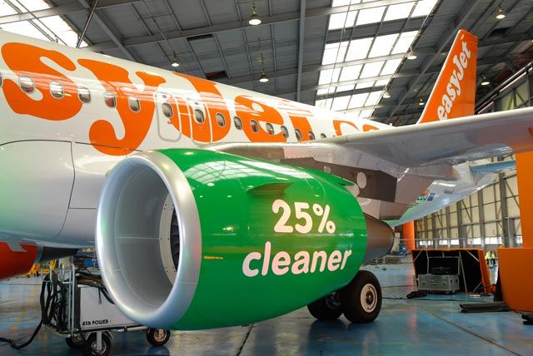

REFERENCES:
- EasyJet (2022). “Our journey – history”. (Online accessed 25-07-2022)

- Haji-Ioannou, Stelios (2005). "Risky business: Why the unpronounceable will achieve the improbable in Britain". The Economist. “If you are not failing occasionally, you are not taking enough risk and there is no reward without risk. In America a past business failure is almost a badge of honour. In Europe it is a lasting handicap” —Stelios Haji-Ioannou.

- Jerry Kliatchko (2005) Towards a new definition of Integrated Marketing Communications (IMC), International Journal of Advertising, pp. 7-34.

- Barnlund, D. C. (1970). A transactional model of communication in K.K. Sereno and C.D. Mortenson (Eds.), Foundations of communication theory (pp. 83-92). New York, NY: Harper and Row

- EasyJet (2022). “What we do”. (Online accessed 01-08-2022)

- Zablocki, A., Schlegelmilch, B., & Schant, E. (2017, May). Customer-Based Brand Equity in the Digital Age: Development of a Theoretical Framework: An Abstract. In Academy of Marketing Science Annual Conference (pp. 741-742). Springer, Cham.

- Salesforce (2018) ‘What is Customer Journey Mapping & why is it important?’ Available at: <https://www.salesforce.com/uk/blog/2016/03/customer-journey-mapping-explained.html > (accessed 03-08-2022)
- Gentile, C., N. Spiller, and G. Noci (2007) ‘How to Sustain the Customer Experience: An Overview of Experience Components that Co-create Value with the Customer’ European Management Journal, 25, 395-410

