
Engineering and Construction Surveying
ACBA4020

April 25, 2025
2318123@student.uwtsd.ac.uk
2318123

Contents
Earthworks calculations. 1

Figure 1 Typical pavement construction with depths. (Williams, 2025) 1
Figure 2 Volume Calculations. 2

Earthworks calculations.
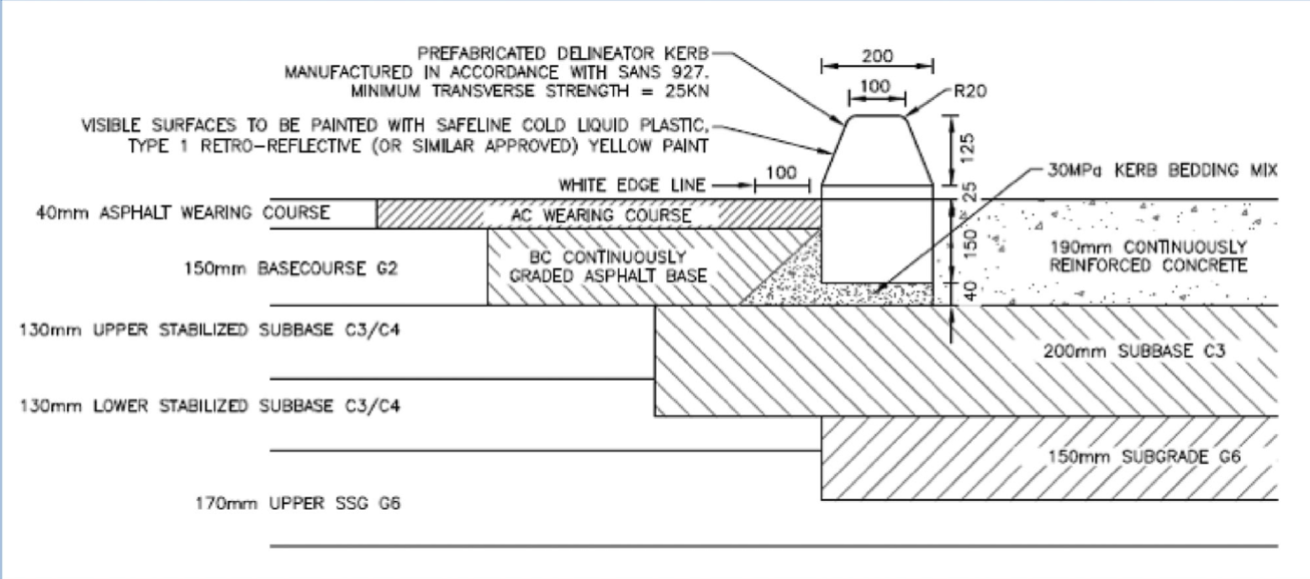
Figure 1 Typical pavement construction with depths. (Williams, 2025)
Using the above figure for reference the depth of excavation required for reconfiguration is 620mm. 170 + 130 +130 +150+40 = 620mm
I have calculated the area required for reconfiguration utilising a Pline on Autocad, the area is 137.92m2.
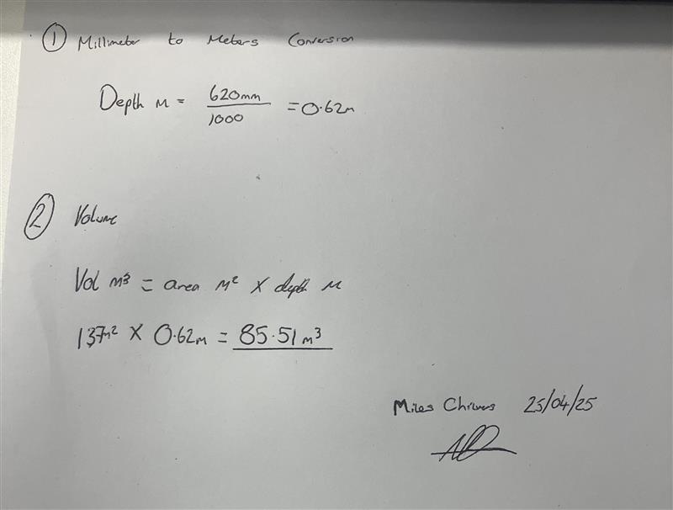
Figure 2 Volume Calculations.

