Architecture in your hometown
Swansea is an area filled with character when it comes to architecture. From modernised super structures like the Grape and Olive Tower in the marina, to the historical master pieces such as Swansea Castle in the city centre. I have chosen to focus on two particular buildings in this paper, and they are The Morgans Hotel and Oystermouth Castle. Despite both buildings being used in a very different way compared to what they were originally intended for, I will be trying to focus on the original buildings.
Morgans Hotel was originally erected in 1902 for the Swansea Harbour Trust as an office for the dock staff and was a symbol of confidence the people of Swansea had as the town was at the heart of world trading. It was designed by Edwin Seward whose design was chosen from over 100 different entries. The location is key with this building as it is situated right next to Swansea Docks which at the time was one of the major import/export locations in Wales. The location allowed for the dock staff to rotate between office and workstation very effectively and allowed management to keep a close eye on operations from their office situated a stone's throw away. As well as being close to the docks, the office was also situated right next to the city centre which would have very easy access to transport to ship imported goods across the country. Oystermouth Castle was built a lot sooner than Morgans Hotel building as it was founded around 1106 by William de Londres following the capture of Gower by the Normans. It was used as a place of residence for the de Londres family after they captured Gower much to the native Welsh resident's disgust. The castle was burnt down numerous times by the Welsh as an attempt to drive the de Londres out of the town, therefore resulting in numerous rebuilds of the castle throughout the twelfth and thirteenth century. The location, similar to the Morgans Hotel building, was chosen for its practical use as it is on hill which at the time had a very clear view of the surrounding area, especially the coast, so any intruders or threats could be spotted in plenty of time to gather a defence together. Both buildings were clearly situated where they are today for good reason as they both served completely different purposes, but both shared the practicality and convenience of location.
Morgans Hotel had a very different layout originally back in 1902 than what it does now. Referring to appendix ‘a’, we can see that in fact at the time it had a very similar ‘office building’ layout as many do today. We can see it has a large public reception area upon entering that leads to the shipping office, this would’ve been used for members of the public to submit items ready to export. We can also see that there is an entrance to the right of the building too. This was used by workers on the docks and members of staff of the building as an entrance to the office’s bank branches as seen on the bottom right corner of appendix ‘a’. We can also see that there are individual offices for the staff members of the docks, for example the ‘Resident Dock Engineer’ has his own office in the building which would be of great benefit remembering how close the building was situated to the docks, the engineer has the chance to closely monitor his work. The same argument could be used for all the staff members who have their own offices in the building as they all play a key role in the smooth operations of Swansea Docks, it makes perfect sense to have their office building as close to the docks as possible.
In comparison to this, Oystermouth castle’s layout (appendix ‘b’) can be analysed very similarly to that of Morgans Hotel, but for a very different use. We can see that immediately the first thing that catches the eye of the onlooker is the massive courtyard in the front of the castle just after the castle entrance. This is strategically placed here as it provided an area between castle entrance and the main heart of the castle therefore if any attackers were to gain access, this is where most of the battle would be done. The courtyard would also be used for formal events such as feasts and banquets which would suggest why the castles courtyard is so big and prominent. The barracks were also situated close to the entrance of the castle as we can see, this would be efficient when defending an unforeseen attack as the barracks are nearly the first line of defence being so close to the entrance, troops were able to gather their weaponry and fight as quick as possible. Finally, it can be argued that the position of the north and south keep was strategically picked as it was traditionally where the nobles would have lived therefore it was placed as deep into the castle as possible to help protect from possible invaders.
Finally, I am going to talk about the materials and styles used in both structures and whether the design was a success. Firstly, Morgans Hotel was completed with a baroque style exterior, cladded in red brick and white stone and appears to have been decorated in greek style statues. The interior of the building featured stained glass windows with maritime themed images on them. I think the design by Seward was a success as it not only fitted the practical criteria of an office but was beautifully constructed to bring a very different style into Swansea and catch the attention of onlookers. If you compare this with Oystermouth castle however it is very different. Oystermouth castle was constructed using mainly stone, with little eye-catching features. This was done intentionally as you wouldn’t want to stick out to intruders therefore the natural stone would help blend the castle in with the surrounding landscape. Overall, I believe the layout and design of the castle was also a success as not only did it blend in with the surroundings to stay under the radar from potential intruders at distance, but also structurally seemed to serve its purpose of protecting those who inhabited the castle too. Therefore, to conclude both structures despite having very different uses, seemed to succeed in their purposes with design and practicality due to the location, materials used and layout of each building and features of this can still very much be seen today with their new renovated and adapted uses.

Word count : 1102

Appendix A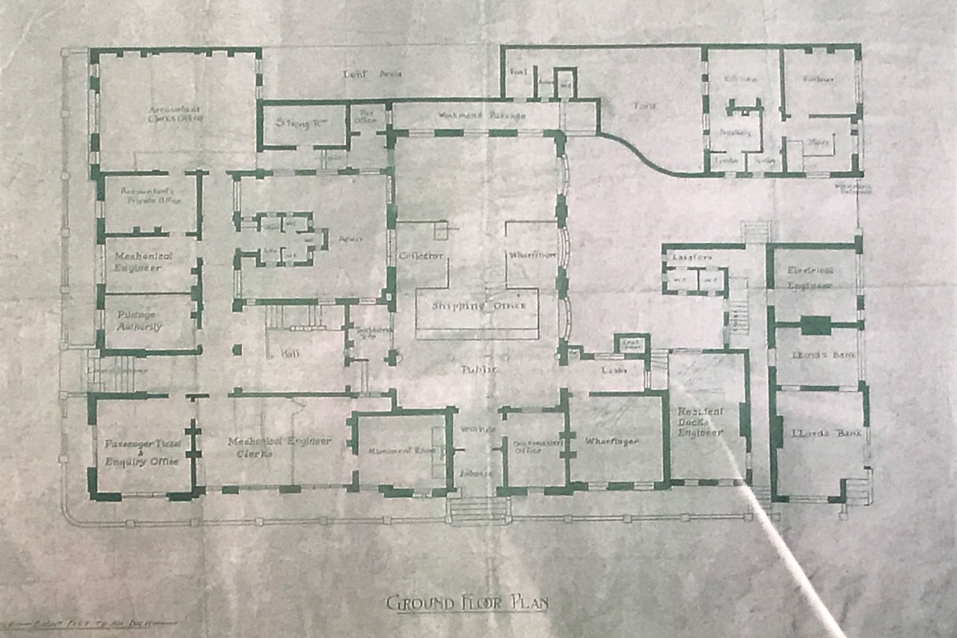
Appendix B

