
managing people
LCBB5004


ASSESSMENT 2: WRITTEN ASSIGNMENT

STUDENT NAME: AMNA MASAUD
STUDENT ID: 2113737
LECTURER: ZE ZOOK
UNIVERSITY OF WALES TRINITY SAINT DAVID
WORD COUNT: 2087

TABLE OF CONTENTS

INTRODUCTION 2
PART 1 2
a. HOW IMPORTANT ARE THE BEHAVIOURS FOR HR PROFESSIONALS IN THE UK 2
b. HOW CAN THE MAP BE APPLIED TO HR PROFESSIONALS ON A GLOBAL SCALE 4
PART 2 5
a. WHY THE UK’S PUBLIC SECTOR IS HAVING SKILLS SHORTAGES 5
b. LONG-TERM LABOUR IMPROVEMENTS FOR SILLS SHORTAGES IN THE HEALTHCARE SECTOR, UK 6
CONCLUSION 7
REFERENCES 8

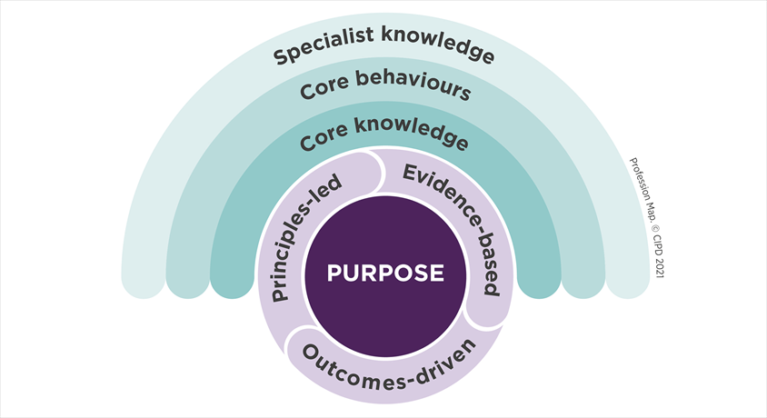
Figure 1: Profession Map (CIPD, 2021)

INTRODUCTION
According to CIPD (2022), the Profession Map sets an international standard for people’s profession. It is focusing on the practices and knowledge that are needed to generate value and have a significative impact at work by shifting from generic to value-based practices. As shown above, in Figure 1, the Map includes four different area: core knowledge and behaviours, specialist knowledge, values and purpose. By using the Map, people are building their professional credibility by proving organisations that are serious about their skills and keeping themselves up to date.

PART 1

HOW IMPORTANT ARE THE BEHAVIOURS FOR HR PROFESSIONALS IN THE UK

The Profession Map stays at the base of decision-making and is composed of core behaviours that are creating value for society, organisation, people, and professions. It is emphasising on the fact that certain ways of acting, and thinking should always be consistent and universal for all professions, especially for the HR professionals. (CIPD, 2022)
According to Adams (2018), the challenge for HR departments is being able to adhere to the core behaviours to add value to their workplaces. For a better understanding of how important these behaviours for HR departments in the UK are, CIPD (2022), is mentioning few ways trough which effectiveness can be achieved.
- Ethical values are staying at the base of HR’s morality. The way the decisions are made should focus on organisation’s wellbeing, based on good principles. If the professionals are living by good values, their life and experiences at work are improving. For a more ethical decision making, there should be taken into consideration transparency, people’s opinions and believes, professional values and principles.
- Professional influence and courage: the ability to influence others and challenge decisions and activities is one of the key behaviours in HR and should be put into practice daily. On the other side, courage is necessary as well to understand when mistakes have been made, taking responsibility for them and learn how to improve in the future. In order to achieve positive outcomes, relationships with others should be built for a better view of their concerns, needs and perspectives.
- Valuing people: appreciating what people bring to their organisation and focus their perspective to business decisions. People are put at the centre of the approach to stabilize fairness, compassion, and consideration. By doing this, professionals will feel that they matter, and their development and wellbeing is primordial.
- Working inclusively: they way others are listened to and enabled to work together stays at the base of delivering effective outcomes in the processes of planning and delivering of the work
- Commercial drive: by using a business and customer-focused approach, HR professionals are proofing their commitment to deliver outcomes that are adding value to the organisation. By identifying the risks, issues, and opportunities will impact the success and performance of the business.
- Passion for learning: committing to enable professional development. This mindset helps professionals to seek opportunities to discover new ways of doing things and improving their work.
- Insights focused: employees focus should be understanding and solving the problems by using different evidence to develop insights and positive outcomes. For this to be possible, there are some key steps that need to be followed: asking the right questions, gathering evidence, assessing the evidence in a critical way, and accumulating the evidence to understand the whole situation and its implications.
- Situational decision-making: making effective decisions by taking in consideration the specific context. Should be identified the benefits, options and risks that are associated with the problem and rely on the organisation’s principles and values.

HOW CAN THE MAP BE APPLIED TO HR PROFESSIONALS ON A GLOBAL SCALE

The Map aims to take a further step in connecting with more business leaders around the world and developing better work and working lives by being able to support, challenge and encourage HR profession towards the future and practicing it everywhere. Furthermore, The Profession Map is engaging in developing the standards between British and international HR. It is believed that by sharing the knowledge, expertise and points of view, people management practises can be supported in countries where the professional practice is not well established. As people’s development is an important source of adding value to the organisation, the approach is strategic. The standards are beneficial for stakeholders, wider society, and organisations, being principle-led, measurable and consistent. (CIPD, 2021)
According to Pilbeam and Corbridge (2010) and CIPD (2021), once the HR management developed the philosophy about managing people, there will be steps that can be followed on a global scale that are composed of the core knowledge and behaviours and specialist knowledge:
- Selecting the people that are capable to perform the job under the developed structure
- Rewarding their performance to ensure that motivation is maintained
- Enhancing their performance by providing competent and high-skilled development
- Specialist knowledge: has a wide spectrum of opportunities that are showing how to apply the knowledge in order to make a positive impact in nowadays’ world of work. Career paths can be developed and recognised internationally, depending on the chosen area of expertise.
- Professionals are having the role to support the wellbeing of themselves and others, hence why standards on wellbeing have been integrated in the core knowledge and behaviour areas of the Map. Regardless of sectors and sizes of organisations, creating a holistic wellbeing strategy is beneficial for both sides (employees and organisation) as it prevents stress and creates positive working environments.
- Change: is implemented for the good of the organisation and its professionals. It is mandatory for each workplace, no matter the country or the culture to understand the change and to be involved in all its stages. The Map is helping HR department to choose the right approach that supports the change, to know how to involve the right people and understand them and to know what needs to be developed in order to be a long-term implementation.

PART 2

WHY THE UK’S PUBLIC SECTOR IS HAVING SKILLS SHORTAGES

They way how organizations develop and put in place their recruitment policies is directly affected by the nature of labour regarding the availability of people for employment and its composition. Recruitment problems arise in the UK’s public sector because of the skills shortages and the reduced number of workers from overseas. Other reasons might be the development of the gig economy, the implications of Brexit and the shift towards zero-hours contracts that affect the labour market and employment requirements. It is foreseeable that as labour becomes more scarcer, the market will eliminate the poor jobs and the employees will seek to improve their competencies. The whole process will necessity time as there as too many workers in low-skill and reduced wages in the UK that are not able to progress, and the in-work poverty remains an issue. Furthermore, as an impact of emerging technologies and the rapid development in automation (machine learning), there are large-scale job loses as the technological advancements are substituting the skilled labour. (Armstrong and Taylor, 2020)
CIPD (2021) is highlighting several challenges that the public sector is having in attracting and retaining skilled workers:
- The unattractiveness of the industry: jobseeker’s expectations are not direct proportional with the wages and working conditions that are offered
- The sector is not taking actions in addressing the skill and labour shortages: experiencing recruitment difficulties and lack of resources and capability
- Some of the departments and not taking an active approach in the recruitment process and are relying on the recruitment agencies and temporary workers. As there are 52 % hard-to-fill vacancies in the public sector, the solution might be to upskill the existing staff
- Lack of investment in technology: short term interventions need to be made to recruit people in the key roles and long-term and provide more support for them to adapt to the new technology
In consonance with Pilbeam and Corbridge (2010), organisations are acknowledging the need to maximize employees’ contribution by developing the skills and competencies and making sure that are reflecting the strategic direction that the company aims towards. As the market is in a continuous change, it is difficult to identify all the changes that the public sector might go through, but certain predictions can be made in terms of the workforce. For example, there has been an increased need for highly skilled workers, more pronounced competition for talent and increased diversity in the workplace. These factors should be taken in consideration by the public sector to revisit the planning processes to generate appropriate staffing levels and complexity.

LONG-TERM LABOUR IMPROVEMENTS FOR SILLS SHORTAGES IN THE HEALTHCARE SECTOR, UK

According to CIPD (2021), Government’s aim to transition to a high skill economy in the healthcare sector that is relying less on the migrant workers will be threatened if there will not be made some interventions on the immigration policy to support the skills shortages. By analysing the labour and skills shortages post-Brexit, there will need to be taken some measures in order to be able to return to the previous norms, such as:
- A job mobility scheme to be implemented for EU nationals to ease the acute skills and labour insufficiency as the healthcare is having 64% hard to-to-fill vacancies because of this lack (CIPD, 2021-2022)
- Government to provide funds to the healthcare sector to improve consultancy service, invest in new technology, workforce development and people management
- The Apprenticeship Levy should be reformed to be able to create more flexible training and help employers invest in a wider range of skills development
UKParliament (2022), created a plan to supplement the NHS workforce and updated their long-term strategic framework by:
- Expanding the specialities that are in shortage: there has been created an extra 250 foundation year to facilitate doctors to grow some posts: psychiatry, general practice and some other priority areas like cancer developing.
- Undergraduate places have been increased: universities have been providing over 5000 new places in nursing, dental therapy, hygienist speciality and midwifery
- Clinical commissioning groups to recruit additional 26000 roles until 2023/24 that are funded by the ‘additional roles reimbursement scheme’
On the other hand, to support employee engagement and retention, CIPD (2022) is suggesting measures such as:
- Facilitating flexible working arrangements can attract and retain high skilled people, as it had an increased expectation from the candidates in the past years.
- Focusing on the existing workforce and offering training to upskill or reskill staff
- Providing financial wellbeing support to staff in order to increase cost-of-living, motivation and willingness to develop their skills
However, these changes in people management capability and investment in the healthcare system that is facing acute skills shortages, are taking time, hence why there is a need to be reviewed to make sure that are still relevant for the market’s needs. (CIPD, 2021)

CONCLUSION

In conclusion, the primordial role of The Profession Map is to develop and facilitate better working and work lives by creating opportunities, new roles, and organisations. All these changes will be generating prosper organisational outcomes by driving the economy and creating an inclusive and diverse work environment. It will not tell organisations what to do but will show how to lead to better decisions by using principles, evidence, and outcomes. In this way, will be created a long-term and positive impact for the organisations and its employees.

REFERENCES

Adams, K. (2018) ‘CIPD launches new Profession Map’, People Management, p. 54–.
Armstrong, M. and Taylor, S. (2020) Armstrong’s Handbook of Human Resource Management Practice. London: Kogan Page, Limited.
CIPD (2021). CIPD. [Online] Available at: https://peopleprofession.cipd.org/profession-map#gref [Accessed 3 1 2023].
CIPD (2021). Labour and skills shortages. [Online] Available at: https://www.cipd.co.uk/about/media/press/201021labour-skills-shortages#gref [Accessed 7 1 2023].
CIPD (2022). People Profession 2022: UK and Ireland survey report. [Online] Available at: https://www.cipd.co.uk/Images/people-profession-uk-ireland-2022-report_tcm18-111972.pdf [Accessed 6 1 2023].
Pilbeam, S. and Corbridge, M. (2010) People resourcing and talent planning: HRM in practice. 4th ed. Harlow: Financial Times Prentice Hall.
UKParliament (2022). Staff shortages in the NHS and social care sectors. [Online]
Available at: https://lordslibrary.parliament.uk/staff-shortages-in-the-nhs-and-social-care-sectors/
[Accessed 7 1 2023].

