Report Title: Reshaping Johnson & Johnson’s Strategic Direction for Innovative Customer Care during the Pandemic

Module: Strategic Management

Module code: BMMB7013

Name:Ruohan Zhao

ID number:2234009

Executive summary
This business report presents a strategic analysis of Johnson & Johnson (J&J) focusing on reshaping the organization’s strategic direction for delivering innovative customer care in the midst of the COVID-19 pandemic. The aim of this analysis is to identify a new way forward for delivering innovative customer care, ensuring future resilience and sustainable competitive advantage against a backdrop of a pandemic. The external analysis uses several strategic management tools about J&J, including Porter’s Five Forces, Porter’s Generic Strategies, Ansoff’s Matrix, and PESTEL analysis. It has been found that the pandemic has significantly impacted the healthcare industry with increased emphasis on remote healthcare solutions and personalized customer care. The company needs to adapt to these changes by leveraging technology and digital platforms to improve customer engagement and satisfaction. The internal analysis examines the organization’s strengths and weaknesses in relation to customer care through Value Chain Analysis and Resource-Based View. J&J has a strong reputation for quality and innovation along with a wide range of products and services. However, there is a need to enhance personalized customer care and improve agility in responding to rapidly changing customer needs. It’s recommended that J&J invest in prioritizing digital transformation, cultivating collaborative innovation, and promoting customer engagement considering the strategic options for more personalized customer care. These measures will enable the organization to provide personalized experiences, improve customer satisfaction, and strengthen brand loyalty. The proposed strategies has wider implications on different areas of the organization. Overall, this strategic analysis recommends that J&J adopts a customer-centric approach to reshape its strategic direction for delivering innovative customer care. The organization needs to enhance personalized experiences and maintain a sustainable competitive advantage in the face of the pandemic. Implementation of the proposed strategies will require collaboration across various departments and investment in technology and digital solutions.

Introduction
Johnson & Johnson (J&J) is a renowned global healthcare company known for its commitment to delivering quality products and services. In the face of the COVID-19 pandemic, it has become imperative for the company to reimagine its strategic direction for delivering innovative customer care to ensure future resilience and sustainable competitive advantage. This business report aims to conduct a thorough strategic analysis of J&J by assessing both internal and external factors as well as critically evaluate strategic options for more personalized customer care. It will also discuss the wider implications of the proposed strategy on different areas of the organization.•

Main findings of strategic analysis and critical evaluation of the strategic options
- Strategic analysis
  - External analysis
1.1.1 Porter’s Five Forces
Porter’s Five Forces consists of five components, including Competitive Rivalry, Bargaining Power of Suppliers, Bargaining Power of Buyers, Threat of New Entrants, and Threat of Substitutes (Oluwo, 2007; Kotler & Philip, 2007). The analytic results are shown with details considering J&J’s objective of delivering innovative customer care and ensuring future resilience and sustainable competitive advantage
- Competitive Rivalry: J&J operates in a highly competitive healthcare industry which includes companies such as Pfizer, Novartis, and Merck. There is intense competition in segments like pharmaceuticals, consumer healthcare, and medical devices. The differentiation of innovation, product quality, and brand reputation is the key factor for competitive advantage (Siaw & Yu, 2004).
- Bargaining Power of Suppliers: J&J relies on a diverse range of suppliers for raw materials, ingredients, and components (Gold et al, 2005). J&J’s large scale and global presence allows for stronger negotiation power with suppliers. However, supplier power would be significant for highly specialized components. It also acts as an inevitable component during supply chain disruptions.
- Bargaining Power of Buyers: Hospitals, healthcare providers, pharmacies, and patients are J&J’s customers. The customers have some power due to the availability of alternatives and their ability to negotiate prices and terms (Brosnan & Sean, 2016). However, the critical nature of healthcare products limits buyers’ power to some extent.
- Threat of New Entrants: Entry barriers in the healthcare industry are high due to substantial R&D investments, stringent regulations, and complex distribution channels (Anderson et al, 2000; Wei-Ming & Kang-Wei, 2007). Therefore, it’s needed for strong relationships to establish companies like J&J with customers and a vast product portfolio, which increases the difficulty for new entrants to gain market share.
- Threat of Substitutes: In the healthcare industry, there are various substitutes available for products in different categories. Generic drugs, alternative therapies, and traditional medicine is posing a threat to J&J’s pharmaceuticals and consumer healthcare products (Keller, 2011). However, our organisation has been focusing on research, development, and innovation aiming to protect against substitute products.
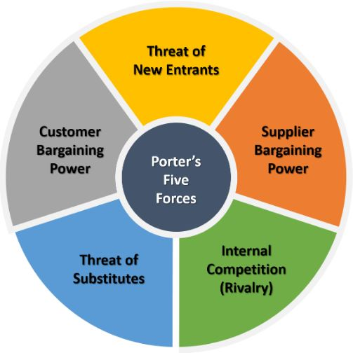
Chart.1 Strategic management tool - Porter’s Five Forces
According to the results of strategic analysis, J&J can take leveraging digital technologies, investing in telemedicine solutions, and leveraging data analytics to enhance patient outcomes into account to effectively reshape the strategic direction and deliver innovative customer care. Additionally, the company can also focus on strengthening supply chain resilience, diversifying product portfolio, and driving sustainability initiatives to meet the evolving demands of customers and stakeholders during and after the pandemic.

1.1.2 Porter’s Generic Strategies
Based on the structure Porter’s Generic Strategies, this section will use it as a strategic management tool to evaluate J&J’s target scope and advantage (Eldring, 2009; Pretorius, 2008).
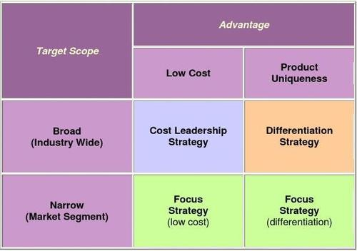
Chart.2 Strategic management tool - Porter’s Generic Strategies
- Cost Leadership: J&J utilizes cost leadership strategy mainly based on operational efficiencies and cost reduction measures, which can be achieved through streamlining supply chain processes, improving manufacturing capabilities, and optimizing the utilization of resources (Wicke et al, 2015). J&J can offer competitive pricing to customers while maintaining profitability through leveraging economies of scale (Akan et al, 2006).
- Differentiation: J&J has a wide range of products and a strong focus on research and development. The company can differentiate itself by continuously innovating, developing new products, and improving existing ones. J&J can provide unique features, improved quality, and superior customer care to differentiate its products from competitors by investing in technology and research (Islami et al, 2020). Additionally, J&J’s strong reputation should be emphasized for safety and reliability as a key factor to influence differentiation strategies (Hlavacka et al, 2001).
- Focus: J&J can adopt a focus strategy by targeting specific customer segments or geographical markets. The company can tailor its products and services to meet the unique requirements of these segments focusing on specific areas of expertise or specific patients’ needs (Kumar et al, 1997). These strategies would facilitate offering service for specific customer groups as well as building strong relationships with key stakeholders (Viltard, 2017).

1.1.3 Ansoff’s Matrix
Ansoff’s Matrix is a strategic management tool for organizations to assist identifying potential growth strategies by analyzing the relationship between products and markets (Wayland & Wayland, 2015; The Oxford Handbook of Strategy, 2006). It consists of four quadrants: Market Penetration, Market Development, Product Development, and Diversification. The detailed results of strategic analysis are shown as below considering J&J’s objectives, including delivering innovative customer care and developing sustainable competitive advantage.
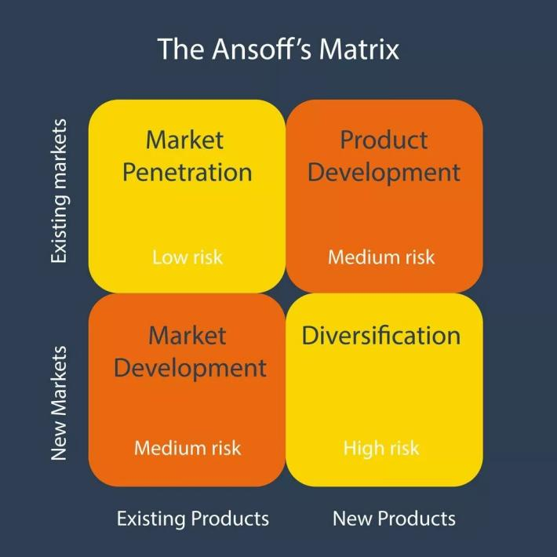
Chart.3 Strategic management tool - Ansoff’s Matrix
- Market Penetration: This quadrant focuses on increasing market share in existing markets with existing products. J&J can explore different strategies like expanding distribution channels, increasing promotion efforts, and offering competitive pricing to attract more customers (Capon & Go, 2016). The company can also target specific segments within their existing markets by tailoring their offerings to meet specific needs (Todorov & Akbar, 2018).
- Market Development: This quadrant aims to enter new markets with existing products. J&J can examine potential geographical expansion opportunities by entering emerging markets and untapped regions where they currently have limited presence (Koch, 2011). The company can capitalize on new customer segments and increase revenue when adapting their products and marketing strategies to these new markets (Reeves et al, 2015).
- Product Development: This quadrant entails introducing new products to existing markets. J&J needs investment in research and development to innovate and develop new healthcare products as well as enhance their existing product portfolio. The company can stay ahead of the competition and enhance their market position after meeting evolving customer needs (Rainey, 2005). Additionally, they can explore partnerships to incorporate new technologies into their product offerings.
- Diversification: This quadrant requires entering new markets with new products. J&J can consider diversifying their product portfolio into related industries. For example, the opportunities in digital health solutions, telemedicine, or personalized medicine deserves to be identified in healthcare industry (Knecht, 2013). However, it’s essential to conduct careful analysis and planning to minimize risks of entering unfamiliar markets.
Several potential growth strategies have been identify by analyzing J&J’s strategic direction through Ansoff’s Matrix. It’s important for the organisation to evaluate each quadrant and select the most appropriate strategies based on J&J’s capabilities, resources, and market dynamics. The continuous monitoring of the external environment and customer needs is also critical for successfully implementing these strategies, in order to retain a sustainable competitive advantage in the backdrop of a pandemic.

1.1.4 PESTEL analysis
The PESTEL analysis is a strategic management tool for organizations to assess the external macro-environmental factors associated with their business (Grünig & Kühn, 2018; Aliekperov, 2021; Johnson, 2020). A thorough strategic analysis of J&J will be investigated using the PESTEL framework.
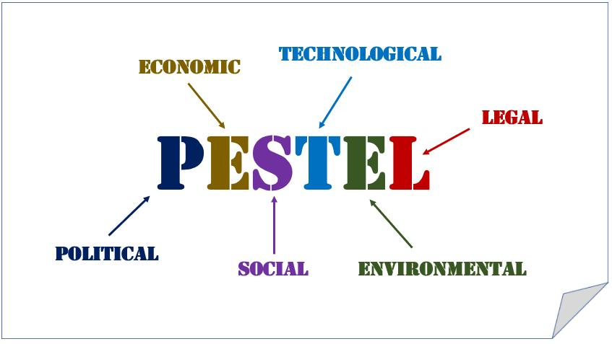
Chart.4 Detailed factors included in PESTEL analysis
- Political Factors: J&J’s operations in multiple countries must comply with various regulations related to product quality, safety, and advertising. The organisation’s operations and market access can be affected by changes in healthcare policies and regulations (Iacovidou et al, 2017). In certain regions, the political instability can affect the company’s supply chain and market presence (Mohammad et al, 2022).
- Economic Factors: J&J’s performance is influenced by the overall economic conditions in the countries where it operates. The economic downturns can affect consumer spending on healthcare products (Vivek, 2022). As a multinational company, currency fluctuations can impact the organisation’s profits and global competitiveness (Martin, 2018).
- Socio-cultural Factors: The global trend towards aging populations presents both challenges and opportunities for J&J in terms of developing products and services focusing on age-related health concerns. As consumer attitudes and preferences towards healthcare products are evolving, the organisation needs to cater to these changes positively (Okafor & Daniel, 2021). There is an increasing focus on preventive healthcare and overall well-being, which may create opportunities for healthcare industries to develop new products and services (Berniak-Woźny & Rataj, 2023).
- Technological Factors: Rapid technological advancements can influence J&J’s product development and innovation strategies. The use of digital platforms and technologies in healthcare present opportunities for healthcare industries, such as telemedicine, remote monitoring, and online sales to enhance customer care and engagement (Alharbi et al, 2022; Cohn, 2011).
- Environmental Factors: J&J needs to align its operations with environmental sustainability practices. These measures can minimize its carbon footprint and address growing consumer demand for eco-friendly products (Albi et al, 2023). Proper disposal of medical waste is crucial for the reputation and environmental impact of the company (Thaveewatanaseth & Limjirakan, 2018).
- Legal Factors: The ability for protection of J&J’s intellectual property is vital to maintain its competitive advantage and prevent unauthorized use of its products (Paul & Townsend, 1997). The organisation must comply with stringent regulations related to product safety, testing, and labeling (Handtke et al, 2019).
The comprehensive PESTEL analysis can identify the key external factors affecting J&J’s strategic direction. This analysis will provide insights into potential opportunities and threats that the company needs to consider in order to deliver innovative customer care and maintain a sustainable competitive advantage. It’s still the main challenge posed by the pandemic and the broader external environment.

1.2 Internal analysis•
1.2.1 Value Chain Analysis
Value Chain Analysis is a strategic management tool, which helps organizations identify and analyze the key activities involved in delivering value to customers (Ďurišová, 2010; Bloomsbury Publishing Plc, 2015). An internal analysis of J&J has been conducted using the Value Chain framework.
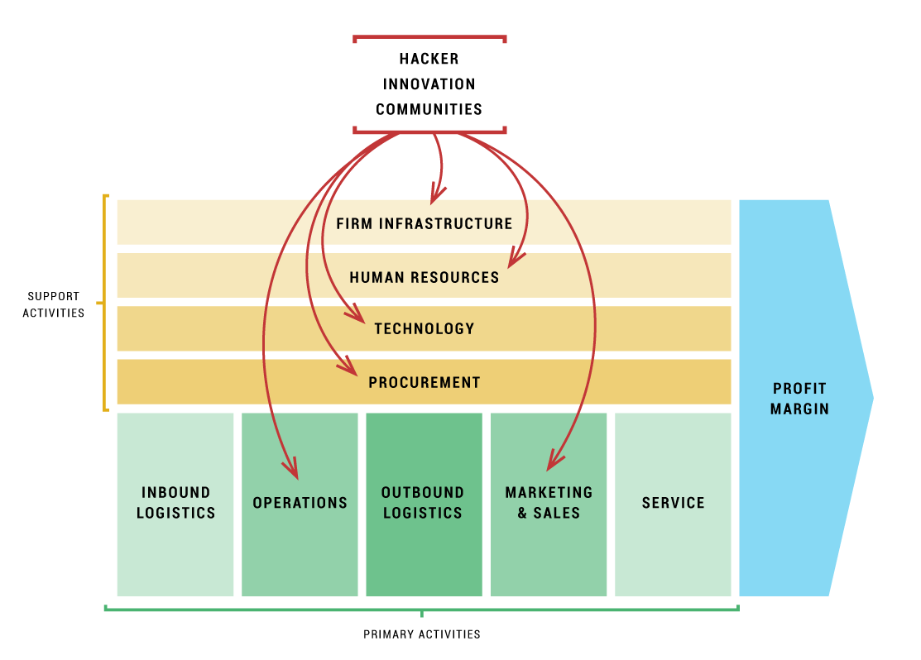
Chart.5 Detailed structure for Value Chain Analysis
- Inbound Logistics: J&J’s success depends on reliable and sustainable suppliers providing high-quality raw materials for its healthcare products (Montgomery & Oladapo, 2014). The efficient management of the supply chain timely deliveries materials to manufacturing facilities (Walters & Helman, 2019).
- Operations: J&J must invest in R&D to develop innovative products to meet customer needs and differentiate themselves from competitors. Efficient and high-quality manufacturing processes are crucial for producing safe and effective healthcare products (Hokey, 2014). It’s also essential for rigorous quality standards to maintain customer trust and comply with regulatory requirements.
- Outbound Logistics: J&J must optimize its distribution network to ensure timely delivery of products to retailers, hospitals, and healthcare providers. Meanwhile, effective inventory management should be conducted to reduce costs and minimize stockouts (Tierney, 2017).
- Marketing and Sales: J&J uses various marketing strategies to build and maintain its brand image and promote its products to consumers and healthcare professionals. A well-trained sales force is essential for establishing and maintaining relationships with healthcare providers and driving sales (Gamble et al, 2004).
- Service: It’s crucial for J&J to provide after-sales support responding to customer queries in order to enhancing customer satisfaction. The organisation can provide value-added services by educating consumers on health-related issues and promoting healthy living.
- Firm Infrastructure: J&J’s decision-making effectiveness and ethical practices can be promoted by strong corporate governance. A positive and inclusive workplace culture can attract and retain talented employees (Walters & Rainbird, 2007). Otherwise, the application of advanced technology and data analytics can improve internal processes and decision-making.
This thorough analysis of J&J’s internal value chain has identified the concise areas of strength and weakness the organisation. This analysis helps to understand how the company’s internal activities contribute to customer care, resilience, and competitive advantage. It enables the organisation to identify opportunities for improvement and innovative strategies, which can reshape J&J’s strategic direction, especially in the context of the pandemic and shifting customer needs.

1.2.2 Resource-Based View
Resource-Based View is a strategic management framework focusing on the internal resources and capabilities of an organisation to gain a competitive advantage (Penrose, 1959; Wernerfelt, 1984; Amit & Schoemaker, 1993). An internal analysis of J&J is conducted using Resource-Based View framework.
- Tangible Resources: J&J’s strong financial position permits investment in research and development, acquisitions, and marketing initiatives. The company owns manufacturing facilities, distribution centers, and an extensive network of sales offices globally, which has invested in advanced technologies and equipment to develop innovative healthcare products.
- Intangible Resources: J&J’s patents, trademarks, and copyrights protect the innovative products and provide a competitive advantage. The strong brand reputation built over decades contributes to customer loyalty and trust (Dierickx & Cool, 1989). A culture of innovation, collaboration, and ethical practices fosters a positive work environment and attracts top talent.
- Human Resources: J&J’s employees contribute to the development of cutting-edge healthcare solutions, including scientists, researchers, and healthcare professionals (Barney, 1986). The company invests in training and development programs to facilitate employees developing necessary skills and expertise.
- Organizational Capabilities: The innovation abilities of J&J helps differentiate the company from competitors. An efficient and well-managed supply chain promote the company to deliver products reliably and timely (Conner, 1991; Peteraf, 1993). It would contribute to J&J’s success in the market through effective marketing strategies and strong relationships with healthcare professionals.
- Strategic Alliances: J&J needs to partner with external entities to access expertise, share knowledge, and develop innovative healthcare solutions (Newbert, 2008).
The Resource-Based View framework has identified unique strengths and opportunities for delivering innovative customer care and maintaining a sustainable competitive advantage during the pandemic. This analysis helps the organisation understand how the internal resources can be leveraged, combined, or developed to create value for customers and stay ahead of the competition.

- Critical evaluation of strategic options for personalised customer care
The ongoing pandemic has disrupted traditional business models, which has underscored the need for organisations to adapt and transform their strategies to ensure their sustainability and competitive advantage. According to above analysis, three strategic options have been proposed for J&J, including Digital Transformation and Remote Care, Collaborative Innovation Ecosystem, and Enhanced Customer Engagement and Communication, which focus on delivering innovative customer care in the face of the pandemic. This section will critically evaluate these strategic options by providing insights into the potential benefits and challenges. The wider implications will also be taken into consideration for the proposed strategies on different areas of the organisation.

2.1 Digital Transformation and Remote Care
The COVID-19 pandemic has highlighted the urgency for digital transformation across industries that the healthcare sector is no exception. J&J faces the challenge of reshaping its strategic direction to deliver innovative customer care while navigating the complexities posed by the pandemic. Digital transformation and remote care offers the company the potential to provide personalized customer care, enhance resilience, and establish sustainable competitive advantages.

2.1.1 Benefits of Digital Transformation and Remote Care
- Personalized Customer Care: Digital transformation enables J&J to collect customer data and leverage advanced analytics to tailor personalized care experiences, which can encompass remote consultations, health monitoring, medication reminders, and customized treatment plans.
- Increased Accessibility: Remote care eliminates geographical barriers, which enables customers to receive healthcare services from anywhere. This can be particularly beneficial for individuals with limited mobility or residing in underserved areas.
- Cost Efficiency: Digital platforms can streamline operations, reduce overhead costs, and improve resource allocation. Remote care leads to cost savings for both the company and customers by minimizing the need for physical infrastructure and travel expenses.
- Scalability: Digital transformation allows J&J to rapidly scale its customer care offerings and then expand its reach to a larger audience. This scalability can be crucial during the pandemic and beyond with increased demand and without compromising service quality.

2.1.2 Challenges and Mitigation Strategies
- Digital Divide: Not all customers have equal access to digital technologies or the necessary digital literacy. J&J must consider outreach programs, partnerships, and innovative solutions to bridge the digital divide.
- Data Privacy and Security: J&J must prioritize robust data privacy and security measures with the increased collection and utilization of customer data. It will build trust with customers and conform to regulatory standards, such as HIPAA compliance.
- Human Touch: While digital transformation offers numerous benefits, it’s important not to overlook the human element in customer care. J&J should strike a balance between digitally-driven care and maintaining personal connections.

2.1.3 Implications & Considerations
- Customer Care: Implementing a digital transformation strategy would provide J&J with innovative customer care solutions. The company can provide personalized and round-the-clock support to patients, healthcare professionals, and other stakeholders when integrating with technologies like AI-powered chatbots and telehealth platforms.
- Research and Development: Digital transformation and remote care offer opportunities for J&J to revolutionize its research and development processes. Advanced analytics, artificial intelligence, and machine learning can optimize the drug discovery process, clinical trials, and product development, which would accelerate innovation and improve time-to-market for life-saving pharmaceuticals and medical devices.
- Supply Chain and Logistics: As adopting digital transformation, J&J can enhance supply chain visibility, resilience, and efficiency. The implementation of advanced technologies such as blockchain, IoT, and data analytics would empower the company to monitor and optimize inventory levels. These improvements would enable the organisation to respond effectively to pandemic-related challenges and potentially reduce costs.
- Human Resources and Workforce: Digital transformation entails reskilling and upskilling the workforce to leverage new technologies for remote working models. J&J needs to invest in training programs, workshops, and technological support to facilitate a smooth transition. Moreover, a remote work culture would offer the opportunity to attract and retain top talent from a wider geographic pool.
- Sales and Marketing: Digital transformation would revolutionize J&J’s sales and marketing strategies. It would enable the organisation to reach a wider audience and gather valuable customer insights by implementing customer relationship management systems, leveraging social media platforms, and adopting personalized digital marketing campaigns. J&J can strengthen its market presence and drive revenue growth by delivering targeted and tailored messaging.
- Information Security and Data Privacy: J&J must prioritize information security and data privacy with increased digitalization. Rampant cyber threats demand robust security measures, seamless data encryption, and strict compliance with applicable regulations. J&J can protect the sensitive patient and customer data by leveraging digital technologies while implementing adequate safeguards.
The strategic option of digital transformation and remote care holds significant potential for J&J in delivering personalized customer care, future resilience, and a sustainable competitive advantage. This strategy can be effectively tackled with the appropriate strategies and considerations in the post-pandemic era while challenges such as the digital divide, privacy concerns, and maintaining human touch exist.

2.2 Collaborative Innovation Ecosystem
The development of collaborative innovation ecosystem enables J&J to harness external partnerships, knowledge sharing, and co-creation to enhance personalized customer care. This approach emphasizes collaboration with stakeholders such as healthcare providers, patients, startups, and research institutions. J&J can foster resilience and secure sustainable competitive advantages by leveraging collective intelligence and resources in the midst of the pandemic.

2.2.1 Benefits of Collaborative Innovation Ecosystem
- Co-creation and User-Centric Solutions: Collaboration with diverse stakeholders brings together different perspectives to develop customized solutions matching customer needs. Co-creation ensures that solutions are tailored to individual preferences and health conditions to enhance customer satisfaction.
- Rapid Innovation and Agility: A collaborative ecosystem facilitates access to external expertise, technologies, and resources which can accelerate innovation. Thus, J&J can swiftly respond to the evolving demands of the pandemic for the delivery of cutting-edge customer care.
- Enhanced Access to Market Opportunities: Collaborating with startups and research institutions opens up opportunities for J&J to tap into emerging technologies and markets. It enables the company to stay ahead of competitors and offer differentiated products/services.
- Improved Cost Effectiveness: A collaborative approach enables cost-sharing and resource optimization for greater efficiency in research, development, and deployment of personalized customer care solutions. It can help reduce costs and increase profitability in the long run.

2.2.2 Challenges and Mitigation Strategies
- Intellectual Property Protection: J&J may necessitate sharing intellectual property when collaborating with external partners. The organisation should establish clearly defined agreements to protect its proprietary information while fostering collaboration.
- Alignment of Objectives and Values: Diverse stakeholders may have different goals and values. It’s essential to maintain collaborative synergies for alignment and effective communication of objectives. Regular engagement and transparent communication channels can foster a shared vision and build trust among partners.
- Governance and Decision-making Processes: Management of collaborative innovation ecosystem requires establishing robust governance structures to facilitate effective decision-making. J&J should institute clear frameworks to manage conflicts of interest, maintain direction, and support equitable value-sharing mechanisms.

2.2.3 Implications & Considerations
- Customer Care: Developing a Collaborative Innovation Ecosystem will enable J&J to tap into a wide range of external partners, including startups, research institutions, and technology providers. The company can gain valuable insights, co-create enhanced services and products, and better address customer needs by collaborating closely with these entities.
- Research and Development: The Collaborative Innovation Ecosystem offers J&J an opportunity to expand its research and development capabilities. The company can access cutting-edge technologies, novel scientific approaches, and fresh perspectives by collaborating with external partners. This partnership-driven model allows for increased agility, accelerated innovation, and the development of breakthrough solutions.
- Supply Chain and Logistics: Implementing a Collaborative Innovation Ecosystem can enhance the resilience and efficiency of J&J’s supply chain and logistics operations. Collaborative partnerships can improve visibility, streamline processes, and mitigate disruptions to strengthen the company’s supply chain resilience.
- Human Resources and Workforce: Developing a Collaborative Innovation Ecosystem necessitates a strong focus on human resources and workforce development. J&J should foster a culture of collaboration for knowledge-sharing as well as creating opportunities for cross-functional and inter-organizational collaboration. This measure can attract top talent and promote innovation and creativity.
- Sales and Marketing: The Collaborative Innovation Ecosystem presents J&J with opportunities to enhance sales and marketing strategies. Collaborations with marketing agencies, data analytics firms, and digital platforms can unlock new customer segments and enable personalized marketing campaigns. The company can maintain a competitive advantage and better position its products and services.
- Information Security and Data Privacy: With increased collaborations, J&J must prioritize information security and data privacy. Robust protocols and agreements with external partners is essential to maintain trust and protect sensitive data. It will safeguard confidential information and mitigate cybersecurity risks.
Collaborative innovation ecosystem as a strategic option empowers J&J to deliver personalized customer care for achieving sustainable competitive advantages. After collaborating with various stakeholders, the company can co-create user-centric solutions, accelerate innovation, tap into new market opportunities, and optimize costs. Intellectual property protection, alignment of objectives, and effective governance can be addressed through appropriate mitigation strategies. J&J can creatively reshape its strategic direction and foster a thriving ecosystem to deliver innovative customer care during and after the pandemic.

2.3 Enhanced Customer Engagement and Communication
The strategy of enhanced customer engagement and communication enables J&J to establish deeper relationships with its customers. This approach emphasizes proactive and personalized interactions. J&J can navigate the complexities of the pandemic and differentiate itself from competitors by leveraging effective communication channels and technologies.

2.3.1 Benefits of Enhanced Customer Engagement and Communication
- Tailored Solutions: Improved customer engagement allows J&J to gain a deeper understanding of individual preferences and needs. The company can enhance customer satisfaction and loyalty by offering tailored solutions.
- Real-time Feedback and Proactive Support: Engagement strategies, such as feedback platforms and social media monitoring, enable J&J to gather real-time insights, identify emerging trends, and respond rapidly to customer concerns. It facilitates proactive support to adapt J&J’s offerings to meet evolving customer expectations.
- Building Trust and Brand Reputation: Open and transparent communication builds up trust with customers. J&J can enhance its brand reputation and foster long-term customer loyalty by providing accurate and timely information.
- Customer-driven Innovation: It can lead to breakthrough innovations by engaging customers in co-creation activities and involving them in the product development process. J&J’s offerings can truly address customers’ needs and distinguish the company in the market by actively involving customers and incorporating their input.

2.3.2 Challenges and Mitigation Strategies
- Data Privacy and Security: Engagement with customers necessitates the collection and storage of personal data. J&J must prioritize data privacy and security obeying legal and ethical standards. It can build customer trust by implementing robust data protection measures and transparent privacy policies.
- Scalability and Resource Allocation: Implementing enhanced customer engagement and communication requires significant resources. J&J should prioritize investments in technology infrastructure, skilled personnel, and training. A phased implementation approach could help manage scalability challenges.
- Cultural and Linguistic Diversity: Global operations demand effective communication strategies tailored to diverse cultural and linguistic backgrounds. J&J should invest in localization and cultural sensitivity training to ensure effective engagement across its customer base.

2.3.3 Implications & Considerations
- Customer Care and Experience: Adopting an enhanced customer engagement and communication fosters a customer-centric approach across the organization. J&J can deliver superior customer care and improve the overall customer experience by leveraging digital platforms, personalized marketing campaigns, and proactive communication strategies.
- Research and Development: Enhanced Customer Engagement and Communication can influence J&J’s research and development efforts. The organisation can obtain valuable insights into their needs and preferences, which guides research and development initiatives aligning with customer expectations and emerging trends.
- Sales and Marketing: Emphasizing enhanced customer engagement and communication is instrumental in optimizing J&J’s sales and marketing efforts. The organisation can identify and engage with potential customers more effectively by leveraging data analytics, social media platforms, and targeted messaging. This approach allows for the development of tailored marketing strategies, expansion into new markets, and increased sales revenue.
- Supply Chain and Logistics: The strategic option of enhanced customer engagement and communication can positively impact J&J’s supply chain and logistics operations. The organisation can enhance agility, coordination, and responsiveness within the supply chain by maintaining transparent communication channels with suppliers, distributors, and logistics partners.
- Human Resources and Workforce: Enhanced customer engagement and communication strategy necessitates a skilled and customer-oriented workforce. J&J should focus on recruiting and training employees with excellent communication skills and understanding of customer needs. The organisation can empower employees to deliver exceptional customer care and contribute to its competitive advantage.
- Information Technology and Data Management: Successful implementation of the enhanced customer engagement and communication strategy relies heavily on robust information technology infrastructure and effective data management practices. J&J should invest in technology solutions for real-time customer engagement, streamline data collection and analysis as well as data privacy and security.
- Corporate Social Responsibility and Ethical Considerations: This strategy should align with J&J’s social responsibility and ethical considerations. The organisation should establish transparency, open dialogue, and responsible marketing practices while engaging with customers.
Adopting an enhanced customer engagement and communication strategy presents J&J with opportunities to deliver more personalized customer care during and after the pandemic. The company can deepen relationships with customers while building trust, loyalty, and brand reputation by leveraging tailored solutions, real-time feedback, proactive support, and customer-driven innovation. J&J can effectively reshape its strategic direction and position itself for sustainable competitive advantage in the ever-evolving business landscape.

Conclusions
In conclusion, this report has provided external and internal strategic analysis of J&J comprehensively and evaluated strategic options critically for more personalized customer care. The proposed strategy combining digital transformation and customer centricity would enable J&J to navigate the challenges posed by the pandemic. J&J can reshape its strategic direction effectively to improve customer care and promote long-term success.

Recommendations
Based on the conducted strategic analysis of J&J and the aim of delivering innovative customer care, several strategic recommendations are proposed as shown below.
- Prioritize Digital Transformation:
- Investing in scalable digital infrastructure, including telehealth capabilities, data analytics, and AI-powered platforms.
- Establishing a robust cybersecurity framework to maintain customer data privacy and protect against cyber threats.
- Developing user-friendly interfaces for seamless customer interactions.

2. Cultivate Collaborative Innovation:
- Creating internal teams to identify and evaluate potential collaboration opportunities.
- Implementing flexible partnership models to support joint research and development initiatives.
- Evaluating the effectiveness and impact of innovation projects regularly.

3. Promote Customer Engagement:
- Implementing customer segmentation strategies to tailor communication approaches based on individual needs.
- Applying customer feedback and experiences to continuously improve personalized care offerings.
- Leveraging social media platforms to listen, engage, and interact with customers.

Bibliography
Oluwo, M. 2007. Strategic use of financial ratio to prevent bankruptcy: a study of opportunity for business enterprises. Dissertations & Theses - Gradworks.

Kotler, & Philip. 2007. Marketing management. Upper Saddle River, 17(1), 99-99.

Siaw, I. & Yu, A. 2004, "An Analysis of the Impact of the Internet on Competition in the Banking Industry, using Porter's Five Forces Model", International Journal of Management, vol. 21, no. 4, pp. 514-523.

Gold, M.A., Godsey, L.D. & Cernusca, M.M. 2005, "Competitive market analysis of eastern redcedar", Forest Products Journal, vol. 55, no. 12, pp. 58-65.

Brosnan, S., Doyle, E. & Sean O’Connor 2016, "From Marshall’s Triad to Porter’s Diamond: added value?", Competitiveness Review, vol. 26, no. 5, pp. 500-516.

Anderson, G.M., Halcoussis, D., Johnston, L. & Lowenberg, A.D. 2000, "Regulatory barriers to entry in the healthcare industry: The case of alternative medicine", Quarterly Review of Economics and Finance, vol. 40, no. 4, pp. 485-502.

Wei-Ming, O. & Kang-Wei, C. 2007, "Use of Leadership and Differentiation Strategies by Professional Service Firms: A Case Study", International Journal of Management, vol. 24, no. 3, pp. 477-488,619.

Keller, G.F. 2011, "Comparing the Affects of Management Practices on Organizational Performance Between For-Profit and Not-For-Profit Corporations in Southeast Wisconsin", Journal of Management Policy and Practice, vol. 12, no. 5, pp. 86-95.

Eldring, J. 2009, Porter´s (1980) Generic Strategies, Performance and Risk: An Empirical Investigation with German Data, 1st edn, Diplomica Verlag, Hamburg.

Pretorius, M. 2008, "When Porter's generic strategies are not enough: complementary strategies for turnaround situations", The Journal of business strategy, vol. 29, no. 6, pp. 19-28.

Wicker, P., Soebbing, B.P., Feiler, S. & Breuer, C. 2015, "The effect of Porter's generic strategies on organisational problems of non-profit sports clubs", EJSS.European Journal for Sport and Society, vol. 12, no. 3, pp. 281-307.

Akan, O., Allen, R.S., Helms, M.M. & Spralls,Samuel A., I.,II 2006, "Critical tactics for implementing Porter's generic strategies", The Journal of business strategy, vol. 27, no. 1, pp. 43-53.

Islami, X., Mustafa, N. & Topuzovska Latkovikj, M. 2020, "Linking Porter’s generic strategies to firm performance", Future Business Journal, vol. 6, no. 1.

Hlavacka, S., Bacharova, L., Rusnakova, V. & Wagner, R. 2001, "Performance implications of Porter's generic strategies in Slovak hospitals", Journal of management in medicine, vol. 15, no. 1, pp. 44-66.

Kumar, K., Subramanian, R. & Yauger, C. 1997, "Pure versus hybrid: Performance implications of Porter's generic strategies", Health care management review, vol. 22, no. 4, pp. 47-60.

Viltard, L.A. 2017, "STRATEGIC MISTAKES (AVOIDABLE): THE TOPICALITY OF MICHEL PORTER’S GENERIC STRATEGIES", Independent Journal of Management & Production, vol. 8, no. 2, pp. 474-497.

Wayland, M. & Wayland, M.S. 2015, Strategic Analysis for Healthcare Concepts and Practical Applications, Health Administration Press, Chicago.

The Oxford Handbook of Strategy: A Strategy Overview and Competitive Strategy, 2006, Oxford University Press, Incorporated, Oxford.

Capon, N. & Go, F. 2016, Frameworks for Market Strategy: European Edition, Taylor & Francis Group, London.

Todorov, K. & Akbar, Y.H. 2018, Strategic Management in Emerging Markets: Aligning Business and Corporate Strategy, Emerald Publishing Limited, Emerald Publishing Limited, Bingley, Bingley.

Koch, R. 2011, The Financial Times Guide to Strategy: How to Create, Pursue and Deliver a Winning Strategy, 4th edn, Pearson Education, Limited, Harlow.

Reeves, M., Haanaes, K. & Sinha, J. 2015, Your Strategy Needs a Strategy: How to Choose and Execute the Right Approach, Harvard Business Review Press, Boston.

Rainey, D.L. 2005, Product Innovation: Leading Change Through Integrated Product Development, Cambridge University Press, Cambridge.

Knecht, M. 2013, Diversification, Industry Dynamism, and Economic Performance: The Impact of Dynamic-Related Diversification on the Multi-business Firm, 1st edn, Springer Fachmedien Wiesbaden GmbH, Wiesbaden.

Grünig, R. & Kühn, R. 2018, The Strategy Planning Process: Analyses, Options, Projects, Springer Berlin / Heidelberg, Springer Berlin / Heidelberg, Berlin, Heidelberg, Berlin, Heidelberg.

Aliekperov, A. 2021, Creating Business and Corporate Strategy: An Integrated Strategic System, Taylor & Francis Group, Milton.

Johnson, W.H.A. 2020, Managing Global Strategy: Developing an Effective Strategy in International Business, Taylor & Francis Group, Milton.

Iacovidou, E., Busch, J., Hahladakis, J.N., Baxter, H., Kok, S.N. & Herbert, B.M.J. 2017, "A Parameter Selection Framework for Sustainability Assessment", Sustainability, vol. 9, no. 9, pp. 1497.

Mohammad, F.A., Zainol, Z., Siaw, Y.T., Noor Hisham, A.G., Azman, M.J., Mohd Zaki, M.A. & Mohamad, N.A. 2022, "Big Data in Criteria Selection and Identification in Managing Flood Disaster Events Based on Macro Domain PESTEL Analysis: Case Study of Malaysia Adaptation Index", Big Data and Cognitive Computing, vol. 6, no. 1, pp. 25.

Vivek, R. 2022, "A Systematic Review of the Consequences of Covid-19 Pandemic and Expansion of Pestle Framework: Time to Perceive Health Environment as a Separate Dimension", International Economic Policy, , no. 37, pp. 55-76.

Martin, B 2018, Strategic Planning in Healthcare : An Introduction for Health Professionals, Springer Publishing Company, Incorporated, New York. Available from: ProQuest Ebook Central.

Okafor, U.B. & Daniel, T.G. 2021, "Development and Validation of Prenatal Physical Activity Intervention Strategy for Women in Buffalo City Municipality, South Africa", Healthcare, vol. 9, no. 11, pp. 1445.

Berniak-Woźny, J. & Rataj, M. 2023, "Towards Green and Sustainable Healthcare: A Literature Review and Research Agenda for Green Leadership in the Healthcare Sector", International Journal of Environmental Research and Public Health, vol. 20, no. 2, pp. 908.

Alharbi, F., Sabra, M.N.A., Alharbe, N. & Almajed, A.A. 2022, "Towards a Strategic IT GRC Framework for Healthcare Organizations", International Journal of Advanced Computer Science and Applications, vol. 13, no. 1.

Cohn, K 2011, Getting It Done: Experienced Healthcare Leaders Reveal Field-Tested Strategies for Clinical and Financial Success : Experienced Healthcare Leaders Reveal Field-Tested Strategies for Clinical and Financial Success, Health Administration Press, Chicago.

Albi, T., Ma, S., Rehman, A.U. & Yusuf, S.U. 2023, "Green Operation Strategies in Healthcare for Enhanced Quality of Life", Healthcare, vol. 11, no. 1, pp. 37.

Thaveewatanaseth, K. & Limjirakan, S. 2018, "Key factors of low carbon development strategy for sustainable transport", IOP Conference Series.Earth and Environmental Science, vol. 117, no. 1.

Paul, R.J. & Townsend, J.B. 1997, "Some legal and managerial strategies for managing healthcare fraud", Health marketing quarterly, vol. 14, no. 3, pp. 19-33.

Handtke, O., Schilgen, B. & Mösko, M. 2019, "Culturally competent healthcare – A scoping review of strategies implemented in healthcare organizations and a model of culturally competent healthcare provision", PLoS One, vol. 14, no. 7.

Ďurišová, J. 2010, "Value chain analysis and its position within other value-oriented concepts", Scientific Papers of the University of Pardubice.Series D.Faculty of Economics and Administration, , no. 16, pp. 65-76.

Putting Labour in Its Place: Labour Process Analysis and Global Value Chains, 2015, Bloomsbury Publishing Plc, London.

Montgomery, E.G. & Oladapo, V. 2014, "TALENT MANAGEMENT VULNERABILITY IN GLOBAL HEALTHCARE VALUE CHAINS: A GENERAL SYSTEMS THEORY PERSPECTIVE", Journal of Business Studies Quarterly, vol. 5, no. 4, pp. 173-189.

Walters, D. & Helman, D. 2019, Strategic Capability Response Analysis: The Convergence of Industrié 4. 0, Value Chain Network Management 2. 0 and Stakeholder Value-Led Management, Springer International Publishing AG, Springer International Publishing AG, Cham, Cham.

Hokey, M. 2014, Healthcare Supply Chain Management: Basic Concepts and Principles, Business Expert Press, Business Expert Press, New York, New York.

Tierney, N.W. 2017, Value Management in Healthcare: How to Establish a Value Management Office to Support Value-Based Outcomes in Healthcare, 1st edn, Productivity Press, Milton.

Gamble, J.E., Savage, G.T. & Icenogle, M.L. 2004, "Value-Chain Analysis of a Rural Health Program: Toward Understanding the Cost Benefit of Telemedicine Applications", Hospital topics, vol. 82, no. 1, pp. 10-7.

Walters, D, & Rainbird, M 2007, Strategic Operations Management : A Value Chain Approach, Bloomsbury Publishing Plc, London. Available from: ProQuest Ebook Central.

Penrose, E. T. 1959, The Theory of the Growth of the Firm, Cambridge, MA.

Wernerfelt, B. 1984, A resource-based view of the firm. Strategic Management Journal, 5(2), 171-180.

Amit, R., & Schoemaker, P. J. 1993, Strategic assets and organizational rent. Strategic Management Journal, 14(1), 33-46.

Dierickx, I. & Cool. K. 1989, Asset stock accumulation and sustainability of competitive advantage. Management Science, 35, 1504-1511.

Barney, J. B. 1986, Organizational culture: can it be a source of sustained competitive advantage? Academy of management review, 11(3), 656-665.

Conner, K. R. 1991, A historical comparison of resource-based theory and five schools of thought within industrial organization economics: do we have a new theory of the firm?. Journal of Management, 17(1), 121-154.

Peteraf, M. 1993, The cornerstones of competitive advantage: A resource-based view. Strategic Management Journal, 14, 179-192.

Newbert, S.L. 2008, Value, rareness, competitive advantage, and performance: A conceptual-level empirical investigation of the resource-based view of the firm. Strategic Management Journal, 29, 745-768.

Appendices
Johnson & Johnson Background
Johnson & Johnson (J&J) is an American multinational corporation that was founded in 1886. It is one of the world’s largest healthcare companies, operating through three main segments: Consumer Health, Pharmaceutical, and Medical Devices.
J&J was founded by three brothers, Robert Wood Johnson, James Wood Johnson, and Edward Mead Johnson. Initially, the company focused on creating sterile surgical dressings and other medical products. Over the years, it expanded its product line and entered various healthcare sectors through acquisitions and organic growth.
J&J offers a wide range of products, including pharmaceuticals, over-the-counter drugs, medical devices, diagnostics, and consumer healthcare products. Some of its well-known brands include Band-Aid, Listerine, Tylenol, Neutrogena, Johnson’s Baby products, Acuvue, and many more.
J&J has served customers in over 60 countries around the world. The company maintains a strong foothold in the healthcare market due to its diverse portfolio and reputation for high-quality products. With its broad range of offerings, J&J caters to both consumer and professional healthcare markets.
In terms of financial performance, J&J has consistently shown robust figures. In 2020, it reported net sales of $82.6 billion with a 0.6% increase from the previous year. The pharmaceutical segment contributed the highest revenue, followed by medical devices and consumer health. The company has a strong cash flow and invests significantly in research and development.
J&J operates under a decentralized organizational structure, with various business segments having their own leadership teams. The CEO and Chairman of the company is Alex Gorsky. J&J has a reputation as a highly diversified organisation, which allows it to adapt to changing market dynamics effectively.
In recent years, J&J has faced various legal challenges related to product safety, including lawsuits related to its talcum powder and opioid products. These cases have had an impact on the company’s reputation and financials, which leaded to significant legal costs and settlements.
Overall, J&J has a long history of innovation and has positioned itself as a major player in the healthcare industry. Its extensive product portfolio, global presence, and financially stable position have contributed to its strong market presence and continued success.

