Strategic Analysis and Sustainable Growth

Madalina Blaglosov 2207678

Table of Contents
Executive Summary 4
1 Introduction 5
2 External Analysis 5
2.1 PESTEL Analysis 5
2.2 Porter’s Five Forces 7
2.3 Key Economic Trends 7
3 Internal Analysis 8
3.1 Resource-Based View (RBV) Analysis 8
3.2 Value Chain Analysis 9
3.3 SWOT Analysis 10
4 Strategy Formulation and Competitive Positioning 11
4.1 Current Strategic Positioning 11
4.2 Growth Strategies (Ansoff’s Matrix) 12
4.3 Mergers and Acquisitions (MandA) 12
5 Sustainability and Strategic Recommendations 13
5.1 Sustainability Initiatives and Strategic Implications 13
5.2 Strategic Recommendations 13
6 Conclusion 14
References 15

Executive Summary
This report critically examines Sainsbury’s strategic position, competition, internal capabilities and sustainability. Competing in a highly competitive UK grocery sector, the company must balance cost leadership and differentiation to retain market share. Strategic adaptation becomes the need of the day owing to external challenges like inflation, supply chain disruptions and changes in consumer behaviour. While Sainsbury’s strengths are digital transformation, brand equity, and sustainability efforts, profit is being weighed down by rising costs and competition. Among other key recommendations, supply chain sustainability should be improved, and digital operations should be expanded and considered to begin international growth. Sainsbury’s can support the company’s competitive advantage and long-term success by integrating sustainability into its core strategy.

Introduction
Sainsbury’s is the largest supermarket chain in the UK, with 1,400 stores and millions of customers weekly (Yang et al., 2023). It is a highly competitive market and plays a key role in competing with Tesco, ASDA, and rising discounters such as Aldi and Lidl. Due to its strategic positioning, supply chain management and sustainability efforts, the company is a good subject for strategic analysis. The UK grocery sector is highly volatile, inflationary pressured and has changed consumer preferences, which requires businesses to react quickly. To remain competitive, Sainsbury’s should balance cost leadership and differentiation and tackle the sustainability problems (Solanki et al., 2024). The rising operational costs, supplier constraints, and digital transformation pressures complement the situation. An analysis of Sainsbury’s competitive landscape, internal capabilities, and sustainability initiatives will help us understand how Sainsbury can cope with these challenges and maintain long-term growth in an increasingly dynamic market.

External Analysis

PESTEL Analysis
Sainsbury's retail environment is dynamic and influenced by macro factors such as the economy (Scarr et al., 2024). After Brexit, post policies still create political disruption to supply chains and increase import costs. Introducing new border cheques in 2024 will create a financial strain and impact pricing strategies. In addition, minimum wage increases make operational costs rise, leaving Sainsbury’s to cut operational costs and optimise efficiency. High inflation has also made consumers more economically vulnerable, so they shop increasingly at Aldi and Lidl. Sainsbury’s expands Aldi Price Match and bolsters its brand value range (Scarr et al., 2024). Margins have also been hit due to rising energy costs, meaning that stores must be designed to be energy efficient. Consumer demand for health-conscious and plant-based products has socialled, and Sainsbury’s has responded by expanding its Plant Pioneers range.
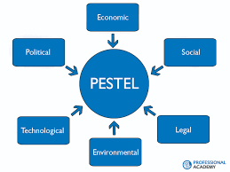
Figure 1 PESTEL Analysis
So much investment continues in e-commerce to drive customers to shop online, as digital sales account for a substantial portion of revenue for any business. Sainsbury’s has technology advancing AI-based ‘demand forecasting’ and autonomous checkout systems to eliminate inefficiencies (Samadzadeh, 2024). Digital transformation efforts such as increased data analytics and loyalty programs improve an intensely competitive market. Retailers are more pressured to follow sustainability regulations due to the increasing environmental pressure. Supermarkets are required to manage packaging sustainability in new waste disposal policies, and the company’s net zero target for 2040 requires huge investments in renewable energy and supply chain sustainability (Rusanen, 2023). Therefore, regulations, such as changes to high-fat, sugar, and salt (HFSS) products, must be adapted to legal requirements, formulation, and advertising strategies. The operational complexity includes compliance with data protection and labour laws as well.

Porter’s Five Forces
However, rapid grocery delivery startups present a challenge to the threat of new entrants, which is low because of high capital investment requirements (Sahidi and Nadda, 2025). Due to import restrictions and rising costs, supplier power has increased, particularly in fresh food. This is mitigated by Sainsbury’s, which secures long-term contracts with local suppliers. The price-sensitive consumers are switching brands frequently. Thus, buyer power is high. Sainsbury’s has been forced to maintain aggressive pricing strategies as the Aldi, Lidl and price comparison tools have expanded. Meeting the challenge of substitutes is coming through meal kit services and food delivery platforms capturing spending at traditional supermarkets as the former rise in popularity (Rop, 2023). There is intense competition between Tesco, ASDA, and discounters in price wars. The main part of Sainsbury’s differentiation strategy is still based on selling premium products and convenience.
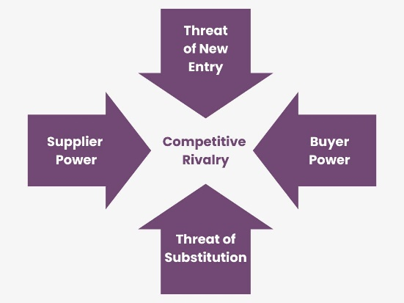
Figure 2 Porter's Five Forces

Key Economic Trends
The UK retail sector faces economic uncertainty, changing consumer behaviour and sustainability issues (Osiyevskyy et al., 2024). The affordability of the master plan is becoming a key issue due to rising living costs, making pricing strategy crucial. Digital transformation investments and investments in e-commerce are increasingly essential for competitiveness. Regulatory compliance and green innovations stay connected to the dominant force of Sustainability (Ndlovu, 2024). The leadership role Sainsbury plays when it comes to sustainable retail has been evidenced by its commitment to net zero emissions and reducing plastic waste.

Internal Analysis

Resource-Based View (RBV) Analysis
Sainsbury’s has good resources and capabilities, which will help it compete in the UK grocery market (Liu, 2023). Customer loyalty and market trust are also solidified, with its brand value over £6.8 billion. With digital sales almost tripling from 2021 to nearly 18% of total revenue in 2023, the company’s robust retail infrastructure is based on a very extensive physical store network with more than 1,400 locations. Supply chain efficiency is increased by tangible resources like its automated distribution centres, which shorten delivery times and lower operating costs (Li et al., 2023).
As a result, the company’s investment in demand forecasting based on AI has reduced stockouts and decreased food waste by 11% yearly. Sainsbury’s also has major intellectual property in logistics and retail technology, including a customer data analytics platform to make promos and retention more personal (Jones et al., 2025). Still, the last mile remains out of the control of online sellers, as they rely on third-party delivery services. In addition, although it still has a stable financial position, with an annual revenue of more than £30 billion, its net profit margin of 1.6% is lower than Tesco’s 3.3%, resulting from fewer cost efficiencies (Hartfield, 2024).
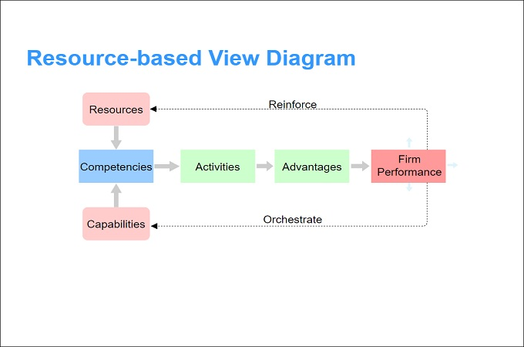
Figure 3 Resource-Based View Method

Value Chain Analysis
Strategic supplier partnerships in Sainsbury’s inbound logistics help offset the rising cost of post-Brexit import tariffs (Grashuis and Hakelius, 2023). Automating warehouses and route optimisation will reduce distribution costs by 5% in 2023 through investment. It has also reduced operational expenses in operations, store refurbishments, and energy-efficient technologies. Nevertheless, rising labour costs, which are being caused by the 7% hike in the minimum wage, are a challenge. Using sandbox data to set up the Nectar loyalty program with 18 million active users allows its marketing and sales strategy to promote data-driven and increase basket size by 12% for frequent users (Do et al., 2023). Sainsbury’s is a key differentiator for their customer service, which has gone on to have same-day delivery in over 500 stores, making for a convenience proposition.
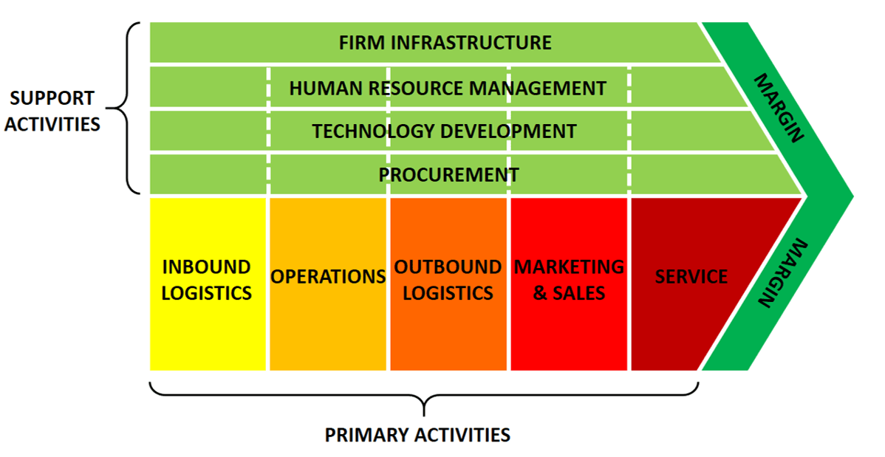
Figure 4 Value Chain Analysis

SWOT Analysis
The strengths of Sainsbury’s are its strong brand reputation, extensive store network, and advanced supply chain technology (de Boer and Chin, 2025). The problem is its relatively lower profitability and vulnerability to price competition. There are opportunities to extend plant-based product lines as the demand for vegan products in the UK has been growing by 11% p.a. Similar improvements should be made in its margins through further digitisation of its supply chain and AI efficiency. Aggressive expansion of discount retailers, rising inflation and higher supplier costs could lead to erosion of competitive advantage if they are left unmanaged strategically (Coyle and Gamberi, 2024).
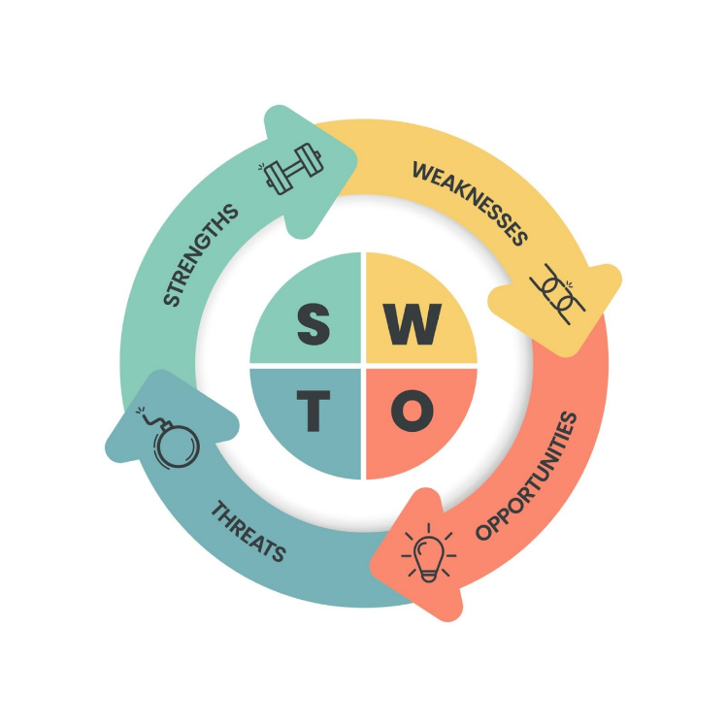
Figure 5 SWOT Analysis

Strategy Formulation and Competitive Positioning

Current Strategic Positioning
A hybrid strategy has been adopted by Sainsbury’s, which combines cost leadership and differentiation and is consistent with Porter’s Generic Strategies (Sahidi and Nadda, 2025). Aldi Price Match, covering more than 300 essential products, is a price-competitive commitment, responding to the growing share of the discount retailer market. However, Sainsbury’s also differentiates itself through high-quality, own-brand products, which account for 52% of total sales (Grashuis and Hakelius, 2023). Its differentiation approach is shown by an 8% year-on-year growth in its premium Taste the Difference range.
Therefore, Sainsbury’s is positioned as a hybrid in the Strategy Clock model, balancing perceived value and cost efficiency (Solanki et al., 2024). Price-matched customers are attracted by price, but middle-income group shoppers are loyal because of superior product quality and service. Yet, Sainsbury’s position is under threat from Aldi and Lidl’s aggressive expansion, which now controls over 18% of the UK grocery market, and Sainsbury’s is forced to refine its pricing and product strategies continuously (Carruthers et al., 2023).

Growth Strategies (Ansoff’s Matrix)
Aggressive price-matching, promotions, and loyalty incentives through the Nectar card, which helped Sainsbury’s retain 12% of customers in 2023, show that market penetration is still Sainsbury’s main strategy (Borrero, 2023). It is also at the digital transformation, with the shares in online grocery sales growing 23% in five years, creating the need for increased investment in e-commerce infrastructure. Sainsbury’s is also focusing on product development, particularly on the sustainable and plant-based categories, and it has continued to add to its Plant Pioneers range in response to the 11% year-on-year demand growth in vegan products (Liu, 2023).
Changing consumer lifestyles also demand increased investment in ready-meals and convenience products. Sainsbury’s on-demand grocery delivery development, partnering with Deliveroo and Uber Eats, is a market development for expansion into these rapid fulfilment services (de Boer and Chin, 2025). Despite diversification, there are no major moves beyond the company's core grocery and retail business. Nevertheless, Sainsbury’s Bank, part of the company’s financial services division, has 1.8 million active customers and is an area in which the company could potentially expand if it is effectively integrated into the wider retail ecosystem (Coyle and Gamberi, 2024).

Mergers and Acquisitions (MandA)
In 2019, in an attempt to merge with Asda, Sainsbury’s put forward a deal priced at £7.3bn, which was blocked after action by the Competition and Markets Authority (CMA) on fears of reduced consumer choice and an increase in prices (Jones et al., 2025). While such a setback will prevent immediate expansion, major MandA activity may arise from acquiring technology-focused grocery platforms or regional convenience stores to improve digital capabilities and geographic reach. The retail sector's consolidation can grow, and strategic acquisitions may be an important lever for long-term competitiveness (Li et al., 2023).

Sustainability and Strategic Recommendations

Sustainability Initiatives and Strategic Implications
In the context of becoming Net Zero by 2040 – a decade ahead of the UK government’s 2050 target – Sainsbury’s has made several sustainability commitments (Rusanen, 2023). Since 2005, the company has cut carbon emissions by 47% and continues investing in solar panels, energy-efficient refrigeration and fleet electrification. However, supply chain emissions remain a hurdle, as more than 95% of its carbon footprint is from suppliers, and stronger partnerships are needed there for emission reductions. However, Sainsbury’s has promised to make 100% of its plastic packaging recyclable by 2025, but only 61% of its plastic packaging was achieved as of 2023 (Rop, 2023). Sainsbury’s hasn’t gone as far as competitor Tesco, which has adopted reusable packaging schemes that Sainsbury’s has yet to adopt fully.

Strategic Recommendations
In order to remain competitive, Sainsbury’s should increase its speed of transition to a fully sustainable supply chain by incorporating supplier carbon reduction targets into its procurement policies (Yang et al., 2023). Further product offerings can be differentiated by expanding its partnerships with ethical and Fairtrade-certified suppliers in premium categories. Due to Sainsbury’s limited global presence, it has the potential to generate new revenue streams by expanding its online operations into high-growth European markets and reducing risk by partnering with some of the regional players in the market and riding on the wave of e-commerce growth trends. Moving towards circular economy initiatives like deposit return schemes for packaging will enable better customer engagement while the government directs environmental policies to bring together producers of products that people use (Rusanen, 2023). Sainsbury’s position as a leader in sustainable grocery retail can future-proof its market share and increase long-term profitability.

Conclusion
Concluded that this report has critically reviewed Sainsbury’s strategic positioning, internal capabilities, competitive environment and sustainability efforts. However, the company operates in a highly competitive UK grocery market in which discounters pressure consumers, change what they buy, and challenge the economy. Market resilience is achieved through its hybrid cost leadership and differentiation strategy, but profitability is an issue. However, with its robust supply chain, digital transformation, and good brand equity, Sainsbury’s strengths are still threatened by rising operational costs and supply chain vulnerabilities. According to industry trends, sustainability initiatives such as carbon reduction and waste management are also progressing, so the process should continue to adapt to sustainable packaging and effective sourcing. To sustain its competitive advantage, Sainsbury’s must increase its rate of innovation, refine supplier relationships, and try out strategic global expansion.

References
Borrero, J.D., 2023. Agri-food Cooperatives’ Online Marketing: Evaluation of the Strategies Utilized by Spanish and UK Food Retailers Pre-and Post-COVID-19 Pandemic. CIRIEC-España, revista de economía pública, social y cooperativa, (107), pp.169-195.
Carruthers, T.R., Huynh, Q.C., Hordyk, A.R., Newman, D., Smith, A.D., Sainsbury, K.J., Stokes, K., Morison, A., Agnew, D., Parma, A. and Sobrino, I., 2023. Method evaluation and risk assessment: a framework for evaluating management strategies for data‐limited fisheries. Fish and Fisheries, 24(2), pp.279-296.
Coyle, D. and Gamberi, L., 2024. A real options approach to data valuation. Business Economics, pp.1-8.
de Boer, E. and Chin, X.Y., 2025. Loyalty Program Currency Valuation, Articulation, and Monetization. In Loyalty Programs and the Currency Effect: A Comprehensive Guide to Realizing the Power of Points (pp. 157-173). Cham: Springer Nature Switzerland.
Do, B., Nguyen, N., Nguyen, H. and Jiang, X., 2023. Examining ecological strategies adopted by agricultural exporting firms in an emerging country. British Food Journal, 125(3), pp.1008-1025.
Grashuis, J. and Hakelius, K., 2023. Pricing strategies of corporations and consumer co-operatives in the food retail sector: Evidence from England, Sweden, and the Netherlands. Journal of Co-operative Organization and Management, 11(1), p.100204.
Hartfield, T.R., 2024. Overcoming Data Barriers: Strategies for New Entrants to Achieve Differentiation in the UK Food Retail Market. Journal of World Economy, 3(3), pp.68-83.
Jones, G.G., Lopes, T.D.S., Pananond, P., van Tulder, R., Sinkovics, N. and Sinkovics, R.R., 2025. Transitioning from responsible and reactive to deeply responsible and proactive international business. Critical Perspectives on International Business, 21(2), pp.196-225.
Li, L., Wang, Y. and Zhang, Y.Y., 2023. A critical examination of MandS's current strategic and marketing position, as well as potential sustainable competitive marketing strategies. International Journal of Science and Business, 18(1), pp.108-117.
Liu, R., 2023. Multi-Perspective Analysis of the Sustainable Transformation of Multinational Companies. Journal of Progress in Engineering and Physical Science, 2(2), pp.59-65.
Ndlovu, S.G., 2024. Private label brands vs national brands: new battle fronts and future competition. Cogent Business and Management, 11(1), p.2321877.
Osiyevskyy, O., Umantsiv, Y. and Kavun, O., 2024. Strategy for striking the omnichannel balance in Retail 4.0. Strategy and Leadership, 52(3/4), pp.7-19.
Rop, F.K., 2023. Influence of corporate social responsibility on sustainable growth of large supermarkets in Kenya (Doctoral dissertation).
Rusanen, O., 2023. The importance of resources. The Red Queen Retail Race: An Innovation Pandemic in the Era of Digitization, p.13.
Sahidi, B. and Nadda, V., 2025. Corporate Governance and Sustainable Development. In Governance Strategies for Effective Sustainable Development (pp. 51-64). IGI Global.
Samadzadeh, M., 2024. Investigating Successful E-Commerce and Digital Marketing Strategies for Major Supermarkets in the UK.
Scarr, J.P., Meddings, D.R., Lukaszyk, C., Vincenten, J.A., Rahman, A., Wills, S. and Jagnoor, J., 2024. A framework for identifying opportunities for multisectoral action for drowning prevention in health and sustainable development agendas: a multimethod approach. BMJ Global Health, 9(8), p.e016125.
Solanki, S., Shah, S. and Hasan, S., 2024, November. The Resilience of UK's Food Retail Supply Chains and Business Strategies. In 2024 IEEE International Conference on Technology Management, Operations and Decisions (ICTMOD) (pp. 1-5). IEEE.
Yang, M., Chen, L., Wang, J., Msigwa, G., Osman, A.I., Fawzy, S., Rooney, D.W. and Yap, P.S., 2023. Circular economy strategies for combating climate change and other environmental issues. Environmental Chemistry Letters, 21(1), pp.55-80.

