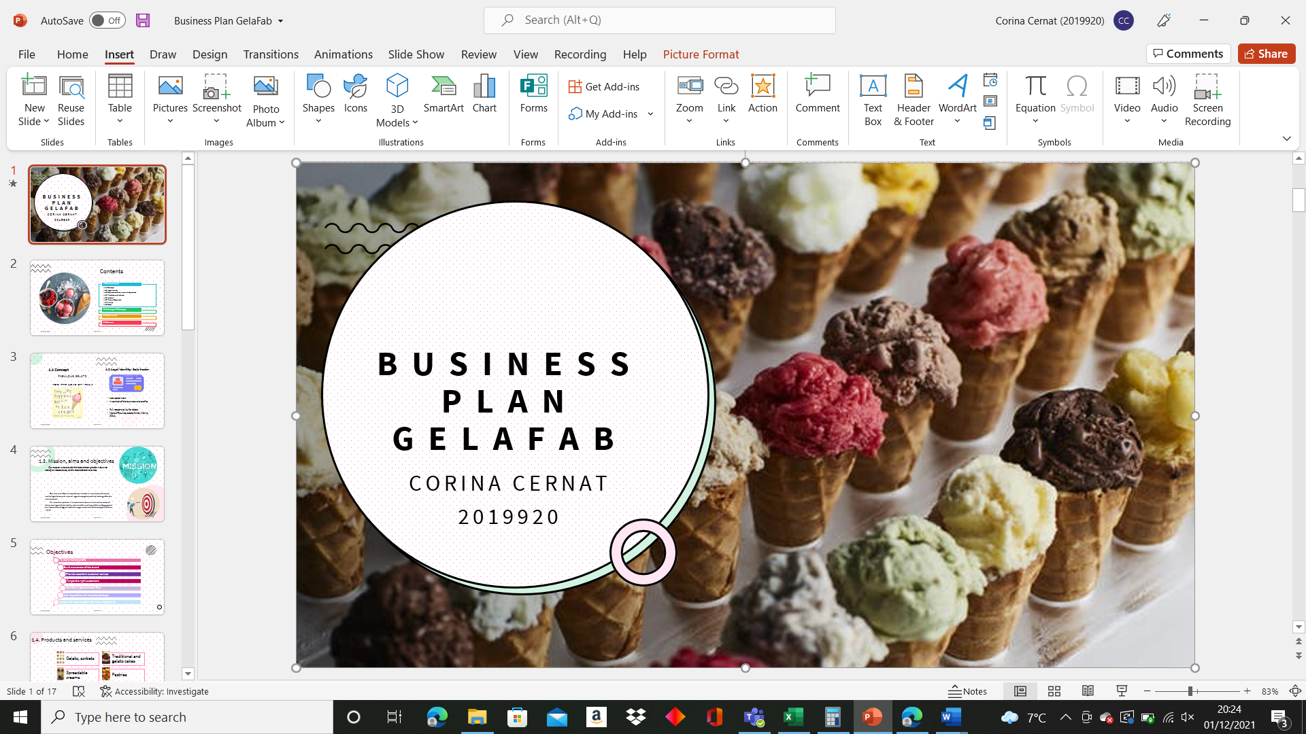
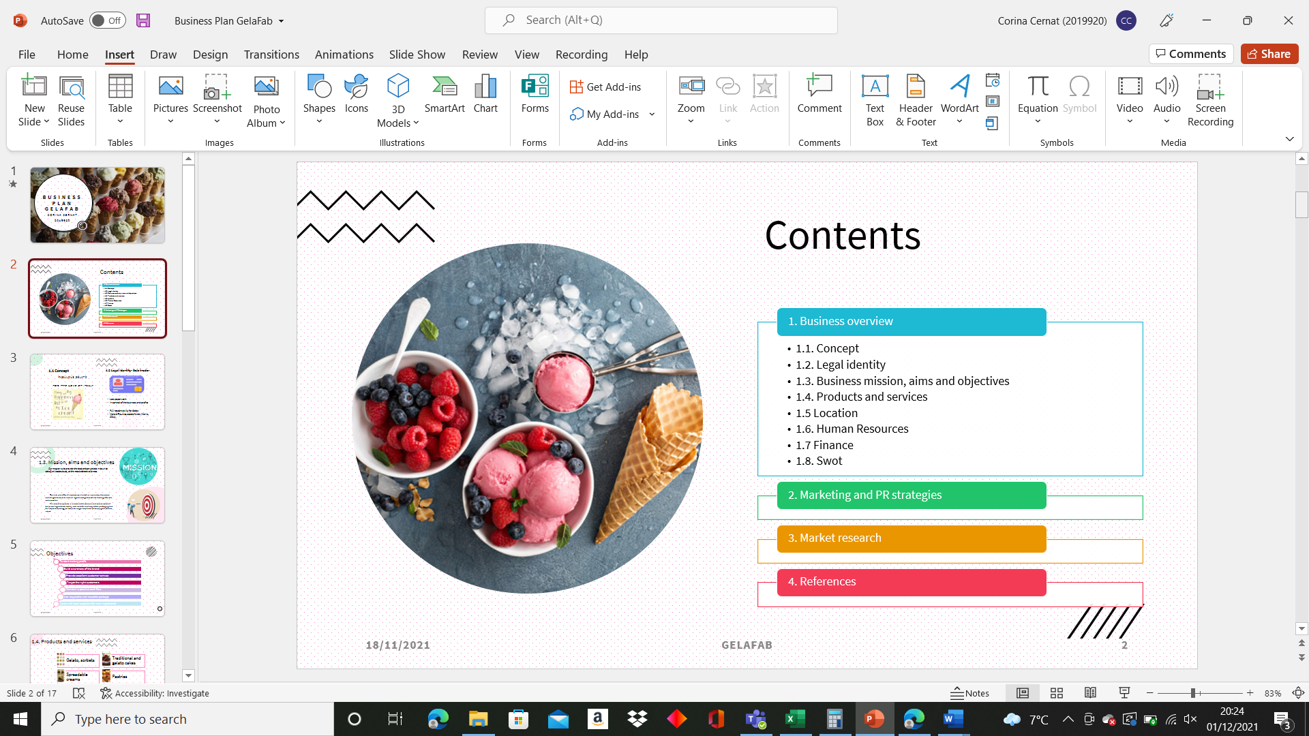
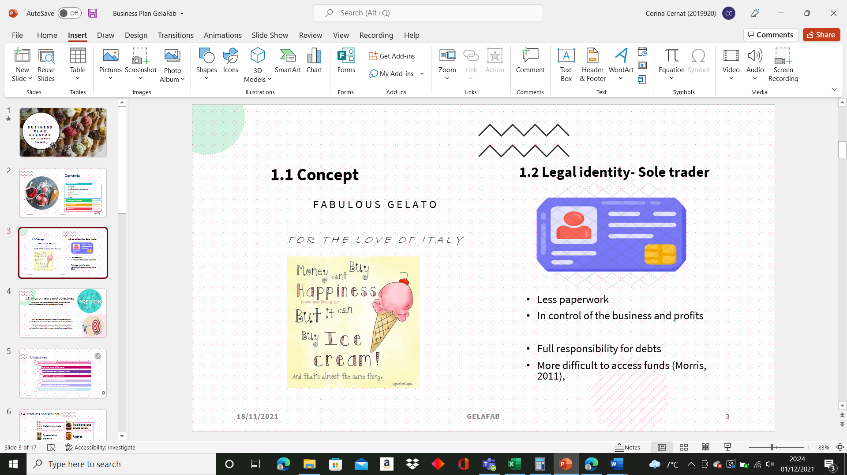
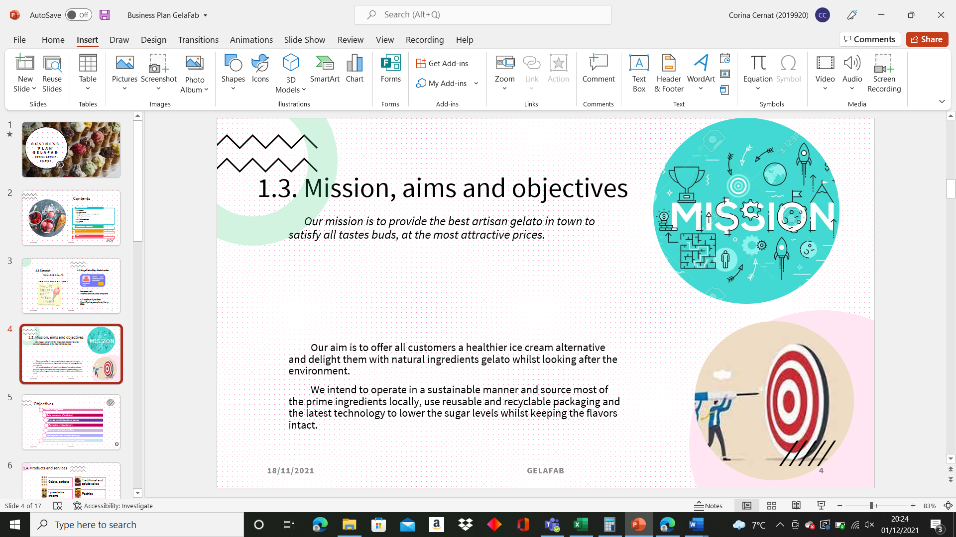
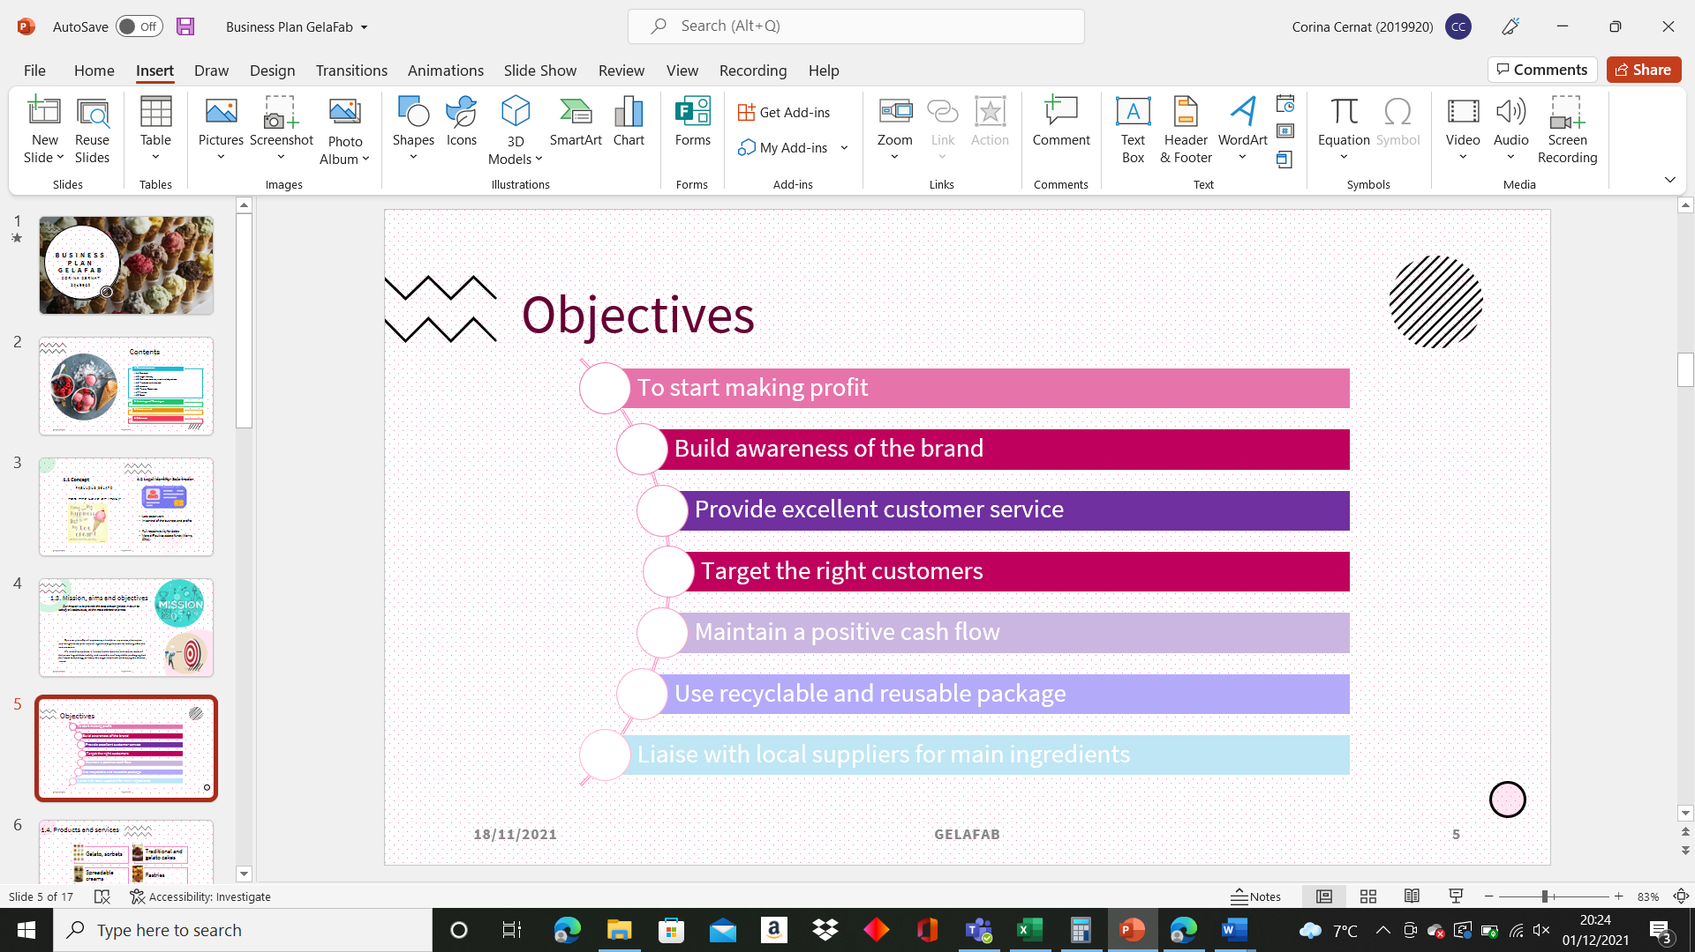
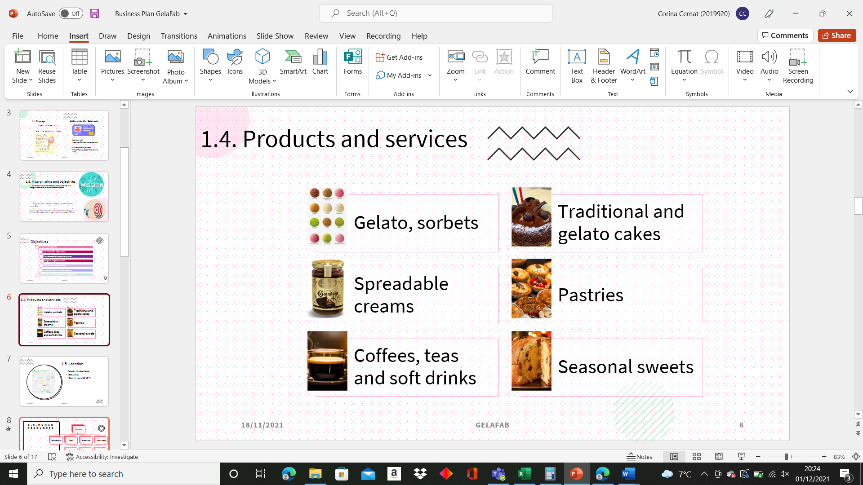
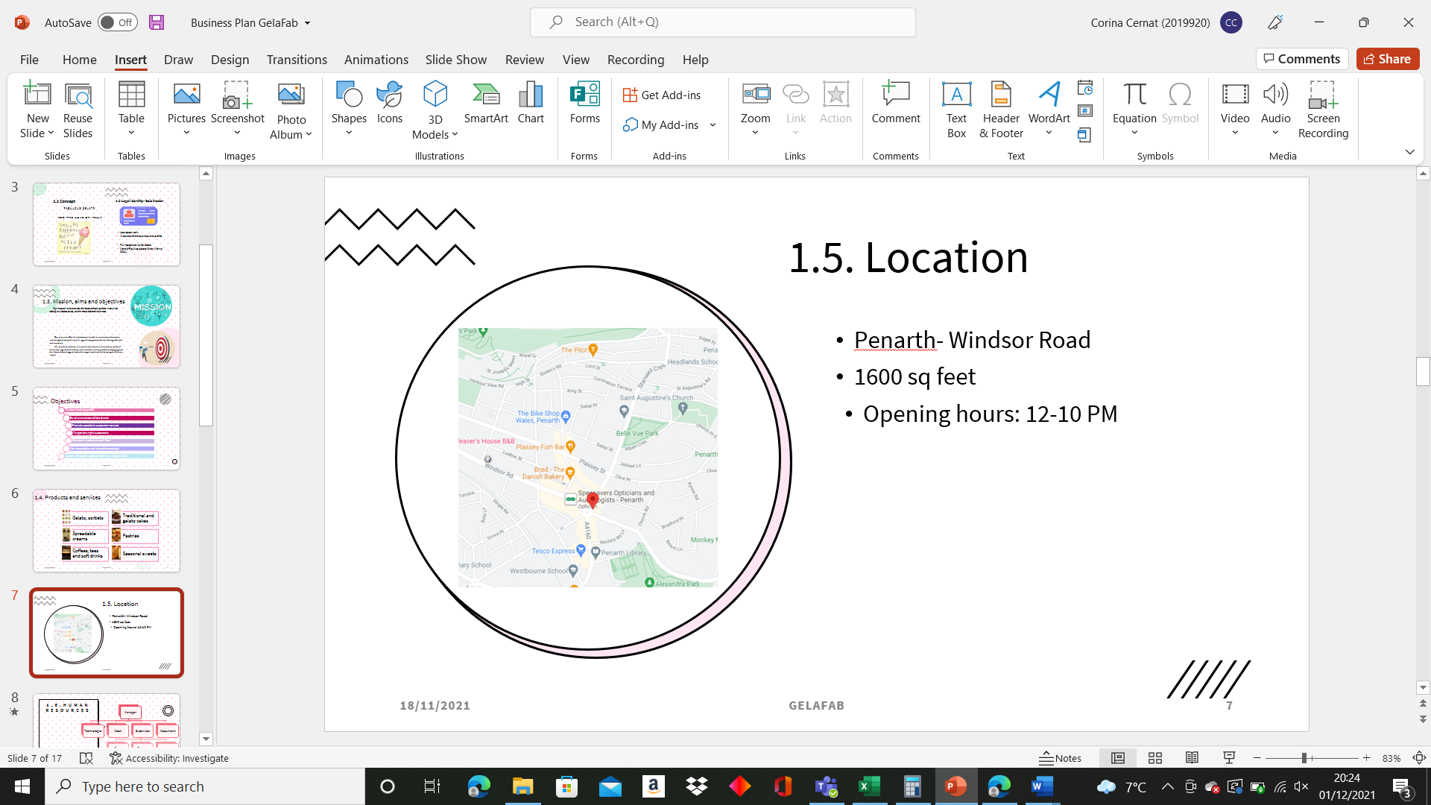
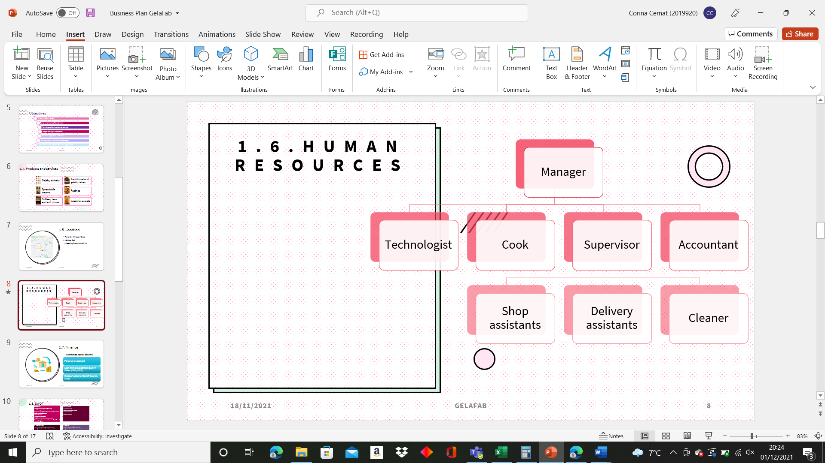
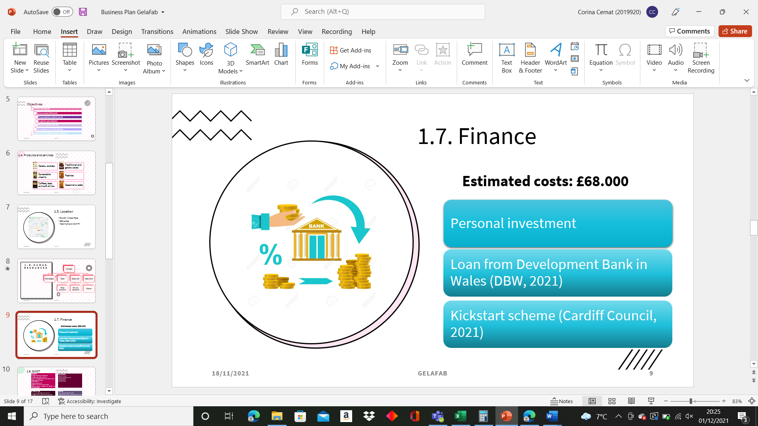
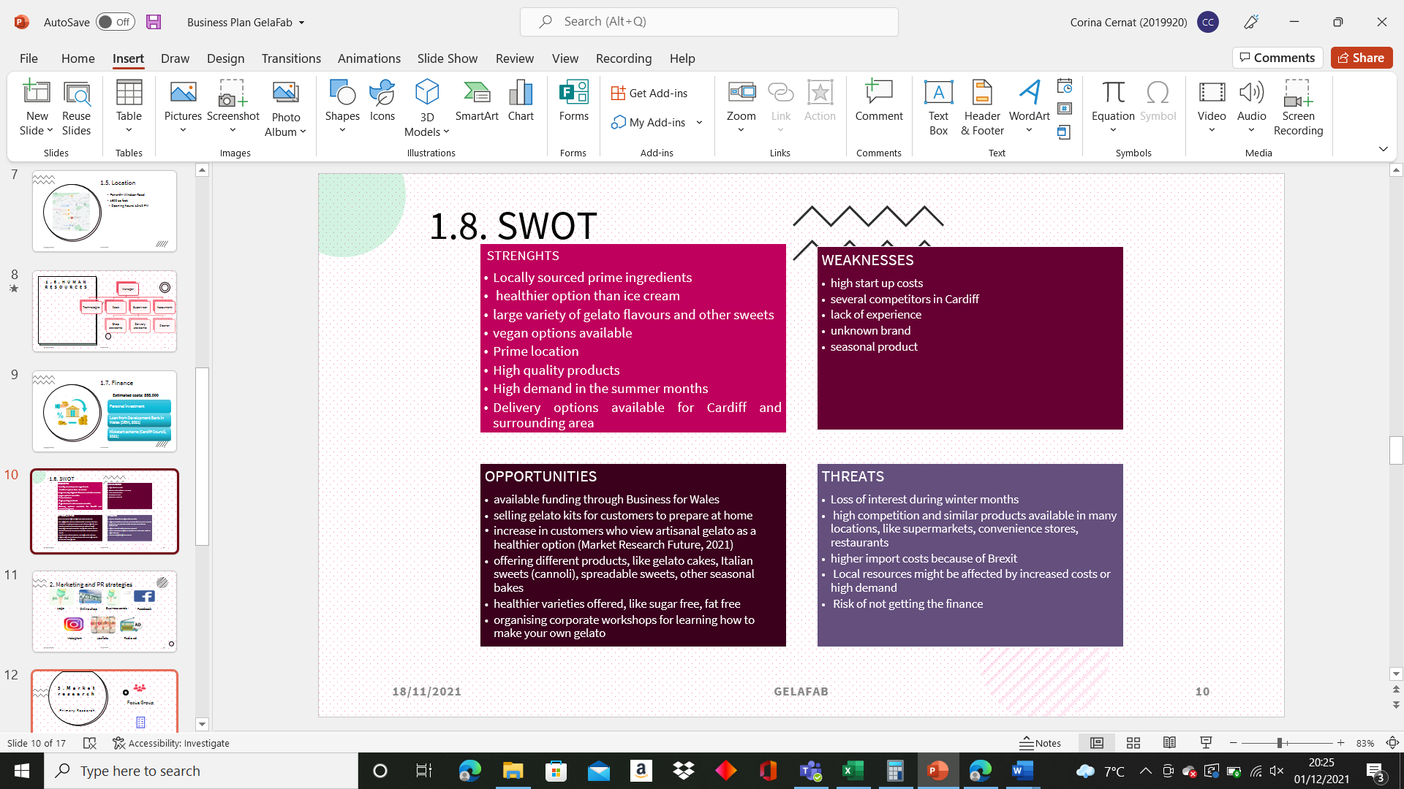
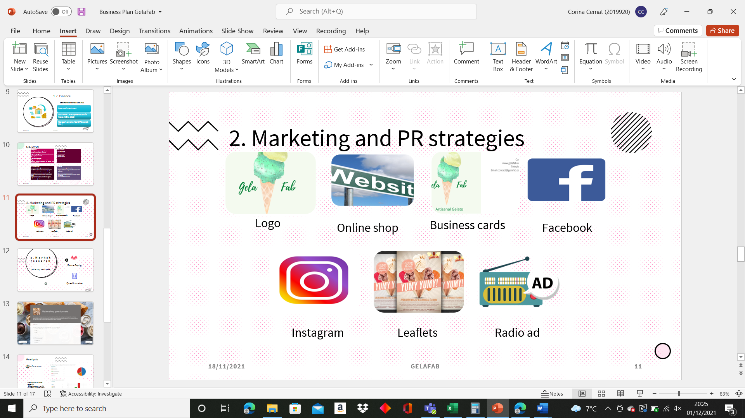
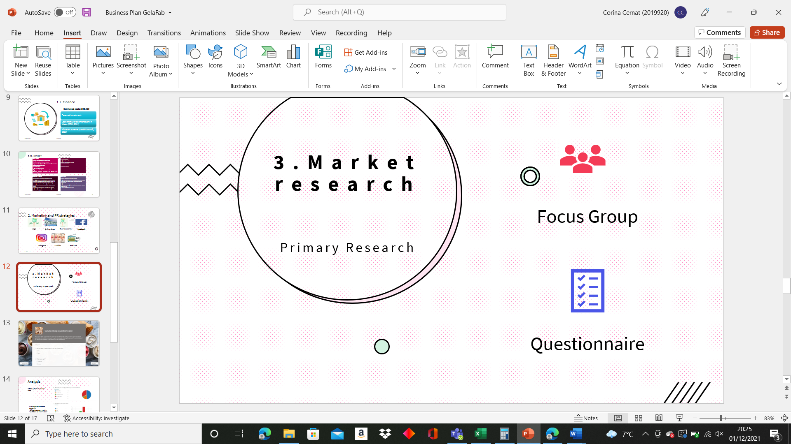
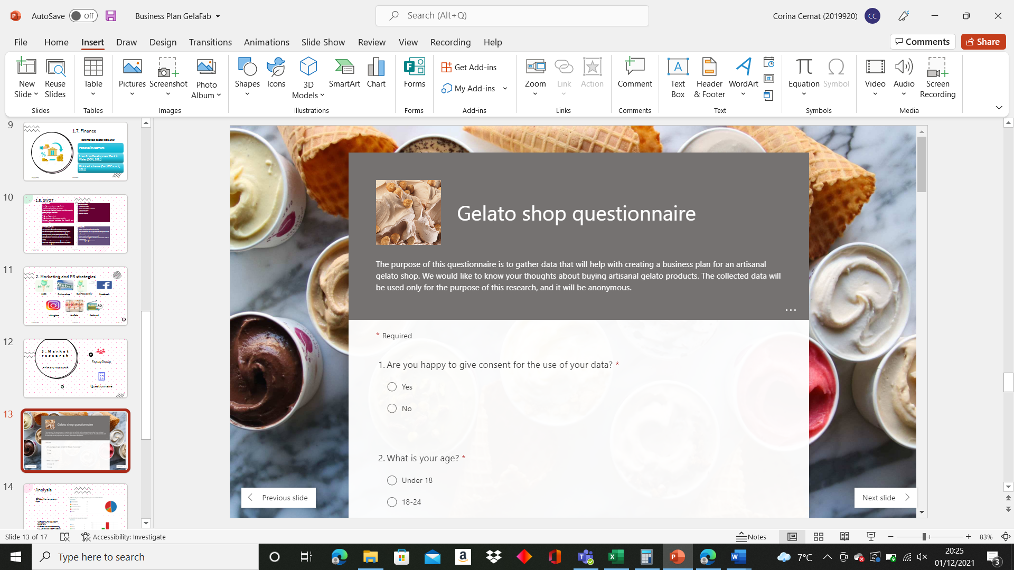
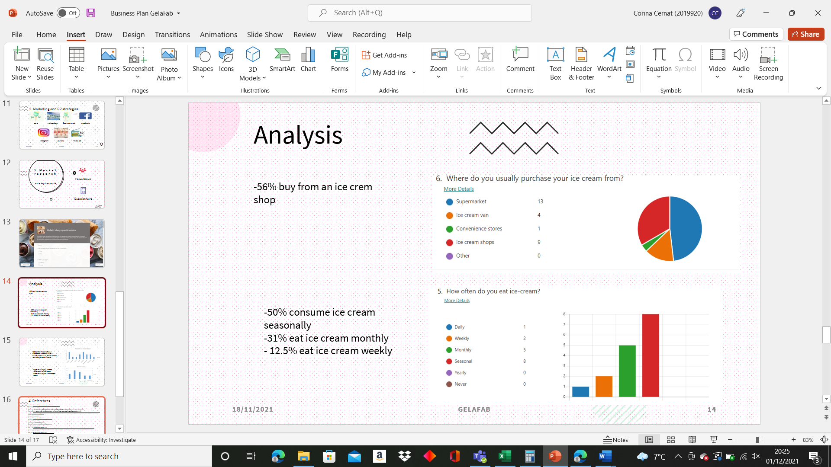
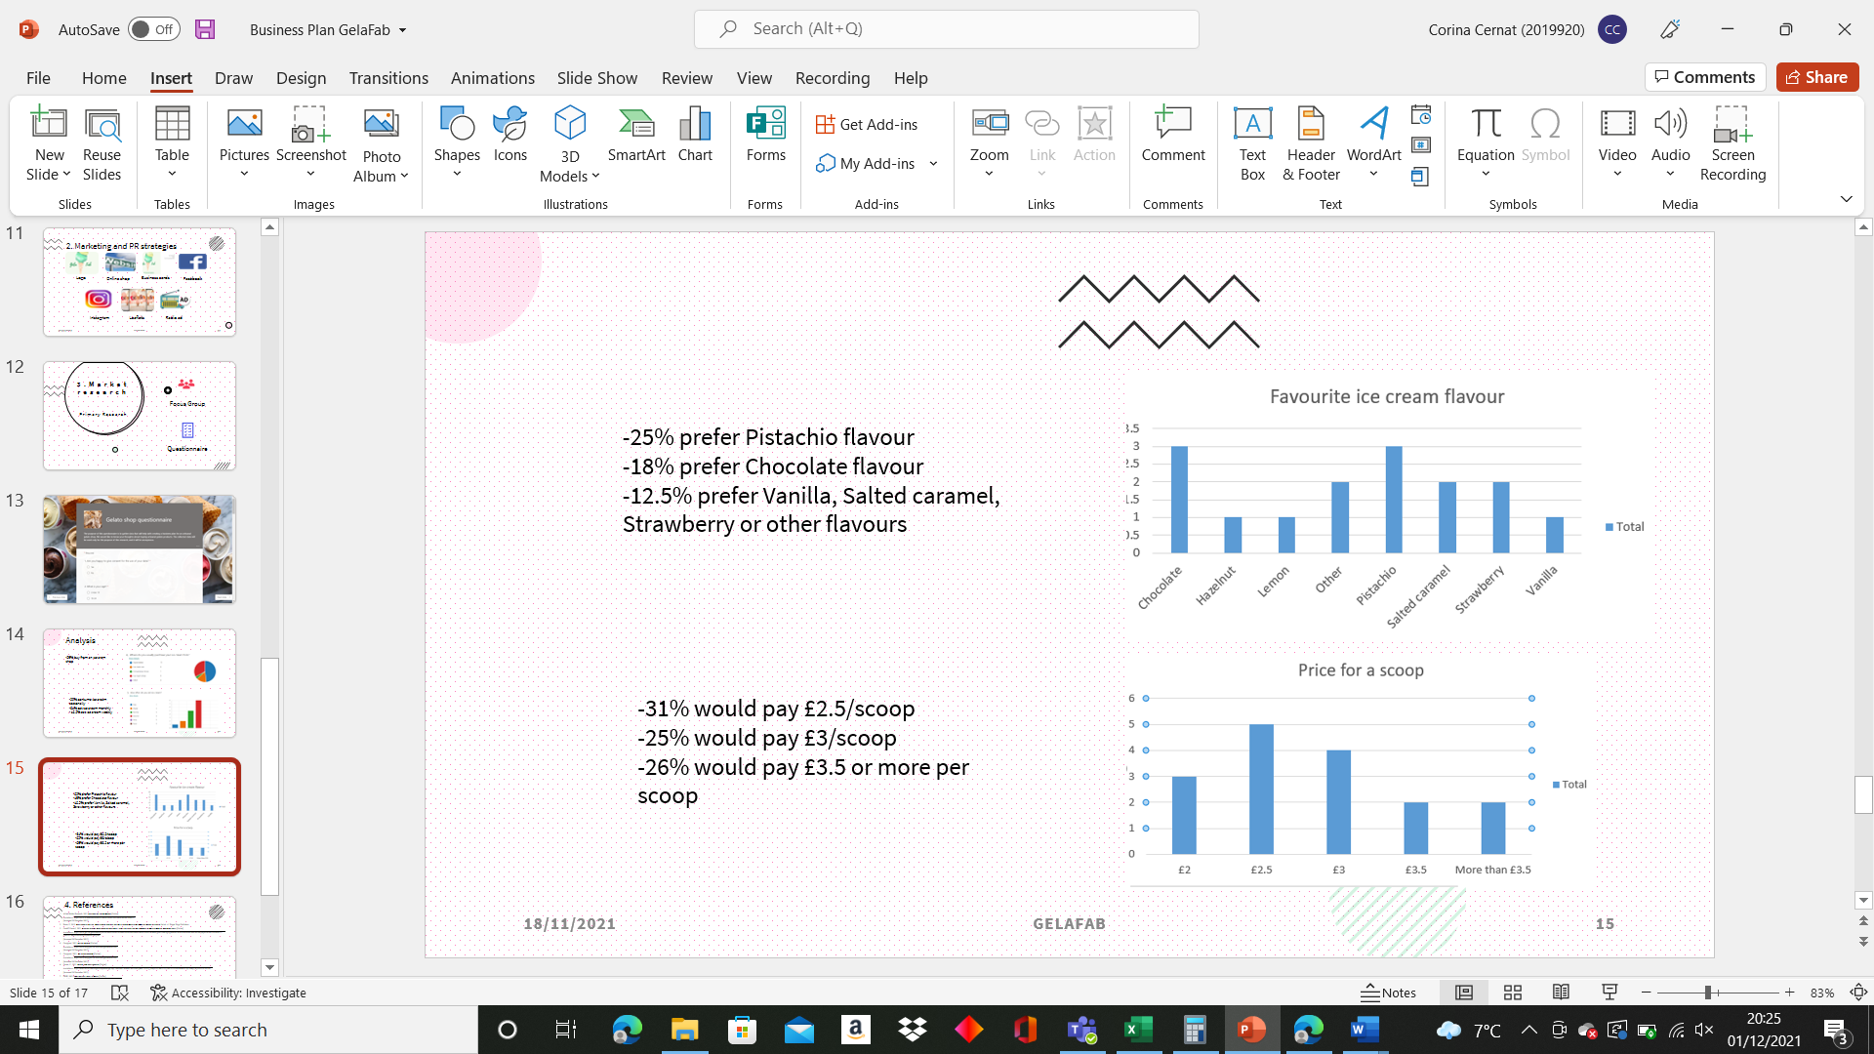
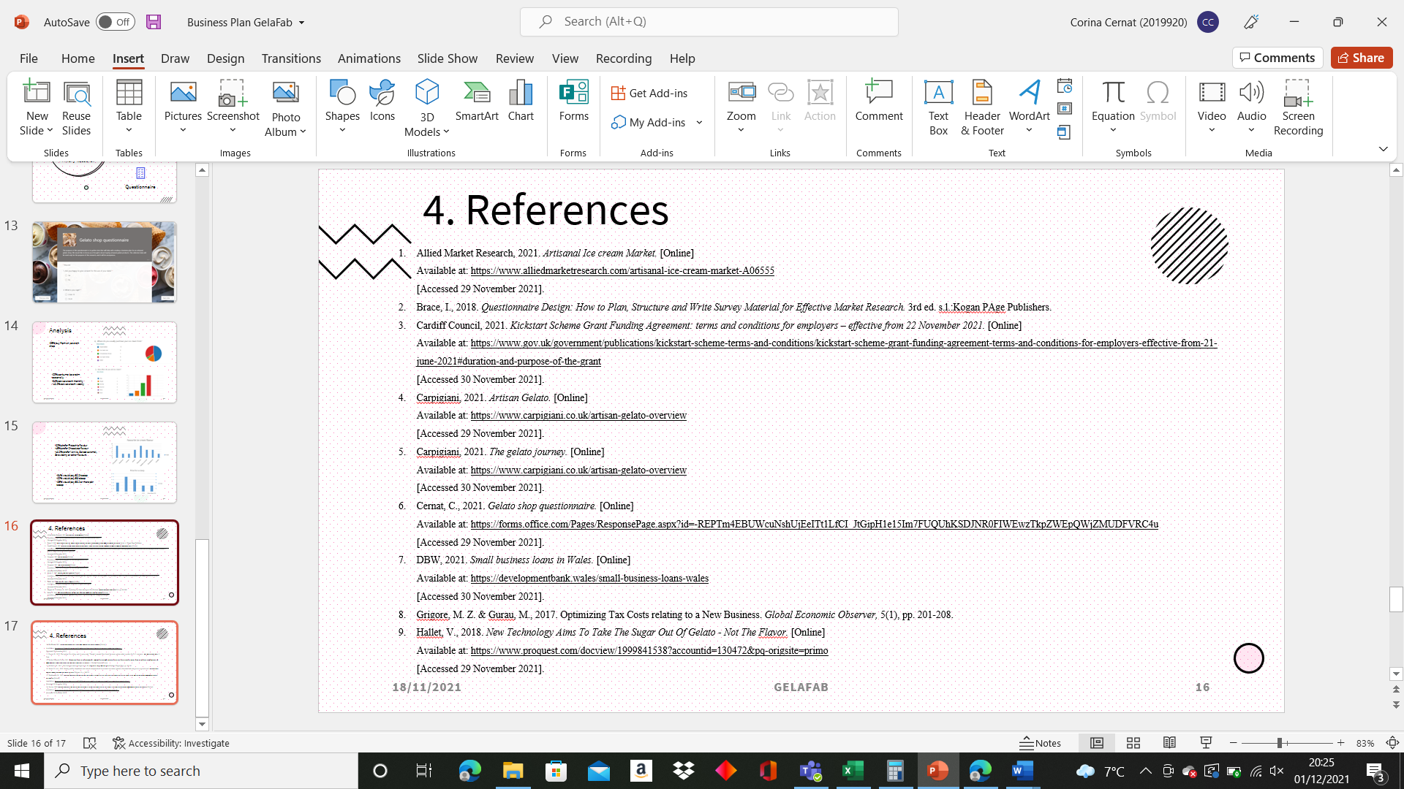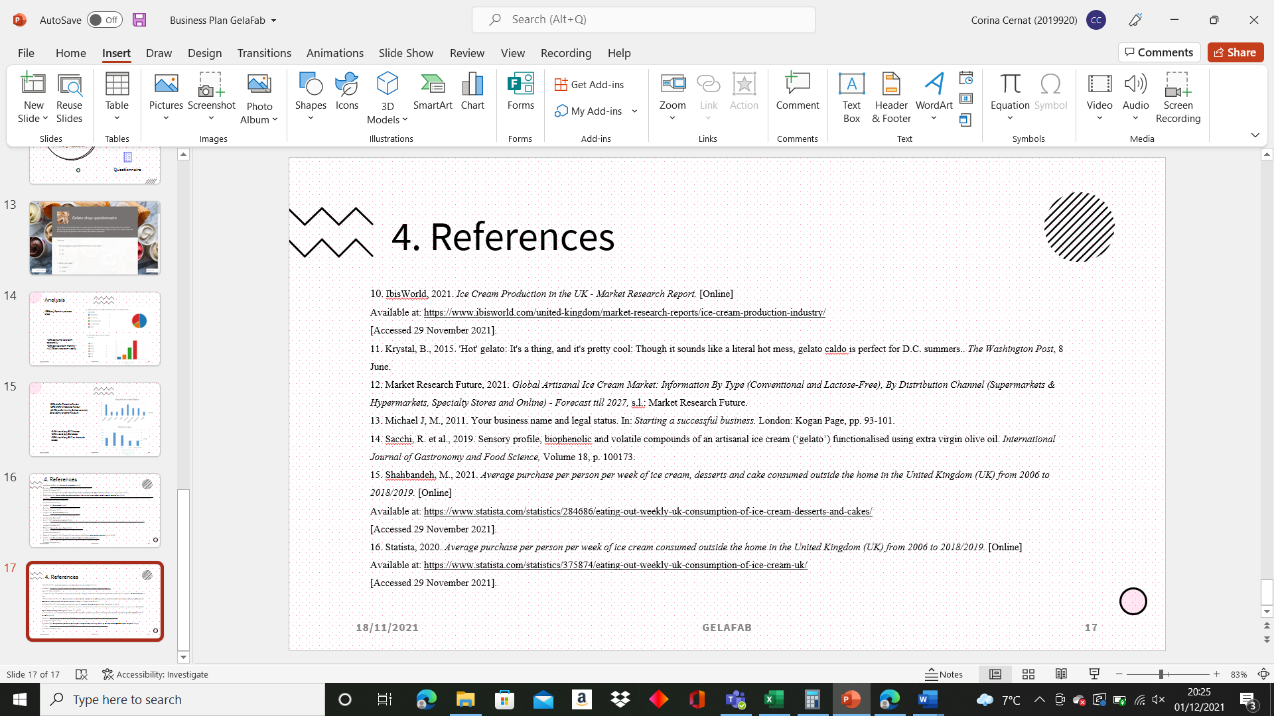

Supplementary notes

- My name is Corina Cernat, student number 2019920 and today I will be presenting my business plan for an artisanal gelato shop in Cardiff
- I will go through a short business overview, marketing, and PR strategies, present my market research and a list of references used
- I came up with this idea from passion and a love for Italy, my favourite country to visit. Gelato is my favourite desert and is also adored by everyone of us
- I have decided to operate as a sole trader as I will have to deal with less bureaucracy, I can be in control of my profits. This also presents some disadvantages, like full responsibility for debts, and more difficult to access funds. (Morris, 2011)

- Mission

- Our mission is to provide the best artisan gelato in town to satisfy all tastes buds, at the most attractive prices.

Aims:

- Our aim is to offer all customers a healthier ice cream alternative and delight them with natural ingredients gelato whilst looking after the environment.
- We intend to operate in a sustainable manner and source most of the prime ingredients locally, use reusable and recyclable packaging and the latest technology to lower the sugar levels whilst keeping the flavors intact.

Objectives
My objectives for the first year are:
• to start making profit
• to build awareness of the brand
• employee retention
• provide excellent customer service
• target the right customers
• maintain a positive cash flow
• liaise with local food suppliers
• use recyclable and reusable package

- Products and services
The shop will focus on selling mainly gelatos and sorbets, will have a selection of the most popular gelato flavours and other classic Italian ones. I will also be selling vegan options, fat free and some sugar free flavours as well.
Based on my market research and the growing demand for these types of deserts, among the gelato flavours, I will also be selling gelato cakes (semifreddo) and traditional ones, pastries, Italian sweets like cannoli, spreadable sweet creams, coffees, including affogato, teas, soft drinks, and other seasonal sweets, like panettone.
In the colder months when the demand is likely to drop, I will be introducing a new gelato concept called gelato caldo (Krystal, 2015), a combination between ice cream and parfait that is soft and creamy and feels warm on the palate.

- Location
I have decided to open a physical gelato shop in one of the most sought-after areas from Cardiff. The shop will be in Penarth, on the busy Windsor Road. It is close to the beach and will have no issues in attracting customers and tourists. It will have a size of 1600 square feet and be opened every day from 12-10 PM.

- HR
Once the shop will open, I will be taking the role of the manager for the business. I will be looking to employ 4 shop assistants, a supervisor, a technologist, a cook, and a supervisor.
I will also employ a cleaner on a part time basis who will come in a few hours a day, I will work with an accountant on a flexible basis at the end of each month and employ delivery drivers on a commission basis.

- Finance
The estimated cost for opening my business is around £68.000 that I intent to cover with a personal investment, a loan from Development Bank in Wales for £50.000 and a Kickstart scheme that is meant to cover the cost of my wages for the part time employees for the first 6 months.
- SWOT
I have also conducted a SWOT analysis and discovered that my main strengths are:
Gelato is a healthier option than ice cream
vegan options available
Prime location
High quality products

Weaknesses:
- high start- up costs
- several competitors in Cardiff
- seasonal product
Opportunities:
- available funding through Business for Wales
- organising corporate workshops for learning how to make your own gelato
- increase in customers who view artisanal gelato as a healthier option (Market Research Future, 2021)

Threats
- Loss of interest during winter months
- high competition and similar products available in many locations, like supermarkets, convenience stores, restaurants
- Risk of not getting the finance

- Marketing and PR strategies
I have created a logo for my business that represents a cone with pistachio gelato as this is the preferred flavour of the potential customers I interviewed.
With the logo I have then created business cards that I will hand on to customers and suppliers.
The main marketing instrument will be the website I created, along with other digital tools like Facebook and Instagram page. I intend to organise monthly competition where I will give one winner Amazon vouchers for posting their gelato on their social media pages and tag us, this way I hope to increase the reach on my Facebook and Instagram page.
Before the opening of the store, I will be spreading leaflets in Cardiff and surrounding areas, on the leaflet there will be a voucher that the customers can bring to the shop in the first week and claim a free scoop from a selection of gelato flavours. I will also contact the local radio for an ad that will run for a few weeks once the shop is opened.

- Market research
To determine my target demographics, I have conducted some primary research through a focus group and a questionnaire, the latter has provided valuable findings that helped me develop my website and logo for my business.
I have concluded that 56% buy ice cream form a specialized shop, 50% of them consume the dessert seasonally, while 31% eat it monthly and nearly 13% consume it weekly.
I also managed to find out the favourite flavours of my potential customers and these will be stocked in higher quantities in the shop.
Most importantly, I also determined the price they are willing to pay and this information will be used to establish my pricing strategy, with gelato scoop prices starting from £2.50.

