Assignment 2
ECAY6004: Relationships, Communication & Families in Contemporary Society
Through the use of 1-3 images; critically reflect upon how social media can influence current representations of family within society.
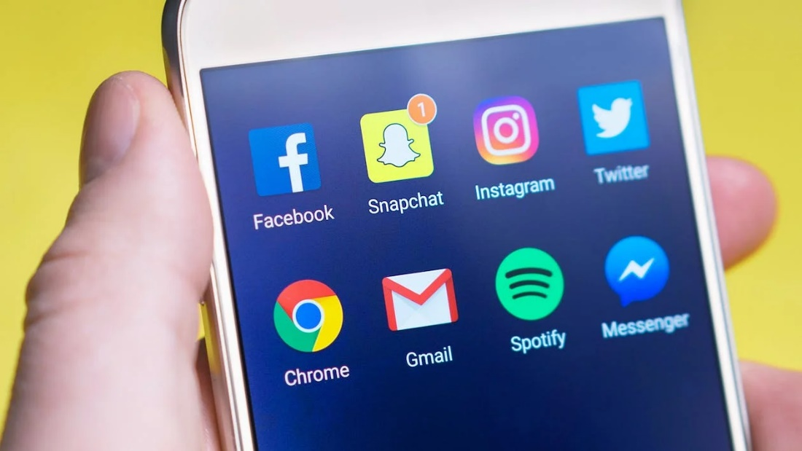
(Pexels, 2022).
These days social media is everywhere, according to Dean (2021) up to 4.48 billion people at present use social media worldwide, this has more than doubled from 2.07 billion in 2015. With Facebook being at the top of the list, with figures of 2.9 billion from statistics provided from Woosuite (2022) followed by You Tube with a close 2.5 million users.
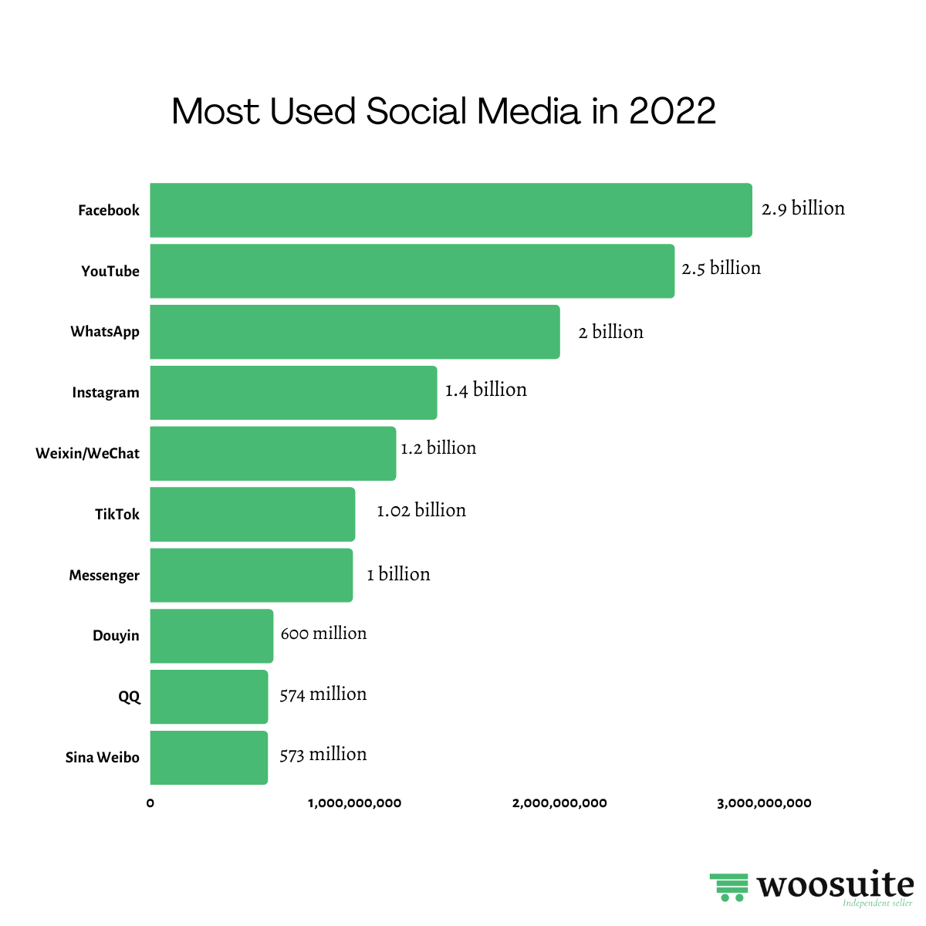
(Woosuite, 2021).
Social media it appears is an important part of people's lives. But why do so many people use social media? According to Desreumaux (2018) people use social media to firstly stay connected with family and friends and to keep up to date with current affairs, locally and worldwide. Other reasons are:
1. To see what friends and family are doing and to stay connected (42%).
2. To keep informed with news and current events, locally and worldwide (41%).
3. When bored, just for something to do (39%).
4. To find content that is funny or just entertaining (37%).
5. Staying connected with other people in general (34%).
6. Usually family and friends are already using them (33%).
7. Sharing photos or videos with others (32%).
8. To express their opinion (30%).
9. Research new products before buying (29%).
10. To connect to new people (27%).
(Desreumaux, 2018).

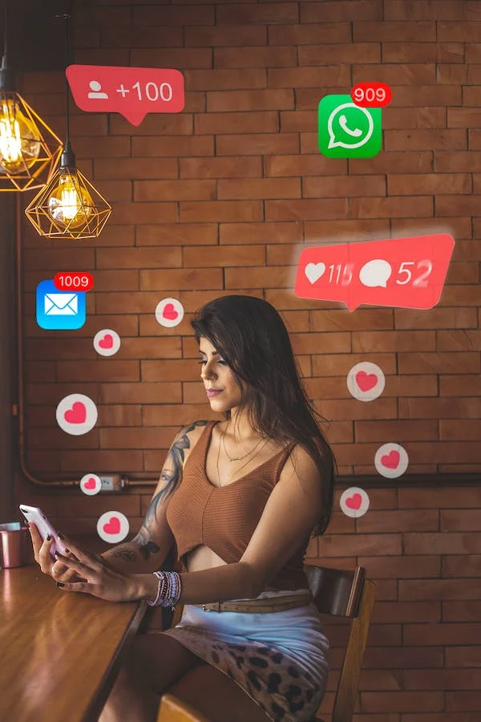
(Pexels, 2022).
What do you think when you look at the above photo, this lady is extremely popular? has she lots of friends? or do you see a lady whose life revolves around social media and less time for family? Since social media, there has been an increased rate of parents who are now posting pictures and achievements of their family, from births to general photos of how well their child is doing in school. But can they be over sharing? According to Evans (2021) there is now a word that is used globally for parents who over share photos of their children all over different social media platforms, this is called ‘sharenting’. But with parents posting pictures of their children, is it safe? A parent could post a picture of their child in their school uniform, with the school's name clearly on their clothes, a would-be kidnapper now has the child’s name, school name and already knows the parents name, and could say to the school that they have been asked to pick the child up. As Sharma (2022) states, there are at least 45.2% of posts that feature children names on families Facebook accounts and 19% of posts on Instagram that also have their names and their date of births. This could lead to ‘digital kidnapping’ according to Online Sense (2017) where would be hackers/kidnappers consume all the information that the family has posted about their child and use it for malicious intentions.
Mothers often feel isolated, being at home with the children all day, this is why Research (2019) suggests why mothers spend so much time on social media, they are able to catch up with friends and family, sharing aspects of their lives through photos and messages etc. But mothers also depend on social media to keep up to date with school events, the children’s social events, they look for parenting advice and give their own opinion and before they buy a product, they will look for product recommendations (Research, 2019). However, on the negative side this can affect their well-being due to the fact they are only communicating via social media and not face to face contact with other mothers, and they do not always post a certain picture or air their option on the fact of they are worried that they will be judged (Research, 2019).
What constitutes as a family in the 21st century? How does social media affect an individual, their families and contemporary society? Social media can be a good thing for families and individuals for keeping in contact with friends and family that are further away or living in another country. According to Valentine (2020), a study showed that up to 93% of people used social media to connect with their family, whilst 91% used it to connect with friends, whilst catching up with old friends was as much as 87%. Whilst another study contacted, Valentine (2020) and stated that when it came to teenagers, that 57% made lasting friendships through their social media, whilst 81% felt more connected with their friends and family and when times were tough 68% felt supported whilst going through it.
However, Stegner (2022) is much more concerned with the negative psychological distress that is caused through chronic social users due to constant use of all the different platforms that especially teenagers use. Stegner (2022) suggests that through constant usage, people develop depression, anxiety which leads to unhappiness and poor mental health, especially if they are comparing their lives to other families or people. Long (2022) also agrees with this statement and states that although there are many different forms of using social media, this is potentially creating depression, anxiety and other issues in people lives. Long (2022) suggests that by using social media it is accessing the brains reward centre, which in turn realises dopamine, which is a feel-good chemical and that there are three main issues whilst using social media, these are:
- Using social media for validation – when people of all ages start connecting popularity to sharing their content and starting to feel that they need other people’s validation on what they post through other people’s responses. But if the person doesn’t get the response that they wanted, this can increase their depression or anxiety so that next time they post something, they hope for a better response! But if someone posts something that another doesn’t like, you no longer must tell them to their face by saying something hurtful or nasty, know you can just type it onto their social media platform. This is also known as being a ‘keyboard warrior’.
- Fear of missing out – a person could get worried and stressed encase they have missed a post or something going on a certain social media platform. But also, if they haven’t posted in a while, they feel they should even though it might not be received well by others.
- Seeing life through a filter – nearly all people like to look their best and this is just as important for allot of people when they post a picture of themselves on social media. They can feel that other people are judging them so most people will not post the first picture they take, but will take a few with different poses, lighting and certain filters to make themselves feel that they are fulfilling what distorted view today’s society thinks is beautiful. As everyone is their worst critic and if they are not happy with their photo then this can bring their mood down and lead to depression.
(Long, 2022).
As Long (2022) mentioned earlier, since the beginning of social media there has been keyboard warriors. Sommer (2020) characterizes that a keyboard warrior is someone who sends messages via the internet which are brutal attacks on other people and would not do this in real life and say it to their face. These people are named trolls and are usually outspoken but only online and like to abuse and harass other people if they do not have the same views etc as themselves. They are known to have “all bark but no bite,” but in real life are weak and unassertive (Sommer, 2020).
Then you have the other side of social media whereas Walton (2019) explains, even if you start talking to friends or even catching up with old friends, which could include old flames, this could be the start of something harmless and seen as just catching up, however, old feelings could arise. Even if there is no physical contact, there is still an emotional aspect, which in turn could lead to the person investing more energy outside their marriage or relationship on an old flame or a new friend, Walton (2019) refers to this as Micro-cheating. This view is supported by Manning-Schaffel (2018) who writes that Micro-cheating is less a particular behaviour and more about the secrets and what happens when the secrets are uncovered, where boundaries have been crossed and the fidelity is sexually charged. This does not just affect a partner but also any children that are involved as a person gets more involved in their affair. They will start spending more time on their phone, whether this is through messages, emails or phone calls and less time doing things with their children and partner and slowly pulling emotionally away. Walton (2019) suggests as soon as you start being secretive and disregarding your partner and even comparing your partner to others, then you are in too deep.

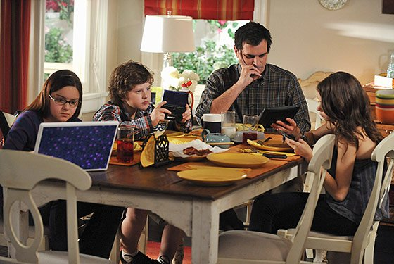
(Shepherd, 2018).
The above picture is what many of everyday families looks like today, where no one speaks to each other and all are using technology to speak to other people, but not their own family sitting yards from them. Shepherd (2018) believes that there are changes in the way society is starting to interact with each other, especially when you see ‘families out to eat together at a restaurant all on their phones barely saying two words to each other’. Before social media, families would bond over face-to-face conversations, where each person would say how their day went, from school to work and as stated by Nair (2019), these days families are too engrossed in their own news posts on their own social media accounts to acknowledge each other and greet their family members.
Teenagers of this generation tend to be more engrossed in social media than anyone else and according to Mayo Clinic (2022), there is up to 45% of teenagers that are online constantly whilst 97% are using a social media platform. Through social media teenagers can create online identities that help them build social networks even through gaming. This can lead them to avoid depression as according to Mayo Clinic (2022) they can gain valuable support and meaningful connections to their peers. This is especially good for teenagers who have experienced exclusion from being shy, disabled or through chronic illnesses and they are distracted through the entertainment of social media and are able to self-express themselves without actually having to meet someone face to face. However, as long as this self-expression is not through the bullying, gossiping or damaging of another person’s reputation. There is a high-end risk of mental health problems from too much social media use with teenagers. Even with using social media for up to three hours a day can lead to poor mental health and well-being which affects their sleep quality. Mayo Clinic (2022) suggests even with a problem such as not being able to log in to one of their accounts can cause them stress and anxiety, and with all the different social media platforms that are out there these days, teenagers are open to being bullied, harassed and in some cases blackmailed, as teenagers do not always think about what they are posting, nor about the consequences or privacy concerns.
Whilst Tech Baji (2022) suggests that before, a person’s family would be considered the primary source of support, but social media has now changed the dynamics and the importance of that bond and relationship. Now, they can turn to anyone else that they can talk to on social media, this has weakened the dependency of children over parents and the bond of parents toward their children. According to Tech Baji (2022), ‘children can now share their emotions, feelings, and problems with their friends on social media and get satisfied without letting their parents know anything about their problems.
Social media is not always a good thing for families, as there are lots of diverse types of platforms which keep families apart, as suggested by Nair (2019) family members are engaged for extended periods of time, and the longer each day someone spends on social media the more chance of them becoming addicted. Gone are the days when families would meet up with other members of their families after work or over the weekend, due to the fact that after working all day according to Adil (2022) a person can just set a group chat with other members of the family to catch up and send photos, video chats etc without having to travel to see them.
To conclude, this assignment has looked at the positive and the negative risks with social media and how it can influence current representations of families within society. From the positive aspects where social media brings friends and family, old and new together. From the negative, where people develop anxiety, depression and get jealous of how other people live, to starting on-line affairs and destroying relationships and family bonds, due to children no longer turning to their parents or family for advice or support. At the end of the day, social media is how the individual person decides to control its usage and what to do with it. Frame of mind before anyone starts looking for old flames or friends is a big one, as if they are not happy in a relationship are they just looking for adventure or a bit of extra spark in their lives? What ever platform or social media a person decides to use is up to them, as long as it is not used for bullying or to black mail someone or to cause destress to another person. Especially with the rise in anxiety and mental health problems, people need to be careful with what and how they use social media, as a person’s well-being is important. No one should do something to someone else that they would not do to themselves.

Reference
Adli, M. (2022) Reasons How is Social Media Changing Our Life and Our Family Relationships. Available at: https://techstonz.com/how-social-media-changing-family-relationships/#:~:text=Negative%20Effects%20of%20Social%20Media%20on%20Family%20Relationships,...%205%205%3A%20Addiction%20to%20Social%20Media%3A%20 (Accessed: 10th December 2022).
Dean, B. (2021) Social Network Usage & Growth Statistics: How Many People Use Social Media in 2022? Available at: https://backlinko.com/social-media-users (Accessed: 27th November 2022).
Desreumaux, G. (2018) The 10 Top Reasons Why We Use Social Networks. Available at: https://wersm.com/the-10-top-reasons-why-we-use-social-networks/#:~:text=What%20Are%20The%20Top%2010%20Reasons%20For%20Using,5%205.%20General%20networking%20with%20other%20people%20%2834%25%29 (Accessed: 27th November 2022).
Evans, M. (2021) [Parents’ Guide] What Is Sharenting & How Dangerous Is It? Available at: https://www.clevguard.com/parental-control/what-is-sharenting/ (Accessed: 26th November 2022).
Long, K. (2022) Why Does Social Media Give Me Anxiety? Available at: https://www.dochaspsych.com/blog-why-does-social-media-give-me-anxiety/ (Accessed: 11th December 2022).
Manning-Schaffel, V. (2018) What is 'micro-cheating'? And does it really count? Available at: https://www.nbcnews.com/better/pop-culture/what-micro-cheating-does-it-really-count-ncna905206 (Accessed: 9th December 2022).
Mayo Clinic. (2022) Tween and teen health. Available at: https://www.mayoclinic.org/healthy-lifestyle/tween-and-teen-health/in-depth/teens-and-social-media-use/art-20474437 (Accessed: 11th December 2022).
Nair, A. (2019) The Effects of Social Media on Family and Marriage. Available at: https://parenting.firstcry.com/articles/magazine-effects-of-social-media-on-family-and-marriage/ (Accessed: 26th November 2022).
On line Sense. (2017) Sharenting: Why Parents Must Stop Sharing Everything about Their Kids on Social Media. Available at: https://onlinesense.org/sharenting/ (Accessed: 26th November 2022).
Pexels. (2022) Social media [Online]. Available at: https://www.pexels.com/search/social%20media/ (Accessed: 27th November 2022).
Research, E. (2022) moms on social media 2019. Available at: https://www.edisonresearch.com/moms-on-social-media-2019/ (Accessed: 9th December 2022).
Sharma, S. (2022) Seven dangers of posting photos of your children on social media - cyber expert's warning to parents. Available at: https://www.msn.com/en-gb/lifestyle/family/seven-dangers-of-posting-photos-of-your-children-on-social-media-cyber-experts-warning-to-parents/ar-AA14BUmQ (Accessed: 25th November 2022).
Shepherd, M. (2018) Social Media: Slowly Tearing Us Down? [Online] Available at: https://evidenceinmotion.com/social-media-slowly-tearing-us/ (Accessed: 25th November 2022).
Sommer, L. (2020) WHAT IS A KEYBOARD WARRIOR?. Available at: https://stayhipp.com/glossary/what-is-a-keyboard-warrior/ (Accessed: 10th December 2022).
Stegner, B. (2022) 7 Negative Effects of Social Media on People and Users. Available at: https://www.makeuseof.com/tag/negative-effects-social-media/ (Accessed: 7th December 2022).
Tech Baji. (2022) How is Social Media Changing Family Relationships. Available at: https://techbaji.com/technology/how-is-social-media-changing-family-relationships/ (Accessed: 10th December 2022).
Valentine, M. (2020) 5 Positives of Social Media: Why Social Media Is Good for Us. Available at: https://technologyformindfulness.com/positives-of-social-media/ (Accessed: 8th December 2022).
Walton, J. (2019) Social Media: A Gateway to Emotional Affairs? Available at: https://www.mendedlife.com/social-media-a-gateway-to-emotional-affairs/ (Accessed: 5th December 2022).
Woosuite. (2022) Most Used Social Media 2022. Available at: https://woosuite.com/stats/most-used-social-media/ (Accessed: 27th November 2022).

