University of Wales Trinity Saint David
Wales Institute of Science and Art

Electronic Circuits Testing and Applications

Electronic control systems
ACHA4010

Callum Francis-Beck
2312005
06/04/25
Contents
1 Task 3 1
1.1 Scope Time Division Calculations (3) 1
1.2 Function Generator output square wave (3) 1
1.3 Capacitor charge and discharge wave marked at correct points. (3) 1
1.4 Basic Capacitor Calculations (3) 1
1.5 Capacitor discharge table (2) 1
1.6 Plot log(V) Gradient (2) 1
1.7 Gradient Calculations and Compare(4) 1
1.7.1 Gradient Calculations 1
1.7.2 Comparison table 1
1.8 Capacitor Uses (5) 1
1.9 Inaccuracies Question (4) 1
2 References 2

Task 3

Scope Time Division Calculations (3)

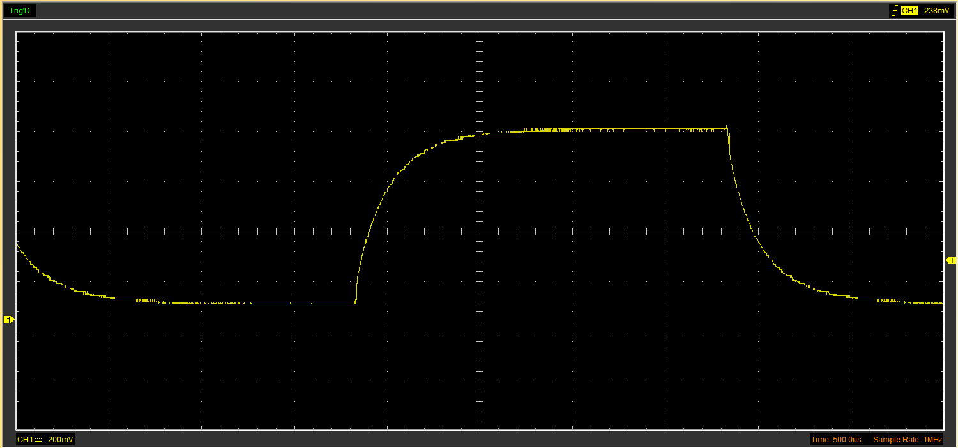

Function Generator output square wave (3)
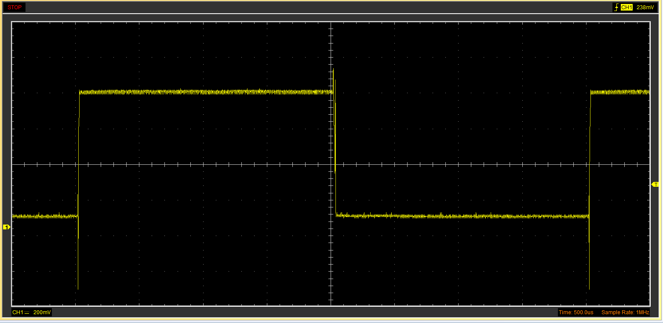

Capacitor charge and discharge wave marked at correct points. (3)
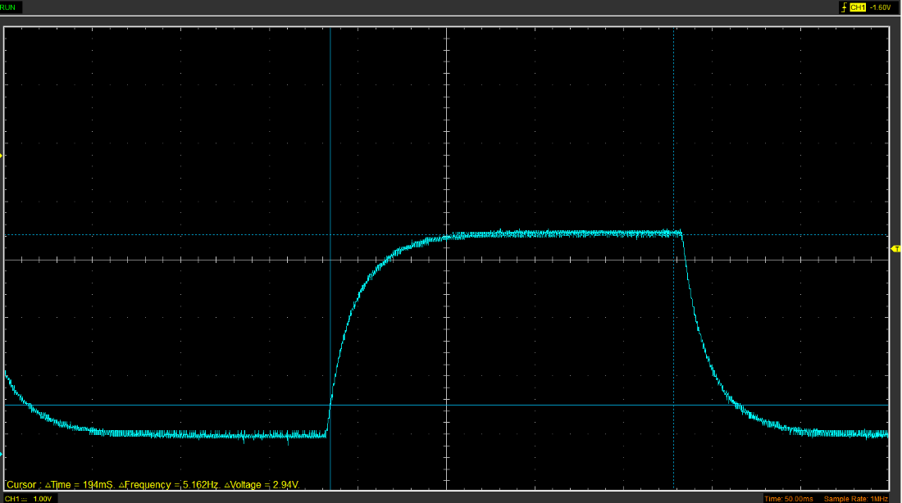

Basic Capacitor Calculations (3)

Capacitor discharge table (2)
Time (s) | Voltage (V) | ln (V) | dy = y2 – y1  dy = ln(V)2-ln(V)1 | dx = x2- x1  dx = Time2 – Time1 | dy/dx
 |  |  | x | x | x

Plot log(V) Gradient (2)

Gradient Calculations and Compare(4)

Gradient Calculations

Comparison table
 | Capacitance | Delta | Percentage difference
Actual | 1 µF | x | X
Marker Calculation
Gradient Calculation

Capacitor Uses (5)

Some uses for capacitors are as follows:
- Energy storage in case there is any temporary power loss or if a device needs extra power. (Edington, 2025)
- Smoothing of a rectified waveform (Poole, 2025)
- Regenerative braking in vehicles- the braking system turns the kinetic energy of heat into electrical energy, which is then stored in a capacitor ready to be distributed to acceleration for the vehicle. (Powers, 2015)
- Timing- along with resistors capacitors can be used to make a timing circuit. (Weishi, 2024)
- Voltage regulation- they can regulate voltage by absorbing voltage spikes and surges. (Weishi, 2024)
- Bypass- the capacitor can remove noise and stabilise circuits to make sure they operate smoothly. (Wilson, 2021)
- Control systems- to ensure the electronics perform reliably under various temperatures. (Shepard, 2022)
- Start/stop systems- the capacitors give quick energy storage and release for the engine to restart. (Passive Components, 2017)
- Peak power- capacitors give high starting current to items that need it such as window lifter motors. (Hake, 2025)
- Airbag deployment- capacitors deliver a high amount of current that devices such as airbags need to deploy. (VinaTech, 2025)

Inaccuracies Question (4)

Results may differ from that of the Specified values due to many issues such as systematic errors, this can be due to the equipment not being calibrated properly or not being well maintained. Giving results that are marginally wrong, to solve this, the results would have to be taken a few times and averaged to give more accuracy. (BBC, 2025)
Human error or misreading of information, since there is a lot of data points to analyse, some key points may be missed when looking for specific numbers in thousands of other numbers. Having excel can limit this and also speed up the process as it can pull out all required data with a simple formula. (Barchard, Pace, 2011)
Continuing on human error. Insufficient knowledge of the equipment being used may have an impact on the recording of data. Knowing how to use the equipment properly is crucial to find accurate results. (Dobberton, Neumann, Schroeck, 2013)

References
Barchard, K. Pace, L. 2011 Preventing human error: the impact of data entry methods on data accuracy and statistical results [Online] Available at: https://www.sciencedirect.com/science/article/abs/pii/S0747563211000707 [Accessed on 30th March 2025]
BBC. 2025 Evaluating an experiment [Online] available at: https://www.bbc.co.uk/bitesize/guides/zf4djty/revision/5#:~:text=Random%20errors%20are%20due%20to,with%20the%20equipment%20you%20used. [Accessed 30th March 2025]
Dobberton, M. Neumann, M. Schroeck, H. 2013 Chapter 10- Tree Growth Measurements in Long Term Forest Monitoring in Europe [Online] Available at: https://www.sciencedirect.com/science/article/abs/pii/B9780080982229000108 [Accessed 30th March 2025]
Edington. 2025. What Are Capacitors used for? [Online] Available At: https://www.edingtonagencies.com.au/what-are-capacitors-used-for/#:~:text=capacitors%20used%20for%3F-,Articles,sensing%20and%20signal%20coupling%2Fdecoupling. [Accessed on 29th March 2025]
Hake, R. 2025 Supercapacitors in the automotive industries [Online] Available at: https://capcomp.de/en/applications/supercap-automotive [Accessed on 29th March 2025]
Passive Components. 2017 The role of ultra capacitors in automotive technologies [Online] Available at: https://passive-components.eu/the-role-of-ultracapacitors-in-automotive-technologies/ [Accessed 29th March 2025]
Poole, I. 2025. Capacitor uses and applications. [Online] Available at: https://www.electronics-notes.com/articles/electronic_components/capacitors/capacitor-uses.php [Accessed on 29th March 2025]
Powers, N. 2015 Capacitor Powered Cars: Capacitors in automotive applications [Online] Available at: https://www.arrow.com/en/research-and-events/articles/capacitors-in-automotive-applications [Accessed 29th March 2025]
Shepard, J. 2022 Ensure reliable automotive systems through careful selection and use of passive components [Online] Available at: https://www.digikey.co.uk/en/articles/ensure-reliable-automotive-systems-through-careful-selection-and-use-of-passive-components [Accessed 29th March 2025]
VinaTech. 2025 Supercapacitors in the automotive industry [Online] Available at: https://www.vinatechusa.com/supercapacitors/use-cases/automotive/ [Accessed on 29th March 2025]
Weishi. 2024 What are capacitors used for? 8 Applications you need to know [Online] Available at: https://weishielectronics.com/what-are-capacitors-used-for/ [Accessed on 29th March]
Wilson, A. 2021 How to choose reliable capacitors for automotive applications [Online] Available at: https://www.edn.com/how-to-choose-reliable-capacitors-for-automotive-applications/ [Accessed 29th March]

