Research Methods and Communication: M7X02233

Student Name: Jacqueline Ann Fowler Student Number: 1703065
Course: Master by Research Word count: 2736
Tutor: Professor Catrin Webster Date: 14 January 2021

Making the transparent apparent: Reconstructing a feminist history for twentieth century female stained-glass artists

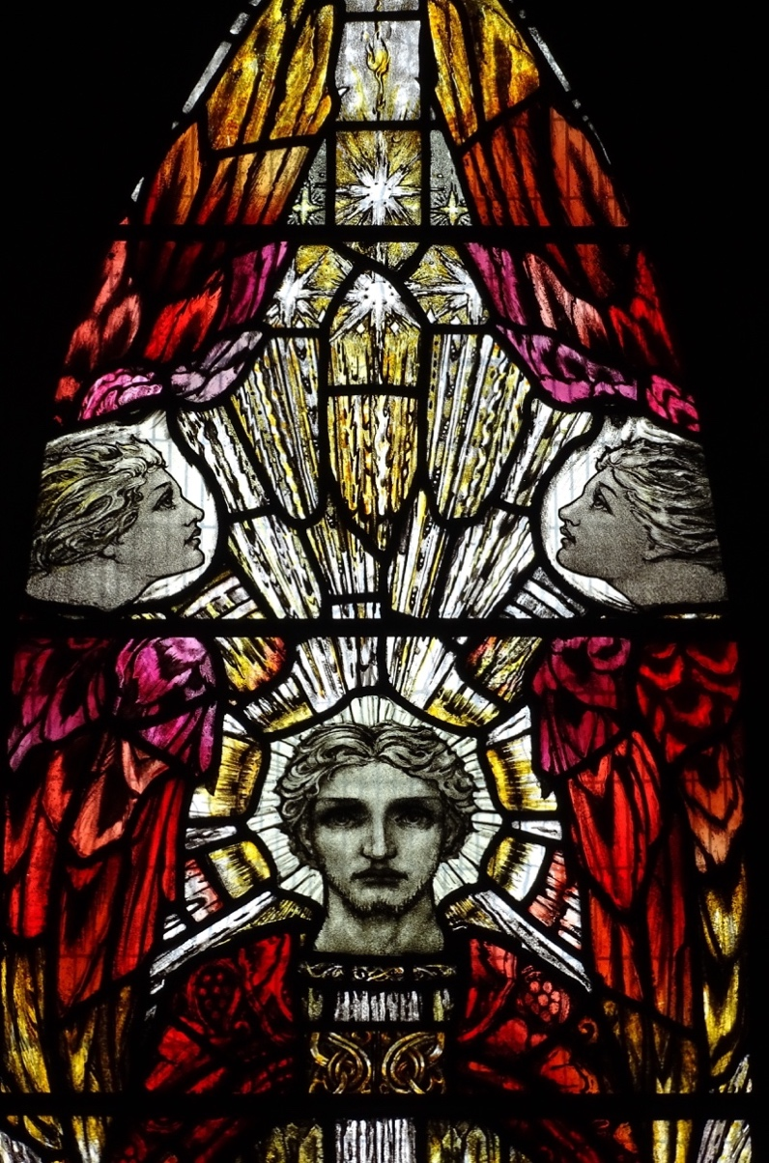
Figure 1. Resurrection
By Theodora Salusbury (1875-1956)

Background and Context

Working question: Who are the 20th century female stained-glass artists in need of further research and how could their work be honoured in the 21st century?

Female stained-glass artists are largely absent from the discourse of contemporary culture within the UK. This research aims to rediscover their work. Stained-glass has been part of British culture and heritage since the middle ages. For instance, there are examples of windows that have been painted and stained in Canterbury Cathedral, dating from 1175 that replaced the previous large, coloured windows destroyed by fire in 1174 (Caviness, 1977, p.4). Yet there is relatively little written about the cultural heritage and the importance of the art form in either religious or secular settings, historically and in the contemporary. Crampin, in his survey of stained-glass in the churches of Wales suggests “the neglect of stained glass by historians of visual culture has been a failure to understand its impact on congregations and communities and to ignore its ubiquity right across urban and rural Wales” (2014, pp.6-7). This applies not only to Wales, but throughout the United Kingdom and, indeed, the world. This author proposes to address some of this imbalance by undertaking and publishing research into a previously under-reported genre, the female stained-glass artists of the 20th Century.

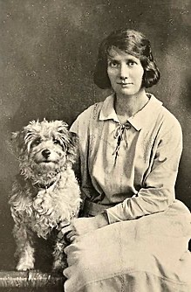 | 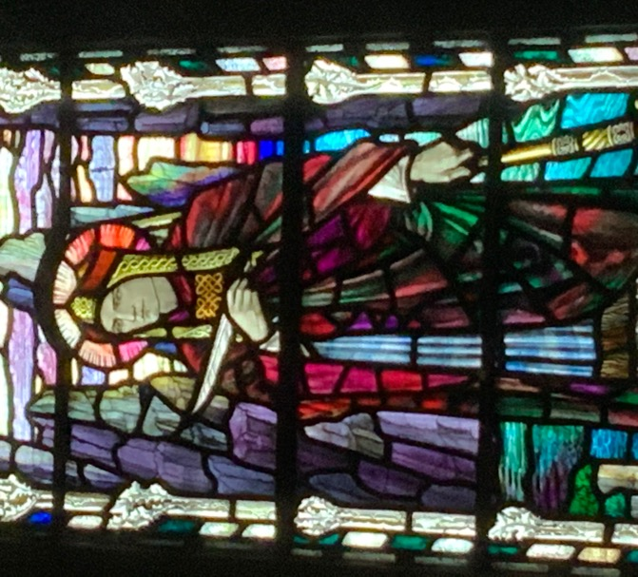 | 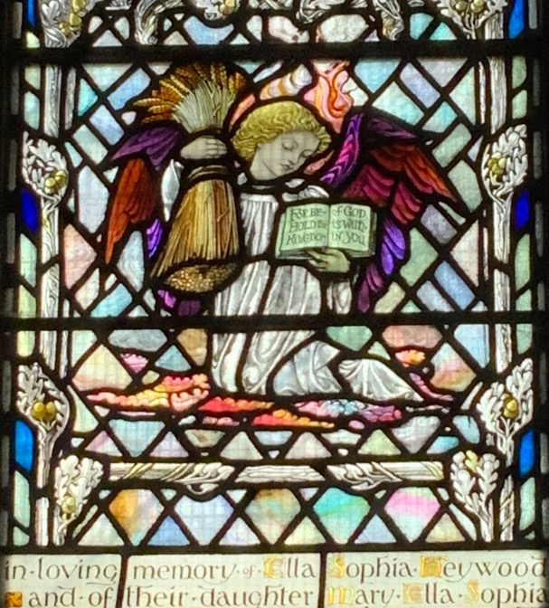
Figure 2. Veronica Whall  (1887-1967) | Figure 3. St Hilda | Figure 4. Cherub

As a female stained-glass designer and maker, I have a special interest in the history, cultural influence and social stories of stained-glass artists, particularly gendered accounts of accomplishment, that is, successful women in a man’s world. As a feminist, this author proposes to ask feminist research questions. Åhäll (2018) reminds us that “feminist research questions are about power and how the world works through power structures”. It is proposed therefore to ask these questions in the context of female stained-glass artists to consider how the power structures within twentieth century British stained-glass culture have acted against female stained-glass artists. This research is important because, as Pollock, quoting Nochlin, asked, “how can women know themselves in a country – where they have no language, if there are no representations or spaces of the feminine?” (Pollock, 2007, p.13).

This research adopts the premise that stained-glass made by women, especially in ecclesiastical contexts, is not known or celebrated as having been created by female artists. For there to be a ‘space’ for contemporary female stained-glass artist, we need to establish a history. To be aware of the context of the stained-glass, of its authenticity, its creation out of devotion and its “difference” (Pollock, 2007, p.14) means that women and girls can see their own potential, their dreams and ambitions, achievable in the reflections of the accomplishments of hitherto unknown, hidden women.

Bibliography

Åhäll, L. (2018) ‘Affect as methodology: Feminism and the politics of emotion’, International Political Sociology, Volume 12, Issue 1, pp. 36–52.

Caviness, M.H. (1977) The Early Stained Glass of Canterbury Cathedral, Circa 1175-1220. Princeton, New Jersey: Princeton University Press. Available online: https://hdl-handle-net.ezproxy.uwtsd.ac.uk/2027/heb.32778 (Accessed: 27 December 2020).

Crampin, M. (2014) Stained Glass from Welsh Churches. Ceredigion, Wales: Y Lolfa Cyf.

Pollock, G. (2007) Encounters in a Virtual Feminist Museum: Time, Space and the Archive. London: Routledge.

Aims and Objectives

AIM
Through the identification of examples, begin to establish a research methodology for recording the history of hidden or forgotten twentieth century British women stained-glass artists.

OBJECTIVES
- Develop a repository of data from a combination of published and unpublished written records and through the documentation of stained-glass artefacts in situ or archive of female stained-glass artists mainly of, but not limited to, the 20th Century:
  - Museums and library archives will be visited (when Covid-19 regulations allow) to access primary research into documents, cartoons, communications, records etc.
  - Stained-glass installations will be mapped geographically and cross referenced by designer/maker, contacts and context.
  - Social stories of struggles and successes will be collated in order to create case studies.
  - Case studies will be used to compare and contrast careers and life-experiences with changes over time

- Devise ways to raise the profile of key female stained-glass artists so they are less hidden and forgotten
  - Record and collate research findings into curatable data for publication and potential exhibition
  - Create a searchable online directory similar to the Stained Glass in Wales repository: http://stainedglass.llgc.org.uk
  - Map out potential ecumenical tourism routes
  - Explore the publication of social stories, struggles and successes into relevant formats – leaflets, posters, online-directory, book, for example
  - Prepare talks for delivery in informative oration format, podcasts, live talks, etc.
- Develop a responsive practice, by experimenting with materiality, style and techniques observed during autoethnographic experiences:
  - Visit as many field sites as possible (Covid-19 restrictions allowing) in order to encounter notable works of art
  - Observe, sketch, photograph and experience the effect of their work on my practice.
  - Test ideas through practical methods - translating intangible autoethnographic experiences into tangible examples of my own skills and artwork.
- Write a critical analysis of the qualitative research:
  - Identify theoretical perspectives through the evolving case studies
  - Respond to emergent feminist research questions.

Proposed Methodology

This research builds upon a repository begun whilst an undergraduate, which records biographical information on women involved in the stained-glass industry within the UK, and maps the relationships to each other and the British Society of Master Glass Painters. See Appendix A, a spreadsheet where initial findings are recorded.

Library based research:
The research will therefore be continued through library-based and online research and through the critical consolidation of initial findings.

Interviews:
In addition to this library based research, it is proposed that a series of interviews be conducted with existing experts and agencies: Peter Cormack, Martin Crampin, Dr Sara Gray, Dr Jasmine Allen, The Women’s History Network, etc., to make those network connections and collaborations.

Autoethnography:
As part of this research a sketchbook and blog of encounters of the artwork and locations will be developed. These personal responses together with practical testing of ideas in the glass workshop will form alternative data for the study.

Site visits and fieldwork:
Analysis of visual and experiential data, visiting churches/cathedrals, keeping a diary to log good and bad experiences, how easy it was to get access into the building, what sort of welcome was received, first-hand experience of environment and culture, do they know about and value their artworks/installations, etc.

Museum archives:
Visiting museums and archives to find previously unreported correspondence, artifacts and data to help build case studies of social stories.

Practice-based research:
It is proposed that in-studio thinking through making will be conducted – informed by what I am experiencing viewing other artists’ work. A way of understanding craftsmanship, materiality, haptic (how things feel to the touch), writing down everything experienced, testing by trial and error, logging how successful tests are, recording time taken, etc.

Proposed plan of work:

Action | Writing | Target completion date
Refine and finalise research question | Introduction | February 2021
Identify published and unpublished research | Initial literature review | April 2021 - on-going
Mapping geographical data | Data collection | May 2021
Develop repository to add collated data to | Chapter 1 | July 2021
Site visits/fieldwork – museum/library archives | Chapter 2 | August 2021
Develop technological solutions for raising awareness | Case studies | August 2021
Site visits/fieldwork – churches and cathedrals | Chapter 3 | September 2021
 | Literature review final version | October 2021
Practice based research Autoethnographic sketchbook and blog | Final conclusions | November 2021
 | Footnotes and bibliography | November 2021
Proof Reading, corrections and binding of thesis |  | December 2021

Note: Covid-19 restrictions may impede research timescales – to be considered a guide only.

Sources of information:
- British Society of Master Glass painters and Journals held in UWTSD library and Library of Antiquaries, London
- American Society of Stained Glass – available online
- Worshipful Company of Glaziers’ library and archives
- Women’s History Network
- British Academy Corpus Vitrearum project
- Victoria and Albert Museum archives
- Stained Glass Museum, Ely Cathedral
- Martin Crampin – expert in stained glass in Welsh Churches
- Peter Cormack – expert in Arts and Crafts Stained Glass
- Dr Jasmine Allen – curator of Ely Stained Glass Museum
- Glenys Cour – former lecturer at Swansea College of Art
- Chris Bird Jones – former student and contemporary glass artist
- Helen Whittaker – designer and creative director of Barley Studios
- Online databases, libraries and repositories of information

Literature Review

“Although specialist books and articles have been written on 20th Century stained-glass explaining how design and style evolved and about the great men who made it happen (Cormack, 2015; Crampin, 2018; Broady, Adams and Broady, 2010) very little has been recorded about the female stained-glass artists of the early 20th Century” (Fowler, 2020). Until very recently the most comprehensive literature about female stained-glass artists was a 25-page catalogue from an exhibition at the William Morris Gallery, Waltham Forest: Women Stained Glass Artists of the Arts and Crafts Movement (Cormack, 1985). This exhibition introduced the work of fifteen little known or forgotten artists and the hand-typed catalogue with black and white illustrations has provided a sound basis for further enquiry.

- The status of craft in contemporary art

“There are many forms of discrimination that women have to contend with, not least the status of stained glass in the eyes of art critics” (Fowler, 2020). In its definition of the term ‘craft’ the Tate Modern explains that items made for domestic use (windows for example) are generally considered to be craft and therefore have a lesser status than fine art, painting and sculpture for instance (Tate Modern, 2019). The Tate Modern acknowledges that the “boundaries between art and craft became blurred in the twentieth century” (Tate Modern, 2019). Art establishments such as the Bauhaus encouraged artists to investigate using different media in their creations. That pushing of boundaries continues as contemporary artists such as Grayson Perry and Tracey Emin “use craft techniques but their status as artists is never brought into question” (Tate Modern, 2019).

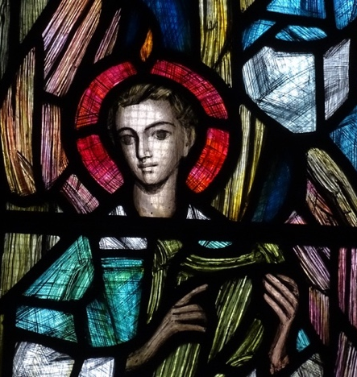 | 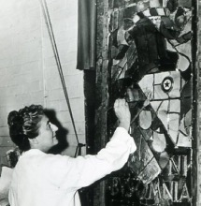 | 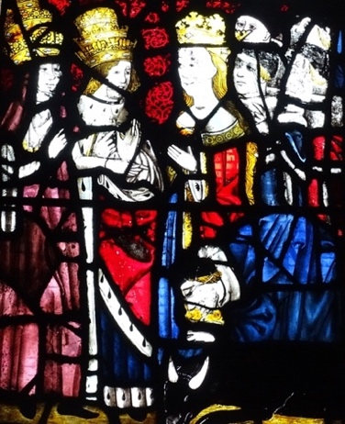
Figure 5. Nativity Window  (1964) | Figure 6. Moira Forsyth  (1906-1991) | Figure 7. Medieval windows in the same church, at risk of closure

Ahmed and Dwyer (2017) found a fitting quote in the archives of the Victoria and Albert Museum amongst correspondence of Moira Forsyth (1906-1991) “Not specifically a career for women … physically tiring and heavy work. But for the enthusiast for light and colour, perhaps the most wonderful medium in the world”. The artistic process of designing to manipulate light and colour that has a profound effect on the emotion of the viewer surely can only be achieved by a true artist and that is how Mary Lowndes, Wilhelmina Geddes, Moira Forsyth and their professional colleagues should be revered.

- The general absence of women from art history

It is very gratifying to find the biographies of eleven stained-glass artists in British Women Artists: A Biographical Dictionary of 1000 Women Artists in the British Decorative Arts (Gray, 2019). Unfortunately, there are only four pictures (hand-drawn) in the whole book, and little detail of their work and where it can be found. This is not surprising for a dictionary, but with such a wealth of art represented, it could provide an even richer resource for the reader with detailed descriptions and photographs of art installations included.

As Nochlin (1971) identified in her seminal text Why have there been no great women artists? institutional and societal discrimination to the education and careers of women artists has been insidious and ubiquitous. Cormack (1985) admits “these women students learned the same skills of glass-cutting, painting, leading etc. as their male colleagues and were thus as well equipped, at the end of their training, to set up their own studios and work full-time in the craft”. So, the question begs, why do men get all the press? Edward Burne-Jones, William Morris, Christopher Whall, Harry Clarke, John Piper, Patrick Reynteins, Thomas Denney and David Hockney are all acclaimed. However, Veronica Whall, a very proficient and talented artist in her own right, has been overshadowed by her father Christopher Whall, leader and tutor of Arts and Crafts stained-glass. Moira Forsyth, a very accomplished artist, is similarly overshadowed by her father Gordon Forsyth, a famous ceramicist of the Arts and Crafts Movement.

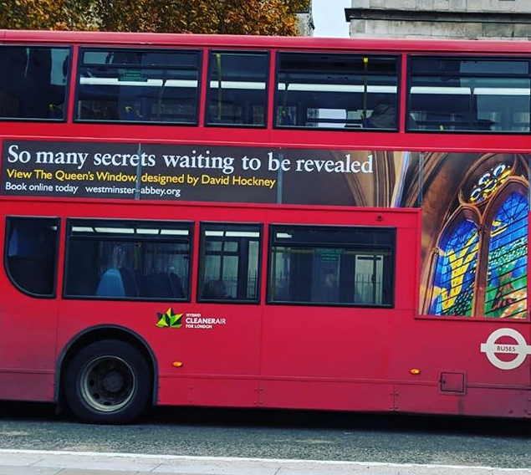 | 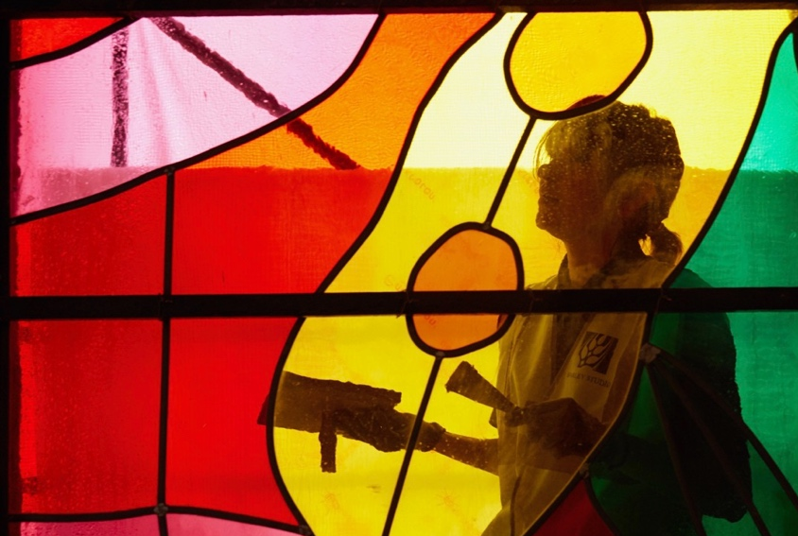
Figure 8: Advert on a London Bus for The Queen’s Window  by David Hockney | Figure 9: Made by Helen Whittaker,  Creative Director at Barley Studios

Oredsson and Dasal (2017) summarise the issues very well: “…unless you believe that women are inherently less good at art, then those reasons have to be societal. Institutional gender-related barriers are complicated, but we have to start trying to unpack them”.

- An underdeveloped history of contemporary glass practice and the absence of women from this

It is widely recognised that the narrative of the stained-glass discipline has been under-represented by historians. In his survey of stained-glass in the churches of Wales, Crampin asserts: “the neglect of stained glass by historians of visual culture has been a failure to understand its impact on congregations and communities and to ignore its ubiquity right across urban and rural Wales” (2014, pp.6-7). Crampin notes that “the appreciation of stained glass has suffered in a culture that values innovation over tradition in the visual arts” (2014, p.4).

Dr Jasmine Allen, Director and Curator of The Stained Glass Museum based at Ely Cathedral, believes there is a significant need for research into post-medieval stained-glass. She suggests a national inventory to be invaluable “not only to the researcher but as a means of better protecting our stained-glass heritage, much of which remains in situ and therefore vulnerable to changes in a building’s use or environment” (Atkins, Allen and Nichols, 2020). Allen continues: “stained-glass studies remains behind its sister arts, and further research on individual artists and makers, as well as better contextual studies … within wider art movements and different settings, is to be welcomed” (Atkins, Allen and Nichols, 2020).

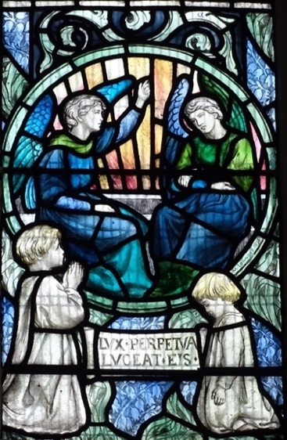 | 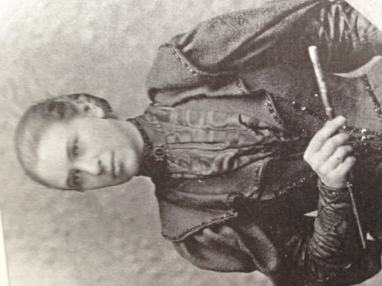 | 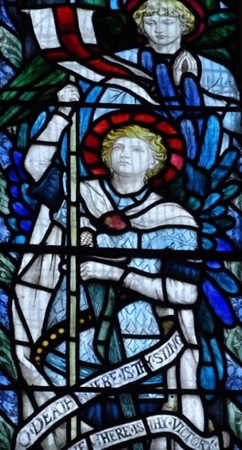
Figure 10. Detail of Resurrection War Memorial | Figure 11. Mary Lowndes  (1856-1929) | Figure 12. St George’s Parish Church, Altrincham

Gray also recognises the need for further investigation, particularly into the work of under-represented women: “Ultimately, this book strives to show that more research needs to be carried out on women in the decorative arts … so that a fair, accurate, balanced picture of their contributions to British art and design can finally be drawn” (Gray, 2019).

This author hears the call to action and proposes to follow in the footsteps of Crampin, Gray and Allen to uncover the hidden history of these talented, skilled, creative women to help ensure they are not forgotten.

- The Consideration of Ethics
“The age of value-free inquiry for the human disciplines is over, and researchers now struggle to develop situational and transsituational ethics that apply to any given research act” (Denzin and Lincoln, 1994, p.12).

This researcher is aware of the necessity to consider ethical concerns which may form part of this research. The research will include interviews which will be conducted in accordance with the university’s ethical guidelines. In addition the researcher is mindful of using archive material in an appropriate and sensitive manner having observed how opinions can be formed by researchers which are not always fair nor balanced.

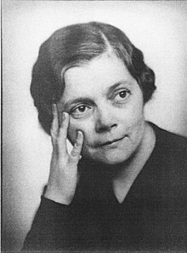 | 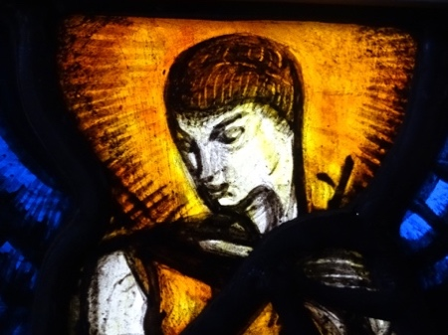 | 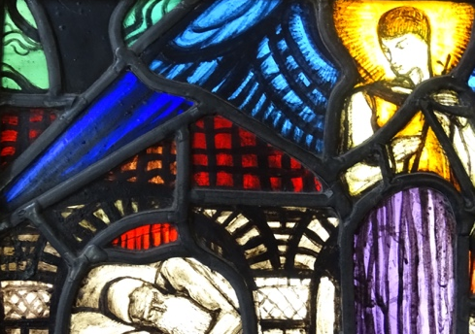
Figure 13. Wilhelmina Geddes (1887-1955) | Figure 14. Detail of St Joseph and the Angel | Figure 15. At Ely Stained-Glass Museum

Conclusion
There has been extensive research into the stained-glass of the Arts and Crafts Movement by scholars like Peter Cormack (1985, 2015, 2017), who have recorded the work of the great male tutors, Christopher Whall, Karl Parsons and Henry Holliday, for instance, mainly based around the London schools. That research has included, highlighted and even celebrated some of the women who studied under these tutors. It has, however, been more difficult to find names and stories of women from later art movements who did their training in the 1930s onwards (Fowler, 2020).

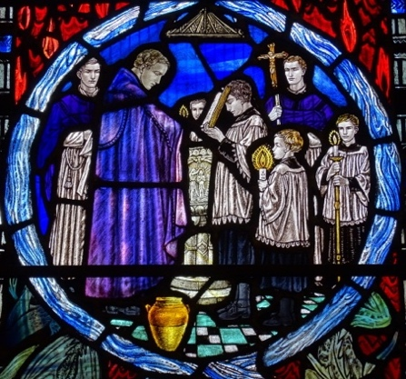 | 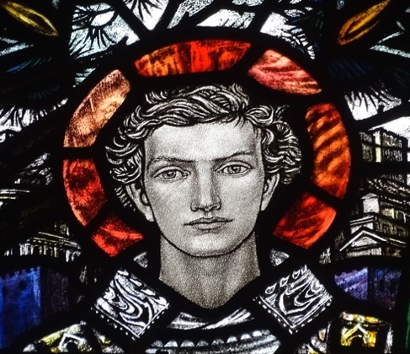 | 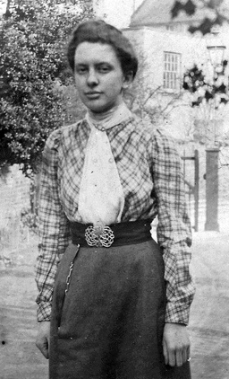
Figure 16. Detail of Baptistry Window (1912) | Figure 17. Cathedral Church of Our Lady and Saint Peter of Alcantara, Shrewsbury | Figure 18. Margaret Agnes Rope (1882 – 1953)

Whether stained-glass is considered to be art or craft by the art community, its intrinsic beauty and stunning creativity deserves to be acknowledged, appreciated and revered rather than dismissed as ‘decorative’ as though it is somehow less valuable or precious than fine art. This is important because, while stained-glass is considered low on the art hierarchy, the women who designed and fabricated such stunning windows are not regarded as highly as recognised fine artists. As a result, their names and achievements are deliberately written out of the art canon and their stories become hidden or completely forgotten (Fowler, 2020).

More research is required to uncover their stories, struggles and list of achievements in order to give them the glory that they deserve because, despite sexism and discrimination, female stained-glass designers and makers have had a profound influence on our cultural heritage all over Britain and across the world (Fowler, 2020).

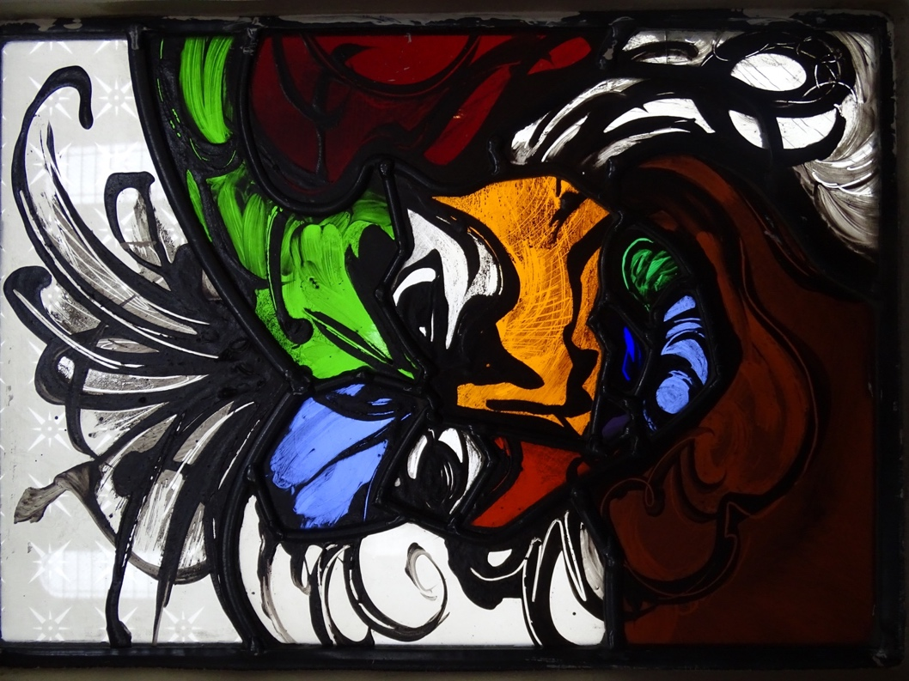
Figure 19. Self Portrait by Debora Coombs (1956-)

Figures:

No. | Title and material | By | Where | When
1. | Resurrection - War Memorial Window, stained glass in lead | Theodora Salusbury | St Mary’s Parish Church, Queniborough, Leicestershire | Circa. 1923
2. | Photograph of Veronica Whall (1887-1967) | Unknown | © V&A Museum | Circa. 1915
3. | St Hilda, stained glass in lead | Veronica Whall | St Peter's Church, Swinton, Greater Manchester | 1932
4. | Cherub, stained glass in lead | Veronica Whall | St Peter's Church, Swinton, Greater Manchester | 1932
5. | Nativity Window, stained glass in lead | Moira Forsyth | St Michael Parish Church  Ashton under Lyne, Greater Manchester | 1964
6. | Photograph of Moira Forsyth (1906-1991) | Unknown | © Benyon Studios | Circa. 1960
7. | Conversion of St Helen, stained glass in lead | Unknown | St Michael Parish Church  Ashton under Lyne, Greater Manchester | Circa. 1500
8. | Photograph of an advert on a London Bus for The Queen’s Window, Westminster Abbey,  designed by David Hockney | © Barley Studio | London | 2018
9. | Photograph of Helen Whittaker, Creative Director at Barley Studios and maker of  The Queen’s Window | © Alan Williams | www.thetablet.co.uk | 2018
10. | Detail of Resurrection War Memorial Window, stained glass and lead | Mary Lowndes | St George’s Parish Church, Altrincham | 1915
11. | Photograph of Mary Lowndes (1856-1929) | Unknown | © V&A Museum | Circa. 1886
12. | Detail of Resurrection War Memorial Window, stained glass and lead | Mary Lowndes | St George’s Parish Church, Altrincham | 1915
13. | Photograph of Wilhelmina Geddes (1887-1955) | Unknown | © Gordon-Bowe | Circa. 1920
14. | Detail of St Joseph and the Angel, stained glass in lead | Wilhelmina Geddes | Ely Stained-Glass Museum | Circa. 1920
15. | Detail of St Joseph and the Angel, stained glass in lead | Wilhelmina Geddes | Ely Stained-Glass Museum | Circa. 1920
16. | Detail of Baptistry Window, stained glass in lead | Margaret Agnes Rope | Cathedral Church of Our Lady and Saint Peter of Alcantara, Shrewsbury | 1912
17. | Detail of Baptistry Window, stained glass in lead | Margaret Agnes Rope | Cathedral Church of Our Lady and Saint Peter of Alcantara, Shrewsbury | 1912
18. | Photograph of Margaret Agnes Rope (1882 – 1953) | Unknown | © Arthur Rope | Circa. 1915
19. | Self Portrait, stained glass in lead | Debora Coombs | Ely Stained-Glass Museum | 1994

Appendices

Appendix A: Spreadsheet being used to collate data research on female stained-glass artists available here: Female S-G Artists 1914-1975.xls
There are two pages, see the first tab for names, dates and information, see the second tab for their membership of the British Society of Master Glass Painters.

Bibliography
Books:
Broady, M. Adams, A. and Broady, E. (2010) A Vision Fulfilled: The Story of Celtic Studios and Swansea's Architectural Glass Tradition. Swansea: West Glamorgan Archive Service.
Callen, A. (1979) Angel in the Studio: Women in the Arts and Crafts Movement 1870 to 1914. London: Astragal Books.
Chadwick, W. (1996) Women, Art and Society, 4th ed. London: Thames and Hudson.
Cormack, P. (2015) Arts and Crafts Stained Glass. Newhaven and London: Yale University Press.
Crawford, E. (2018) Art and Suffrage: A Biographical Dictionary of Suffrage Artists. London: Francis Boutle Publishers.
Denzin, N. and Y. Lincoln (1994) Handbook of Qualitative Research. London: Sage.
Gordon Bowe, N. (2015) Wilhelmina Geddes: Life and Work. Dublin: Four Courts Press.
Nochlin, L. (1989) Women, Art, and Power: And Other Essays. London: Thames and Hudson.
Tsjeng, Z. (2018) Forgotten Women: The Artists. Great Britain: Octopus Publishing Group.

Peer reviewed articles:
Ahmed, N. and Dwyer, C. (2017) ‘Living, changing light: stained glass art and gendered creativity in the suburban church’, Culture and Religion, Vol 18(4), pp. 371-388.
Anderson, C.M and Futter, C.L. (2014) ‘The decorative arts within art historical discourse: where is the dialogue now and where is it heading?’ Journal of Art Historiography, 11, pp.1-9.
Atkins, G., Allen, J., and Nichols, K. (2020) ‘Reframing stained glass in nineteenth-century Britain: Culture, aesthetics, contexts’, 19: Interdisciplinary Studies in the Long Nineteenth Century, Issue 30.
Binnall, P.B.G. (1980) ‘Women glass painters’, Journal of Stained Glass, XVI(3), pp.26-29.
Cormack, P.(2017) ‘The Glass House: a great feminist enterprise’, The Journal of Stained Glass – Glass House Special Issue, XLI, pp.15-54.
Crampin, M. (2018) ‘A change of direction: modernism in the stained glass of the Diocese of Llandaff in the 1950s and 1960s’, The Journal of Stained Glass, XLII, pp.54-69.
Gogarty, L. (2014) ‘Art school: another history’, Art Monthly, 377, p.35.
Krohn, D.L. (2014) ‘Beyond terminology, or, the limits of decorative arts’, Journal of Art Historiography, 11, pp.1-13.
Kirby, H.T. (1956) ‘Obituary: Wilhelmina Geddes’, Journal of Stained Glass, XII(1), p.69.
Martin, P. (2011) ‘Lawrence Lee FMGP (1909-2011)’, Journal of Stained Glass, XXXV, pp.314-137.
O’Donohue, A. (2000) ‘Mary Lowndes: a brief overview of her life and work’, Journal of Stained Glass, XXIV, pp.38-52.

Websites:
Billard, J. (2019) The Other Art History: The Forgotten Women of Bauhaus. Available at: https://www.artspace.com/magazine/art_101/in_depth/the-other-art-history-the-forgotten-women-of-bauhaus-55526 (Accessed: 08 January 2021).
Cambridge Dictionary (2019) Definition of Erasure. Available at: https://dictionary.cambridge.org/dictionary/english/erasure (Accessed: 08 January 2021).
Oredsson, E. and Dasal, J. (2017) Why Have There Been No Great Women Artists?: A Case Study. Available at:
http://www.howtotalkaboutarthistory.com/art-history-101/5-female-artists-left-history (Accessed: 07 January 2021)
Dickson, A. (2019) Anni Albers: Picking Up The Thread. Available at: https://www.nybooks.com/daily/2017/11/21/anni-albers-picking-up-the-thread (Accessed: 08 January 2021).
Fowler, J. (2020) Hope and Glory: An investigation to uncover the stories of British female stained-glass designers, artists and makers, from 1914 to 1975. Available at https://jacquifowler.wordpress.com/2020/03/04/hope-and-glory (Accessed: 02 January 2021).
Gajewski, C. (2015) A Brief History of Women in Art. Available at: https://www.khanacademy.org/partner-content/tate/women-in-art/history-of-women-in-art/a/a-brief-history-of-women-in-art (Accessed: 08 January 2021).
Oxford Dictionary of Art Online (2014) Definition of Fine Art. Available at: https://www-oxfordreference-com.ezproxy.uwtsd.ac.uk/view/10.1093/acref/9780198604761.001.0001/acref-9780198604761-e-1267# (Accessed: 08 January 2021).
Tate Modern (2019) Art Terms: Craft. Available at: https://www.tate.org.uk/art/art-terms/c/craft (Accessed: 08 January 2021).
The Art Society (2019) Archives of James Powell and Sons held at the Archive of Art and Design, V and A London compiled by Dr Dennis Hadley. Available at: https://theartssociety.org/sites/default/files/james%20powell%20%26%20sons%20orders%20%28england%29_0.pdf (Accessed: 08 January 2021)

Exhibitions, catalogues, booklets and leaflets:
Cormack, P. (1985) Women Stained Glass Artists of the Arts and Crafts Movement Catalogue. William Morris Gallery Exhibition and Brangwyn Gift. London: London Borough of Waltham Forest Libraries and Arts Department.
Guildford Cathedral leaflet (2019): Sacred glass tour, a tour of the inspiring glass at the Cathedral.

Reference Libraries:
Society of Antiquaries of London
Victoria and Albert Museum

Further reading:
Armstrong, B. and Armstrong, W. (2013) The Arts and Crafts Movement in The North East of England: A Handbook. Wetherby: Oblong Creative Ltd.
Armstrong, B. and Armstrong, W. (2005) The Arts and Crafts Movement in The North West of England: A Handbook. Wetherby: Oblong Creative Ltd.
Armstrong, B. and Armstrong, W. (2013) The Arts and Crafts Movement in Yorkshire: A Handbook. Wetherby: Oblong Creative Ltd.
Borzello, F. (2000) A World of Our Own: Women as Artists. London: Thames and Hudson.
Boxer, S. (2016) ‘Move over, Michelangelo’, Atlantic, 318(5), pp.44–50.
British Society of Master Glass Painters (1924-1974) ‘Committee members and membership lists’, Journal of Stained Glass I(1) - XV(3).
British Society of Master Glass Painters (1961) ‘Obituary of Florence Camm’, Journal of the British Society of Master Glass Painters, XIII(2), p.445.
British Society of Master Glass Painters (1973) ‘Rosemary Rutherford’, Journal of The British Society of Master Glass-Painters, XV(1), pp.25-26.
British Society of Master Glass Painters, (2002) Stained Glass Windows and Master Glass Painters 1930-1972: The BSMGP Directories Reprinted. London: British Society of Master Glass-Painters.
Brooks, A. and Cormack, P.(2017) ‘The artists of The Glass House’, The Journal of Stained Glass – Glass House Special Issue, XLI, pp.15-54.
Broude, N. and Garrard, M.D. (1982) Feminism and Art History: Questioning the Litany. New York: Harper & Row.
Buckley, C. (1993) ‘She does windows’, Forbes, pp.178–180.
Carrier, D. (1993) ‘Art and its canons’, Monist, 76(4), pp.524–536.
Chamberlain-Brothers, R., Legrove, J., Morris, D., Reyntiens, P. and Walford, S. (2012) The Stained Glass of Coventry Cathedral: Its Making and Meaning. Coventry: Coventry Cathedral.
Chapman, C. (2018) ‘The female gaze made flesh’, History Today, 68(5), pp.64–78.
Clark, R., Folgo, A.R. and Pichette, J. (2005) ‘Have there now been any great women artists? An investigation of the visibility of women artists in recent art history textbooks’, Art Education, 58(3), pp.6–13.
Cormack, P. (2011) ‘Anne Haward, The stained glass windows of Rosemary Rutherford: an annotated catalogue with photographs’, The Journal of Stained Glass – Burne-Jones Special Issue XXXV, pp.300-301.
De Beauvoir, S. (1997) The Second Sex. London: Vintage.
De Putron, M.E. (1977) ‘Joan Howson’, Journal of the British Society of Master Glass Painters XVI (1), pp.48-54.
Dormer, P. (1994) The Art of the Maker. London: Thames & Hudson.
Fortune, J., Falcone, L. and Bonadio, A. (2009) Invisible Women. Florence: The Florentine Press.
Harrod, T. (2006) ‘Obituary: Margaret Traherne’, Journal of Stained Glass, XXX, pp.267-272.
Jones, P. (2012) ‘Trena Cox: emergence of a stained glass artist’, Historic Churches 19, pp.11-14.
Little, J. (2002) Stained Glass Marks and Monograms. Goedicke, A and Washbourn, M. (eds). London: National Association of Decorative and Fine Arts Societies.
Kerney, M. (2017) ‘And then the heavens espy: the windows of Norwich Cathedral’, Journal of Stained Glass, 41, pp.278-279.
Maltby, G. and Loutit, A. (2018) Theodora Salusbury Stained Glass Artist 1875-1956. Loughborough: Automedia Ltd.
Nochlin, L., Fraser, A., Jones, A. and Cameron D. (2003) ‘Feminism and art: nine views’, Artforum International, 42(2), pp.141–149.
Nochlin, L. (2005) ‘Venice Biennale: what befits a woman?’, Art in America, 93(8), pp.120–125.
Pitt, S. (1996) ‘Rosemary Rutherford, 1912-1972’, The Journal of Stained Glass XX(1), pp.31-40.
Pollock, G. (1999) Differencing the Canon: Feminist Desire and the Writing of Art's Histories. London: Routledge.
Randell, S. (2018) ‘Invisible women’. Cosmopolitan Civil Societies: An Interdisciplinary Journal, 9(2), pp.41-54.
Robertson, P.(2017) ‘The little-known greatest stained-glass artist of our time', Anglican Journal, 143(7), p.19.
Rope, A. (2016) Margaret Rope of Shrewsbury: Arts and Crafts Stained Glass Artist. Norfolk: Pangapilot Publications.
The British Academy (2020) Corpus Vitrearum Medii Aevi. Available online: https://www.thebritishacademy.ac.uk/projects/academy-research-projects-corpus-vitrearum-medii-aevi (Accessed: 27 December 2020).

