4/3/2026
E-Portfolio Link: https://2525499.wixsite.com/learning-in-the-digi

Module Name: Learning In the Digital Era
Module Code: ACCA 4025

Student Name: AL NATHIR ADAM HAMED
Student ID:2525499
Group: 1

Lecturer’s Name: Koushik Modak

University of Wales Trinity Saint David
London campus
LDE Assignment 1
E-Portfolio
Table of Contents
Introduction 2
Main Body 2
Task 1: Essential Academic and Employment Skills for the future career Path 2
Task 1 (a): Report on Essential Academic and Employment Skills 2
Task 1 (b): Evaluation of Task 1 (a) based on Similarity report 2
Task 2: Collaborative Mind Map and Individual Poster 2
Mind Map (Collaborative) 2
Poster (Individual) 2
Task 3: Virtual Collaboration and RefWorks 2
Report on Virtual Collaboration 2
Step-by-step process of using RefWorks with visuals 2
Task 4: E-Portfolio Creation and Evaluation 2
Task 4 (a): E-Portfolio Creation 2
Task 4 (b): Illustrative Review of E-Portfolio tool Selection 2
Conclusion 2
References 2
Task 1 References: 2
Task 3 References: 2

My name is ALNATHIR HAMED, I’m going to be talking about learning in the digital era, through online tools and worldwide resources, learning in the digital age has revolutionized education by making knowledge more accessible, adaptable, and personalized. However, to navigate information ethically and successfully, one must possess strong critical thinking and digital literacy abilities.
INTRODUCTION
Main Body

Task 1: Essential Academic and Employment Skills for the future career Path

Task 1 (a): Report on Essential Academic and Employment Skills
- Report on Critical skills for education and employment.
A basic set of transferable abilities is essential for classroom and business. These fundamental academic and professional abilities help people function well, adjust to change, and accomplish long term objectives. Here are some examples.
Ability to communicate.
The capacity to effectively communicate through writing, speaking, listening and nonverbal clues is known as communication. Students use their communication abilities to write articles, present research, and take the in conversation in academic contexts. Effective communication at work to promotes teamwork, minimise miscommunication and fortifies professional bonds [1].

Critical thinking and problem solving

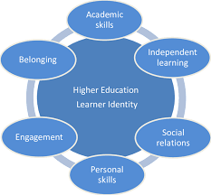

Figure 1: Higher Education Learner Identity[2]

Making logical decisions and long doing objectives information analysis are both components of critical thinking. By recognising difficulties and creating workable solutions, problem solving expands on this. These abilities are used in academic settings for data interpretation and argument construction. In their professional capacity, they assist staff members in resolving issues at work, streaming procedures and reaching well informed conclusions.

Team and collaboration.
The capacity to collaborate well with others to achieve a shared objective is known as teamwork. Group projects the classroom fosters collaboration and shared accountability. Collaboration is crucial in the workplace for sustaining a healthy work atmosphere, productivity and innovation.
[3]
Time Management and Organisation.
To fulfil deadlines, time management entails organising and prioritizing tasks. Organizations facilities this by uphold9ong organised work and information systems. While employees utilise these skills to effectively manage workloads and fulfil goals, students rely on them to balance coursework and assignments.
[4]
Digital literacy.
The capacity to use technology sensibly and efficiently is referred to as digital literacy. People must use software tools, browse online platforms and evaluate digital material in both modern job and education. In a word driven by technology, having strong digital skills boosts productivity and adaptability.
[5]

Task 1 (b): Evaluation of Task 1 (a) based on Similarity report

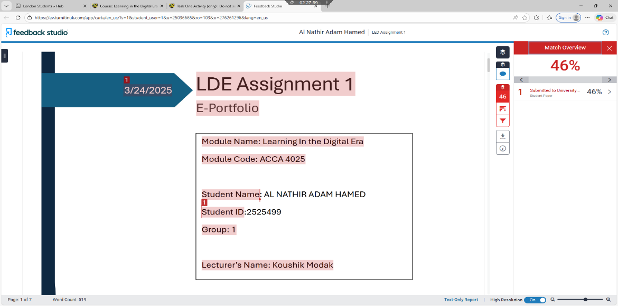

The key reason my high similarity score of 46% is that I followed the official assignment form that was given to all students. Many sections of my work naturally mirrored other papers because all students had to adhere to the same format, titles section titles, modules information, and cover page details. The shared structure and necessary formatting rules, not plagiarized academic content, are what cause the similarities. Every written response and analytical component was finished on its own. Therefore, rather than academic misbehaviour, the common template is the main cause of the high similarity percentage.
Self-assessment:
I showed in this assignment that I understand critical thinking, communication, teamwork, time management, and digital literacy all of which are important academic and professional abilities. I demonstrated my understanding of future professional requirements by outlining their significant in both school and the workplace. I would give myself 80% based on my works strengths and flaws because I fulfilled the task requirements but made a few spelling and grammar errors. I also need to work on my referencing and sentence structure. To get a better mark, I will proofread more thoroughly, work on my academic writing style, and make sure my references are formatted correctly in future assignment.

Task 2 (A)
COLLABRATIVE MIND MAP

https://mm.tt/map/3973198152?t=6ZgKt2WcRB
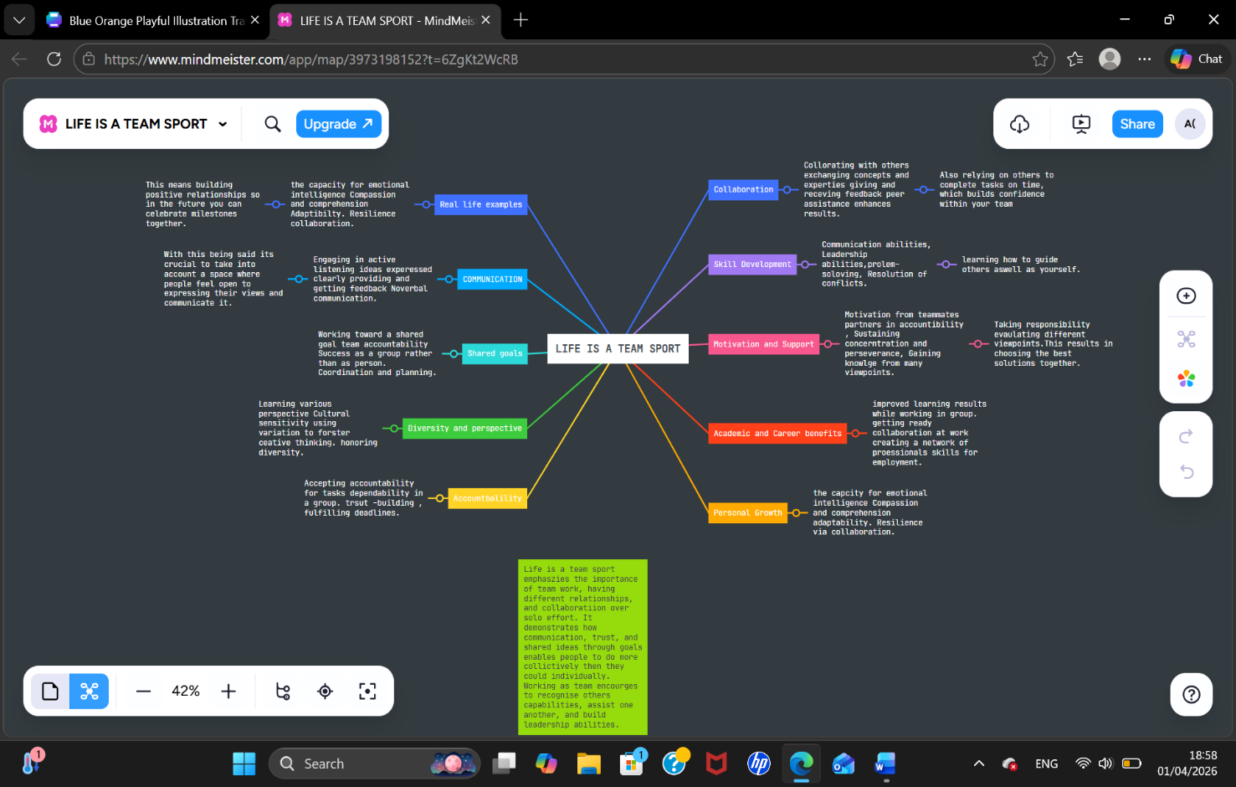

Summary about the mind map

A group ability to collaborate effectively and accomplish common objectives depends on several important factors. Clear communication is one of the most crucial elements since team member must freely share their information, and share different ideas, taking their time to think about others’ opinions, and offer criticism. Share viewpoints and try to demonstrate it with others. Every member in the group needs to contribute, despite differences in thought is another crucial component. Additionally, clearly defined roles and responsibilities are essential since they guarantee that everyone knows what they are doing and their responsibilities and prevent misunderstanding and try to work together to fix the errors or redundant labour. Cooperation and increase team members self-assurance. Strong leadership also aids in team direction, dispute resolution, and maintaining everyone’s attention on goals. Lastly working as team that possess flexibility is better for understanding, adaptability and working together. The reason for this is it allows us to work and benefit from each other and hear different opinions.
Poster
TASK 2 (B)
Poster Link:

https://www.canva.com/design/DAHE3q1aKCU/rW3Omqult-BQdEI3B3dsIA/edit?utm_content=DAHE3q1aKCU&utm_campaign=designshare&utm_medium=link2&utm_source=sharebutton
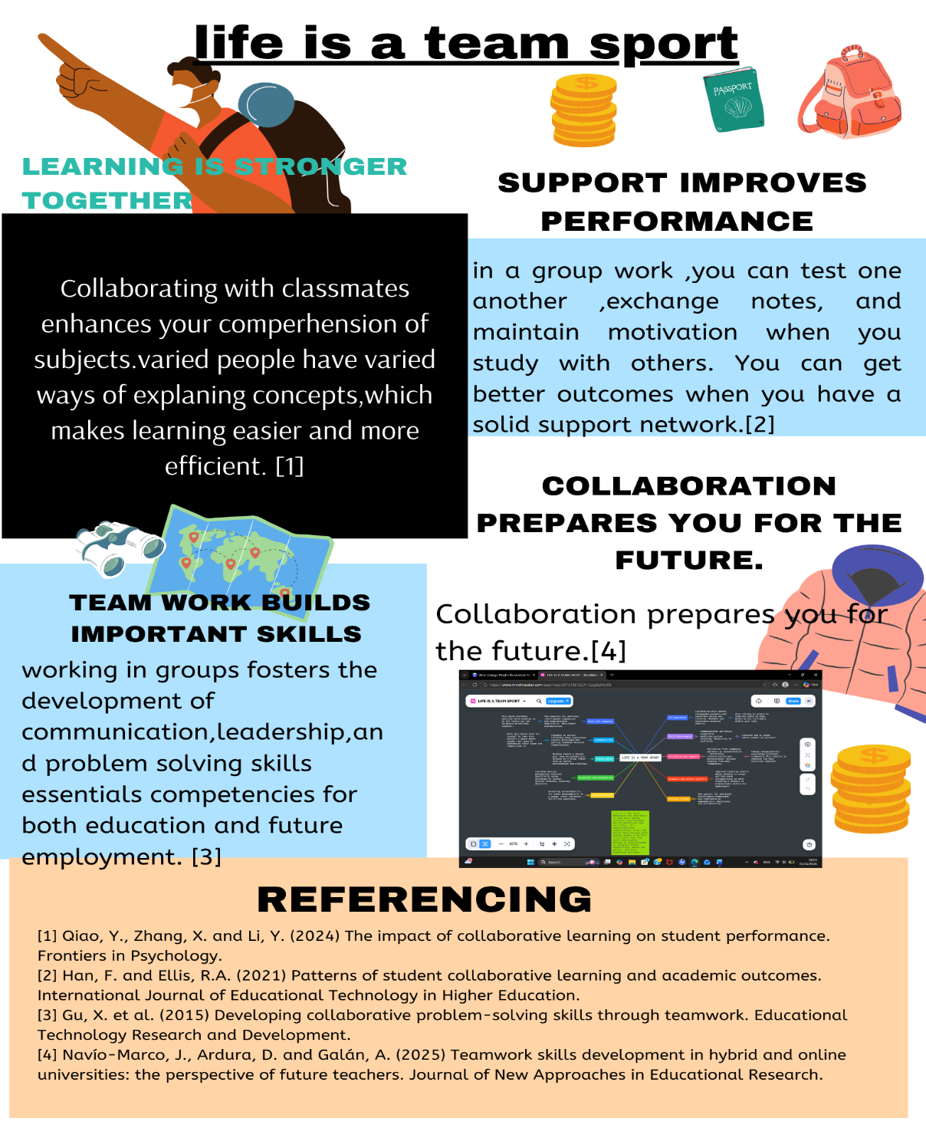

Task 3: Virtual Collaboration and RefWorks

FORMING A TEAM
There are stages to form a team. When the squad gets together, this is known as “forming” period. Team members are introduced to one another during this initial meeting. They establish initial impressions of one another by exchanging details about their experience, interests, and backgrounds. They become familiar with projects they are working on.[1]
The squad enters the “storming” phase as they begin working together. Every team member, especially a new member who has never collaborated before, will inevitably go through this phase of team development. The member competes with one another for placement and validation of their ideas throughout this phase. They disagree on what should be done and how, which cause conflict within the team. As they progress through this phase under the guidance of the team leader, they learn how to solve problems as a group, operate fairly as an autonomous and cohesive team, and fulfil tasks and obligations within the team. [2]
Taking the lead being extremely visible, facilitating introductions, giving the big picture, setting clear goals, conveying success criteria, and making sure response times are fast all techniques for the forming phase in teams. The forming phase tactics mentioned above for human phase are also applicable to teams.[3] The team members gradually go into norming phase. At this point, people start to resolve conflicts, acknowledging the abilities of their colleagues, and respect the authority of the team leader. Now that the acquainted, they may begin interacting and are prepared to ask each other for help and provide constructive outcomes. [4]The team is concentrating on achieving their goals as a unit is operating at a very high level. Each member of the team now knows themselves well enough to rely on, trust, and obey one another since not every team member reaches the performing stages, some collaborative participation ends at stage three norming, because the members have grown reliant on and trusting of one another, the highly effective team operates without errors.[5]
Screenshot showing RefWorks step by step

I’ll demonstrate how to login into RefWorks here. You must enter your student email address and password to login as you can see it on the screenshot.
Here you click login to get you into the page.

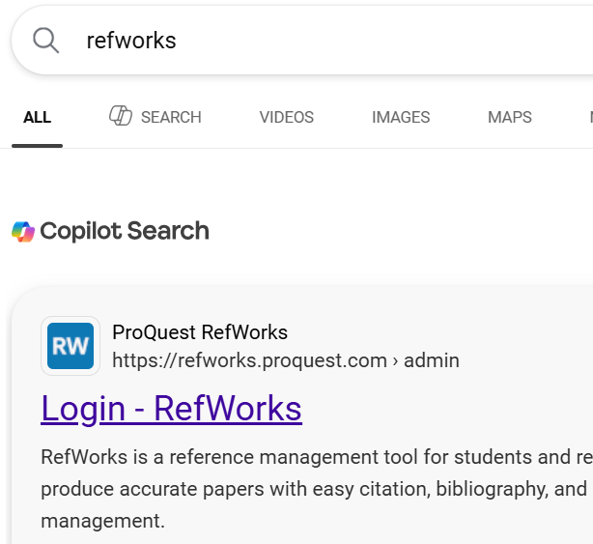
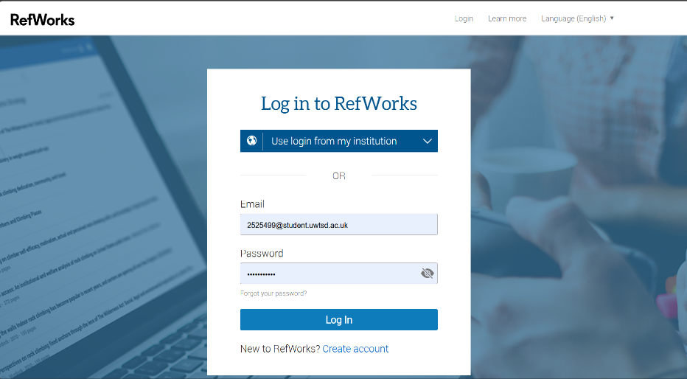

I went on google and searched for RefWorks, as you can see it, RefWorks showed up.

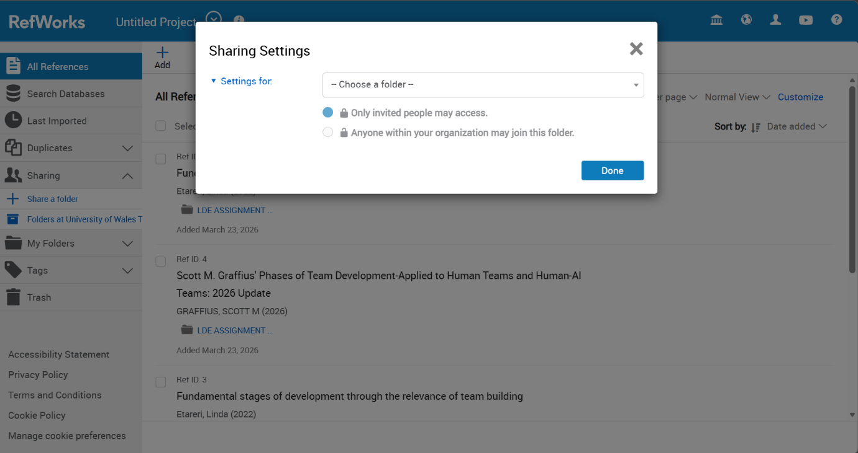
This where may make or share with all the references.
This where you choose your file then click on done.

After setting a RefWorks account, I went into google scholar and looked for the topic I wanted to discuss. As you can see, I selected forming a team as my topic, then clicked cite to get the RefWorks.
here, you click on the RefWorks and the RefWorks page will appear.

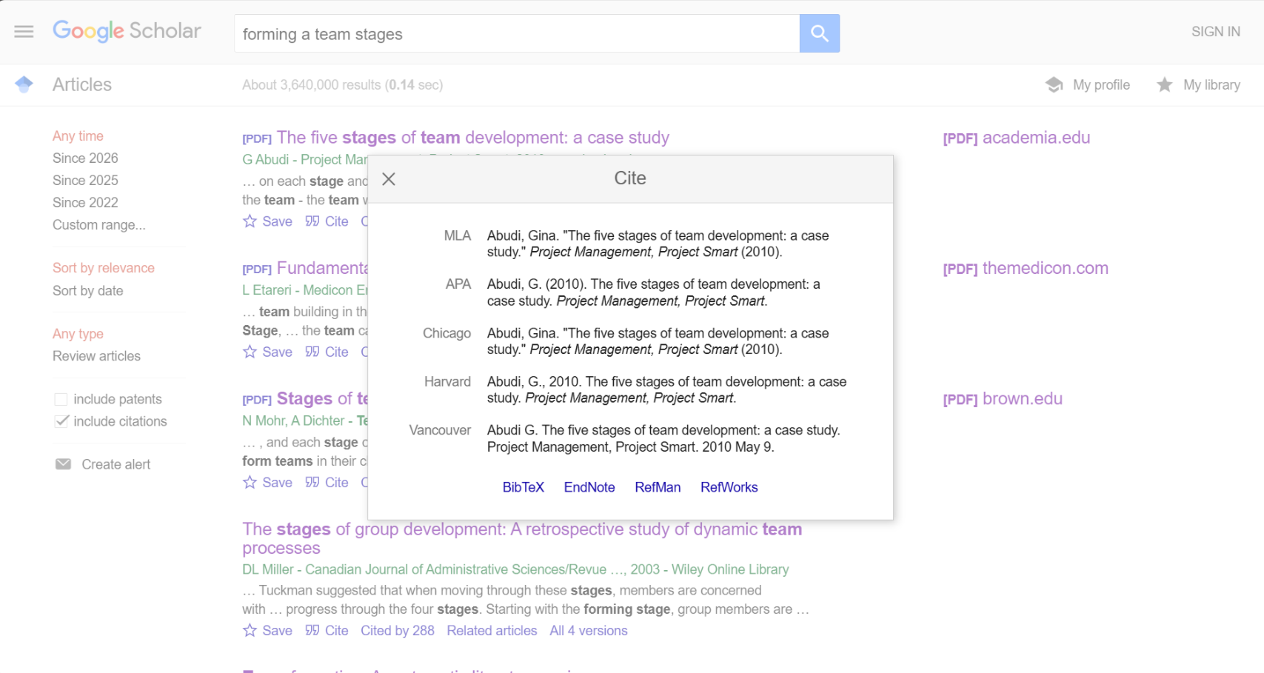

After clicking on the RefWorks, you will be taken to the RefWorks site and import reference will then appear, then click import.
After all the references have been imported, you come to word document and select the task that you want to reference.
Here you click on the folder you want import your reference.

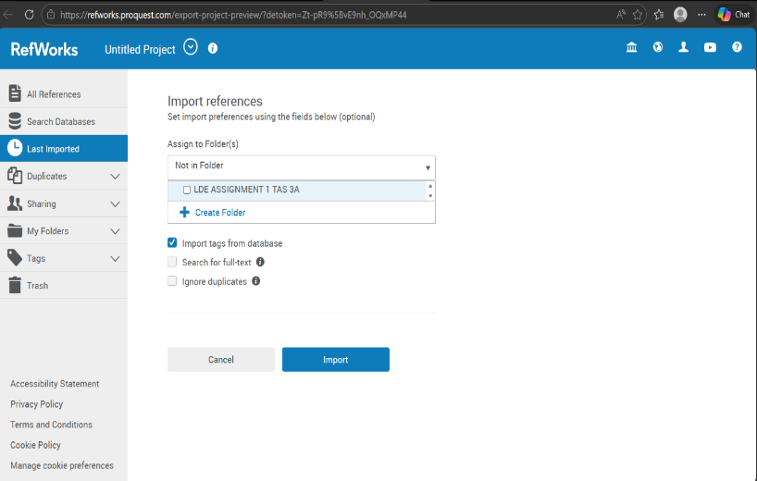
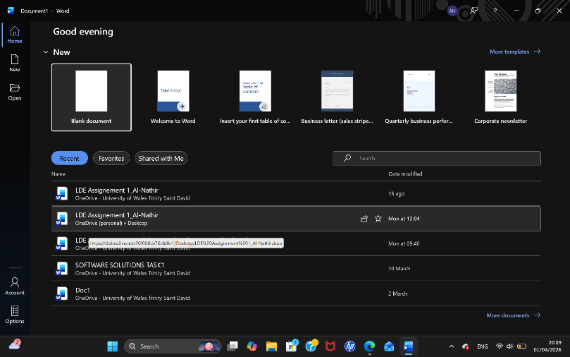

As you can see the RefWorks appeared. Click on it then it will take you to all the references that have been imported.
After importing all the references, go to the Word document, click Home, then Add Ins, and RefWorks will appear.

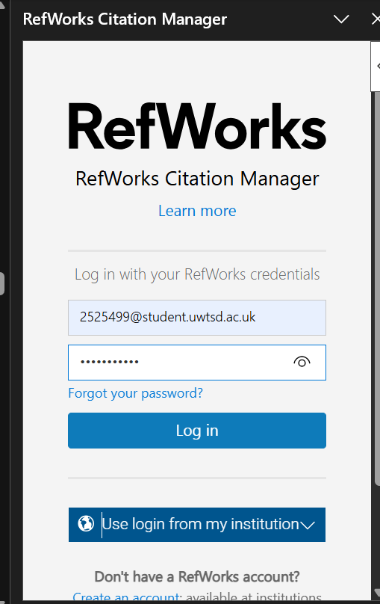
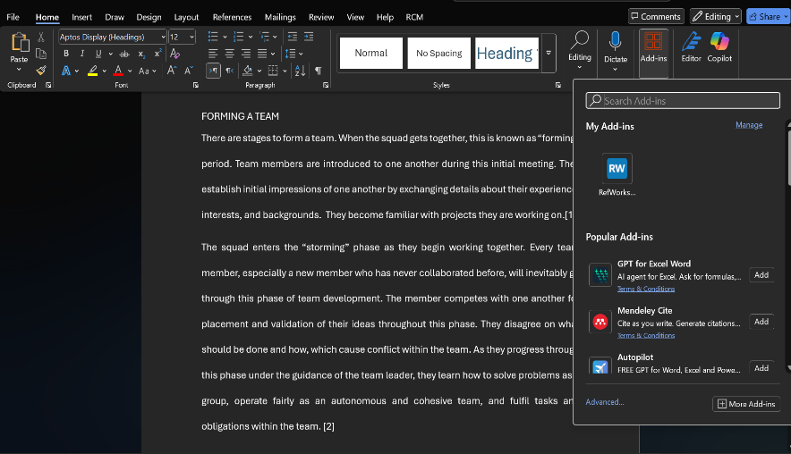

After the RefWorks appears, you fill up with your details, student email and password to login as you can see it.
After filling up putting the details then you click login.

This step is where you need to make sure the citation style is IEEE UWSTD ( institutional).
As you can see, this includes all the imported references.
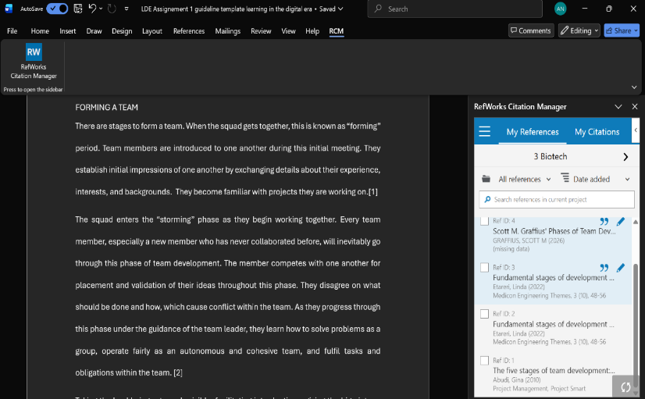

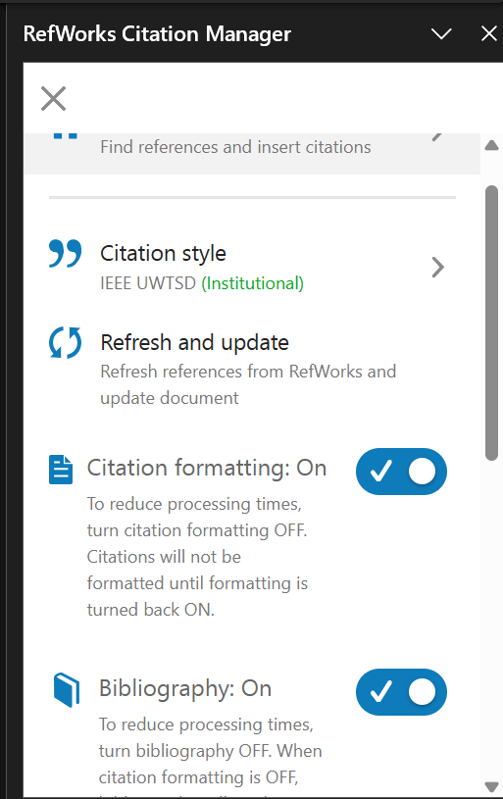

select one of the references then click insert citation and it will successfully be inserted.
As you can see that’s the insert citation button, click on it then citation will be inserted.
As you can see reference (2) successfully inserted.

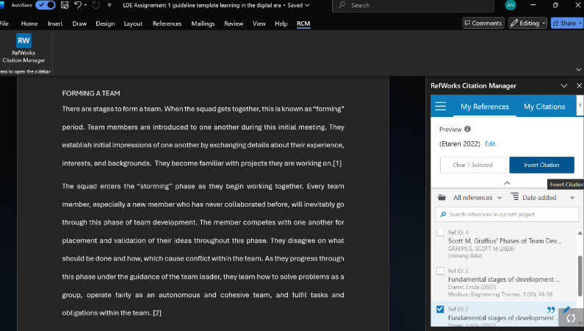
This where to find Bibliography from all the selected references. It also allows you to copy them.

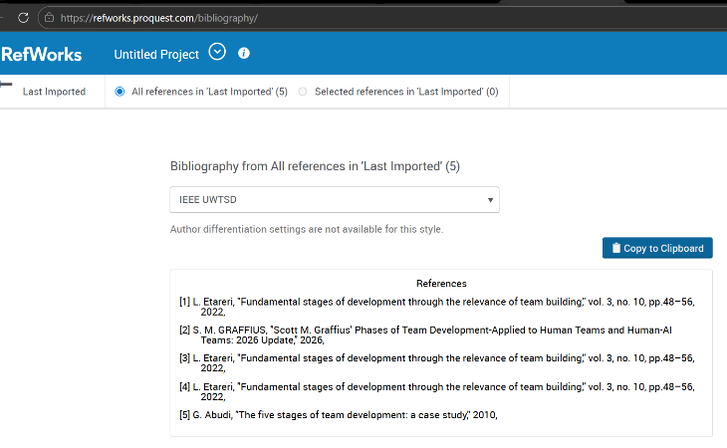

TASK 4 (A)
This is the first page that I made which’s the home page as you can see it.
E- PORTFOLIO CREATION

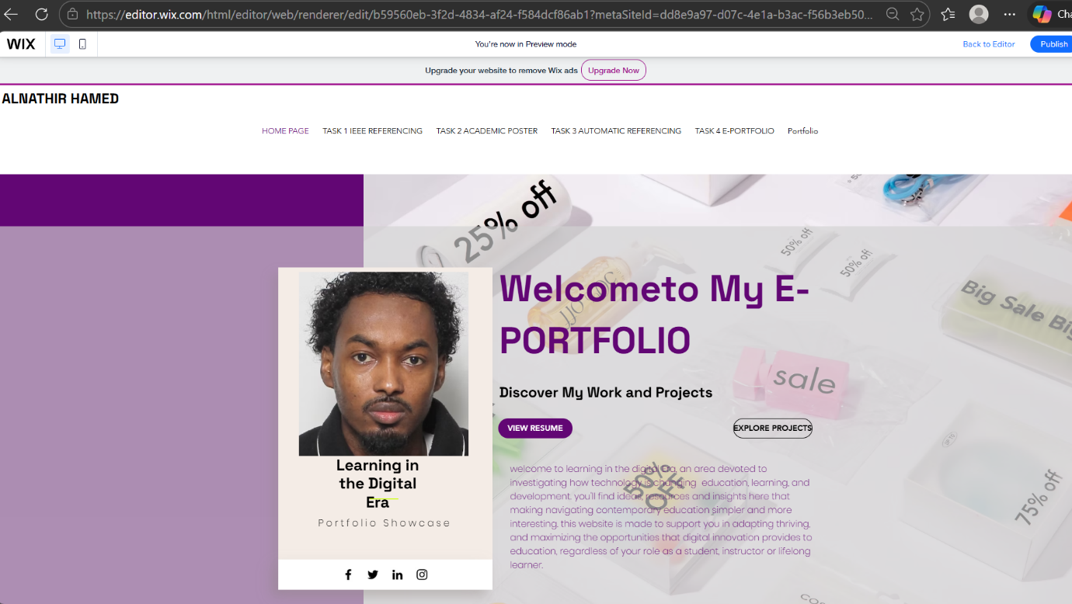

This is the task 1 page that I made which’s the IEEE Referencing.
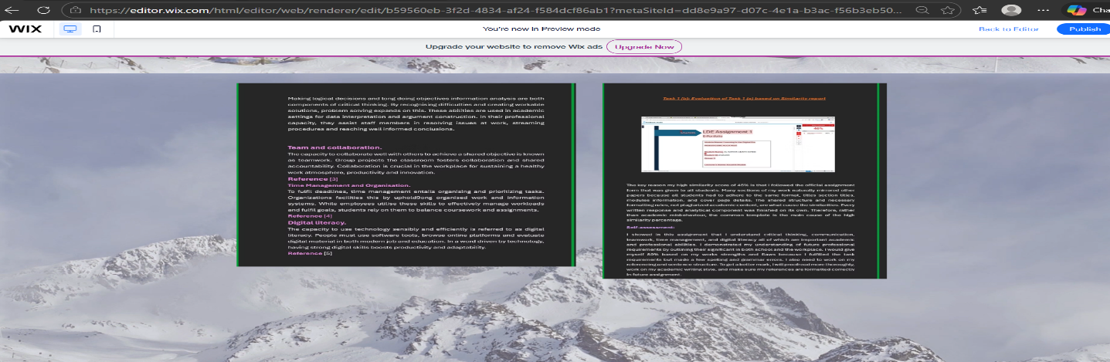
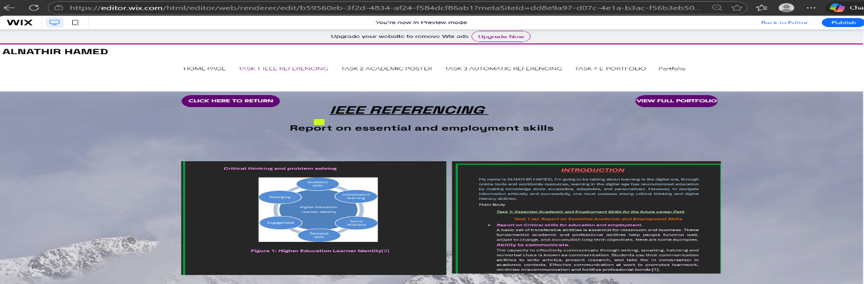
This is the task 2 page which’s the mind map and academic poster.

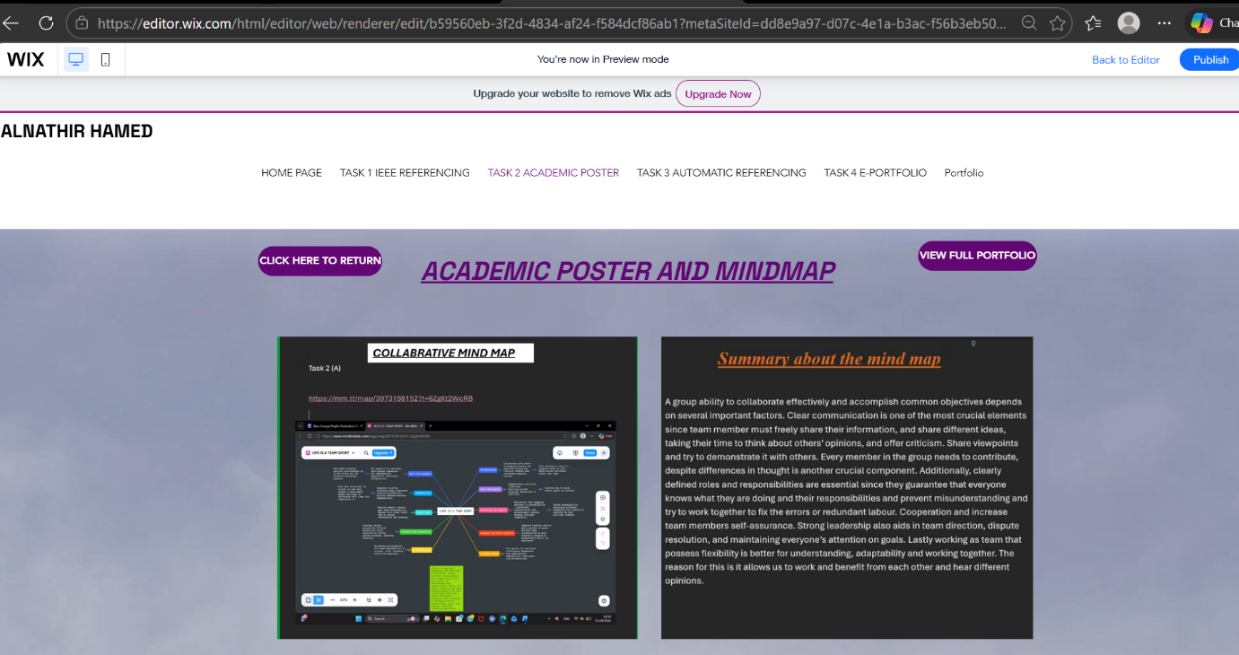

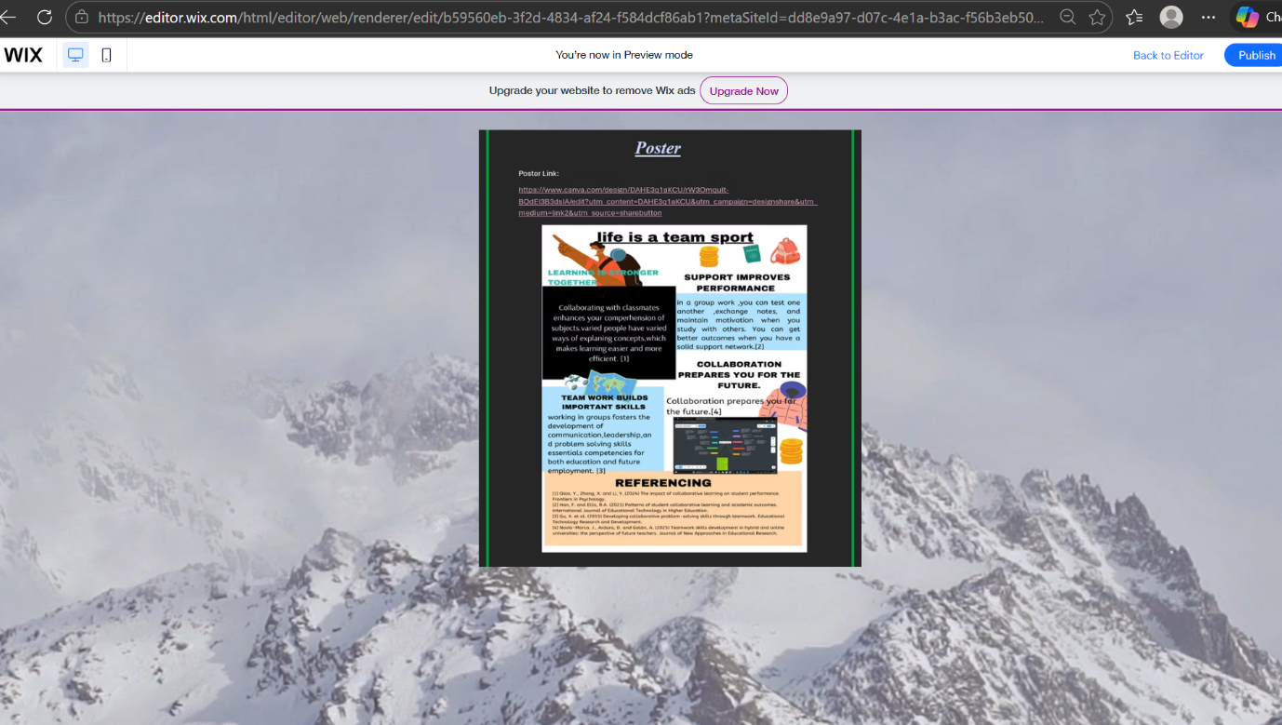

This page I made is for task 3 which’s the automatic referencing.

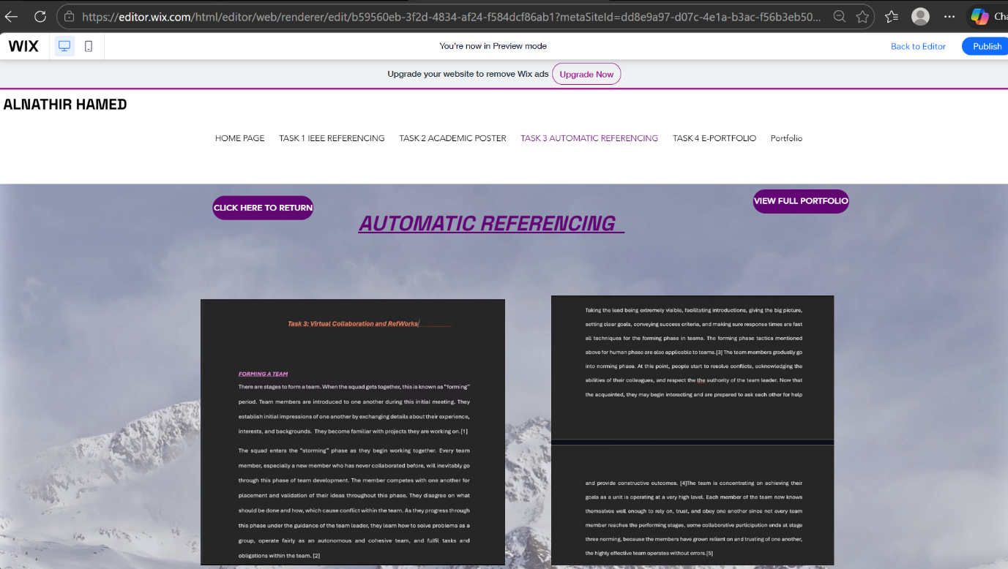

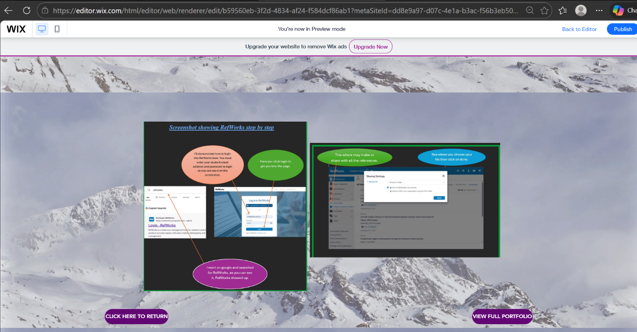

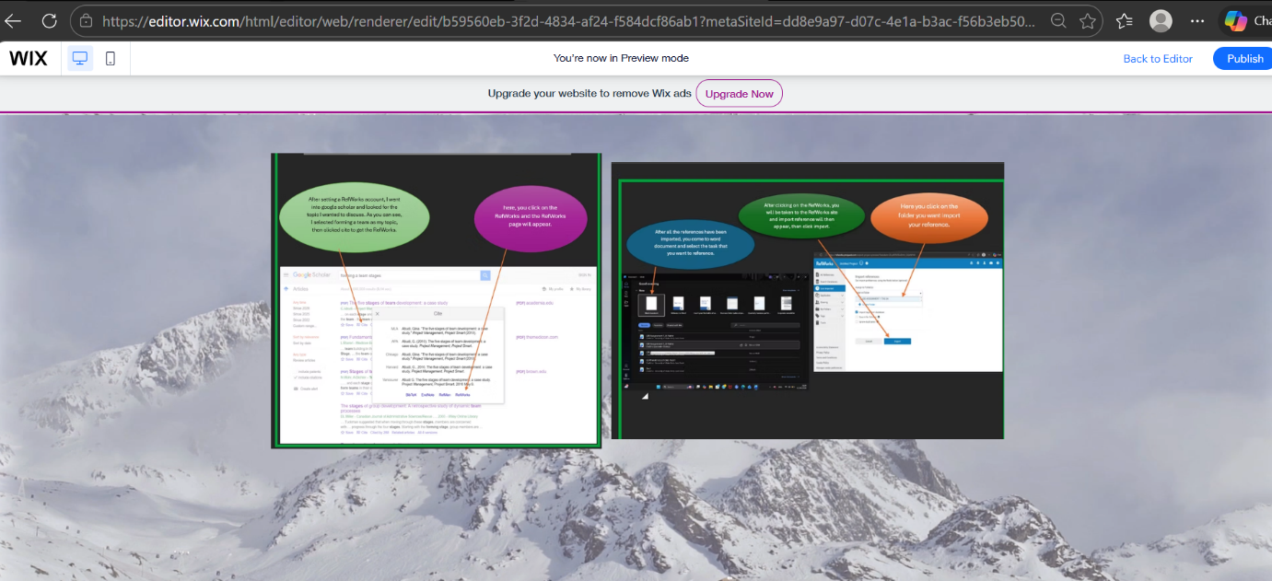

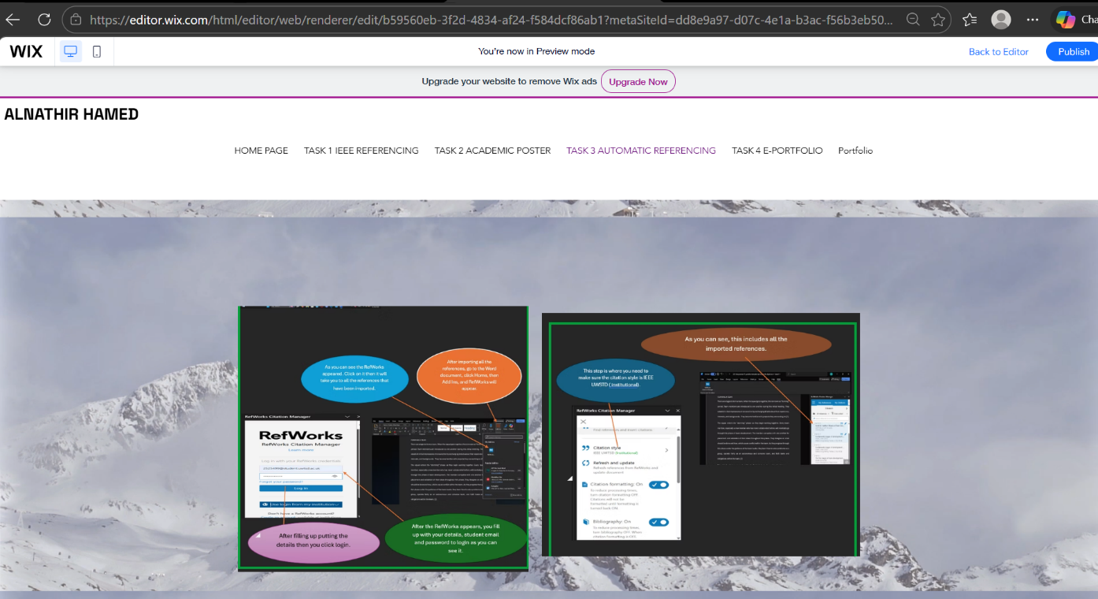

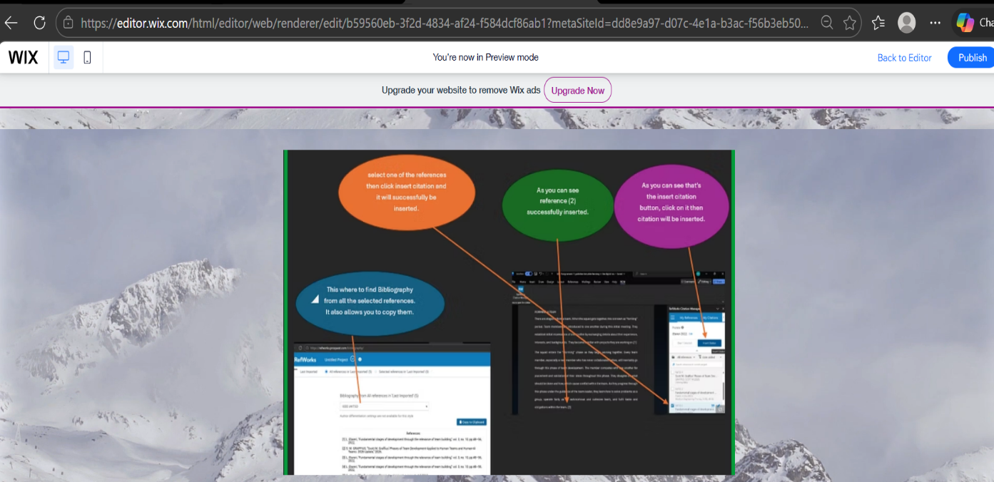

This is task 4 which’s the e- portfolio itself.
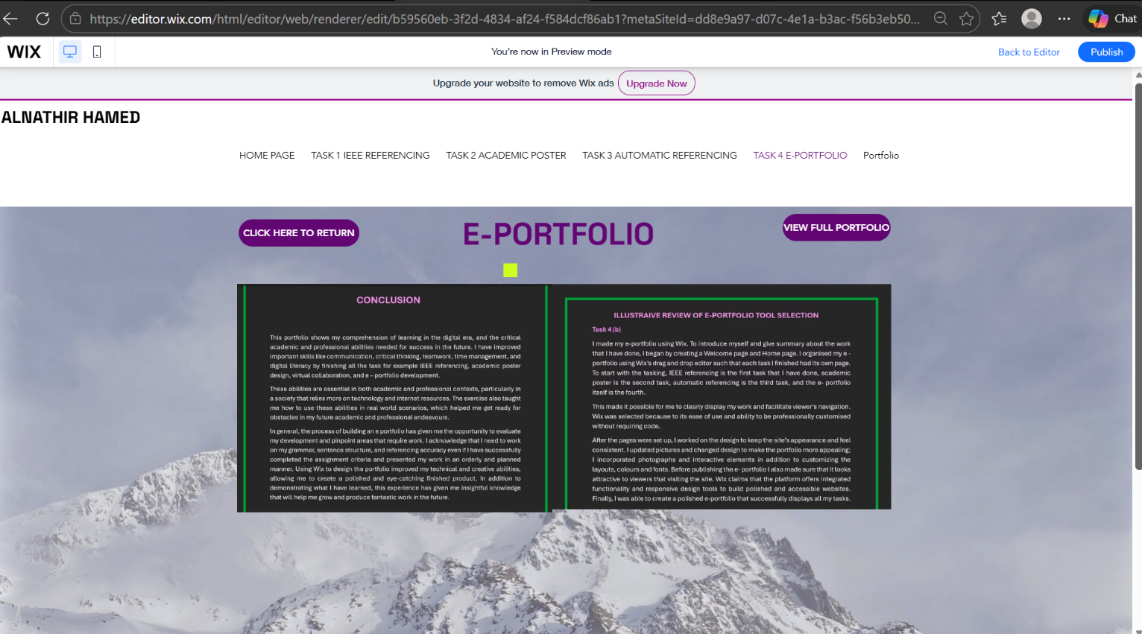

Task 4 (b)
ILLUSTRAIVE REVIEW OF E-PORTFOLIO TOOL SELECTION
I made my e-portfolio using Wix. To introduce myself and give summary about the work that I have done, I began by creating a Welcome page and Home page. I organised my e -portfolio using Wix’s drag and drop editor such that each task I finished had its own page. To start with the tasking, IEEE referencing is the first task that I have done, academic poster is the second task, automatic referencing is the third task, and the e- portfolio itself is the fourth.
This made it possible for me to clearly display my work and facilitate viewer’s navigation. Wix was selected because to its ease of use and ability to be professionally customised without requiring code.
After the pages were set up, I worked on the design to keep the site’s appearance and feel consistent. I updated pictures and changed design to make the portfolio more appealing; I incorporated photographs and interactive elements in addition to customizing the layouts, colours and fonts. Before publishing the e- portfolio I also made sure that it looks attractive to viewers that visiting the site. Wix claims that the platform offers integrated functionality and responsive design tools to build polished and accessible websites. Finally, I was able to create a polished e-portfolio that successfully displays all my tasks [6].
CONCLUSION

This portfolio shows my comprehension of learning in the digital era, and the critical academic and professional abilities needed for success in the future. I have improved important skills like communication, critical thinking, teamwork, time management, and digital literacy by finishing all the task for example IEEE referencing, academic poster design, virtual collaboration, and e – portfolio development.
These abilities are essential in both academic and professional contexts, particularly in a society that relies more on technology and internet resources. The exercise also taught me how to use these abilities in real world scenarios, which helped me get ready for obstacles in my future academic and professional endeavours.
In general, the process of building an e portfolio has given me the opportunity to evaluate my development and pinpoint areas that require work. I acknowledge that I need to work on my grammar, sentence structure, and referencing accuracy even if I have successfully completed the assignment criteria and presented my work in an orderly and planned manner. Using Wix to design the portfolio improved my technical and creative abilities, allowing me to create a polished and eye-catching finished product. In addition to demonstrating what I have learned, this experience has given me insightful knowledge that will help me grow and produce fantastic work in the future.
Task 3 references

References
[1] G. Abudi, "The five stages of team development: a case study," 2010,
[2] L. Etareri, "Fundamental stages of development through the relevance of team building," vol. 3, no. 10, pp.48–56, 2022,
[3] S. M. GRAFFIUS, "Scott M. Graffius' Phases of Team Development-Applied to Human Teams and Human-AI Teams: 2026 Update," 2026,
[4] L. Etareri, "Fundamental stages of development through the relevance of team building," vol. 3, no. 10, pp.48–56, 2022,
[5] L. Etareri, "Fundamental stages of development through the relevance of team building," vol. 3, no. 10, pp.48–56, 2022,
Task 1 (A) References

Bibliography

[1] | “Career Readiness Competencies,” 2023. [Online]. Available: https://www.naceweb.org/career-readiness/competencies/career-readiness-defined/.
[2] | “Resreachgate,” feburary 2020. [Online]. Available: esearchgate.net/publication/355378120_Widening_Participation_in_Higher_Education_immersion_as_a.
[3] | P. f. 2. C. Learning, “Framework for 21st Century Learning,” 2019. [Online]. Available: http://www.battelleforkids.org/networks/p21/frameworks-resources.
[4] | N. A. o. C. a. Employers, “Professionalism – Career Readiness Competency,” 2022 (no specific day listed). [Online]. Available: https://www.mindtools.com/pages/article/newHTE_00.htm.
[5] | UNESCO, “A Global Framework of Reference on Digital Literacy Skills,” July 2018. [Online]. Available: https://unesdoc.unesco.org.
[6] | k. campbell, “researchgate,” feburary 2020. [Online]. Available: https://www.researchgate.net/publication/355378120_Widening_Participation_in_Higher_Education_immersion_as_an_enabler.
[7] | “resaerchgate,” it does not give a day feburary 2020. [Online]. Available: esearchgate.net/publication/355378120_Widening_Participation_in_Higher_Education_immersion_as_an_enabler.

