Effective Team Working for Team Success

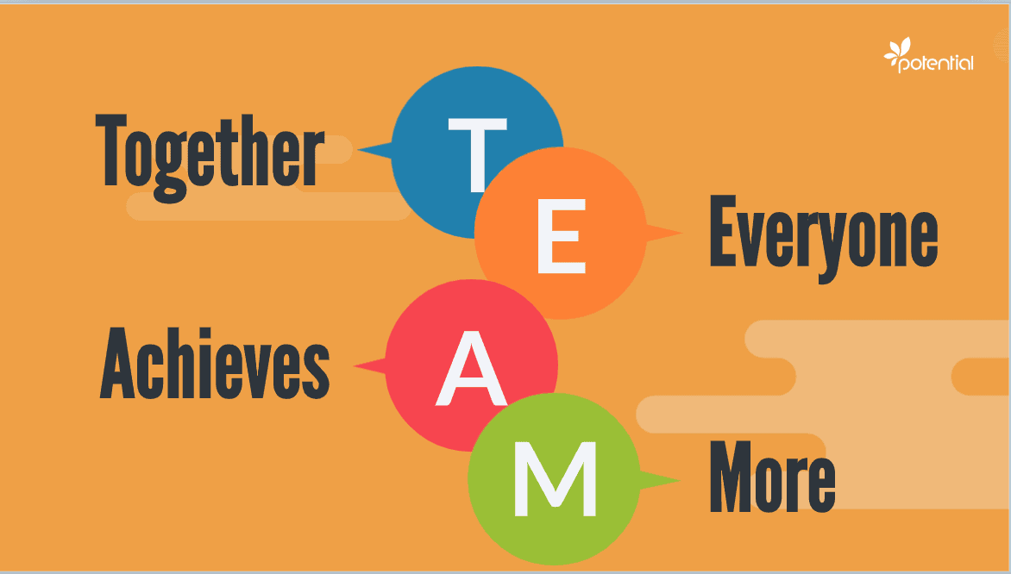
(Effective team working - Google Search, 2020)

Selina Shafiq - 2028762
Module Code: BMSW4002
Assignment: Effective Team Working and Communication
Lecturer: Suzannah Ogwu

SUMMARY

This report will analyse how the management at Trinity Social Care Home can develop an effective team within their working environment giving examples of different theories and team bonding skills. The impacts of effective team working in a Health and Social Care setting will also be outlined. In order to build an effective team we will discuss the barriers as well as the roles that are needed to create an effective team with reference to research in relation to effective team working.

CONTENTS PAGE

Introduction 4
Overview of Team Working………………………………………………………………………. 5
Definition of a Team 5
What contributes to effective team work 5
Models of Team Development 6
Tuckman’s Model of Team Development 6
Wheelan’s Model of Team Development 7 – 8
Team Roles ………………………………………………………………………………………..... 8
Belbin’s Theory of Team Roles ………………………………………………………………..8 - 10
Advantages of Effective Team Working ………………………………………………………11
The Impact of Ineffective or Poor Team Working ……………………………………...............12
The Culture Code (Coyle 2018) ……………………………………………………………….... 13
Conclusion & Recommendations ……………………………………………………............ 14
Refrences/Bibliography ……………………………………………………………………. 15- 17

INTRODUCTION

The information that will be discussed in this report is for the management team at Trinity Social Care Home to consider, so that progress can be made in order to develop effective team working within the organisation. It is stated due to diverse nature there has been conflicts that have damaged the organisations reputation; this report will outline different theories including Tuckmans Model, Wheelan’s Model and Belbin’s Team Roles theory to identify the differences in effective team work and the barriers to effective teamwork.
The types of roles to create an effective team will also be highlighted so that the management at Trinity Social Care Home can use the context of the research within this report to create a cohesive and effective team as well as understand the impact effective team working can have at this particular organisation.

What is a Team?
A group of individuals whom deliver independent tasks in order to achieve a common goal or a specific objective defines the term ‘team’ with in a workplace environment.
Working as a team can consist of just as minimal of two people whom work together to accomplish the same purpose. They can also be groups which vary from departments of work or even an organisation as a whole can be referred to as a team. ‘The principles of developing understanding and trust will apply, but the structure will get more complex’ (ASQ, 2021). This statement given from the American Society for Quality refers to the development of a team which expands so that it consists of a lot more people, explaining there are many internal relations within an organisation or workplace that will always develop and new teams will be made as an outcome. However things can get more complex such as conflicts and disagreements can come to light at these stages which then will have to be looked in to by management or members of higher authority in order to get to a solution.
What contributes to effective teamwork?
Teamwork is essential when it comes to achieving goals and objectives in the work place. In relation to Trinity Social Care Home due to the diverse nature conflicts it is clear that there are problems that need to be solved so that staff work effectively looking beyond the struggles.
Trust, interaction, and strong leadership are important components of successful teamwork, as is a concentrate on shared goals and a shared responsibility for achievement (or failure). The team, on the other hand, will struggle to function effectively without trust and communication. ‘For a team to be truly effective, its members must unite with the same vision and be motivated to bring that vision to life’ (Building an effective team | Michael Page, n.d.). It is clear that there are many skills that each individual may need to build an effective team however the ultimate factor that has to be considered by each individual is unity within the team.

MODELS OF TEAM DEVELOPMENT
How management at Trinity Social Care Home can develop an effective team?
In order to improve and form an effective team the management team at the Trinity Social Care Home can use the practise of Tuckman’s Theory to look beyond the conflicts caused in the Care Home.
TUCKMANS MODEL OF TEAM DEVELOPMENT (1965)
Bruce Tuckman, was an educational psychologist, he developed a five-stage growth process that most teams use to accomplish their goals within the workplace environment. According to him, the phases are as follows:-
- Forming - to make and ‘form’ a team
- Storming - to discuss the ideas, knowledge, experiences and conflicts between all the individuals of the team
- Norming – to normalise the situation and come to a mutual agreement after discussing all potential conflicts and problems within the team
- Performing - the team comes together and moves forward progressing to reach the results and outcome set.
- Adjourning – tasks completed, solution is found and team finished.
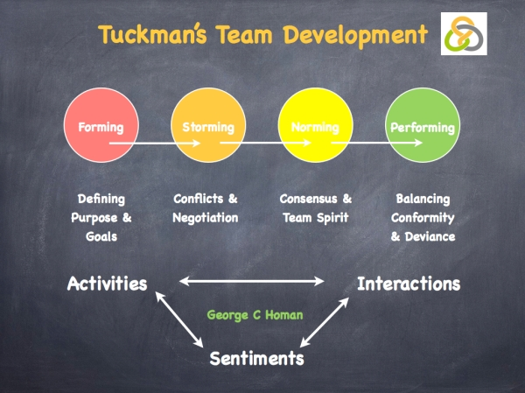
As a result, Tuckman's model is extremely valuable. The framework illustrates how a team's wisdom and ability develop an effective team. Tuckman's concept describes how industries grow and mature. It encourages people to develop for group work and allows them to fully exploit their abilities. He claims that teams go through a series of stages. (Tuckman Theory, 2013).
(TheHiddenEdge, 2018)

WHEELANS MODEL OF TEAM DEVELOPMENT (2016)
Another Development Method that the management team at Trinity Social Care Home can look into for developing a good working team amongst the staff members is Wheelan’s model of team development.
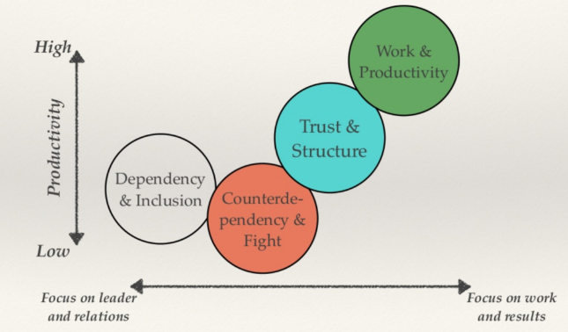

(Ronning, 2018)
Susan Wheelan suggested a group development "unified" or "integrated" model (Wheelan, S. A. 1994a). Despite being straightforward, this model assumes that groups develop while collaborating together instead of simply going through stages of activity. Specific concerns and trends of speaking, such as relying, counter-dependence, and belief, are linked in this "early" stages of team building, preceding the actual activities that are carried out in the "more mature" periods of a group presence.
The stages combine of:-
- Stage 1 – Dependency and Inclusion
- Stage 2 – Countering on conflicts and disagreements
- Stage 3 – Trust and Structure
- Stage 4 – Working together and Performing
Wheelan studied the relationships between the times the group meet and the spoken behaviour patterns of the team members according to Ebrary (2021). The findings indicate that the time a group comes together and the spoken conduct patterns of its members had a strong relationship. Members of older groups perceived their groups to be more productive, but they also exhibited characteristics of stages 3 and 4.
From my personal opinion I believe that the management team at the Care Home should try to resolve the diverse conflicts between the staff at the organisation using Tuckmans model as this is the appropriate structure to follow and all staff will need to be involved to create an effective team in order that the organisations reputation progresses. By following the stages correctly, the staff will achieve the outcomes they strive.

TEAM ROLES
To form an effective team there are a variety of roles and skills that the members of the team will need. Whether the individuals have all the skills or just one, to form a cohesive and effective team all roles must be distributed amongst the members of the team. Even though this may be challenging for some, ‘It is important to consistently make sure your team is working well together and reaching results effectively’ (Huhman, 2013)
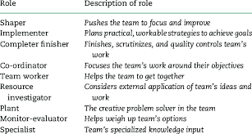
(Jones, 2015)
The types of roles that are needed to create a cohesive and effective team are highlighted in Belbin’s Theory. This theory was developed in 1981 which was studied for a further nine years, to support team building. The team roles were created to describe and predict the future success of management teams, with the understanding that the most successful teams contain a diverse range of personalities and characters. The definition of ‘team role’ from Belbin’s perception is "a tendency to behave, contribute and interrelate with others in a particular way." (Belbin's team roles, n.d.). For a team to be successful it is essential for members of the team to have a balance of personalities and duties.

Belbin’s Theory consists of three categories:-
- Thinking
- People
- Action
of which consist of 9 roles
Thinking People Action
- Plant - Co-ordinator - Shaper
- Monitor/evaluator - Team worker - Implementer
- Specialist - Resource Investigator - Complete finisher
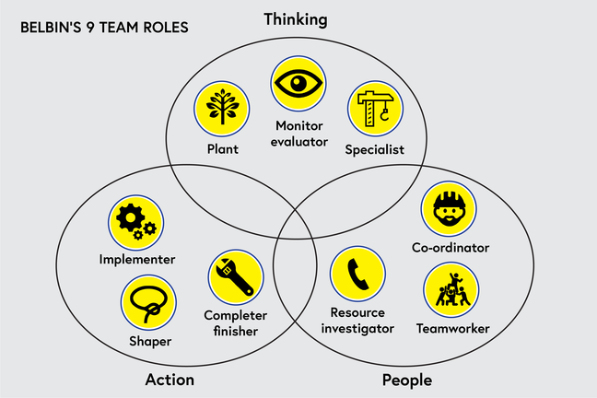

(Adapted from Belbin 1993)

From looking at both images above there is a clear understanding to Belbin’s concept of buiding a team and the roles that are required to combine a good team. The management team at Trinity Social Care Home can look in to Belbin’s theory and adapt the method to their working policies and procedures so that all staff members are a part and take up a role to form an effective team. This procedure will enhance the skills within the staff members where staff can discuss their opinions and address their conflicts to which can be amicably dealt with. However, if members of staff have lack of interest in their positions this could cause barriers to and effective team as this would reflect on the staff that are willing to learn, co-operate and wanting to make a strong team. The head on effect may also cause some of the team members to feeling pressurised with extra work responsibilities trying to keep the team strong picking up for those who are not. Another negative impact may be that those who were initially willing to keep the team strong lose motivation therefore the team collapses.
When recruiting new staff within the Care Home, it is important to consider the changes that will be made and the way a new member will adapt to the team. Too have a good working environment it is good to have positive people who are willing to progress in this field of work. To look out for motivated individuals whom have work experience can be a good factor as this individual will have some knowledge and background that will help them contribute to the team with confidence.

ADVANTAGES OF EFFECTIVE TEAM WORKING
There will always be challenges and obstacles when working as a team, nothing is ever perfect and straight forward however for the staff at Trinity Social Care Home it is important they work as a team to provide the best service for their patients. Some of the many advantages that can be looked into are as follows:-
- Different Ideas & Meeting Deadlines
From my personal experience this is an advantage in the work place as everyone thinks differently and when ideas are put together it becomes easier to reach the objectives and goals. For example at my work place when different departments come together with new ideas, we put them together to get the deadlines submitted on time, however if each department done it separately it would be a lot more time consuming.
- Increased Productivity
Individuals who contribute to a team's success will feel appreciated, supported, and devoted to one another. Employees will be happier, more productive, and motivated as a result of this.
- Good Working Relationships
Colleagues form strong ties as a result of teamwork. Team members get to know one another and gain a deeper knowledge of one another's strengths, limitations, and personal characteristics. Stronger relationships, trust, and communication becomes more natural making the workplace a happy environment to be in.
- Resolving Conflicts and Disagreements
There is sometimes the possibility of personality clashes between individual team members, but working toward shared goals generally allows employees to figure out how to overcome differences for the benefit of the team. However from looking at my experience from working alongside my colleagues for 6 years there are many occasions we have to look past the disagreements and settle at mutual decisions which is not as easy as it sounds. But when working in a team it is important to listen out for others and work around each other.
The Staff at the Care Home will need to come together as it is clear there are not just the above advantages but many more that will help the team work better together cutting out the diverse conflicts as this has a great effect on the reputation of the organisation as well as the patients within the organisation.

THE IMPACT OF INEFFECTIVE OR POOR TEAMWORKING
It is only normal to say that failure is a part of life and not always will things go as planned. An example of this is shown through the conflicts at the Trinity Social Care Home. No matter how good someone’s work ethics are it is necessary for colleagues to interact and work together at any work place. ‘When a team fails, falling into factions and division, everyone loses’ (Shannon, 2017). It is clear that at the Care Home there are encounters between the work staff in relation to diversity which may have been caused due to the following reasons:-
- Lack of Communication
When passing information, ideas, and knowledge from one person to another is known as communication. Without this ability, participation will never be successful. If the majority of employees are incapable of communicating effectively the team will fail.
- Negative Attitude
Having a negative approach to work can be a big disadvantage to the others that are part of the team. Not being motivated and having the wrong attitude to work can bring failure to the objectives set and leaving colleagues to feel upset at work. A similar situation at my work place resulted in the member of staff being sacked from work as they were not committed to the job and would make the work place feel like a toxic environment for others to work in.
- Lack of Support/ Training
When teams face challenges, individuals draw motivation from the support and encouragement of their teammates; however, when a team fails, individual members are left to face challenges alone, limiting the individual's ability to meet them. Without the support and training required a team cannot progress to gain the objectives set which then causes setbacks.

THE CULTURE CODE (COYLE 2018)
To work out the problems and develop an effective team at the Care Home, The Culture Code (Coyle 2018) can be considered. The culture code is a step-by-step method to teamwork that is not only efficient but also very satisfying. Whether you are a team leader or a member of a group this is a good method to work an effective team.
In the Culture Code, Coyle characterises vulnerability to share as how shared risk behaviour leads to collaboration with confidence. Sharing our vulnerabilities allows us to communicate our excellent ideas without fear of being judged. It also helps us to learn from setbacks and discuss ideas that did not work (even if it is an unpopular view)
This method consists of three categories:-
- Build Safety
To communicate and show good listening skills to each other, to embrace the messenger for example if you get negative feedback then to address a response with a positive and thoughtful attitude.

- Share Vulnerability
To discuss the vulnerabilities within the team, choose a leader whom can speak the truth and work in a good manner with everyone. To be able to address any negativity in a positive manner without causing conflicts. Also to be able to listen to all opinions, make other feel safe and support them.

- Establish the Purpose
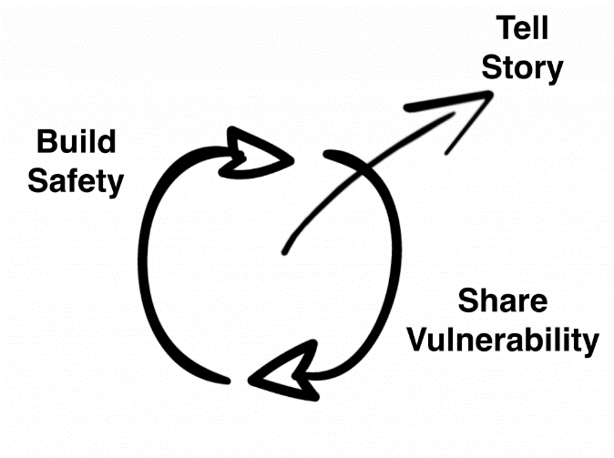
To succeed and achieve goals it’s important to put your priorities in place, to makes sure each member of the team is comfortable in their roles and to be very sure of what everyone ones contribution to the team involves.
(Coyle, 2018)
CONCLUSION/ RECOMMENDATIONS

The Information provided in this report outlines how an effective team can be developed, the impacts of an effective team as well as the barriers. There is also discussion of the team roles needed to create a good team. The management at Trinity Social Care Home can use this report to consider what methods and theories can be used to build a successful team in order to resolve the conflicts within the organisation. A useful theory that can be practised and I believe successful is that of Tuckmans, however it is also important to reflect on Belbin’s theory of team roles to form a successful team at the workplace. I recommend practising these theories to develop an effective team cutting out the conflicts and disagreements to build a good reputation of the organisation as well as keeping the patients in the care home as priority and happy.

REFERENCES/BIBLIOGRAPHY

ADVANTAGES OF EFFECTIVE TEAMWORK

Nibusinessinfo.co.uk. n.d. Advantages of effective teamwork | nibusinessinfo.co.uk. [online] Available at: <https://www.nibusinessinfo.co.uk/content/advantages-effective-teamwork> [Accessed 31 October 2021].

BELBIN'S TEAM ROLES

Ifm.eng.cam.ac.uk. n.d. Belbin's team roles. [online] Available at: <https://www.ifm.eng.cam.ac.uk/research/dmg/tools-and-techniques/belbins-team-roles/> [Accessed 19 October 2021].

BELBIN, M

Belbin, M., 2021. Home. [online] Belbin.com. Available at: <https://www.belbin.com/> [Accessed 16 October 2021].

BUILDING AN EFFECTIVE TEAM | MICHAEL PAGE

Michael Page. n.d. Building an effective team | Michael Page. [online] Available at: <https://www.michaelpage.ae/advice/management-advice/development-and-retention/building-effective-team> [Accessed 15 October 2021].

COYLE, D.

Coyle, D., 2018. How to Think About Culture - Daniel Coyle. [online] Daniel Coyle. Available at: <http://danielcoyle.com/2018/02/06/how-to-think-about-culture/> [Accessed 31 October 2021].

EBRARY 2021
Ebrary. 2021. Wheelan's Integrated Model of Group Development. [online] Available at: <https://ebrary.net/3071/management/wheelans_integrated_model_group_development> [Accessed 15 October 2021].

EFFECTIVE TEAM WORKING - GOOGLE SEARCH

Google.co.uk. 2020. effective team working - Google Search. [online] Available at: <https://www.google.co.uk/search?q=effective+team+working&source=lnms&tbm=isch&sa=X&ved=2ahUKEwji_b2W8PHzAhVjlFwKHXOHBIgQ_AUoAXoECAEQCg&biw=1318&bih=657&dpr=1#imgrc=2X5QAjUCasHXvM> [Accessed 16 October 2021].

HUHMAN, H

Huhman, H., 2013. 8 Ways to Build a Cohesive Team. [online] HuffPost. Available at: <https://www.huffpost.com/entry/8-ways-to-build-a-cohesiv_b_3390565> [Accessed 14 October 2021].

JONES, W. W.

Jones, W., 2015. [online] Research Gate. Available at: <https://www.researchgate.net/figure/Summary-of-Belbin-team-roles-Adapted-from-the-Belbin-website-wwwbelbincom_tbl3_281303895> [Accessed 13 October 2021].

RONNING, B.

Ronning, B., 2018. Managing Projects & Teams — Ben Ronning. [online] Ben Ronning. Available at: <http://www.benronning.com/writing/2018/8/24/managing-projects-teams> [Accessed 30 October 2021].

SHANNON, A.

Shannon, A., 2017. What Do You Lose When Teamwork Fails? | Kent State University. [online] Kent.edu. Available at: <https://www.kent.edu/yourtrainingpartner/what-do-you-lose-when-teamwork-fails> [Accessed 20 October 2021].

THEHIDDENEDGE, V.

TheHiddenEdge, V., 2018. Tuckman’s Team Development. [online] Laura McHarrie @ The Hidden Edge. Available at: <https://thehiddenedge.co.uk/portfolio/tuckmans-team-development/> [Accessed 30 October 2021].

TUCKMAN THEORY 2013
Tuckman Theory 2013.. [online] Available at: <https://kirbyxo.wordpress.com/2013/11/13/tuckman-theory/> [Accessed 26 October 2021].

WHAT IS A TEAM? TYPES OF TEAMS & PROCESSES | ASQAsq.org. 2021. What is a Team? Types of Teams & Processes | ASQ. [online] Available at: <https://asq.org/quality-resources/teams> [Accessed 25 October 2021].

WHEELAN S A
Wheelan, S. A. (1994a). Group processes: A developmental perspective. Boston: Allyn & Bacon. Group processes: A developmental perspective. Boston: Allyn & Bacon.

