

Assignment Title- Communication and Customer journey of Burberry Trench coats (75%)

Student Name :- Krupaben Hasmukhbhai Dhameliya
Student ID :- 2207957
Module Name :- Marketing Management
Module Code :- LCMB7001
Name of Lecturer :- Tushara Balendran
Submission Date :- 9th January 2023
Table of content

- Executive summary...……………………………………………………………………. 3
- Introduction ……..………………………………………………………………............. 3
- Company background……………………………………………………………………. 3
- Mission and vision statement……………………………………………………………. 3
- Definition of communication……………………………………………………………. 4
- Shannon and Weaver Communication model …………………………………………... 4
- Communication diagram of Burberry…………………………………………………… 5
- Integrated marketing communications………………………………………….............. 6
- Definition
- Importance
- Recommendation of IMC tools
- New promotional strategies for Burberry to raise awareness of the brand……………… 7
- Definition of branding and brand equity………………………………………………… 8
- Keller’s Brand Equity model to the company…………………………………………... 9
- Advantages and disadvantages of Brand Equity model………………………………… 10
- Customer Journey ……………………………………………………………………… 11
- Stages of the customer journey with diagram…………………….................................. 12
- Discussion of customer touchpoints for the company in the three stages……………... 14
- Customer Journey Map ……………………………………………………………….... 15
- Discussion of what touchpoints are affected and what touchpoints are not affected with reason ……………………………………………………………………………………16
- Strength and weaknesses of the Burberry ……………………………………………… 17
- Total Engagement Model ………………………………………………………………. 18
- Recommendation ………………………………………………………………………. 18
- Conclusion ……………………………………………………………………………... 19
- References ……………………………………………………………………….. 20/21/22

Executive summary
This project is based on the marketing communication and customer journey in the company of Burberry. It begins with an overview along with the vision of the company. A clear description of communication and integrated marketing communication has been given with an analysis of the same in Burberry. A brand equity model has also been applied to the iconic trench coats of Burberry. Following that, a customer journey has been depicted along with the map of a buyer in Burberry. A total engagement model has also been applied to the company. Finally, a conclusive recommendation is provided on the same.
Introduction
This project is based on marketing strategies and the customer journey on which they are implemented. Marketing is one of the most important functions of a company. The primary purpose of this activity is to make the targeted customers aware of the products that a company offers and help them in their purchasing behaviour. Companies use innovative ideas to promote their products and utilise various touch points to influence their buying decisions. The organisation selected to explain the above points briefly is Burberry. Its famous branded trench coats have been taken to define its specific customer journey.

Company background
Burberry is a luxury fashion house which has its headquarters in London, UK. The company was established by its founder, Thomas Burberry in 1856 (Olteanu, 2020). He opened his own shop in Basingstoke, Hampshire, after being an assistant to a draper. The company expanded all over the world throughout the years. The company has 418 stores across 34 countries. The products of Burberry include ready-to-wear men's and women's clothing, trench coats, eyewear, and leather products like bags, belts, and footwear. The worldwide revenue of Burberry amounted to 2.83 billion British pounds in 2022. The company has held its heritage while adopting modern innovations in fashion and design.

Mission and vision statement
The core belief of Burberry states that spaces are opened by creativity. The open spaces logic gives a tribute to the fabric that was created by Thomas Burberry and further denoted the freedom that was felt by its customers after wearing their products. There are four values of the company deeply rooted in its actions. They are open and caring, inclusive, have respect and belonging, and are driven by creativity (Demangeot, 2021). The mission and vision of Burberry are to become a leading brand by providing high-quality value, growth, and sustainability to all its stakeholders.

Definition of communication
In a general sense, communication is a process that involves a sender and a receiver. Through this process, information and messages are exchanged from one individual or group to another (Van Ruler, 2018). Analysing the purpose of marketing, it can be realized that communication is one of the key elements contributing to better and strategic marketing of designated products. Marketing communications use different channels and media to communicate all the information on the products or brand name using digital marketing, sales promotion techniques, social media, or personal selling. All their activities are generally concentrated towards a specific market or target potential or existing customer group.

Shannon and Weaver’s Communication model

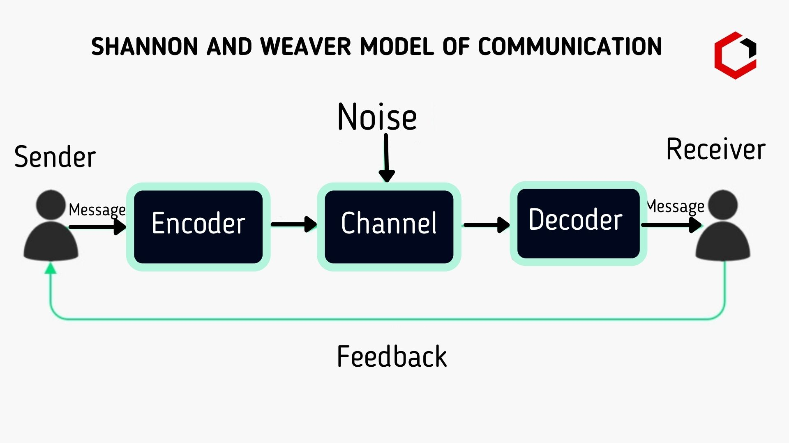

There are two main models of communication that are involved in marketing called Macro and Micro communication models. The Macro communication model has nine elements that are focused on customer marketing engagement. They include Sender, Encoding, Media and Message, Decoding, Receiver, Response, Feedback, and Noise (Eke, 2020). Senders and receivers here are the company entity and the targeted customers respectively to whom the marketed message is sent. The message is the information needed to be communicated, while the media is the channel of communication connecting the sender and the receiver. Encoding refers to the process of sending cues to customer segments. Decoding is a reading process of cues sent by companies about themselves or their products.
Noise is the element that causes disruptions in the communication process, especially in between marketing channels chosen for communication. For Burberry, the receivers of their marketing message are mainly women who have high disposable income to spend on fashion and accessories (Phau, Akintimehin and Lee, 2022). Burberry trench coats are targeted at both men and women and their variations in premium pricing depend on the design and material. Media like social networks of Instagram and advertising on television throughout the UK help them communicate their message to the targeted audience.
Communication diagram of Burberry
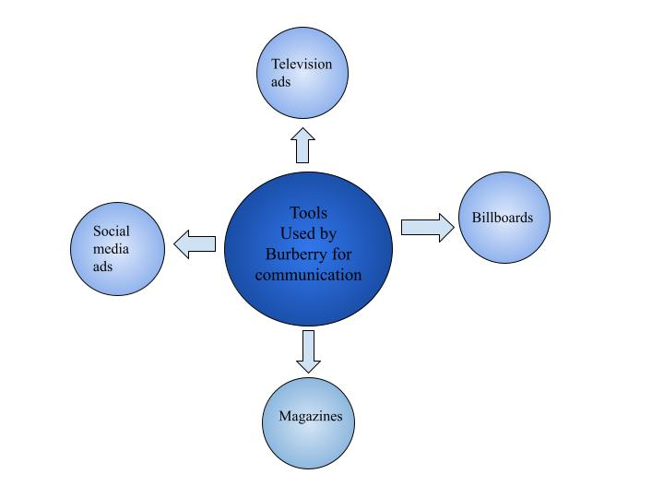

Integrated Marketing Communications in simple terms can be defined as a process which is used to unify Marketing Communication elements like public relation, Sock, different customer Analytics, business development, advertisement and more together. The Integrated Marketing Communication or IMC tools help in communicating brand messages to the larger audience that is being targeted. IMC tools have become an integral part of marketing activities in the modern business era.

Integrated Marketing Communications

Definition
There are different processes that can use multiple elements of communication together and implement strategies using a unified system. This process of aligning marketing communication elements is called Integrated Marketing Communications (Laurie and Mortimer, 2019). This technique is applied mainly to keep the authenticity and consistency of the brand identity of a company. Another purpose of this framework is to use all channels to provide an innovative and immersive marketing experience to the targeted or existing consumers. Burberry uses both traditional and modern marketing approaches to promote its trench coat fashion wear. All of its information is the same throughout television commercial advertising, print media, and social media.

Importance
There is importance in integrating different marketing communication elements even after the customers are aware of the marketing message that is communicated because it showcases the marketing values that the company is ready to present to its customers (Mogaji and Yoon, 2019). Communicating the same message through all the channels while integrating the mediums can help save costs for the company for more content creation. It also builds a brand using the same consistency. The usage of the right mix of marketing communication channels can improve the effectiveness of marketing channels. It also helps the marketing channels to reinforce each other until the message is completely communicated to the target audience.

Recommendation of IMC tools
Burberry spends a lot on digital advertisements and running posts on social media platforms. Along with that, the company can indulge in direct marketing to engage customers. There are a lot of tools concerning direct marketing that can help Burberry. The company can use various tools like emails, text messages, catalogues, and promotional letters to integrate the marketing strategy. Implementation of these IMC tools will help to deliver messages to end users directly. Burberry can also price the option of sales promotion. Burberry can give discount coupons to attract more customers as well as let them try free samples (Kushwaha et al., 2020). The exchange scheme can also be initiated by the company where the customers would be able to exchange their older clothes and buy new ones in Exchange with a discount attached. Separate discounts can also be provided for a limited period on products on demand (Šķiltere and Bormane, 2018). The company can also increase awareness through public relations. Burberry can host events to promote its awareness and launch new products. Burberry already actively organises events to promote its product but there is still a lot to be improved. Burberry is on its way to becoming one of the major sustainable fashion brands in the world. Through its events, the company can promote sustainability majorly to increase awareness among customers and generate a positive Outlook. Burberry can also implement email campaigns Inside its marketing activities. Email campaigns have been seen to be one of the most effective ways to drive traffic on the official website of a company so focusing on email campaigns can prove to be fruitful for Burberry.
New promotional strategies for your company to raise awareness of the brand
Proper use of technology - Every company uses technology for marketing. But this strategy of promoting involves the advanced usage of the latest technology. Burberry can apply Virtual Recognition systems on its websites or stores to let customers try their trench coats virtually before purchasing (Corriveau Lecavalier et al., 2020). The automated AI systems can recognise customers' patterns and Burberry can use it to target the audience to promote trench coats using email marketing.
Personalisation - Generalized promotions have failed to create appeal for fashion and clothing products. Big data analytics and refined data can be used to target customers individually and relate their information to the company products. Burberry can use Facebook and Google search results for customer information regarding fashion wear and promote trench coats by relating to their preferences.
Using fashion influencers on social media platforms - This is a new trend taken up by companies to promote their brand using influencers. They are people that have access to a large number of people and sponsoring their activities in exchange for promotion through their media can help spread the name of the company brand (Wielki, 2020). Burberry can use fashion influencers like Sophie Milner and Dianne Crowe to use their social media for promotions on Instagram or other media. This is a kind of personal recommendation that people trust and tend to buy Burberry trench coats.
Giveaways - Many companies have attained more customers by marketing products using giveaways. Burberry can also organize giveaways for its trench coats. They can use themes based on different seasons, events, or festivals. It will be more eye-catching and improve knowledge of the product for its customers. Burberry can make Christmas trench coats, autumn trench coats, and fall trench coats and advertise them through giveaways.
Branding and Brand Equity Model

Definition
Branding is a method of creating a strong perception in the minds of customers for a certain company. It can be about the name of the company itself or its individual products and services that create a brand. Branding is done by utilizing and modifying different elements like the brand logo, name, theme, or specific design and spreading them through marketing communications. The marketing term for the value of a brand is called Brand equity (Shariq, 2018). This value is dependent on the perception and experience of customers with the company itself. Companies try to create positive brand equity on the basis of customer trust and loyalty.

Explain and relate Keller’s Brand Equity model to the company
There are various factors that can affect the strength of a particular brand and its representing product. This can be analysed using Keller’s model of brand equity. This particular model can help understand the elements of branding and the customer's perception towards the product. It is categorised into 4 different levels that help the company understand the aspects of its brand - brand identity, brand meaning, brand response, and resonance (Świtała et al., 2018). This model is also called the Customer-Based Brand Equity or CBBE model and formulates results after an in-depth analysis of customer experience with the selected product. The elements of this model with respect to Burberry are as follows:
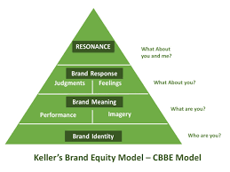
Fig- Keller’s brand equity model
Source- (Lee and Choi, 2022)
Salience - The quality of being noticed by the customers defines the salience or rather, the brand identity of a product. Burberry targets those women and men that have an appeal for the exceptional qualities in their trench coats. Salience is moderate against trench coats because even after the recognisable quality and classic style produced by Burberry, the recall and logo recognition is less than the product category in the UK.
Performance - It denotes the brand-meaning aspect of the model. Burberry trench coats are one of those products that have stuck to smart designs, great quality clothing material, and durability (Lee and Choi, 2022). Customers are assured these elements by the company through the official trademark of Burberry on their trench coats. The edgy designs, classic base colours, and tartan print make it unique from other competitors.
Imagery - This is also a part of brand meaning in Keller’s model. The professional design and craftsmanship of the Burberry trench coats appeal to those people who like a clean style and classic look. The sophistication makes it target the exact customer group that the company wants - women and men with high-end income and a fashion sense. The customer experience and sustainable production of these trench coats have led customers to have a good image of the product and its brand.
Judgements - This element represents the brand response part of the model. Some judgments associated with trench coats in single words are superior quality and high priced (Silvano, 2020). The brand judgment of trench coats is high because of the brand presence it has created. The appeal has not yet shifted to the younger generation, who deem it to be overpriced and suggest adding more style according to the modern generation.
Feelings - Feelings are also a part of the response by its customers and others for this brand. Trench coats have been embedded in British culture for decades. They started during the First World War and gave a feeling of nostalgia and self-respect to the UK citizens. And the premium quality of Burberry also gives a feeling of luxury and comfort, which denotes the success of the brand.
Resonance - The element of resonance proves the equity of the brand in the market. The loyalty of the customers in Burberry trench coats has led to establishing a separate brand of class among common people. The eliteness and sleek look give them edges in fashion during adverse situations like fall seasons. The response is very high and positive towards trench coats because of dependability and strong customer engagement.

Advantages and disadvantages of Brand Equity model
The benefit of analysing a brand through this model is that it exactly depicts the perception of customers towards a brand. It creates a perfect identity for the company and its products which the customers have viewed with their own points. Burberry trench coats are a strong brand and have a presence in the UK fashion statement or trends (Fernie and Perry, 2019). It is a perfect blend of classic and modern fashion. But there are certain disadvantages of this model as well. A clear depiction leads companies to incur extra costs in maintaining this brand equity and modify it more. This also hinders the other opportunities that could have been taken from those excess funds. The model also lacks some other elements important in branding like authenticity, purpose, and unique proposition.

Customer journey
The concept of customer journey depicts the entire process through which customers interact with a particular brand, product or service. It can be both direct and indirect interaction that starts from hearing about the product to after sales and more. There are different stages or marketing touch points that any customer has contact with before purchasing the product. Therefore, understanding this journey is beneficial for companies. There are certain ways through which companies can encourage and influence the purchasing decisions of customers through these touch points (Wilson-Nash, Goode and Currie, 2020). A clear understanding of the demands of the customers can help companies serve them with optimum quality and provide satisfaction through their products.
There are different elements involved in buying a Burberry trench coat for customers. The knowledge of this product comes from different sources. After that, the customer checks all his considerations and mainly engages in the comparison of different factors or substitute products. Then, the customer avails to buy the trench coat and uses different methods to purchase it. In the retention process, the company representatives keep contact with the customers by keeping them updated. Finally, the customer shows loyalty and buys another trench coat of the same or different style.

Stages of the customer journey
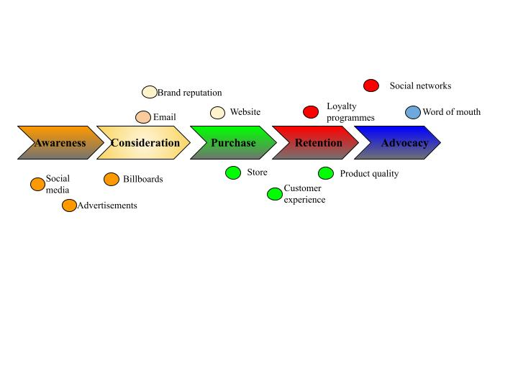

- Awareness
The first stage of the customer journey is to create awareness about the product among the customers. The promotional strategies of Burberry are heavily related to creating awareness for its products. The company creates awareness among customers by promoting its products on different social media platforms. To target, specific customer’s advertisements are also done in magazines (Santana, Thomas and Morwitz, 2020). Apart from that advertisements are done on television and billboards are also set. The company also engages by bringing in famous models and celebrities to promote their products in order to create awareness. Famous British model Kate Moss is the most recent example of that.
- Consideration
The consideration face of the customer journey explains the time when a customer considers buying products from a company, here Burberry. The consideration to buy products from Burberry is created by the mammoth promotion done by the fashion brand. Throughout the years the company has also built a great reputation for it among customers which also influence them to consider buying products from Burberry.
- Purchase
In the third phase of the customer journey, the customer decides to buy fashion products from Burberry. The decision is mainly e taken due to the message promotion done by the company. The products that Burberry offers are also very rich in quality which massively influences customers to purchase them as well.
- Retention
Burberry retains its customers through the impeccable customer experience that it provides inside the retail stores. The brand also creates a very positive Outlook about itself in the mind of customers by providing products of very high quality. Customers often stay loyal and come back to Burberry in future to purchase products of similar quality. The company also runs loyalty programmes to improve the emotional attachment of customers to the brand which helps in retaining customers.
- Advocacy
After purchasing from Burberry the customers most often spread the positive word of mouth. The reason behind this is the impactful customer experience they had while buying the product and the satisfaction level with the quality of the product which has been provided to them (Hoyer et al., 2020). The company also actively engages with customers on social media platforms to ask for their feedback. Any complaints and negative feedback are taken very seriously by Burberry.

Customer touchpoints for the organisation
Some of Burberry's interactions with its customers do not include the company's website or promoted material. Burberry can reach a wider audience in their target market via collaborations since their customers are likely to be fans of the partners' other brands. The format of partnered material varies widely. It may be anything like an asset or an event that Burberry creates and sponsors for a partner to use on their platforms (Bascur, Rusu and Quiñones, 2018). Experts, authorities, and influential members of your industry, as well as other firms, may be among those with whom Burberry has collaborated to create a win-win marketing strategy.
Burberry can use the capabilities given by each platform to target certain demographics based on their available profile information, such as location, ethnicity, age range, and activity preferences. This enables Burberry to reach the people who will be most receptive to and interested in their message (Marques, 2018). A percentage of its advertising budget is needed, but the investment may be worthwhile if Burberry is able to leverage increased social interaction into a point of contact with its target audience.

Discussion of customer touchpoints for the company in the three stages
Pre-purchase
Many touch points affect the customer journey throughout all of its different phases. In times of pre-purchase, some important touch points are social media, online advertisement, digital marketing content, company events, Conversation with company representatives and more. Burberry makes great use of some of the mentioned touch points as the company focuses on expanding awareness about its products in the pre-purchase phase. Customer touch points such as digital marketing, social media and online advertisements are integral to the company's promotional activities.
Purchase
The most important customer touch points in terms of purchase are the website, customer service team and physical stores. This response is important to the Purchase phase as the purchase is directly connected to these factors (Wünderlich and Hogreve, 2019). All the purchases from Burberry are done from its physical stores and online website which proves the fact that physical stores and websites are the most important customer touch points related to purchases from Burberry.
Post-purchase
Post-purchase touchpoints include email, new loyalty programmes, customer feedback and more. The post-purchase actions of Burberry are mainly related to acquiring information about customer perception regarding their products in the market. The post-purchase initiatives of Burberry are also heavily connected to retaining their customers and attracting them to come back in future to make more purchases.

Customer Journey Map
The following table has been made to depict the customer journey map of purchasing a branded trench coat from Burberry.
Stage | Awareness | Consideration | Decision | Service | Loyalty
Customer action | Suggestions from friends,  Social media trends, television advertisements | Finds more information on social media and company website and compare with other products | Goes to a Burberry trench coat or purchase online | Delivery and customer care service, suggestions to buy other products | Goes back to purchasing more trench coats after satisfied product
Touchpoint | Commercial ads, Facebook, Instagram | Company website and social media handle | Online retail websites, company website, third-party fashion stores and Burberry store | Personalised messaging, after-sales services, email and notifications on new products | Websites and stores
Customer experience | Finds about the brand and its quality | Highly decisive and confused | Happy from getting the product and enjoying its quality | Feel recognised and improved iteration with company representative | Trust the company and enjoy new products
Business goals | Get customers to notice the brand | To promote products and showcase premium quality | Make sales and provide good customer service | Use personalised methods to retain loyalty | Resale and take care of customers
Teams involved | Marketing, Finance | Marketing and IT | Sales department | Sales and Marketing department | Sales department

Fig: Customer journey map
Source: Self-created

It is clear that the company has upheld its values and provides good care and service to customers to help them make buying decisions in their customer journey.

Discussion of what touchpoints are affected and what touchpoints are not affected with reason
In the pre-purchase phase, the touch points that are affected in Burberry are the ones related to digital marketing, social media, and online advertisement and company events. This is due to the reason that Burberry organises special events to launch its new fashion wear and other products. It has already been mentioned that online advertisements and social media posts are an integral part of the company's promotion in order to obtain awareness from customers. All the touch points in the purchase phase that have been mentioned customer service, website and physical store affect Burberry. Most of the purchases are from Burberry London from its online website or its physical stores (De Keyser et al., 2020). Customer service also is very important as Burberry looks to provide impeccable customer experience to increase loyalty. Loyalty programs and customer feedback are the two touch points that affect the company in post-purchase. Burberry pays a lot of attention to acquiring feedback from customers on what they think about the products (Jaakkola and Terho, 2021). Various loyalty programs are also done by the company to increase the number of loyal customers. The loyalty programs are deeply associated with helping customers develop an emotional connection with the company.

Strength and weaknesses of the Burberry
Strengths of Burberry
The first strength of Burberry is that it has a huge network of retail wholesale and licensing channels from a global standpoint. The company also has a wide range of products. Burberry is also one of the most valuable companies in the world right now. The company also has a strong workforce with more than 10,000 people working inside the company.
Weaknesses of Burberry
The premium price range of the products available inside the company does not fit the budget of many customers which works as a weakness. The company generates a lot of revenue from the Asian continent. But since the pandemic customer demands and preferences have drastically changed over there which could work as a weakness for Burberry and lead to lesser demand.

Total Engagement Model and its application to the company

This model is based on establishing a brand of products through a collective experience of four distinct elements. They are value proposition, organisation culture, brand advertising, and experience of the customers. All of these interactions help create a brand image of the product or the company in which the customer is engaged in the entire process. The value proposition of Burberry trench coats is to provide products of high quality while maintaining the classic image of fashion in the UK (Chen et al., 2021). It showcases the integrity, consistency, and creativity of Burberry which has preserved the pride, strength, and forwardness of the brand.
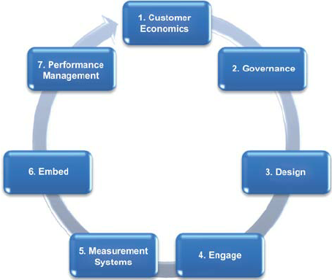
Fig- Total engagement model
Source- (Silvano, 2020)
The culture of Burberry that it passes to its customers through its employees is an open and caring nature. The promotion of inclusiveness and respect has helped to nurture positive core values so that the customer towers can get a quality experience while purchasing Burberry trench coats. Burberry advertises its brand through both traditional and modern channels using personal selling, social media, sponsorship, digital marketing, and commercials on television (Silvano, 2020). They connect the potential and existing customers to the values of Burberry and the quality of the trench coat brand. The customer experience is one of quality, care, and class, which originates from all the points mentioned above.

Recommendation
Burberry needs to focus on specific customer touch points in order to increase profits and customer satisfaction in the coming days. It is recommended that the company puts detailed focus on digital advertisements as the most important pre purchase touch point. Barberry is recommended to utilise several social media platforms and internet marketing at the same time to draw enough attention from the customers. Utilising these touch points will also keep the customers constantly engaged. The retail stores of the company will act as one of the most integral touch points of Burberry that the customers come in touch with. Customer experience needs to be enhanced in retail stores to increase the satisfaction level of customers. But probably the most important customer touchpoint comes in the post purchase phase which will be customer feedback. Customer feedback must be obtained by analysing the word of mouth spread by the customers after purchase and feedback must be openly asked from the customers on social media platforms. Obtaining customer feedback will help Burberry to understand where they need to improve for better performance and providing better customer experience. Any complaints of the customers must be taken very seriously and dealt with great importance.

Conclusion
It can be concluded that Burberry has been making clothes for a very long period, giving them a wealth of knowledge in the field. If Burberry were allowed to set up shops in an emerging nation, it would alter the textile sector, leading to the creation of new jobs. The fashion industry in the area would benefit from the company's expertise since it would help them become more efficient and produce more marketable goods.
Allowing Burberry to set up shops in a nation can have a significant effect on the local textile sector, spawning new businesses and providing much-needed employment. It might help the government bring in more money, which would be used to improve their social services. Before deciding whether or not to let the corporation enter the nation, the government should consider the potential rewards and dangers associated with doing so. Governments should take precautions to safeguard domestic manufacturing.
Offering incentives might help local firms keep their market share in the face of Burberry's expansion. The organisation has earned a reputation for its dedication to employee well-being and respect for human rights. Still, the government must enact effective labour rules to safeguard workers without discouraging foreign-based businesses from setting up shops.
Burberry needs to expand its distribution options. In addition, the corporation relies on independent dealers for product distribution. Burberry has an official website where customers may apply for discounts and other special offers. In this business model, consumers place orders on a website and get home delivery of the goods they purchased. A large part of Burberry's marketing strategy in the U.S. and European markets relies on the support of celebrities. Romeo Beckham, Charlotte Wiggins, and Max Rendell are just a few of the famous people that have collaborated with the firm.

References
Aghara, V.N., Nwaizugbo, I.C., Oparah, P.C. and Ifeanyichukwu, C.D., 2018. Sales promotion as a leverage strategy for improving sales and profitability in alcohol beverage industry. International research journal of management, IT and social sciences, 5(4), pp.18-25.
Bascur, C., Rusu, C. and Quiñones, D., 2018, October. User as customer: touchpoints and journey map. In International Conference on Human Systems Engineering and Design: Future Trends and Applications (pp. 117-122). Springer, Cham.
Camilleri, M.A., 2020. The use of data-driven technologies for customer-centric marketing. International Journal of Big Data Management, 1(1), pp.50-63.
Chen, X., Cheng, S., Shu, R. and Yang, Y., 2021, September. Digital Marketing Transition for Luxury Industry Under the New Coronavirus Epidemic-The Case of Burberry. In 2021 International Conference on Financial Management and Economic Transition (FMET 2021) (pp. 248-254). Atlantis Press.
Corriveau Lecavalier, N., Ouellet, É., Boller, B. and Belleville, S., 2020. Use of immersive virtual reality to assess episodic memory: A validation study in older adults. Neuropsychological rehabilitation, 30(3), pp.462-480.
Czinkota, M.R., Kotabe, M., Vrontis, D. and Shams, S.M., 2021. Direct Marketing, Sales Promotion, and Public Relations. In Marketing Management (pp. 607-647). Springer, Cham.
De Keyser, A., Verleye, K., Lemon, K.N., Keiningham, T.L. and Klaus, P., 2020. Moving the customer experience field forward: introducing the touchpoints, context, qualities (TCQ) nomenclature. Journal of Service Research, 23(4), pp.433-455.
Demangeot, M., 2021. How Do Heritage Brands Transfer Their Brand Identity While Transitioning From A Complex To A Simple Visual Identity?: A Burberry Case Study.
Eke, G.J., 2020. Effective Communication Processes: A Peanacea for Organizations’ Success. IOSR Journal of Business and Management, 22(8), pp.42-54.
Febriyantoro, M.T., 2020. Exploring YouTube Marketing Communication: Brand awareness, brand image and purchase intention in the millennial generation. Cogent Business & Management, 7(1), p.1787733.
Fernie, J.O.H.N. and Perry, P.A.T.S.Y., 2019. Luxury fashion supply chain management. Logistics and Retail Management, pp.149-182.
Hoyer, W.D., Kroschke, M., Schmitt, B., Kraume, K. and Shankar, V., 2020. Transforming the customer experience through new technologies. Journal of Interactive Marketing, 51(1), pp.57-71.

Jaakkola, E. and Terho, H., 2021. Service journey quality: conceptualization, measurement and customer outcomes. Journal of service management.

Kushwaha, B.P., Singh, R.K., Varghese, N. and Singh, V.N., 2020. Integrating social media and digital media as new elements of integrated marketing communication for creating brand equity. Journal of Content, Community & Communication, 11(6), pp.52-64.
Laurie, S. and Mortimer, K., 2019. How to achieve true integration: the impact of integrated marketing communication on the client/agency relationship. Journal of Marketing Management, 35(3-4), pp.231-252.
Lee, M. and Choi, S.Y., 2022. How does Burberry Infuse ‘Freshness’ into Classic Trench Coats?. International Journal of Costume and Fashion, 22(1), pp.63-79.
Marques, S.M.E., 2018. The disruption of retail through Gen Z: An exploratory study on the new customer journey and the impact of customer touchpoints on Brand Loyalty.
Mogaji, E. and Yoon, H., 2019. Thematic analysis of marketing messages in UK universities’ prospectuses. International Journal of Educational Management.
Olteanu, L., 2020. Rebranding strategies and their boomerang effect—The curious case of Burberry. The Journal of World Intellectual Property, 23(5-6), pp.777-797.
Phau, I., Akintimehin, O. and Lee, S., 2022. Investigating consumers' brand desirability of “upcycled” luxury: the many faces of designer facemasks. Journal of Fashion Marketing and Management: An International Journal, (ahead-of-print).
Santana, S., Thomas, M. and Morwitz, V.G., 2020. The role of numbers in the customer journey. Journal of Retailing, 96(1), pp.138-154.
Shariq, M., 2018. Brand equity dimensions-a literature review. International Research Journal of Management and Commerce, 5(3), p.312.
Silvano, M.D.C.L.F., 2020. Playing against the rules: how a digital strategy can enhance a luxury business: the case of Burberry (Doctoral dissertation).
Silvano, M.D.C.L.F., 2020. Playing against the rules: how a digital strategy can enhance a luxury business: the case of Burberry (Doctoral dissertation).
Šķiltere, D. and Bormane, S., 2018. Integrated marketing communication as a business management tool in the context of sustainable development. Open Economics, 1(1), pp.115-123.
Van Ruler, B., 2018. Communication theory: An underrated pillar on which strategic communication rests. International Journal of Strategic Communication, 12(4), pp.367-381.
Wielki, J., 2020. Analysis of the role of digital influencers and their impact on the functioning of the contemporary on-line promotional system and its sustainable development. Sustainability, 12(17), p.7138.
Wilson-Nash, C., Goode, A. and Currie, A., 2020. Introducing the socialbot: a novel touchpoint along the young adult customer journey. European Journal of Marketing.
Wünderlich, N.V. and Hogreve, J., 2019. Configuring customer touchpoints: a fuzzy-set analysis of service encounter satisfaction. Journal of Service Management Research, 3(1), pp.3-11.
Świtała, M., Gamrot, W., Reformat, B. and Bilińska-Reformat, K., 2018. The influence of brand awareness and brand image on brand equity–an empirical study of logistics service providers. Journal of Economics & Management, 33, pp.96-119.

