
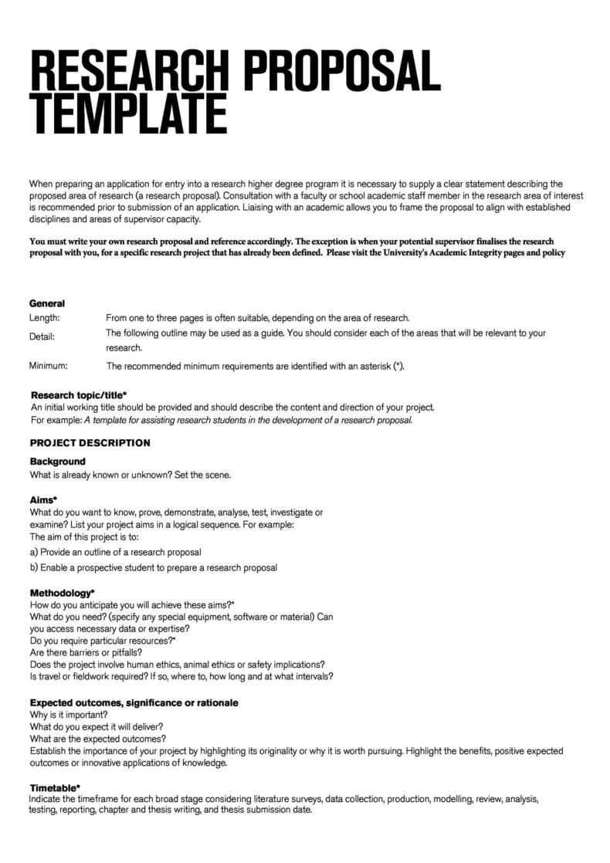
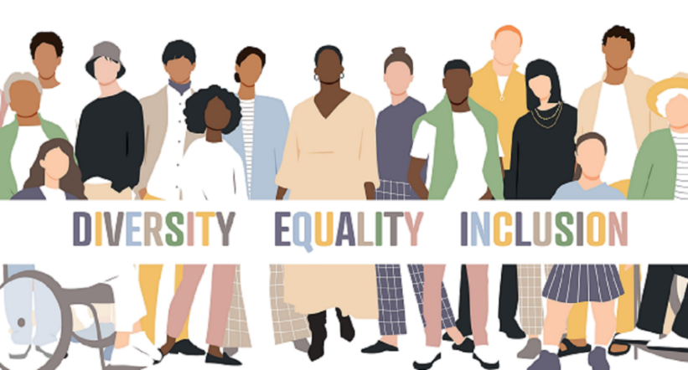
Assignment 2: 2,000 Word Research Proposal
How Effective are Diversity and Inclusion Policies, Initiatives and Strategies in Increasing Ethnic Minority Representation in Football?
Module: Business Inquiry and Research (BMSP5015)
Name: Iestyn Thomas 2404285
Lecturer: Helen Evans

Figure 2: (Hinds, 2024)
Figure 3: (Diversity Dashboard, 2023)
Figure 1: (Template Lab, n.d.).
Introduction
Diversity and inclusion have become increasingly relevant topics within football in recent years, particularly due to concerns surrounding racial inequality and the underrepresentation of ethnic minorities in playing, coaching, officiating and leadership roles, from elite to grassroots levels in the UK (Griggs, 2024).
In response to these concerns, governing bodies and organisations such as the FA and Kick it Out have introduced a range of D&I policies, strategies and initiatives, aimed at promoting equality, reducing discrimination and increasing ethnic minority representation within football (Lincolnshire FA, n.d.).
Therefore, this research proposal will serve as a roadmap for investigating how effective these D&I policies, initiatives and strategies are in increasing ethnic minority representation in football. This proposal will include the rationale underpinning the study, and its aims and objectives. It will also critically examine existing literature and outline the methodology that will be used for data collection and analysis. Furthermore, the proposal will discuss the ethical considerations, expected outcomes, resource requirements and time plan for completing the research project (Hassan, 2024a).
Research Rationale
The rationale for selecting this research topic is its modern-day relevance, as issues surrounding representation within football have gained significant attention in recent years, particularly following the BLM movement, which contributed to the introduction of several D&I policies across the sport (Rigby, 2021). Examples of these include the Premier League’s five year ‘No Room For Racism’ action plan introduced in 2021, and the FA’s ‘Football Leadership Diversity Code’ introduced in 2020 (Premier League, n.d.; The FA, 2023). However, despite the introduction of these D&I efforts, there remains ongoing debate regarding the extent to which they have led to significant and sustained improvements in ethnic minority representation in football (GOV.UK, 2021). This research study is therefore justified, as it seeks to examine the D&I strategies is actual impact.
Research Aim, Objectives and Question
The aim of this research proposal is to evaluate the effectiveness of D&I policies introduced in recent years in improving ethnic minority representation in playing, coaching, officiating, and other footballing roles across all levels of football.
To help achieve this research aim, a set of objectives have been created. These objectives were developed using the SMART framework to ensure they are the most suitable and effective objectives possible. The reasoning for these objectives being SMART can be seen in appendix 1 (Phair & Shaeffer, 2022; Day, 2025). The 3 objectives are:-
- To examine the level of awareness and understanding of D&I policies and there aims among football stakeholders.
- To identify and analyse the barriers affecting ethnic minority representation across all different levels of football.
- To evaluate the impact caused by D&I policies on ethnic minority representation in footballing roles.
Based on the aim and objectives of this study, the research question that has been chosen to guide the study is, ‘How effective are diversity and inclusion policies, initiatives and strategies in increasing ethnic minority representation in football?’.
Literature Review
This literature review will explore existing studies and data relating to the effectiveness of D&I policies in increasing ethnic minority representation within football in the UK, the barriers that still exist for minority representation, and the awareness and understanding of policies and their aims amongst football stakeholders.
Research shows that there is debate over how effective D&I policies have been in increasing ethnic minority representation within football. Bradbury (2013) argues that following the introduction of D&I initiatives and anti-racism campaigns, ethnic minority representation among players has improved. This aligns with recent FA data, which shows that grassroots participation among Asian male players in England has increased from 10.7% in 2021 to 11.9% in 2022 (The FA, 2022). However, on the other hand, Bradbury’s study (2013), also suggests that D&I initiatives and anti-racism campaigns in football have had limited success in improving ethnic minority representation within coaching, management and leadership roles. A more recent study from Bradbury and Conricode (2024) reinforces this, as it found that while more recent D&I policies have slightly improved representation and increased visibility and awareness of the issues, they have not substantially changed the underlying racial inequalities and under representation of ethnic minorities in academy coaching.
Research suggests that there are several institutional barriers that continue to limit ethnic minority representation in footballing roles, even after the introduction of D&I policies. Bradbury (2013) argues that barriers to representation for ethnic minorities in football stem from a White dominated organisational culture, particularly within leadership roles. Findings from the Lawrence et al (2024) study, identify stereotypes and discrimination as still being barriers, suggesting that ethnic minorities such as British South Asians are viewed as less interested in having roles in football and less suitable for leadership roles in particular. Furthermore, findings from Bradbury and Conricode (2024) emphasise the lack of clear progression pathways in coaching roles as another barrier, including limited routes into and from youth academies to first-team environments.
While there is limited, existing data suggests that awareness of D&I efforts amongst football stakeholders has grown in recent years. However, Penfold and Cleland (2022) argue that while awareness of D&I initiatives has improved amongst stakeholders, their understanding of their broader aims is low. Their findings showed that participants, who were White football fans, had a lack of clear understanding of what Kick it Out is aims are and what they aspire to achieve, highlighting the need for improved visibility of aims and education amongst stakeholders.
In conclusion, the literature shows that although D&I efforts have increased ethnic minority representation among players, there impact within coaching and leadership roles remains limited. Furthermore, it highlights institutional barriers such as racial stereotypes and limited pathways, as key factors that still exist which are preventing improvements in representation. Overall, much of the existing research focuses on professional and academy football, with limited research examining the effectiveness of D&I policies within grassroots football. This highlights a research gap, which this study aims to address.
Methodology
This study will be based on the pragmatism research paradigm, because rather than committing to a single philosophical approach it supports the use of the methods that are most suitable for answering the research question. Therefore, a mixed-methods approach will be adopted, combining qualitative and quantitative methods, which is suitable as it allows for both personal experiences and measurable numerical data to collected which can provide a better and broader understanding of the effectiveness of D&I policies on ethnic minority representation in football (Ulz, 2023; McLeod, 2024).
Qualitative Method
The qualitative section of this study will involve using semi-structured interviews to explore how three football stakeholders perceive the impact of D&I policies on ethnic minority representation (George, 2022). For these interviews the purposive sampling technique will be used to ensure that the three participants selected have experience that is relevant to the football environment, making them more suitable to comment on the impact of D&I initiatives on ethnic minority representation (Hassan, 2024a). Each interview will last approximately 20 minutes, and questions will be prepared in advance. The interviews will include open-ended questions to allow for follow-up questions and enable participants to expand on their experiences and perspectives. These interviews will be conducted either in person or through Microsoft Teams depending on participant availability and preference. Additionally with participant consent, for data collection, interviews will be recorded to ensure accuracy and help with later analysis (George, 2022; Chavez, 2026).
One advantage of using this method is that semi-structured interviews provide rich and detailed data by allowing participants to express their views and experiences in depth, due to their open-ended nature (George, 2022). However, there are limitations to this method, such as the small sample size of three participants and the use of purposive sampling, which may result in similar responses and reduce the generalisability of findings. Furthermore, gathering qualitative data through interviews can be time-consuming (Hassan, 2024b; Kangail & Niches, 2025).
Quantitative Method
The quantitative section of this study will use an online survey, which will consist of 8 questions and be distributed through WhatsApp and Email to 20 participants selected via purposive sampling (Bhandari, 2020; Hassan, 2024b; Mailpro, n.d.). The online survey will be created using Microsoft Forms due its ability to easily collect and transfer data into Microsoft Excel for analysis, as well as for the variety of question types it offers, including Likert-scale, ranking and multiple-choice questions (Microsoft, 2025; junyuB, 2024).
An advantage of using this method is that online surveys are easy to distribute to participants and are more time-efficient, as responses can be collected quickly and surveys are relatively easy to create. Additionally, online surveys tend to have larger sample sizes compared to interviews and some other survey methods, improving the potential accuracy and generalisability of the findings. However, there are limitations to this method including the potential for the collection of inaccurate data as participants may rush through the survey or use the internet to answer questions, resulting in false responses that do not reflect their true perceptions (Hassan 2024c; VYPR, 2025).
Data Analysis Methods
To analyse the qualitative data Braun and Clarke’s six-stage thematic analysis approach will be used to identify and interpret themes within the transcribed data. While this method is beneficial as it provides a transparent and structured step-by-step process for analysing qualitative data, it can also be time-consuming. Additionally, the interpretation of themes can be influenced by researcher bias as personal perspectives could affect the coding process and theme development (Stevens, 2024; Academic Service, n.d.).
To analyse the quantitative data collected from the online surveys, descriptive statistical analysis will be used. This will be done through Microsoft Excel where survey result will be transferred to calculate the percentages and create graphs, making the data, trends and patterns easier to identify, analyse and interpret (Hassan, 2024d; junyuB, 2024).
Ethical Considerations
This study will follow the UWTSD ethical guidelines, as well as general ethical research principals, to ensure that all research is conducted responsibly and ethically (Hassan, 2024e). This includes for example, informing all participants of the purpose of the research before taking part and gathering informed consent prior to data collection. Furthermore, participants will be made aware that their participation is voluntary, and that they have the right to withdraw at any stage without any consequences. Additionally, to maintain confidentiality and anonymity, participants’ names will not be included within the research findings, instead, pseudonyms such as participant A, B, C will be used. Furthermore, all interview transcripts and survey data will be stored securely in the personal vault section of Microsoft One Drive behind password protection, accessible only by the researcher, ensuring protection and confidentiality. Moreover, data will be used solely for academic purposes and following the completion of the study all data will be permanently deleted. In addition to this, the UWTSD ethics form required prior to the research has been completed and can be found in appendix 2 (InnovateMR, 2025; Bhandari, 2021; Microsoft, n.d.).
Expected Outcomes
This study is expected to provide a greater understanding of how effective D&I policies are in improving minority representation within football roles across all levels but particularly within grassroots football where there is currently limited research, highlighting the significance of the study. It is also anticipated that the findings will identify both the positive impacts and challenges relating to D&I initiatives on ethnic minority representation in football, including the barriers that continue to limit participation. Therefore, the research may highlight areas where governing bodies could improve existing or future policies to better support ethnic minority participation.
Resource Requirements
For this research project to be conducted successfully, several resources will be required. Digital resources such as, Microsoft Forms, Excel, and Teams will be essential for creating surveys, conducting interviews, and analysing data for the research project. Another resource required is a mobile phone, which will be needed to record during interviews to ensure accurate data transcription and analysis (Stone, 2026; Chavez, 2026). Financial resources for the study are expected to be minimal, as the necessary software and equipment such as a laptop are already available. However, the only potential expense may be the fuel cost associated with travelling to conduct in person interviews (Hassan, 2024a).
Time Plan
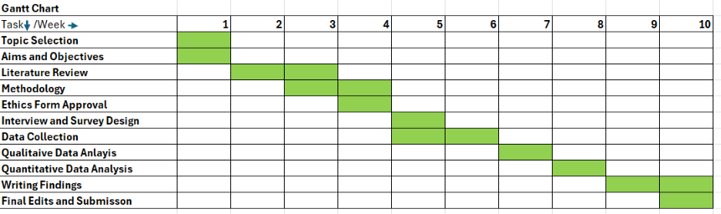
To help structure and schedule the research project, a 10-week Gantt Chart has been created through Microsoft Excel. Using this method is beneficial as it allows complex projects to be broken down into manageable tasks and helps to balance the workload by allocating weekly activities, thereby reducing cramming and stress. Furthermore, it ensures that each phase of the research is completed in the correct order and allows for sufficient time to be allocated to time-heavy sections such as the literature review and data collection and analysis (Nalimov, 2023).

References
Academic Service. (n.d.). Define Thematic Analysis | Advantages and Disadvantages. Available at: https://academicservice.co.uk/blog/what-is-thematic-analysis-advantages-and-disadvantages/
Bhandari, P. (2020). What Is Quantitative Research? | Definition, Uses & Methods. Scribbr. Available at: https://www.scribbr.com/methodology/quantitative-research/
Bhandari, P. (2021). Ethical Considerations in Research | Types & Examples. Scribbr. Available at: https://www.scribbr.com/methodology/research-ethics/
Bradbury, S. (2013). Institutional racism, whiteness and the under-representation of minorities in leadership positions in football in Europe. Soccer and Society, 14(3), 296–314. Available at: https://doi.org/10.1080/14660970.2013.801262
Bradbury, S., & Conricode, D. (2024). Racialisation and the inequitable experiences of racialised minority coaches in men’s professional football club youth academies in England. International Review for the Sociology of Sport, 60(2), 251–277. Available at: https://doi.org/10.1177/10126902241266613
Chavez, A. (2026). Semi-Structured Interviews (2026): The Comprehensive Guide. MAXQDA. Available at: https://www.maxqda.com/research-guides/semi-structured-interviews
Day, B. (2025). The Ultimate Guide to S.M.A.R.T. Goals. Forbes. Available at: https://www.forbes.com/advisor/business/smart-goals/
Diversity Dashboard. (2023). An Introduction to Equality, Diversity and Inclusion. Available at: https://diversitydashboard.co.uk/edi-conferences-and-events/an-introduction-to-equality-diversity-and-inclusi/411/
George, T, (2022). Semi-Structured Interview | Definition, Guide & Examples. Scribbr. Available at: https://www.scribbr.com/methodology/semi-structured-interview/
GOV.UK. (2021). Fan-Led Review of Football Governance: securing the game’s future. Available at: https://www.gov.uk/government/publications/fan-led-review-of-football-governance-securing-the-games-future/fan-led-review-of-football-governance-securing-the-games-future
Griggs, A. (2024). FA 'demand 25% of England coaches are black, Asian, mixed or other ethnic background'. Express. Available at: https://www.express.co.uk/sport/football/1980825/FA-England-coaches-BAME
Hassan, M. (2024a). How To Write A Research Proposal – Step-by-Step [Template]. ResearchMethod.Net. Available at: https://researchmethod.net/how-to-write-a-research-proposal/
Hassan, M. (2024b). Sampling Methods – Types, Techniques and Examples. ResearchMethod.net. Available at: https://researchmethod.net/sampling-methods/
Hassan, M. (2024c). Survey Research – Types, Methods, Examples. ResearchMethod.net. Available at: https://researchmethod.net/survey-research/
Hassan, M. (2024d). Descriptive Statistics – Types, Methods and Examples. ResearchMethod.net. Available at: https://researchmethod.net/descriptive-statistics/
Hassan, M. (2024e). Ethical Considerations – Types, Examples and Writing Guide. ResearchMethod.net. Available at: https://researchmethod.net/ethical-considerations/
Hinds, R. (2024). Premier League announces its No Room For Racism Action Plan three-year update. The Voice. Available at: https://www.voice-online.co.uk/sport/premier-league/2024/04/06/premier-league-announces-its-no-room-for-racism-action-plan-three-year-update/
Innovate MR, (2025). The Top 5 Ethical Considerations in Qualitative Research. Available at: https://www.innovatemr.com/insights/the-top-5-ethical-considerations-in-qualitative-research/
junyuB. (2024). Introducing Forms data sync to Excel. Microsoft. Available at: https://techcommunity.microsoft.com/blog/microsoftformsblog/introducing-forms-data-sync-to-excel/4036051
Kangail, R., & Niches, R. (2025). Advantages and Disadvantages of Qualitative Research: A Comprehensive Guide. Rich Niches. Available at: https://richniches.com/advantages-disadvantages-qualitative-research/
Lawrence, S., et al. (2025). Boards for Diversity? A Critical Economic Sociology of British South Asian Senior Leaders’ Experiences of the Executive Level of Football. Work, Employment and Society, 39(4), 859–881. Available at: https://doi.org/10.1177/09500170241299380
Lincolnshire FA. (n.d.). A Game Free From Discrimination: The FA Release New EDI Strategy (2024-2028). Available at: https://www.lincolnshirefa.com/news/2024/nov/26/fa-new-edi-strategy-2024
Mailpro. (n.d.). 3 Great Ways to Share Your Surveys. Available at: https://www.mailpro.com/blog/share-survey
McLeod, S. (2024). Mixed Methods Research. Simply Psychology. Available at: https://www.simplypsychology.org/mixed-methods-research.html
Microsoft. (2025). Available question types. Available at: https://learn.microsoft.com/en-us/dynamics365/customer-voice/available-question-types
Microsoft. (n.d.). Protect your OneDrive files in Personal Vault. (n.d.). Available at: https://support.microsoft.com/en-us/office/protect-your-onedrive-files-in-personal-vault-6540ef37-e9bf-4121-a773-56f98dce78c4
Nalimov, C. (2023). Gantt Chart for a Research Project Proposal: Step-by-step guide. Gleek. Available at: https://www.gleek.io/blog/gantt-project-proposal
Penfold, C., & Cleland, J. (2022). Kicking It Out? Football Fans’ Views of Anti-Racism Initiatives in English Football. Journal of Sport and Social Issues, 46(2), 176–198. Available at: https://doi.org/10.1177/01937235211067190
Phair, D., & Shaeffer, A. (2022). Research Aims, Objectives & Questions. Grad Coach. Available at: https://gradcoach.com/research-aims-objectives-questions/
Premier League. (n.d.). Five Year Action Plan. Available at: https://no-room-for-racism-action-plan-2026.premierleague.com/?_gl=1*19q4ivl*_gcl_au*MjAxMDM1Mzc1NS4xNzc3NDU5MTk1*_ga*MjUwNTM0NTI4LjE3Nzc0NTkxOTk.*_ga_Z815NWVZJY*czE3Nzc0NTkxOTgkbzEkZzEkdDE3Nzc0NTk4NTkkajQ1JGwwJGgw
Stevens, G. (2024). Braun and Clarke’s Approach to Thematic Analysis. Academic Writing & Research. Available at: https://academic-writing.uk/braun-clarke-thematic-analysis/
Stone, N. (2026). Top 10 Best Online Survey Tools in 2026 (Free & Paid). Smart Survey. Available at: https://www.smartsurvey.com/blog/best-online-survey-tools
Template Lab. (n.d.).40 Best Research Proposal Templates & Format Examples. Available at: https://templatelab.com/research-proposal/
The FA. (2022). FA provides Asian inclusion update to mark South Asian Heritage Month.. Available at: https://www.thefa.com/news/2022/aug/18/asian-inclusion-strategy-update-20220818
The FA. (2023). FLDC year three report published as we commit to mandatory diversity reporting. Available at: https://www.thefa.com/news/2023/nov/22/fldc-year-3-report
Ulz, J. (2023). What is a Research Paradigm? Types of Research Paradigms with Examples. Researcher.Life. Available at: https://researcher.life/blog/article/what-is-a-research-paradigm-types-examples/
VYPR. (2025). The Pros and Cons of Qualitative and Quantitative Research. Available at: https://vyprclients.com/pros-and-cons-of-qualitative-and-quantitative-research/

Appendix
Appendix 1
The 3 objectives are: -
- To examine the level of awareness and understanding of diversity and inclusion policies, initiatives, and strategies and there aims among football stakeholders.
- To identify and analyse the barriers affecting ethnic minority representation across all different levels of football.
- To assess the change and impact caused by diversity and inclusion policies, initiatives, and strategies on ethnic minority representation in footballing roles
These objectives follow the SMART framework as they are specific, measurable, achievable, relevant, and time-bound. They are specific because each objective clearly focuses on D&I policies, initiatives, and strategies, and ethnic minority representation within football. The objectives are measurable through primary data collected via qualitative and quantitative research methods, including interviews, surveys, as well as through secondary research data. They are achievable as the objectives are realistic and manageable for a small research study, and the required data and information can be collected easily and directly from stakeholders. The objectives are also relevant because they directly support the overall research aim. Finally, they are time-bound as the objectives are designed to be completed within the timeframe of the research project (Day, 2025; Bouchrika, 2026).
Appendix 2
Ethics Forms



