University of Wales Trinity Saint David
School of Engineering

Kinetic Energy Recovery
Sami Naas
2203564

Motorsport Engineering
14/01/2024
Alternative Propulsion Systems
ACHA5010


Contents
1 Introduction 2
2 The car 3
2.1 Turbo lag 3
3 World wide light vehicle testing. 4
4 Kinetic Energy Recovery System 8
4.1 Fly wheel based KERS 8
4.2 Battery based KERS 10
5 Conclusion 12
6 References 14

List of figuers:
Figure 1: Subaru Impreza WRX STI (evo, 2004) 2
Figure 2: Subaru Impreza WRX STI ((www.iconicauctioneers.com, 2024.) 3
Figure 3: WLTP Medium speed 4
Figure 4: WLTP Low speed 4
Figure 5: WLTP Extra high speed 4
Figure 6: WLTP High speed 4
Figure 7: graph showing resistive forces over time 6
Figure 8: graph showing total resistance over time 6
Figure 9: graph shoeing power needed over time. 7
Figure 10: graph showing energy loss over time 7
Figure 11: Fly wheel based KERS system (Jones, 2014) 8
Figure 12: Volvos KER system (www.media.volvocars.com, 2024) 9
Figure 13: graph showing cumulative power over an acceleration period 10
Figure 14: battary based KERS system (Wikipedia Contributors, 2019) 10

Introduction

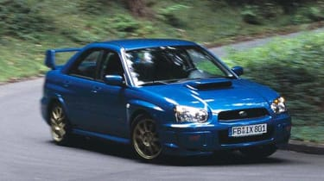
This report looks aims to analyse how the introduction of a KERS system into a existing car will affect the fuel consumption as well as improving the performance of the vehicle. The car that was selected for this task is the 2005 Subaru Impreza WRX STI, the report will look at how KERS system could be implemented to help reduce the fuel consumption in addition to help fill the gap in power due to turbo lag. To be able to analyse specific KERs systems the appropriate WLPT data was looked at to understand the drive cycles of the car to be able to calculate specific requirements of the KERS system.
Figure 1: Subaru Impreza WRX STI (evo, 2004)

The car

the car that is going to be assed is the 2005 Subaru Imprezza WRX STI. The car uses a 2.5 litter turbocharged boxer engine that makes 276 Hp at 5600RPM. its use as a fast road car would make it perfect to add a Kinetic energy recovery system to improve the performance. As it utilizes a turbocharger, they are known to suffer with turbo lag it could benefit for a low end addition in power to support the engine until the turbo kicks in. to choose a suitable KERS system the specifications of the car need to be looked into further detail.
Figure 2: Subaru Impreza WRX STI ((www.iconicauctioneers.com, 2024.)
- Curb Weight- 1470 Kg
- Engine Displacement- 2457cc
- Power- 276Hp/206Kw
- Power to weight (Kw/Kg)- 0.14 Kw/Kg
- Coefficient of drag- 0.33
- Frontal area- 22.63 $m^{2}$

(www.carfolio.com, 2024)

To calculate the rolling resistance by using the rolling resistance of the car’s tiers assumed to be 0.012 and multiplying it by the force of the car on the road.
$rolling resistance=0.012×(1470( Kg) ×9.81 (\frac{m}{s^{2}} )$)
Roling resistance = 173.05N

Turbo lag
As mentioned, the Subaru Impreza uses a IHI VF39 turbocharger which is able to use exhaust gasses to compress fresh air in order to increase the power in the engine (MotorTrend, 2015). As a turbo uses exhaust gasses it is designed to work in a certain RPM range which on a a car such as the Subaru, which is based on a road going rally car, is aimed at higher RPMs to improve performance. Due to the design, they suffer from a reduction in power before experiencing a surge in torque when the turbo kicks in. this issue can be fixed by using systems such as nitrous or an anti-lag tune. However, these methods are aimed at track cars and arnt suitable to reducing emissions. Another strategy is to uses a hybrid turbo that uses electricity to spool up the turbo when at low RPMs. By using recovered energy this system could be beneficial in eliminating the turbo lag. In addition to this a KERS system that can deploy the energy harvested straight to the wheels could also prove to beneficial as it would reduce demand on the engine and therefore lower the fuel consumption. It would also plug the gap in performance until the turbo has spooled up to a point where the engine is running more efficiently.

Worldwide light vehicle testing.
The worldwide light vehicle test or WLTP is a new test to replace the old NEDC test that looks into the real world drive cycles of a car. It tests the car in four different speed categories. Low, medium, high and extra high. By doing this it aims to show a more accurate data on the drive cycles of a car compared to laboratory data showing ideal or theoretical values. To make it more applicable to different regions as well as driving styles by EU countries conduct the test on their roads. (WLTPfacts.eu, 2017.)

As the Subaru Impreza has a power to wight ratio of 140W/Kg it falls into class 3 which requires a power t wight of over 34W/Kg. class 3 uses 4 speed categories where class2 only gose to high speed and class 1 only goes up to medium speed. The test is conducted over 1800 seconds and gose through stops and starts. From this acceleration and speed graphs can be plotted to look at the drive cycle and demand on the car.
Figure 3: WLTP Medium speed
Figure 4: WLTP Low speed
Figure 5: WLTP Extra high speed
Figure 6: WLTP High speed

Figer 4 to 5 show the WLTP results for a class 3 vehicle. The velocity acceleration graphs show the demands on the vehicle. The low-speed section of the test shows allot of stop starts and allot of braking. As the tests go into the high speed tests there are less stops but when the car is braking those brake events are from higher speed. In the low-speed test this is where the car suffers from turbo lag as not pressure in the exhaust system is being generated to effectively power the turbo. To improve this a KERS system could be implemented in to help power the car until the turbo has spooled up.
From the WLTP data and specific vehicle data forces due to resistance can be found. Figure 33 show the aerodynamic, rolling and acceleration resistances. This is an important consideration as it shows how much force is required by the engine to maintain that current speed the change in force shows the power needed to accelerate the vehicle. In figure 8 we can see the total resistive force at any given moment, from this the low and medium speed show that there is less force required by the car as well as allot of braking events. This would be beneficial to run a KERS system in this drive cycle of the car as energy can be easily recoverable during the braking events and there is less power needed by the system to drive the car making it more efficient. In contrast the turbo will suffer from turbo lag at the in slow speed areas making less effective than the KERS system. figure 9 shows the required power needed to drive the car, the negative gradients in the graph show where energy can be recovered due to braking
To calculate the total resistive forces in applied on the car several equations had to be used:
- Aerodynamic resistance = this is a resistive force otherwise known as drag applied opposite to a vehicles motion. as the vehicle speed is increased so is the aerodynamic resistance.

$$F_{aero}=0.5×C_{d }×A×ρ×V^{2}$$

Where Cd is coefficient of drag
A is frontal area
P is air density
V is velocity

- Acceleration resistance= this is the force required to accelerate the vehicle and over come it resistance to moment or Inertia.
$$F_{accel}=V×mass$$

Where v is velocity
Mass is the mass of the vehicle

- The total resistance is a sum of the aerodynamic and accelraton resistance as well as the rolling resistance which is a constant throughout the test
Figure 7: graph showing resistive forces over time
$$F_{total}=F_{aero}+F_{accel}+rolling resistance$$
Figure 8: graph showing total resistance over time

Figure 9: graph shoeing power needed over time.

To find the energy that can be recovered during a braking event the cumulative energy can be used to find how much energy is recovered. Using a brake event in the medium speed drive cycle 1175.3 KJ could be recovered. Using this value, a KERS system can be further investigated.
Figure 10: graph showing energy loss over time

Kinetic Energy Recovery System

a KERS can recover energy that would other wise be lost when a vehicle brakes and then be able to store and appropriately deploy that anergy when needed. It was originally developed for formula 1 cars in the 60s (Engineering, 2009) but did not become popular until the 2009 season. Since then, it was widely picked up in the automotive industry especially in electric and hybrid cars. It helps to reduce emissions by using energy that would otherwise be wasted to power the car.
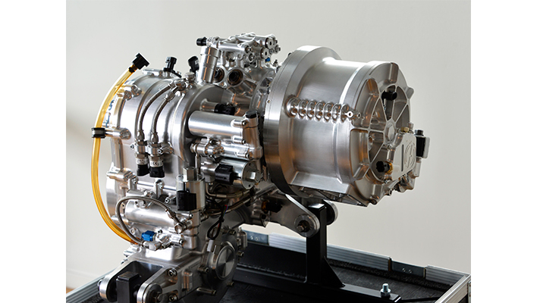
Figure 11: Fly wheel based KERS system (Jones, 2014)
For the intended roll of helping to fill the gaps of the turbo charged Subaru it is important to pick a suitable KERS system as well as storge method and deployment method.

Fly wheel based KERS
The first is a flywheel based system that also helps with braking. When the car starts to brake a flywheel is connected to the gearbox which then spins a fly wheel. By doing this the fly wheel will start to spin and depending on the materials used, gear ratios and design of the casing the fly wheel can spin to around 64,000 RPM as used in F1 cars (Sam, 2011). The force needs to overcome the inertia of the fly wheel will also help to slow the car down and therefore reduces wear on the braking system. when the car is ready to set off aging the flywheel can be engaged to the gearbox and all the energy can be used to help assist the engine. The benefits of this system are that , depending on the design, can be allot lighter than using a battery to store the energy as electrical energy. In addition to the gearing system is often a continuous variable transmission and therefore is always at the optimal gear ratio. For its specific use in the Subaru, it could also be used to spool the turbo at low engine RPM. by doing this it eliminates the turbo lag problem.

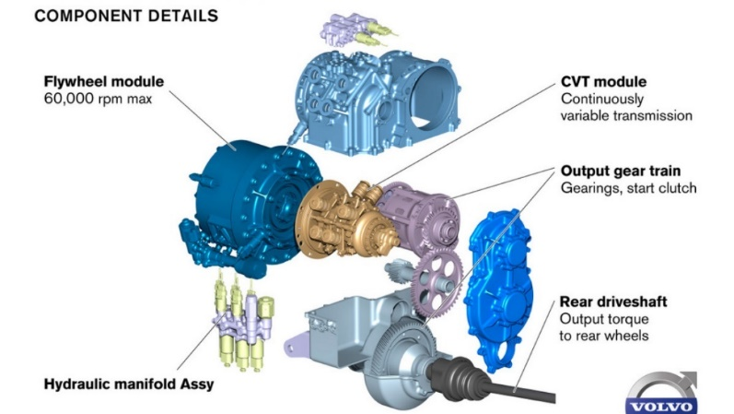
Figure 12: Volvos KER system (www.media.volvocars.com, 2024)

Using a Fly wheel KERS system such as the Volvo system that uses an RPM of 60,000 the inertia can be found thus allowing to approximate measurements needed for the flywheel.

$$I= \frac{2×KE}{( {2π×RPM}/{60} )^2}$$

Using equation 44 gives a value of 0.0595 Kgm^2 , this can then be used to help select a material as well as radius of the flywheel so that it can be packaged efficiently whilst keeping the weight of the system down.

By assuming perfect conditions the fly wheels power output can be calculated using equation6, after the car came to a stop it accelerated for 22 seconds up to a speed of 53.3. by tuning the deployment system the flywheels energy can deployed in a certain amount for a certain amount of time. For the vehicle to be powered until it reaches 20Km/h at the same acceleration rate as the WLTP data the equation can be used to calculate the deployment time of the system

$$Pfw=1/2*I*w2/t$$

Using the equation with the previously calculated inertia value as well as the 60,000 RPM and required power of 275 Kw we get a time of 4.3 seconds. This means that the car could run on the energy produced in the flywheel to get to 20 km/h before the IC engine would need to be ran.

Figure 13: graph showing cumulative power over an acceleration period

The difference between the fly wheel power and power needed to accelerate indicated the assumption made that there is now resistance in the flywheel system.

Battery based KERS
The second type of KERS system uses a battery to store the energy as electrical energy. This system works similarly to the Fly wheel system but uses the flywheel to generate an AC current. This AC current then gets converted to DC in the Power control unit where it can then be stored in the battery. in motorsports the driver is then able to uses this energy when they see fit, however in the automotive industry there is less driver input and energy is harvested as well as deployed under set parameters. For example, at low speeds allot of hybrids will use the battery to drive the car before cutting to the IC engine when a certain speed is met. To store the energy generated in the MGU a battery or supper capacitor can be used. the most common system in lithium ion batteries commonly used in F1 cars. They have a high energy density, lightweight and have a long service life compared to some other systems. A super capacitor can also be used, they have a extremely fast recharge and discharge rate and a very high power density. Theas would be beneficial in faster cars or where energy can only be harvested in short periods of time and could suit the Subaru. The impact of using a battery KERS system is that it has allot of extra components and therefore would drastically increase the weight of the car. this would have a knock on effect on the handling as well a performance of the car. whilst this would work well for a car such as the McLaren P1 which utilises a hybrid system with KERS () as it already has a battery so it would not make a massive impact on the weight of the car.

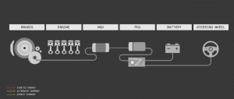

Figure 14: battary based KERS system (Wikipedia Contributors, 2019)

Upon thorough examination of both systems, the Flywheel Kinetic Energy Recovery System (KERS) emerges as the more fitting choice for the Subaru. Its lightweight design presents a minimal impact on the driver's experience, setting it apart from the bulkier battery storage alternative. However, it's imperative to acknowledge that the Flywheel KERS excels in rapid energy release rather than prolonged storage.

The Flywheel KERS proves most effective during acceleration from a standstill, strategically filling the gap during turbo spool-up or even potentially aiding in turbo initiation by linking the impeller to the flywheel. While some losses occur within the system, impeding the complete recovery of braking energy or efficient deployment of stored energy, innovative measures can be implemented to mitigate these challenges.

By incorporating a vacuum-sealed flywheel chamber and leveraging the use of ceramic bearings, frictional losses can be significantly reduced. This proactive approach enhances the overall efficiency of the Flywheel KERS, addressing concerns related to energy conservation and deployment limitations. In essence, the Flywheel KERS option aligns with the performance and design considerations of the Subaru, offering a balanced solution that optimizes energy recovery and utilization while maintaining a seamless driving experience.

Conclusion
In conclusion, this report aimed to assess the impact of introducing a Kinetic Energy Recovery System (KERS) into the 2005 Subaru Impreza WRX STI, focusing on fuel consumption reduction and performance improvement. Through an analysis of the specific characteristics of the Subaru and Worldwide harmonised Light vehicle Test Procedure (WLTP) data, potential benefits of KERS implementation were explored.

The selected Subaru model, renowned for its fast-road capabilities, features a turbocharged boxer engine, making it an ideal candidate for KERS integration to address challenges such as turbo lag. The examination of WLTP data highlighted specific drive cycle characteristics, providing insights into the demands on the vehicle during acceleration, braking, and varying speeds.

Calculations for rolling resistance and exploration of turbo lag issues emphasized the need for an effective solution. The WLTP results illustrated the forces due to resistance, showcasing the potential advantages of a KERS system in recovering energy during braking events and reducing overall power demands.

Two types of KERS systems were considered: a Flywheel-based system and a Battery-based system. The Flywheel KERS emerged as the more suitable option for the Subaru, offering advantages such as lightweight design, rapid energy release, and the potential to assist in turbo spool-up. Mitigating losses through innovations like vacuum-sealed chambers and ceramic bearings further enhances the Flywheel KERS efficiency.

References
Engineering, R. (2009). The basics of F1 KERS. [online] Racecar Engineering. Available at: https://www.racecar-engineering.com/articles/the-basics-of-f1-kers/.
evo. (n.d.). Subaru Impreza WRX STI (2005) review. [online] Available at: https://www.evo.co.uk/subaru/impreza-wrx-sti [Accessed 14 Jan. 2024].
Jones, M. (2014). Why we need cars with KERS. [online] Top Gear. Available at: https://www.topgear.com/car-news/future-tech/why-we-need-cars-kers.
MotorTrend. (2015). What Is Turbo Lag? And How Do You Get Rid Of It? [online] Available at: https://www.motortrend.com/how-to/what-is-turbo-lag-how-do-you-get-rid-of-it/.
Sam (2011). Flywheel hybrid systems (KERS). [online] Racecar Engineering. Available at: https://www.racecar-engineering.com/articles/f1/flywheel-hybrid-systems-kers/.
Wikipedia Contributors (2019). Kinetic energy recovery system. [online] Wikipedia. Available at: https://en.wikipedia.org/wiki/Kinetic_energy_recovery_system.
WLTPfacts.eu. (n.d.). WLTPfacts.eu - Worldwide Harmonised Light Vehicle Test Procedure. [online] Available at: https://www.wltpfacts.eu/ [Accessed 14 Jan. 2024].
www.carfolio.com. (n.d.). 2005 Subaru Impreza WRX STI specifications, technical data, performance. [online] Available at: https://www.carfolio.com/subaru-impreza-wrx-sti-135201 [Accessed 14 Jan. 2024].
www.carthrottle.com. (2016). 5 Ways To Reduce Turbo Lag | News | CarThrottle. [online] Available at: https://www.carthrottle.com/news/5-ways-reduce-turbo-lag [Accessed 14 Jan. 2024].
www.iconicauctioneers.com. (n.d.). Iconic Auctioneers - 2005 Subaru Impreza WRX STi Type UK-Auction Lot. [online] Available at: https://www.iconicauctioneers.com/2005-subaru-impreza-wrx-sti-rec11365-1-sywell-0522 [Accessed 14 Jan. 2024].
www.media.volvocars.com. (n.d.). The Flywheel KERS (Kinetic Energy Recovery System) (0:36). [online] Available at: https://www.media.volvocars.com/global/en-gb/media/videos/38350.

