
Data Warehousing & Data Mining
ACCA6026

Bsc applied computing
KELVIN BARETO TAVARES
2321297

Contents
Introduction 3
TASK 1: THE CASE FOR A DATA WAREHOUSE 3
1.1 OLTP vs Data Warehouse 3
1.2 Data Warehouse Architecture and ETL 4
1.3 Data Marts for Management Decision-Making 6
1.4 OLTP Normalisation vs Dimensional Modelling 7
TASK 2: SCHEMA DESIGN AND IMPLEMENTATION PLAN 9
2.1 Source System Identification 9
2.2 Star Schema Design 9
2.3 Data Marts and Schema 12
2.4 ETL Plan 13
2.5 Data Quality and Governance 13
References 14

Introduction
This report is submitted to the Chief Executive and Board of NHS England. It sets out the case for a centralised data warehouse, explains why NHS England's current OLTP systems cannot support strategic reporting, and presents a detailed schema design and implementation plan. Section 1 covers architecture, ETL, data marts, and dimensional modelling. Section 2 provides the schema design, ETL pipeline, and data quality and governance framework that will govern the solution.

TASK 1: THE CASE FOR A DATA WAREHOUSE

1.1 OLTP vs Data Warehouse
Operational databases such as the Electronic Patient Record (EPR), Patient Administration System (PAS) and Electronic Staff Record (ESR) are Online Transaction Processing (OLTP) systems. OLTP is a type of database that is used to capture individual events as they happen. Data is normalised over many related tables to avoid redundancy and to maintain consistency of hundreds of users writing at the same time [1].
That speed comes at a cost. Ask a PAS to explain why readmissions in the North West increased over the last two quarters, and it has to join dozens of tables across millions of rows, a query that can slow down or crash a live clinical system. Dates, diagnosis codes and patient identifiers are also stored in each trust’s EPR in different ways, so data from two regions cannot be placed side by side without substantial manual work [1].
A data warehouse takes a different approach, with a centralised repository that pulls together data from all operational sources, standardises it via ETL, and arranges it to support the complex cross-system queries that OLTP systems were never built to handle. A board-level query around elective backlog trends can’t touch the EPR a ward nurse is using at the same time because it runs on a completely separate infrastructure. The Chief Executive can make the query “are A&E waiting times improving across all five regions” and get a reliable answer in seconds, with no impact on clinical operations [2].

1.2 Data Warehouse Architecture and ETL
The NHS England data warehouse has a three-tiered architecture with source systems feeding a staging area, a central warehouse where data is integrated and stored, and specialist data marts to serve each management audience [1]. This flow is shown in Figure 1.
At the source layer, NHS England has more than a dozen operational systems generating relevant data every day. Internal sources include EPR systems (EMIS Health, Lorenzo, SystmOne), the Patient Administration System, Electronic Staff Records, Oracle financial ledgers, Theatre Management Systems, and Datix, the quality and incident platform. External sources feed in alongside these: Hospital Episode Statistics from NHS Digital, population and deprivation data from the Office for National Statistics, and inspection ratings from the Care Quality Commission. Each of these systems stores data differently. Pulling them together is the job of the ETL pipeline [3].
ETL stands for Extract, Transform, Load. In the extract phase, read-only connectors pull data from source systems without writing back to them, so there is no risk of corrupting a live EPR record or disrupting a ward system. Extraction runs outside clinical hours, typically between 2 and 5 am [3].
That’s where the NHS-specific transformation work happens. Duplicate records are removed, and formatting issues are fixed. “A Midlands trust may record admission dates differently from a trust in the South East – and that is all sorted out at this stage. NHS numbers are validated and pseudonymised before being stored in the warehouse. Diagnoses are coded to ICD-10, procedures to OPCS-4 and staff grades to Agenda for Change bands. Referral-to-treatment waiting times are derived from the referral and admission timestamps. Trust identifiers are mapped to the NHS Organisational Data Service hierarchy, ensuring that regional comparisons are based on a consistent organisational structure [4].
The transformed data is loaded into the central warehouse using a staging area. Any record that fails a quality check at this point is held back, so analysts are working from verified data, not partial or corrupted loads [4].
ETL only reads from source systems and never writes back to them, so clinical operations continue without interruption [1].
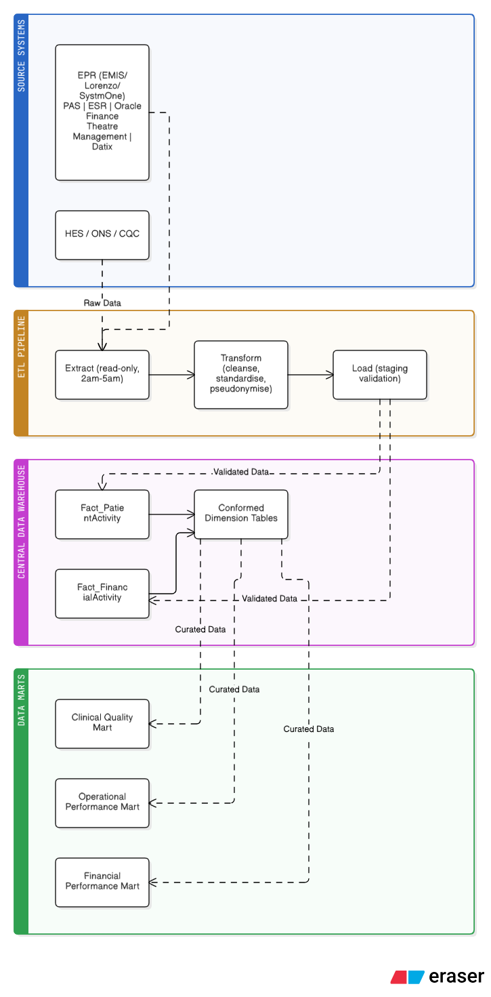
Figure 1: Proposed NHS England Data Warehouse Architecture (source systems to ETL to central warehouse to data marts)

1.3 Data Marts for Management Decision-Making
A data mart is a subject-specific view of the central warehouse, filtered for a particular audience. Rather than every executive querying the same database, each leadership function gets its own analytically optimised layer. Three data marts are proposed for NHS England’s first phase [5].

Chief Executive: Strategic Performance
The CEO needs to see how NHS England is doing against national targets without waiting for monthly statutory returns. The mart includes referral-to-treatment waiting times by region and speciality, A&E four-hour performance, elective care backlog volumes, bed occupancy rates and ambulance response times across all five Integrated Care System regions [6].
This allows cross-regional comparison on one screen. The CEO can see where elective recovery is ahead of target, where bed pressures are building, and where workforce gaps are showing up in the performance data for that area. “Today, that sort of image takes weeks of manual collation to assemble.”
Finance Director: Financial Performance
This mart pulls data from the financial ledger, national tariff schedules, and activity-based costing. It includes cost per patient episode by type of treatment, budget variance by cost centre, tariff reconciliation to identify over- or underpayment and agency workforce spend against substantive staffing costs.
In a system spending over £160 billion a year [6], the ability to identify a trust where agency nursing costs have increased significantly above forecast, and to cross-reference that against patient safety data, could prevent serious financial and clinical harm. This cannot be achieved through the statutory monthly reporting. The can do can.
Medical Director: Clinical Quality
The Medical Director’s mart is based on EPR data, Datix incident data and national benchmark data sets. It monitors readmission rates by diagnosis, mortality indicators, hospital-acquired infection rates, and adherence to national clinical standards [5].
In practice, it provides an early warning. The mart exposes what is going wrong when it is wrong in a speciality or trust before it goes any further. This is where a targeted intervention differs from a formal CQC investigation. This is exactly the kind of continuous, cross-system visibility, not quarterly snapshots, needed to underpin the NHS Patient Safety Strategy [7].
It is of the utmost importance that all three marts have consistent dimensions, meaning the CEO, Finance Director, and Medical Director adhere to consistent definitions of a patient episode, a trust, and a reporting period [1].

1.4 OLTP Normalisation vs Dimensional Modelling
HS England’s OLTP systems use normalised database design, Third Normal Form (3NF). Normalisation spreads data out over many tables to remove redundancy. In a PAS, the patient record may be held in separate tables for demographics, address, GP practice, admission episodes and ward assignments, all linked by keys. That design is appropriate for live systems. It ensures record consistency when hundreds of admissions are being processed at once [2].
It is slow to analyse. What is the average length of stay for cardiac patients from deprived areas in Northern England, by financial quarter? This question requires joining eight or more tables across millions of rows. Such a query is too expensive to run against a live clinical system and too slow for board reporting [2].
Dimensional modelling doesn’t remove redundancy, but it does organise data to answer questions quickly. Dimension tables surround the core fact table of countable events (patient care episodes) describing the context: who, where, when, and what. Such a layout is called a star schema because, in a diagram, it has the shape of a star [8].
The proposed Patient Activity Star Schema is shown in Figure 2. This is driven by the Fact_PatientActivity table, which contains key measures of length of stay, referral-to-treatment days, procedures performed, bed days used, and the 30-day readmission flag. It is surrounded by six dimension tables: patient demographics; date attributes (including NHS financial year); care location (mapped to ICS region); clinician grade and speciality; ICD-10 diagnosis codes; and service type. Some data is deliberately repeated across dimensions. The cost of storage is small compared to the speed gains, and analysts can query the schema without needing deep technical knowledge of the underlying database [2].

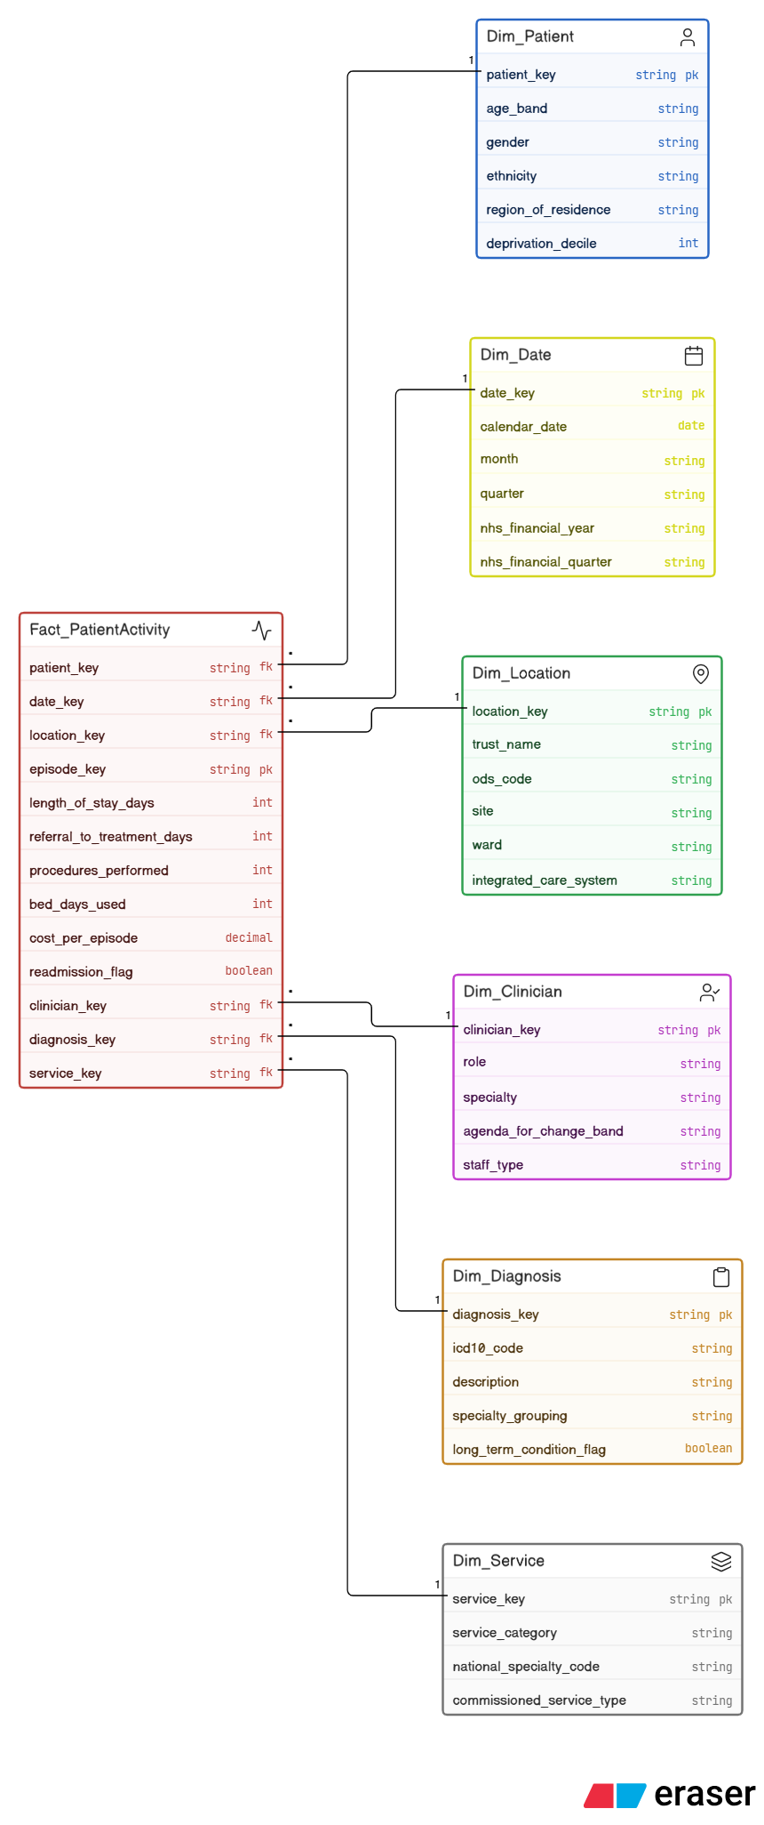
Figure 2: Patient Activity Star Schema (Fact_PatientActivity with six dimension tables)

TASK 2: SCHEMA DESIGN AND IMPLEMENTATION PLAN

2.1 Source System Identification
The NHS England data warehouse extracts data from two types of source: internal operational systems and external reference datasets [5].
Each internal source uses a different type of data. EPR platforms (EMIS Health, Lorenzo, SystmOne). Patient data: NHS number, demographics, ICD-10 diagnoses, OPCS-4 procedures and length of stay. The Patient Administration system provides operational data: admissions, discharges, transfers and referral-to-treatment timestamps. Electronic staff record: workforce information, staff ID, role, shift patterns, contracted hours, agency usage. It is fed by financial data from Oracle financial systems: treatment costs, national tariffs, budgets and expenditure by cost centre. Theatre Management Systems include clinical activity data on elective scheduling and utilisation. Datix has data on quality and performance: patient safety incidents, complaints and outcomes [5]
External feeds include NHS Digital’s Hospital Episode Statistics, Office for National Statistics population and deprivation data, Care Quality Commission inspection ratings and NHS Benchmarking Network comparative performance data [6].

2.2 Star Schema Design
Fact_PatientActivity contains a row for each patient care episode. Measures include: length_of_stay_days, referral_to_treatment_days (from referral and first treatment timestamps), procedures_performed, bed_days_used, theatre_time_minutes, cost_per_episode (from the national tariff), readmission_flag (defined as a patient readmitted within 30 days of discharge) [8].
The dataset is organised into six-dimensional tables.
Dim_Patient contains pseudonymised demographic data (age band in 10-year groupings, gender, ethnicity, region of residence and deprivation decile from the ONS Index of Multiple Deprivation). A Type 2 Slowly Changing Dimension (SCD) strategy is used to insert a new row when demographics change and expire the old record. This maintains historical accuracy when analysing outcomes by deprivation group over time [2].
Dim_Date is a static calendar dimension loaded once at go-live, covering calendar and NHS financial year attributes, including the April to March financial cycle.
Dim_Location: Where care was provided (trust name, ODS code, site, ward, Integrated Care System and commissioner code). The organisational changes are reflected immediately as type 1 SCD is applied, rather than historically tracked, as NHS constitutional reporting always uses the current trust structure and historical variants would add complexity without analytical benefit [2].
Dim_Clinician is sourced from ESR: hashed staff ID, role, speciality, Agenda for Change band, contracted hours and a flag indicating whether the staff member is substantive, bank or agency. The agency flag is especially valuable to the Finance Director for reporting workforce costs.
Dim_Diagnosis uses ICD-10 coding: code, chapter, description, speciality grouping, and flags for long-term conditions and emergency-sensitive diagnoses.
The care pathway is defined in Dim_Service as service type (acute, community, mental health or specialist), national speciality code and commissioned service type [1].
Aggregate summary tables support fast dashboard queries. Monthly_Performance_Summary calculates trust level KPIs (A&E compliance, bed occupancy, RTT rates) in the overnight ETL run so board dashboards load in seconds. Monthly_Financial_Summary totals Fact_FinancialActivity by cost centre and service line for quick budget vs actual reporting. Pre-aggregation is a common practice for high-volume data warehouses [2].

Schema 2: Financial Activity
Fact_FinancialActivity has one row per cost event. Measures: actual_cost, national_tariff_value, budget_allocation, cost_variance, episode_count. Conformed dimensions are shared from Schema 1 and include Dim_Date, Dim_Location and Dim_Service. The schema is completed by two finance-specific dimensions: Dim_CostCentre and Dim_TreatmentType.
The choice of two schemas instead of one large table is about grain. Each fact table has one, and only one, clearly defined level of detail. An aggregation of clinical and financial facts in a single table would be unreliable when rolling up data at different levels of granularity [2].
Figure 2: Patient Activity Star Schema (Fact_PatientActivity with six dimension tables)

2.3 Data Marts and Schema
Three data marts are built from the central warehouse, each filtered and pre-aggregated for a specific audience, as shown in Figure 3 [5].
The Clinical Quality mart supports the Medical Director and clinical governance teams. It is based on Fact_PatientActivity, with filtering for quality-relevant measures: readmission rates, mortality measures derived from Hospital Episode Statistics, counts of patient safety incidents from Datix (with an additional Fact_Incident table), and patient-reported outcome scores where available. These are Dim_Diagnosis and Dim_Service so that results can be compared across speciality and care pathway. The readmission rates per month are pre-calculated per trust and speciality to enable fast loading of the dashboard [5].
The Financial Performance mart is derived from Fact_FinancialActivity. It shows cost per patient episode by trust and service, budget vs actual by cost centre, agency spend as a proportion of total workforce cost and national tariff variance. Pre-aggregated monthly summary tables speed up the query time for the regular financial reporting cycle [3].
The Operational Performance mart is designed for the CEO and the regional directors. It includes: A&E waiting times (from Fact_PatientActivity with an emergency service type filter), referral-to-treatment volumes and completion rates, bed occupancy extrapolated from bed_days_used against available capacity, and elective backlog by trust and speciality. The Board can see how it is performing against the NHS constitutional standards daily and not wait for the monthly statutory returns [4].

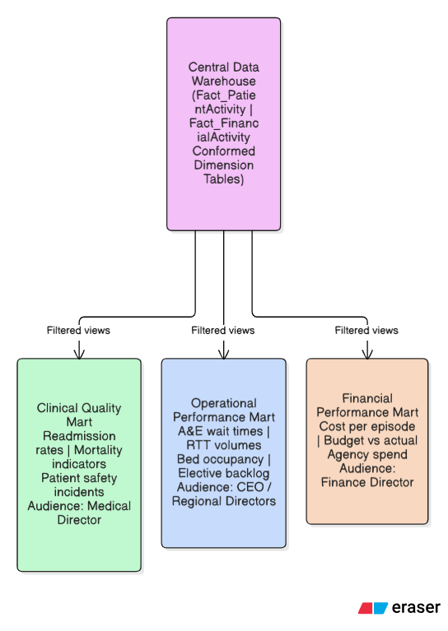
Figure 3: NHS England data marts architecture showing central warehouse feeding three audience-specific marts

2.4 ETL Plan
The majority of tables in the ETL plan are based on a nightly batch model, but some data changes less frequently, as shown in Figure 4 [6].
Fact_PatientActivity is pulled nightly from EPR and PAS. The transformations include NHS number pseudonymisation, ICD-10 code validation, derivation of length_of_stay from timestamps and flagging of 30-day readmissions. Load strategy: incremental add. Dim_Patient updates are nightly (SCD Type 2). Dim_Location updates are weekly via NHS Organisational Data Service (SCD Type 1). Dim_Date is a static load, which is done only once. Fact_FinancialActivity is loaded monthly from Oracle Finance using a snapshot strategy [3].
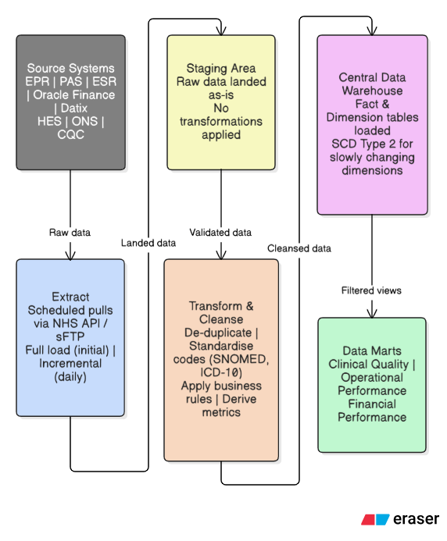
Figure 4: NHS England ETL pipeline showing extract, staging, transform and load stages with nightly batch schedule

2.5 Data Quality and Governance
Validation rules are run during ETL to check the NHS number formatting, ICD-10 code validity and referential integrity between fact and dimension records before any row is put into the live warehouse. Patient data is pseudonymised at source, and identifiable linkage keys are stored in a separate, access-controlled environment that meets the requirements of UK GDPR and the NHS Data Security and Protection Toolkit [9]. Role-based access controls restrict each data mart to the appropriate audience, and all access is audit-logged. NHS England’s Data Quality Maturity Index is used to monitor data quality, and alerts are sent to data stewards if anomalies are detected [8].

References
[1] T. Knezevic Ivanovski, S. Honap, R. Matic, S. Markovic, and L. Peyrin-Biroulet, "Building a healthcare data warehouse: considerations, opportunities, and challenges," Frontiers in Digital Health, vol. 7, p. 1691142, 2025. [Online]. Available: https://doi.org/10.3389/fdgth.2025.1691142
[2] R. Kimball and M. Ross, The Data Warehouse Toolkit: The Definitive Guide to Dimensional Modelling, 3rd ed. Hoboken, NJ: Wiley, 2013.
[3] K. Y. Cheng, S. Pazmino, and B. Schreiweis, "ETL processes for integrating healthcare data: tools and architecture patterns," Studies in Health Technology and Informatics, vol. 299, pp. 151-156, 2022. [Online]. Available: https://doi.org/10.3233/SHTI220974
[4] K. G. Devi, "An efficient hybrid optimisation of ETL process in data warehouse of cloud architecture," Journal of Cloud Computing, vol. 13, no. 1, p. 12, 2024. [Online]. Available: https://doi.org/10.1186/s13677-023-00571-y
[5] B. Ozaydin, F. Zengul, N. Oner, and S. S. Feldman, "Healthcare research and analytics data infrastructure solution: a data warehouse for health services research," Journal of Medical Internet Research, vol. 22, no. 6, p. e18579, 2020. [Online]. Available: https://doi.org/10.2196/18579
[5] M. C. Jones, T. Stone, S. M. Mason, A. Eames, and M. Franklin, "Navigating data governance associated with real-world data for public benefit: an overview in the UK and future considerations," BMJ Open, vol. 13, no. 10, p. e069925, 2023. [Online]. Available: https://doi.org/10.1136/bmjopen-2023-069925
[6] Department of Health and Social Care and NHS England, "Data saves lives: reshaping health and social care with data," UK Government, Jun. 2022. [Online]. Available: https://www.gov.uk/government/publications/data-saves-lives-reshaping-health-and-social-care-with-data
[7] R. D. Thantilage, N. A. Le-Khac, and M. T. Kechadi, "Healthcare data security and privacy in data warehouse architectures," Informatics in Medicine Unlocked, vol. 39, p. 101270, 2023. [Online]. Available: https://doi.org/10.1016/j.imu.2023.101270
[8] S. Kumar, "Implementing star and snowflake schemas in healthcare data warehousing," International Journal of Science and Research, vol. 13, no. 11, pp. 237-241, 2024. [Online]. Available: https://doi.org/10.21275/SR241030061006
[9] M. C. Jones, T. Stone, S. M. Mason, A. Eames, and M. Franklin, "Navigating data governance associated with real-world data for public benefit: an overview in the UK and future considerations," BMJ Open, vol. 13, no. 10, p. e069925, 2023.

