Numbers Count Level 5
Name - Ethan Smith.
Student Number – 2311689

Element 1
Why is good numeracy important?
Numeracy is often referred to the ability to use and work with numbers. Numeracy is a skill that we use daily in everyday life. This can be from sorting your personal finances to paying for a chocolate bar in your local shop. For a person who had the ability of understanding good numeracy, it can allow them to solve problems, understand data and be able to look at information correctly. If a person struggles with numeracy, it can have a knock-on effect with their personal finances, their performance in their job and everyday critical thinking. This essay will discuss why good numeracy is important in our personal lives, our educational settings, our jobs and us as a society every day in our community.
Numeracy is especially important when it comes to managing our day-to-day tasks and activities. These could be tasks like tracking our finances, measuring ingredients when we are cooking and even just understanding what time of the day it is. For example, as adults we need to do regular food shops, looking and understanding the pricing of the food we pick, comparing prices between different shops to save money all require you to have good numeracy skills. Without having the ability to use and understand numeracy, this could lead to having a challenging time when it comes to carrying out your daily tasks and can also lead to having poor financial management (Media Officer, 2019).
Educational settings and the subjects that we are all taught throughout our time in school all have a link to numeracy. Numeracy can be seen as a fundamental part of education as most subjects such as mathematics, science, catering, construction and many more all have a link and all use numeracy in some shape or form while learning. As quoted by a famous mathematician, Rachel Riley, “More than half of the working-age population has the numeracy level expected of a primary school child” this statistics shows that having good numeracy skills doesn’t mean being the best at maths or understanding how to work out long sums, “it’s about having the knowledge and confidence to apply numbers-based solutions to everyday tasks” (Riley, 2019).
In subjects such as physics, the ability to use numeracy is essential as you will also be learning how to measure, how to make different formulas and carrying out experiments and then putting your findings into different graphs. This shows, that having poor numeracy skills can affect and limit our future career and being able to achieve a higher academic result while sitting exams in school.
Moving onto our jobs and employment, having good numeracy skills is an essential key skill that mostly, if not all employers and companies will look for when looking for new candidates. Mostly all different sections of employment have some sort of numeracy involved, whether it be looking at data or even working out calculations. Even the jobs that are not directly seen to be working with numbers can also have some sort of numeracy involved. Such as, retail workers who are required to manage stock and count and record the number of items, it all involves numeracy,
As quoted by the lead employment recruitment website, indeed, Numeracy is “Fundamentally important to perform everyday job functions, numeracy skills reflect your critical thinking and problem-solving abilities and can lead to better-paying jobs. Because companies rely on big data more than ever to guide their decisions, strong numeracy skills can give you an instant advantage in the job market.” This shows that having the ability of good numeracy skills, it allows you the chance to achieve higher paid jobs in the future as companies value you as more of an advantage to have working for them (Indeed Editorial Team, 2024).
Lastly, when it comes to having the ability to use and understand good numeracy skills, numeracy is seen to implement massively into our society as a whole. Numeracy is used in healthcare, government and many more social developments which all require the use of numeracy to allow them all to run smoothly. Healthcare workers use numeracy day-to-day when treating patients, prescribing medication and tracking the data of each patient. Not having good numeracy skills will lead to you firstly not being able to work in this section of work but also if you do it could lead to serious consequences which can affect the health of each patient that you work with and even yourself and the others working around you, Numeracy is used by government to track statistics of our society, help developments and ensure that we as humans live a good life. Government use numeracy to undergo studies, make reports and follow and implement budgets to help our society develop. Even though we many not always see it, numeracy is in everything we do, even in the smallest of tasks we complete daily. There are many governments that promote learning numeracy skills whether it be in your employment or through schemes to allow people to be able to achieve more and are given the chance to better themselves if wished.
To conclude, we all can see that good numeracy is a key vital skill that has influence of our personal lives, education, our jobs and employment and our society. Numeracy is seen to be linked to how us as individuals are able to carry out problem-solving in our day-to-day tasks and how we carry out challenges. The ability of good numeracy plays a massive part to everyone in all we do, and to those that are unfortunate, who do struggle with numeracy face financial insecurity, unemployment and the struggle to carry out daily tasks that others may take for granted.
By using our educational systems, our workplaces and how we improve personal development, we should be promoting the use if good numeracy and helping our society to enhance our skills, to better our opportunities and overall well-being as a whole.

References
Indeed Editorial Team. (2024, April 18). Numeracy Skills: Definition and Examples. Retrieved from Indeed: https://www.indeed.com/career-advice/finding-a-job/numeracy-skills#:~:text=Fundamentally%20important%20to%20perform%20everyday%20job%20functions%2C%20numeracy,problem-solving%20abilities%20and%20can%20lead%20to%20better-paying%20jobs.
Media Officer. (2019, May 15). The importance of numeracy as a life skill. Retrieved from GOV.UK: https://educationhub.blog.gov.uk/2019/05/the-importance-of-numeracy-as-a-life-skill/
Riley, R. (2019, May 15). King;s College London. Retrieved from Research reveals how poor maths skills are holding the UK back: https://www.kcl.ac.uk/news/research-reveals-how-poor-maths-skills-are-holding-the-uk-back

Element 2
What can schools do to encourage numeracy?
Numeracy is being able to have the understanding and knowledge of working with numbers, numeracy is a skill that everybody will need to use on a daily basis to throughout their life. Schools are the most vital place that ensure the developmental process of children and young people learning and developing their numeracy skills. There are many children that do struggle with their numeracy skills which does have a massive negative impact on their development. It is crucial that schools and educational settings encourage numeracy to ensure that children are able to gain the skills needed to bypass daily challenges. There are many ways that schools can encourage numeracy and ensure children are gaining these vital skills.
Making numeracy fun for our pupils.
Making numeracy a positive lesson in a setting is very important, there are many children who look at numeracy as a scary subject or something they don’t feel comfortable working on. By ensuring that children see numeracy as a positive it will give children a different look on it. This can be done by making numeracy more fun in class, playing games that encourage numeracy development but also allow the children to enjoy, planning lessons that will make the learners engaged which will ensure that they are interacting and picking up on different vital skills throughout your lessons. Making numeracy fun is a massive way that we as practitioners can provide the best learning to our pupils and give them the best chance to develop their numeracy skills. As mentioned, that some learners do find numeracy a daunting task, providing pupils with positive reinforcement can make a massive difference. Praising the children when they are trying their best, getting answers right or simply joining in on activities will allow them to feel more comfortable trying and giving it their best go, even if they aren’t fully grasping the skill or not getting the answer right, showing them that it’s okay and that they are doing their best, will allow them wanting to carry on.
Numeracy – What doesn’t meet the eye?
Numeracy isn’t all about sitting at a desk and practising sums or listening to a teacher explain things over and over again, there are many ways that numeracy can be implemented into everyday learning. There are many numeracy-based apps that can be downloaded onto a class computer or iPad which allows children to be more engaged while also learning. By allowing children to play educational games in the classroom, between lessons, on break or even in a digital area in the classroom. Its shows massive benefits to children’s development. It allows the children to enjoy themselves and learn together. As seen by children in my own class, some children don’t even know that they are playing an educational game as they find it fun to do so. As we all know, there are always pros and cons to allowing children to play on computers or iPads but in this day and age, there are thousands of helpful educational resources apps on the app store that each and every school setting should be taking full advantage of (EYR Team, 2019).
Another way that schools can encourage numeracy is implementing project-based learning into numeracy lessons. Allowing children to have a more realistic feel on how they need to use numeracy in a daily basis throughout life. This could be setting lessons to allow them to work in groups and use role play to evolve their learning, a shop as an example, in a group children need to go to the shop to get certain items, they have a certain amount of money, they need to work out if they have enough, how much they need to pay and hoe much change they need, thus is allowing the children to see how numeracy is used outside the school setting and shows that the importance of why we teach numeracy across each school. Visiting another setting could also encourage numeracy to children, taking them on a trip to see numeracy in action. Taking them to a bank, on a shopping trip or even a setting that they might not realise uses numeracy in their jobs but does, this will show them that numeracy is really used in everything that we do. There are also many guest speakers that come into school to talk about the importance of numeracy and set up workshops to help children develop their skills. As used in my current setting, I’ve seen the massive affect that this has on the children and how much it shows children the importance of numeracy and also promoting learning of numeracy through fun ways which allows the children to be more engaged (Gowland, 2019).
Us as teachers/practitioners.
Teachers are the biggest part of a child’s development in the school setting, as these are the people who work closely with the children to teach them in the classroom. It is also important that all teachers are kept updated with effective teaching strategies and resources that can be used to help the development of children’s learning. Schools should be ensuring that all teachers are accessing local workshops that allow teachers to gain new ways of learning to implement into their teaching, allowing teachers from different schools to meet up to discuss their individual strategies that have worked to help others in different schools learn new ways to encourage numeracy and also allowing teachers who aren’t fully confident with numeracy themselves the chance form them to develop new skills and improve on the skills that they have to allow them to feel more confident and comfortable implementing their skills into the learning provided to the children (Howard, 2020).
Conclusion.
There are many ways that schools can encourage numeracy in each setting and many more ways that I haven’t discussed. By creating a more positive, comfortable learning environment in our schools it allows the children to feel more at ease when it comes to learning and allows them to have the confidence to carry on trying to develop their skills. The strategies that have been spoken about will allow each child to be equip with the skills and the understanding of numeracy that they will use daily throughout their life. It is also important that schools ensure that teachers are also kept updated with new resources, activities etc. that can be implemented into their teaching to benefit the children more in their learning. As mentioned, numeracy is a massive part in everyone’s daily tasks and should be encouraged throughout all schools to help children.

References
EYR Team. (2019, March 21). EYR. Retrieved from Improving Numeracy in the Classroom: https://blog.earlyyearsresources.co.uk/2019/03/improving-numeracy-in-the-classroom/
Gowland, G. (2019, September 17). SB Pedagogy. Retrieved from 5 Ways to Implement Numeracy into your Lessons: https://sbpedagogy.wordpress.com/2019/09/17/5-ways-to-implement-numeracy-into-your-lessons/
Howard, M. (2020, April 8). teachit. Retrieved from 20 ideas for numeracy across the curriculum: https://www.teachit.co.uk/cpd/teaching-and-learning/numeracy-across-the-curriculum

Element 3
TT Rock Stars – Develop Numeracy skills.
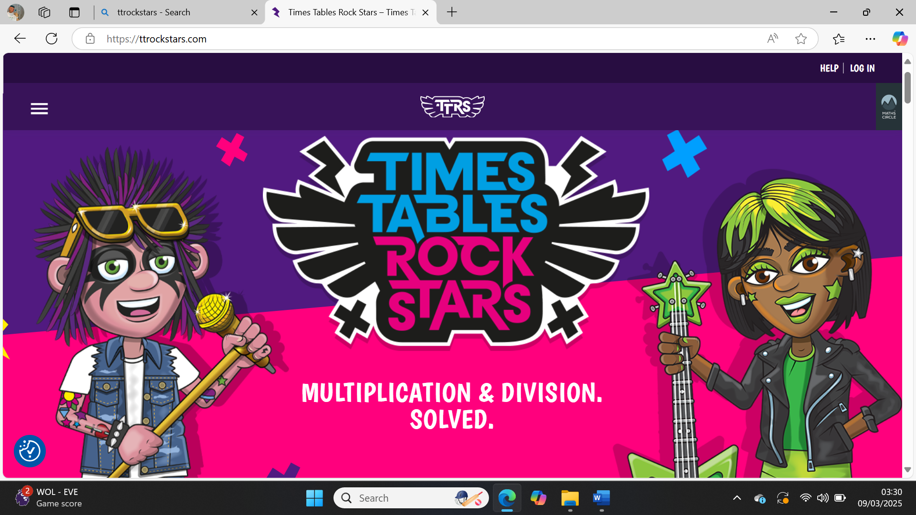
(TT Rock Stars, 2010)

Our purpose.
The purpose for TT Rock Stars is to help encourage children to learn and develop their numeracy skills. TT Rock Stars is an online website that can be accessed via computer, mobile or any technical device. This website makes learning numeracy fun for all children, no matter their age. TT Rock Stars is focused on addition, subtraction, division and helping them develop their times tables skills. This website is also updated regularly to ensure that it follows and implements the requirements of the ‘Curriculum of Wales – Maths and Numeracy’ (Hwb, 2019).
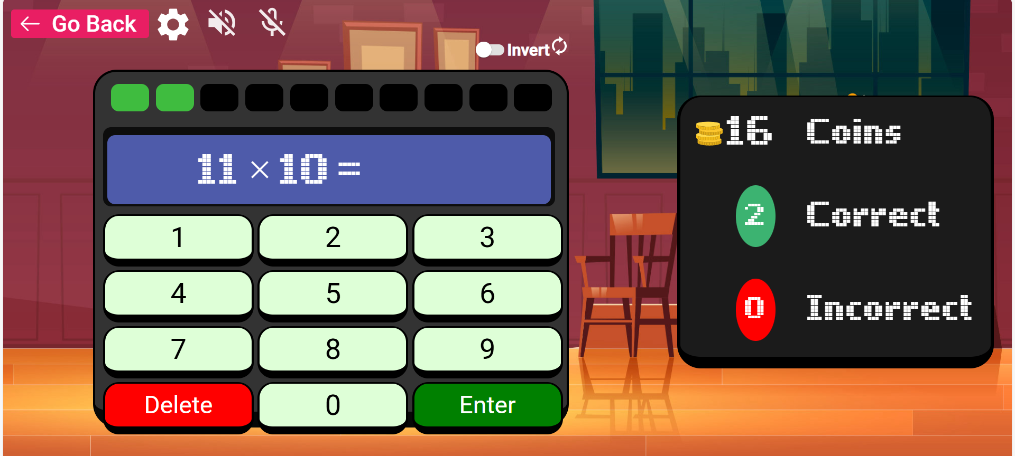
Our audience.
TT Rock Stars is aimed for all children, no matter their age or ability. Once first signed up, the website will ask the child to undertake a simple quiz to show their level ability. From then, the website will implement the areas of learning needed into the game to ensure each child has their own individual learning journey. TT Rock Stars is also a way for children to firstly be introduced to multiplications and allows them to watch videos and complete tasks which activate their prior knowledge to complete each set/task.
Fellow teachers.
TT Rock Stars also has a teacher log in which allows the class teachers to view the development of each child. The website will show the teacher the level that the child is currently on, the levels that they have completed, the answers that they have had right and the multiplications that they need to work on. This gives the class teacher a view of the different abilities that each child has and makes it easier for the class teacher to set tasks, record progress and a view of what next they need to implement into their teaching to ensure each child is making progress.

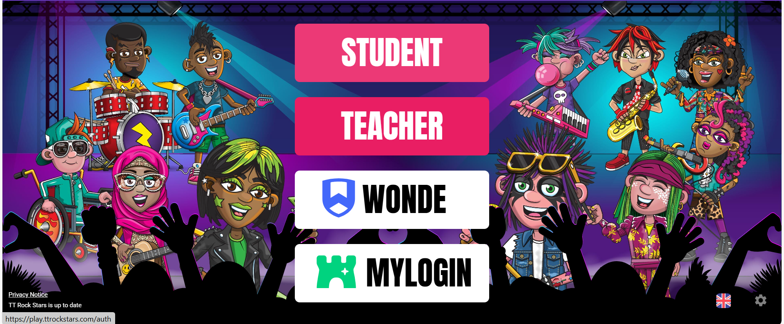

Here is a video created by TT Rock Stars explaining briefly what it is their website is all about.
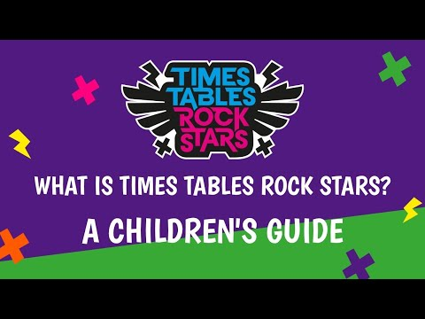
(Stars, 2023)
Where to find TT Rock Stars?
TT Rock Stars is available for users to use at school, at home and on the go, while connected to the internet. Children don’t need to be supervised by an adult as the website is 100% safe and secure and allows each child to have independence while learning and having fun!

You can access the TT Rock Stars website by following this link: Times Tables Rock Stars: Play

References
Hwb. (2019, April 30). Mathematics and Numeracy. Retrieved from Hwb: https://hwb.gov.wales/curriculum-for-wales/mathematics-and-numeracy/
Stars, T. T. (Director). (2023). What is Times Tables Rock Stars? A Children's Guide [Motion Picture].
TT Rock Stars. (2010). TT Rock Stars. Retrieved from TT Rock Stars: https://play.ttrockstars.com/auth

Element 4 (Video)

Attachment for video bellow:
Video (1).mov

Element 5 (Evaluation)
There are many pros and cons when it comes to how us as practitioners see the effectiveness in our activities and strategies to encourage learning in the classroom setting and we all have different views and opinions on what we think works best for our pupils. When it comes to the resource that was mentioned in my previous work, I can also see both sides to how purposeful this resource can be.
Firstly, I will evaluate the advantages of my resource, which was TT Rock Stars. The most important aspect that is seen within the implementation of using TT Rock Stars in our class settings and allowing our pupils to learn through technology is that TT Rock Stars follows the Maths and Numeracy framework within the local curriculum and ensures that their teaching is working alongside the targets and aims set by the local authority (Hwb, 2019).
The next advantage of this resource is that TT Rock Stars is a fun and enjoyable website that lets our pupils enjoy learning. I can strongly say that my personal experience using TT Rock Stars in my classroom with my pupils has been nothing but positive. My pupils are always wanting to grab a computer and play, I fell like this is a way that we can let our pupils understand that learning can be fun and enjoyable, its not just about sitting at a table and learning through writing or worksheets. While researching the use of positive technology in our schools, I came across a survey carried out in 2022/2023 researching how the use of technology is used and how teachers, pupils and parents feel about it. The survey quoted “education leaders were more positive than teachers about the impact of technology on pupil attainment; 67% of leaders thought that technology had contributed to improved pupil attainment over the last three academic years, as compared with 45% of teachers”, this quote shows us that teachers and education leaders see the positive impact that technology has on pupils development and learning (Research IFF, 2023).
Another positive aspect which is seen within TT Rock Stars is that it is assessable to the majority of users, children can access the website any time of the day, from anywhere and on any digital device. This is seen to be a massive benefit spoken about by teachers and parents as its an easy way to learn while at home in the evenings, weekends and school holidays. As we all know it can be a challenge trying to get our children to do schoolwork the majority of the time and even harder when its school holidays, but with this resource being fun for the users, it’s made it much easier for parents and guardians to ensure learning is done within these tricky times. Many of the parents from all the classes that I have had, have always had such positive feedback from using TT Rock Stars at home throughout out of school hours and have praised the school for funding into such an amazing resource that parents can use for free to help them implement their own learning. We can see this by the review that Lisa Lyons left on the TT Rock Stars website, "It’s so very user friendly and feels like a game rather than yet another schoolwork chore. My kids are eager to play to rack up reward points. I used to have to beg them to practise times tables, now they are doing it without me even asking! Yay to that!" (TT Rock Stars, n.d.).
As mentioned previously, there are always positive and negative factors seen within the purposefulness of resources and how much they help. A negative factor that would be seen as a challenge faced by many users is that not all children are able to use technology, there are many reasons for this, some users might not be able to use this resource as they don’t have any digital skills, meaning they don’t understand how to use a computer, phone or digital device, some users may not be able to access the internet at home which means that they couldn’t use this website as a resource. This needs to be taken into consideration when providing this resource to the use of parents and children for at home use. This can be seen as in 2021 BBC issued a statement “Internet access: 1.5m UK homes still offline, Ofcom finds” which shows us that there are many households in the UK that wouldn’t be able to use this resource if it was given to them by their child/children’s school (Kleinman, 2021).
The other negative factor that needs to be taken into consideration, which I have also experienced, is that children can become too reliant on this resource. As it’s a fun way to encourage Maths and Numeracy through other aspects of learning, children can become to see it for another use, which takes away the purposefulness of the website. Within my classroom it has become a common activity that the pupils request which can be seen as a positive, but when its all they want to do within the classroom it can also ten have a knock on affect to other areas of their development and also have a negative effect on their health is sat on a computer for hours on end while at school or home.
To conclude my evaluation, my honest professional opinion on the use and implementation of TT Rock Stars being used to help promote, encourage and improve the development of Maths and Numeracy is that I find it to be such an amazing, beneficial resource that lets children enjoy learning. It’s an easy way that children can use independently, within a group or with parents and has shown to be a positive reinforcement used in the majority of schools across the UK. I will continue to implement TT Rock Stars in my classroom learning schedule to continue the positive development of my pupils.

References
Hwb. (2019, April 30). Mathematics and Numeracy. Retrieved from Hwb: https://hwb.gov.wales/curriculum-for-wales/mathematics-and-numeracy/
Kleinman, Z. (2021). Internet access: 1.5m UK homes still offline, Ofcom finds. London: BBC News.
Research IFF. (2023, November). 2022-23 Technology In Schools Survey. Retrieved from Department For Education: https://assets.publishing.service.gov.uk/media/655f8b823d7741000d420114/Technology_in_schools_survey__2022_to_2023.pdf
TT Rock Stars. (n.d.). Families. Retrieved from TT R ock Stars: https://ttrockstars.com/families/

