

Managing Enterprise in the 21st Century

Business Plan

Island Bites
Gourmet Sandwich Takeaway

Submission Date: 23/11/2025
Lecturer: Balendran Kandasamy

Contents
Executive Summary 3
Business Description 3
Product Description 4
Business Objectives (SMART Objectives) 4
Short-Term Objectives (less than a year) 4
Long-Term Objectives (More than a year) 4
Market Analysis and Marketing Plan 5
Market Analysis (Competitors, Customers, Target Groups) 5
PESTEL Analysis 5
SWOT Analysis 6
Marketing Mix (4Ps) 7
Management Team 7
Management Team and Their Background 7
Organisational Chart 7
Financial Plan (One Year) 8
Sources of Finance 9
Technology Plan 10
Reference List 11
Appendices: 12

Executive Summary

Island Bites is a new gourmet sandwich takeaway offering a unique fusion of Caribbean and British flavours. The business will be in Bromley Town centre, a vibrant and diverse area with high footfall, strong lunchtime demand and a growing mix of office workers, students and shoppers. Bromley is ideal because it provides:
- A busy town centre with strong weekday and weekend traffic.
- Excellent transport links bringing consistent footfall
- A multicultural community receptive to Caribbean cuisine.
- Lower and more manageable rental costs compared to Central London.
Island Bites aims to provide fresh, flavour-packed meals at affordable prices, including jerk chicken sandwiches, curried chickpea wraps, plantain sides and tropical salads combining convenience with authentic Caribbean taste.
Turnover Expectations
The business is projected to make a first-year turnover of approximately £108,000, based on expected weekly sales growing brand awareness.
Marketing Strategy Overview
Marking will focus on:
- Instagram and TikTok campaigns with strong visuals.
- A 50% off launch day offer.
- Food blogger and influencers collaborations.
- Local advertising in Bromley town centre.
- Loyalty cards schemes and student discounts.
- Corporate lunch platters for nearby offices.
Finance and Start-Up Costs
Island Bites requires £48,000 in start-up funding to cover the lease deposit, kitchen equipment, initial stock, marking and contingency costs.
Island Bites will position itself as Bromley’s go to destination for bold, delicious Caribbean-inspired sandwiches, delivering excellent service and building a loyal customer base.

Business Description

Island Bites is a specialised takeaway shop and deli counter offering gourmet English and Caribbean fusion sandwiches. The lunchtime takeaway market is dominated by generic, repetitive and often unhealthy options, leaving a gap for vibrant, fresh and culturally authentic flavours served quickly and affordably. Caribbean cuisine is popular across the UK, yet it is rarely presented in a convenient, grab and go sandwich format that appeals to the mainstream customers as well as Caribbean communities.

Product Description

Island Bites provides that solution. Our menu combines traditional Caribbean ingredients such as jerk seasoning, scotch bonnet, plantain, and roti with familiar English sandwich styles. Our offering includes Jerk Chicken with Mango Salad, Trinidadian Curried Chickpea Roti, Saltfish & Avocado, and artisan English options such as Mature Cheddar and Caramelised Onion.
The business aims to deliver high-quality, freshly prepared meals using locally sourced ingredients where possible. Our mission is: “To bring the vibrant, authentic flavours of the Caribbean to the high street through bold, gourmet sandwiches made fresh every day.”

Business Objectives (SMART Objectives)

Short-Term Objectives (less than a year)

Achieve consistent weekly sales of £2,500 by Month 6.
- Specific: Increase sales through marketing and customer retention.

- Measurable: £2,500 per week.

- Achievable: Based on footfall for cash flow stability.

- Time-Bound: By Month 6.

- Launch Island Bites within six months.

- Reach A customer base of at least 100 regulars per week by month 6.

- Gain 1,000 followers on Instagram within the first first year through social media marketing.

Long-Term Objectives (More than a year)

Build a customer loyalty base of at least 300 repeat customers by the end of the year
- Using loyalty cards and local engagement.
Achieve a minimum of 1,500 social media followers (Instagram + TikTok) by Months 9.
- Help increase footfall and brand recognition.
Earn a 4 or 5 Food Hygiene Rating within the first inspection (first 3 months).
- Critical for credibility and trust.
Break even by Month10.
- Based on projected revenue and cost control.

Market Analysis and Marketing Plan

Island Bites will be registered as Private Limited Company (Ltd), which limits personal liability for the owner and creates credibility when negotiating leases, supplier agreements and investor funding. This format protects personal assets in an industry with food safety, health standards and potential legal risks.

Market Analysis (Competitors, Customers, Target Groups)

The UK lunchtime marking is highly competitive, with big names like Greggs, Subway and Pret A Manger dominating. However, none focus on Caribbean-style sandwiches which gives Island Bites a unique edge.
Our main target customers are:
The core audience includes office workers, students, and local shoppers ages 18-45 seeking a fresh, flavourful lunch. The business also appeals to Caribbean communities looking for authentic flavours.
Competitors include small local delis and sandwich shops, but few offer the same fusion of taste and culture. Our strong branding, service and distinctive menu will help us us stand out.

PESTEL Analysis

Political
Island Bites must meet FSA (Food Standards Agency) regulations including allergen labelling and hygiene ratings. Potential future changes to minimum wage policy may increase staff costs. Brexit has raised import costs for some Caribbean ingredients such as spices and tropical produces.
Economic
The cost-of-living crisis affects consumer spending, making affordability crucial. However, customers still value convenient, high-quality meals. Inflation impacts ingredient prices, particularly for chicken, bread and energy. A competitively priced meal (£6-£8) remains accessible for most workers and students.
Social
There is a growing demand for global flavours and authentic ethnic cuisine. Consumers prefer fresh, healthy and visually appealing meals. Caribbean flavours are trending due to social media influences. Busy lifestyles increase demand for takeaway and grab-and-go options.
Technological
A modern EPOS system will streamline service. Social media platforms (Instagram, TikTok) will be key for visual marketing. Online ordering and potential partnerships with Deliveroo or Uber Eats may expand reach.
Environmental
Using biodegradable or compostable packaging aligns with customer expectations for sustainability, Local sourcing for bread and produce helps reduce the carbon footprint. Waste reduction strategies will be implemented.
Legal
Island Bites must comply with food safety laws (Food Safety Act1990) and allergen regulations. A premises licence and waste disposal compliance will be required. Health and safety procedures must be documented.

SWOT Analysis

Strengths
- Unique English-Caribbean fusion not offered by competitors in Bromley.
- Fresh, homemade ingredients with strong flavour appeal.
- Affordable pricing compared to restaurants while offering higher quality than standard takeaways.
- Strong social media marketing potential.
Weaknesses
- New business with no established customer base.
- Limited seating may reduce appeal for dine-in customers.
- Reliance on consistent ingredient supply, especially Caribbean imports.
Opportunities
- Growing UK demand for ethnic and fusion cuisine.
- Potential expansion into delivery platforms (Uber Eats, Deliveroo).
- Corporate lunch catering for local offices in Bromley.
- Opportunity to introduce seasonal menus and premium deals.
Threats
- Competition from existing sandwich chains and fast-casual outlets.
- Rising food and energy costs effecting profitability.
- Changing economic conditions affecting customer spending.
- Potential supply chain disruptions for imported Caribbean ingredients.

Marketing Mix (4Ps)

Product
High-quality English- Caribbean fusion sandwiches, sides (plantain chips, slaw), and homemade drinks (sorrel, ginger beer).
Price
Sandwiches priced £6.50-7.95. Meal combo at £9.50.
Place
A small, high-footfall retail unit in the city centre that are near offices and shops. Primarily takeaway service.
Promotion
- Pre-launch social media campaign with giveaways.
- Launch day:50% off all sandwiches.
- Loyalty card scheme.
- Ongoing Instagram and TikTok marketing.
- Corporate catering platters for local businesses.

Management Team

Management Team and Their Background

Island Bites will be managed by myself, drawing on my experience in customer service and business management studies. I will handle daily operations, staff management and finances.
Additional roles include:
- Chef: Experienced in Caribbean cuisine.
- Part-time assistants: To help with food prep and customer service.
Staff will receive training in food hygiene, customer service and allergen awareness.

Organisational Chart

- Owner/Manager: Oversees operations, strategy, finance and supplier relationships. Responsible for marketing and compliance.

- Head Chef/Cook: Manages food preparation, recipe creation, stock control and kitchen hygiene standards.

- Front-of-House Assistants (2 part-time): Handle customer service, takeaway orders, packaging and payment processing.

- External support will include a qualified accountant for bookkeeping and payroll and a solicitor for lease and regulatory matters.

Financial Plan (One Year)

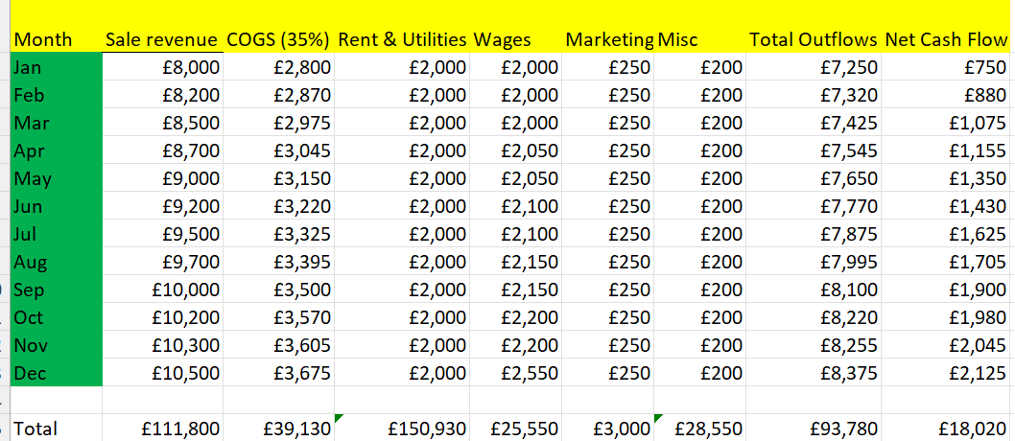

Year-End Summary
- Total Revenue: £111,800
- Total Outflows: £93,780
- Net Annual Cash Flow: £20,120 positive
This indicates that Island Bites maintain stable liquidity, becomes cash-flow positive from Month 1, strengthens its financial stability throughout the year.
Cash flow is essential to ensure Island Bites can operate smoothly, especially during the startup phase.
Assumptions:
- Average monthly revenue: £9,000
- COGS: 35% of revenue
- Trading days: 20-22 per month

Sources of Finance

Funding will come from personal savings (£3,000) and business loan (£40,000) and a grant start-up of (£2,000).

Monthly cash Flow Summary:
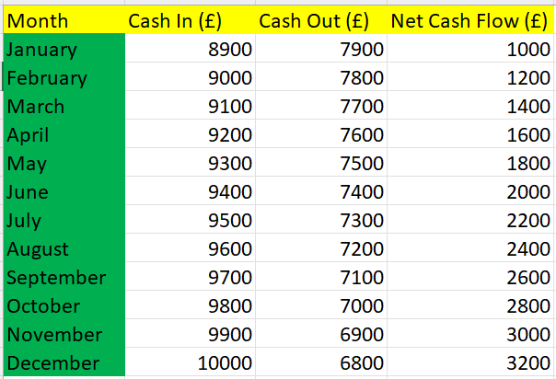

Monthly Outflows:
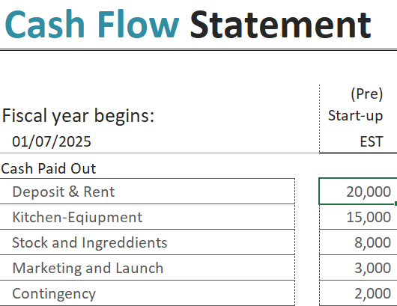

Key Points:
- The business is cash-tight for the first 3 months.
- From Month 4 onwards, cash flow strengthens.
- Break-even expected in month 10.

Technology Plan

An EPOS system will be use for transactions and stock management. Social media will a key marketing tool.

Expansion Plan
Once the first location is stable. Island Bites aims to expand through a food truck or a second branch. We’ll also explore catering for local events and partnerships with delivery apps.

Reference List

Bidfood (2024) “ UK Food Eating Out Market: Where is it headed?”25 July. Available at: https://www.bidfood.co.uk/blog/the-uk-eating-out-market-where-is-it-headed/ (Accessed:10 November 2025).
Credence Research (2024) United Kingdom Ethnic Food Market Size. Growth & Forecast 2023. Available at: https://www.credenceresearch.com/report/united-kingdom-ethnic-food-market (Accessed: 10 November 2025).
Food Standards Agency (2023) Starting a food business. Available at: https://www.food.gov.uk/ (Accessed: 10 November 2025).
Jones, P. (2021). The Successful Restaurant Manager: A Guide for the Hospitality Industry. Oxford: Hospitality Press.
Lumina Intelligence (2025) UK Food to Go Market Set to Surpass £24 bn in 2025 as Demand for Convenience Drives Growth. Caterer and Licensee. 19 March. Available at: https://catererlicensee.com/uk-food-to-go-market-set-to-surpass-24bn-in-2025-as-demand-for-convenience-drives-growth/ (Accessed: 10 November 2025).
Mintel (2023). The Lunchtime Eating Habits Market Report. London: Mintel Group Ltd.
Thompson, K. (2022). “The Globalisation of Palates: Consumer Acceptance of Ethnic Cuisine in the UK.” Journal of Food Science and Marketing, 4(2), pp.45-59, Food Standards Agency (2023). Starting a Food Business.
UK Hospitality (2022). Key Hospitality Statistics. London: UK Hospitality. Available at: https://www.ukhospitality.org.uk/ (Accessed: 10 November 2025).
Zego (2025) ‘ UK Food Delivery Market Statistics (2025)’. Available at: https://www.zego.com/food-delivery-statistics/ (Accessed:10 November 2025).

Appendices:


