
Marketing plan
Ibis Hotel Nord Bucharest

Student name: Adam Maria-Monica
Student ID number: 2241338
Module title: Marketing Essentials BMIH4005
Lecturer’s name: Scott James
Word Count: 1159

Introduction
Ibis is a French brand hotel owned by Accor. The first Ibis hotel was opened in Bordeaux in 1974 and as of December 2019, there were 1,218 hotels under the Ibis brand across 70 countries. The year 2000 was marked by the opening of the first IBIS Hotel in Romania, located in Bucharest, near the North Railway Station. Then followed the opening of the IBIS Constanta and IBIS Parliament hotels (Bucharest), in the first part of 2005. Ibis hotels are present in six cities in Romania: Bucharest, Arad, Galați, Timișoara, Pitesti and Sibiu. Accor is one of the most important companies worldwide, its areas of interest being hotels, casinos and restaurants. Accor, one of the most important hotel groups worldwide, operates in approximately 100 countries with around 150,000 employees. With 40 years of experience in the hotel industry, the group counts among its hotel brands: Sofitel, Pullman, Novotel, Mercure, Suitehotel, Ibis, All Seasons, Etap Hotel, Formule 1 and Motel 6. The offer includes more than 4,000 hotels with approximately 500,000 rooms (Wikipedia, 2023).

Situational Analysis
The Ibis Nord hotel is intended for business customers and offers three-star quality services. The accommodation includes: upstairs hallways with armchairs and low tables, maids' offices, room-service office, accommodation spaces with corridor access, the accommodation space includes the room itself, the bathroom and the vestibule. The interior is comfortable and modernly equipped. The equipment of the rooms complies with the standards of Crowne Plaza hotels. All accommodation spaces are equipped with air conditioning, color TV, mini bar and room service. All items in the rooms are provided with the hotel logo. The welcome letters contain information on how to contact the service manager, the service guide indicates check-in and check-out times, the room-service menu, forms for ordering breakfast, instructions for using the phones and charging them, the list of tariffs from the minibar and the evacuation plan. (Hoteluri Bucuresti, 2023)

Shareholders and organizational structure
The company Accor Services was founded in July 1998, the main shareholders being the French group Accor (82%) and CNS Cartel Alfa (8%). In 2005, the Accor group took control of another Romanian meal ticket issuer, Hungastro, but the two companies will operate separately for now. The organizational structure of the Ibis Hotel is composed of: the production structure, which includes all the departments in which the services are produced; they record receipts and costs, and are: the accommodation service, food and the services that provide services directly and the functional structure, made up of all the compartments in which functional, preparation and decision-making activities are carried out in the hotel. The hotel has 250 rooms, of which 106 rooms are for non-smokers and 4 rooms are designed for people with disabilities, equipped with all necessary amenities for guests: room access based on magnetic card, air conditioning, shower, telephone, internet access, TV, radio, room service, safe, bar (Hoteluri București, 2023)

SWOT Analysis
Among the strengths of the hotel, we list: the central location (the hotel is located 200 meters from the North Railway Station), the modern building, the Estaminet restaurant equipped with a terrace during the summer and the six fully equipped conference rooms. Among the weaknesses, we list: relatively small rooms, the lack of a swimming pool and the fact that you have to pay extra for parking. Among the opportunities, we list: possible collaborations with various suppliers/producers, taking over the events in the city. Among the threats, we list: the competitors, the inflation, the economic crisis.

Clients
Knowing the customers is based on the daily systematic collection of information regarding: the origin of the customers, the means of transport used, the type of clientele, the source of information regarding the existence of the hotel. The most numerous clients of the hotel are those whose main reason is business and professional reasons. Business clients include teachers, sales agents, commercial representatives, employers and truck drivers (Ibis Styles, 2023).

Competitors
The hotel's market activity is marked by the presence on the market of a fairly large number of competing hotels, including: Sofitel, Lido, Majestic, Boulevard. In the situation where the hotels on the Bucharest market address the same needs, offering similar services, we can talk about direct competition.

Marketing mix
In the product strategy of the hotel, it was opted for the standardization of the services in terms of the product and the related services. The price policy of the hotel is based on demand orientation, approaching the strategy of relatively stable prices. The hotel room rates include breakfast and regarding the demand variation, the price strategy is temporally differentiated by season. The hotel’s main distribution channel is social media. The promotion policy is mostly based on social media and targets business people (Marketing91, 2023).

Objectives
The objective I propose is to increase the Ibis Nord Hotel’s visibility by creating the hotel’s own Tik Tok account. I aim to reach 5000 followers in the first month by promoting the Ibis Nord Hotel on Tik Tok. I will measure whether the plan works or not by tracking the number of accesses to the account, the number of followers and the number of likes granted by the followers.

Strategy
The hotel will use the Market Penetration strategy because I want to increase the number of customers and sales of the hotel. I chose this strategy because it is less risky and it is effective. I will attract customers from the online environment by creating content that will show potential customers the places they can visit while they are staying in Bucharest, by showing them how long it takes to get from the hotel location to the tourist spots in the city, by showing how each type of room is, what activities they can do while staying at the hotel and by showing them live reviews from the guests already staying in order to change the brand reputation affected by several bad reviews left on social media. I plan for the hotel to become visible on other social networks as well, such as: Facebook, Instagram, Twitter, Google.

Tactics
Another idea that I want to implement is to promote the hotel through e-mail marketing and push notifications: if they are used correctly, these communication and promotion channels are very effective, through them news, discounts and loyalty program can be displayed. Another tactic that the PR team can implement is maintaining a close relationship with journalists and editors of specialized magazines, in the event they want to make an editorial about a hotel or a vacation destination, to make sure they will contact our hotel. I also propose to develop a customer loyalty program that they can access through a membership card. The program will offer special prices to loyal customers.

Conclusion
Overall, hotel marketing is essential for the success of any hotel business. It helps to increase visibility, and guest loyalty, while also managing the hotel’s reputation and this is what we aim for by effectively marketing our hotel, attracting new guests, increase bookings, and build a strong and recognizable brand.
Power Point Presentation

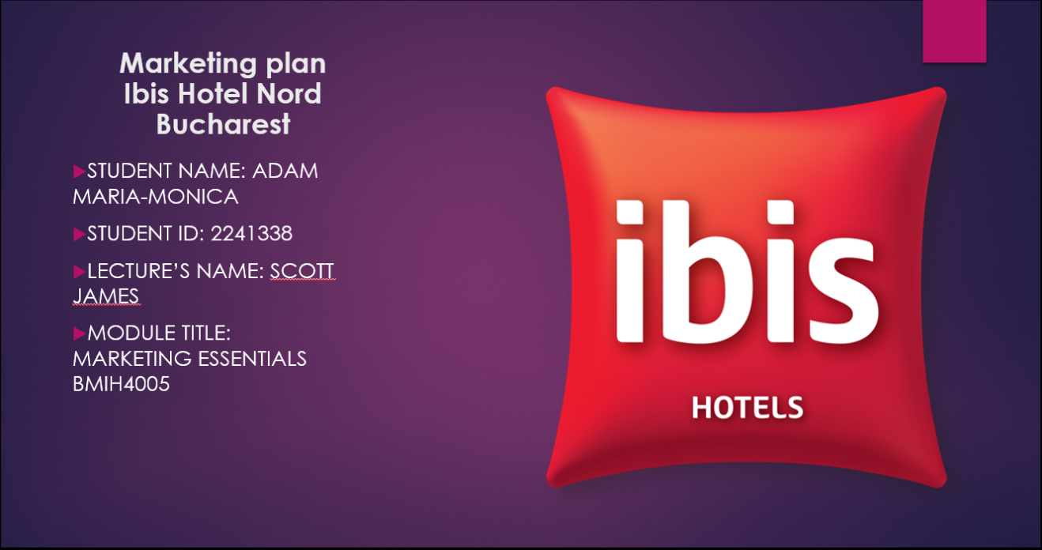
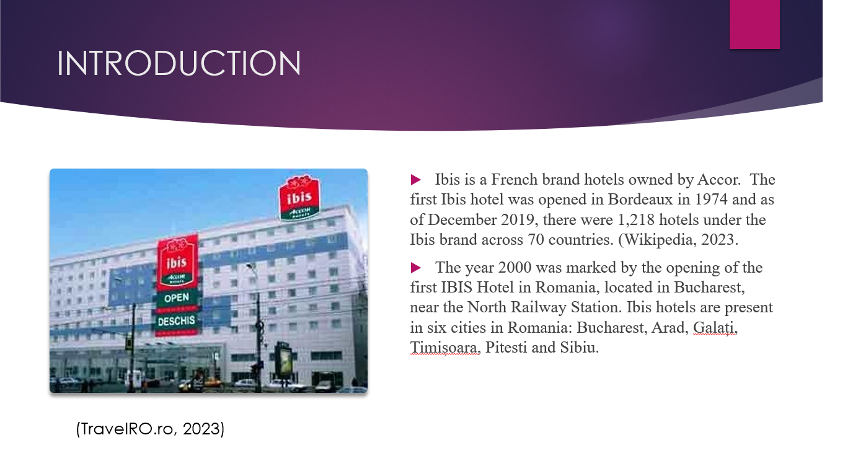
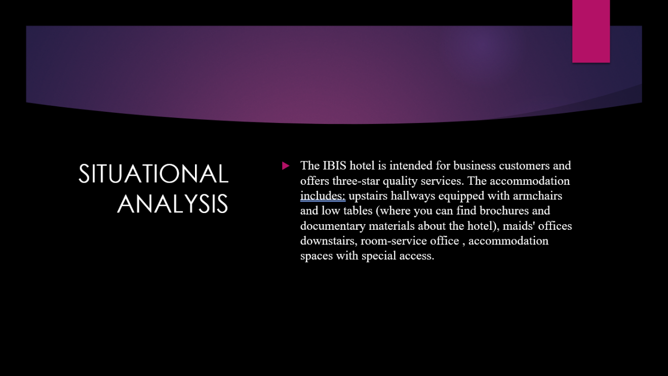
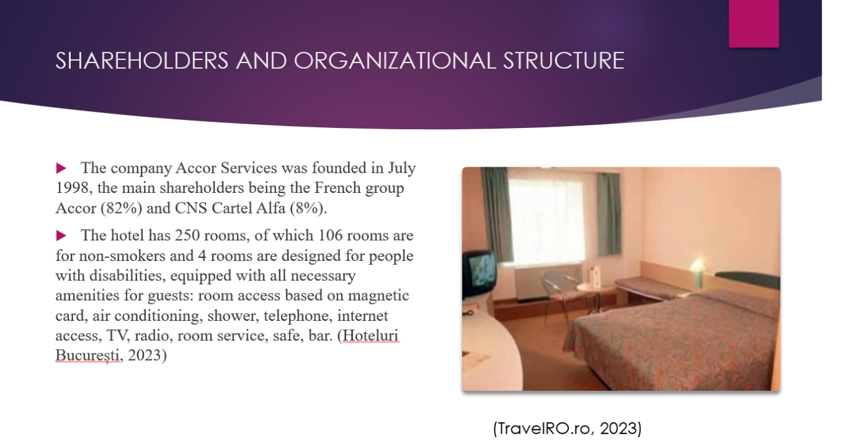
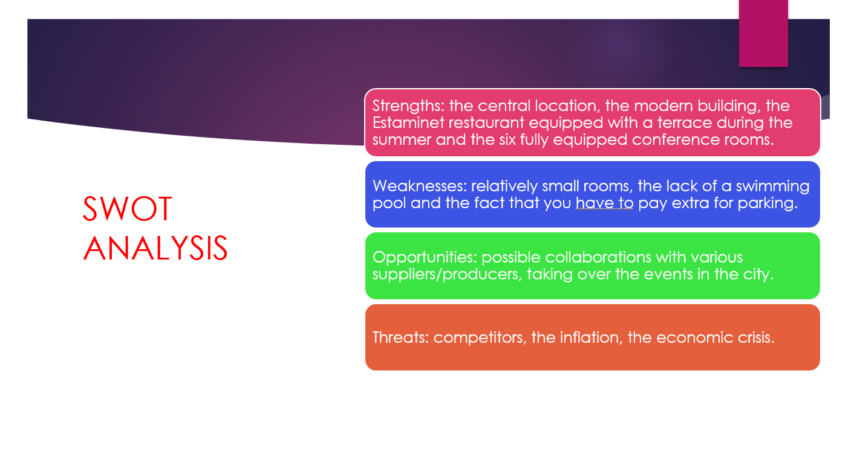
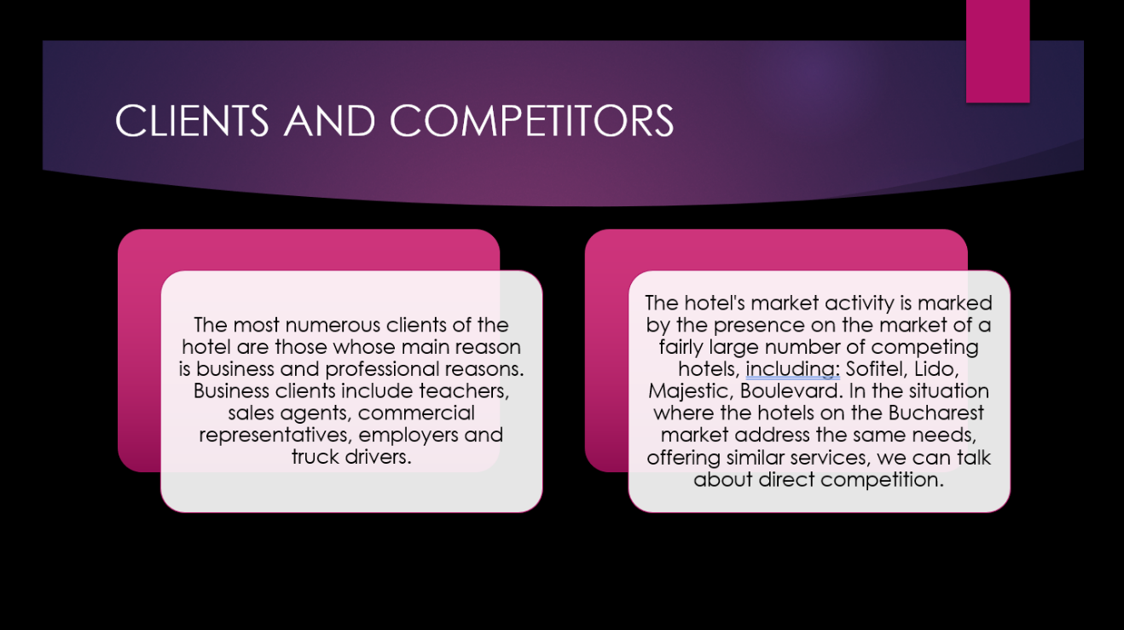
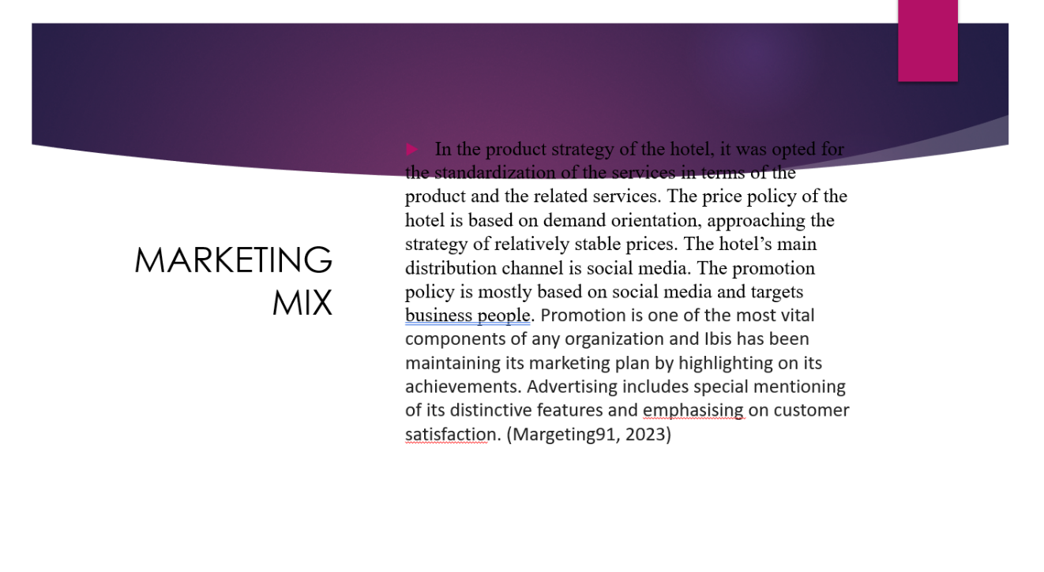
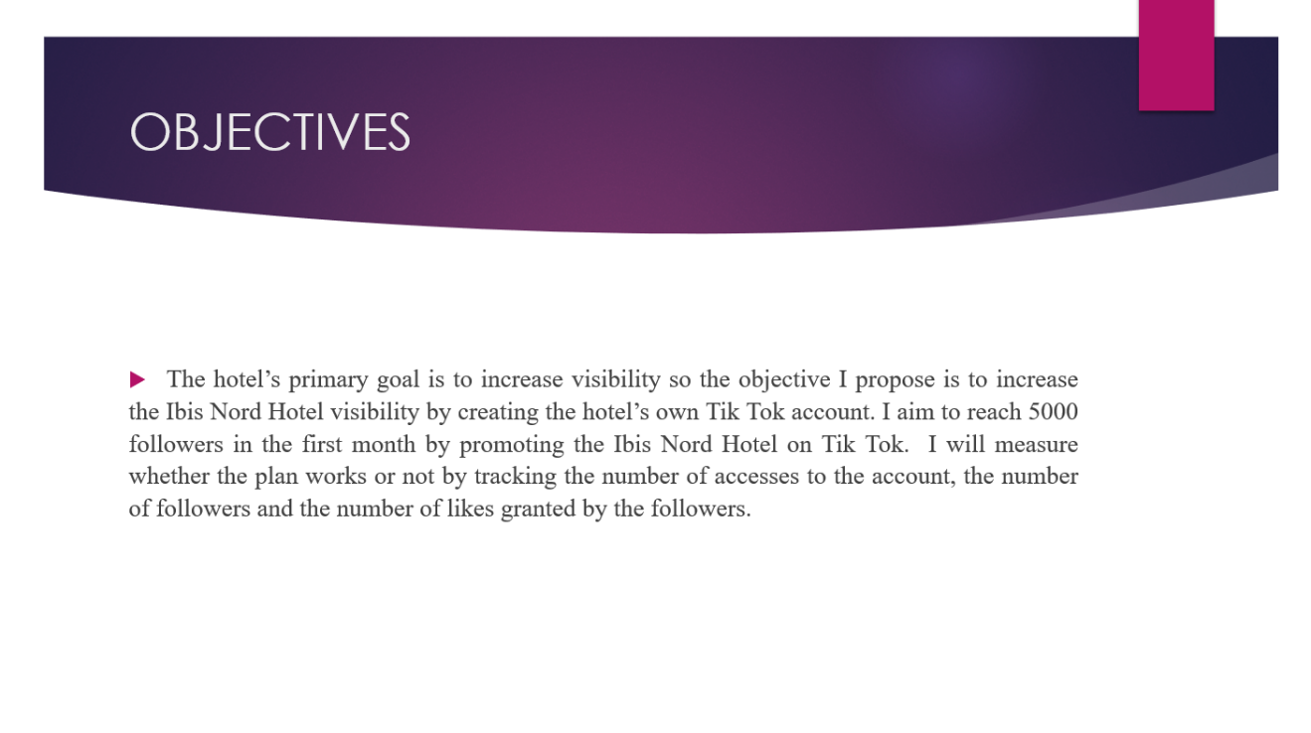
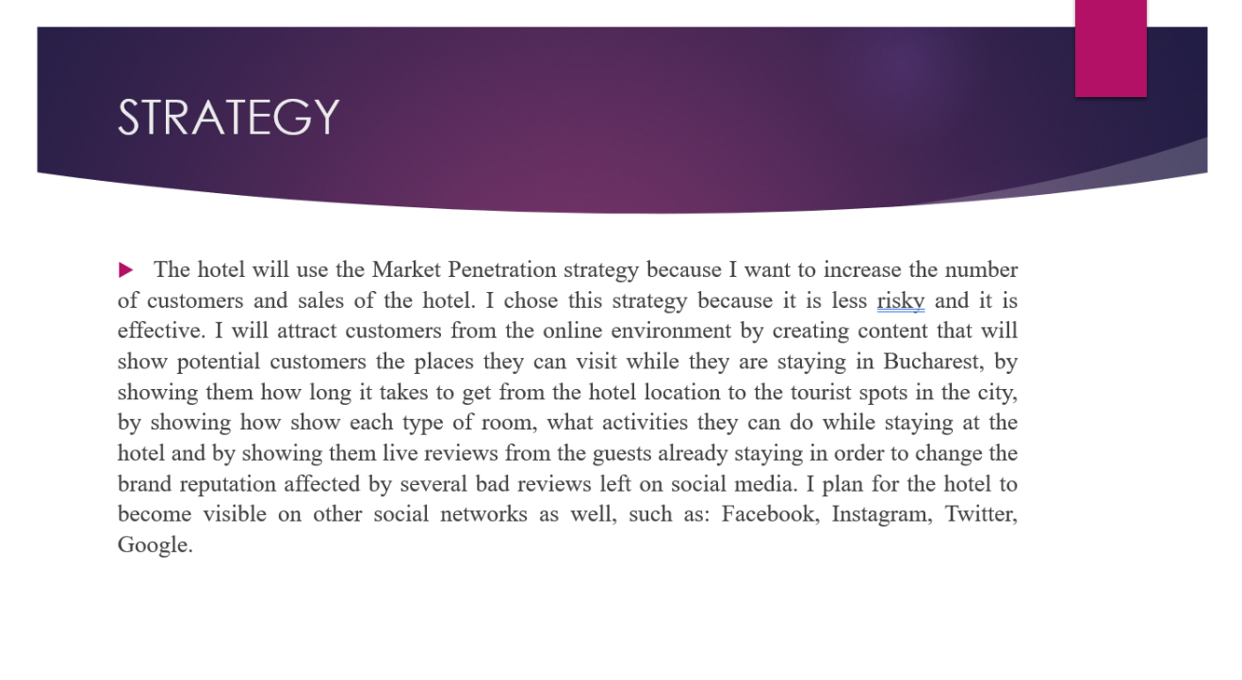
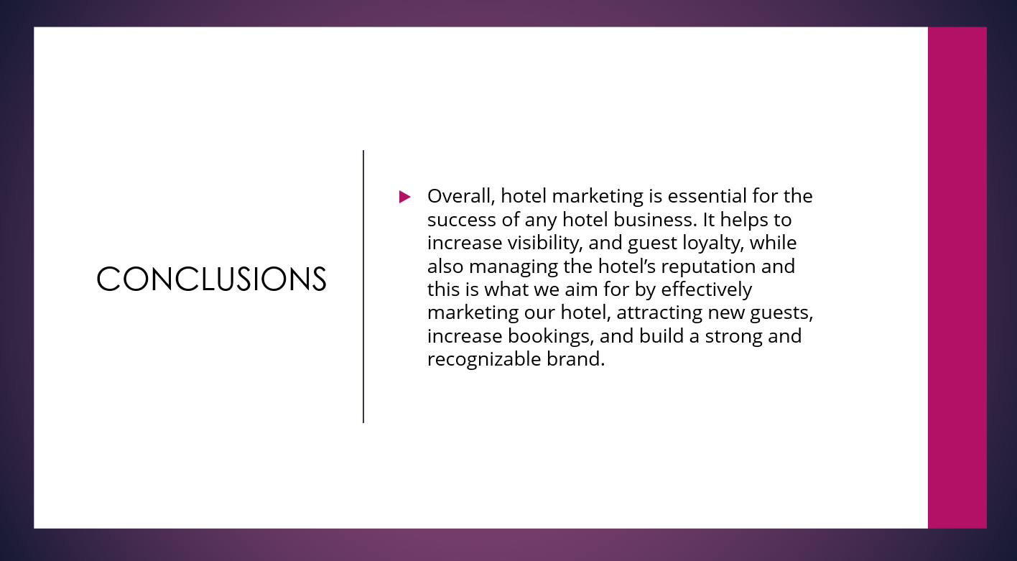
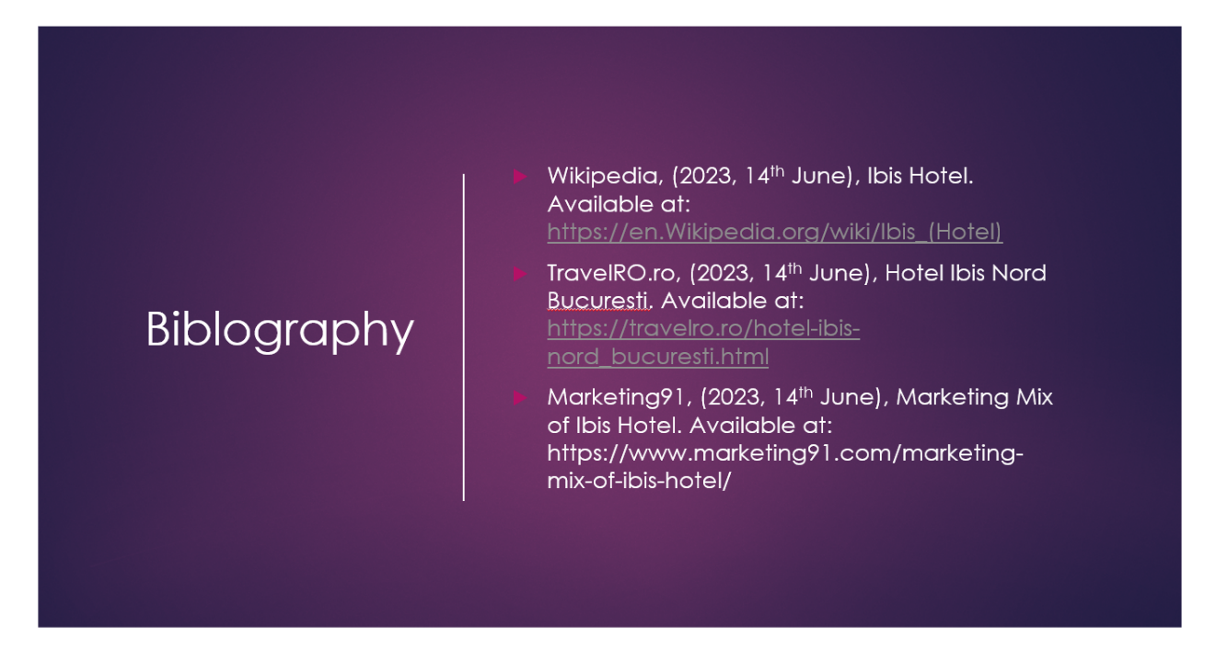

Bibliography

Hoteluri Bucuresti, (2023, 14th June), Hotel Ibis Gara de Nord. Available at: https://www.hotel-bucuresti.com./hoteuri/hotel_ibis_gara_de_nord-71.html
Marketing91, (2023, 14th June), Marketing Mix of Ibis Hotel. Available at: https://www.marketing91.com/marketing-mix-of-ibis-hotel/
TravelRO.ro, (2023, 14th June), Hotel Ibis Nord Bucuresti. Available at: https://travelro.ro/hotel-ibis-nord_bucuresti.html
Wikipedia, (2023, 14th June), Ibis Hotel. Available at: https://en.Wikipedia.org/wiki/Ibis_(Hotel)

