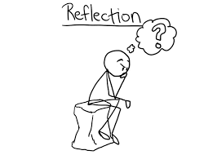

Reflective Review
  - assessment 2
Joanne Jarrett
[BMSK4001] (ACE)
Cert HE Skills for the Workplace - Level 4, Semester 2
Anita Nan
Submitted 29th August 2018

Contents Page

Abstract 3

Introduction 4

Main Body 5

Conclusion 11

Reference List 12

Abstract

The purpose of this Reflective Review, is to attempt to explain how the learning outcomes in this module have resulted in an improvement in my level of employability skills and also learning new academic ideas.
Previously, I have not had any experience of completing a Reflective Review of any sort and my methods here will be to gather information by reading widely and drawing a conclusion on my findings.
The development of my academic abilities especially, have increased my thought processes, which allows me to demonstrate my capabilities around academic ideas and also within the world of employment, by being taught new ways of thinking and I will be expanding on my increased awareness.
During the first term, I learned how to analyse my relevant employability skills and also to acknowledge those skills I was lacking and needed to develop in the future, to enable me to be seen as a credible candidate when seeking to take advantage of employment opportunities – especially from the vantage point of a perspective employer.
I will also be sharing my favourite Reflective Model and the reason behind this, finishing with any skills gaps and my intention to rectify these.
I have now realised that I also could not have done this review without not only looking back at what I have learned this term – but also looking ahead and thinking about it in an analytical way.

Introduction

In this Reflective Review, I will give an overview of how in my opinion, developing as a team manager can be enhanced by continuous reflective learning and in this second term of the Academic and Employability Skills module, the learning outcomes I have experienced, have enabled me to clarify my viewpoint by utilising several different ‘theories’ in order to proceed in the correct direction.

Main Body

Being able to reflect has not been a straight-forward process for me, as I tend to like to learn new concepts, consolidate them in my mind and move forward onto the next, instead of making a deliberate effort to go back and re-think my actions and thought processes – which is necessary if you want to make changes and improve going forward.
This term, however, I have learnt several things that I’ve not only enjoyed, but found very interesting and as a result, they have helped me greatly in formulating ideas of my own, which has increased my academic abilities and also, will potentially provide more opportunities for me at management level.
The most significant aspect of my learning, was my becoming more aware of the importance of finding ways to manage my time more efficiently; especially when trying to accomplish numerous different things in a limited time-frame. I’ve discovered that learning to structure my work in a more organised way, as well as developing more analytical habits, has enabled me to focus more on specific areas of study.
While researching various academic concepts, I am able to apply my own ideas and growing level of knowledge around the subjects covered by the Academic and Employability Skills module.
I have significantly developed my understanding of many reflective ‘models’.

Reflection can enhance studying.⁴ Illeris⁴ describes learning to consist of expressive and community possibilities, as well as cerebral. In the real world, mental features are normally calculated by measuring, or in the way something is carried out. While the more expressive and communal characteristics may not be as easily ascertained. Structures of consideration may maintain the progress of both these measurements.⁵ In addition, studying may be thought to happen as part of a sequence.
The Author 2012),Author name, article name website name Published by Oxford University Press on behalf of Faculty of Public Health.

Firstly, and when addressing conflicts - to break down problems into smaller parts and then deal with them.
So, I can say that learning more about the above and how to apply them, have all helped me to move forward and make progress not only on this course – but also, in some areas of my life.
In order to evaluate and explain what I have learnt, the first theory I will refer to is John Driscoll’s Model of Reflection – although this model is most suited to clinical practice.
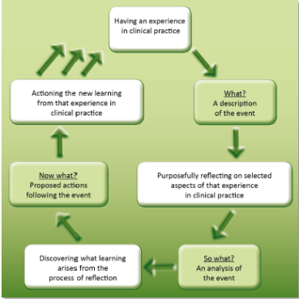

Enhancing managerial development With Experiential Learning.
To begin with. The fragile connection between knowledge that has been observed or mastered and an evaluation of learners’ growth as leaders for a group setting, did not discourage the department from its obligation to the genuine consulting framework, which provides matchless worth for learners. Lecture hall training and enactments, might propose additional openings for organized directives and clear theoretical understanding, but two important features recommend the Capstone Experience is the favoured choice for emergent group supervision expertise: intrinsic demonstrative commitment with a scheme and self-managed group situation.
The firsthand knowledge theory is effective because it produces expressive signals that encourage and direct the learning of knowledge and in particular understood wisdom (Kolb, 1984), but this same mechanism can cause tension, which makes obvious mental education harder. Within capstone project, we have seen this force sh0w itself frequently. The elements that petition commitment are at the same time causes of strain. (Cyphert, D., et al (2016)
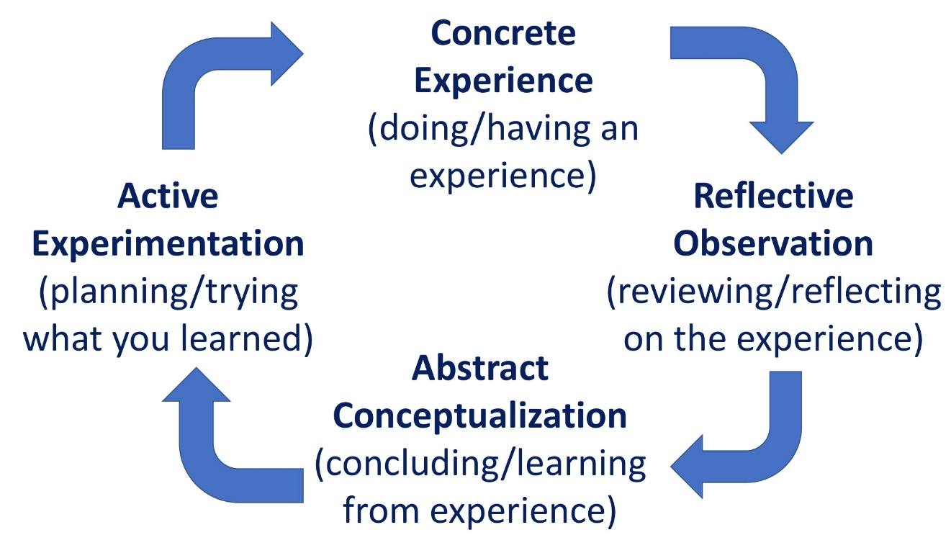

Fig 1. Kolb’s Learning Cycle
Or, Atkins & Murphy’s Model of Reflection (1993)

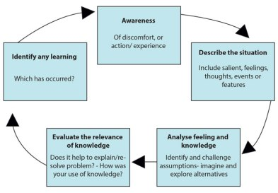

Fig 2. Atkins & Murphy’s Model of Reflection (1993)
The knowledge gained as a result of my reflecting and using all (3) of these models – but especially ‘Graham Gibb’s Theory’, will be indispensable to me as a learner, because I can then go on to make changes to my thought processes and more importantly, my behaviour – as I can do with most of the models.

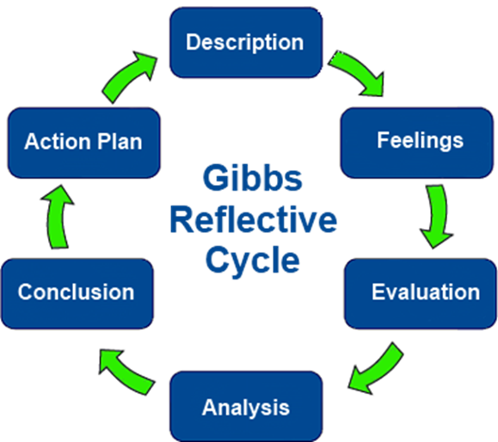

Fig 3. Gibb’s Reflective Cycle

According to Gibb’s Model, the main definition relates to being alert to the things that create regular, everyday actions and it’s the ability to then go back and reflect or examine a person’s actions (usually one’s own), in order to learn over a longer period of time.
One of the main concepts to understand is that just going through a particular experience, is not what leads to learning lessons; it is actually, consciously, taking the time to methodically, reflect on all aspects of whatever has happened.
Previously, I would not have been able to use any particular model, or style to examine what I had learnt, because it would not have occurred to me.
When considering the skills learned over the past (10) weeks, the below (3) rank at the top (in order).
- Critical Thinking Skills
- Time-Management Skills
- CV Construction

Critical Thinking Skills
I have found it is normally quite common to be able to use basic thinking and acting skills on a day-to-day basis. But most do not find it easy to use these same abilities routinely when in new surroundings and under different conditions. This is to some extent because although people may be able to utilise this expertise during conditions that they may be used to, they may not be fully cognisant of other ways of approaching various situations and being able to change them to fit new settings.
It can be hard to recognize fundamental skills, when we habitually apply them in the same way and using only one perspective, instead of critically thinking things through cautiously. (Cottrell S. 2011)

Time-Management Skills
Since I have employed the Pareto Principle Management Tool, I have been able to control and track how I spend my time, not only my working life – but also my personal life too.
Pareto’s 80-20 Rule – simply put, is that in a given situation; 80% of output is produced by 20% of input. An example of this might be in a mini-cab company, 20% of the drivers bring in 80% of earnings to the business.
Or,
In a beehive, a minority of worker bees – around 20%, contribute approx. 80% of the honey produced.

CV Construction
Building a more accurate, current CV was one of the skills I mastered this term, along with the recognition that fashions and styles change with regards to what potential employers are looking for and consider important. Using the ‘STAR’ Method (Situation Task Action Result) – although not a strong reflective tool – it is highly effective when creating an impressive CV, or during interviews & meetings, as it makes clear all the necessary requirements for a given job.
In the next stage, I will use the expertise I’ve gained in creating a more effective CV, by securing appropriate job interviews and ultimately obtaining my target position.

Conclusion
This reflective review focused on my expectations of how I would feel about what I’d learnt by the time I got to the end of the second term of Academic & Employability Skills.
Having analysed the various models and theories, I now realise there are basic similarities with the reflective philosophies, but definite differences regarding the best circumstances in which to use them.
Furthermore, I have learnt that, as a next step, it is my intention to utilise the most appropriate one for me, at each stage of my academic and employment careers.
Or, Atkins and Murphy’s Model

References
(Cyphert, D., et al (2016) A. Maund, M. Schriek and P. Tinkler, (2017) Cert in Higher Education: Skills for the Workplace (Developing Communication Management Skills: Integrated Assessment and Reflection in an Experiential Learning Context. London: Sage Publishing. p414 - 415,)
Reflection as part of continuous professional development for public health professionals: a literature review [Online] Available from: https://academic.oup.com/jpubhealth/article/35/2/308/1543818 (Accessed 28 August 2018)
Cottrell, S. (2011) Palgrave Study Skills, Critical Thinking Skills, Developing Effective Analysis and Argument. 2nd Edn. London. Palgrave Macmillan.

