Student Name: Sultana Bibi
Student ID: 1604274
Module Name: Effective Team Working & Communication
BMSK 4002
Lecturer Name: Richard Small

Contents
Introduction 2
Types of communication practiced by employer 3
Working collaboration system 3
Group dynamics theory; Tuckman's theory 5
Belbin’s team development theory: 6
Group strategies in our organization 8
Conclusion and recommendations on communication development in the organization 9
References 11

Introduction

Communication is the process of interaction between two or more persons where a message is shared to achieve a common goal. In an organization or our daily life, we communicate with our friends, family and colleagues. Again, a group communicates among the group members to achieve a goal. Effective communication and group formation can bring organization desire easily if employer uses the communication theory and team building theory appropriately (Collins, 2009). I have been working in the Hummingbird Bakery. The employer of this bakery is Tarek Malouf who is good at communication and team development. But he has also some lacking. Here it will be presented the communication process, group theory and team development theory that are practicing in Hummingbird Bakery.

Types of communication practiced by employer

Tarek Malouf uses both formal and informal communication process. The formal communication processes are written communication, meeting and verbal communication. Basically, the employer sends us email and we also send him email writing report. Again, we talk to formally using mobile phone and meeting through online participation.
Face to face communication, gestures and some oral communication is used by our owner. His facial expression tells us what should do. Again, we communicate with our group members informally. Basically, communication process is sender to receiver. As a mediator email and our manager works here (Gamble and Gamble, 2013).
Interpersonal communication system is active listening, personal presentation and body language. Employer often shows his facial expression about our work. Sometimes, his smiling face indicates our job is good or sometime rude eyes and words gives us pain. We communicate our employer through personal presentation as there we have a few employees.
Written communication structure is business style. He sends mail maintaining the formal procedure like spelling, syntax, grammar and punctuation. Basically, the written communication structure is written like business report.

Working collaboration system

Tarek Malouf has given us the ownership giving decision making power. We can communicate directly to manager proposing our understanding about the bakery. Any suggestion is send to manager both formally or informally. When we propose for changes we have to send letter in email to our employer. But during discussion about the topic we sue informal communication system.
My employer determines the roles and responsibilities and orders individually to get his thing. He identifies every drawbacks and strength that has been provide through formal communication process. Confidential report is communicated in meeting where we discus on how to compete with competitor and the strategy. So a few employees get the chance to participate in meeting (Beebe, 2015).
Negotiating and developing ideas:
Employer of the Hummingbird bakery is competent in negotiation and development ideas. He is fully conscious about other’s side viewpoint and limitation. He asked us what is our opinion when we raise voice against the organization. He tells us to present our saying. We talk about working hours, working place and salary. At first, we bargain then he reaches a point where both we are satisfying. This is the deal points. Your leverage" and "their leverage" is working here.
When we want to develop our own place or organization we discuss our colleagues. Scrutinizing the pros and cons, we submit a paper to our employer. Then also analyzing the ideas. Basically, initiating new item of food, we discus among our group members. Then our employer takes decision it will be produced or not in this bakery (Lee in tae, 2016).

Theoretical application from my understanding:
From my understanding I have known that employer is using certain theories fro group development and team building. Here I have presented below a group theory and team structure theory if Belbin.

Group dynamics theory; Tuckman's theory

Employer creates group with several individuals for achieving a definite goal. Tarek Malouf has made groups for sales department, accounting, chefs and waiters and cleaners. Group development theory is concerned with how to develop the group for the certain task. We have command groups, task groups, operation groups and reference groups Here I have presented Tuckman’s group development theory that has been used in our Bakery. The forming process is described below-

- Forming: employer gives the guidance and direction. Basically, he gives the direction how to increase the sales for certain menu. When he determines the sales target for group, they show a little agreement. Actually, they don’t know what is the purpose from the agreement.
- Storming: when our employer determines the target of sales, we create conflict with manager and shows the reluctant to achieve the target. But the manager is able to convince us and gradually we understand the purpose. Employer arranges coaching or training how to get the purpose.
- Norming: after getting training on the purpose, employer determines roles and responsibilities of each member. The marketing group disseminate information to crate values where sales assistance work politely to draw the attention of customer. Chefs try to ensure the best taste for every food. Employer facilitates all tasks to achieve the goal.
- Performing: after designing the roles and responsibilities, power is delegated for each group and members. We have a clear vision and mission to achieve the goal. Every group member work together focusing on target.
- Adjudication: we achieve our goal and the employer recognizes us. He gives tank and provides financial and nonfinancial support for motivating future works. Thus we end the game (Seck and Helton, 2014).

Belbin’s team development theory:

From my personal experience I have assume that my employer use Belbin’s team development theory. This team development theory assists us to reach our target easily. The theory is discussed below basis on my working experience-
Action Oriented Roles:
Shaper, implementer and complete finisher takes action within team. Shapers are dynamic and takes challenges to improve teamwork. They are introverted characteristics whose are responsible to stimulate others employees finding the best approaches to accomplish the work to solve problems.
Implementer is a person who gets things done that means practical application of ideas given by team members. They are conservative, disciplined and efficient. Completer-finisher supervise all project. They supervise every errors and omissions, conscious about project deadline. They are conscious to finish the whole project (Johnson, Beyerlein and Beyerlein, 2009).
Employer of the Hummingbird Bakery appoints the employees identifying their skills in different sectors. In our colleagues, everyone has different skills and experience. Identifying the skills and experience, employer gives them placement where they are perfect.
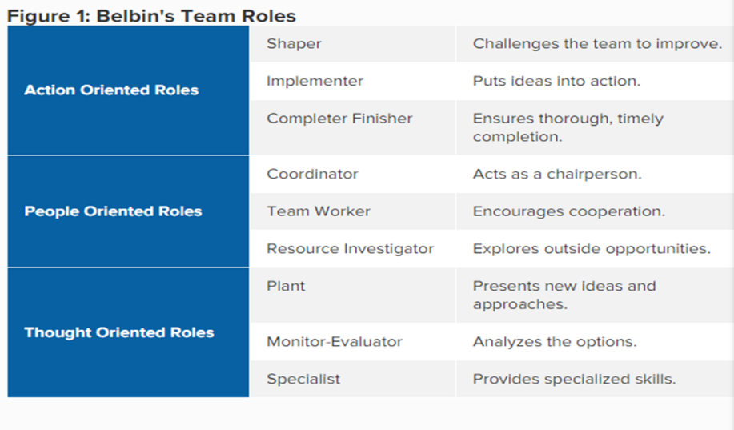
People oriented roles:
Coordinator, team worker and resource investigator performs people oriented roles. The coordinator performs the traditional role and considered the chairman of team. They are the excellent listener who gives equal treatment for every employee. They are calm, good nature and task oriented. Team workers are people oriented whose provides the services. Resources investigators explore the available options and negotiates resources for team.
Our sales team and chefs team are people oriented. They arrange all components for serving customers.
Thought oriented roles:
Plant, monitor, and specialist gives the hypothetical decision in team. They are responsible to develop how tem ambers can work perfectly, which sectors should be developed, how problem is created and solution process. The plant is the core creative innovator. In our bakery, three main chefs discover new food menu. The monitor supervising the food menu that there has any defects or hygiene ingredients there. Specialists are people who have specialized knowledge that is needed to get the job done. Employer has designed their task based on their field. Suppose, accountant, manager, computer operator etc. (Aritzeta, Swailes and Senior, 2007).
Using Belbin’s team development structure, employer of the Hummingbird Bakery specifies roles and responsibilities for every employee. Thus he gets a good output from this team.

Group strategies in our organization

Employer makes our group using Tuckman’s dynamic group theory. Actually, a group is created for achieving a specific goal. We have sales group, accountant group, casher, chefs, waiters and cleaners group. Everyone is responsible for performing their duties. These group are operated following some strategies like share objectives, agreements, delegation and meaningful schedule. These group strategies assist to perform everyone roles effectively.
Employer shares the objectives among group members that assist to know what they are going to do. When employer shares the objectives group members may agreement or not. At this time employer convince them why they are going to do the task and what is the benefits from it. Employer keeps rewards for us so that we can engage ourselves completely to work. A meaningful schedule is created by our employer to perform our task. Excessive workload can demotivate employees or may decrease the quality of service. Strong schedule is followed for chefs as they are main responsible to produce food. If food taste becomes silly, then customers will lose the attraction on us (Cacioppe and Stace, 2009). Delegation of power is another strategy of group development. Every group member has specific roles. When task is delegated, they feel ownership and can accomplish the task according to their comfortable idea.

Conclusion and recommendations on communication development in the organization

Tarek Malouf the employer of Hummingbird bakery follows strategic communication procedure to manage his organization. Basically, as small entrepreneur, there have a few employees. So informal communication like face-to-face, oral, phone calling and facial expression is used here to communicate. Again, using dynamic group development theory of Tuckman is also used here. He follows Belbin’s team development structure where he identifies everyone roles and responsibilities basis on education, experience, age and expertise (Whitcomb and Whitcomb, 2013). To operate group, he sues some strategies that has been discussed above. From my personal observation, employer has some drawbacks. Here some recommendations are presented below to improvement communication and team development-
- Employer should maintain a regular meeting with employees about to disseminate information on target setting. But employer creates pressure without informing them. Again, communication process is informal oriented and that’s why it loses the acceptability to employees. So proposal form should be written form maintaining the formal structure.
- Gesture communication is used here, as it is SME. Gesture communication may be unaccepted to employees. Even sometime employees can’t understand what is the meaning of facial expression or body language. So he should focus on oral communication.
- Employer should identify the mission and vision but his communication is scattered and indiscipline. He should build a formal procedure. Formally giving feedback on strength and weakness of employees can overcome any problems.
- Development of technology based communication like social media. Every group should have a chat group where they can discus beyond office time. They can delegate their task discussing here.
- During team development, he should analyses the background and expertise. Though employer follows the guidelines but he should give the chance to others employees to show their expertise (Pierce, 2012).
- Roles of group and team members should update according to their performance. It encourages employees to work appropriately. In communication process between group and team there should a channel that will facilitate communication.

References

Aritzeta, A., Swailes, S. and Senior, B. (2007). Belbin's Team Role Model: Development, Validity and Applications for Team Building. Journal of Management Studies, 44(1), pp.96-118.
Beebe, S. (2015). Communication. Pearson Education Limited.
Cacioppe, R. and Stace, R. (2009). Integral team effectiveness: validity analysis of a theory‐based team measure. Team Performance Management: An International Journal, 15(5/6), pp.220-234.
Collins, S. (2009). Effective Communication.
Gamble, T. and Gamble, M. (2013). Leading with communication. Los Angeles: SAGE Publications.
Johnson, D., Beyerlein, S. and Beyerlein, M. (2009). Team development. Bingley: Emerald Group Publishing Limited.
Lee in tae (2016). A Study on Negotiation skill as Moral Implementation. KOREAN ELEMENTARY MORAL EDUCATION SOCIETY, null (51), pp.253-284.
Pierce, J. (2012). Team collaboration. Redmond, Washington: Microsoft Press.
Seck, M. and Helton, L. (2014). Faculty Development of a Joint MSW Program Utilizing Tuckman's Model of Stages of Group Development. Social Work with Groups, 37(2), pp.158-168.
Whitcomb, C. and Whitcomb, L. (2013). Effective interpersonal and team communication skills for engineers. Piscataway, NJ: IEEE Press.

