

Module Name: Academic Skills in the Digital Era
Module Code: BMSW4013
Assessment 1: E-Portfolio
Student Name: Mohammed Sumon ali
Student Number:1813647
Lecturer: Scott James

AI Acknowledgement

I confirm that I have not presented any AI generated text as my own work. I confirm that I have copies of my drafts, notes, and other resources I used before, and after the use of AI tools which I may be asked to provide in evidence.

Component 1: Research and Planning

Source Exploration

My source is from an article which I got from the Frontiersin website called “digital learning in the 21st century: trends, challenges, and innovations in technology integration”, which was authored by Yumei Zou, Florence Kuek, Wenqin feng and Xiaoli Cheng which was published on the 28th of March 2025.

The main point of this article is digital learning is a big part of modern education, tools like AI can make learning more accessible. The authors talk about these advantages also coming with challenges. Some of these challenges are unstable internet connection, not enough teacher training and many others.

I chose this source because it was peer reviewed and very recent, this makes the information in this article reliable as it is also recent.

This source will help me to answer the main question because it explain opportunities and challenges that students face, it also point out the barriers that can hold student back.

Key Challenge for Students

One key challenge students face is when using digital using digital tools is not having a stable internet connection. This is a basic issue many students face when using digital tools and can make it very hard for students to keep up with work and accessing learning resources.

For an example in the past, I have faced difficulty accessing my work and joining teams meetings due to my internet connection being down, this is an issue many students face which shows it can be a problem which many students face

Key Opportunity for Students

There are many benefits to students using digital tools and they all come with advantages and disadvantages. In the past students were held back with limited learning material. Now they have access to more digital tools such as google, wikepedia, chat gpt. You can also access educational videos on youtube to help you learn.in the past I have used some of these digital tools to help me. I found this opportunity very valuable as it helped me complete my assignments in the past. I think many students would benefit from using digital tools as they can help you with research tasks, assignments and many more.

Planning Your Report

For component 2 I am planning to focus equally on opportunities and challenges because I believe that they are equally as important to focus on.

In the report I am planning on including tools such as google Wikipedia you tube chat gpt because they are all digital tools that are often used in education.

My report will follow this structure.

Introduction, challenges, opportunities, digital tools, conclusion.

Component 2: Answering the Question

Introduction

Digital tools like laptops, tablets, and smartphones have changed how students learn. These tools bring many benefits but also create some problems. It is important for students to understand both the good and bad sides of using technology in education. Knowing this helps students use digital tools better and avoid difficulties. This report will explore two key challenges students face, two opportunities digital tools provide, and offer three practical ways students can adapt to succeed in the digital era.

Challenges Students Face

One big challenge many students face is distraction. When using digital tools for learning, it is easy to get sidetracked by social media, games, or other websites. For example, while studying on a laptop, I often find myself checking Instagram or watching YouTube videos that are not related to my homework. This makes it hard to finish tasks on time.

Another challenge is digital fatigue. Using screens for a long time can cause tiredness, headaches, and loss of focus. The article "How Technology Affects Student Learning" by Smith (2022) explains that long hours on devices can reduce attention span and lower the quality of learning. These challenges are important because they affect students’ ability to concentrate and do well in school. If students cannot manage distractions or digital fatigue, their learning will suffer.

Opportunities Digital Tools Provide

Digital tools also offer many opportunities for students. One great benefit is easy access to learning resources. Now, students can watch videos, take online quizzes, and read articles anytime. For example, I use Khan Academy videos to understand difficult topics, which helps me learn better outside of class.

Another opportunity is personalised learning. Digital tools can adapt to each student’s needs. According to Lee (2023), apps and platforms can offer exercises and feedback based on how well a student is doing, helping them improve at their own pace. These opportunities are valuable because they make learning more flexible and fun. When used correctly, digital tools can help students understand subjects better and learn in ways that suit them.

How Students Can Adapt

To succeed in the digital era, students need to learn how to use technology wisely. Here are three ways they can adapt:

- Use Time Management Tools
Apps like digital planners or the Pomodoro technique (working for 25 minutes, then taking a 5-minute break) can help students focus and avoid distractions. Research by Johnson (2023) shows that using these methods improves concentration and productivity. For example, I use a timer app that helps me work without checking my phone.

- Be Critical When Using AI Tools
AI tools like ChatGPT can help with ideas or explanations, but students must check the information and avoid copying answers. Learning to evaluate online information helps students develop critical thinking and avoid mistakes. The Digital Literacy Guide (2023) recommends always verifying facts from multiple sources to ensure accuracy.

- Access Support Services
Many schools offer workshops or online training to improve digital skills. For example, attending a digital skills workshop helped me learn how to use Google Docs and online libraries better. Getting support helps students feel confident using new tools and solving problems quickly.

By following these suggestions, students can use digital tools effectively and improve their learning experience.

Conclusion

In summary, students today face challenges like distraction and digital fatigue when using technology for learning. However, they also have opportunities such as access to many learning resources and personalised learning experiences. To adapt and succeed, students should manage their time well, use AI tools critically, and access support services. Understanding these points will help students make the most of digital learning and succeed in school and beyond.

Appendices

Appendix 1: CRAAP Test

CRAAP analysis of the article

currency

the article was published on march 28th 2025 which makes it very recent. Because digital learning changes a lot, it is important to have a recent and credible source which is up to date.

relevance

the articles I have used fits my research very well as they focus on modern education in digital learning. They discuss both opportunities and challenges which students commonly face when using digital tools.

Authority

The article was written by Yumei Zou, Florence Kuek, Wenqin feng and Xiaoli Cheng who are all related to academic or research institutions. It was published on the frontiersin website which has a good reputation and is peer reviewed. This makes the author and the publisher both very reliable.

Accuracy

The information from the article is very reliable as it is supported by research and evidence. The authors explain both the advantages and challenges of digital learning such as lack of teacher training and also unstable internet connection.

purpose

The purpose of this article is to inform readers about how digital learning is changing education. It shows problems which both students and teachers may face and explores possible solutions.

Component 3:

Slide1:


Slide2:

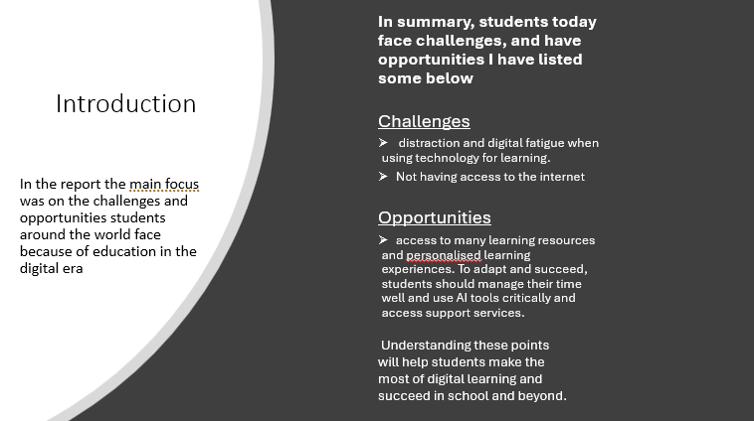

Slide 3:


Slide 4:
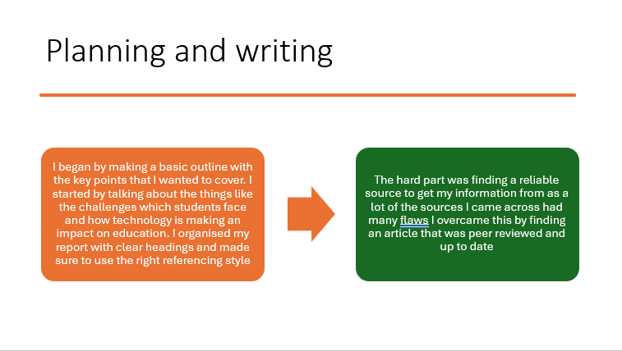

Slide 5:
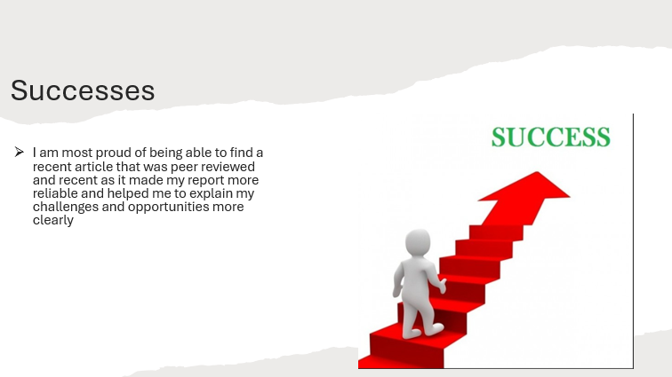

Slide 6:


Reference List

Frontiers (2024). Frontiers | Peer Reviewed Articles - Open Access Journals. [online] Frontiers. Available at: https://www.frontiersin.org/.

Timotheou, S., Miliou, O., Dimitriadis, Y., Sobrino, S.V., Giannoutsou, N., Cachia, R., Monés, A.M. and Ioannou, A. (2022). Impacts of digital technologies on education and factors influencing schools’ digital capacity and transformation: A literature review. Education and Information Technologies, [online] 28(28), pp.6695–6726. doi:https://doi.org/10.1007/s10639-022-11431-8.
‌

