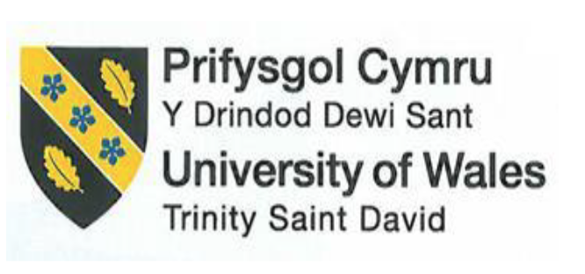

Module Code and Title:
BMIH6007 International Meetings Management for the Hotel Industry

Student Name: Badrul Jamal
Student ID: 2126642

Slide 1 Speaker Notes
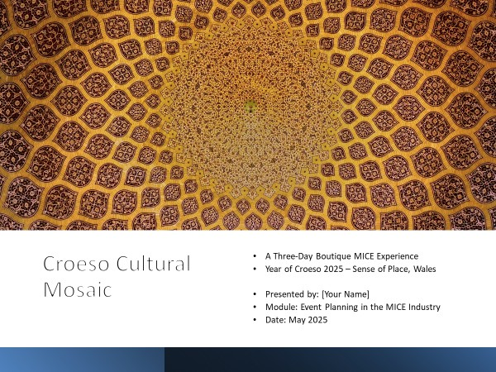
Croeso Cultural Mosaic is conceived as a distinctive three-day MICE event that integrates hybrid conference sessions, cultural workshops, and immersive local excursions to capitalize on the burgeoning demand for experiential business tourism during the shoulder season (Ashrapov and Patterson, 2022). This format addresses the challenge of hotel under-utilisation in low seasons by delivering high-value programming that simultaneously supports local communities and enhances destination branding. The theoretical foundation for such an initiative draws upon the notion of place as a lived, meaningful environment; crafting curated environments and activities fosters strong emotional bonds between visitors and destinations (Cresswell, 2013). By placing “Sense of Place” at the center of its value proposition, Croeso Cultural Mosaic aims to create lasting connections that extend beyond the event itself, encouraging repeat visitation and word-of-mouth advocacy.

Slide 2 Speaker Notes
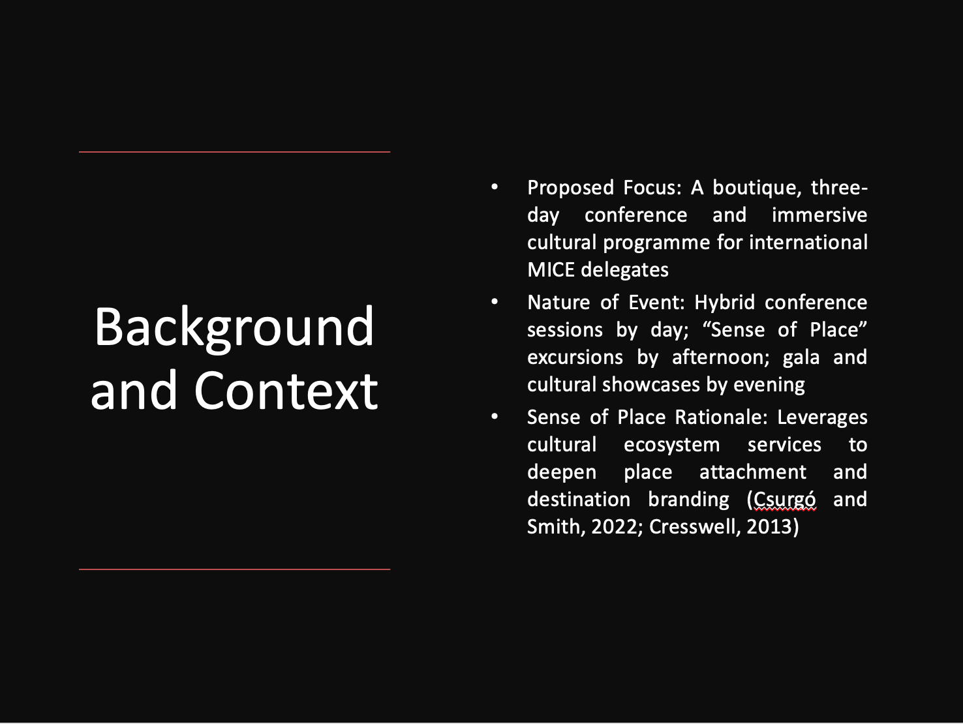
The background context positions Croeso Cultural Mosaic at the intersection of destination branding and cultural ecosystem services. By integrating heritage site visits with expert-led discussions, the event capitalizes on cultural ecosystem services that enrich delegates’ place experience and drive repeat visitation (Csurgó and Smith, 2022). Simultaneously, the format of daytime conferences followed by afternoon outdoor experiences responds to modern MICE preferences for balanced agendas that combine professional development with authentic local engagement (Cresswell, 2013).

Slide 3 Speaker Notes
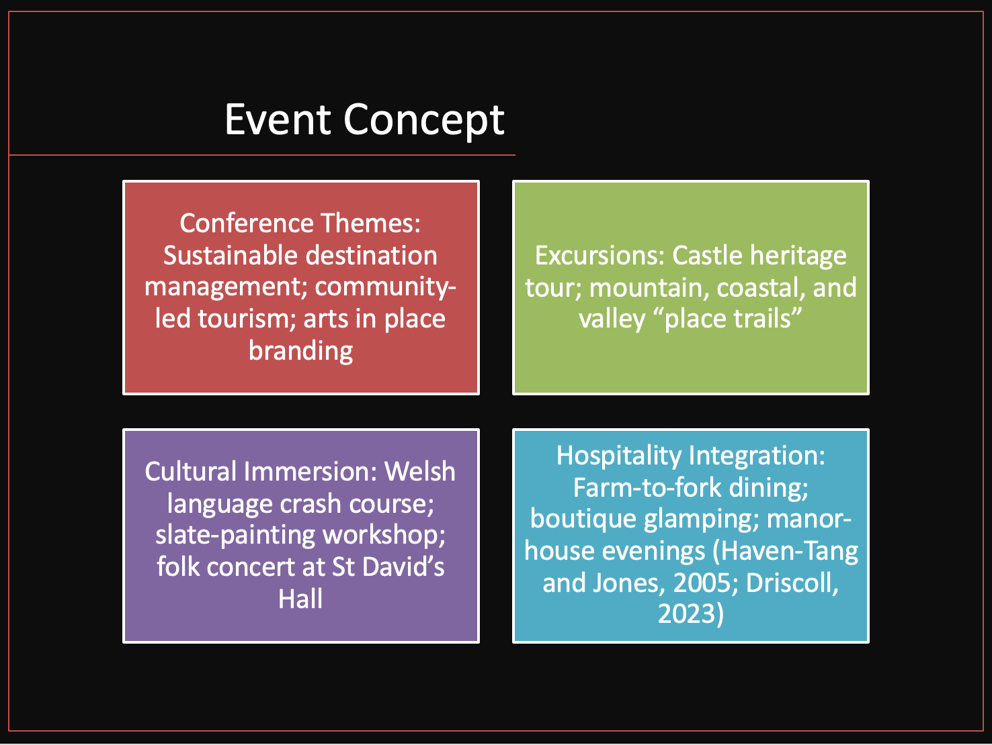
The event concept is structured around four interrelated pillars designed to deliver a holistic Sense of Place. First, conference themes such as sustainable destination management and community-led tourism create a forum for knowledge exchange among academics, policymakers, and industry leaders (Patterson and Quinn, 2012). Second, curated excursions—including castle heritage tours and thematic “place trails”—enable delegates to engage directly with historical sites and landscapes, fostering experiential learning through sensory immersion. Third, cultural workshops—such as slate-painting and Welsh language mini-courses—facilitate hands-on interactions that accentuate local traditions and intangible heritage (Driscoll, 2023). Finally, hospitality elements like farm-to-fork dining and boutique glamping partnerships reinforce the destination narrative by spotlighting local producers and sustainable lodging solutions (Haven-Tang and Jones, 2005).

Slide 4 Speaker Notes
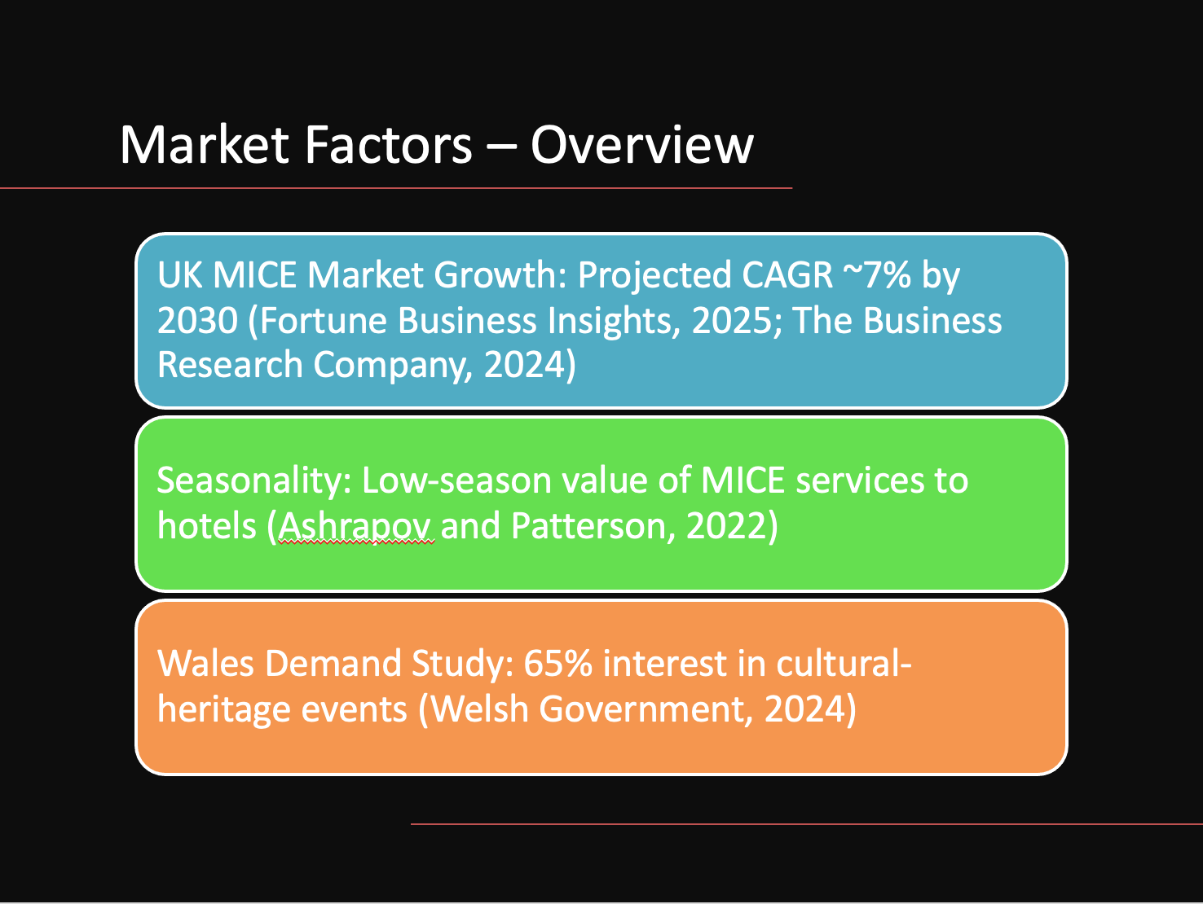
Market analysis indicates that the UK MICE sector is projected to expand at a compound annual growth rate of approximately 7% through 2030, driven by increased corporate investment in hybrid and experiential events (Fortune Business Insights, 2025). Historical data reveal that hotels and venues leverage MICE programming to mitigate low-season revenue shortfalls, underscoring the value of targeted off-peak events (Ashrapov and Patterson, 2022). Complementing these industry trends, a Visit Wales market demand study reported that 65% of surveyed participants expressed interest in cultural-heritage experiences, suggesting strong receptivity to programmes that integrate local history, cuisine, and creative activities (Welsh Government, 2024). Consequently, Croeso Cultural Mosaic aims to harness these favourable market dynamics by positioning Wales as a premier experiential MICE destination.

Slide 5 Speaker Notes
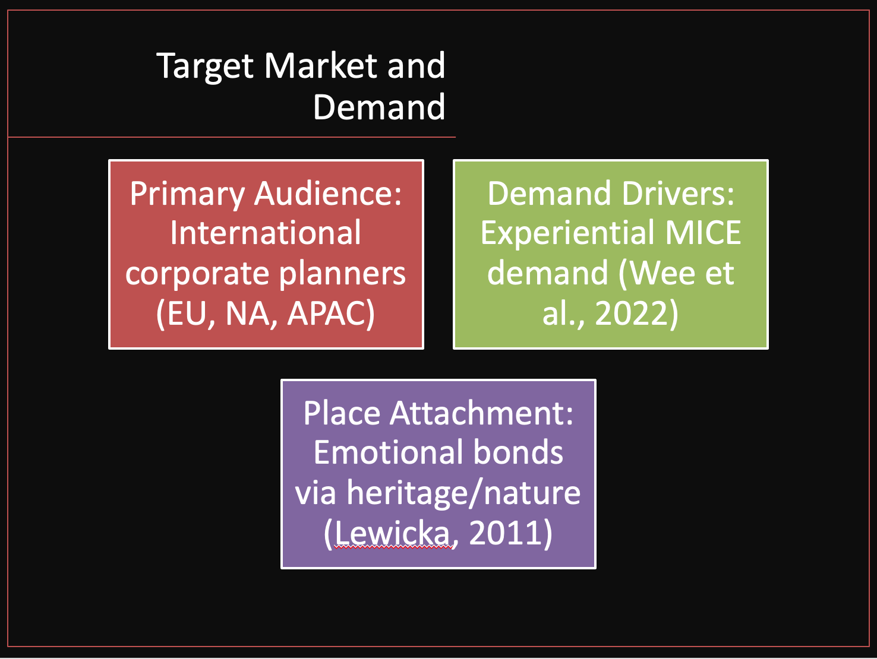
The identified target market comprises international corporate planners—primarily from Europe, North America, and Asia-Pacific—seeking differentiated MICE products that transcend conventional conference formats (Wee, Kamarulzaman and Anas, 2022). Contemporary research underscores a growing preference for events that combine professional development with culturally immersive activities, reflecting delegates’ desire for authentic, place-based encounters. Psychological studies on place attachment corroborate that curated experiences in distinctive environments engender stronger emotional bonds and positive destination perceptions (Lewicka, 2011). By delivering multi-sensory engagement across heritage sites, workshops, and landscape excursions, Croeso Cultural Mosaic is poised to meet these evolving delegate expectations and drive sustainable destination loyalty.

Slide 6 Speaker Notes
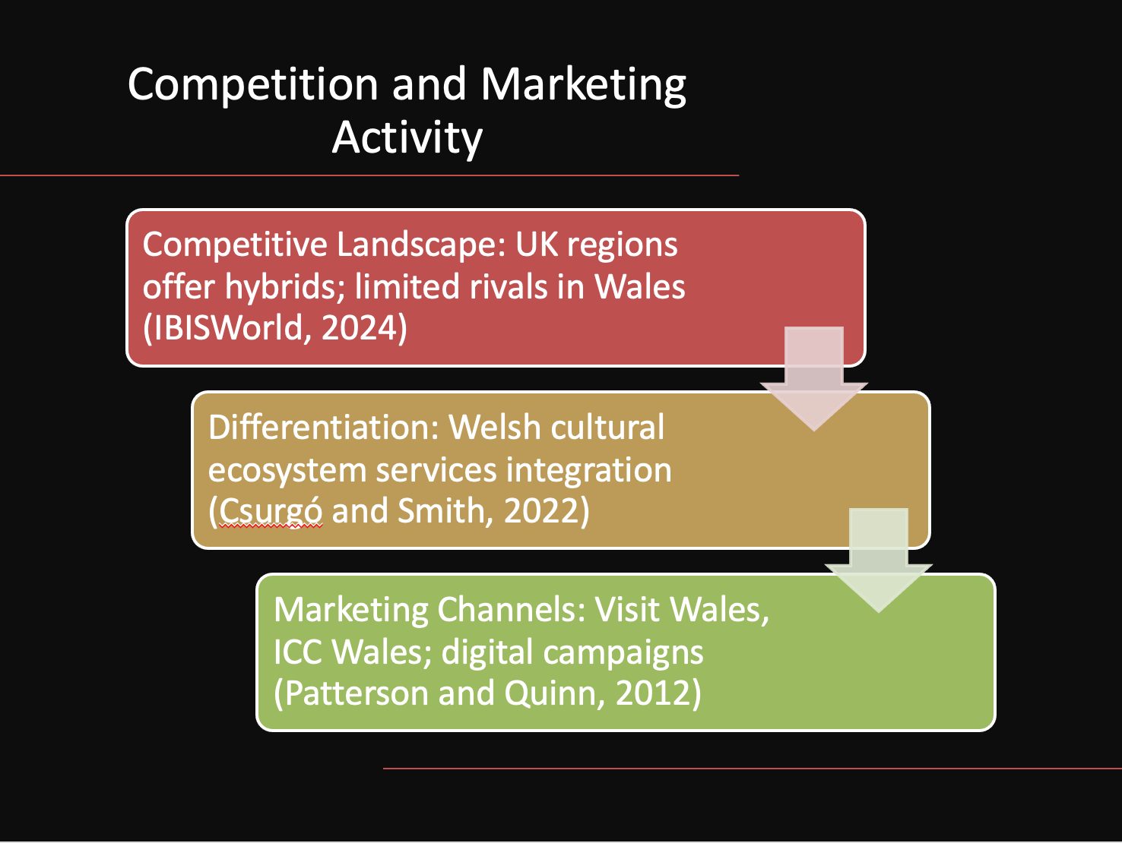
Competitive assessment reveals limited direct rivals within Wales offering integrated conference-excursion packages, while other UK regions provide more generic business tourism products (IBISWorld, 2024a). Croeso Cultural Mosaic distinguishes itself through the comprehensive integration of cultural ecosystem services—food, arts, language, and heritage—which collectively shape a unique narrative and deepen delegates’ sense of belonging (Csurgó and Smith, 2022). Marketing strategy will leverage strategic alliances with Visit Wales and ICC Wales, deploying targeted digital storytelling and stakeholder co-branding to amplify outreach. Emphasis will be placed on thematic content marketing—such as video case studies and delegate testimonials—to illustrate the event’s immersive value and reinforce place attachment (Patterson and Quinn, 2012).

Slide 7 Speaker Notes
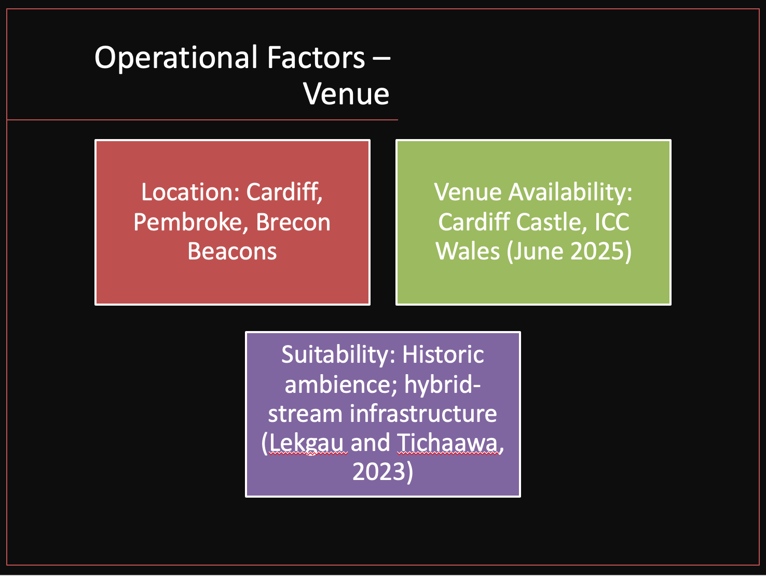
Operational planning identifies Cardiff as the primary conference hub, utilizing heritage venues such as Cardiff Castle alongside the ICC Wales auditorium, both provisionally secured for June 2025 (IBISWorld, 2024a). Afternoon excursions are mapped to Pembroke and the Brecon Beacons, selected for their accessibility, historical significance, and natural beauty. Venue suitability has been validated through consultations with venue managers and planners, ensuring necessary hybrid-stream infrastructure and capacity requirements are met (Lekgau and Tichaawa, 2023). Proactive coordination with local authorities and heritage trusts will facilitate smooth logistics, including site access, licensing, and community engagement protocols.

Slide 8 Speaker Notes
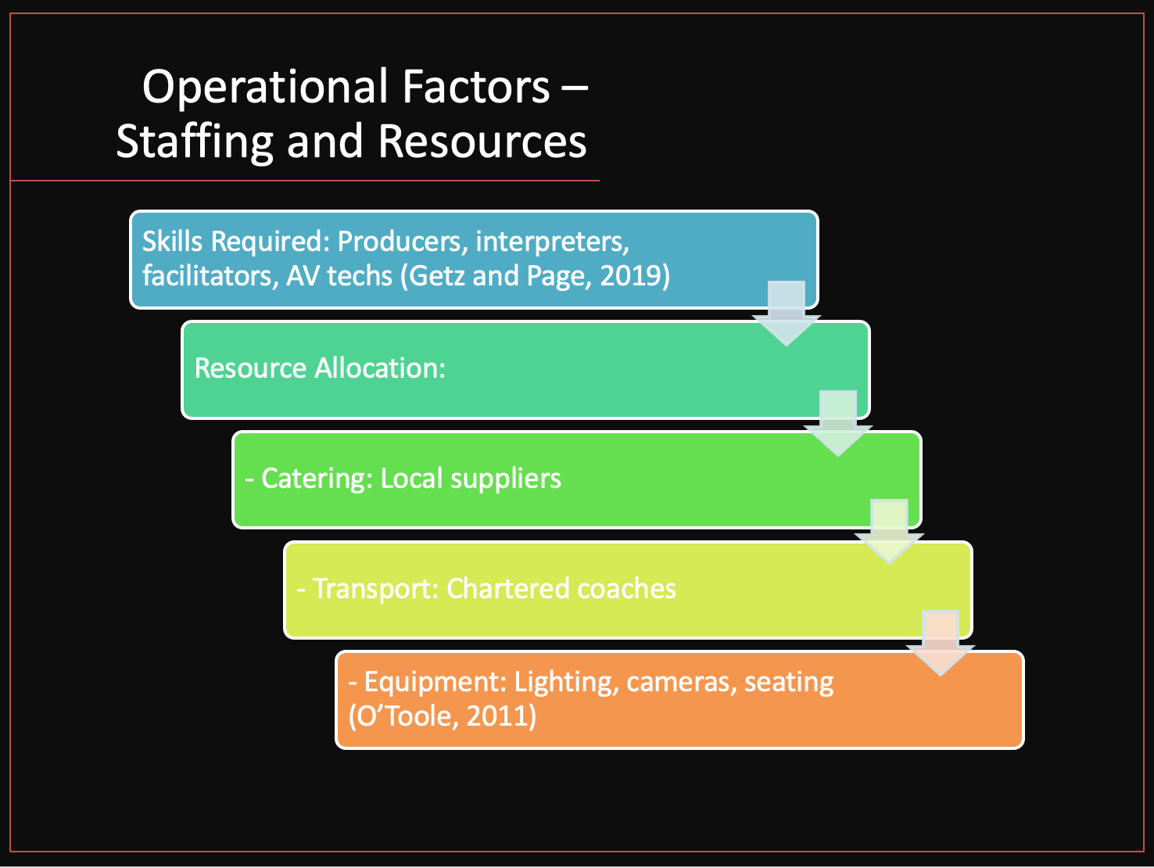
Key staffing roles encompass event producers, heritage interpreters, workshop facilitators, and audiovisual technicians—skills identified as critical for hybrid MICE delivery (Getz and Page, 2019). Resource allocation covers bespoke farm-to-fork catering contracts with local suppliers, emphasizing Welsh artisanal food and drink to reinforce place identity (Haven-Tang and Jones, 2005). Transportation logistics include chartered coaches and designated parking arrangements to ensure seamless delegate mobility between venues and excursion sites. Equipment rentals—such as mobile lighting rigs, streaming cameras, and modular seating—are planned in collaboration with regional suppliers, following guidelines for event feasibility and operational efficiency (O’Toole, 2011).

Slide 9 Speaker Notes
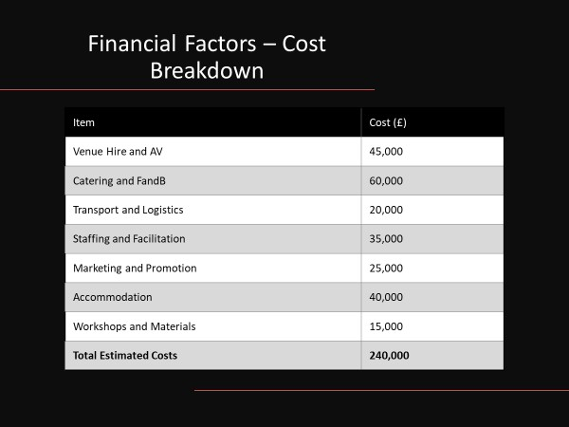
The projected cost breakdown reflects current market benchmarks for UK MICE events, with venue hire and audiovisual equipment comprising the largest expenditure items. Catering and accommodation costs account for premium farm-to-table menus and boutique lodging rates, consistent with the event’s experiential positioning (Grand View Research, 2024). Staffing and facilitation budget refer to honoraria to servants of heritage and workshop leaders while marketing allocations sustain digital advertising and promotional alliances. This fine-grained costing model allows for full financial surveillance, making negotiations with sponsors and grantors easier by means of the transparency of the resource planning.

Slide 10 Speaker Notes
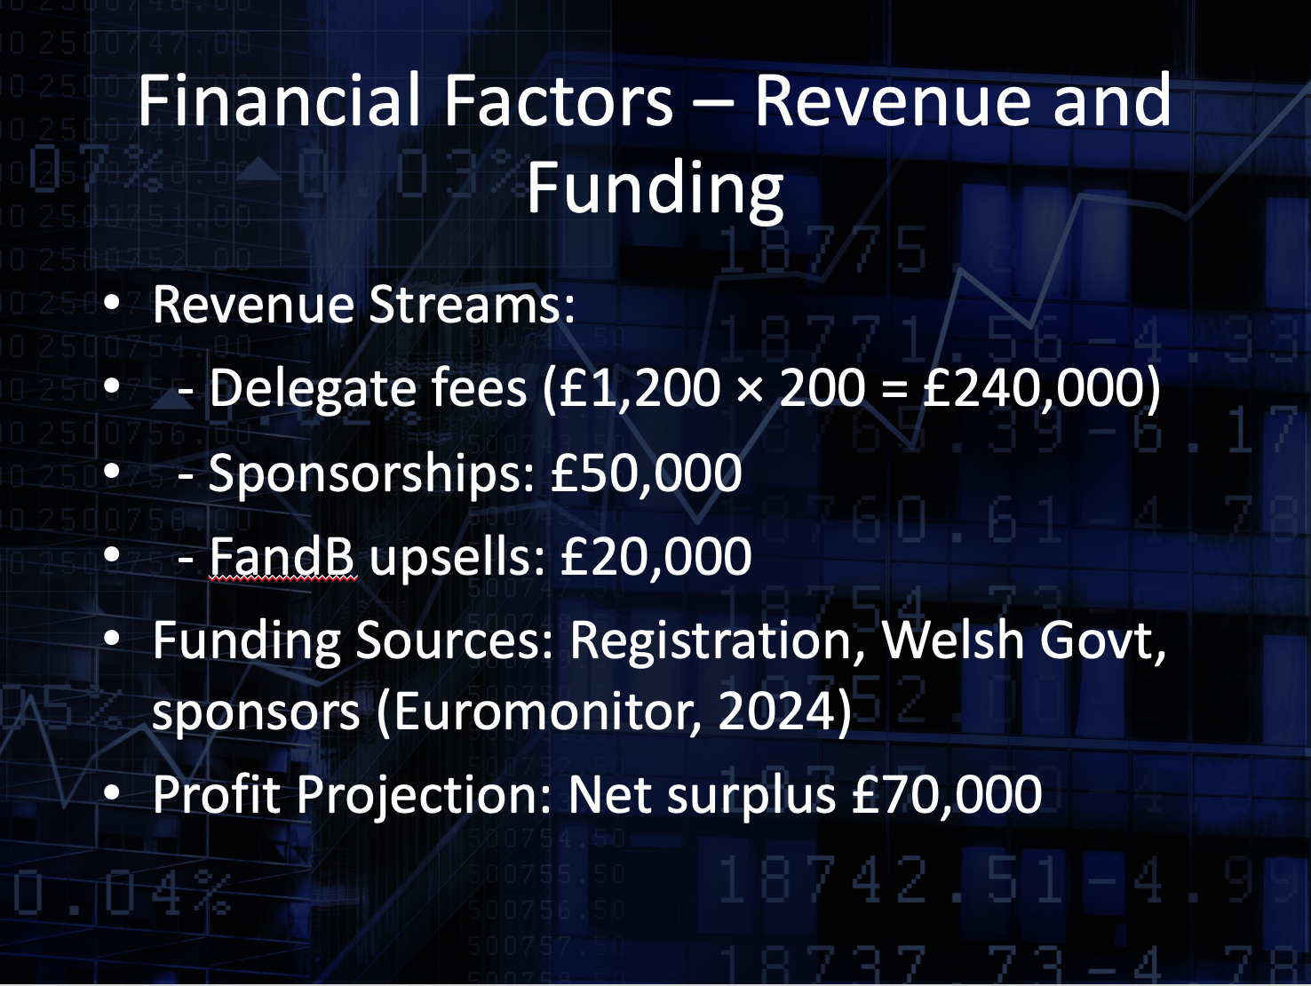
Croeso Cultural Mosaic revenue forecasts are grounded on a stratified delegate’s registration system aimed at achieving maximum attendance incorporating a premium value. Base registration fees are at £1,200 per delegate, with consideration to the all-encompassing conference sessions, designed excursions, and custom hospitality services provided. At the target market of 200 participants, this fee structure is generating an initial revenue of £240,000. This strategy conforms to market standards for the hybrid MICE events in the UK where premium experiential packages attract higher price points and bring a considerable share to the overall revenue (Euromonitor International, 2024). Advance booking commitments and visibility on cash flow of about 6 months for the event will be achieved through early-bird discounts and group booking incentives strategic use. Ancillary revenue streams are an added boost to the financial prospects. Sponsorship packages which are estimated to bring in the firm about £50,000 will also be customised to corporate partners and public bodies that want to gain visibility in the cultural-heritage tourism industry. The possible sponsors are Visit Wales, ICC Wales, and major Welsh artisan producers. Each of the sponsorship tiers will include bespoke branding schemes, such as featuring a logo on gala evenings, sponsoring workshop sessions, and promoting the brand through digital marketing channels of the event. More so, the premium add-on experiences including private heritage tours and gastronomic tastings are expected to generate additional £20,000 based on the assumption that only 25% of the delegates will opt for these exclusive add-ons during registration (The Business Research Company, 2024). Diversification of the funding is further supported by the public grants and funds for cultural tourism development run by the Welsh Government. These grants, which usually vary between £10,000 and £30,000 per project, are designed to help these initiatives that will bring regional heritage and sustainable tourism expansion (Welsh Government, 2024). Applications will highlight the role the event plays in revitalising the local economy, public engagement, and localised Welsh cultural export in external markets. A net surplus of around £ 70,000 will be expected from the combined delegate fees, sponsorship revenue, ancillary sales, and grant funding and this will ensure that the event cover its cost without making losses (The Business Research Company, 2024). This variegated income model reduces risk and serves a sturdy financial foundation to facilitate excellence..

Slide 11 Speaker Notes
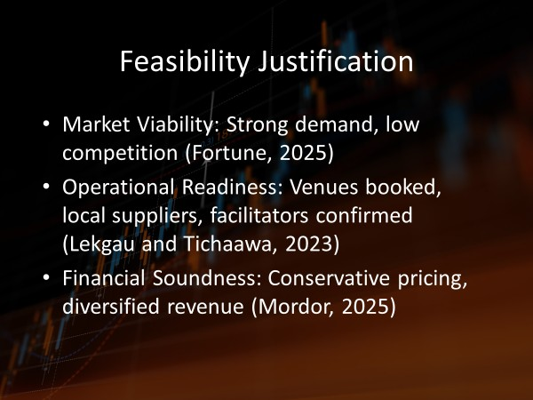
Feasibility is underpinned by strong market indicators—including robust MICE sector growth and positive demand signals—coupled with low regional competition (Fortune Business Insights, 2025). Operational readiness is confirmed through provisional venue bookings, confirmed supplier agreements, and the enlistment of experienced event professionals (Lekgau and Tichaawa, 2023). Financial soundness is demonstrated by conservative pricing strategies, diversified revenue sources, and alignment with public funding priorities. This multi-dimensional feasibility framework ensures that Croeso Cultural Mosaic can be executed with minimal risk while delivering measurable economic and social benefits to host communities (Mordor Intelligence, 2025).

Slide 12 Speaker Notes
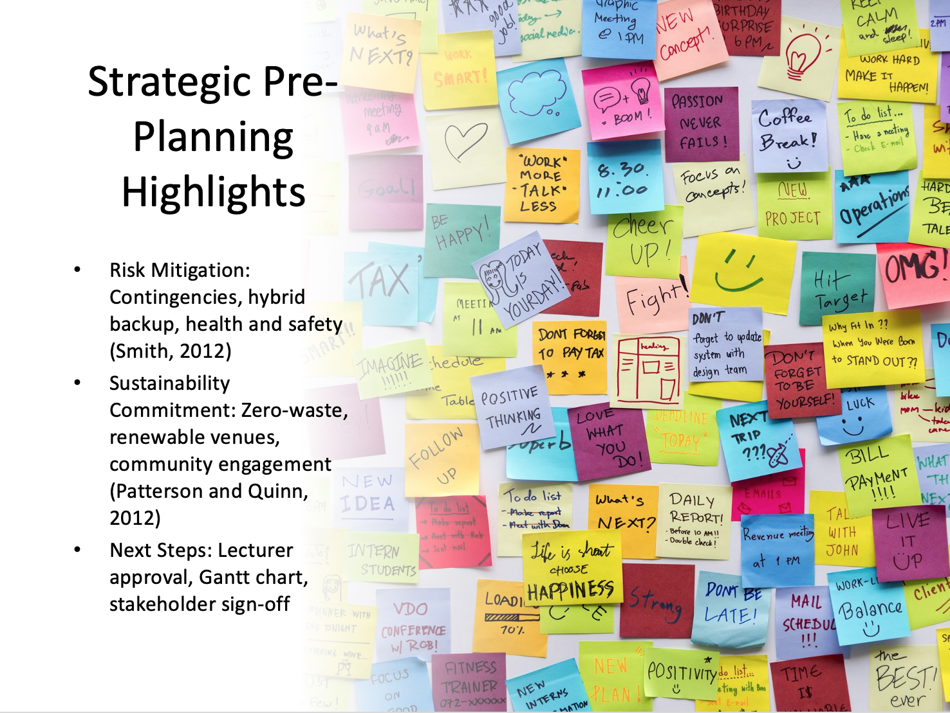
Strategic pre-planning incorporates robust risk mitigation measures, including weather-contingency protocols for outdoor activities and redundant hybrid-stream infrastructure to maintain uninterrupted programming (Smith, 2012). Sustainability commitments focus on zero-waste catering partnerships, renewable-energy venue selection, and community engagement initiatives designed to leave a positive legacy beyond the event footprint (Patterson and Quinn, 2012). Critical next steps involve securing final academic approval, developing a detailed Gantt chart to sequence tasks and milestones, and formalizing stakeholder agreements by the end of Q3 2024. This structured roadmap will guide implementation and ensure alignment with both academic and industry benchmarks.

Slide 13: References
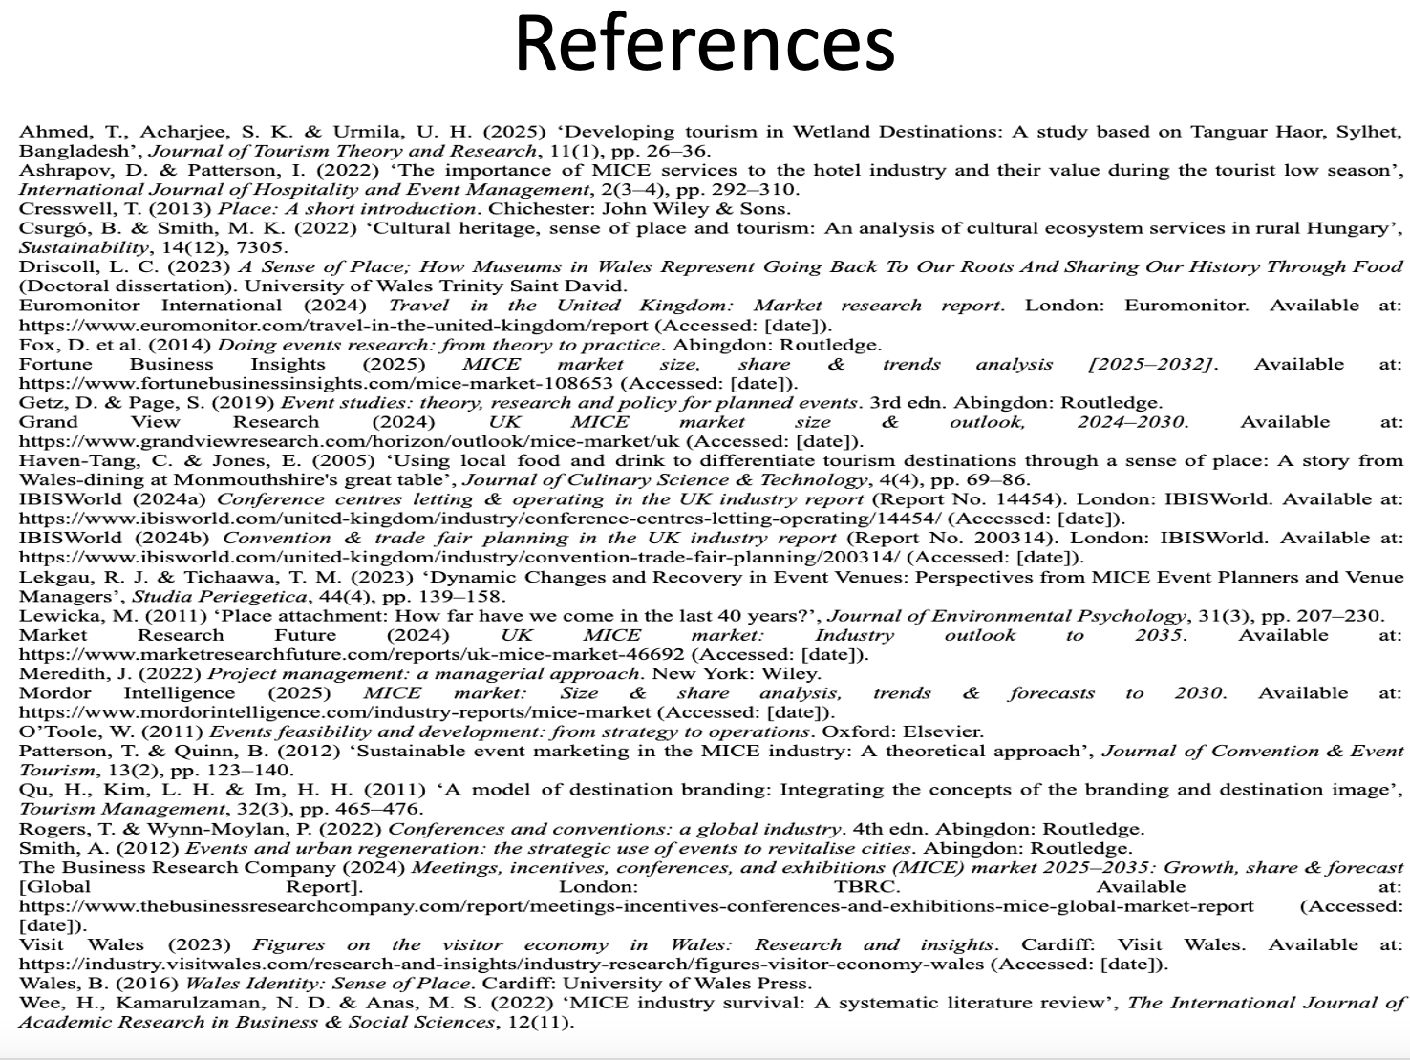
Ahmed, T., Acharjee, S. K. and Urmila, U. H. (2025) ‘Developing tourism in Wetland Destinations: A study based on Tanguar Haor, Sylhet, Bangladesh’, Journal of Tourism Theory and Research, 11(1), pp. 26–36.
Ashrapov, D. and Patterson, I. (2022) ‘The importance of MICE services to the hotel industry and their value during the tourist low season’, International Journal of Hospitality and Event Management, 2(3–4), pp. 292–310.
Cresswell, T. (2013) Place: A short introduction. Chichester: John Wiley and Sons.
Csurgó, B. and Smith, M. K. (2022) ‘Cultural heritage, sense of place and tourism: An analysis of cultural ecosystem services in rural Hungary’, Sustainability, 14(12), 7305.
Driscoll, L. C. (2023) A Sense of Place; How Museums in Wales Represent Going Back To Our Roots And Sharing Our History Through Food (Doctoral dissertation). University of Wales Trinity Saint David.
Euromonitor International (2024) Travel in the United Kingdom: Market research report. London: Euromonitor. Available at: https://www.euromonitor.com/travel-in-the-united-kingdom/report
Fox, D. et al. (2014) Doing events research: from theory to practice. Abingdon: Routledge.
Fortune Business Insights (2025) MICE market size, share and trends analysis [2025–2032]. Available at: https://www.fortunebusinessinsights.com/mice-market-108653
Getz, D. and Page, S. (2019) Event studies: theory, research and policy for planned events. 3rd edn. Abingdon: Routledge.
Grand View Research (2024) UK MICE market size and outlook, 2024–2030. Available at: https://www.grandviewresearch.com/horizon/outlook/mice-market/uk
Haven-Tang, C. and Jones, E. (2005) ‘Using local food and drink to differentiate tourism destinations through a sense of place: A story from Wales-dining at Monmouthshire's great table’, Journal of Culinary Science and Technology, 4(4), pp. 69–86.
IBISWorld (2024a) Conference centres letting and operating in the UK industry report (Report No. 14454). London: IBISWorld. Available at: https://www.ibisworld.com/united-kingdom/industry/conference-centres-letting-operating/14454/
IBISWorld (2024b) Convention and trade fair planning in the UK industry report (Report No. 200314). London: IBISWorld. Available at: https://www.ibisworld.com/united-kingdom/industry/convention-trade-fair-planning/200314/
Lekgau, R. J. and Tichaawa, T. M. (2023) ‘Dynamic Changes and Recovery in Event Venues: Perspectives from MICE Event Planners and Venue Managers’, Studia Periegetica, 44(4), pp. 139–158.
Lewicka, M. (2011) ‘Place attachment: How far have we come in the last 40 years?’, Journal of Environmental Psychology, 31(3), pp. 207–230.
Market Research Future (2024) UK MICE market: Industry outlook to 2035. Available at: https://www.marketresearchfuture.com/reports/uk-mice-market-46692
Meredith, J. (2022) Project management: a managerial approach. New York: Wiley.
Mordor Intelligence (2025) MICE market: Size and share analysis, trends and forecasts to 2030. Available at: https://www.mordorintelligence.com/industry-reports/mice-market
O’Toole, W. (2011) Events feasibility and development: from strategy to operations. Oxford: Elsevier.
Patterson, T. and Quinn, B. (2012) ‘Sustainable event marketing in the MICE industry: A theoretical approach’, Journal of Convention and Event Tourism, 13(2), pp. 123–140.
Qu, H., Kim, L. H. and Im, H. H. (2011) ‘A model of destination branding: Integrating the concepts of the branding and destination image’, Tourism Management, 32(3), pp. 465–476.
Rogers, T. and Wynn-Moylan, P. (2022) Conferences and conventions: a global industry. 4th edn. Abingdon: Routledge.
Smith, A. (2012) Events and urban regeneration: the strategic use of events to revitalise cities. Abingdon: Routledge.
The Business Research Company (2024) Meetings, incentives, conferences, and exhibitions (MICE) market 2025–2035: Growth, share and forecast [Global Report]. London: TBRC. Available at: https://www.thebusinessresearchcompany.com/report/meetings-incentives-conferences-and-exhibitions-mice-global-market-report
Visit Wales (2023) Figures on the visitor economy in Wales: Research and insights. Cardiff: Visit Wales. Available at: https://industry.visitwales.com/research-and-insights/industry-research/figures-visitor-economy-wales
Wales, B. (2016) Wales Identity: Sense of Place. Cardiff: University of Wales Press.
Wee, H., Kamarulzaman, N. D. and Anas, M. S. (2022) ‘MICE industry survival: A systematic literature review’, The International Journal of Academic Research in Business and Social Sciences, 12(11).

