
Programme: MBA - Master of Business Administration
Module: Financial Management
Module Code: LCMB7002
Company: Tesla
Name of the Student: Kharthik Raaja Vadivel Saveetha
Student ID: 2330743

List of Abbreviations
PR: Profitability Ratios
LR: Liquidity Ratios
ER: Efficiency Ratios
GR: Gearing Ratios
NPR: Net Profit Margin
ROCE: Return on capital employed
CR: Current Ratio
QR: Quick Ratio
ATR: Asset Turnover Ratio
ITR: Inventory Turnover Ratio
Table of Contents
Part A). Introduction 5
Company Overview 5
Business Model 5
Marketplace and Key Competitors 6
Recent Events 7
Part B). Financial performance review 7
Critical Evaluation of the Financial Ratios 7
Profitability Ratio 7
Liquidity Ratio 9
Efficiency Ratio 10
Gearing Ratio 11
Comparison to significant competitor(s) 12
Recommendations to improve financial management 18
Part C). Investment appraisal 20
Project A 20
Payback period (PBP) 20
Accounting Rate of Return (ARR) 20
Net Present Value 21
Project B 21
Payback period (PBP) 21
Accounting Rate of Return (ARR) 22
Net Present Value 22
Selection with appropriate reasons 22
Critical discussion on the advantages and shortcomings of the PBP, ARR and NPV techniques 23
Payback Period (PBP) 23
Accounting Rate of Return (ARR) 23
Net Present Value (NPV) 24
Consideration of Non-Financial Factors 24
Conclusion 24
Reference list 26
Appendix 31
Ratio Analysis 31
‌Investment Proposal 33

Part A). Introduction

Company Overview
Tesla In. is an American multinational automobile manufacturer with the main mission of providing clean energy to global automobile consumers (Maradin, Malnar, and Kaštelan, 2022). The company was founded in 2003 by Martin Eberhard and Marc Tarpenning (Bhardwaj et al., 2020). Both of the founding members have served as the CEO and CFO of the company till the year of 2005. In 2005, Elon Musk took over the active roles of the company, but the new owner is not highly involved in its day-to-day operations. The company has started its operations as a premium sports car manufacturer. Later, the company shifted to producing mainstream vehicles such as sedans. On May 10, the Tesla automotors opened its Tesla factory in 2010 with the production of Tesla Model S vehicles.

Figure 1: Tesla’s Logo
(Source: Tesla, 2024)

Business Model
The founders of Tesla have set its vision and mission for commercialising electric vehicles, with the start of its operation on luxury vehicles (Anderson et al., 2022). The vehicles are set for making affordable vehicles in the mass market. The profitability of Tesla mostly comes from selling its EVs and home batters, which Tesla calls Powerwall. The business structure of Tesla has a U form function for its engineering for sales and service. The company also deals in energy generation models to deliver sustainable forms of energy in my cities in the US. The combination of selling sedan-based cars and providing sustainable power plants.

Marketplace and Key Competitors
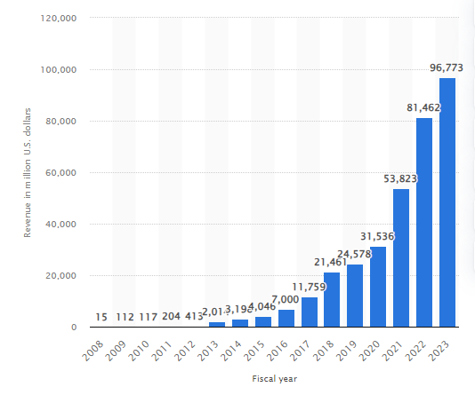
Figure 2: Tesla’s Yearly Revenue
(Source: Statista, 2024)
Tesla's marketplace is available in the western urban areas to run its advanced vehicles and energy supplies. In Western countries, Tesla will make a profit of about 96 billion dollars in 2023 (Statista, 2024). Tesla's automotive segment induces the design, manufacturing sales and service. On the contrary, the key competitors of Tesla are General Motors, Ford Motors, BMW< Toyota, and Volkswagen. All of these competitors have a great presence in the automotive sector. After the covid 19 lockdown, the rivals of Tesla have improved their operation in the development of their electric vehicles. These global changes in the automotive industry can set a challenging situation for Tesla Inc. in its automotive business. However, a good sales effort for Tesla can lead to improving its car sales and customer loyalty for a longer period.

Recent Events
On 23rd April 2024, Tesla introduced its new model named Tesla Model 3 (Tesla, 2019). The features of the Tesla Model 3 leverage the hardware improvements of its chassis hardware that deliver performance. Along with improving the reduction of mass, including adaptive dampers with damper pistons, stabiliser bars, strength steel springs, and stiffer suspension top mounts. With these updates, the Tesla group has improved its Tesla Model 3 car. Additionally, Tesla has started using its in-house lithium refinery, located in the Corpus Christi area of Texas.

Part B). Financial performance review

Critical Evaluation of the Financial Ratios

Profitability Ratio
The PR is one of the significant measuring tools which provides opportunities for the organisation to evaluate the company's performance in the market. By using this ratio investors can compare the performance of Tesla with the different competitors. The Organisation can introduce multiple business expansion strategies by utilising the ratio (Husain and Sunardi, 2020). The stakeholders can analyse the capability of the management to generate profit and manage the overall cost of the operations by using this ratio.
The NPR is the most important ratio for Tesla for determining the actual profit of the business in the market. The company's ratio is gradually improving, a positive sign for the business (Nariswari and Nugraha, 2020). In 2019, Tesla witnessed a loss of 3.54%. The increasing demand for electric vehicles is the primary reason behind increasing revenue and profit. Currently, the Governments of different countries are influencing sustainability, which provides multiple opportunities to the Tesla company.
However, the organisation's income is increasing rapidly and positively impacting the profit. In 2021, the profit of the organisation was 10.26%. In 2023, the profit of the Tesla company was 15.47% (Wsj, 2024). So, the organisation is closely focusing on improving the organisation's performance and marketing. The Organisation is attracting different customers through which the overall profit and revenue have been enhanced.
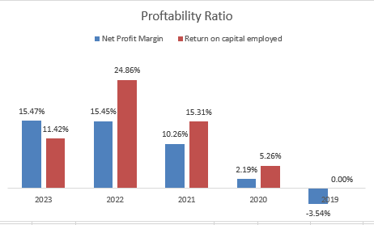
Figure 3: Profitability Ratio
(Source: Self-developed)
The ROCE is also a practical financial metric which provides the opportunity to understand the capital efficiency in the market. Using the stakeholders, Tesla can develop knowledge about the capability of the management to utilise the capital to generate profit. The ratio provides an in-depth understanding of how effectively the organisation uses capital in different areas (Maeenuddina et al., 2020).
In 2020, the ratio of Tesla was 5.26%. In the following years, the ratio is gradually increasing. In 2022, the company's ratio was 24.86%, which is an excellent sign in this current market condition. The primary reason for increasing this ratio is that the company's profit has improved by almost 50% (Wsj, 2024). So, the management has introduced multiple new strategies for enhancing the company's profit. However, in 2023, the ratio declined to 11.42%. The company has to focus on improving this ratio to generate more capital from the investment.

Liquidity Ratio
The LR is also a critical financial metric that provides the opportunity to understand the capability to pay short-term debt in time. The creditors can realise the ability to free the date by analysing this ratio (Markonah et al., 2020). A good liquidity position provides an opportunity for collecting the debt from the market and utilising it to improve the business performance. The ratio also develops a compelling scenario regarding the business's financial stability. The automobile industry is very competitive and the liquidity ratio has maintained a crucial role in raising the depth of the capital structure.
The CR is an essential part of this ratio, which is necessary for managing the company's ability to repay debt. The ratio is the competition between the current assets and the current liability of Tesla. The stakeholders can understand the operating cycle of the business and the credit status by implementing this ratio (Mulyadi and Sinaga, 2020). The investors are also utilising this ratio but developing multiple decisions regarding the investment. In 2019, the ratio of Tesla was 1.134. In the following year, the ratio improved to 1.8. In 2024, the ratio of the organisation was 1.72. The CR ratio of the company is excellent compared to the industrial standard.
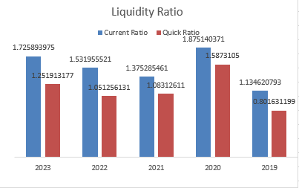
Figure 4: Liquidity Ratio
(Source: Self-developed)
The QR is also a critical ratio that provides an opportunity to understand how quickly the company uses the liquid asset to pay the debt. The 2012 ratio of the Tesla company was 0.80. the effective performance for improving this ratio in 2023 to 1.25 (Wsj, 2024).

Efficiency Ratio
The ER is also a significant financial metric which can provide the opportunity to understand the ability of the organisation to manage its operations. The ratio is the critical indicator which provides the opportunity for analysing financial health and management efficiency (Iqbal and Anwar, 2022).
The ATR is a significant part of this ratio for recognising how effectively the company uses this asset to generate revenue. So, the ratio is a competition between the net sales and the company's assets (Patin et al., 2020). In 2019, the ratio of the organisation was 0.71 (Wsj, 2024). In 2022, the ratio improved to 0.98, and in the next year, the ratio declined to 0.90. The primary design behind the decline is that the sales did not increase like the company's assets.
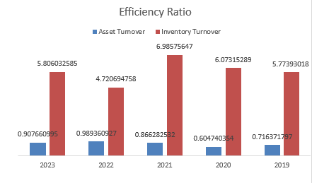
Figure 5: Efficiency Ratio
(Source: Self-developed)
The ITR is an integral part through which the inventory management capability can be understood. Implementing this ratio can evaluate the flow of the organisation's sales. The organisation can introduce this ratio to improve the inventory management capability and development decisions (Herison et al., 2022). In 2020, Tesla's Ratio was 6.07. In the last year, the ratio of the organisation reduced to 5.80. The company has to sell more products to improve this ratio.

Gearing Ratio
The GR develops the picture regarding a company's financial stability and health in the automobile industry. The investors understand the risk of the investment by utilising this ratio. The ratio provides a clear picture of the company's capital structure (AvaTrade, 2022).
Debt-to-equity is very effective for comparing the equity and the debt in the organisation's capital structure. The risk in the capital structure can be evaluated very quickly by implementing this ratio. The ratio of Tesla in 2016 was 3.23. the ratio of the company declined heavily, and in 2023, that ratio was 0.67. So, it is a convenient sign for the company as Tesla reduces the date in the capital structure and the risk also. The management has gradually focused on raising the capital from the equity (Desmon and Meirinaldi, 2022). The organisation has successfully attracted multiple investors, which has created a positive effect on the capital structure.
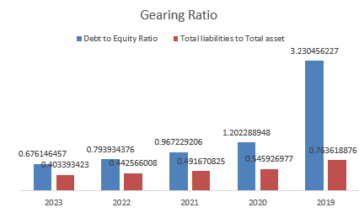
Figure 6: Gearing Ratio
(Source: Self-developed)
The leverage condition of Tesla can be evaluated by calculating the total liabilities to assets ratio. The ratio is a competition between the assets and liabilities of the company in a financial year. In 2019, the ratio was 0.76 (Wsj, 2024). Tesla is rapidly increasing its assets every year, which has developed the effects of reducing this ratio and providing strong financial stability. In the last year, the ratio was reduced to 0.40. So, the CEO of Tesla focuses on improving the total assets every year.

Comparison to significant competitor(s)
Profitability Ratios
According to the “Net Profit Margin”, the performance of Tesla has continuously improved over the last five years. In 2019, the company had a ratio of (3.54%) which increased to 2.19% in 2020. Again in 2021, the company has made a vast improvement, represented by a ratio of 10.26% (Wsj, 2024). In 2022, the ratio increased to 15.45%. However, the following year, the company failed to maintain the exact increase, and its ratio got stuck at 15.47%.
In comparison, the performance of one of its competitors, Toyota, presents areas of improvement. In 2019, the company had a ratio of 6.23%, which slightly increased to 6.82% in 2020 and 8.25% in 2021 (Wsj, 2024). Despite a further increase to 9.08% in 2022, Toyota has experienced a decline in ratio to 6.60% in 2023, representing a negative attribute. So, compared with Tesla, Toyota needs to focus on increasing its ratio to maintain competitiveness.
Similarly, Volkswagen is another competitor of Tesla but has not maintained the same ratio over the last five years (Volkswagen Group, 2024). Even Volkswagen's ratio is lower than Toyota's. From 2019 to 2023, Volkswagen's ratio has witnessed a significant fluctuation. From 2019 to 2020, the ratio has declined from 5.28% to 3.74%. However, in 2021, the ratio increased to 5.93% but again declined to 5.33% in 2022 and 4.97% in 2023.
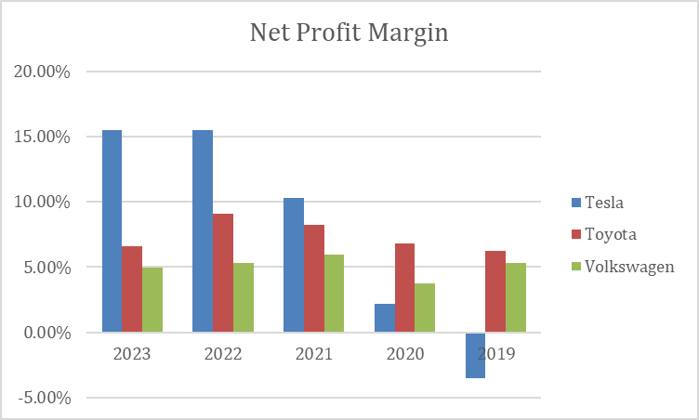
Figure 7: Net Profit Margin of Tesla, Toyota and Volkswagen
(Source: Self-Developed)
According to the “ROCE”, Tesla also significantly improved until 2022. However, the company has experienced a sharp decline in recent years, impacting its financial performance. In 2019, they were at 0%, while they increased to 5.26% in 2020 (Wsj, 2024). Again, in 2021, the company experienced a sharp increase, represented by a ratio of 15.31%. The same increase continued in 2022, a ratio of 24.86%. However, in 2023, the ratio heavily declined to 11.42%.
In comparison, Toyota has experienced a sharp decline in the ratio from 2019 to 2023. In 2019, the ratio was 7.27%, reaching 5.41% after several fluctuations over the last five years (Toyota Industries, 2023). Even Volkswagen has experienced a lower financial performance than Tesla. However, Volkswagen has represented a better performance than Toyota but failed to match it with Tesla. In 2019, the ratio of 5.25% will become 5.09% after several fluctuations in 2023.
So, the overall comparison concludes that the profitability status of Tesla is better than Toyota and Volkswagen, represented by both the Net Profit Margin and ROCE.
Liquidity Ratios
According to the “Current Ratio”, Tesla's performance has improved in the last five years. In 2019, the ratio was 1.13, which drastically increased to 1.87 in 2020 (Wsj, 2024). However, Tesla experienced a sharp fall in 2021, but in the two subsequent years, they have improved their performance, represented by the ratios of 1.53 and 1.72 in 2022 and 2023, respectively.
In comparison, Toyota's performance is still lower than Tesla's. In 2019, the ratio was 1.03, slightly increasing to 1.04 in 2020 and 1.06 in 2021. In the two consecutive years of 2022 and 2023, the ratio increased at the same level and became 1.08 and 1.10 (Wsj, 2024). So, compared with Tesla, Toyota needs to improve its liquidity performance. The performance of Volkswagen is also present in the study to maintain competitiveness. In the last five years, the ratio has increased from 1.15 to 1.19 despite a significant increase till 2022.
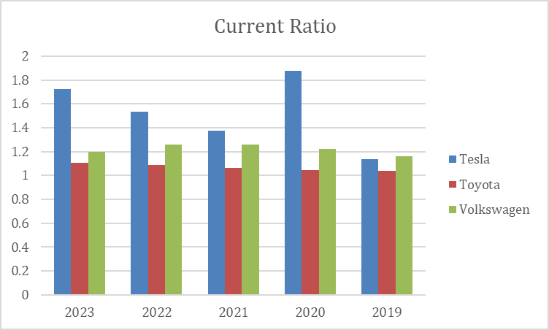
Figure 8: Current Ratio of Tesla, Toyota and Volkswagen
(Source: Self-Developed)
According to the “Quick Ratio,” a similar situation has been witnessed in Tesla. In 2019, the ratio was 0.80, which again experienced a boost in 2020 due to the ratio of 1.58 (Wsj, 2024). However, in 2021, the ratio declined to 1.08; in 2022, it again fell to 1.05. However, the ratio will increase to 1.25 in 2023.
In contrast, Toyota's ratio has slightly increased. In 2019, it was 0.89, rising to 0.90 and 0.92 in 2020 and 2021. Despite a slight decline in 2022 to 0.91, Toyota experienced a slide increase to 0.92 in 2023. So, in comparison with Tesla, Toyota is in a lower position and needs to improve its ratio. Similarly, the comparison with Volkswagen represents a similar status as Toyota. From 2019 to 20123 the ratio has shifted from 0.8 to 0.93 (Wsj, 2024). However, between the five years the ratio has significantly fluctuated. Volkswagen has seen to maintain the same level of liquidity in terms of the ratio. Even in comparison with Tesla, Toyota and Volkswagen have failed to maintain the same level of competitiveness.
From the above comparison of the three companies based on the significant ratios under the liquidity ratio, it has been observed that Toyota and Volkswagen need to focus on their assets and liabilities to improve their liquidity position and maintain their competitiveness with Tesla.
Efficiency Ratios
Based on the “Asset Turnover Ratio”, an increase has been witnessed in the ratios over the last five years in Tesla. For example, in 2019 the ratio was 0.71, which declined to 0.60 in 2020. Again, in 2021 and 2022, the increase to 0.86 and 0.98 is impressive for Tesla. However, Tesla has failed to maintain its position in 2023, as the ratio has declined to 0.90.
Compared with Toyota, the ratio declined from 0.58 to 0.50 from 2019 to 2023. In Contrast, Tesla's ratio has increased in the past five years. However, the opposite scenario is witnessed in Toyota. Despite several declines from 2019 to 2021, the ratio increased in 2023 (Wsj, 2024). In 2019, the ratio was 0.58, which declined to 0.55 in 2020 and 0.43 in 2021. Again, in 2022 and 2023, the increase has been witnessed.
Volkswagen's ratio has increased from 0.48 to 0.51 within five years. For example, in 2019, the ratio was 0.48, which became 0.42 in 2020 and 0.44 in 2021 (Wsj, 2024). After several fluctuations, the ratio recently stands at 0.51, representing a significant improvement from Volkswagen, but the company needs to focus on the multiple fluctuations.
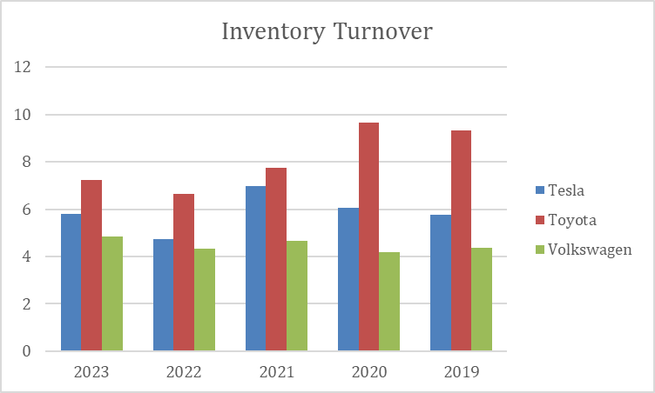
Figure 9: Inventory Turnover of Tesla, Toyota and Volkswagen
(Source: Self-Developed)
Again, the “Inventory Turnover Ratio” represents Tesla's efficiency. According to the ratio, the company has been in a similar position from 2019 to 2023. For example, in 2019, the ratio was 5.77, which increased to 6.07 in 2020. The exact ratio increased to 6.98 in 2021 (Wsj, 2024). However, in 2020, the ratio declined to 4.72. Again, in 2023, the ratio increased to 5.80.
In comparison, Toyota has experienced a decline. From 9.33, the ratio became 7.24 within five years. However, in 2022, the ratio increased, but after that, significant modifications took place at Toyota. In comparison with Tesla, the ratio of Toyota is better. In this case, Toyota has a better proposition than Tesla, and Tesla needs to work on their inventory management. In Volkswagen, the ratio is similar to Tesla. In Volkswagen, the ratio was 4.34 in 2019, declining to 4.19 in 2020. Despite an increase in 2021, the company experienced a decline in the ratio in 2022. In 2023, the ratio stands at 4.85 (Wsj, 2024). So, in comparison with Tesla, Volkswagen has a similar situation regarding its inventory management.
So, the efficiency ratio analysis concludes that both Toyota and Volkswagen are competitors of Tesla in the automotive industry. However, according to the ratios, Tesla is still leading these two companies.
Gearing Ratios
The “Debt to Equity Ratio” compares the performance of the three automotive companies in the last five years. In 2019, Tesla's ratio was 3.23, which heavily declined to 1.20 in 2020 (Wsj, 2024). Again, the decline was maintained in the previous three years, 2021, 2022, and 2023. Presently, the ratio stands at 0.67, compared with 3.23 in 2019.
In contrast, Toyota's ratio represents a flight increase from 1.52 to 1.53 from 2019 to 2020. Despite a slight dip in 2022, the ratio needs to improve. Finally, compared with Volkswagen, the ratio is higher than Toyota and Tesla's (Wsj, 2024). In Volkswagen, the ratio was 3.66 in 29, slightly increasing to 3.67 in 2020. However, the ratio started to decline after 2020, and it became 2.60 in 2023. Volkswagen is present in a tough competition between the two companies.
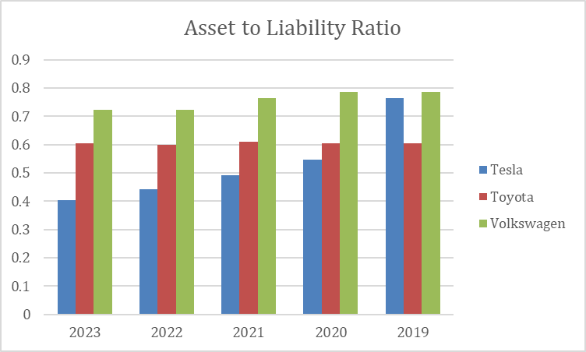
Figure 10: Asset to Liability Ratio of Tesla, Toyota and Volkswagen
(Source: Self-Developed)
The “Asset to Liability Ratio” represents the competitiveness between the three companies in the automotive sector. In 2019, Tesla witnessed an increase of 0.76, which declined to 20.54 and 0.49 in 2020 and 2021. In the two consecutive years, 2022 and 2023, the decline remained, represented by the figures 0.44 and 0.40 (Wsj, 2024). So, over the last five years, Tesla has experienced a declining ratio, demonstrating a negative aspect.
In comparison, Toyota's ratio has remained similar over the last five years. The changes in the ratio have not impacted the organisation, and it should focus on improving the ratio not only to maintain the competitive landscape in the automotive industry but also to remain a profitable and efficient business. Lastly, Volkswagen's ratio declined from 0.78 to 0.72 (Wsj, 2024). Within the last five years, a decline has been witnessed in Volkswagen.
The three companies are in a competitive landscape based on the gearing ratio. However, Toyota still lags in this competitive landscape.

Recommendations to improve financial management
Improving financial Management for the organisation is directly associated with addressing fundamental issues highlighted in the ratio analysis and the company balance sheet. Here in the following section, possible recommendations on how it could enhance its financial management have been presented.
Enhancing profitability
Increase gross profit margin: The organisation should focus on reducing its cost of goods sold relative to its revenue. This process could be achieved through better supply chain management optimisation and maintaining structural negotiation between different suppliers for profound manufacturing process optimisation.
Boosting return on capital employed: Despite having a profound margin of return on capital employed, it has been indicated that over recent years, it needs improvement and sustainability towards efficient asset utilisation (Kim, Fallov and Groom, 2020). To do so, the company should acknowledge continuous investment into high-return projects by closely monitoring the overall capital allocation to maximise the margin of business profitability.
Improving liquidity:
Modifying current and quick ratio: It has been acknowledged that it should acknowledge a liquidity ratio with reasonable short-term solvency so that greater management of the higher ratio can be enhanced for flexible financial conditions. This should be achieved by maintaining a business capital structure and working capital to maintain sufficient cash reserves.
Enhancing Efficiency:
Increase Asset Turnover: Considering the calculated ratio analysis, it has been found that the asset turnover ratio has experienced profound fluctuation after completion. To improve it, it is essential to optimise the organisation's inventory turnover acceleration and efficiency in the production process. This is considered necessary for reducing idle inventory and focusing on cash flow improvements.
Optimise Inventory Management: Despite having a reasonable margin of inventory turnover ratio, should acknowledge streamlining the inventory level to reduce the holding cost and enhance the company's liquidity.
Managing Gearing and Financial Structure:
Reduce Debt to Equity Ratio: should focus on reducing its business Reliance on debt financing. This process directly integrates with refinancing high-cost debt, increasing equity throughout profitable business operations to issue equity capital.
Maintain Optimal Debt Levels: Debt can benefit business growth, but needs to ensure that the organisation's debt-to-asset ratio becomes manageable to mitigate radical financial risk.
Strategic Recommendations:
It has been recommended that the organisation prioritise growth measures with a long-term vision in alignment with market demand so that business expansion into new product offerings and foreign markets can be acknowledged with the help of leveraged innovative technology and Research and Development (Nukala and Prasada Rao, 2021).
- Financial transparency and reporting should be enhanced so that investor confidence can be improved by attracting additional capital. The brand needs to acknowledge clear communication about financial risk performance and operation strategies to attract capital to invest in risk management effectively.
- Considering the prospect of market volatility, it should be acknowledged with a management framework incorporating commodity price risk, hedging, and currency fluctuation risk exposure associated with geopolitical uncertainties.
- In addition, robust corporate governance practices must be contained within the company, followed by ethical conduct, accountability and effective oversight. In this context, we should continue improving the governance framework to acknowledge regulatory requirements appropriately.

Part C). Investment appraisal

Project A

Payback period (PBP)
The payback period is a financial metric that should be utilised for timely evaluation to distinguish how long it will take for complete investment recovery based on the initial cost. In the case of project, A, the margin of payback period is considered to be calculated as 2.18 years (Locatelli, Mancini and Lotti, 2020). The complete calculation involves dividing the overall initial investment of the project, which is 80 pounds million, by the annual cash flow until the valuation of cumulative cash flow turns positive. (Refer to appendix)
The shorter payback period is considered to emphasise that project A directly indicates a Quicker margin of recovery in terms of investment and a lower margin of risk associated with this project's cash flow. It is recommended that the organisation obtain the means to get rapid liquidity alongside a reduced margin of uncertainty exposure over a short time.

Accounting Rate of Return (ARR)
The accounting rate of return directly measures the level of average annual profit that can be generated by the company's investment as a percentage of the initial investment. It can be calculated by dividing the average annual profit by the average investment associated with 100% multiplication (Magni and Marchioni, 2020). Considering Project, A, the value of the ARR has been estimated at 14.06%. (Refer to appendix)
The estimation indicates that considering Project A's lifespan, it can potentially expect to earn an annual average return of around 14.06% on the initial investment of 80 million. The accounting rate of return is deemed beneficial as it helps assess the profitability of the project investment in relation to the cost to acknowledge financial liability based on different project potential returns.

Net Present Value
The investment appraisal technique of net present value directly calculates the future cash inflow present value, considering the generation from investment and discounting it at a specific rate, which is acknowledged from the cost of capital or sometimes the required rate of return (Alkaraan, 2020). Net present value is considered to be essential to determine whether the chosen investment will add value to the organisation or not. (refer to appendix)
Considering project, A, it has been identified that with a discount rate of 10%, the NPV estimation is 16.57 million. The positive net present value directly suggests that the chosen project proposal has high expectations to generate a high margin of return in terms of the discount rate. Hence, it is evident that this project will be of value to the organisation, considering the time value for money, providing a clear indication that the investment in this project will be worthwhile.

Project B

Payback period (PBP)
Considering project B, the payback period is calculated to be three years. Considering the calculation of the project's initial investment division with the annual cash flow that is 75 million pounds and till the valuation of cumulative cash flow becomes positive, it has been identified that the project has an extended margin of payback period. The long period of 3 years directly suggests that there will be a slower recovery of the interior initial investment of 75 million pounds which causes a high rest associated with the project cash flow. Considering the possible implications of tying up business capital with long-term projects is essential before getting any positive return.

Accounting Rate of Return (ARR)
For Project B, the ARR is 11.67%, calculated from the initial investment as a percentage associated with average annual profit but generated with a suitable accounting rate of return (Grzeszczyk and Waszkiewicz, 2020). The calculation indicates that the organisation can expect an average yearly return of 11.67%, considering the initial investment done on the project is around 75 million pounds over the project lifespan. This estimation is beneficial as it is helpful for company profitability decision-making in terms of investment and the cost to stay aware of the potential returns.

Net Present Value
For Project B, with a discount rate of 10%, the NPV is 16.08 million pounds. Focusing on the calculator present of positive net present value, it has been suggested that the project also has the potential to generate a return higher than the overall discount rate. It outlines what brand can add value to the project by investing in Project B and Project A, considering the prospect of the time value of money to determine whether the investment is worth it.

Selection with appropriate reasons
Project A represents a compelling financial matrix as a matter of representing the preferred choice for the company. With a shorter payback period of 2.18 years, going with a higher recovery initial investment of 18 million is much quicker than project B, which is considered to have a long-term payback period of 3 years (Shahriar, 2021). Due to the short time frame for project A and the chance of getting higher liquidity associated with reducing the risk associated with a prolonged margin of organisation capital commitment, project A is considered much more suitable.
Considering the accounting rate of return, project A's ARR value is 14.06%, which outlines a substantial profitability margin and Organisational annual return on the initial investment. The estimated figure directly surpassed the ARR value of Project B, which emphasises that Project A has more significant potential in terms of generating higher average annual profit. (Refer to appendix)
In addition, the net present value for project A is considered to be 16.57 million, which indicates a discount rate of 10% to confirm that project A has the potential to provide substantial value to the brand by generating a return that directly exceeds the cost of capital. The positive value of net present value directly represents the viability and enhancement of shareholder wealth.

Critical discussion on the advantages and shortcomings of the PBP, ARR and NPV techniques
Capital budgeting techniques are identified as valuable for business organisations in terms of evaluating and appropriate selection of investment projects. Each investment-applicable technique has unique exposure as being advantageous. On the other hand, shortcomings relating to financial liability and project potential are associated with considering non-financial factors.

Payback Period (PBP)
Advantages: The payback Period (PBP) is a transparent and easy-to-understand process of capital budgeting as it provides a clear indication about the initial investment recovery time period. The tool is highly appealing to the business organisation due to its concern for organisation liquidity and risk (Chrysalis and Papadopoulos, 2020). The payback period is beneficial because it favours the project in terms of quick investment return so that the company can give priority to short-term investment, focusing on reducing the liquidity risk exposure.
Shortcomings: One of the most essential shortcomings of the payback period tool is that it does not consider the time value of money and outlines resistance to evaluating cash flow beyond the payback period. These are significant limitations that could be improved for the organisation's Outlook towards investment profitability beyond the initial investment to the recovery period. The main reason is that considering the payback period, there is a chance to get negative cash flow after the payback lifespan, which could cause long-term profitability issues for the brand.

Accounting Rate of Return (ARR)
Advantages: Computing the accounting rate of return is extremely easy when computing the percentage return based on the average investment made. It emphasises organisation profitability by outlying the project on earnings (Lai and Locatelli, 2021). The accounting rate of return directly complements the financial metric by highlighting performance evaluation.
Shortcomings: The accounting rate of return directly overlooks cash flow timing along with the time value of money, which is beneficial for the project to estimate a shorter duration for long-term profitability. However, the estimation of the accounting rate of return could be misleading for the project and cause cash flow disparities.

Net Present Value (NPV)
Advantages: One of the most essential advantages of net present value is its strategic consideration of the time value of money preference, discounting future cash flow. Measuring the organisation's project profitability is beneficial by successfully comparing outflow and inflow (Siziba and Hall, 2021). Facilitating an optimal decision-making process generates a clear indication of business value creation.
Shortcomings: Net present value directly depends upon the discount rate assumption, which can impact project evaluation. The high margin of sensitivity towards discount wait can impact misleading investment decision-making. Another potential shortcoming is that net present value requires an accurate margin of cash flow projection as it is often susceptible towards forecasting error.

Consideration of Non-Financial Factors
Decisions regarding capital budgeting are heavily influenced by non-financial factors, which impact project viability, strategic alignment, and stakeholder interests. Financial metrics should be evaluated alongside environmental impact, regulatory compliance, technological advancement, and organisational capabilities (Baum, Crosby and Devaney, 2021). A project's long-term viability and stakeholder relations may be harmed by regulatory obstacles or a lack of alignment with corporate sustainability goals despite having positive financial metrics.

Conclusion
It is concluded that the investment appraisal technique of net present value directly calculates the future cash inflow present value, considering the generation from investment and discounting it at a specific rate, which is acknowledged from the cost of capital or sometimes the required rate of return. Net present value is considered to be essential to determine whether the chosen investment is going to add value to the organisation or not.

Reference list
Alkaraan, F. (2020). Strategic investment decision-making practices in large manufacturing companies: a role for emergent analysis techniques?. Meditari Accountancy Research, 28(4), 633-653.https://repository.lincoln.ac.uk/articles/journal_contribution/Strategic_investment_decision-making_practices_in_large_UK_manufacturing_companies_a_role_for_emergent_analysis_techniques/24383224/2/files/42954946.pdf
Anderson, E.G., Bhargava, H.K., Boehm, J. and Parker, G., 2022. Electric vehicles are a platform business: What firms need to know. California Management Review, 64(4), pp.135-154. https://journals.sagepub.com/doi/pdf/10.1177/00081256221107420
AvaTrade. (2022). Gearing Ratio Explained | AvaTrade. [online] Available at: https://www.avatrade.com/education/market-terms/gearing-ratio [Accessed 11 July. 2024].
Baum, A. E., Crosby, N., and Devaney, S. (2021). Property investment appraisal. John Wiley and Sons.https://books.google.com/books?hl=en&lr=&id=4-ASEAAAQBAJ&oi=fnd&pg=PP1&dq=investment+appraisal+techniques&ots=GMTt_snXjL&sig=XDWFPBY5_tGkq9ne-zfxjAzkRzU
Bhardwaj, S., Pandey, R., Sharma, S., Sejal, S., Iyer, G., Sharma, S., Ranjith, P.V. and Kulkarni, S., 2020. Problems faced by automobile industries: Case study on Tesla. International journal of Tourism and hospitality in Asia Pasific (IJTHAP), 3(2), pp.78-88. https://www.ejournal.aibpmjournals.com/index.php/IJTHAP/article/viewFile/825/787
Chrysafis, K. A., and Papadopoulos, B. K. (2020). Decision making for project appraisal in uncertain environments: A fuzzy-possibilistic approach of the expanded NPV method. Symmetry, 13(1), 27.https://www.mdpi.com/2073-8994/13/1/27/pdf
Desmon, A. R. W. A., and Meirinaldi, Y. C. (2022, January). The Effect of Return on Asset, Return on Equity and Debt to Equity Ratio on the Value of the Manufacturing Firm Listed on Stock Exchange 2015-2019. In MIC 2021: Proceedings of the First Multidiscipline International Conference, MIC 2021, October 30 2021, Jakarta, Indonesia (Vol. 196). European Alliance for Innovation.https://eudl.eu/pdf/10.4108/eai.30-10-2021.2315839
Grzeszczyk, T. A., and Waszkiewicz, M. (2020). Sustainable investment project evaluation. Entrepreneurship and sustainability issues, 7(3).https://repo.pw.edu.pl/docstore/download/WUTc8977461e7804c31a12d9d9deb114c30/Sustainable_Investment_Project_Evaluation.pdf
Herison, R., Sahabuddin, R., Azis, M., and Azis, F. (2022). The effect of working capital turnover, accounts receivable turnover and inventory turnover on profitability levels on the Indonesia Stock Exchange 2015-2019. Psychology And Education, 59(1).https://eprints.unm.ac.id/30153/1/The_Effect_of_Working_Capital_Turnover_A.pdf
Husain, T., and Sunardi, N. (2020). Firm's Value Prediction Based on Profitability Ratios and Dividend Policy. Finance and Economics Review, 2(2), 13-26.http://www.riiopenjournals.com/index.php/finance-economics-review/article/download/102/53
Iqbal, M., and Anwar, S. (2022). Pengaruh Capital Adequacy Ratio, Non Performing Financing, Financing to Deposit Ratio, Operational Efficiency Ratio, dan Profit Sharing Ratio Terhadap Kinerja Keuangan Bank Umum Syariah. Jurnal Revenue: Jurnal Ilmiah Akuntansi, 2(2), 259-270.https://revenue.lppmbinabangsa.id/index.php/home/article/download/69/169
Kim, J. H., Fallov, J. A., and Groom, S. (2020). Public investment management reference guide. World Bank Publications.https://books.google.com/books?hl=en&lr=&id=Jg7UDwAAQBAJ&oi=fnd&pg=PP1&dq=investment+appraisal+techniques&ots=o5Cc4vo25x&sig=oimKiuJDvE7OC56z7othyGFo85c
Lai, C. S., and Locatelli, G. (2021). Economic and financial appraisal of novel large-scale energy storage technologies. Energy, 214, 118954.https://www.sciencedirect.com/science/article/pii/S0360544220320612
Locatelli, G., Mancini, M., and Lotti, G. (2020). A simple-to-implement real options method for the energy sector. Energy, 197, 117226.https://eprints.whiterose.ac.uk/157998/1/
Maeenuddina, R. B., Hussain, A., Hafeez, M., Khan, M., and Wahi, N. (2020). Economic value added momentum and traditional profitability measures (ROA, ROE and ROCE): A comparative study. Test Engineering and Management, 83(April), 13762-13774.https://www.researchgate.net/profile/Maeenuddin-Dr/publication/340793341_Economic_Value_Added_Momentum_Traditional_profitability_measures/links/5e9df62692851c2f52b60c3d/Economic-Value-Added-Momentum-Traditional-profitability-measures.pdf
Magni, C. A., and Marchioni, A. (2020). Average rates of return, working capital, and NPV-consistency in project appraisal: A sensitivity analysis approach. International Journal of Production Economics, 229, 107769.https://mpra.ub.uni-muenchen.de/99922/1/MPRA_paper_99922.pdf
Maradin, D., Malnar, A. and Kaštelan, A., 2022. Sustainable and clean energy: the case of tesla company. Journal of economics, finance and management studies, 5(12), pp.3531-3542. https://www.bib.irb.hr:8443/1235912/download/1235912.Sustainable_and_Clean_Energy_The_Case_of_Tesla_Company.pdf
Markonah, M., Salim, A., and Franciska, J. (2020). Effect of profitability, leverage, and liquidity to the firm value. Dinasti International Journal of Economics, Finance and Accounting, 1(1), 83-94.https://dinastipub.org/DIJEFA/article/download/225/164
Mulyadi, D., and Sinaga, O. (2020). Analysis of Current Ratio, Net Profit Margin, and Good Corporate Governance against Company Value. Systematic Reviews in Pharmacy, 11(1).https://turcomat.org/index.php/turkbilmat/article/download/3237/2785
Nariswari, T. N., and Nugraha, N. M. (2020). Profit growth: impact of net profit margin, gross profit margin and total assests turnover. International Journal of Finance and Banking Studies (2147-4486), 9(4), 87-96.https://www.ssbfnet.com/ojs/index.php/ijfbs/article/download/937/712
Nukala, V. B., and Prasada Rao, S. S. (2021). Role of debt-to-equity ratio in project investment valuation, assessing risk and return in capital markets. Future Business Journal, 7(1), 13.https://link.springer.com/content/pdf/10.1186/s43093-021-00058-9.pdf
Patin, J. C., Rahman, M., and Mustafa, M. (2020). Impact of total asset turnover ratios on equity returns: Dynamic panel data analyses. Journal of Accounting, Business and Management (JABM), 27(1), 19-29.https://journal.stie-mce.ac.id/index.php/jabminternational/article/download/559/268
Shahriar, M. S., Hasan, K. B. M. R., Hossain, T., Beg, T. H., Islam, K. A., and Zayed, N. M. (2021). Financial decision making and forecasting techniques on project evaluation: a planning, development and entrepreneurial perspective. Academy of Entrepreneurship Journal, 27(4), 1-7.https://www.academia.edu/download/91261672/Financial-decision-making-and-forecasting-techniques-on-project-evaluation-a-planning-development-1528-2686-27-4-553.pdf
Siziba, S., and Hall, J. H. (2021). The evolution of the application of capital budgeting techniques in enterprises. Global finance journal, 47, 100504.https://repository.up.ac.za/bitstream/handle/2263/74586/Siziba_Evolution_2020.pdf?sequence=1
Statista (2024). Tesla’s Revenue 2008-2022 | Statistic. [online] Statista. Available at: https://www.statista.com/statistics/272120/revenue-of-tesla/.
Tesla (2019). News | Tesla. [online] Tesla.com. Available at: https://www.tesla.com/blog.
Toyota-industries.com. (2023). Toyota Industries Report 2023 | Toyota Industries Corporation. [online] Available at: https://www.toyota-industries.com/investors/library/annual_reports/2023/index.html [Accessed 11 Jul. 2024].
Volkswagen Group. (2024). Annual Report & Full Year Results 2023. [online] Available at: https://www.volkswagen-group.com/en/annual-report-and-full-year-results-2023-18144 [Accessed 11 Jul. 2024].
Wsj.com. (2024). TM | Toyota Motor Corp. ADR Annual Balance Sheet - WSJ. [online] Available at: https://www.wsj.com/market-data/quotes/TM/financials/annual/balance-sheet [Accessed 11 Jul. 2024].
Wsj.com. (2024). TM | Toyota Motor Corp. ADR Annual Cash Flow - WSJ. [online] Available at: https://www.wsj.com/market-data/quotes/TM/financials/annual/cash-flow [Accessed 11 Jul. 2024].
Wsj.com. (2024). TM | Toyota Motor Corp. ADR Annual Income Statement - WSJ. [online] Available at: https://www.wsj.com/market-data/quotes/TM/financials/annual/income-statement [Accessed 11 Jul. 2024].
Wsj.com. (2024). TSLA | Tesla Inc. Annual Balance Sheet - WSJ. [online] Available at: https://www.wsj.com/market-data/quotes/TSLA/financials/annual/balance-sheet [Accessed 11 Jul. 2024].
Wsj.com. (2024). TSLA | Tesla Inc. Annual Cash Flow - WSJ. [online] Available at: https://www.wsj.com/market-data/quotes/TSLA/financials/annual/cash-flow [Accessed 11 Jul. 2024].
Wsj.com. (2024). TSLA | Tesla Inc. Annual Income Statement - WSJ. [online] Available at: https://www.wsj.com/market-data/quotes/TSLA/financials/annual/income-statement [Accessed 11 Jul. 2024].
Wsj.com. (2024). VOW.XE | Volkswagen AG Annual Balance Sheet - WSJ. [online] Available at: https://www.wsj.com/market-data/quotes/XE/XETR/VOW/financials/annual/balance-sheet [Accessed 11 Jul. 2024].
Wsj.com. (2024). VOW.XE | Volkswagen AG Annual Cash Flow - WSJ. [online] Available at: https://www.wsj.com/market-data/quotes/XE/XETR/VOW/financials/annual/cash-flow [Accessed 11 Jul. 2024].
Wsj.com. (2024). VOW.XE | Volkswagen AG Annual Income Statement - WSJ. [online] Available at: https://www.wsj.com/market-data/quotes/XE/XETR/VOW/financials/annual/income-statement [Accessed 11 Jul. 2024].

Appendix

Ratio Analysis
Profitability |  |  |  |  |  | Tesla
 |  | Net Profit Margin |  | Net income/Sales revenue |  | 15.47% |  | 15.45% |  | 10.26% |  | 2.19% |  | -3.54%
 |  | Return on capital employed |  | EBIT/ Total asset- Total current liabilities |  | 11.42% |  | 24.86% |  | 15.31% |  | 5.26% |  | 0.00%
Liquidity |  | Current Ratio |  | Current assets/Current liabilities |  | 1.725893975 |  | 1.531955521 |  | 1.375285461 |  | 1.875140371 |  | 1.134620793
 |  | Quick Ratio |  | Current assets (excluding inventories)/Current liabilities |  | 1.251913177 |  | 1.051256131 |  | 1.08312611 |  | 1.5873105 |  | 0.801631199
Efficiency |  | Asset Turnover |  | Net Sales/ Average Total Assets |  | 0.907660995 |  | 0.989360927 |  | 0.866282532 |  | 0.604740354 |  | 0.716371797
 |  | Inventory Turnover |  | (COGS/Average inventories) |  | 5.806032585 |  | 4.720694758 |  | 6.98575647 |  | 6.07315289 |  | 5.77393018
Gearing |  | Debt to Equity Ratio |  | Total liabilities/ Shareholder's Equity |  | 0.676146457 |  | 0.793934376 |  | 0.967229206 |  | 1.202288948 |  | 3.230456227
 |  | Asset to Liability Ratio |  | (Total liabilities/ Total assets) |  | 0.403393423 |  | 0.442566008 |  | 0.491670825 |  | 0.545926977 |  | 0.763618876
Profitability |  |  |  |  | Toyota
Profitability | Net Profit Margin |  | Net income/Sales revenue |  | 6.60% |  | 9.08% |  | 8.25% |  | 6.82% |  | 6.23%
Profitability | Return on capital employed |  | EBIT/ Total asset- Total current liabilities |  | 5.41% |  | 6.53% |  | 5.39% |  | 0.00% |  | 7.27%
Liquidity | Current Ratio |  | Current assets/Current liabilities |  | 1.104344563 |  | 1.086077976 |  | 1.061337624 |  | 1.045259703 |  | 1.035787635
Liquidity | Quick Ratio |  | Current assets (excluding inventories)/Current liabilities |  | 0.926729179 |  | 0.911124774 |  | 0.926763287 |  | 0.905591375 |  | 0.890047522
Efficiency | Asset Turnover |  | Net Sales/ Average Total Assets |  | 0.500036445 |  | 0.46358512 |  | 0.437061892 |  | 0.553367415 |  | 0.581944812
Efficiency | Inventory Turnover |  | (COGS/Average inventories) |  | 7.247199112 |  | 6.648905258 |  | 7.750001039 |  | 9.663139155 |  | 9.335204917
Gearing | Debt to Equity Ratio |  | Total liabilities/ Shareholder's Equity |  | 1.53904583 |  | 1.492698202 |  | 1.563665001 |  | 1.529281253 |  | 1.525476229
Gearing | Asset to Liability Ratio |  | (Total liabilities/ Total assets) |  | 0.606151244 |  | 0.59882829 |  | 0.609933426 |  | 0.604630763 |  | 0.604035077

Profitability |  |  | Volkswagen
Profitability | Net Profit Margin | Net income/Sales revenue | 4.97% | 5.33% | 5.93% | 3.74% | 5.28%
Profitability | Return on capital employed | EBIT/ Total asset- Total current liabilities | 5.09% | 0.00% | 4.59% | 2.86% | 5.25%
Liquidity | Current Ratio | Current assets/Current liabilities | 1.19807252 | 1.259788668 | 1.260309528 | 1.219616423 | 1.158290308
Liquidity | Quick Ratio | Current assets (excluding inventories)/Current liabilities | 0.938617849 | 0.974921391 | 0.995142393 | 0.955482424 | 0.880578215
Efficiency | Asset Turnover | Net Sales/ Average Total Assets | 0.510892068 | 0.470442457 | 0.445784292 | 0.421900259 | 0.487991068
Efficiency | Inventory Turnover | (COGS/Average inventories) | 4.854741516 | 4.332555381 | 4.645831904 | 4.193186226 | 4.349771084
Gearing | Debt to Equity Ratio | Total liabilities/ Shareholder's Equity | 2.609732371 | 2.612300328 | 3.261154766 | 3.67220306 | 3.664450211
Gearing | Asset to Liability Ratio | (Total liabilities/ Total assets) | 0.722971152 | 0.72316809 | 0.765321831 | 0.785968207 | 0.785612461

‌Investment Proposal
Year | Projected cash(£m) | Cumulative cash (£m) |  | Year | Projected cash(£m) | Cumulative cash (£m)
0 | -80 | -80 |  | 0 | -75 | -75
1 | 25 | -55 |  | 1 | 50 | -25
2 | 25 | -30 |  | 2 | 20 | -5
3 | 20 | -10 |  | 3 | 20 | 15
4 | 55 | 45 |  | 4 | 20 | 35
Payback period |  | 2.181818 |  | Payback period |  | 3
Year | Projected cash(£m) | Cost of capital | Present value (£m) | Year | Projected cash(£m) | Cost of capital | Present value (£m)
0 | -80 | 1 | -80 | 0 | -75 | 1 | -75
1 | 25 | 1.0975 | 22.77904328 | 1 | 50 | 1.0975 | 45.55809
2 | 25 | 1.204506 | 20.75539251 | 2 | 20 | 1.20450625 | 16.60431
3 | 20 | 1.321946 | 15.1292155 | 3 | 20 | 1.321945609 | 15.12922
4 | 55 | 1.450835 | 37.90919601 | 4 | 20 | 1.450835306 | 13.78516
NPV |  |  | 16.57284729 | NPV |  |  | 16.07678
Average annual profit | 11.25 |  |  | Average annual profit | 8.75
ARR | 14.06% |  |  | ARR | 11.67%

‌
‌
‌
‌
‌
‌
‌
‌

‌

