
UNIVERSITY OF WALES TRINITY SAINT DAVID

Assignment 1: E-Portfolio
Turnitin Submission Document
Module: ACCA4025 – Learning in the Digital Era
Student NameSyed Shah Zain
Student Number: 2542857
Career Area: Healthcare / Nursing

Lecturers: Martin Svejda & Malik Mehmood

Table of Contents

E-Portfolio Homepage 3
Task 1 – Written Summary: Essential Skills for Healthcare & Nursing 4
Task 2 – Mind Map & Academic Poster 7
Task 3 – Automatic Referencing Tool (Digital Collaboration Platforms) 8
Task 4 – E-Portfolio Creation and Review 11

E-Portfolio

E-Portfolio Link (Homepage): file:///D:/New%20Downloads/acca4025_eportfolio.html
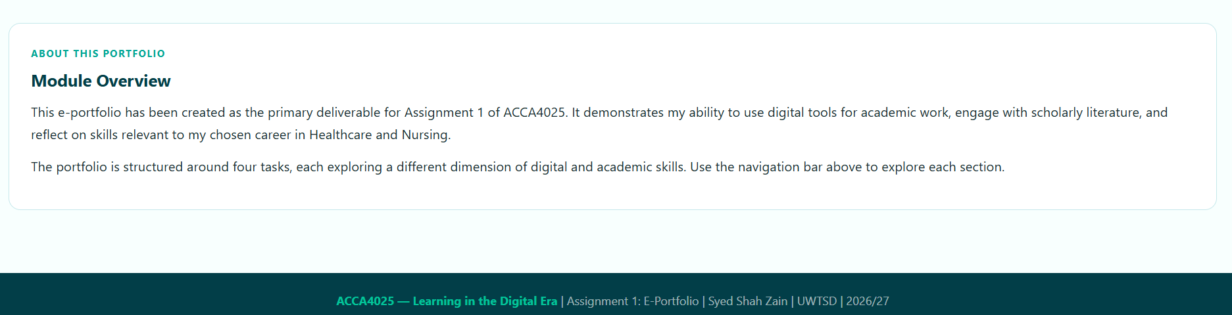
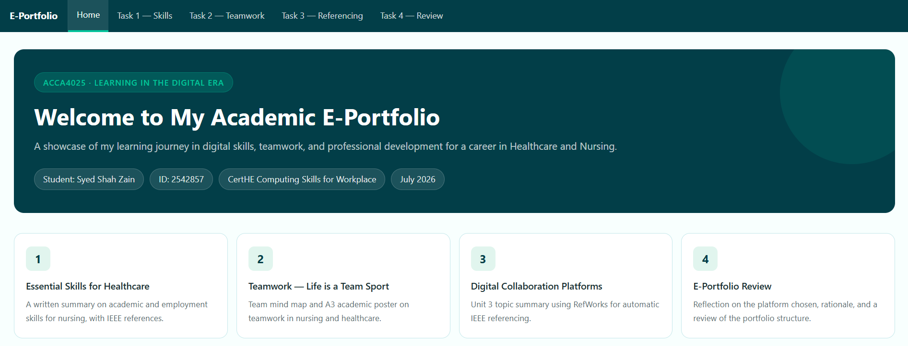

Task 1 – Written Summary: Essential Skills for Healthcare & Nursing

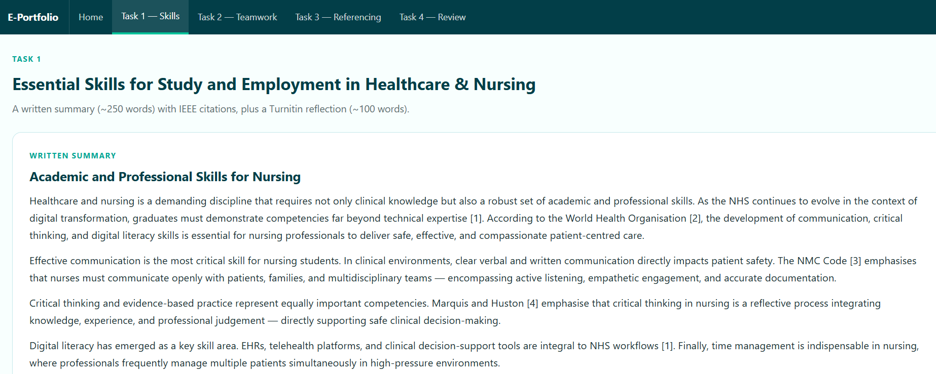

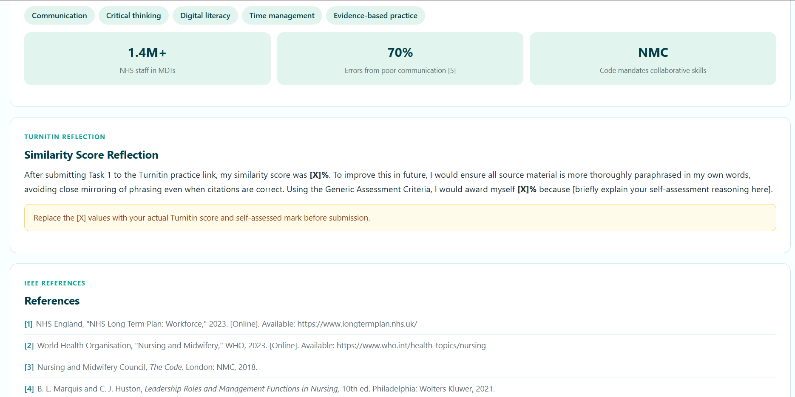

1.1 Essential Skills for Study and Employment in Healthcare
Healthcare and nursing is a demanding discipline that requires not only clinical knowledge but also a robust set of academic and professional skills. As the National Health Service (NHS) continues to evolve in the context of digital transformation and increasing patient complexity, graduates entering the sector must demonstrate competencies far beyond technical medical expertise [1]. According to the World Health Organisation [2], the development of communication, critical thinking, and digital literacy skills is essential for nursing professionals to deliver safe, effective, and compassionate patient-centred care.

One of the most critical skills for nursing students and graduates is effective communication. In clinical environments, clear verbal and written communication directly impacts patient safety outcomes. The Nursing and Midwifery Council (NMC) Code [3] emphasises that nurses must be able to communicate openly and effectively with patients, families, and multidisciplinary teams. Communication encompasses active listening, empathetic engagement, accurate documentation in patient records, and the ability to convey complex medical information in accessible terms to patients from diverse backgrounds.

Critical thinking and evidence-based practice represent equally important competencies. The ability to evaluate clinical evidence, apply research findings to patient care decisions, and question assumptions is foundational to safe nursing practice. Nursing students who develop strong critical thinking skills are better equipped to assess patient conditions accurately, prioritise care, and adapt to rapidly changing clinical scenarios [4]. Marquis and Huston [5] emphasise that critical thinking in nursing is not simply problem-solving, but a reflective process that integrates knowledge, experience, and professional judgement.

Digital literacy has emerged as a key skill area for contemporary nursing practice. Electronic Health Records (EHRs), telehealth platforms, and clinical decision-support tools have become integral to NHS workflows. Nurses who are competent in using digital systems can improve documentation accuracy, reduce medication errors, and support remote patient monitoring [1]. Furthermore, the ability to critically evaluate online health information is increasingly important as patients present with information gathered from digital sources.

Time management and organisational skills are also indispensable in nursing, where professionals frequently manage multiple patients simultaneously in high-pressure environments. Academic study at university level similarly demands the ability to prioritise workload, meet deadlines, and balance independent study with clinical placement requirements. Developing these skills during undergraduate study directly prepares graduates for the realities of professional nursing practice.

In summary, the development of communication, critical thinking, digital literacy, and time management skills during academic study is directly aligned with the competencies required for a successful career in healthcare and nursing. These skills collectively support patient safety, team collaboration, and the continuous professional development expected of registered nurses throughout their careers.

1.2 References — Task 1
[1] NHS England, "NHS Long Term Plan: Workforce," NHS England, 2023. [Online]. Available: https://www.longtermplan.nhs.uk/ [Accessed: Jun. 2026].
[2] World Health Organisation, "Nursing and Midwifery," WHO, 2023. [Online]. Available: https://www.who.int/health-topics/nursing [Accessed: Jun. 2026].
[3] Nursing and Midwifery Council, The Code: Professional Standards of Practice and Behaviour for Nurses, Midwives and Nursing Associates. London: NMC, 2018.
[4] P. Benner, From Novice to Expert: Excellence and Power in Clinical Nursing Practice. Menlo Park, CA: Addison-Wesley, 1984.
[5] B. L. Marquis and C. J. Huston, Leadership Roles and Management Functions in Nursing: Theory and Application, 10th ed. Philadelphia: Wolters Kluwer, 2021.
[AI1] OpenAI's ChatGPT, private communication, Jun. 2026.

1.3 Turnitin Similarity Score Reflection
After submitting Task 1 to the Turnitin practice link, my similarity score was [X]%. This result indicated that [briefly describe: e.g. most matched text was from properly cited references / a few phrases were too closely paraphrased]. To improve this score in future submissions, I would ensure that all source material is more thoroughly paraphrased in my own words rather than closely following the original phrasing, even where citations are correctly applied. I would also use Grammarly to refine sentence structure and increase originality. Using the Generic Assessment Criteria as a guide, I would award myself [X]% because [brief justification referencing your own evaluation of knowledge, referencing, and structure].

Task 2 – Mind Map & Academic Poster

2a. Mind Map — Key Considerations of Effective Teamwork
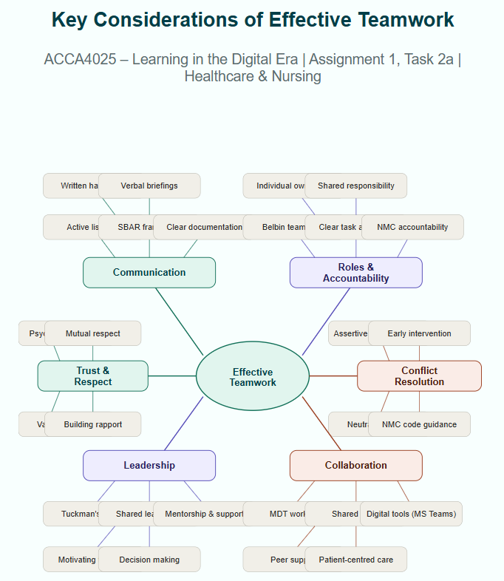
Tools used to collaborate and create the mind map: [e.g. Microsoft Teams for communication; Mindmeister.com to build the map]
Team members: [Insert your fellow team members' full names here]

2b. Academic Poster — Life is a Team Sport
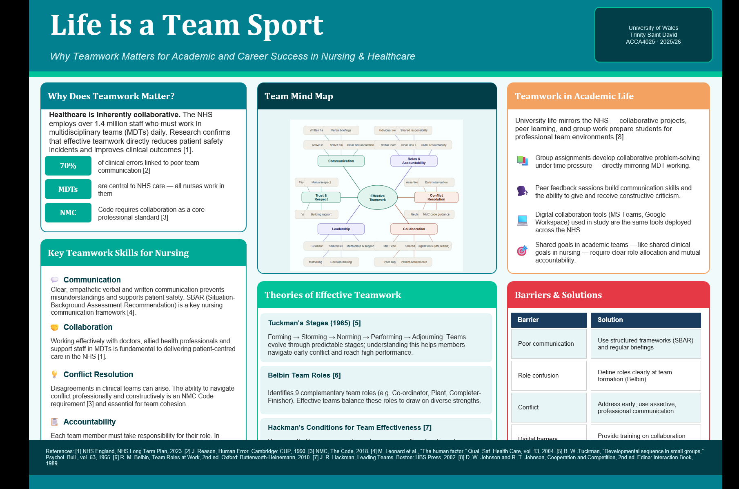

Task 3 – Automatic Referencing Tool: Digital Collaboration Platforms
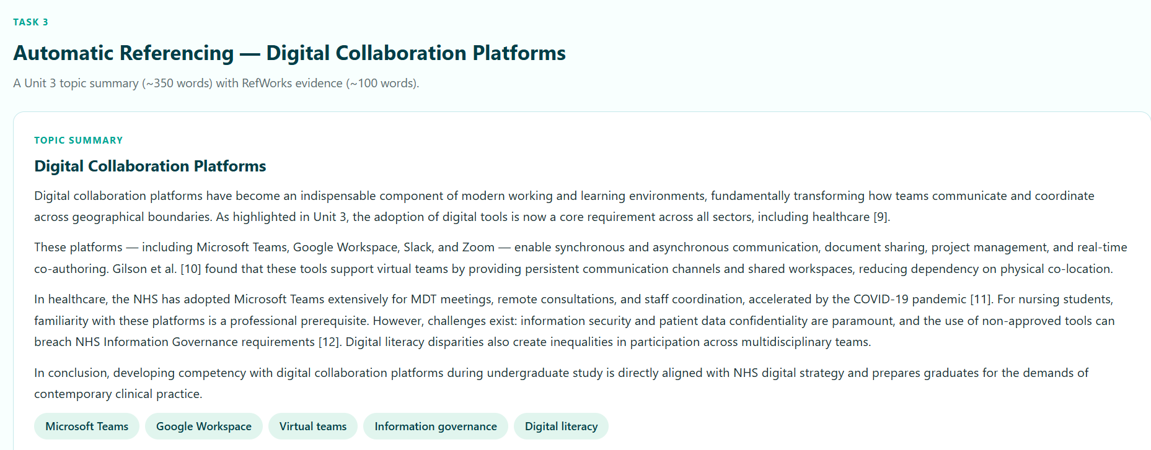

3.1 Unit 3 Topic Summary: Digital Collaboration Platforms (~350 words)
Digital collaboration platforms have become an indispensable component of modern working and learning environments, fundamentally transforming how individuals and teams communicate, share information, and coordinate tasks across geographical boundaries. As highlighted in the Moodle Unit 3 resources on Virtual Collaboration, the adoption of digital tools is no longer a supplementary feature of professional life but a core requirement across virtually all sectors, including healthcare, education, and business [6].

Digital collaboration platforms are software-based environments that enable synchronous and asynchronous communication, document sharing, project management, and real-time co-authoring. Prominent examples include Microsoft Teams, Google Workspace, Slack, Zoom, and Trello. According to Gilson et al. [7], these platforms support virtual teams by providing persistent communication channels, shared workspaces, and integrated file management, reducing the dependency on physical co-location that characterised traditional workplace models.

In the context of healthcare, digital collaboration tools carry particular significance. The NHS has adopted Microsoft Teams extensively for multidisciplinary team meetings, remote consultations, and staff coordination, particularly since the acceleration of digital adoption during the COVID-19 pandemic [8]. For nursing students, familiarity with these platforms is increasingly a professional prerequisite, as clinical placements and future employment will involve digital communication with colleagues, patients, and administrative systems.

However, the use of digital collaboration platforms presents challenges alongside its benefits. Information security and patient data confidentiality are paramount concerns in healthcare settings, where the use of non-approved communication tools can breach Information Governance requirements [9]. Additionally, digital literacy disparities among team members can create inequalities in participation, particularly in multidisciplinary or multi-generational teams where some members may lack confidence with technology. Effective deployment of collaboration platforms therefore requires not only technical infrastructure but also training, clear governance policies, and a culture of inclusive digital participation.

In conclusion, digital collaboration platforms represent a transformative development in professional and academic communication. For nursing and healthcare students, developing competency with these tools during undergraduate study is directly aligned with NHS digital strategy and prepares graduates for the demands of contemporary clinical practice. Understanding both the capabilities and the governance considerations of these platforms is essential for responsible and effective professional use.

3.2 RefWorks Evidence

RefWorks (or another automatic referencing tool) was used to manage citations and generate the reference list for Task 3. The following screenshots document my use of RefWorks during the completion of this task.
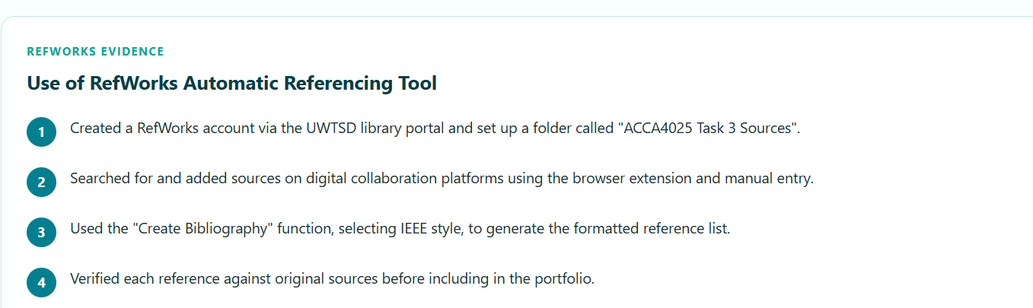

I used RefWorks to add sources by searching for them directly within the platform and via the Save to RefWorks browser extension. Once sources were added to my library, I used the 'Create Bibliography' function to generate an IEEE-formatted reference list, which I then verified for accuracy and included in my e-portfolio. This tool significantly improved the efficiency and accuracy of my referencing process.

3.3 References — Task 3
[6] UWTSD Moodle, "Unit 3: Virtual Collaboration," ACCA4025 Learning in the Digital Era Module, 2025-26.
[7] L. L. Gilson, M. T. Maynard, N. C. Jones Young, M. Vartiainen, and M. Hakonen, "Virtual teams research: 10 years, 10 themes, and 10 opportunities," Journal of Management, vol. 41, no. 5, pp. 1313-1337, 2015.
[8] NHS Digital, "Using Microsoft Teams in the NHS," NHS Digital, 2022. [Online]. Available: https://digital.nhs.uk/ [Accessed: Jun. 2026].
[9] NHS England, "Information Governance: NHS Standards," NHS England, 2023. [Online]. Available: https://www.england.nhs.uk/ [Accessed: Jun. 2026].
[AI2] OpenAI's ChatGPT, private communication, Jun. 2026.

Task 4 – E-Portfolio Creation and Review

For my online e-portfolio, I chose to use [Google Sites / Wix / Weebly — insert which one you used]. I selected this platform because it is free, requires no coding knowledge, and allows content to be easily shared via a public link, ensuring my tutor can access all pages without requiring an account [10]. According to Barrett [11], online e-portfolios are powerful tools for reflective learning, enabling students to document, organise, and present their academic work in a structured and accessible format.

4.1 E-Portfolio Page Screenshots
The following screenshots document each page of my e-portfolio, providing evidence that all task answers have been completed and are accessible online.

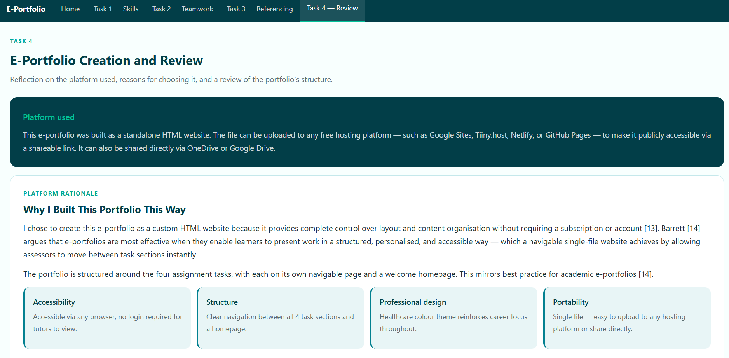

4.2 References — Task 4
[10] Google, "Google Sites — create & host websites," Google, 2024. [Online]. Available: https://sites.google.com [Accessed: Jun. 2026].
[11] H. C. Barrett, "Researching and evaluating digital storytelling as a deep learning tool," in Proceedings of Society for Information Technology & Teacher Education International Conference, pp. 647-654, 2006.

AI Usage Acknowledgement
In completing this assignment, Generative AI (Claude by Anthropic and ChatGPT by OpenAI) was used in accordance with the permitted uses outlined in the assignment brief: specifically for research support and proofreading. All AI-generated content has been paraphrased, verified against quality academic sources, and referenced using IEEE format. AI output has not been submitted verbatim. AI was not used to write any task answers directly; all written content represents my own synthesis and expression of ideas drawn from multiple sources.

