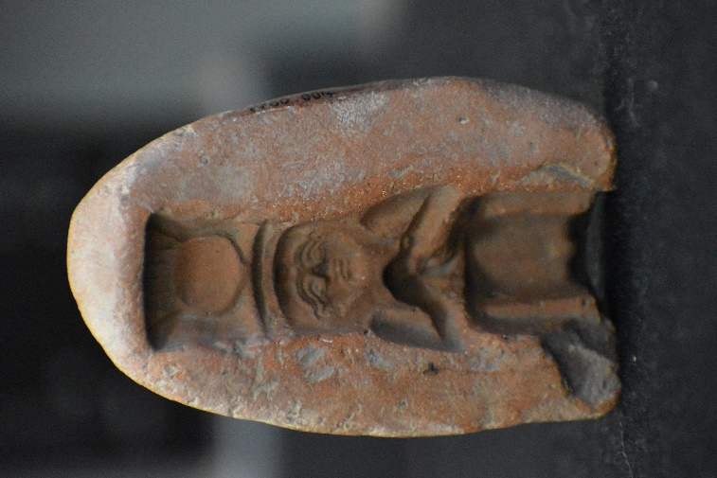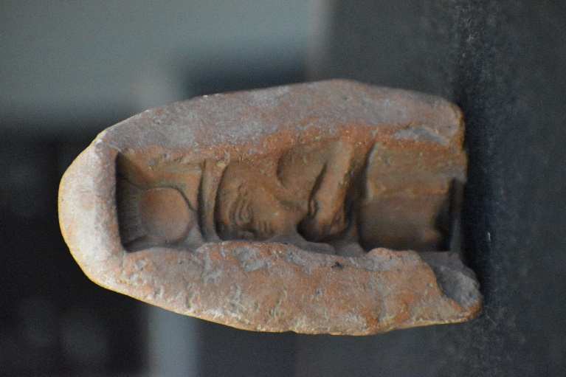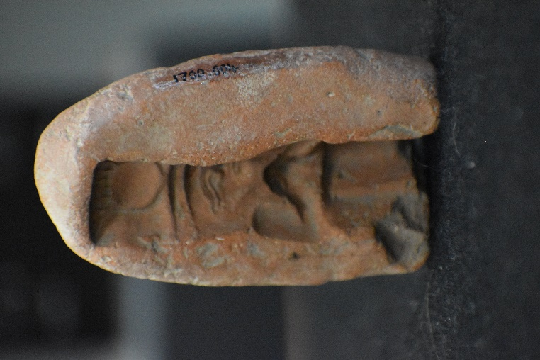

Amulet Mould
Cyfartha Castle, Merthyr Tydfil 1700.004
Object Type: Mould impression.
Material: Possibly Faience.
Period: New Kingdom 1550 – 1070 B.C.
Provenance: Egyptian.
Dimensions:
Mould: Height: c.8cm
Width:
top: c.3.7cm
middle: 4.7cm
bottom: 4.5cm
Depth: c.1.5cm
Amulet:
Height: 6.7 cm
Width: Top- 1.6 cm, Middle- 1.4 cm, Bottom – 2.6 cm

Description: The object in question is a brown mould that is standing upright at a height of 8cm, there are three different measurements for the width of the object however as each of them are different in size. The first one being the top of the mould at 3.7cm, the second is the middle at 4.7cm and finally the bottom at 4.5cm. Not only is the mould standing upright and uniquely shaped, but there’s also an impression of an amulet in the middle of the mould with a depth of 1.5cm. The impression itself appears to be the Goddess Hathor standing up straight with her hands crossed over her chest and wearing her crown with cow horns that hold the small sun in the middle of the horns. As for the amulet itself, we are able to discern its size to be sitting at a height of 6.7cm and again three different measurements for the width of the object with the top part being 1.6cm, the middle 1.4cm and the bottom 2.6cm.

The amulet mould was designed for showing to today’s society what the object in question looked like, however… most people would focus more on the amulet than the mould itself. So firstly: what were amulets used for back in Ancient Egypt? Amulets were to do with the belief of magic, basically they were used as items of protection against the evil of this world such as diseases, spirits and even bad luck. By using the proper material, colour and ritual the Ancient Egyptians believed they would be able to imbue amulets with the magic necessary to protect their wearer against the forces of the world. The belief was that when a person would wear an amulet, the magic inside of the object would be transferred to the owner and therefore the owner of the amulet would have the protection instead of the object.
Where does that fit in with the funerary beliefs of Ancient Egypt? It’s quite simple actually, there was another big belief about the afterlife in Ancient Egypt where the objects the deceased was buried with would be taken with them to the afterlife to use. Naturally, some people would bury themselves with these funerary amulets for one of two reasons: either they wish to protect themselves from the evil of the afterlife, or they were not confident they would pass judgement and therefore would have the amulet’s power to help reassure that their judgement would bring positive results and would not end up in the underworld.
As for this object, it definitely shows that the amulet in question was one used for the deceased’s journey to the afterlife, mostly because of two tell-tale signs: there is no hole at the top of the amulet that would indicate a string which would be used to wear around the neck and there are no cracks or signs of use on the impression in the mould that would no doubt be there should the amulet have been used during the owner’s time alive.
One thing people wonder when seeing catalogues like these is how do people know what year or rather, what period of time the object comes from. Well, it comes from a combination of examining the object and information we had beforehand. For example: I believe the object was create during the New Kingdom period due to two connections to do with the object and information, firstly… on the impression, we can see the amulet has the Goddess Hathor as its design, and while amulets were created and used throughout all of Ancient Egypt, it’s most likely the New Kingdom is when the amulet was made and used since the era of the New Kingdom was when amulets designed after Gods and Goddesses were more popular and therefore more likely to be found.
Another part of the object I’m confident was the fact that the amulet, while not here with us today was most likely made out of the substance known as faience. It’s a light blue/green coloured substance that is commonly used with amulets due to the nature that the colour of blue and green back in Ancient Egyptian times was a colour favoured with both life and regeneration, two common things that Ancient Egyptians both vied for and believed in thoroughly. Therefore, it’s likely that the amulet was made of faience, as a way of continuing to protect the deceased owner from both harsh judgement and to continue living healthily and to their fullest in the afterlife since they would have the magic of the amulet. It also helps that another amulet of Hathor found on the website of the National Museum of Asian Art has the exact same material used for it.
The amulet is most likely from a series of amulets that were created during the New Kingdom era, mostly due to the fact that while amulets were easy to access/purchase and therefore pretty much anyone in Ancient Egypt times could get one, these types of amulets involving the Goddess Hathor were most likely a part of a series. I come to this conclusion due to one deciding factor: the fact that it’s the Goddess Hathor who the amulet is designed after, Hathor was the Goddess of maternal care, as well as joy, dance and song. This says to me that while Hathor is an Ancient Egyptian Goddess, she is more of a Goddess for the women of Ancient Egypt, in other words, it’s most likely that this amulet was designed for a series of amulets which would be used to market to women in order to gain the protection of the Goddess during their time of pregnancy. This answers two questions as well: that the object in question was a part of a series and the owner was undoubtedly a woman who sought the Goddess’ protection as she passed on to the afterlife.

