Ashley John Rees (2009258)
L4 – Introduction to Web and Database Concepts (Web)
ACCA4023
Database Analysis and Design
05/05/2021

Table of Contents
Context Diagram 3
Level 0 Data Flow 4
Entity Relationship Diagram 6
Reports 7
Forms 8
Accounts 8
Customer 9
Kitchen 10
Store Manager 11
Supplier 12
Queries 13

Context Diagram
Please seem below screen shot of my context diagram for Celtic Caterers.

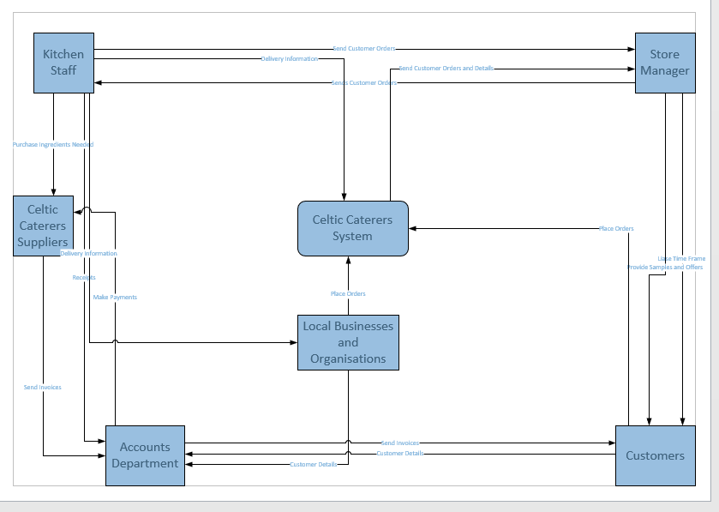

Level 0 Data Flow
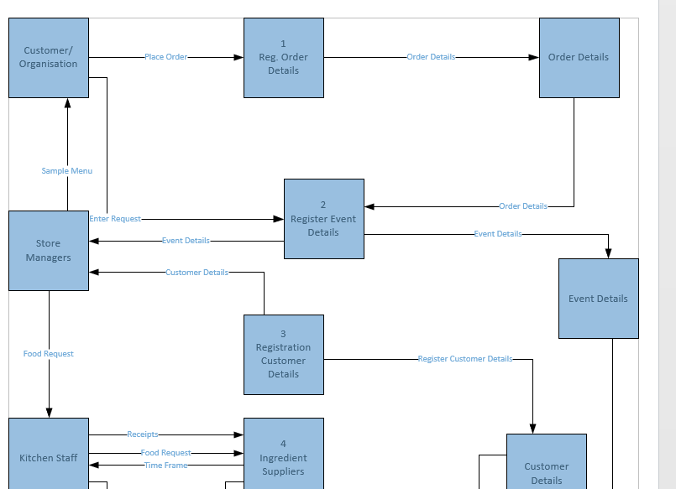
Please seem below screen shot of my Level 0 Data Flow Diagram for Celtic Caterers.

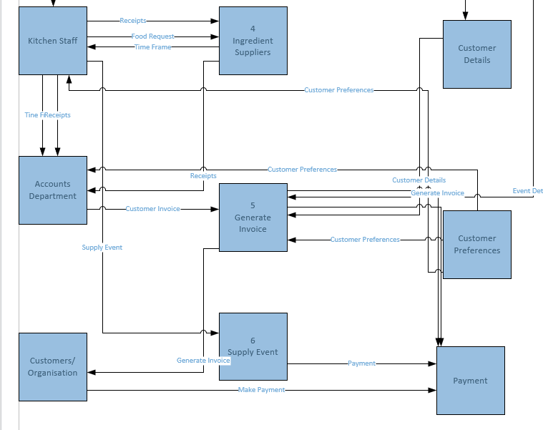

Entity Relationship Diagram
Please seem below screen shot of my Entity Relationship Diagram for Celtic Caterers.
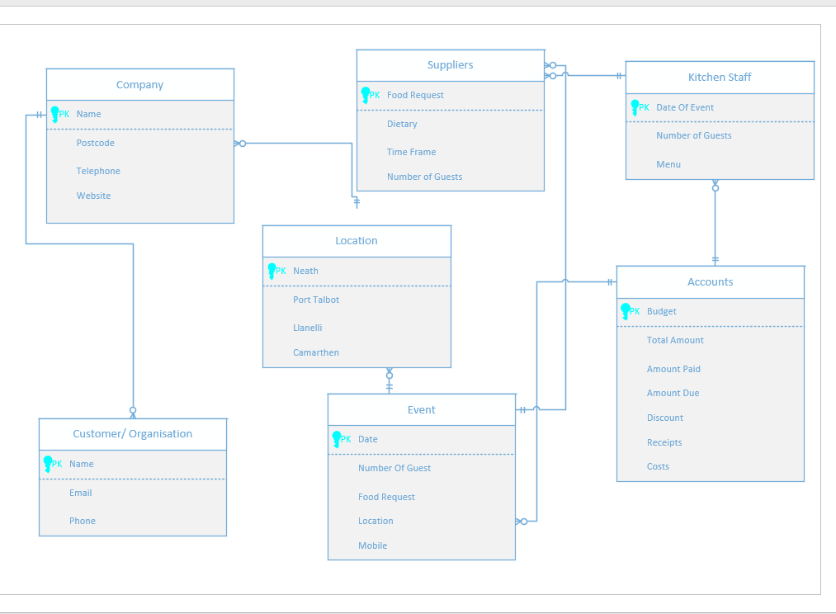

Reports
Please see below my report output for Customer

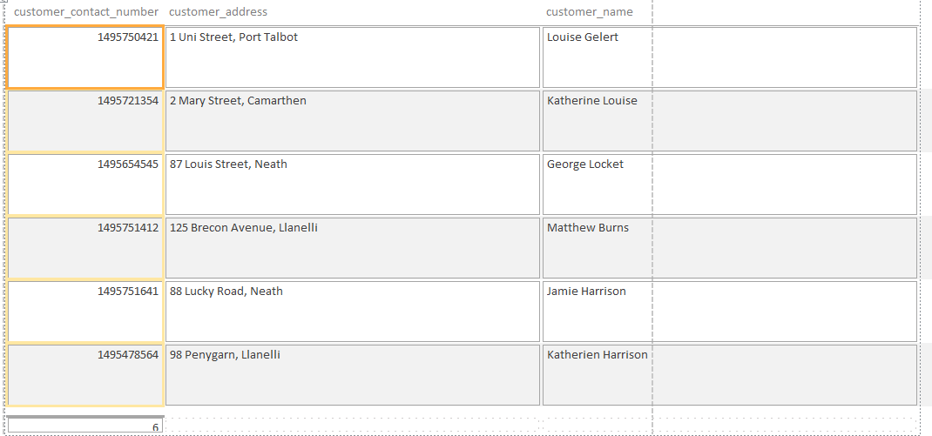

Forms
Please see below for my forms

Accounts
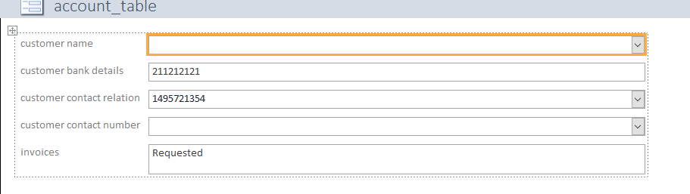

Customer

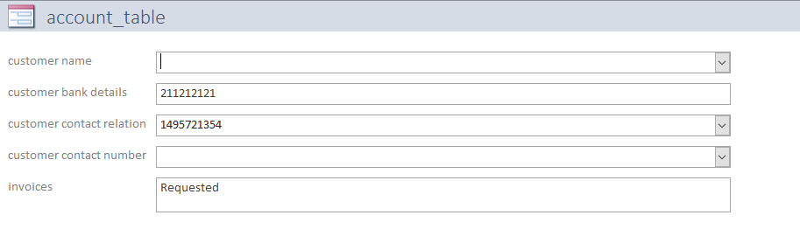

Kitchen

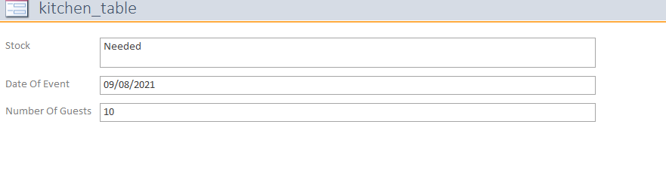

Store Manager

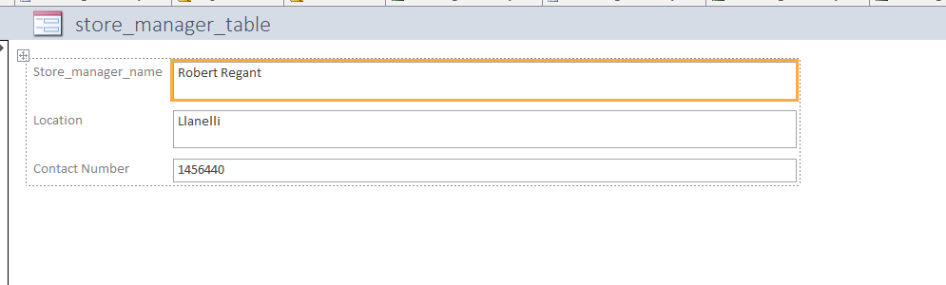

Supplier

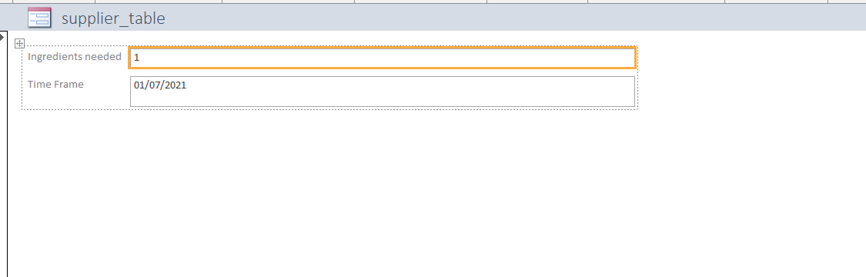

Queries
Please see below for my Query
Customer


