Operating systems
Rhys Davies
Student Number: 152694
Applied Computing



Table of Contents
Table of Figures 3
Introduction 4
Key functions of Operating Systems 4
User Interface 4
Managing the device 5
Security 5
Use of CLI commands in Windows 6
CLS 6
Ipconfig 7
Ping 8
Use of CLI commands in Linux 9
Alias 9
Df 11
Man 12
Use of batch scripts in Windows 13
Multi-line script 13
Variables 14
Use of bash scripts in Linux 15
Multi-line script 15
Conclusion 16
References 17

Table of Figures
Figure 1 - Windows 10 Operating System 4
Figure 2 - Android OS 5
Figure 3 - Windows Command Prompt 6
Figure 4 - before cls command 6
Figure 5 - after cls command 7
Figure 6 - ipconfig command 8
Figure 7 - ping command 8
Figure 8 - terminal emulator in linux 9
Figure 9 - alias command 10
Figure 10 - terminal emulator after cls 11
Figure 11 - df command 12
Figure 12 - man command 13
Figure 13 - ver_tasklist batch file 14
Figure 14 - ver_tasklist batch file in cmb 14
Figure 15 - winner bat file 15
Figure 16 - winner bat in cmb 15
Figure 17 - alias bash script 16

Introduction
This document will look into operating systems. The document will go into what they are, what features they typically have and different types of operating systems. The document will also look into commands and scripts that are widely used and can be helpful in some scenarios. A few decades back, computer users had to utilise commands and scripts in order to work with operating systems. As time has moved on, operating systems have become more and more complex, with commands no longer being necessary to use, but can still be useful.

Key functions of Operating Systems
An operating system is a “set of programs which controls a computer”. Operating systems have many different functions, but there are a few functions which are seen as the most important. The list can change depending on who you ask, but the key functions of an operating system are usually to provide a user interface, managing the device and provide security. [1]

User Interface
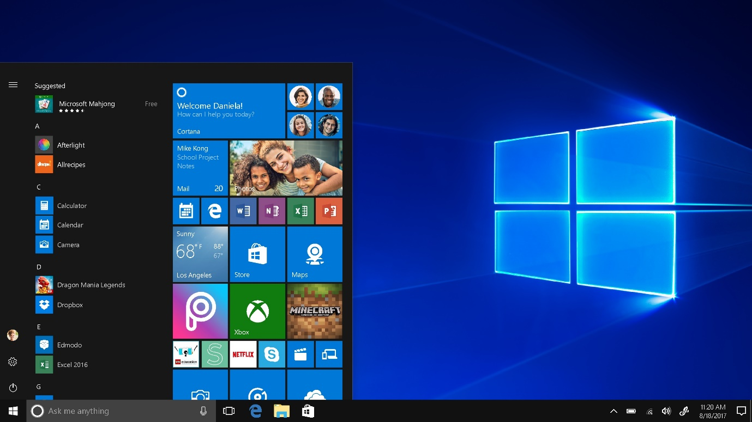
Figure 1 - Windows 10 Operating System
Figure 1 shows the “Windows 10” operating system, which is one of the most popular operating systems for desktop computers and laptops. Modern computer operating systems typically have a desktop which can hold widgets and shortcut links, a toolbar to hold current processes and widgets, plus some sort of menu which is typically accessed from the toolbar. The menu allows users to see their applications, computer’s settings and turn off or restart their device. [2]

Figure 2 - Android OS
Figure 2 shows an android operating system, a highly popular operating system for mobile devices. Mobile operating systems share characteristics with computer operating systems. They have some kind of dashboard that can hold widgets and apps, a kind of toolbar which is activated by swiping it, typically down, and a menu to access the applications which are installed on the device.

Managing the device
The operating system manages many different aspects of the device. This includes the processor, “memory”, “peripherals”, the “backing store”, and much more. Essentially, the operating system can manage every piece of hardware a computer or device has, being able to manage how they operate, managing what they do and when they do it and managing their settings. Hardware isn’t the only thing managed by the operating system. Software also gets managed, with specific amounts of the processor’s power and memory being allocated to software. Overall, a computer or device just wouldn’t work without this operating system function. [3]

Security
Operating systems should also include features to ensure that the user’s system and data are secured. Firewalls can prevent harmful malware from accessing a device, they are nearly always a part of an operating system these days, a very effective tool in protecting a device. Antivirus is another security software which could be included in the operating system, allowing users to search their device for any malware, then remove it. An example of a firewall and antivirus is “Windows Defender”, which is built into the windows 10 operating system. [4]

Use of CLI commands in Windows
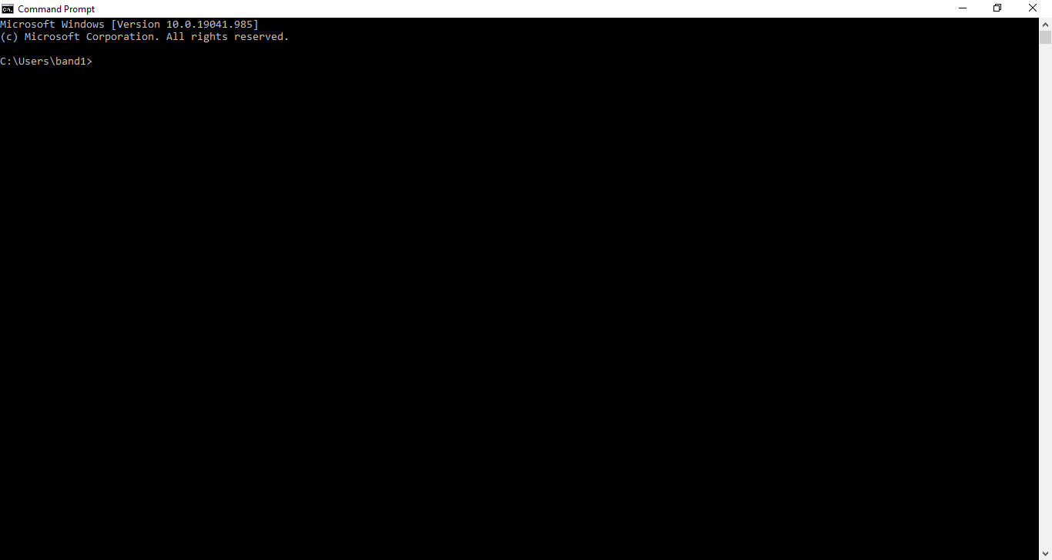
Figure 3 - Windows Command Prompt
Figure 3 shows the windows command prompt, which is window’s version of a command line interface. This will be used to demonstrate some windows commands. Windows has a vast number of commands, which can be seen in the “Windows commands” webpage. [5]

CLS
The CLS command allows you to clear the command line interface, removing any text which is displayed in the command prompt. Previously executed commands in the command prompt could be very long, so being able to clear the command prompt can prove useful when one or more long commands have been used and the command prompt is quite filled.
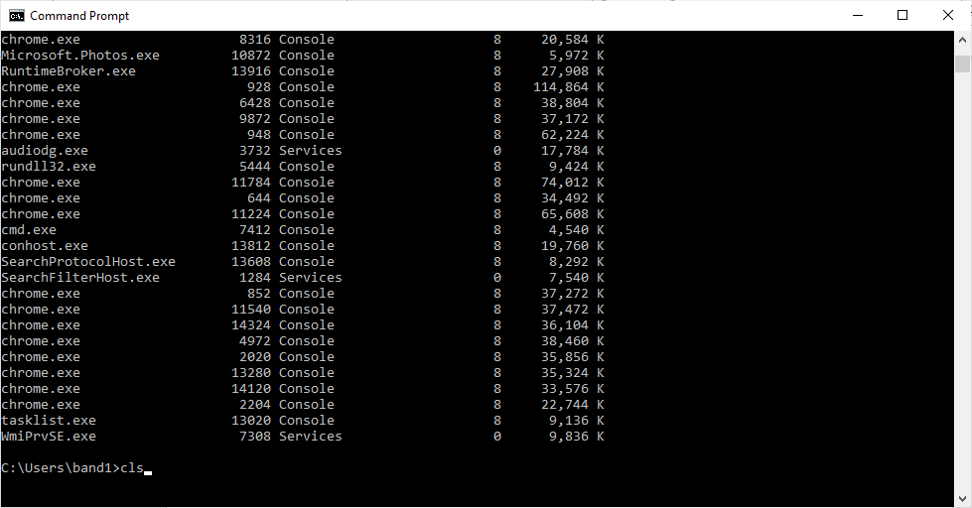
Figure 4 - before cls command
Figure 4 shows the command prompt before the cls command has been executed. A tasklist command has been used, which displayed quite a long list of information. The cls command has been entered, but not executed.
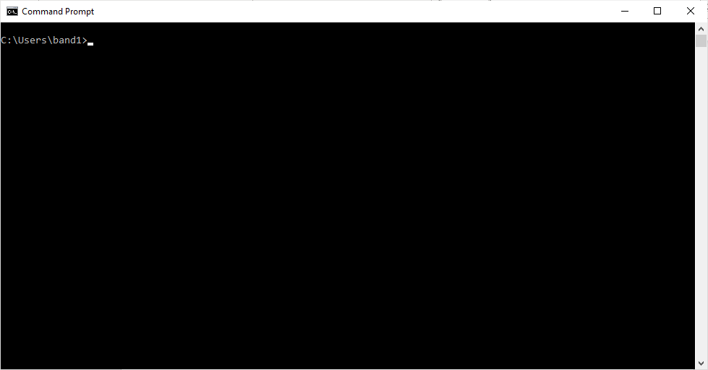
Figure 5 - after cls command
Figure 5 shows the command prompt after the cls command has been executed, which has resulted in a fresh and clear command prompt. The cls command can be very useful when wanting to see the results of just one command.

Ipconfig
The “Configure IP” command can be useful in both networking and in personal use. It allows you to see information related to your computer’s network connection, such as which connections are available and functional and what IP address your computer has. [6]
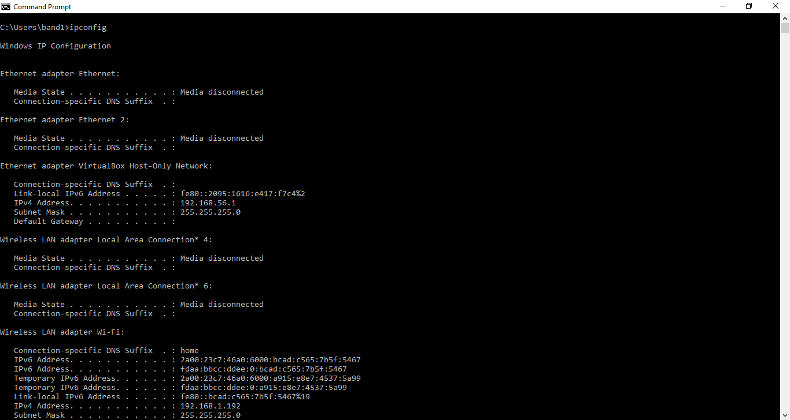
Figure 6 - ipconfig command
Figure 6 shows the ipconfig command running in the command prompt. The only two active connections are the virtual box network and the wireless lan adapter Wi-Fi, the virtual box network being a virtual network and the later for internet connection. The computer’s IP address can also be seen in figure 6.

Ping
Ping is a command used in networking to test whether a connection is working. Use the ping command, followed by the IP address which you want to attempt to communicate with to send packets to that IP address that will return to the sender. The ping command can be used to test whether a connection is operational, how fast and efficient it is and whether a connection to the called device can be made. Figure 7 shows the ping command in action.
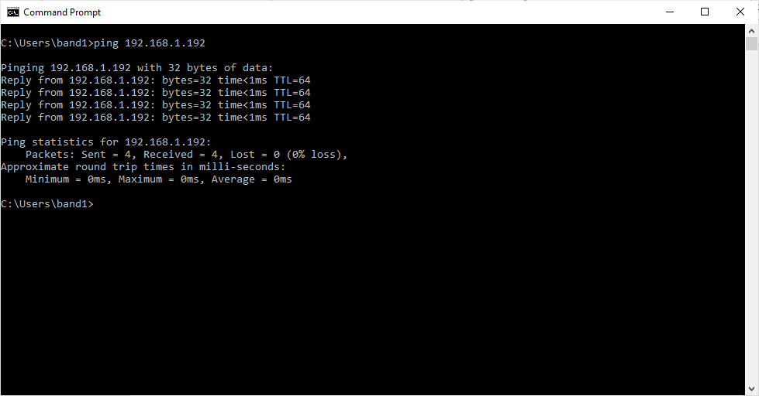
Figure 7 - ping command

Use of CLI commands in Linux
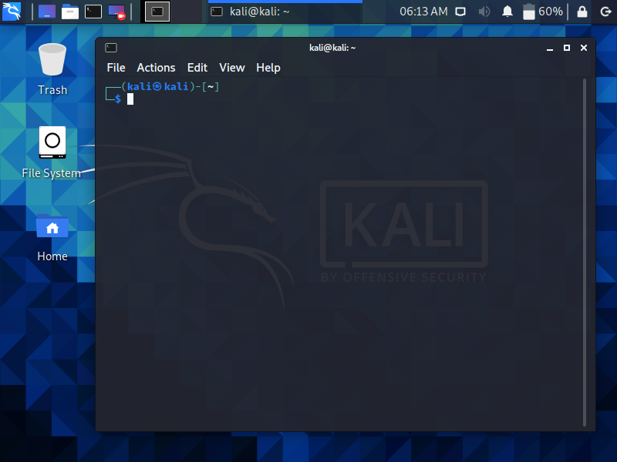
Figure 8 - terminal emulator in linux
Figure 8 shows the “Linux Terminal Emulator”, which is linux’s version of a command line interface. This will be used to demonstrate a couple of linux commands. [7]

Alias
For some, the commands used in linux can be unusual and hard to remember. The Alias command can help with that. This command allows you to set up a different name for a command that already exists as a linux command. If you don’t like a certain linux command and wanted to use a windows command instead, you could use the alias command to set that up.
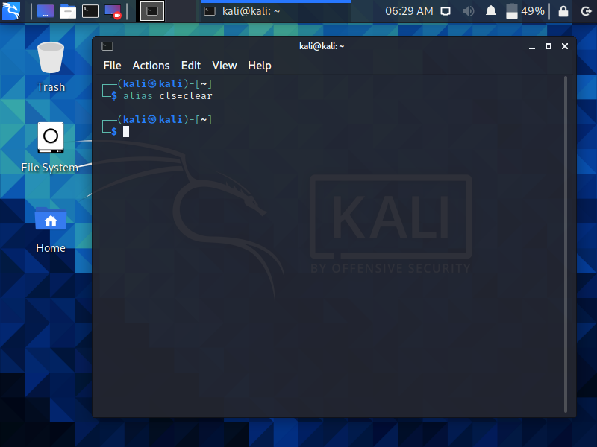
Figure 9 - alias command
Figure 9 shows the alias command being executed. The command has been used to set up a command called cls which does exactly what the clear command does. But did the alias command work?
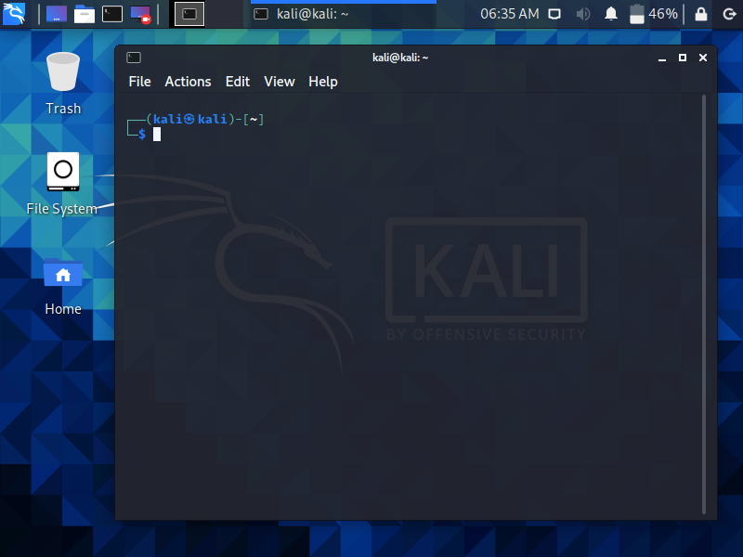
Figure 10 - terminal emulator after cls
Figure 10 shows the terminal emulator after the cls command has been executed. The cls command would normally not be recognised, but here it has worked exactly how the clear command would. Therefore, the alias command has worked.

Df
The df command can be used to show how much storage you have used and how much storage you have left in file systems. Df is short for “disk free”. This command can be useful to quickly check how much storage space you have left in a location to discover whether you have enough space for a file or not. The df command can be followed with a -h to tell the command to display data quantities in kilobits, megabits or gigabits instead of just displaying the numbers in bits. The df command can be seen in figure 11. [8]
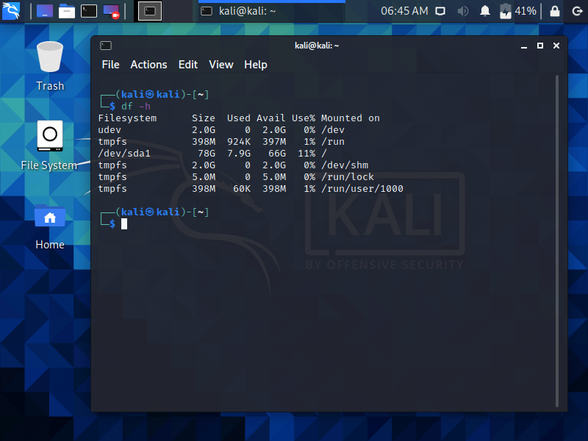
Figure 11 - df command

Man
The man command can be used to discover the purpose of a specific command. If you know a linux command, but you can’t remember what exactly it does, you can type it in after the man command in the terminal to be provided information about that command. You can then enter h to get help about using commands or q to quit. The man command can also be helpful if you know a command but don’t quite know how to write it out in the terminal. Overall, the man command can be useful for people who aren’t used to linux commands or have limited knowledge. Figure 1 shows the man command being used for the clear command.
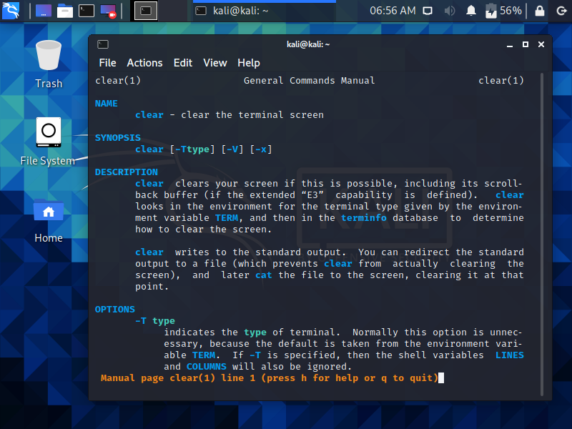
Figure 12 - man command

Use of batch scripts in Windows
Batch scripts are used on windows to group together a list of windows commands and can create a more complicated sequence of commands which cannot be done directly in the command prompt. Batch files can be stored in “.bat”, “.cmd” and “.btm” file types. The batch files can be executed in the command prompt by typing it in, although make sure to include the file’s directory to tell the command prompt where it is. [9]

Multi-line script
One of the main uses of batch scripts is to make the command prompt carry out a series of commands by just executing the one batch file. The command prompt will execute each command in the batch file line by line, allowing the creator of the batch file to create chains and sequences of events. So, instead of having to type out different commands one after the other, you can just execute a bat file with all of the commands that you want to run contained within that file, in the order that you want them to run.
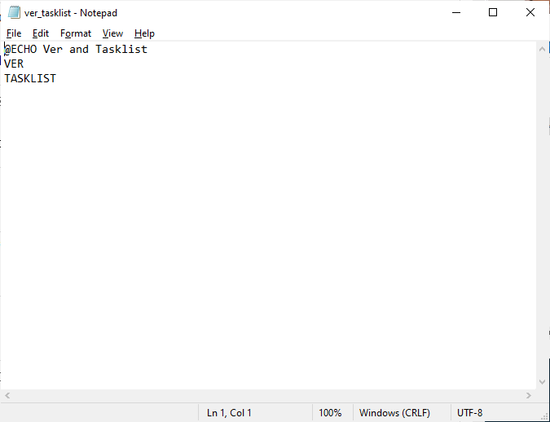
Figure 13 - ver_tasklist batch file
Figure 13 shows the ver_tasklist batch file, which contains an @echo, ver and tasklist command. If someone wanted to carry out a ver and tasklist command with one execution, they might make a batch file like this. Figure 14 shows the batch file running in the command prompt.
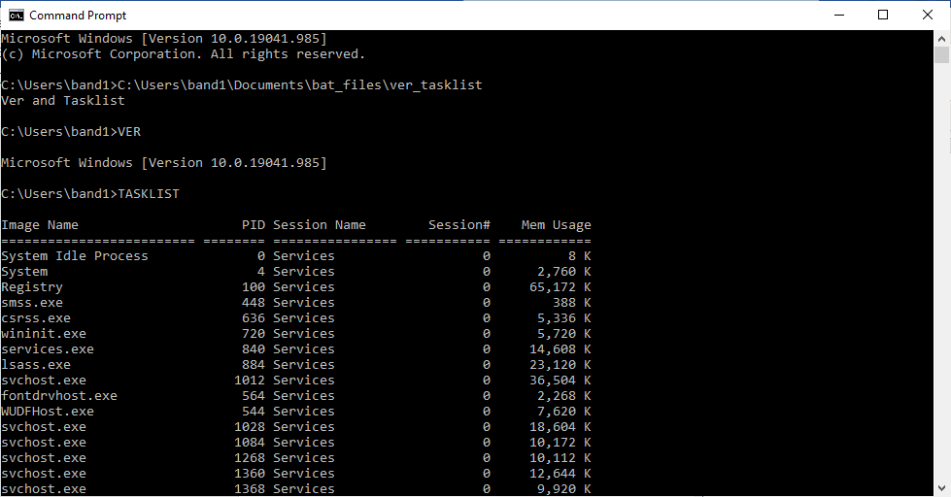
Figure 14 - ver_tasklist batch file in cmb

Variables
Variables can be used in batch files to store information which could then be used by the batch file. Creating variables can be done in the command prompt directly with the set command, but you can also do it in batch files, either with the set command or by inputting values after writing the directory of the batch file and having the batch file make use of them.
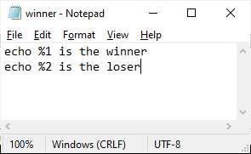
Figure 15 - winner bat file
Figure 15 shows the winner.bat file in notepad. The batch file is very simply just two echo commands; however, they use “%1” and “%2”. These are referring to the first and second items entered after the directory to the batch file. Figure 16 shows the batch file running in the command prompt. After the directory was entered, the names Kian and Rhys were entered. Due to the name Kian being the first item, it gets assigned to the %1 slot, while Rhys gets assigned to the %2 as it is the second item inputted. [10]
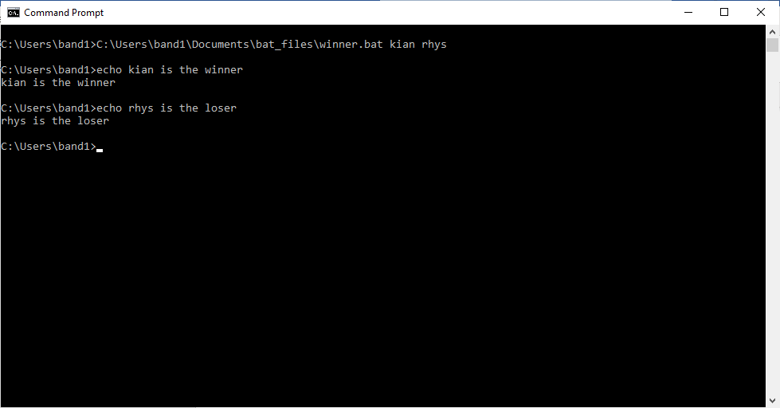
Figure 16 - winner bat in cmb

Use of bash scripts in Linux
Bash scripts in linux share the same concept as batch scripts for windows, they allow you to create sequences of linux commands. The sequences can also be capable of achieving results which could not be reached by just using the terminal emulator. Just like with batch scripts, you can run the bash scripts by executing them with the terminal, which would be done by typing in the path of the file. The differences between batch files and bash files is that they use different commands, bash files typically start with a “shebang” and they have different file types. [11]

Multi-line script
Bash files also allow for a sequence of commands to be made, just like batch files. Additionally, they also execute the commands from top to bottom, line by line. By executing the bash file, you can get many commands in the bash file to execute, with you only needing to type them out once in the bash file. Overall, batch scripts and bash scripts are quite similar. [12]
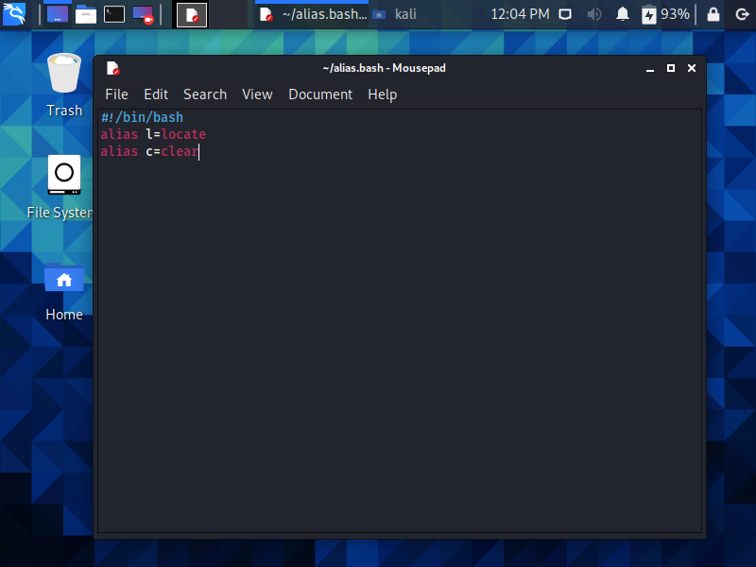
Figure 17 - alias bash script
Figure 17 shows an example of a bash script which could be useful when using the terminal emulator. Using the alias command, you could set a new name for all of the different commands which are used in linux, allowing you to significantly alter how you use the terminal and make the terminal easier for you to use. Figure 17 only shows changes for the locate and clear commands, but you could have a huge list of changes. Then, whenever you use the terminal, execute the bash file to set up all of your custom commands.

Conclusion
Most modern operating systems now use a visual user interface, with the command line interfaces either being included as a small program in the operating system that can be used to simulate the use of a command line interface or just not being included in the operating system at all. Commands can be a great way to work with your computer, but the ease of use which the graphical interfaces offer has led to the decline of the CLI. However, due to the level of control that a CLI provides and the speed which tasks can be executed, command line interfaces have not lost their performance.

References

[1] | E. M. V. S. S. Er. Vivek Sharma, in Design and Implementation of Operating System, Laxmi Publications Pvt Limited, 2010, p. 4.
[2] | "www.microsoft.com," [Online]. Available: https://www.microsoft.com/en-gb/windows. [Accessed 2021].
[3] | "www.bbc.co.uk/bitesize," [Online]. Available: https://www.bbc.co.uk/bitesize/guides/z8vrd2p/revision/1. [Accessed 2021].
[4] | "docs.microsoft.com," [Online]. Available: https://docs.microsoft.com/en-gb/microsoft-365/security/defender-endpoint/microsoft-defender-antivirus-in-windows-10?view=o365-worldwide. [Accessed 2021].
[5] | "docs.microsoft.com," [Online]. Available: https://docs.microsoft.com/en-us/windows-server/administration/windows-commands/windows-commands. [Accessed 2021].
[6] | "ss64.com," [Online]. Available: https://ss64.com/nt/ipconfig.html. [Accessed 2021].
[7] | C. S. o. C. S. &. Informatics, "docs.cs.cf.ac.uk," [Online]. Available: https://docs.cs.cf.ac.uk/notes/linux-terminal-emulator/. [Accessed 2021].
[8] | msdeep14, "df command in Linux with Examples," https://www.geeksforgeeks.org/df-command-linux-examples/, p. 1, 21 feb 2018.
[9] | "fileformats.archiveteam.org," [Online]. Available: http://fileformats.archiveteam.org/wiki/Batch_file. [Accessed 2021].
[10] | "www.tutorialspoint.com," [Online]. Available: https://www.tutorialspoint.com/batch_script/batch_script_variables.htm. [Accessed 2021].
[11] | zonker, "https://www.linux.com/training-tutorials/writing-simple-bash-script/," linux, [Online]. Available: https://www.linux.com/training-tutorials/writing-simple-bash-script/. [Accessed 2021].
[12] | "www.xoogu.com," 2012, updated 2015. [Online]. Available: https://www.xoogu.com/2012/differences-between-windows-batch-and-linux-bash-shell-script-syntax/. [Accessed 2021].

