

Towards a Comprehensive Legal Shield:
Rethinking Protections for Online Abuse Victims

Emily Prothero
BSc Hons Professional Policing

2202485

Declarations

This work has not previously been accepted in substance for any degree and is not being concurrently submitted in candidature for any degree.

This dissertation is being submitted in partial fulfilment of the requirements for the degree of BSc Hons Professional Policing.

This dissertation is the result of my own independent work/investigation, except where otherwise stated. Other sources are acknowledged in the Reference Section.

I hereby give consent for my dissertation, if accepted, to be available for photocopying and for interlibrary loan, and for the title and summary to be made available to outside organisations.

I hereby give consent for my dissertation, if accepted, to be available on the university’s IT system to those who have consent to use the system.

Name: Emily Prothero

Signed:

Date: May 6th, 2024

Acknowledgements
To my supervisor, Mr Mike Durke, your support, motivation, and kind words have been invaluable in the creation of this dissertation. Your guidance, and words of encouragement made it easier for me to believe in myself and realise my true potential.
I would also like to express my gratitude to the rest of my lecturers for their continued support over the past three years. Their guidance and dedication have been instrumental in making this research possible and have played a significant role in enabling me to secure my dream position as a Police Constable.
Furthermore, I wish to extend my heartfelt thanks to the participants of the survey conducted as part of this research. Their valuable contributions and willingness to engage have been greatly appreciated and were essential to the success of this study.
Finally, I’d like to take a moment and express my deepest appreciation to all victims of online abuse. Your strength, resilience, and courage in the face of such challenges are truly inspiring. You are not forgotten, and your experiences are an important reminder of the ongoing need for change and protection within the digital world in which we live in.

Abstract
This dissertation critically examines the existing legal frameworks designed to protect victims of online abuse, highlighting the inadequacies and gaps that fail to provide comprehensive protection within the digital age.
The proliferation of cyberbullying, harassment, online sexual abuse, and other forms of exploitation has exposed significant vulnerabilities in existing legal protections, which remail ill-equipped to adequately respond to the rapidly evolving nature of digital harm. Drawing upon an extensive review of current legal measures and the impact in which online abuse has on its victims, this dissertation advocates for the development of a forward-thinking legal framework that transcends reactive models of intervention.
Informed by an extensive review of the literature surrounding online abuse, an online survey was distributed to the public to gather insights and opinions on the topic. The survey garnered ninety responses from a diverse range of participants, providing a mix of both qualitative and quantitative primary data. This allowed for a deep exploration of public perceptions and experiences, complimenting the academic discourse surrounding online abuse.
The findings suggest that existing legal frameworks are often fragmented, insufficient, and overly reactive, highlighting the need for a more cohesive, preventative, and victim-centred approach. This dissertation proposes a comprehensive legal model that integrates both the legal system and societal frameworks to better address the complexity of online abuse. Ultimately, the research aims to cultivate a safer online environment through law that is adaptable, anticipatory, and responsive to the ever-evolving challenges posed by digital harm.

Contents
1. Chapter 1 - Introduction 5
2. Literature Review 9
2.1 Introduction 9
Objective 1 - To critically analyse an existing legal framework and its effectiveness in addressing various forms of online abuse. 9
Objective 2 13
Objective 3 13
3. Research Methods 14
3.2. Research Onion 14
3.2.1 Research Philosophy 15
3.2.2 Research Approach 16
3.2.3 Methodological choice 16
3.2.4 Research Strategy 17
3.2.5 Time Horizon 17
3.2.6. Techniques for Data Collection, Processes and Analysis 18
3.3. Sampling 18
3.4. Reliability and Validity 19
3.5. Limitations 19
4. Findings 20
4. Findings: Description of Data Analysis and Results 21
5. Conclusion (800) 33
Appendices 41

Chapter 1 - Introduction

“Online abuse increases by eighty-nine percent in six years” (National Society for the Prevention of Cruelty to Children (NSPCC), 2024).
As of January 2024, ninety-two percent of the United Kingdom’s population actively used the internet (Office for National Statistics, 2024), reflecting the rapid advancement of technology that has transformed how individuals communicate, engage, and connect (Amin, 2022). While this digital revolution has unlocked unparalleled opportunities for education, socialisation, and access to information (Graham and Dutton, 2019), it has also provided a fertile ground for malicious actors to exploit vulnerable people.

Historically, bullying has been understood as deliberate and repeated aggressive behaviour, occurring predominately within peer relationships marked by power imbalance, typically taking place in physical environments such as the school playground (Dennehy et al., 2020). Indeed, bullying is often perceived as an inevitable aspect of social development, a notion that has, over time, contributed its normalisation within societal and institutional contexts. It is frequently framed as a “rite of passage” for young people, with many dismissing bullying as a natural, albeit unpleasant element of growing up (Allanson et al., 2015). As such, bullying remained largely unchallenged until the past two decades, during which this perspective has faced significant scrutiny, prompting an urgent call for attention.
In recent years, the rapid expansion of information and communication technologies (I.C.T.) including smartphones and social media, has introduced a new setting for such behaviour (Hinduja and Patchin, 2015).
In the United Kingdom, the widespread accessibility of mobile phones and internet-enabled devices among twelve- to fifteen-year-olds, 62% of whom own smartphones, has eliminated the traditional barriers of geography, time, and face-to-face interaction, making it easier for abuse to occur in digital spaces (Ofcom, 2021).
Since 2014, cyberbullying, alone, has been well-established as a public health problem (Public Health England, 2014). Extensive systematic reviews and meta-analyses have constantly highlighted the profound detrimental effects of online abuse on the mental health and overall wellbeing of victims (Fisher et al., 2016), and strongly associates cybervictimisation with a range of psychosomatic symptoms and internalising issues. These include sleep disturbances, avoidance of school or work, diminished self-confidence and self-esteem, and pervasive feelings of worry and anxiety (Nixon, 2014).
During the year ending March 2020, approximately one in five children aged ten to fifteen in England and Wales, fell victim to at least one form of online abuse (Office for National Statistics, 2020). Such abuse often included the transmission of harassing messages through text or online platforms, the publication of derogatory remarks on social media and the sharing of humiliating images, to name but a few.

The United Kingdom’s legal system has implemented a range of measures to combat the increasing prevalence of online abuse, establishing mechanisms to prosecute offenders and protect victims. Central to these efforts is the Online Safety Act 2023, representing a pivotal advancement in the United Kingdom’s legal framework, aiming to address the multifaced challenges of online abuse and harmful digital content. Building upon existing legislation, such as the Malicious Communications Act 1988, the Online Safety Act (2023) is a new set of laws that protects children and adults online (Department for Science, Innovation and Technology, 2025). The legislation introduces robust obligations for social media platforms, including Facebook, and search engines, mandating heightened standards of accountability to ensure the safety and protection of their users in the digital environment.
However, prior to the enactment of the Online Safety Act 2023, existing harassment legislation faced extensive criticism for its failure to adequately address the complexities and unique characteristics of online abuse. Designed in an era predating the widespread adoption of the internet, these laws were inherently limited in scope and ill-suited to regulate the evolving and multifaced nature of digital interactions (Geach and Haralambous, 2009).

This research study will critically assess whether current legal frameworks, like the Online Safety Act (2023), offer the comprehensive and resilient legal safeguard required to protect victims of online abuse in every conceivable scenario, such as those involving anonymous perpetrators, cross-border abuse, or the exploitation of emerging technologies like artificial intelligence and deepfakes (Nash and Felton, 2023). While the Act imposes more stringent obligations on technology companies, several fundamental concerns persist: the efficacy of policing harmful content, the delicate balance between ensuring user safety and preserving the right to freedom of speech, and the ongoing challenge of adapting legal mechanisms to keep up with the rapidly evolving nature of online threats.

The title of this research study is, ‘Towards a Comprehensive Legal Shield: Rethinking Protections for Online Abuse Victims’, and the key objectives designed to address this investigation are as follows:

Objectives

- To critically analyse an existing legal framework and its effectiveness in addressing various forms of online abuse.

- To examine the impact of online abuse on victims, particularly in relation to emotional, psychological, and social harm.

- To propose a comprehensive legal framework that addresses the gaps in existing protections and offers a more robust shield for victims of online abuse.

The remainder of the study will be structured as outlined:

Chapter two presents a comprehensive literature review that critically examines key research and theoretical frameworks related to protections for victims of online abuse. This chapter seeks to provide a nuanced and in-depth understanding of the current landscape, highlighting the strengths and limitations of existing measures, while identifying gaps in the body of knowledge that warrant further exploration.
Chapter three is dedicated to establishing an effective research methodology tailored to the objectives of this study. This chapter will detail the rationale behind the chosen research design, explaining why the chosen approach is the most suitable for the nature of the study. It will outline the specific methods employed for data collection, focusing on the use of a questionnaire as the primary tool for gathering insights from the public.
Chapter four will present the findings derived from the research methods outlined in Chapter three. This chapter will offer a thorough analysis and interpretation of the data collected, providing a clear overview of the results in relation to the research objectives. In addition to reporting the key findings, chapter four will critically assess any patterns, correlations, or trends that emerge from the data.
Finally, chapter five will underscore the importance of rethinking and enhancing legal protections for victims of online abuse, tying the research findings to the overarching aim of the study. This chapter aims to leave the reader with a clear understanding of the study’s significance and its potential to contribute to meaningful change in addressing the challenges posed by online abuse.

2. Literature Review

2.1 Introduction
This chapter provides a review of state-of-the-art relevant research on abusive behaviour within online social settings. In particular, an analysis of an existing legal framework, the impact of online abuse upon victims, and potential avenues for reform.
The proliferation of digital communication technologies has fundamentally reshaped social interactions, enabling unprecedented connectivity; but also opening a gateway of exposure to new and evolving forms of abuse. As social and online platforms continue to grow in scale and influence, so too does the complexity and prevalence of abusive behaviours that occur within these spaces. From cyberbullying to more insidious forms of harassment, such as deepfake exploitation and coordinated hate campaigns (Ramos Salazar, 2021), the digital age has created challenges that traditional legal frameworks often struggle to address comprehensively.

Objective 1 - To critically analyse an existing legal framework and its effectiveness in addressing various forms of online abuse.

The challenge of addressing online abuse presents a significant challenge due to its diverse nature, with legal systems and policymakers emphasising the critical need for legislative systems that are both adaptable and enforceable within the rapidly evolving digital environment.
The Conservative Government introduced the Protection from Harassment Act (PHA) within the United Kingdom’s legal system in 1997 as part of a broader effort to project a firm stance on crime (Bliss, 2019).
A Home Office report titled “Review of the Protection from Harassment Act 1997: Improving Protections for Victims of Stalking” (Home Office, 2012), emphasises the PHA’s critical role in addressing stalking and harassment, including those online, marking a pivotal moment in the evolution of stalking and online abuse legislation in the United Kingdom. The legislation underscores the pressing need for reform by drawing on a wide array of perspectives, including those of victims, advocacy organisations, policing, and legal professionals. The document not only provides valuable insights into the limitations of the legal framework, but also serves as a foundation for subsequent legislative amendments such as the Protection of Freedom Act 2012.
The 2012 Home Office Report places significant emphasis on the critical evaluation of Police Information Notices (PINs), a discretionary measure utilised by the police in cases involving allegations including online harassment (Strickland, 2022). Designed as an early-stage intervention, PINs were intended to caution alleged offenders against continuing their behaviour, without immediately escalating to criminal proceedings. This framework aimed to strike a balance between addressing potential misconduct and avoiding undue criminalisation.
However, the report identifies significant shortcomings in the practical application and impact of PINs, revealing widespread dissatisfaction and critique from victims and advocacy groups. Notably, in July 2017, a joint report by Her Majesty’s Crown Prosecution Service and Her Majesty’s Inspectorate of Constabulary, recommended that “Chief Constables should stop the use of Police Information Notices and their equivalents immediately” (Strickland, 2022). This recommendation was grounded in evidence that PINs were inconsistently applied across police forces, leading to confusion among both the issuing officers and the recipients.
Furthermore, in April 2019, the National Police Chiefs’ Council (NPCC) lead for Stalking and Harassment, Deputy Chief Constable (DCC) Paul Mills, along with the College of Policing, issued a further recommendation to all Chief Constables to cease the use of PINs immediately. The decision was reinforced in September 2019, following a recommendation from the Independent Office for Police Conduct (IOPC), prompting another communication from DCC ills urging any remaining forces still using PINs to withdraw them without delay (UK Parliament, 2019).
The 2012 Home Office Report identifies significant shortcomings in the practical application and impact of PINS, revealing widespread unhappiness and critique. PINs were frequently utilised inconsistently throughout police services, with no clear, standardised approach to when or how they should be issued. The issue of a PIN often left victims feeling unprotected and mistreated, since perpetrators could continue their activity without suffering meaningful consequences unless a breach occurred.
The analysis of the Protection from Harassment Act 1997 (PHA) and its associated measures, such as Police Information Notices, reveals the evolving challenges of addressing online abuse with the United Kingdom’s leal framework. While the PHA provided an essential foundation for tackling harassment and stalking, including online forms, its associated mechanisms – like PINS, faced significant limitations in practical application.
Evidently, it took until 2019 for a clear and decisive acknowledgement from key policing authorities, including the National Police Chiefs’ Council (NPCC) and the Independent Office for Police Conduct (IOPC) to recognise that PINs were not fit for purpose. This delay highlights the challenges of adapting traditional policing tools to the complexities of the digital age, and moving forward, it is essential to develop a legal framework that is both adaptable and enforceable, ensuring that victims of online abuse receive the protection they deserve without compromising fairness or consistency.

.

Objective 2 – To examine the impact of abuse on victims, particularly in relation to emotional, psychological, and social harm.

The increasing prevalence of online abuse has raised significant concern regarding its long-term effect on victims. The advent and widespread use of social media platforms and digital communication technologies have fundamentally transformed the nature of abuse, rendering it more pervasive, persistent, and often inescapable (Black, 2025).
As digital platforms increasingly become central to public and private life, victims often face new forms of harm that existing laws struggle to define or rectify effectively. A growing body of literature argues that current legal protections are not only outdated, but often inattentive to the lived experienced of victims, particularly regarding emotional, psychological, and reputational damage inflicted by online abuse (Schmidt et al., 2023). This review explores the emerging discourse around rethinking legal protections, focusing on the need for a victim-centred, comprehensive approach.
Research consistently demonstrates that online abuse, including cyberstalking, image-based sexual abuse, doxing, and sustained online harassment, can result in intense psychological distress (Citron, 2016). Unlike many forms of offline violence, online abuse is persistent, borderless, and frequently anonymous, creating an enduring sense of vulnerability. While the legal systems have made gradual steps toward recognising and penalising online abuse, a significant body of research argues that the full emotional and psychological toll on victims remains largely unacknowledged in law and policing (Muller et al., 2014).
Victims report symptoms similar to those experienced by physical abuse, including anxiety, depression, post-traumatic stress disorder (PTSD), panic attacks, and suicidal ideation. These psychological effects underscore the severe and pervasive impact of online abuse, which, despite lacking a physical component, can exert comparable levels of emotional and mental distress. Research indicates that the anonymity and ubiquity of online platforms often exacerbate these effects, as victims feel an ongoing sense of vulnerability and lack of recourse (Henry and Powell, 2018).
A report, published by the Victims’ Commissioner for England and Wales (Storry and Poppleton, 2022) presents findings from a survey conducted between January and February 2022. The survey gathered responses from five hundred and thirty-four individuals, documenting their experiences with diverse forms of online abuse. This study offers a crucial blend of quantitative and qualitative narratives, enriching an understanding of scope, nature, and impact of online abuse. The report highlights the harm caused by such abuse, demonstrating the urgent need for systematic interventions and a deeper commitment to victim-centred justice.

Müller, A.R., Röder, M. and Fingerle, M. (2014). Child sexual abuse prevention goes online: Introducing ‘Cool and Safe’ and its effects. Computers & Education, [online] 78, pp.60–65. doi:https://doi.org/10.1016/j.compedu.2014.04.023.

Henry, N. and Powell, A. (2018). Technology-Facilitated Sexual Violence: A Literature Review of Empirical Research. Trauma, Violence, & Abuse, [online] 19(2), pp.195–208. doi:https://doi.org/10.1177/1524838016650189.

Objective 3

Research Methods
The methodological framework for this proposal has been carefully developed to critically evaluate the current protections afforded to victims of online abuse.
This section will critically outline the research design and methodology that will be employed within this study, discussing the researcher’s role, with particular attention to how it may influence the research process. The study’s research questions will also be explored, as well as the sampling strategy, data collection methods, and the procedures implemented to establish the reliability of the research.
As Creswell (2007) highlights, methodology is referred to the practical “how” of a research study. More precisely, it concerns the methodical way in which a researcher plans a study to ensure valid and accurate findings that respond to the aims, objectives, and research questions (Jansen and Warren, 2025).
The Research Onion Model, as proposed by Saunders et al. (2007), will serve as the foundation for developing this methodology, providing a structured and comprehensive framework for its design and implementation.

3.2. Research Onion
The term, “research onion” model, as demonstrated below, was introduced by Saunders et al in 2007, illustrating the sequence of decisions involved in creating a research methodology.

Saunders et al, 2012. Research Onion


The model clearly consists of six layers, each representing a critical step within the research process – philosophies, approaches, strategies, choices, time horizon, and techniques and procedures. These layers guide researchers through the systematic development of a methodology, beginning with broader philosophical considerations and narrowing down to specific techniques and procedures.

3.2.1 Research Philosophy
The first layer of the onion is the research philosophy, which serves as the foundation of any study. It outlines the set of underlying beliefs and assumptions upon which the research is built.
For instance, a researcher adopting a positivist philosophy, would assume that reality is objective and measurable, leading them to focus on quantitative data and empirical analysis.
In contrast, a researcher with an interpretivist philosophy might believe that reality is subjective and shaped by human experiences, prompting them to emphasise qualitative methods and seek deeper insights into social contexts. This layer is crucial because it shapes the approach to knowledge generation and influences every subsequent decision in the research process (Alvermann and Mallozzi, 2010).

3.2.2 Research Approach
Once it is established that this methodology will adopt an interpretivist approach, to further support this paradigm, the research shall employ an inductive approach, which observes patterns to make generalisations, rather than testing predefined hypothesis (Azungah, 2018).
An inductive approach often works parallel with an interpretivist framework as it allows the research to explore emergent patterns and themes organically. Unlike structured methodologies that adhere to predefined hypothesis, an inductive approach prioritises the natural development of insights and understanding based on collection (Leavy, 2020).
Within this research, the researcher will engage closely with the context and participants, encouraging a deeper, nuanced comprehension of their experiences, behaviours, and perceptions. Themes and patterns are not imposed, but are discovered through careful observation and analysis, which is a hallmark of interpretivism.

3.2.3 Methodological choice
Within Saunders’ (2007) Research Onion, the ‘methodological choice’ layer emphasises the importance of determining the most suitable approach for one’s research. This layer requires careful consideration of whether to adopt a mono-method, a single methodological approach, or a mixed method, which is the integration of both quantitative and qualitative methods (Azorin and Cameron, 2010). The decision is shaped by the research objectives, the nature of the research question, and the type of data being collected. This step ensures that the chosen methods align seamlessly with the study’s goals, enabling trust and coherent research design.

This research will incorporate both qualitative and quantitative data. According to Wasti et al., (2022), a defining characteristic of mixed methods research is its embrace of methodological pluralism, which often leads to better insights than those achieved through monomethod designs.
A mixed methods approach is particularly well-suited for this research, as it allows for a thorough exploration of online abuse. Quantitative methods can provide a solid foundation by analysing large-scale data on the prevalence of online abuse, demographic patterns, and the effectiveness of existing legal protections.
Meanwhile, qualitative methods, such as interviews, offer rich insights into the lived experiences of victims, legal professionals, and their real-world consequences. By combining these methods, the researcher can validate the findings through triangulation, ensuring conclusions are both measurable and contextually nuanced.

3.2.4 Research Strategy
The research strategy serves as a blueprint for achieving the primary objectives of the study, detailing the methods or techniques to be employed in its execution (Delener, 2012). For this research, a questionnaire has been selected as the most suitable strategy, providing a systematic approach to gathering data that is parallel with the study’s goals and objectives. Jones et al., (2013) states that questionnaires are an effective survey tool that enables the efficient assessment of large populations with minimal effort.
Utilising mixed methods in a survey enhances research by combining quantitative data for measurable trends with qualitative data for deeper insights. Quantitative survey questions, such as multiple-choice or Likert scale items, yield precise, measurable data, and open-ended qualitative questions invite participants to expand their viewpoints, providing deeper insights.
This study will utilise an online survey to capitalise on it increasing popularity and widespread accessibility, aiming to maximise response rates and ensure convenience for participants.

3.2.5 Time Horizon
In research design, the time horizon refers to the timeframe within which the study is conducted, influencing the scope and structure of data collection (Sciendo, 2022). Saunders et al. (2007) identifies two primary types of time horizons: cross – sectional and longitudinal.
Cross-sectional studies are often referred to as “snapshot” studies, as they collect data at a single point in time (Turner, 2016). Researchers assess both outcomes and exposures of the participants simultaneously, unlike longitudinal, where data is collected over an extended period to observe changes or trends (Wang and Cheng, 2020).
This dissertation will employ a cross-sectional research design, a method chosen to accommodate the time constraints associated with the project’s completion to collect data efficiently within the available timeframe, a structured questionnaire will be administered and remain accessible to participants for a period of two weeks.

3.2.6. Techniques for Data Collection, Processes and Analysis
The primary method for data collection will be a structured questionnaire, meticulously designed to gather quantitative and qualitative insights relevant to the research objectives. In accordance with best practices outlined by the Royal Academy of Engineering (2025), the questionnaire will incorporate closed-ended questions to ensure consistency, standardisation, and ease of analysis, and open-ended questions to elicit rich, individualised perspectives and nuanced responses. The questionnaire will be distributed through Google Forms, offering a convenient and accessible platform to reach a broad and diverse participant base.
Participants will be recruited using a social media outreach and will be invited to complete the questionnaire within a designated two-week period, providing ample opportunity for engagement while adhering to research timeline.

3.3. Sampling
Within most research studies, reaching the entire population is neither feasible nor practical. Therefore, sampling serves as a critical strategy to identify a subset of individuals who can provide meaningful insights reflective of the larger population (University of Bath, 2024). This study will adopt a non-probability convenience sampling approach, which is both pragmatic and well-aligned with the study’s objectives and time restrains.
Under this method, participation will be open to individuals who become aware of the study through public announcements and voluntarily choose to take part (Berndt, 2020). While convenience sampling may limit the generalisability of findings due to self-selection, it offers an effective means of engaging participants within the available resources and timeframe.

3.4. Reliability and Validity
Ensuring reliability and validity is paramount to the integrity and rigor of this research. Reliability refers to the consistency and stability of the results when the study is repeated under similar conditions (Ahmed and Ishtiaq, 2021). To enhance reliability, the questionnaire has been carefully designed, using standardised questions and clear instructions, thereby reducing the likelihood of response variability, and enhancing consistency across participants.
Validity pertains to the extent to which the research accurately measures what it is intended to measure (Heale and Twycross, 2015), ensuring credibility and precision of the findings. To establish strong content validity, the questionnaire items have been appropriately designed, drawing on an extensive review of relevant literature and strategically aligned with the core research objectives.

3.5. Limitations

Findings
This chapter provides a detailed discussion of the research findings, offering valuable insights into the current state of legal protections for victims of online abuse. The questionnaire, created using Google Forms, a web-based platform for designing online forms, surveys, and questionnaires =, was easily accessible to participants through links shared across various social media platforms.
The questionnaire comprised fourteen thoughtfully designed questions and successfully attracted ninety responses, providing a robust foundation for analysis. Participants were presented with a concise introductory briefing statement prior to commencing the questionnaire, which read:
“I am in my third and final year at the University of Wales Trinity Saint David studying BSc Professional Policing. My final research proposal focuses on online abuse, a critical issue evolving with advancements in technology and our increased reliance on digital platforms.
Please be aware that participation in this study is entirely anonymous, and your feedback is highly valued.
You may withdraw consent and discontinue your participation at any time without the need to give any reason.
Diolch”.
Given the sensitive nature of the themes explored in this research, and the potential for emotional distress, the questionnaire concluded with contact information for support services specifically tailored to victims of online abuse.

Findings: Description of Data Analysis and Results

Figure 4.3.1. - Question 1
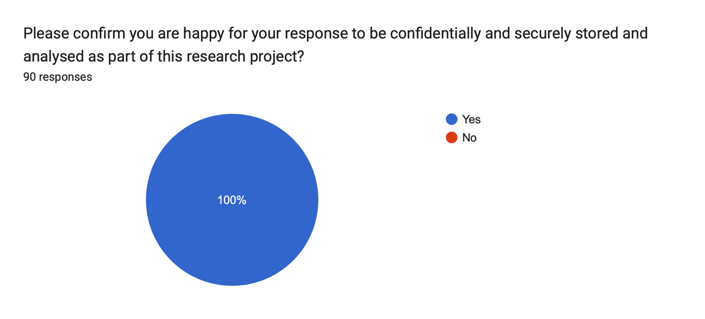

The opening question of the questionnaire served as a strategic measure to obtain formal consent from the participants. In terms of research ethics, informed consent is one of the essential principles, as illustrated by Loughborough University (2024). Consents’ intent is to ensure that human participants can freely and voluntarily engage in research, fully understanding the implications of their participation, and without any form of explicit or implicit pressure (Manandhar and Joshi (2020).
Participants were asked to, “Please confirm you are happy for your response to be confidentially and securely stored and analysed as part of this research project.” Indeed, as demonstrated in the figure above, all ninety individuals provided their consent and proceeded with participation, permitting their date to be used within the study.

Figure 4.3.2. - Question 2
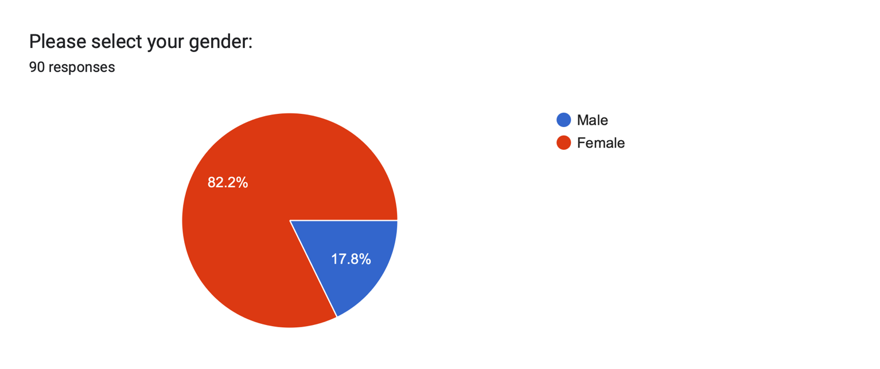

The second question of the questionnaire was designed to determine the gender of participants. This is crucial for multiple reasons, for example, providing a clear understanding of the demographic composition, ensuring the inclusivity of the study, and enabling researchers to analyse how gender may influence various dimensions of the research (University of Oxford, 2023).
As depicted in the figure above, 82.2% of the ninety participants identified as female, whereas 17.8% identified as male, highlighting a significant gender distribution within the sample. This could be influenced by several factors, particularly in the context of a research proposal focusing on online abuse. One possible explanation is that women are twenty-seven times more likely to experience online harassment than men (Storry and Poppleton, 2022), potentially leading to a higher participation rate among women, who are perhaps more likely to engage in research tailored to this issue. It is important, however, to note that platforms used to distribute the questionnaire may have also reached a higher proportion of female participants, influencing the gender breakdown.

Figure 4.3.3. - Question 3
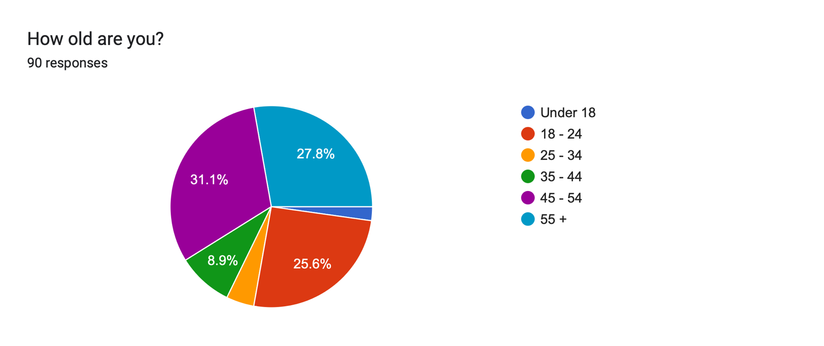

The third question aimed to determine the age group of the participants, enabling the researcher to identify potential trends and patterns related to age in the context of the study. The predefined age categories ranged from 18 to 55 years and older. Notably, the largest proportion of respondents, comprising 31.1%, fell within the 45 – 54 age bracket, whilst only two participants (2.2%) were aged under 18.
This discrepancy may be due to recruitment challenges, particularly the requirement outlined in the consent form stipulating that those under the age of 18 must obtain parental consent prior to participation. Such a requirement, while ethically necessary to ensure the protection of minors (Department for Education, 2023), may have inadvertently created a barrier, including lack of parental availability, timely parental approval, or parental reluctance to permit their children’s involvement in the research.

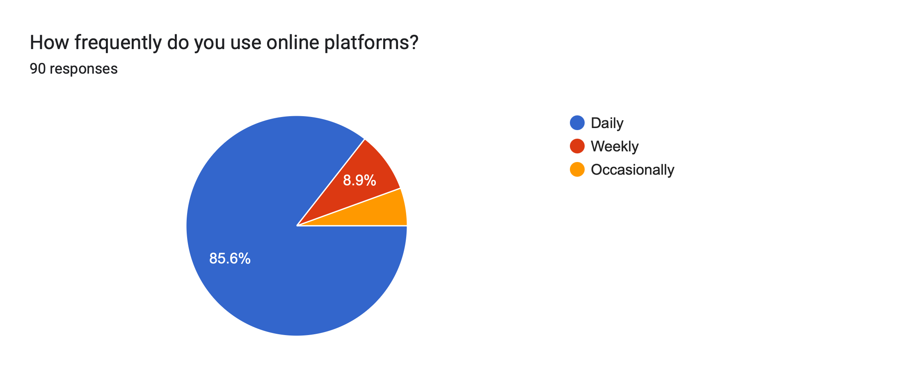
Figure 4.3.4. - Question 4

The fourth question of the questionnaire aimed to evaluate the frequency with which participants engaged with online platforms, including social networking sites like Facebook and Snapchat, payment systems such as PayPal, and collaborative economy platforms like Airbnb and Uber (UK Parliament, 2019). The findings revealed that 85.6% of individuals reported daily usage of online platforms, 8.9% reported weekly usage, and 5.6% stated that they utilise such platforms occasionally.
Given that ninety-two percent of the United Kingdom’s population actively used the internet in 2024 (Office for National Statistics, 2024), these outcomes are consistent with broader, national trends and emphasise the pivotal role of online platforms in contemporary society. The pervasive integration of digital platforms into daily life, underscores their central role in interpersonal communication, social interaction, and commerce. However, this extensive usage also increases exposure to potential risks, including online abuse.
.

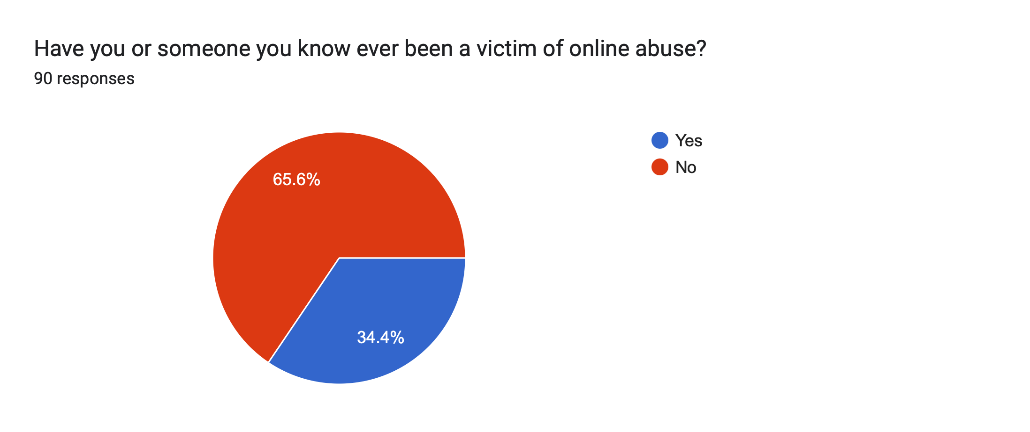
Figure 4.3.5. - Question 5

The fifth question aimed to ascertain whether participants, or individuals within their social or professional circles, had experienced online abuse.
This question was designed to capture both direct and indirect exposure to such incidents, thereby providing a broader understanding of the prevalence and reach of online abuse. By including experiences of individuals known to the participants, the question acknowledges the ripple effects of online abuse, where its impact extends beyond the direct victim to their acquaintances, family members, and colleagues (End Violence Against Women, 2020).
A significant proportion of respondents (34.4%) reported having direct or indirect experience with online abuse, either as victims themselves or through individuals within their personal or professional networks, highlighting the widespread nature of this issue. This statistic is important because it highlights that nearly one-third (1 in 3) of individuals have either personally encountered online abuse or know someone who has.

Question 6

The sixth question asked, “What specific forms of online abuse were experienced by you or the individual you know? Examples may include cyberbullying, harassment, threats, hate speech, sextortion, stalking, doxing, or other types of digital exploitation”.
This question provides a comprehensive analysis of the types of online abuse reported by 27 participants in this study, as it was presented exclusively to respondents who had answered “yes” to the preceding question.

Based on the responses collected, several key forms of online abuse were identified, each contributing to the overall understanding of the prevalence and impact of online abuse.
The following categories emerged as the most prevalent:

- Cyberbullying – Out of 27 individuals, cyberbullying was mentioned by 11 of them, resulting the most frequently cited form of abuse.
Participants described being targeted by persistent, harmful online behaviours, such as abusive messages and offensive comments. A recurring theme across this account was the intentional circulation of false information and derogatory mocking, aimed at damaging the individual’s reputation or emotional well-being. For example, one participant recounted an instance of online trolling after making a civil comment on a political post, leading to a flood of hostile defamatory responses.

- Threats – Threatening behaviour, whether in the form of physical harm or emotional distress, was another prominent type of online abuse, reported by 9 participants. Participants reported receiving hateful messages such as, “I hope you die soon”, via WhatsApp. This is a direct and explicit example of online hate speech and are often targeted at individuals due to their identity, such as race, religion, sexual orientation, or disability (Gwent Safeguarding, 2022).

- Sextortion – Sextortion, a form of image-based sexual abuse (Metropolitan Police, 2023), emerged as a further notable concern among participants. To extort money or coerce someone into doing something against their will, this type of exploitation typically entails the threat of sharing images or videos, often ‘nudes’ (France, 2022). One participant stated that have been a victim of sextortion, but “didn’t report due to stigma and fear of exposure”.

Figure 4.3.6 - Question 7
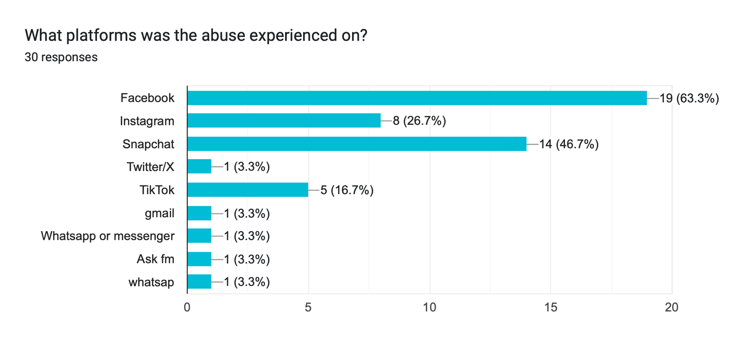

The seventh question aimed to determine where participants experienced online abuse. Again, this question was presented exclusively to respondents who had answered “yes” to question six.
It is evident to note that Facebook emerged as the platform with the highest reported instances of online abuse, accounting for nearly two-thirds (63.3%) of the responses. This could be due to several factors, including its larger user base, which exceeds 3.7 billion monthly active users worldwide (Dixon, 2024). As one of the most widely used social media platforms, Facebook facilitates interactions across diverse demographic groups, which can amplify the risk of conflict, harassment, or exploitation.
Furthermore, nearly half of the participants (46.7%) reported Snapchat as the platform where they experienced online abuse. This aligns with findings from the National Society for the Prevention of Cruelty to Children (NSPCC, 2024), which revealed that over 7000 Sexual Communication with a Child offences were recorded by police in 2023/24, with Snapchat accounting for nearly half of these cases. Snapchat’s unique features, such as disappearing messages and location-sharing capabilities (Snapchat, 2024), may significantly contribute to its appeal for abusive behaviour, inherently affording a sense of anonymity, while simultaneously diminishing the retention of evidence (Sanderson and Weathers, 2020).
Instagram accounted for 26.7% of the reported cases of online abuse. While this proportion is lower compared to platforms such as Facebook and Snapchat, it nevertheless highlights Instagram’s notable role as a platform for harmful online interactions.
Instagram’s emphasis on visual media, such as photos and videos, makes it susceptible to image-based abuse, such as photo manipulation and sextortion (Are, 2024).

Platforms such as Gmail and Ask.fm each accounted for 3.3% of reported online abuse cases, while WhatsApp was slightly higher at 6.6%. While these figures are comparatively lower than those associated with major social media platforms, they underscore the pervasive nature of online abuse across a diverse range of digital environments. The presence of abusive behaviour on platforms designed primarily for private communication, such as WhatsApp and Gmail, or niche social interaction, like Ask.fm, suggests that no digital space is entirely immune to harmful activities.

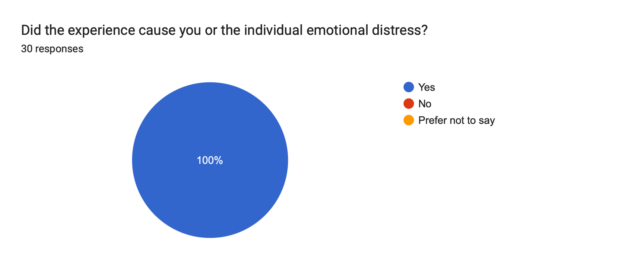
Figure 4.3.7 - Question 8

Question 8, which aimed to determine whether the online abuse caused emotional distress to the participant, or the individual involved, yielded a unanimous response of “yes”. This question was, again, directed at participants who had previously identified as victims of online abuse in question 6.
In parallel, further research compiled by Dr Madeline Storry and Dr Sarah Poppleton (2022), on behalf of the Victim’s Commissioner, involved a detailed survey of 500 individuals. Titled, ‘The Impact of Online Abuse: Hearing the Victims’ Voice’, this study provides valuable insights into experiences and perspectives of those affected by online abuse.
Consistent with these findings, almost all victims of online abuse reported experiencing some form of harm, with 91% indicating that the abuse had a noticeable impact on their wellbeing (Baird, 2022).

Question 9

The nineth question asked, “Did you or the individual report the incident of online abuse? If so, how effective was the response?”. Again, this question was presented exclusively to respondents who had answered “yes” to question six.
The responses highlight the varied experiences individuals had when seeking to address online abuse. Of the 30 responses provided, 23% (7 responses), described situations where the abuse was reported but not effectively addressed. For example, one participant emphasised that their complaint was dismissed with an explanation, “the content did not violate community standards”. Indeed, this sentiment was further echoed by others who noted that they were either ignored or not taken seriously, highlighting that social media platforms’ reporting systems are often ineffective.
Additionally, 17% (5 responses) described situations in which the abuse was reported through formal legal systems, such as the police, court hearings, etc., but again, the responses were inadequate or not followed up. One respondent shared that despite their case being reported as part of a court case, the offender continued their harmful actions, and no meaningful legal intervention occurred.
Furthermore, 33% (10 responses) of participants stated that they did not report the abuse at all, primarily due to perceptions of ineffectiveness or a lack of trust in the reporting systems. The participants expressed significant frustration, with some indicating that their negative experiences had led them to disengage entirely from reporting mechanisms.

On the other hand, 17% reported having positive or neutral experiences, with one participant praising TikTok’s effectiveness in handling abuse. Others stated that their experience was formally logged and shared with authorities, such as the police and social services, although outcomes varied. In one case, a restraining order was issued, although it did not fully prevent the continuation of abusive behaviour.

Figure 4.3.8. Question 10
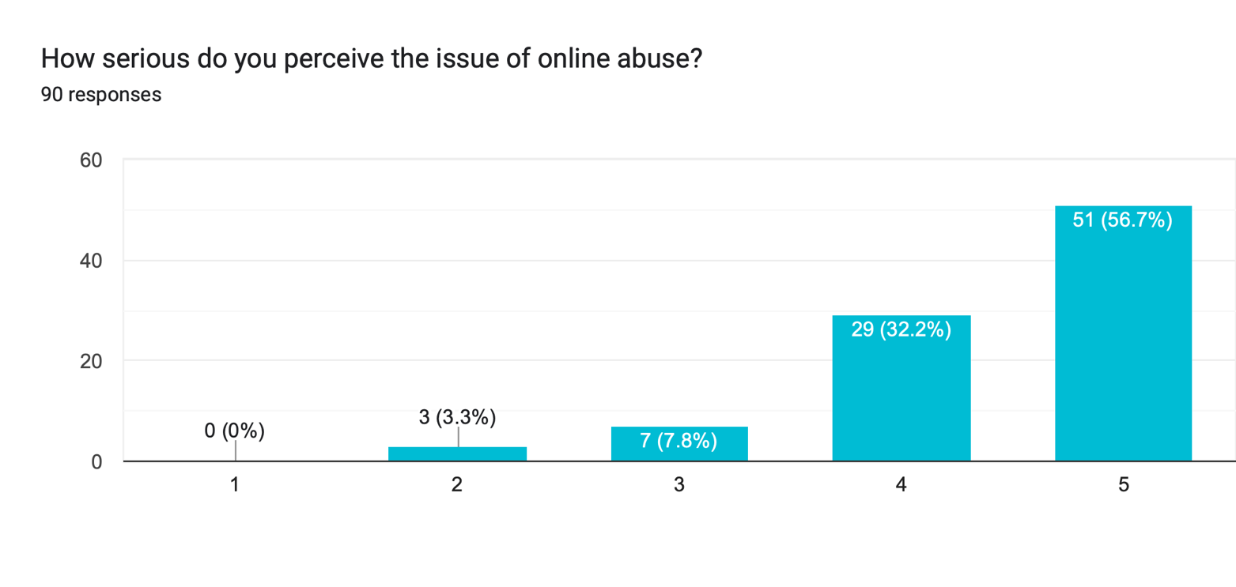

Question 10 explored the perceived seriousness of online abuse on a scale from 1 (not serious) to 5 (very serious) and was posed to all 90 participants.
Evidently, none of the participants rated the issue as “not serious” (1), demonstrating a universal acknowledgment of its importance. Only a small minority rated it as “2” (3.3%) or “3” (7.8%), suggesting that relatively few participants view online abuse as a moderately serious issue.

Most participants rated the seriousness of online abuse as either “4” (32.2%) or “5” (56.7%), with over half of the participants selecting the highest level of seriousness. This distribution highlights a prevalent perception of online abuse as a critical issue, with a combine 88.9% of participants regarding online abuse as serious or very serious.

Question 11

Question 11 posed, “Do you believe victims of online abuse feel confident in seeking help from law enforcement (police)? Why or why not?”. The responses reveal a pervasive lack of trust and significant barriers to reporting. Of the 88 responses analysed, the overwhelming majority expressed doubt, scepticism, or outright lack of confidence in the police’s ability or willingness to address cases of online abuse effectively.
A recurrent theme was that victims feel their cases would be deprioritised compared to more tangible or sever crimes, such as burglary or assault.
- “Victims feel going to the police will not help their situation”.
- “Police would deprioritise this case in comparison to active forms of law enforcement like burglary”.
Furthermore, embarrassment and fear of retaliation from abusers were commonly cited reasons for victims’ reluctance to involve law enforcement.
- “The victim is afraid of involving the police due to fear of repercussions from the abuser.”
- “Many would feel it was their own fault or too embarrassed to report it.”

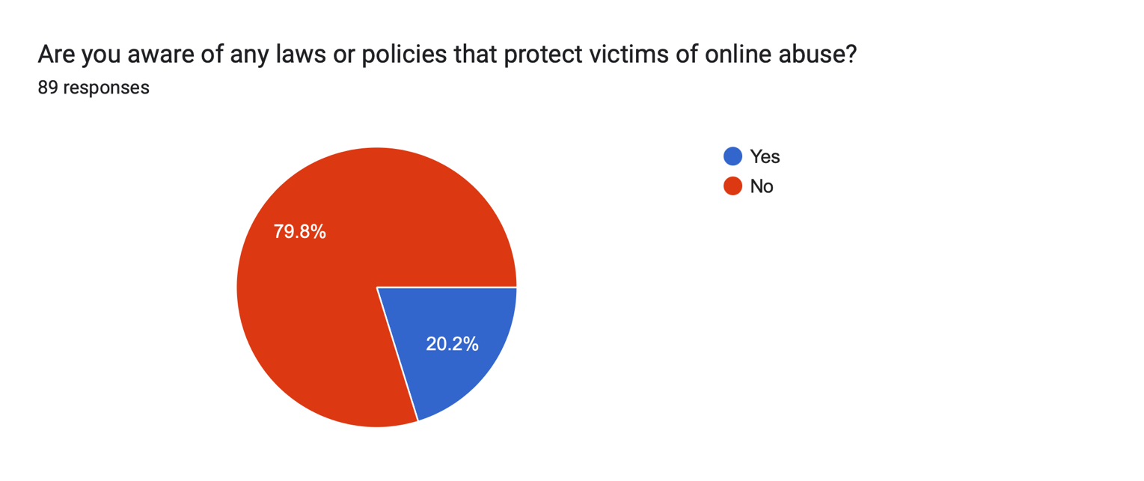
Figure 4.3.9. - Question 12

Question 12 investigated whether participants were aware of any laws or policies that protect victims of online abuse. The survey responses indicate that most participants (79.8%) are unaware of any laws or policies designed to protect victims of online abuse.
In contrast, only a minority (20.2%) reported being aware of such protections. This disparity suggests a significant gap in public knowledge and highlights potential shortcomings in the communication and visibility of legal frameworks addressing online abuse.

Question 13
Question 13 built upon the findings of Question 12, and specifically asked the 20 participants who indicated awareness of laws and policies to detail which ones they were familiar with.
Among the 16 responses from participants, a range of perspectives were shared, reflecting varying levels of understanding. While some participants demonstrated familiarity with specific legislation, others expressed only a general awareness of protections or limited knowledge of their effectiveness. The Communications Act 2003 and Malicious Communications Act 1988 were mentioned multiple times. These acts criminalise the sending of offensive, indecent, or threatening messages (Crown Prosecution Service, 2022).
A few participants expressed awareness that online abuse can lead to legal consequences, though their understanding lacked specificity. This suggests a surface-level familiarity with the idea of legal protections rather than detailed knowledge.

- “I’m pretty sure there can be consequences for online abuse.”
- It’s illegal to video or talk about abuse on social media”.

Figure 4.3.10. - Question 14
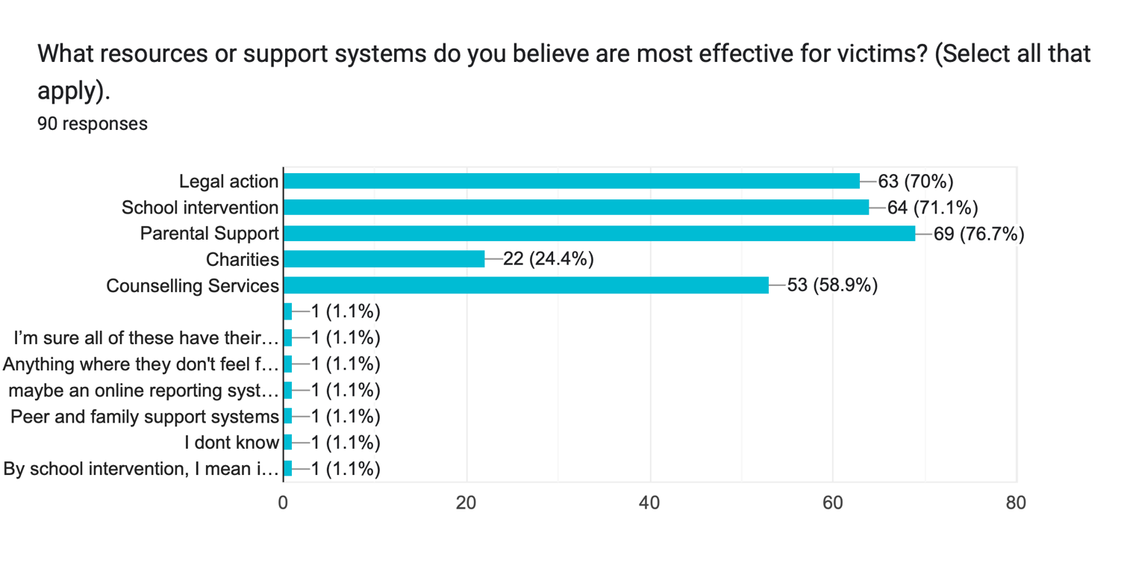

The final question of the questionnaire explored what resources or support systems are most effective for victims of online abuse and were asked to select all that applied.
Parental support emerged as the most favoured resource among participants, with over 70% of respondents highlighting its importance. This finding underscores the pivotal role that family involvement plays in addressing online abuse.
As noted by NSPCC (2024), parental support is essential in creating a safe space for children to openly discuss their experiences, offering emotional guidance, and empowering them to act against abuse. Similarly, school intervention was recognised as a highly effective support system, as schools not only provide a structured support system for educating students about online abuse safety, but also offer resources like counselling services (National Education Union, 2024). Indeed, professional counselling is also considered an effective resource, at 58.9%. According to Mind (2023) counselling plays a critical role in helping victims manage the trauma associated with online abuse, providing the, with the emotional support needed to heal and regain confidence.

Conclusion (800)

Reference List
- Ahmed, I. and Ishtiaq, S. (2021). Reliability and validity: Importance in Medical Research. The Journal of the Pakistan Medical Association, [online] 71(10), pp.2401–2406. doi:https://doi.org/10.47391/JPMA.06-861.

- Allanson, P., Lester, R., Riley, R. and Notar, C. (2015). A History of Bullying. International Journal of Education and Social Science. Available at: https://ijessnet.com/wp-content/uploads/2022/10/5-16.pdf [Accessed 17 Apr. 2025].

- Are, C. (2024). Flagging as a silencing tool: Exploring the relationship between de-platforming of sex and online abuse on Instagram and TikTok. New Media & Society. https://doi.org/10.1177/14614448241228544 [Accessed 29 Apr. 2025].

- Azorin, J.M. and Cameron, R. (2010). The Application of Mixed Methods in Organisational Research: A Literature Review. Electronic Journal of Business Research Methods, [online] 8(2), pp.pp95-105–pp95-105. Available at: https://academic-publishing.org/index.php/ejbrm/article/view/1257 [Accessed 1 May 2025].

- Azungah, T. (2018). Qualitative research: Deductive and Inductive Approaches to Data Analysis. Qualitative Research Journal, 18(4), pp.383–400. doi:https://doi.org/10.1108/QRJ-D-18-00035. [Accessed 29 Apr. 2025].

- Baird, V. (2022). The Impact of Online Abuse: Hearing the Victims’ Voice. Victims Commissioner. Available at: https://victimscommissioner.org.uk/document/the-impact-of-online-abuse-hearing-the-victims-voice/ [Accessed 29 Apr. 2025].

- Berndt, A.E. (2020). Sampling Methods. Journal of Human Lactation, 36(2), pp.224–226. doi:https://doi.org/10.1177/0890334420906850.

- Black, L. (2025). Online Harassment: The Normalization of Digital Abuse. Available at: https://medium.com/@abuserefuge/online-harassment-the-normalization-of-digital-abuse-7e9aa6db211f [Accessed 6 May 2025].

- Citron, D.K. (2016). Hate Crimes in Cyberspace — Harvard University Press. Harvard University Press. Available at: https://www.hup.harvard.edu/books/9780674659902 [Accessed 6 May 2025].

- Crown Prosecution Service (2022). Communications Offences | The Crown Prosecution Service. Available at: https://www.cps.gov.uk/legal-guidance/communications-offences [Accessed 29 Apr. 2025].

- Delener, N. (2012). Service science research, strategy and innovation : dynamic knowledge management methods. Business Science Reference. https://doi.org/10.4018/978-1-46660-077-5 [Accessed 29 Apr. 2025].
- Dennehy, R., Meaney, S., Cronin, M. and Arensman, E. (2020). The psychosocial impacts of cybervictimisation and barriers to seeking social support: Young people’s perspectives. Children and Youth Services Review, 111, p.104872. doi: https://doi.org/10.1016/j.childyouth.2020.104872.

- Department for Education (2023). Research With Children and Young People. Department for Education User Research Manual. Available at: https://user-research.education.gov.uk/guidance/ethics-and-safeguarding/research-with-children-and-young-people.

- Department for Science, Innovation and Technology (2025). Online Safety Act: explainer. GOV.UK. Available at: https://www.gov.uk/government/publications/online-safety-act-explainer/online-safety-act-explainer [Accessed 17 Apr. 2025].

- Dixon, S. (2024). Facebook users by country | Statistic. Available at: https://www.statista.com/statistics/268136/top-15-countries-based-on-number-of-facebook-users/ [Accessed 28 Apr. 2025].

- End Violence Against Women (2020). THE RIPPLE EFFECT COVID-19 AND THE EPIDEMIC OF ONLINE ABUSE. Available at: https://www.endviolenceagainstwomen.org.uk/wp-content/uploads/Glitch-and-EVAW-The-Ripple-Effect-Online-abuse-during-COVID-19-Sept-2020.pdf [Accessed 28 Apr. 2025].

- Fisher, B.W., Gardella, J.H. and Teurbe-Tolon, A.R. (2016). Peer Cybervictimization Among Adolescents and the Associated Internalizing and Externalizing Problems: A Meta-Analysis. Journal of Youth and Adolescence, 45(9), pp.1727–1743. doi: https://doi.org/10.1007/s10964-016-0541-z.

- France, G. (2022). Criminalising sextortion: challenges and alternatives. [online] p.12. Available at: https://www-jstor-org.ezproxy.uwtsd.ac.uk/stable/resrep41907?sid=primo&seq=1 [Accessed 28 Apr. 2025].

- Geach, N. and Haralambous, N. (2009). Regulating Harassment: Is the Law Fit for the Social Networking Age? The Journal of Criminal Law, 73(3), pp.241–257. doi: https://doi.org/10.1350/jcla.2009.73.3.57.

- Gwent Safeguarding (2022). Online Hate Speech - A Guide for General Public. [online] Available at: https://www.gwentsafeguarding.org.uk/assets/en-documents/Online-Hate-Speech-A-Guide-for-General-Public.pdf[Accessed 28 Apr. 2025].

- Hinduja, S. and Patchin, J. (2014). Cyberbullying: Identification, Prevention, & Response. Available at: https://cyberbullying.org/Cyberbullying-Identification-Prevention-Response.pdf [Accessed 17 Apr. 2025].

- Heale, R. and Twycross, A. (2015). Validity and Reliability in Quantitative Studies. Evidence Based Nursing, 18(3), pp.66–67. doi:https://doi.org/10.1136/eb-2015-102129.

- Home Office (2024). Hate crime, England and Wales, year ending March 2024. Available at: https://www.gov.uk/government/statistics/hate-crime-england-and-wales-year-ending-march-2024/hate-crime-england-and-wales-year-ending-march-2024.

- Jansen, D. and Warren, K. (2020). What is research methodology? Available at: https://gradcoach.com/what-is-research-methodology/ [Accessed 29 Apr. 2025].

- Jones, T., Baxter, M. and Khanduja, V. (2013). A Quick Guide to Survey Research. The Annals of the Royal College of Surgeons of England, [online] 95(1), pp.5–7. doi:https://doi.org/10.1308/003588413X13511609956372.

- Loughborough University (2024). Informed Consent | Research Ethics and Integrity | Loughborough University.Available at: https://www.lboro.ac.uk/internal/research-ethics-integrity/research-ethics/guidance-investigators/informed_consent/. (Accessed: 28 April 2025).

- Malicious Communications Act (1988). Available at: https://www.legislation.gov.uk/ukpga/1988/27/section/1 [Accessed 18 Apr. 2025].

- Naresh Manandhar, D., & Sunil Kumar Joshi, P. (2020). Importance of consent in the research. International Journal of Occupational Safety and Health, 10(2). doi: https://doi.org/10.3126/ijosh.v10i2.33284 [Accessed: 28 April 2025].

- National Education Union (2024). Cyberbullying in schools | National Education Union. Available at: https://neu.org.uk/advice/your-rights-work/safeguarding/harassment-and-bullying/cyberbullying-schools [Accessed 6 May 2025].

- Mortelmans, D. (2024). Doing Qualitative Data Analysis with NVivo.(1st ed.). Springer.

- Nash, V. and Felton, L. (2023). Expert Comment: Online Safety Bill - a missed opportunity? University of Oxford.Available at: https://www.ox.ac.uk/news/2023-02-07-expert-comment-online-safety-bill-missed-opportunity[Accessed 17 Apr. 2025].

- Nixon, C. (2014). Current perspectives: the impact of cyberbullying on adolescent health. National Library of Medicine. Available at: https://pmc.ncbi.nlm.nih.gov/articles/PMC4126576/ [Accessed 17 Apr. 2025].

- NSPCC (2024). Online grooming crimes against children increase by 89% in six years. Available at: https://www.nspcc.org.uk/about-us/news-opinion/2024/online-grooming-crimes-increase/ [Accessed 28 Apr. 2025].

- NSPCC (2024b). Preventing online harm and abuse. Available at: https://learning.nspcc.org.uk/online-safety/preventing-online-abuse-and-harm [Accessed 29 Apr. 2025].

- Ofcom (2021). Children and parents: media use and attitudes report 2020/21. Available at: https://www.ofcom.org.uk/media-use-and-attitudes/media-habits-children/children-and-parents-media-use-and-attitudes-report-2021 [Accessed 17 Apr. 2025].

- Office for National Statistics (2020). Online bullying in England and Wales - Office for National Statistics. Available at: https://www.ons.gov.uk/peoplepopulationandcommunity/crimeandjustice/bulletins/onlinebullyinginenglandandwales/yearendingmarch2020[Accessed 17 Apr. 2025].

- Online Safety Act (2023). Available at: https://www.legislation.gov.uk/ukpga/2023/50 [Accessed 18 Apr. 2025].

- Public Health England (2014). Cyberbullying: An analysis of data from the Health Behaviour in School-aged Children (HBSC) survey for England, 2014. Available at: https://assets.publishing.service.gov.uk/media/5a82150b40f0b62305b92623/Health_behaviour_in_school_age_children_wellbeing_of_adolescent_girls.pdf[Accessed 14 Apr. 2025].

- Ramos Salazar, L. (2021). Handbook of research on cyberbullying and online harassment in the workplace (L. Ramos Salazar, Ed.). IGI Global. https://doi.org/10.4018/978-1-7998-4912-4
- Royal Academy of Engineering (2025). The Difference between open-ended and Closed Questions. Available at: https://raeng.org.uk/programmes-and-prizes/programmes/uk-grants-and-prizes/ingenious-public-engagement-grants-scheme/evaluation/the-difference-between-open-ended-and-closed-questions [Accessed 5 May 2025].

- Sanderson, J., & Weathers, M. R. (2020). Snapchat and child sexual abuse in sport: Protecting child athletes in the social media age. Sport Management Review, 23(1), 81–94. doi: https://doi.org/10.1016/j.smr.2019.04.006. [Accessed 5 May 2025].

- Schmidt, F., Varese, F. and Bucci, S. (2023). Understanding the prolonged impact of online sexual abuse occurring in childhood. Frontiers in Psychology, 14. doi:https://doi.org/10.3389/fpsyg.2023.1281996. [Accessed 5 May 2025].

- Snapchat (2024). Snapchat Transparency Report | Snapchat Transparency. Available at: https://values.snap.com/privacy/transparency?lang=en-GB [Accessed 28 Apr. 2025].

- Storry, M. and Poppleton, S. (2022). Impact of online abuse and harassment revealed in new research from the Victims’ Commissioner. Available at: https://victimscommissioner.org.uk/news/impact-of-online-abuse-and-harassment-revealed-in-new-research-from-the-victims-commissioner/ [Accessed 28 Apr. 2025].

- Turner, D. (2016). Snapshot data and longitudinal qualitative studies. [online] Quirkos Qualitative Research Blog. Available at: https://www.quirkos.com/blog/post/snapshot-qualitative-data-longitudinal-studies/ [Accessed 1 May 2025].

- University of Bath (2024). Sampling in research. Available at: https://www.bath.ac.uk/guides/sampling-in-research/ [Accessed 5 May 2025].

- University of Oxford (2023). Gender identity survey questions. Available at: https://edu.admin.ox.ac.uk/gender-identity-survey-questions [Accessed: 28 April 2025].

- UK Parliament (2019). Written questions and answers - Written questions, answers, and statements - UK Parliament. Available at: https://questions-statements.parliament.uk/written-questions/detail/2019-09-25/290567? [Accessed 6 May 2025].
- Wang, X. and Cheng, Z. (2020). Cross-sectional studies: Strengths, weaknesses, and Recommendations. Chest, 158(1), pp.65–71. doi:https://doi.org/10.1016/j.chest.2020.03.012.

- Wasti, S.P., Simkhada, P., Teijlingen, E. van , Sathian, B. and Banerjee, I. (2022). The Growing Importance of mixed-methods Research in Health. Nepal Journal of Epidemiology, [online] 12(1), pp.1175–1178.

Appendices
Appendix A – Survey



