

University of Wales Trinity Saint David
School of Engineering - Logistics and Supply Chain Management

Module: Statistics for Logistics M4X02177
Understanding Statistics Methods Application.  and R charts

Student: Georgiana Florina Cune

Contents

1. Introduction 1
2. Statistical Quality Control – Statistical Process Control 1
3. Control Charts (X-bar, R-bar) 2
4. Case study 2
5. Considerations on the control chart 5
6. Conclusion 6

Abstract
Statistical process control (SPC) is used and implemented by companies to evaluate the manufacturing process using statistics or statistical methods. Control charts are measurement tools employed to provide a decision if the variation output is in control due to common causes or is out of control due to special causes.
Key words: Statistical Process Control, Control Charts, -Chart, R-Chart.

Introduction
This essay discuses about the statistical process control as a method for the quality control in the production processes.
In the production operations, not all the products result in the desirable quality standard, mostly because of the physical factors involved in the production process such as worn tools in the machines, defects into the purchased materials and mistakes of the human operators. For this purpose, methods are available to check the production output in the early stages and to decide whether the process should be continued or whether it can be adjusted and corrected in order to obtain the quality level (Dow Chemicals, U.S.A., 2017).
Statistical process control (SPC) is used to monitor the manufacturing process using statistics or statistical methods (Dale et al., 2007).

Statistical Quality Control – Statistical Process Control

SPC is applied to almost any process to determine if it operates in the most efficient way with minimum waste and less errors. Data is collected and is used to make decisions about the best possible method to improve the operations (Connelly L., 2019). Companies use many tools to evaluate the quality and productivity of its processes. The most used tools are represented by the control charts, used to monitor and control any occurrences during the process performance.
According to Dale et al. (2007), there are four main applications for the Statistical Process Control:
- To establish the output stability
- To understand and provide information on how the operation process may be improved by reducing the variation within the process and keep it under control
- To analyse the execution of a process
- To provide adequate information for the decision-making management.
The process control procedures are based on hypothesis testing methodology. Charts provide tests of the hypothesis that the process is in control. The null hypothesis H0 refers to the process being in control and the alternative hypothesis refers to the process being out of control. A detailed understanding of the hypothesis outcomes is presented in figure 1.
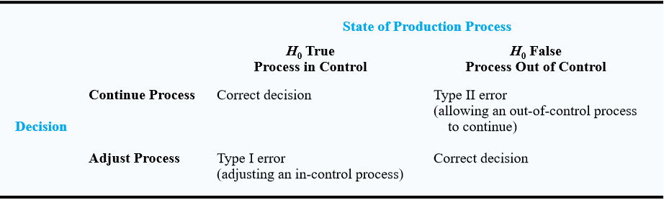
Figure 1. The outcomes of the Statistical Process Control (Source in Dow Chemicals, U.S.A., 2017).

Control Charts (X-bar, R-bar)

An X-bar chart or simply,  is used if the quality of the production measures variables on a continuous scale such as weight, length, diameter, temperature and other. The variables chart determines if the production process will be continued or just adjusted, based on the value of the mean calculated in samples of the output. The most common control charts use the sample mean, the sample standard deviation or the sample range to record the variability of the process. This paper focuses on the X-bar and R-bar chart, one of the most commonly used by organizations.

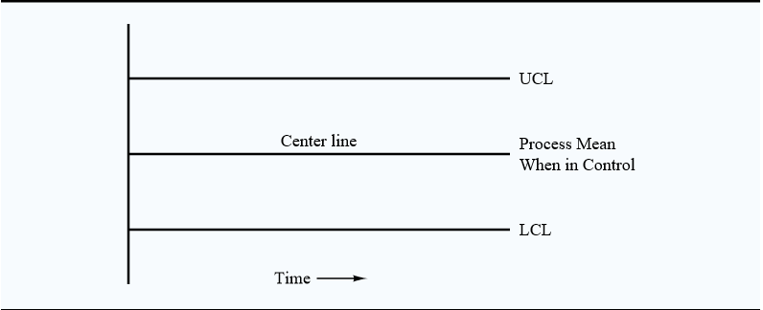
Figure 2. -bar and R-bar Chart Structure (Source in Dow Chemicals, U.S.A., 2017).
Grant and Leavenworth (2007) argue that the adaptation of the control-chart technique by organizations is often a source of confusion due to the large choice of the right variables which are often chosen in regard of the opportunities for saving costs and not as a type of saving accepted as a real saving. This usually refers on start choosing the variables where ‘the spoilage and rework costs are high’ (Grant and Leavenworth, 2007, p. 40).

Case study
An example, adapted from a manufacturer, with slight modifications and simplified to give a better understanding of the construction of a -chart and R-chart. The company Rostim Ltd. produces handbrake spring clips in a continuously manufacturing process. The diameter of the parts is specified as Φ7.8 ± 0.15 mm. It is essential that the handbrake spring clip’s diameter be at least Φ7.65 mm and maximum Φ7.95 mm. The company called one decision - to apply the method of subgrouping 5 random samples of parts every half hour of operation for 8 hours, and the size and frequency of every sample in one hour to use the  and R charts. Table 1 provides the diameter of each sampled part, the mean , and range R for each part of the sample.

 AND R CONTROL CHART DATA SHEET
Product Handbrage spring clips |  |  |  | Dep No. 20 |  | Order No. 11233
Characteristic Diamenter of the spring clip
Specified limits Φ7.8 ± 0.15 mm.
Subgroup No. | 1 | 2 | 3 | 4 | 5 | 6 | 7 | 8 |  |  | R
a | 2.6955 | 2.9750 | 2.5670 | 2.7660 | 2.7750 | 2.6780 | 2.8090 | 2.7755 | 1 | 2.7193 | 0.2410
b | 2.6850 | 2.8865 | 2.6560 | 2.9565 | 2.8100 | 2.8225 | 2.6655 | 2.8900 | 2 | 2.8927 | 0.3015
c | 2.6540 | 2.9800 | 2.6650 | 2.7695 | 2.8000 | 2.8355 | 2.6770 | 2.5600 | 3 | 2.5904 | 0.2110
d | 2.667 | 2.6785 | 2.6670 | 2.8890 | 2.9550 | 2.7700 | 2.8850 | 2.8700 | 4 | 2.8118 | 0.2785
e | 2.8950 | 2.9435 | 2.6970 | 2.6780 | 2.8560 | 2.6750 | 2.7150 | 2.6780 | 5 | 2.8392 | 0.1800
Total | 13.597 | 14.464 | 13.252 | 14.059 | 14.196 | 13.781 | 13.752 | 13.774 | 6 | 2.7562 | 0.1605
Average,  | 2.7193 | 2.8927 | 2.6504 | 2.8118 | 2.8392 | 2.7562 | 2.7503 | 2.7547 | 7 | 2.7503 | 0.2195
Range, R | 0.2410 | 0.3015 | 0.1300 | 0.2785 | 0.1800 | 0.1605 | 0.2195 | 0.3300 | 8 | 2.7547 | 0.3300
Date or time | 07:00 | 07:30 | 08:00 | 8:30 | 9:00 | 9:30 | 10:00 | 10:30 | 9 | 2.8630 | 0.2950
Subgroup No. | 9 | 10 | 11 | 12 | 13 | 14 | 15 | 16 | 10 | 2.7538 | 0.3400
a | 2.9950 | 2.6670 | 2.8080 | 2.8830 | 2.7900 | 2.8500 | 2.6950 | 2.8125 | 11 | 2.7273 | 0.1430
b | 2.8900 | 2.8900 | 2.6785 | 2.6800 | 2.7150 | 2.8150 | 2.8150 | 2.7655 | 12 | 2.7862 | 0.2030
c | 2.7000 | 2.7950 | 2.6650 | 2.7780 | 2.7700 | 2.7950 | 2.7680 | 2.6890 | 13 | 2.7540 | 0.1450
d | 2.8500 | 2.5500 | 2.6950 | 2.8000 | 2.6750 | 2.7760 | 2.7125 | 2.6800 | 14 | 2.8232 | 0.1040
e | 2.8800 | 2.8670 | 2.7900 | 2.7900 | 2.8200 | 2.8800 | 2.7125 | 2.7850 | 15 | 2.7406 | 0.1200
Total | 14.315 | 13.769 | 13.637 | 13.931 | 13.770 | 14.116 | 13.703 | 13.732 | 16 | 2.7464 | 0.1325
Average,  | 2.863 | 2.7538 | 2.7273 | 2.7862 | 2.754 | 2.8232 | 2.7406 | 2.7464 |  |  | R
Range, R | 0.295 | 0.34 | 0.143 | 0.203 | 0.145 | 0.104 | 0.120 | 0.1325 | Total | 44.309 | 3.4045
Date or time | 11:00 | 11:30 | 12:00 | 12:30 | 13:00 | 13:30 | 14:00 | 14:30
Table 1. X-bar and R-bar data sheet for the production of handbrake spring clips in Rostmi Ltd.
The average for each subgroup i was calculated based on formula (1) by summing each measurement in the subgroup and dividing it by the number of measurements. The overall sample mean, -bar or $\overline{\overline{X}}$ for the chart was calculated using formula (2), by summing the averages of each subgroup and dividing by the total number of subgroups.
$$\overline{X_{i}}=\sum_{j=i}^{\dot{n}}{\frac{X_{ij}}{n}}$$
Formula (1). (Grant and Richard, 1999)
$$\overline{\overline{X}}=\sum_{i=1}^{n}{\frac{\overline{X_{i}}}{k}}$$
Formula (2). (Grant and Richard, 1999)
Where, n – number of samples in each subgroup and k is the number of subgroups.
The subgroup range is calculated by subtracting the lowest value from the highest value-formula (3), and the R-bar is determined by the sum of subgroups range values divided by the number of subgroups - formula (4).
R_{i}= X_{i, max} – X_{i, min}
Formula (3) (Grant and Richard, 1999)
$$\overline{R}=\sum_{i=1}^{k}{\frac{R_{i}}{k}}$$
Formula (4) (Grant and Richard, 1999)
For the Rostim Ltd. data in Table 1, the overall sample mean, $\overline{\overline{X}}$ is 2.7693 representing the centreline for the chart and the average range $\overline{R}$ or R-bar is 0.2128. After the production order was completed with the 16 subgroups, the trial control limits were obtained, using formulas (5), (6), (7), (8), where A₂, D₄, D₃ are factors adapted from speciality tables on Control Chart Factors (Grant and Leavenworth, 1999, p.718). The UCL and LCL require future modifications before being applied to upcoming production.
UCL = $\overline{\overline{X}}$ + A₂$\overline{R}$ (5)
LCL = $\overline{\overline{X}}$ – A₂$\overline{R}$ (6)
UCLR = D₄$\overline{R}$ (7)
LCLR = D₃$\overline{R}$ (8)
When the control limits were determined for both, mean of the sample means and average range, the following values were obtained:
-bar, $\overline{\overline{X}}$= 44.309 / 16 = 2.7693
R-bar, $R= 3.4045$ / 16 = 0.2128
UCL= $\overline{\overline{X}}$ + A₂$\overline{R}$ = 2.7693 + 0.58(0.2128) = 2.8927
LCL = $\overline{\overline{X}}$ – A₂$\overline{R}$ = 2.7693 – 0.58(0.2128) = 2.6459
UCL_{R} = D₄$\overline{R}$ = 2.11(0.2128) = 0.4490
LCL_{R} = D₃$\overline{R}$ = 0(0.2128) = 0
Table 2. The calculation of the trial control limits for $\overline{\overline{X}}$ and $\overline{R}$
The plotting charts of the Limits and Central lines are represented in figure 3. and figure 4.

Figure 3. X-bar Chart for the production of handbrake spring clips in Rostmi Ltd.
It can be observed that subgroup 3 is under the lower control limit on the X-bar chart and subgroup 2 falls right on the limit of the upper control limit. It can be observed clearly that the values obtained are not the result of a constant statistic control.

Figure 4. R-bar Chart for the production of handbrake spring clips in Rostmi Ltd.
However, from the representation of the R-bar chart in figure 4. it can be concluded that the process average may be adjusted and improved. It is advisable to centre the process at a level above the 2.7693, depending on how much adjustment is needed and how high the costs of rework or spoilage are.

Considerations on the control chart
When action based on the interpretation of the X-bar and R-bar control charts is taken by the machine operator, quality engineer or supervisor, it is important to make decisions based on the particularities of each occurrence and to have a fundamental understanding of the inspected process and the main principles of the control-chart analysis (Oakland, 2008).
If the charts are correctly maintained and properly interpreted, these will indicate when action needs to be taken on the process or, alternatively, not to be taken. As stated by Dale et al. (2007), over-control happens when all the deviations from the centreline are due to special causes (poor quality in the raw materials, errors made by operators, tool settings etc) and must be corrected immediately; and under-control occurs when the deviations from centreline are allocated to common causes (cause which can not be controlled by the operational personnel such as random variations in the material, temperature etc) and the production operation may not be adjusted. The principal objective of the SPC is to conclude whether variations in the process are due to special causes or common causes (Dow Chemical U.S.A., 2017).
Dale at al. (2007) emphasize the fact that companies encounter issues when introducing and applying the statistical process control, and according to reported studies some of the difficulties are:
- Lack of knowledge and understanding of SPC
- Insufficient SPC training for the operative personnel
- Introducing the SPC to a certain process
- Less action from the senior operative management and so on.
Operators ongoing training programme, expertise on SPC and management commitment are essential for the success of SPC within a company.

Conclusion
Statistical process control (SPC) is an efficient and effective method used to improve the quality and productivity of manufacturing companies. The -chart and R chart are variable control charts, as they are based on data measured on a continuous scale.
It is fundamental to keep control over the mean and variability -the range - of the process. If the R-chart indicates that the process variability is in process control than the -chart will be interpreted. If the control charts are correctly maintained and properly interpreted by operators, these will indicate when to carry out adjustments on the processes, or, alternatively, when to not.
For the control charts to be correctly interpreted and to take appropriate actions, all the operative personnel must be properly trained and develop a high knowledge on the SPC.

References:

Connelly, L. (2018). Statistical Process Control. Medsurg Nursing, 27(5), 331-332.
Dale, Wiele, Iwaarden, Dale, B. G, Wiele, Anthony van der, & Iwaarden, Jos van. (2007). Managing quality (5th ed.). Oxford: Blackwell.
Dow Chemicals, Swlearning.com. (2017). [online] Available at: http://www.swlearning.com/quant/asw/embs_2e/statistics_chapter.pdf [Accessed 17 Feb. 2019].
Grant, E. and Leavenworth R.S. (1999). Statistical quality control. (7th., International ed.). McGraw Hill Education.
Oakland, J. (2008). Statistical process control (6th ed.). Abingdon, Oxon: Routledge.

