The First 1000 Days- Stephanie Rees 2100655- ECEY4005
Introduction
The first 1000 days identifies the time from the start of pregnancy to a child's second birthday. This is a period which evidence shows plays a vital role in whether children grow up happy, healthy and well adjusted (New Parent Support (NPS), n.d.).
The first 1000 days is an extremely important time, whether mums are poorly, and children nourished and cared for during this time can have a profound impact on a child's ability to grow learn and thrive. This is because the first 1000 days is when a child's brain begins to grow and develop and when the foundations for their lifelong health are built (NSP, n.d.).

Pregnancy


(1,000 Days, 2020).
Good nutrition during the first 1,000 days provides the building blocks for healthy brain development.
During the 1,000 days the brain can grow very quickly than any other time om a person's life. nutrition provides the fuel that drives much of the brain growth and development. Beginning early in pregnancy and throughout their childhood, nutrition provides the building blocks for a
child's cognitive ability, motor skills and socio- emotional development, which in turn impacts their future success in school or opportunities later in life.
Parliament UK (2014) states babies who have a good start in life have a much better chance of thriving than babies who are below the norm. With support, it is possible to rebuild the brain properly and put the children back on a course of a healthy development, but doing it is very challenging. Sir Michaels Marmot’s review of health inequalities (2010, cited in Parliament, 2014) stressed that ‘what happens in these early years, starting in the womb, has lifelong effects’

Holistic Play
The holistic Development in EYFS is an approach to learning that emphasises the importance of the physical, emotional psychological well-being of children especially in early childhood (Twinkl, 2022). This can help children to connect with the world around them and learn in a way that differs from the conventional form of schooling that many people choose to adopt.
What is Holistic Development in the Early Years?
Holistic development in the Early Years can recognise the connectedness of mind, body and spirit. When the Early Years practitioners take a holistic approach to child development, they pay attention to the children’s physical, personal, social and emotional and spiritual wellbeing, as well as cognitive aspects of their learning (Twinkl, 2022).
Holistic development approach in the early years is important when planning and assessing the needs of the child. This allows practitioners to assess the child as an individual and understand what they have achieved, as well as what they have not achieved by looking at how their developmental areas link up and how progress in one area can affect progress in another.
There are five aspects to early holistic development.
❖ Physical
❖ Emotional
❖ Social
❖ Mental
❖ Intellectual (Twinkl, 2022).
Holistic Development in the early years allows practitioners to develop an activity that a child enjoys and turn it into a learning opportunity. You should always create a comfortable and safe environment for children to connect and be themselves and make individual small groups and space for some creative play.
Why not use colourful classroom area signs for early years to brighten up your classroom and add a splash of colour to your setting? Create some interest and corners that individual children and small groups like to play in.

Here is an example of areas you can have for the early years
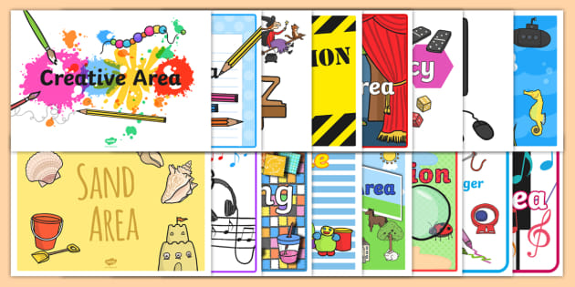
(Twinkl classroom areas 2022)
This is an example of early overall development. Babies and toddlers can learn and develop as a whole. That is, many areas develop at the same time and can usually occur during one activity (Williams, 2020). For example, a child may use a spoon. This means meeting their physical needs which increases independence and self-esteem to meet emotional needs. The overall developmental approach allows early childhood professionals to plan future activities with their children which will benefit their overall learning, development and well-being (Williams, 2020).

The greatest benefit of the overall developmental approach lies not only in the child's intellectual development, but also in the location and importance of the child's psychological, social and emotional growth. This will improve communication and social skills and give birth to a confident child (Williams, 2020).
Practitioners find it very enjoyable to learn and challenge a particular topic they can associate positive reactions with learning (Williams, 2020).

Treasure Baskets
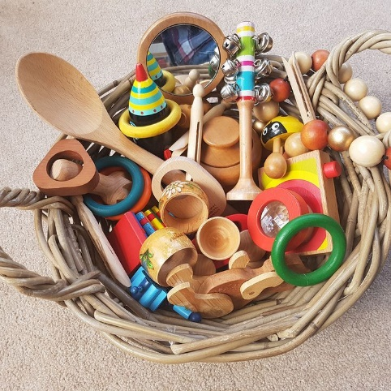 (Williams, 2020).

Treasure baskets are flat baskets, usually made of rattan, however, any type of basket can be used that can hold a lot of random everyday items. These objects are chosen to stimulate the baby's curiosity and allow the baby to interact independently with the object while sitting (Williams, 2020).
Treasure basket games are easy to create and very rewarding. The Treasure Basket is perfect for creating awe and mysteries and inspire babies allowing them to fully focus on what they are doing. Babies like to use them when they are old enough, initially when the baby can sit straight with support and when they can stand up with help. Normally, babies can continue to play in the treasure basket without worry until the they crawl a little and try to move around in surrounding area (Williams, 2020).
Piaget states that development is divided into four phases (Sherrell, 2021). The Sensorimotor Stage 2002 when babies begin to understand through their senses. The Preoperative Stage when 2–7-year-olds develop speech and reasoning. The Concrete Operational Stage when 7-11-year-olds learn rules about objects such as size, weight, and volume and lastly, the Formal Operational Stage 12+years when adolescents understand rules, for example, the concept of justice (Sherrell, 2021)

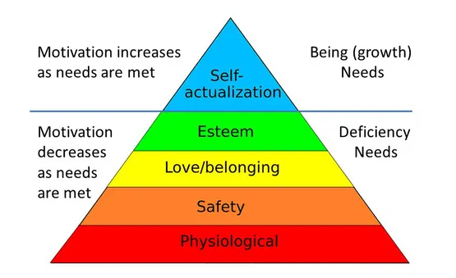
Maslow's Pyramid covers five-levels of human desire (McLeod, 2007). The bottom of the pyramid should be worked through first and so on until the top is reached (McLeod, 2007).

Story Telling
Story telling is one of the maximum effective methods that leaders ought to influence, train and inspire (Boris, 2017). What makes storytelling so powerful for learning, is from the beginning of evolution storytelling forges connections and ideas amongst human beings. Stories can bring the culture, records and values that may unite human beings. When it involves countries, groups and households they are able to connect with the stories as they are an essential part of our heritage (Boris, 2017).
There are many types of stories, such as poetry, song, movement, pictures to say but a few, which can be presented in numerous mediums such as, braille, sign language and dance in order for children and people with various disabilities to enjoy with others. Children can discover objects in a bag to match the story being read. Stories are fresh when they are written, however become eternal as they are read many times (Hurst, n.d.).
Music can be used along with dance to show other ways different cultures show this. Scarves mirrors are just a few examples of what else what will be used.
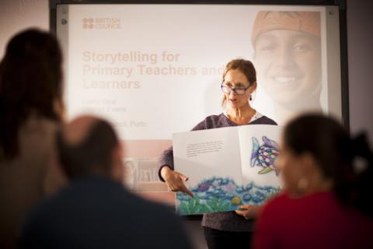(bbc British teaching English 2022)

The challenges people face in when working in childcare
Practitioners come across many challenges when working with children in childcare settings for example: lack of time, limited funding, demanding parents and excessive paperwork. However, many explain it is rewarding even though demanding (Kelly, 2006).

Respectful care in childcare setting
The care inspectorate is framed around key questions. During covid-19 they have introduced the key question 5: How good is their care and support during covid, the question will remain in the framework and will be used in childcare settings (Care Inspectorate, 2021).
Meaningful learning opportunities
For optimal child development its is important to consider additional parenting principles includes physical activity, soothing and sleep, these have been influencing early behaviours and weight outcomes (Sigman, G.M. et al., 2017).
Healthy eating plays an important role on how a child develops physically such as, developing obesity or becoming under nourished (Sigman, G.M. et al., 2017). When encouraging a child to eat, is far better to let the child decided on their food instead of food being given to them. This becomes good practice for the child as it is helping them make decisions (Sigman, G.M. et al., 2017). In order for the child to develop, other factors need to be encouraged such as, sleep and physical activities which have been seen to have had an effect on behaviour and weight control decisions (Sigman, G.M. et al., 2017).

The amount of healthy sleep for infants 4-12 months should beup to 12- 16 hours a day including napping often. Children aged 1-2 years should sleep 11- 14 per 24 hours including napping regularly (Sigman, G.M. et al., 2017).
How to be inclusive and the importance of this for both the infant and their family.
Early education is inclusive education (Nutbrown, 2022) and to be supported makes children feel safe and happy as it relates to their needs of. Practitioners who work in early years settings state they can be overworked and unhappy with their working conditions, whereas others see it as rewarding and worthwhile (Nutbrown, 2022).

Inclusion for parents
Aguilar (n.d.) explains that forming important relationships with parents is vital as it builds a bond between the setting and the home. Families with a child with special needs may be reluctant to form relationships with the setting as they feel the teachers have to spend more time with their child than with the others in the group. However, staff feel the opposite and welcome the connection with parents and can take the child’s needs into consideration while planning the day, changing and varying activities will make inclusion easier for them (Aguilar, n.d.).

Effective team working
Practitioners work effectively with a team of professionals such as health visitors, speech and language therapist and childcare workers working together to support children with special needs (WJEC, 2019). When staff are cooperating well, and respecting each other this helps them to achieve their goals. Working as a team is vitally important to develop positive relationships with families/carers (WJEC, 2019).
There are different types of teams working together but in a different way as people have different ways of working. Principles of working as a team are, working together being supportive and using individual skills (WJEC, 2019).
Multi-agency working is vitally important to support children and families. Professionals need to work together to make sure services are coordinated and well-focused on the child’s needs. There are many multi-agency workers such as parents, class teachers, ALNCO and speech and language (WJEC, 2019).

Reference list
Aguilar, E. (n.d.) The Benefits of Inclusion. Available at: https://www.easterseals.com/blakefoundation/shared-components/document-library/the-benefits-of-inclusion.pdf (Accessed: 21 January 2022).
Boris, V. (2017) What Makes Storytelling So Effective For Learning? Available at: https://www.harvardbusiness.org/what-makes-storytelling-so-effective-for-learning/ (Accessed: 20 January 2022).
Care Inspectorate. (2021) A quality framework for daycare of children, childminding and school aged children. Available at: (Accessed: 21 January 2022).
Hunter, C. (2022) Staff Morale. Available at: https://www.teachearlyyears.com/positive-relationships/view/staff-morale (Accessed: 21 January 2022).
Hurst, K. The Importance of Storytelling and Story Creation. Available at: https://www.pathstoliteracy.org/playing-words/why-it-important/importance-storytelling-and-story-creation (Accessed: 20 January 2022).
Kelly. (2016) 10 biggest challenges you face working in childcare. Available at: https://www.earlyyearscareers.com/eyc/early-years-management/10-biggest-challenges-you-face-working-in-childcare/ (Accessed: 21 January 2022).
McLeod, S. (2007) Maslow’s Hierarchy of Needs. Available at: https://www.simplypsychology.org/maslow.html (Accessed: 21 January 2022).
Nutbrown, C. (2022) Inclusion in Early Years Settings. Available at: https://www.teachearlyyears.com/a-unique-child/view/inclusion-in-early-years-settings (Accessed: 21 January 2022).
Parliament UK. (2014) Written evidence submitted by Barnardo’s. Available at: https://publications.parliament.uk/pa/cm201314/cmselect/cmeduc/364/364we20.htm (Accessed: 20 January 2022).
Sigman, G.M. et al. (2017) Feeding Infants and Young Toddlers: Using the Latest Evidence in Chil-Care Settings. Available at: https://healthyeatingresearch.org/wp-content/uploads/2017/05/her_ece_051817-FINAL.pdf (Accessed: 21 January 2022).
Sherrell, Z. (2022) What are Piaget’s stages of development, and what are examples of each. Available at: https://www.medicalnewstoday.com/articles/325030 (Accessed: 20 January 2022).
Twinkl. (2022) What is Holistic Development (EYFS) Available at: What is Holistic Development (EYFS)? - Answered - Twinkl Teaching Wiki (Accessed: 20 January 2022).
Williams, M. What Is A Treasure Basket? The Essential Guide. Available at: https://earlyimpactlearning.com/what-is-a-treasure-basket/#:~:text=A%20treasure%20basket%20is%20a,the%20objects%20whilst%20sitting%20up. (Accessed: 20 January 2).
WJEC. (2019) Professional Practice as a Childcare Worker. Available at: http://resource.download.wjec.co.uk.s3-eu-west-1.amazonaws.com/vtc/2018-19/hsc18-19_3-3/_multi-lang/unit03/01-types-of-teamworking.html (Accessed: 21 January 2022).
1,000 Days. (n.d.) Why 1,000 Days? Available at: https://thousanddays.org/why-1000-days/ (Accessed: 21 January 2022).

