Module - The Global Business Environment
Module code - LCBB4005
Lecturer - Dr. Eric Osei
Student number - 2009477
Word count - 2480
Submission date – 04.03.2021

Table of Contents
Executive Summary 3
Introduction 3
Overview of the company 3
Porter’s Five Forces 4
PESTLE Analysis 5
How the International Business Environment Impacts Toyota 7
The organizational structure of Toyota………………………………………………………………………………………………7
Recommendations ……………………………………………………………………………………………………………………………8
Conclusion…………………………………………………………………………………………………………………………………………8
Reference list…………………………………………………………………………………………………………………………………….9

Executive Summary
The study's main goal is to look at the various challenges that Toyota Motor Corporation has faced over the last five years and how the company has dealt with them.
Pestel and Porter Five Forces will be used to evaluate Toyota Motor Corporation in order to achieve the goals and priorities of understanding company' s market climate. The report will be supplemented by how the international business environment impacts Toyota .Also recommendations and conclusions will be provided.
Introduction
Business Environment refers to a set of political, economic, social, and technical factors that have a positive or negative influence on a company's business processes and are generally beyond the control of the company (Wetherly and Dorron Otter, 2014) . It refers to those aspects of the business environment that influence the business's functioning and includes both the internal and external environments of an organization.
The Business Environment can be divided into two different categories – Micro and Macro Environment.
Microenvironment refers to the climate that is in direct contact with a business entity and can have an immediate impact on business operations. It is connected to a small area where the business works.
The firm's microenvironment is made up of all the powers that surround it. These powers are unique to the company in question. They can affect the company's efficiency and day-to-day activities, but only in the short term. Suppliers, clients , shareholders, media and the company itself are among the components (Morrison, 2017).
The Macro environment is the overall economic environment that affects the operating, efficiency, decision-making, and strategy of all business groups at the same time.It's a living organism. As a result, it continues to grow.It refers to external factors that are beyond the firm's influence but have a major effect on how it works. It is made up of people, groups, organisations, departments, and those with whom the company conducts business. PESTLE Analysis is the study of the macro environment and stands for Political, Economic, Socio-Cultural, Technical, Legal, and Environmental factors (Guy, 2010).
Overview of the Company
Kiichiro Toyoda founded Toyota Motor Corporation in 1937 in Japan .The company's primary industry is selling passenger cars, commercial vehicles, minivans, and accessories. Toyota now has 53 overseas manufacturing companies in 28 countries and territories, allowing it to conduct business internationally (McCarthy, 2012) .Toyota, Lexus, Daihatsu, and Hino Motors are all part of the Toyota Motor Corporation group.
Toyota was ranked 11th on Forbes' list of the world's largest companies in 2015 (Nkomo, 2014).This ranking was determined by combining the sales, earnings, properties, and market value of various companies. Toyota is traded on a number of Japanese stock exchanges. The Tokyo Stock Exchange is the most well-known of these.

Analysis of the Micro and Macro Environments of Toyota
To grasp the business environment , there are a variety of strategies that can be implemented.
The study of the Porter's Five Forces is a methodology that helps the company understand the market because it focuses on five forces that influence an organization's efficiency (Michaux, Cadiat and Probert, 2015) . The PESTLE review, on the other hand, focuses on the environmental factors around the operation of the company.
Porter’s Five Forces
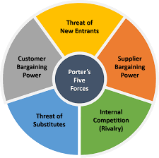
Porter's forces framework is an empirical tool that examines five competitive forces to assist marketers and business managers in determining the power structure in a global market among different organizations (Michaux, Cadiat and Probert, 2015). The model is frequently used in deciding corporate strategies and defining an industry's structure, particularly when starting a new business or entering a new market as a company.
Threat of new entrance
Businesses have trouble increasing or maintaining market share when competitiveness between competitors in the target market is fierce (Brooks and Weatherston, 2000). In order to retain buyers they must participate in price or marketing conflicts, resulting in a decline in profits.
However Toyota faces little competition from new entrants . It is demanding for new companies to get in the automotive manufacturing sector, owing to the high initial capital requirements and the industry's stringent requirements.
The bargaining power of suppliers
Suppliers may have an effect on a company's financial performance by implementing their own cost or quality criteria .If an organization may integrate further operations into their core business further down the supply chain, suppliers have considerable control.
In view of the fact that Toyota imports raw materials in bulk, manufacturers do not have high bargaining power. In addition, switching to Toyota's rivals is too costly for manufacturers, which gives Toyota a competitive advantage.
Bargaining power of the customers
Customers' ability to compromise defines their strength in a competitive market. Companies can be pressured to lower their rates, provide higher quality or additional services, or even take full advantage of the rivalry among the various actors (Brooks and Weatherston, 2000).
Since the company manufactures and sells a wide range of car models at a reasonably low price Toyota does not face strong bargaining power of customers.
Threat of substitutes
The availability of alternatives for products and services will weaken a company's market position, resulting in lower sales volume and, as a result, lower profit(Michaux, Cadiat and Probert, 2015). In comparison, if the danger of alternative goods is low, the business would be less likely to lose customers, which would raise profits.
Given the large number of competing companies in the automotive industry, there are many replacements for Toyota products. Toyota is thus faced with a relatively high danger of substitutes. The company is able to manufacture high quality vehicles and sell them at low prices in order to counter competition.
The Competitive rivalry
The advent of new companies in a specific sector involves the development of new capital in order to obtain or retain market share from existing businesses, reducing profits.
In the automobile industry, many businesses compete with Toyota. This reflects a lively Toyota rivalry. The business is, however, capable of manufacturing distinct vehicles. Moreover, at the same time, Toyota is capable of making both cheap and expensive cars and ensuring good quality. This reduces the competitors' threat.
PESTLE Analysis
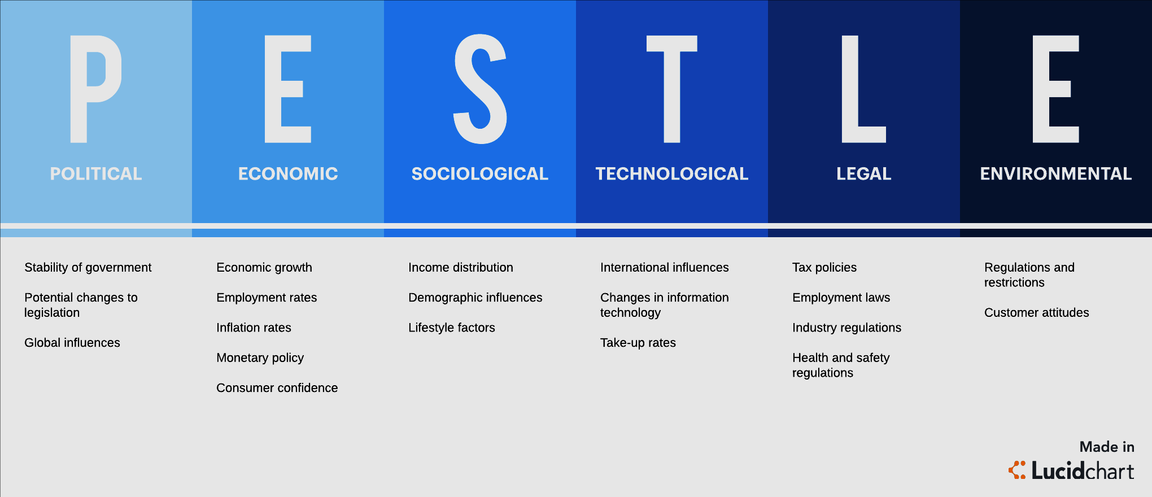
Political factors
Political stability, changes in political constitutions, and changes in political and governmental policies, as well as global trade policies, are all examples of political environmental influences. This environment is extremely important to a business, particularly if it is a multinational corporation, as overall political support is required for success and growth potential.
Companies become more vulnerable to a larger range of political and legal structures as a result of globalization and internationalization, which also increases costs and competitiveness (Guy, 2010). While on the other hand, they are able to expand their markets, reach lower-cost services, and the labor of other nations.
Political stability, the influence of domestic advocacy organizations, major geopolitical developments, and other factors all play a role in the global automotive industry (Chasek and David Leonard Downie, 2021). The strained relations between Japan and China are a prime example of how political power affects Toyota's success. This is due to a territorial dispute between the two countries in the East China Sea over a group of uninhabited and privately owned islands. Toyota's profit margins in China can suffer as a result of this situation.
Economical factors
Economic factors include: state of the economy, economic growth, interest rates, exchange rates and interest rate inflation. The economic climate is diverse and influenced by global factors. If companies are to adapt to the demands faced in terms of opportunity and danger, they must use their knowledge of the environment to impact their own policy choices.
Toyota's organizational development is driven by economic developments. The effects of economic situations or modifications on industry are calculated in this component of the PESTEL model. Because of the weakening of the Japanese yen, Toyota has the capacity to raise its sales from Japan (Toyota says weakening yen will help profits, 2017). Toyota's industry in the United States which is the company's second-largest market after Japan has the ability to expand.
Social and cultural factors
The market climate is intertwined with the country's cultural and traditional values, so adjusting to these principles is crucial for improved efficiency and productivity. Furthermore, purchasing and consumer behaviour are affected by socio-cultural environmental influences that are extremely critical (Wetherly and Dorron Otter, 2014).
Owning a vehicle is seen as a sign of prestige and status in some cultures. Toyota is likely to do well in such societies. Toyota can have an effect on group lifestyles as well as social norms. Businesses where the primary mode of transportation is the use of small cars, for example, would be a perfect market for Toyota's small car models, which are the company' s some of the main source of income.

Technological factors
With the arrival of new goods on the market, consumer expectations change. Technology is vital to the success of every company. It is defined if this market has entry barriers in companies with significant technological operations, innovations, and technical progress.
Toyota is the first company to introduce a hydrogen-powered vehicle. The business places a heavy focus on research and innovation, with the goal of supplying automobiles with alternative fuel options (Clifford, 2018). Not only because of the lack of gasoline, but also because of the challenges that energy vehicles face.
Environmental factors
Environmental and environmental considerations are among the elements that influence the growth of an organization's business operation. Climate change, sustainability, and emissions are now major concerns. These factors influence not only the policies that certain government agencies will enact, but also how consumers determine whether businesses produce revenue from environmentally friendly practices (Wetherly and Dorron Otter, 2014).
Toyota has set six environmental targets for itself that it aims to meet by 2050. The goal is for all vehicle-related operations to have zero environmental effects; however, Toyota also needs these projects to have a positive and long-term impact on society. Zero CO2 emissions from new vehicles, zero CO2 emissions from the life cycle, zero CO2 emissions from plants, reducing and optimizing water usage, creating a recycling-based environment and system, and establishing a future world in harmony with nature are among the six challenges (Clifford, 2019).
Legal factors
Laws, rules, guidelines, and acts should all be taken into account when making decisions. These laws and regulations may have a huge effect on business operations and should be investigated. Following legal edicts will offer a competitive advantage to a corporation over its competitors, as stakeholders consider the business to be legally binding (Guy, 2010).
In 2019, Toyota lost a trademark infringement lawsuit involving the Prius brand. In 2009, it filed a lawsuit in Delhi claiming that Prius Auto Industries had intruded on its Prius trademark, but the constitutional court stated that Prius Auto Industries had secured the license to use the Prius trademark in 2002, though Toyota only introduced its hybrid version in 2010 (www.toyota.co.uk, n.d.).
How the International Business Environment Impacts Toyota
Toyota is a corporation that works on a global scale. As a consequence, the international market climate in various countries has an effect on it, either explicitly or implicitly. The company's success is often affected by foreign economic factors.
Since there are so many other multinational companies in the same field as Toyota, there is a lot of competitiveness on a global level. In general, the foreign world provides Toyota with both advantages and threats.
Toyota Motor Corporation is able to penetrate and establish a broad customer base due to globalization. As a consequence, it has a greater likelihood of achieving high sales growth. Since Toyota is able to obtain more innovations through development, globalization has also led to the company's higher productivity. One of the main advantages that globalization introduces to Toyota is a high proclivity to expand and increase in size and sales. Globalization on the other hand presents a range of challenges for the organization.
The organizational structure of Toyota
Toyota Motor Corporation has a divisional organizational structure. The typical organizational structures used in Japanese companies are also related to this system. In general, the companies operating in the international sector are wide and complex in nature.
Multinational corporations are typically split into regions, with each region having a general manager. The regional manager manages the operations of the organization in a region, usually a country, and is accountable to the overall manager or the CEO (www.toyota-global.com, n.d.). The organizational framework of Toyota has the following principal features:
- Global hierarchy
- Geographic branches
- Product-based branches
Toyota Organizational structure chart
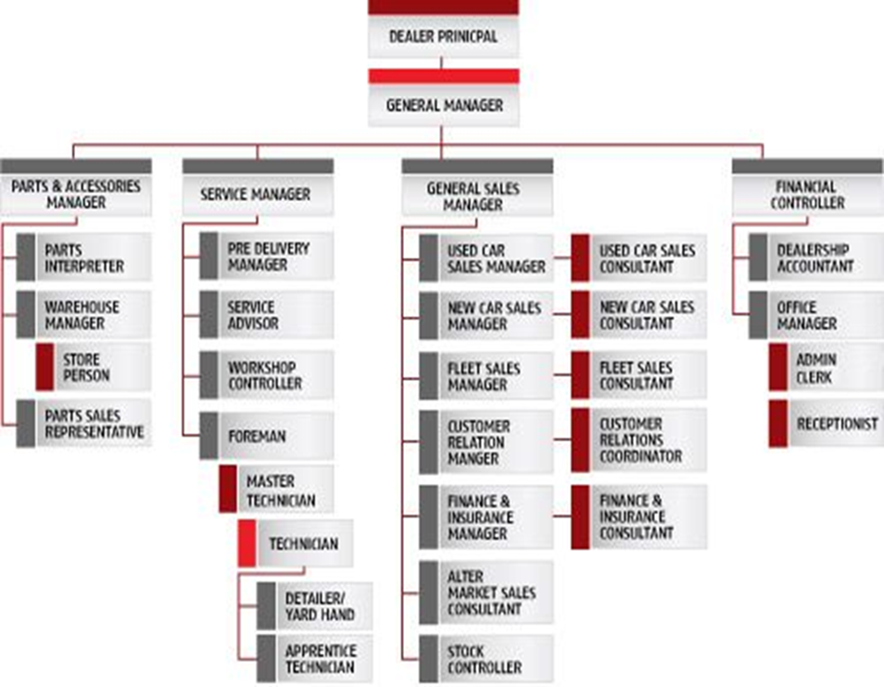
Recommendations
- Toyota should continue to make concerted attempts to enhance its management system and increase shareholder value.
- To take advantage of existing opportunities, the company could focus on product growth.
- Toyota should also boost its business activities and business strategy in order to take advantage of various macroeconomic developments.
- Toyota should think about making Lexus a priority in China. It will be able to compete with other luxury automotive manufacturers as a result of this (Harvard Business Review, 2014). The company would be able to provide cheaper distribution networks and get accessible to developing market consumers by expanding manufacturing facilities in Asia.
Conclusion
The external and internal factors that affect a company's operating circumstances are referred to as the business climate. Clients and distributors, investors, and shareholders will all be part of the market world. Improvements in technology, legislation, and social and economic patterns, on the other hand. Toyota Motor Corporation's PESTEL analysis is a strategic method for analysing the organization's macro environment and influencing the organization's macro environment.

Changes in macro-environmental factors will affect not only Toyota Motor Corporation, but also other competitors in the Car industry. The Porter Five Forces, which form planning and the competitor analysis, can be influenced by macro-environmental factors.They may have an effect on a company's competitive advantage or the consumer goods industry's overall profitability.
Reference list
Chasek, P.S. and David Leonard Downie (2021). Global environmental politics. Abingdon, Oxon ; New York, Ny: Routledge.
Clifford, J. (2019). What is the Toyota Environmental Challenge 2050? [online] Toyota UK Magazine. Available at: https://mag.toyota.co.uk/toyota-environmental-challenge-2050/ [Accessed 2 Mar. 2021].
Guy, F. (2010). The global environment of business. Oxford: Oxford University Press.
Harvard Business Review. (2014). Lessons from Toyota’s Long Drive. [online] Available at: https://hbr.org/2007/07/lessons-from-toyotas-long-drive.
McCarthy, D. (2012). 75 years of Toyota: A brief history. [online] Toyota UK Magazine. Available at: https://mag.toyota.co.uk/75-years-of-toyota-a-brief-history/ [Accessed 2 Mar. 2021].
Morrison, J. (2017). The global business environment : challenges and responsibilities. 4th ed. London: Palgrave Macmillan.
Nkomo, T. (2014). Analysis of Toyota Motor Corporation. [online] Available at: https://scholar.harvard.edu/files/tnkomo/files/analysis_of_toyota.pdf.
Toyota says weakening yen will help profits. (2017). BBC News. [online] 6 Feb. Available at: https://www.bbc.co.uk/news/business-38877750.
Wetherly, P. and Dorron Otter (2014). The business environment : themes and issues in a globalizing world. Oxford: Oxford University Press.
www.toyota.co.uk. (n.d.). Recall Checker | Owners | Toyota UK. [online] Available at: https://www.toyota.co.uk/owners/vehicle-information/recall-checker.
www.toyota-global.com. (n.d.). TOYOTA MOTOR CORPORATION GLOBAL WEBSITE | 75 Years of TOYOTA | Organizational Changes | Last Organizational Chart. [online] Available at: https://www.toyota-global.com/company/history_of_toyota/75years/data/company_information/management_and_finances/management/organizational/organizational_changes15.html.

