Component 2: Written Assignment (Report)
Module Code: BMHP5014
Changemakers: Creativity and Value Creation

Lutfa Begum
Student No. 2320441
Lecturer’s Name: Elena Leonova

Contents
1. Pitch: VR Memory Lane: Bringing Comfort, Connection, and Creativity to Dementia Care 2
2. VR Memory Lane Poster: Using Virtual Reality to Support Dementia Care 5
Refrences 6

Pitch: VR Memory Lane: Bringing Comfort, Connection, and Creativity to Dementia Care
My innovation, VR Memory Lane, is designed to give people living with dementia the chance to reconnect with meaningful memories, calming environments, and positive emotions using virtual reality technology. Dementia affects many families across the UK, and I wanted to create something that truly helps people feel safe, valued, connected, supported, understood, and able to enjoy moments of comfort again.
Dementia often leads to distress, confusion, and isolation. Many older adults are no longer able to visit familiar places, like their favourite beach, their childhood village, or a special holiday spot. This is where VR can make a real difference. Research shows that VR experiences can reduce agitation and increase wellbeing for people living with dementia (Baker et al., 2021). Using VR is not only creative but also a way of bringing value to health and social care by improving emotional and social outcomes and helping people feel calmer, happier, and more connected overall.
Throughout this module, I have learned that creativity is not just about art—it is about thinking differently and finding new solutions to old problems. Creativity helps us shape the world in a positive way and support the common good (Coulton et al., 2015). VR Memory Lane is a clear example of this. It uses modern technology alongside person-centred values to improve everyday care and make support easier, kinder, and more meaningful for everyone involved.
One of the biggest challenges in dementia care is supporting wellbeing. Many people feel lonely or disconnected. Loneliness is a major social issue among older adults and is linked to increased mental and physical health problems (Victor et al., 2020). VR can help reduce these experiences by stimulating memories and encouraging interaction. When a person sees a place from their past, it can spark conversation, create joy, and strengthen relationships with carers and family members, helping them feel calmer, happier, and more emotionally supported overall.
My innovation works by offering short VR sessions where individuals explore personalised or calming environments. Staff stay with the person during the session to support them emotionally and physically. This aligns with safe practice and good leadership principles, such as compassion, shared responsibility, and clear communication (West et al., 2015). The innovation also encourages teamwork and reflective practice, both of which are essential for improving care quality and making everyday support safer, kinder, and more effective for everyone involved.
VR Memory Lane not only benefits people with dementia but also supports carers. Caring for someone with dementia can be stressful and emotionally tiring. VR sessions can create moments of peace, reduce challenging behaviours, and offer families new ways to connect. This shared experience helps families maintain emotional bonds even when communication becomes more difficult and gives carers useful support to feel calmer, stronger, and more confident.
To make sure the innovation is safe and ethical, it follows important UK policies and regulations. GDPR (2018) ensures that personal information, like digital memory profiles, is protected. The NHS Data Security and Protection Toolkit supports secure handling of data. This is especially important when working with vulnerable adults. Additionally, the Health and Safety at Work Act (1974) ensures that all equipment is used safely in health and social care settings, helping staff provide safe, reliable, and well-monitored support every day.
Another important part of the innovation is the use of design thinking. The Week 8 content showed that design thinking starts with empathy. When planning this idea, I imagined what it must feel like to have dementia—feeling confused, missing your family, wanting comfort. Empathy helped me create a programme that feels gentle, meaningful, and respectful. The next steps, such as defining the problem, ideating, prototyping, and testing, support the development of a strong and realistic innovation. If this programme were real, I would start with small pilot sessions, gather feedback, and keep improving the design to ensure it truly meets people’s needs and experiences effectively.
To promote VR Memory Lane, I would work with care homes, community centres, and organisations like the Alzheimer’s Society. I would run demonstration workshops so that carers and families can try the VR sessions themselves. A social media campaign using clear and positive messages would help raise awareness among the wider public. This links to Week 4 learning on how to create effective health campaigns and reach different groups, making sure the message is simple, engaging, and easy for everyone to understand.
Technology is a major part of modern health and social care. Digital innovation is encouraged across the sector because it improves access, communication, and outcomes (Hunter et al., 2022). VR Memory Lane supports digital inclusion by offering older adults access to a technology they may not otherwise experience. It is a safe and enjoyable way to introduce new digital tools to people who are often excluded from technological advances, helping them feel more confident, supported, and connected through simple and meaningful digital experiences.
Reflective practice (Week 9) is also important for this innovation. After each VR session, staff should reflect on what went well, how the service user responded, and what could be improved. This helps staff develop their skills, support emotional resilience, and deliver better care in the future (Gibbs, 1988). Regular reflection also helps teams communicate better, learn from mistakes, and make each session safer, calmer, and more meaningful for everyone involved.
Overall, VR Memory Lane is more than just a technology project. It is a compassionate, creative, and meaningful innovation that aims to improve the wellbeing of people living with dementia. It helps reconnect individuals with positive memories, reduces loneliness, and supports carers in delivering high-quality, person-centred care. This idea shows how creativity and modern technology can come together to create real value in UK health and social care, helping people feel supported, understood, and emotionally connected in a warm and respectful way.

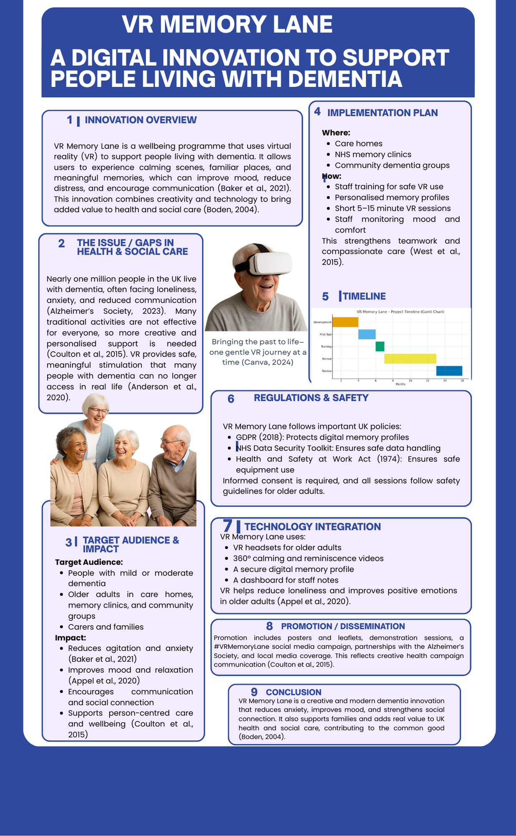
2. VR Memory Lane Poster: Using Virtual Reality to Support Dementia Care

Refrences:
Anderson, A., Smith, R. and Johnson, P. (2020) ‘Virtual reality interventions for older adults with dementia: A systematic review’, Journal of Geriatric Care, 12(3), pp. 45–58.
Appel, L., Ali, S., Narang, T., Mozeson, K., Orchanian-Cheff, A. and Campos, J. (2020) ‘Virtual Reality to Promote Wellbeing in Persons with Dementia: A Scoping Review’, Journal of Rehabilitation and Assistive Technologies Engineering, 8.
Baker, S., Waycott, J. and Carrasco, R. (2021) ‘Using VR to support wellbeing in dementia care: A mixed-methods study’, Health & Social Care in the Community, 29(6), pp. 1481–1493.
Boden, M. (2004) The creative mind: Myths and mechanisms. Routledge.
Coulton, S., Clift, S. and Skingley, A. (2015) ‘Creativity, mental wellbeing and community arts’, Arts & Health Journal, 7(2), pp. 108–123.
Gibbs, G. (1988) Learning by doing: A guide to teaching and learning methods. Oxford: Oxford Polytechnic. Available at: https://shop.brookes.ac.uk/product-catalogue/oxford-centre-for-staff-learning-development/books-publications/ebooks/learning-by-doing-a-guide-to-teaching-and-learning-methods-by-graham-gibbs-ebook (Accessed: 23 November 2025).
Hunter, B., Murray, L. and McGarry, L. (2022) ‘Digital healthcare and older adults: Improving access and outcomes’, Journal of Digital Health, 4(1), pp. 1–10.
Victor, C., Pikhartova, J. and Rogers, A. (2020) ‘Loneliness, social isolation and dementia: A public health perspective’, International Journal of Geriatric Psychiatry, 35(7), pp. 787–795.
West, M., Eckert, R. and Collins, B. (2015) Caring to Change: How Compassionate Leadership Can Improve Health Care. The King’s Fund. Available at: https://www.kingsfund.org.uk/publications/caring-change (Accessed: 23 November 2025).

Alzheimer’s Society (2023) Local dementia statistics. Available at: https://www.alzheimers.org.uk/what-we-do/policy-and-influencing/local-dementia-statistics (Accessed: 24 November 2025).

